PROGRAMME: BA INTERNATIONAL HOTEL MANAGEMENT
MODULE: MANAGEMENT & ORGANISATIONAL BEHAVIOUR
MODULE CODE: BMIH5004
Student name: Lidia Leva
Student number: 2242891
Module leader: Daniel Payne

I confirm that I have not used any AI tools in the research and creation of this
assignment. I confirm that I have not presented any AI generated materials as my own
work. I confirm I have copies of my drafts, notes, and other resources I used, which I may be asked to provide in evidence.

Table of Contents

Assessment 2: Report 3
Introduction 3
Organisation Structure, Culture, and Goals 3
Recent Change Initiatives 6
Strategic Direction 9
Recommendations 9
Conclusion 10
Reference list 11

Assessment 2: Report

Introduction
Hilton Hotels & Resorts is a globally well-recognised hospitality brand which is very well known for its luxurious accommodations as well as exceptional customer service, and also innovative approach to the resort organisation. Founded by Conrad Hilton in 1919, the emblem has grown into one of the world wide’s largest and most successful lodge chains, with over 6,500 homes spanning 119 international locations and territories. Hilton operates under several portfolios of 18 manufacturers, inclusive of Waldorf Astoria, Conrad, DoubleTree, and Hampton Inn, catering to various marketplace segments from finances-conscious vacationers to excessive-surrender purchasers.
The purpose of this record is to investigate Hilton Hotels & Resorts in terms of its organisational shape, corporation lifestyle, and strategic dreams. By inspecting these key factors, this report will offer insights into how Hilton sustains its worldwide management inside the hospitality organisation even as it adapts to converting market tendencies and customer possibilities. The talk will cover the hierarchical and useful structure of the enterprise, its sturdy agency subculture that drives operational excellence, and its overarching business desires that align with every company and personal unit's goals.

Organisation Structure, Culture, and Goals
Organisational Structure
Hilton Hotels & Resorts operates under a proper multidivisional organisational structure, characterised by that a clear hierarchy as well as regional divisions, and brand-unique manipulation. The organisation follows a centralised leadership technique, with its headquarters in McLean, Virginia, overseeing strategic making plans, financial control, and logo consistency in the course of all its international places. The CEO and govt management group set company policies, making sure that each residence aligns with Hilton’s emblem standards and service exceptional (Zeng et al., 2021). At the operational stage, Hilton employs a decentralised management system, granting nearby and asset-diploma managers the autonomy to adapt corporate strategies to neighbourhood marketplace conditions. Each lodge operates as an independent organisation unit within the larger organisation, permitting flexibility in choice-making whilst retaining corporation oversight. Franchise and managed houses follow Hilton's suggestions however function beneath varying stages of possession and management. This hybrid model lets the business enterprise enlarge its footprint unexpectedly while ensuring consistency in visitor research globally.
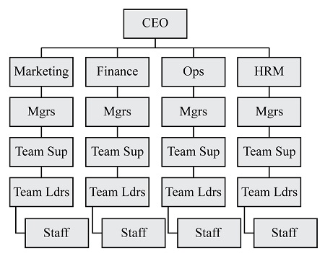
Figure1: Multidivisional organisation structure
(Source: homework.study.com)
Corporate Culture and Its Influence on Operations
Hilton’s corporate culture is built on a proper form of foundation of hospitality, innovation, as well as inclusivity. The company emphasises a proper form of consumer-centric approach, in which first-rate traveller stories pressure commercial organisation success. Hilton's centre values—hospitality, integrity, control, teamwork, ownership, and now—shape worker conduct and operational practices. These values foster a culture of excellence, wherein personnel are endorsed to transport above and past to satisfy visitor expectancies.
A key driver of Hilton's culture is its commitment to employee engagement and development. The employer invests notably in training applications, control improvement, and professional development possibilities. Hilton has been continuously diagnosed as one of the most remarkable offices globally, demonstrating the effectiveness of its human beings-first approach (DZHABAROVA et al., 2021). The “Hilton Effect,” a term coined to describe the corporation’s high quality, has an impact on corporations, displaying its commitment to social responsibility and sustainability.
Moreover, technology and innovation play a massive role in shaping Hilton’s operational culture. The employer constantly invests in digital transformation, along with cell test-in, smart room generation, and AI-driven customer support. This present-day attitude not best complements guest delight but also streamlines inner operations, improving performance and reducing prices.
Theoretical frameworks: Two theoretical frameworks relevant to Hilton's corporate culture as well as its influence on operations are Schein’s Organisational Culture Model and Self-Determination Theory (SDT. Schein's version posits that the business enterprise lifestyle operates at 3 degrees: artefacts, espoused values, and underlying assumptions. At Hilton, artefacts encompass visible elements consisting of employee interactions, service necessities, and virtual improvements like smart room technology. Espoused values are contemplated in Hilton's middle principles—hospitality, integrity, control, teamwork, possession, and now—which shape choice-making and employee conduct. The underlying assumptions, deeply embedded in Hilton's lifestyle, emphasise consumer-centricity, employee engagement, and non-stop innovation, fostering a chunk of surroundings that prioritises both operational overall performance and tourist pride. Additionally, Self-Determination Theory (SDT), which specialises in motivation, explains Hilton's dedication to worker engagement and improvement (Cardoso al., 2021). According to SDT, individuals are intrinsically brought about whilst three mental needs—autonomy, competence, and relatedness—are fulfilled. Hilton's huge schooling programs and professional improvement tasks decorate personnel's competence, whilst its inclusive way of life and teamwork foster relatedness.
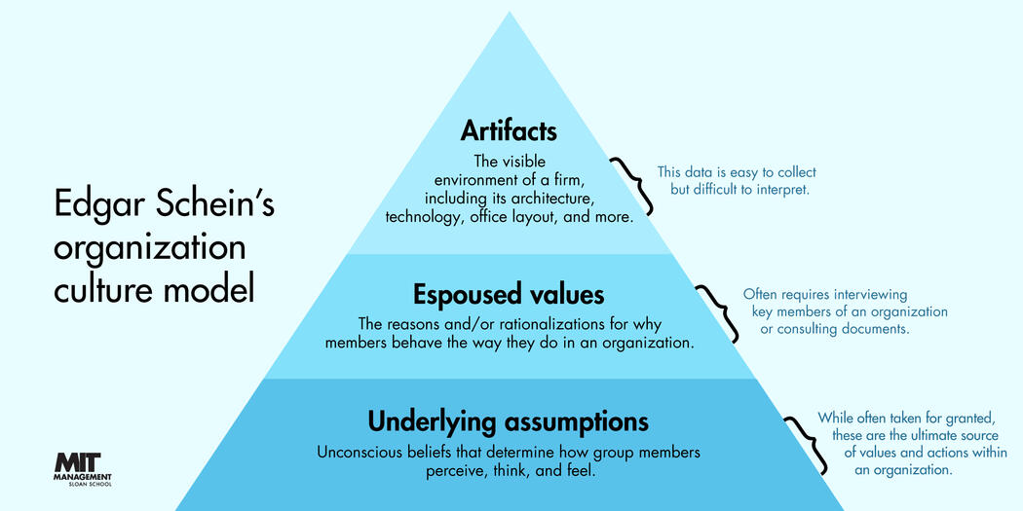
Figure 2: Edger Schwein organisation culture model
(Source: mitsloan.mit.edu)
Organisational Goals
Hilton’s corporate goals are very much well-centred around growth, guest satisfaction, as well as sustainability. At the macro stage, Hilton's goal is to increase its global presence via strategic partnerships, acquisitions, and franchise agreements. The organisation additionally makes a speciality of improving brand loyalty through its Hilton Honors program, offering wonderful advantages and personalised research to its members. Sustainability is another key objective, with Hilton committed to reducing its environmental impact through tasks like carbon footprint discount, water conservation, and sustainable sourcing (Facade et al., 2021). The employer's Travel with Purpose software outlines unique targets for accomplishing internet-zero carbon emissions and reducing food waste by way of 2030. At the man or woman unit level, Hilton houses are tasked with the assembly of overall performance metrics including occupancy fees, sales in keeping with available room (RevPAR), and visitor delight rankings. General managers and branch heads are chargeable for implementing business enterprise techniques even as ensuring operational overall performance and extraordinary service delivery. The emphasis on localised choice-making lets each hotel tailor its offerings to regional market needs whilst adhering to Hilton's worldwide brand standards.

Recent Change Initiatives
Identification of Recent Change Initiatives
Hilton Hotels & Resorts has implemented several change initiatives in order to maintain its actual competitive advantage as well as to mainly adapt to evolving industry trends. One of the most widespread obligations is the expansion of its virtual transformation approach, which includes the implementation of AI-powered customer support tools, cell keyless entry, and clever room technology. These enhancements are designed to beautify the guest's enjoyment via the manner of supplying seamless and customised interactions. Another predominant exchange initiative is Hilton’s dedication to sustainability via its Travel with Purpose program (Alameris al., 2021). This initiative specializes in reducing environmental impact, attaining net-zero carbon emissions, and increasing the use of sustainable belongings in lodge operations. Additionally, Hilton has more of its loyalty utility, Hilton Honors, through integrating AI-pushed personalisation and one type of member blessing to reinforce customer retention and satisfaction.
Impact of These Initiatives on the Organisation
The implementation of digital transformation initiatives has significantly improved the level of Hilton’s operational efficiency as well as customer satisfaction. Mobile keyless access and AI-pushed customer service have streamlined the test-in and take-a-look-out techniques, decreasing wait times and improving tourist comfort (Rockett et al., 2021). Smart room technology, which lets visitors manipulate lighting fixtures, temperature, and amusement through cellular apps, has expanded the quantity of personalisation and luxury supplied via Hilton houses.
Evaluation of Change Management
Hilton’s approach to managing these change initiatives has been largely effective, thanks to its actual strategic planning as well as employee engagement program The company has invested closely in schooling and development to make sure that personnel are well-equipped to evolve to new technological upgrades. Moreover, Hilton has maintained obvious communication with stakeholders, offering regular updates on the progress and blessings of those modifications.
However, the speedy virtual transformation has posed demanding situations in terms of employee edition and gadget integration (Pashayev et al., 2021). Some personnel have faced problems adjusting to AI-powered devices, requiring extra schooling and aid. To mitigate those disturbing conditions, Hilton has performed non-stop getting to know programs and feedback mechanisms to end up aware of areas requiring development. The sustainability tasks have also required substantial investment, but the prolonged period benefits in fee financial savings and greater logo popularity outweigh the preliminary prices.
Theoretical frameworks: Two theoretical frameworks relevant to Hilton's recent change initiatives are Kotter's 8-Step Change Model as well as Lewin’s Change Management Theory. Kotter’s model outlines a based approach to exchange, emphasising urgency, management, and stakeholder engagement. Hilton's virtual transformation and sustainability initiatives align with this model, beginning with the introduction of urgency pushed with the useful resource of evolving consumer expectancies and environmental problems. Strong leadership has been evident in Hilton's strategic investment in AI-driven systems and sustainability programs, ensuring that employees and stakeholders are aligned with the imaginative and prescient. Hilton has additionally centred on empowering employees through schooling and celebrating early successes, including enhancements in client satisfaction and operational efficiency (Baxte et al., 2021). Meanwhile, Lewin's Change Management Theory, which consists of unfreezing, changing, and refreezing, explains Hilton's transition gadget. The "Unfreeze" degree worried about recognising the want for digital transformation and sustainability, getting ready personnel and systems for alternate. During the "Change" segment, Hilton implemented AI-powered offerings, cell keyless get admission, and the Travel with Purpose software, requiring personnel to adopt new capabilities and embody eco-friendly practices. Finally, the "Refreeze" diploma is pondered in Hilton's reinforcement techniques, which incorporates non-stop learning packages, comments mechanisms, and obvious communication with stakeholders to solidify the changes as a part of the business enterprise subculture. While Hilton's change control has been largely successful, challenges in the worker model and era integration screen the complexity of organisational transformation. By leveraging those theories, Hilton has efficiently navigated change, ensuring prolonged-time period advantages in innovation, sustainability, and consumer engagement.
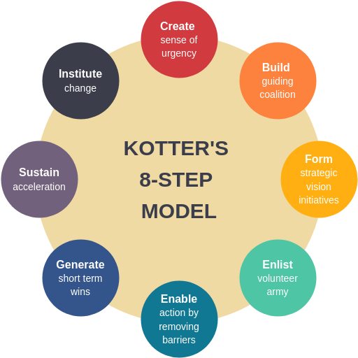
Figure 3: Kotter's 8-step model
(Source: log. Visual-paradigm,2021).

Strategic Direction
Examination of Hilton’s Strategic Direction
Hilton Hotel virtual transformation, customer-centric innovation, and sustainability. The enterprise desires to enhance its function as a marketplace chief with the aid of continuously increasing its footprint via franchising and manipulating agreements. Hilton's technique also consists of leveraging generation to decorate traveller reports and streamline operations, making sure that the logo stays at the forefront of enterprise innovation. Additionally, Hilton places a robust emphasis on environmental and social duty, integrating sustainability into its lengthy-time period business method.
Strategies Implemented to Achieve Long-Term Objectives
Hilton has implemented several key strategies in order to achieve its long-term objectives. The company’s actual global expansion strategy relies on heavily asset-moderate growth, wherein it partners with asset proprietors and developers to feature hotels below its logo while minimising capital expenditure. This technique has allowed Hilton to unexpectedly increase its presence in emerging markets without incurring massive economic hazards (Russo et al., 2021). The virtual transformation method has accomplished a critical function in Hilton's achievement. By incorporating AI-driven customer service, mobile take-a-look-at-ins, and the smart room era, Hilton has extra wonderful operational overall performance and visitor pride. The Hilton Honors software program, with its AI-driven personalisation and one-of-a-type blessings, has similarly reinforced purchaser loyalty. Hilton’s willpower toward sustainability is obvious through the Travel with Purpose software program, which outlines formidable desires to lessen carbon emissions, lower waste, and promote responsible sourcing. These tasks not handiest align with global sustainability developments but additionally decorate the commercial enterprise business enterprise's recognition as an environmentally responsible logo, attracting eco-aware vacationers.

Recommendations
To maintain its industry leadership, Hilton should continue to properly expand its technological innovations by the process of investing in AI-driven personalisation, superior cybersecurity measures, and digital concierge offerings to further enhance visitor memories. Strengthening sustainability tasks through implementing electricity-efficient infrastructure and growing waste reduction applications will assist the business enterprise meet its environmental desires at the same time as attractive to eco-conscious travellers. Additionally, Hilton should refine its patron loyalty strategy by introducing greater unique benefits, personalised offers, and partnerships with global producers to beautify visitor retention. Expanding into emerging markets with an adaptive localisation method will allow Hilton to faucet into new sales streams and give a boost to its international presence Furthermore, the organisation needs to pay attention to employee development using improving worker schooling, selling range and inclusion projects, and presenting aggressive profession growth possibilities to maintain a stimulated and excessive-appearing institution.

Conclusion
Hilton Hotels & Resorts has maintained its position as a global leader in the hospitality industry through a nicely-based organisation, a strong corporate way of existence, and a strategic route that emphasises enlargement, digital transformation, and sustainability (Dodo et al., 2021). The enterprise organisation's determination to innovation and provider excellence has strengthened its logo loyalty, whilst its Travel with Purpose initiative displays a willpower to accountable commercial enterprise practices. Recent trade tasks, which incorporate AI-driven client reviews and sustainability efforts, have in addition strengthened Hilton's ability to evolve to market tendencies. By integrating generation, sustainability, and consumer-targeted techniques, Hilton keeps decorating its aggressive advantage and keeps lengthy-time period fulfilment inside the dynamic hospitality region.

Reference list
/MIT Sloan (2021) https://mitsloan.mit.edu/ideas-made-to-matter/5-enduring-management-ideas-mit-sloans-edgar-schein
Alameri, M., Alshamsi, F., Alsaedi, S., Alkaabi, A., Alamri, R., Alshamsi, M. and Nobanee, H., 2021. Financial Analysis of Hilton Holdings. Available at SSRN 3930493.
Baxter, G. and Rising, P., 2021. An assessment of hotels and resorts' use of the ISO 14001 environmental management system as a tool to achieve environmentally sustainable operations. วารสาร เพื่อ การ พัฒนาการ ท่องเที่ยว สู่ ความ ยั่งยืน, 3(2), pp.59-85.
Cardoso, L.E., 2021. Hilton World Wide Holdings in Travel & Tourism Industry (Master's thesis, Universidade NOVA de Lisboa (Portugal)).
Dodu, S.P., Zamfir, M.M.I. and Ile, F.L., 2021. THE FAST FORWARD RESHAPE OF THE HOSPITALITY INDUSTRY IN TIMES OF GLOBAL CRISIS: A HILTON HOTELS'PERSPECTIVE. Romanian Economic and Business Review, 16(2), pp.106-115.
DZHABAROVA, Y., 2024. A STUDY OF GOOD PRACTICES OF REPUTATION MANAGEMENT IN THE HOSPITALITY INDUSTRY EXAMPLE OF HILTON CORPORATION. Socio-economic Conditions for the Spread of Epidemics in Afric a Milen PENERLIEV Disbalance in the Recovery of Tourism Markets in Bulgaria after the COVID-19 Pandemic, 1(2), p.34.
Facade, B.C., 2023. Business adaptive strategies in crisis: the case of Hilton Hotels Worldwide (Doctoral dissertation).
Pashayev, A., 2022. STUDY OF INTERNATIONAL EXPERIENCE IN THE HOSPITALITY INDUSTRY IN AZERBAIJAN AND COMPARISON WITH WORLD COUNTRIES. The Scientific Heritage, (97), pp.75-80.
Rockett, G., 2023. History/overview of Hilton. The Routledge Handbook of Diversity, Equity, and Inclusion Management in the Hospitality Industry.
Russo, E., Figueira, A.R. and Mataura-dos Santos, L.J., 2023. The Hilton hotels in the midst of the UAE 2071 centennial plan: Redesigning the UAE on the path of innovation and international tourism. Tourism and hospitality management, 29(4), pp.627-638.
Rutherford, D.G., 2021. Hotel management and operations.
Salkar, M.V., 2022. Hilton Goa Resort (Doctoral dissertation, Goa University).
visual-paradigm (2021) https://blog.visual-paradigm.com/kotters-8-step-change-model-a-comprehensive-guide/
Zeng, L., 2021. Analysis of Hilton Worldwide Hotel Group’s Transnational Operation Strategy. Academic Journal of Business & Management, 3(11), pp.20-27.

