Pandora Jewellers

Name: Loredana Forosigan
Student nr.: 1816249
Module title: Marketing Fundamentales
Module cod : LCBB4004
Assignament: 1-Pandora Place Jwwellers
Module lecture´s: Tushara Balendran

BLOG 1
THE RISE OF PANDORA

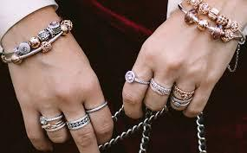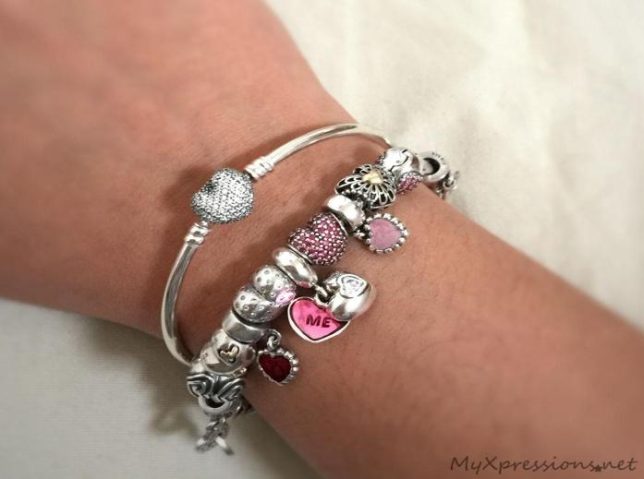

This blog is going to discuss the rise of internationally famous jewellery brand, Pandora. Established in 1982 by Per Enevoldsen along with his wife Winnie, and headquartered in Copenhagen, Denmark, Pandora is one of the largest jewellery brands worldwide. Selling in more than 100 countries and over six continents, Pandora comprises 27,300 employees globally out of which 13,200 employees are from Thailand. Pandora manufactures its jewellery in Thailand. Pandora is publicly listed on the Nasdaq Copenhagen stock exchange in Denmark. This blog is going to talk about how the concept of Pandora rose, how it started and how it got recognition worldwide in details.

The starting of Pandora : 1982-1999
Per Enevoldsen was a Danish jeweller who along with his wife Winnie started a jewellery shop back in 1982 in Denmark. During early days, they were into importing jewellery. Both Per and his wife travelled to Thailand more often in search of jewellery. Gradually the demand for their jewellery increased and as a result, they switched their business from importing jewellery to wholesaling jewellery to its customers in Denmark.In 1987, after successfully running their wholesaling business, Pandora got their first in-house designer. As a result, they decided to create their own jewellery brand with the name of ‘Pandora’.
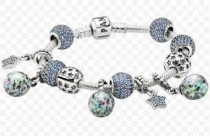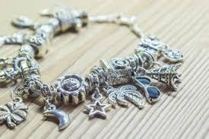
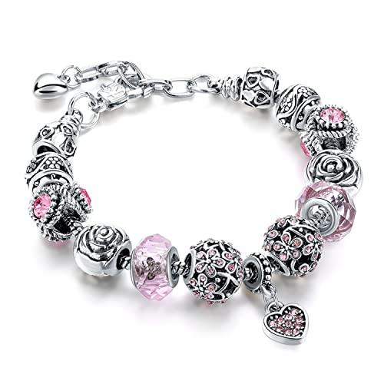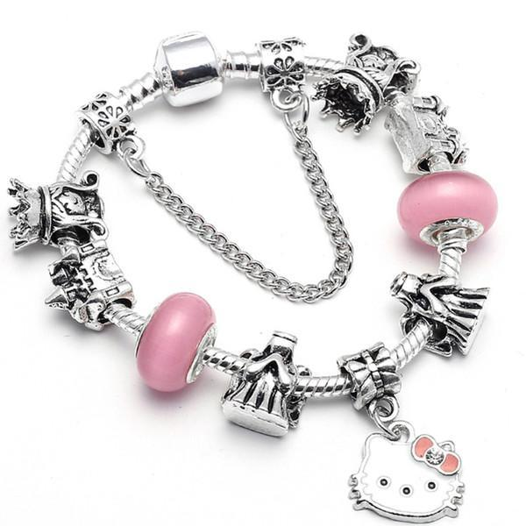

The journey of Pandora is so interesting. The way Pandora started establishing itself is remarkable. Starting from a simple jewellery shop to starting a brand takes a lot of effort, patience, proper strategy and time. Per and Winnie sure had a dream and they were so determined to execute their dream into reality. So how does Pandora get the recognition? How Pandora expanded itself? Let’s find out below.

Establishment of Pandora : 2000-2010
In 2000, along with other jewellery, Pandora introduced a new concept - charm bracelet, where various charms will be attached with the bracelet, giving it a beautiful and sophisticated look at the same time. The new concept proposed by Pandora was gladly accepted by customers and as a result demands for their jewellery increased in no time. The customers had the option to customize their charms in the bracelets. These high customer demands led them to extend their business in Germany, US , Australia in the year 2003 and 2004.By that time Pandora already established a place for itself in the jewellery industry within a very short period of time. In 2005, Pandora opened its first large-scale manufacturing unit in Thailand. Within 2010, Pandora opened another three large-scale manufacturing units providing more power to their business. These total four manufacturing units helped them to take the part of supply chain i.e. manufacturing of jewellery in their hand. Jewelleries in Pandora are hand-made and customizable, which attracted the customers the most. They now have endless options with the help of which they can have jewellery design of their own choice. People now have a jewellery brand where items are beautiful, can be self designed and looks classy and sophisticated all at the same time.
Pandora mainly targeted women at first place within the age group of 18-50. Women prefer jewellery, ornaments before anything and providing them with varieties of jewellery will easily convert them into loyal customers. Also, women give others jewellery on certain occasions. Pandora helps women to customize their jewellery according to their style and preferences. Moreover, the pricing set by Pandora was remarkable. They kept their price very reasonable. This attracted most of the people and hence turned into its loyal clients. The people compared the pricing of Pandora with other existing brands, found it less expensive given the quality of the jewellery is undeniable. This helped Pandora to grow more day by day resulting in huge success and as a result helped in expanding its business worldwide.

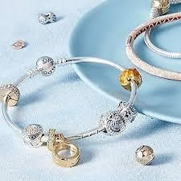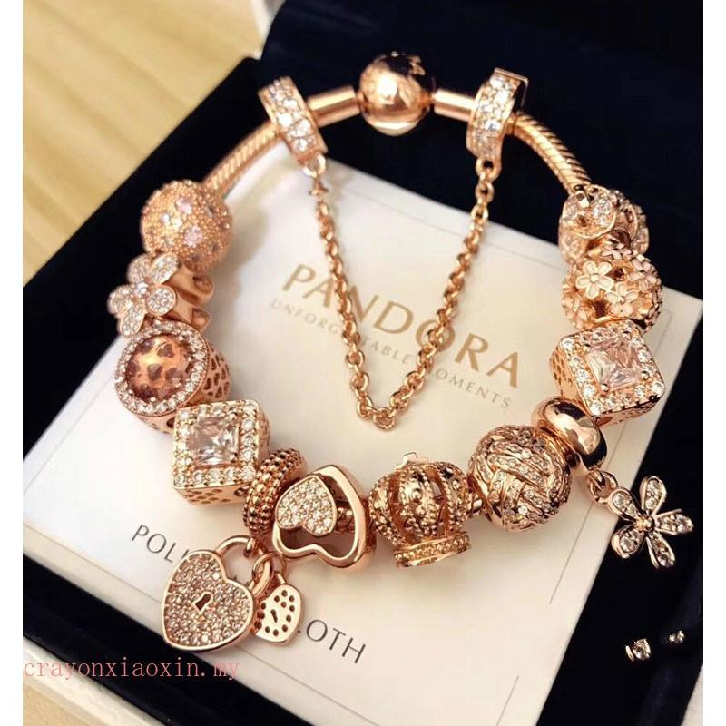

This is so interesting! It is so great to know that Pandora gained so much fame within such a small period of time. Starting from importing jewellery to making an international brand on their own, Pandora paved a long way in the jewellery industry and succeeded. Well then what is the present status of Pandora? Is Pandora able to maintain its reputation? What are the categories of jewellery Pandora works with? Let’s find it out in the next blog. How did you like my blog about Pandora? Don’t forget to let me know in the comments below.

Write a comment

BLOG 2
Expansion of Pandora

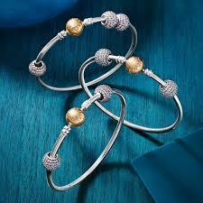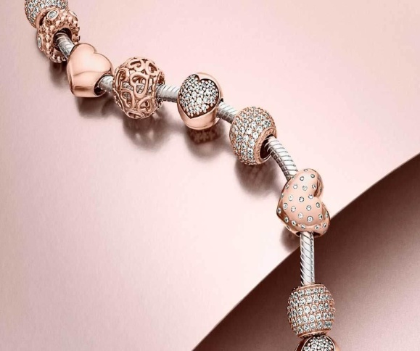

Pandora was founded by Per Enevoldsen, a Danish jeweller and his wife, Winnie in the form of a small jewellery shop in 1982 in Copenhagen, Denmark. It is known how Pandora started its journey and how it established itself as a brand in the jewellery industry. This blog is going to discuss how Pandora expanded throughout the world and set an example in the jewellery industry.
The present scenario of Pandora : 2010- Present
Coming to the present days, Pandora gained worldwide fame. They have their own supply chain starting from their own in-house designing and manufacturing of jewellery to the distribution in the global market directly. The speciality of Pandora jewellery is that they are hand-crafted using original materials. They also contain high quality diamonds, crystals, precious gems etc. Pandora sells their products in more than 100 countries with over 7,700 sale points and approximately 2600 concept stores. Their products include all the possible jewellery starting from necklaces, pendants, chains, earrings, bracelets and what not?

They even have their own collections of exclusive charms for various occasions like Mother’s Day.
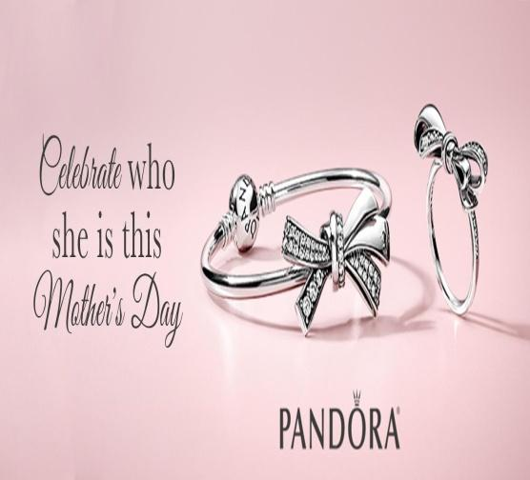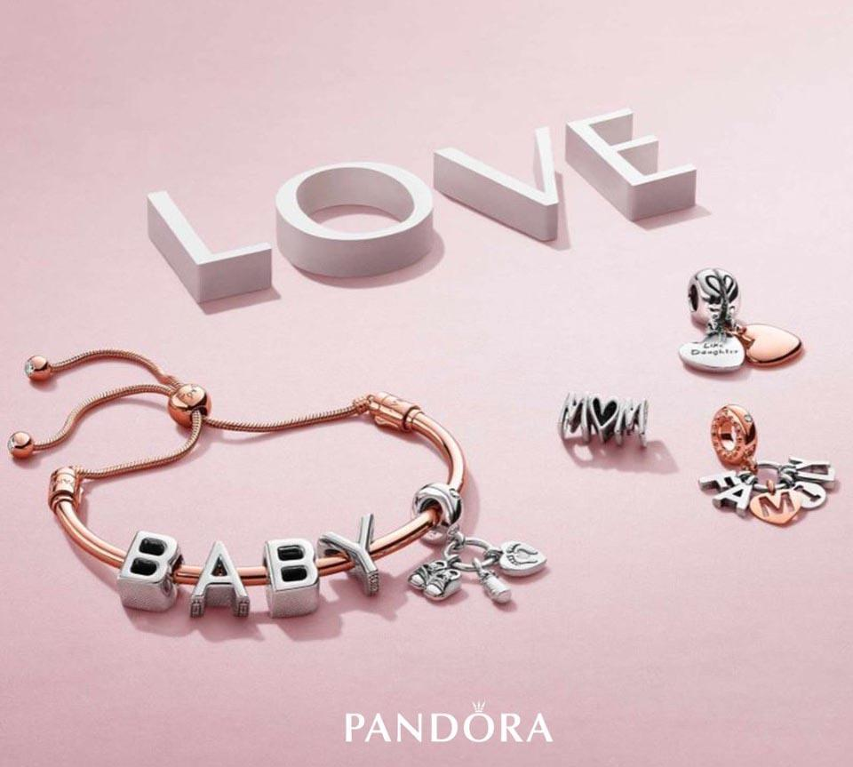
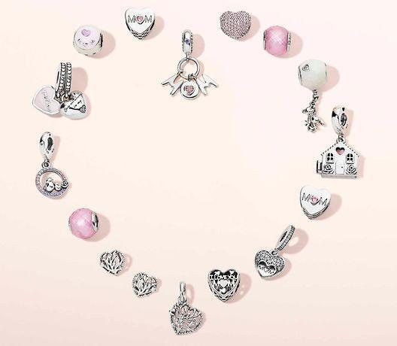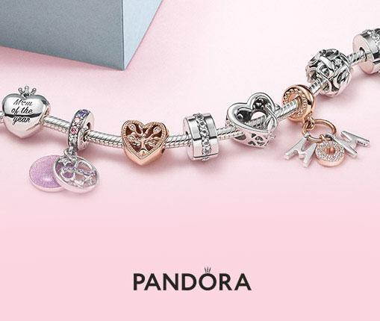
Pandora recently collaborated with Disney and Harry Potter making exclusive charms influenced by Disney and Harry Potter characters.
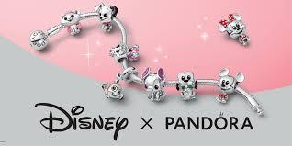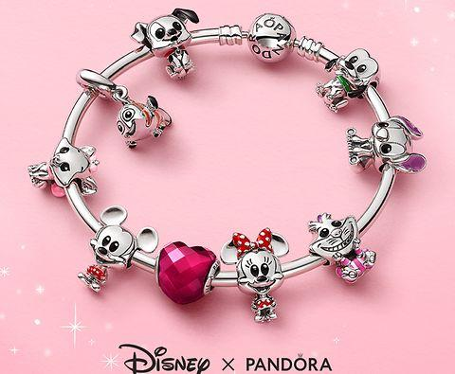
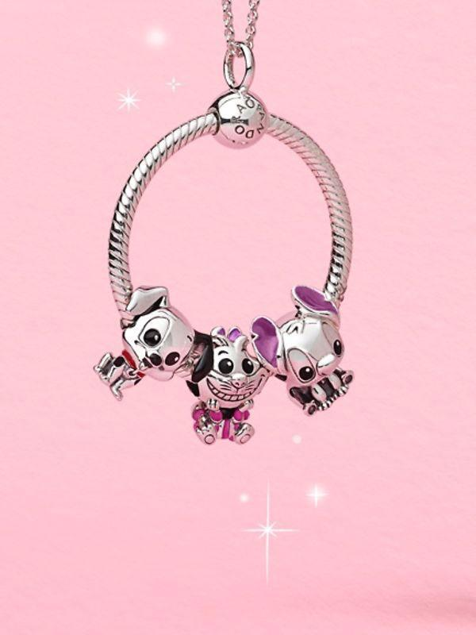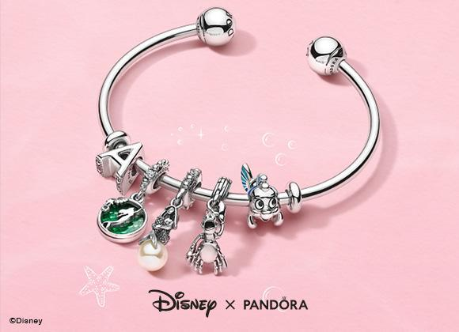

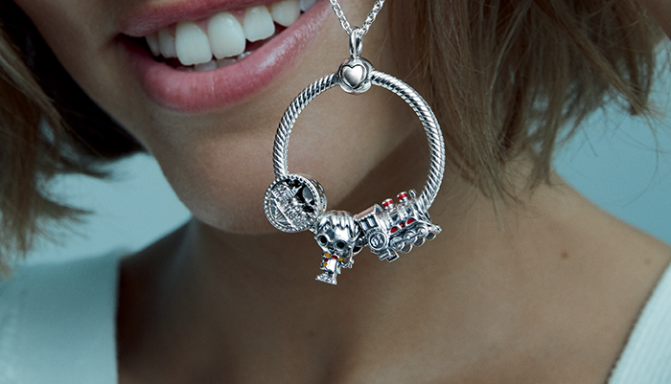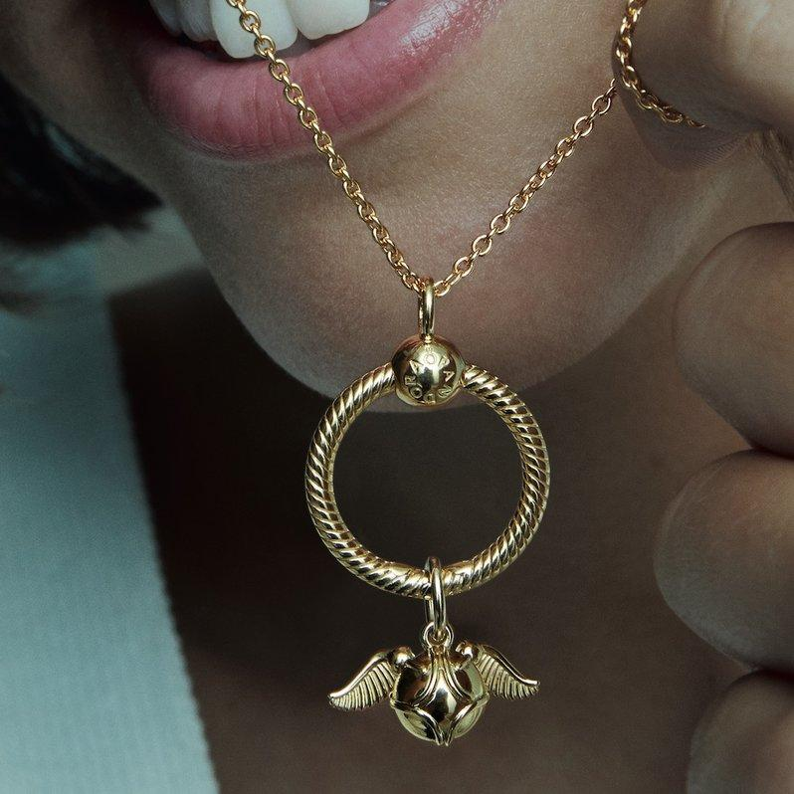
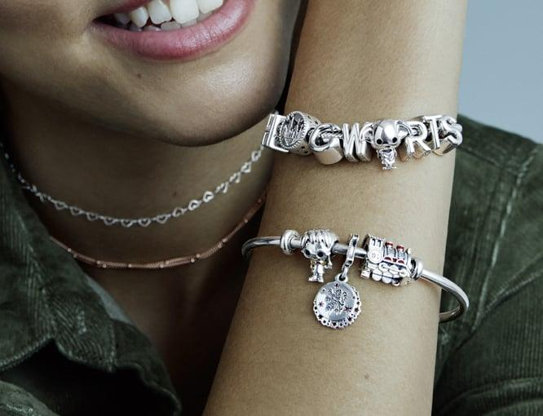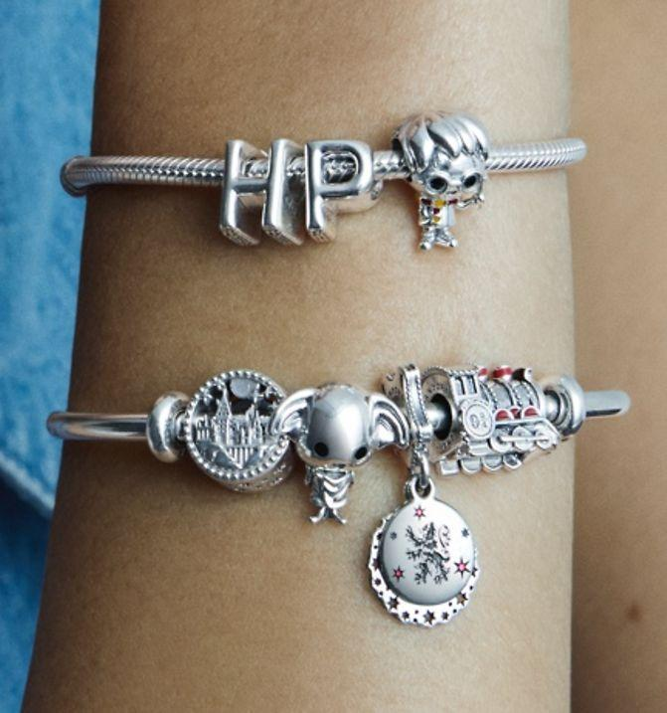

Isn’t it interesting and exciting?
So, till now we got to know everything about Pandora. How it all started, how it established and how it is expanded. But do you know that it requires a proper and strong marketing strategy in order to sustain a position in industry ? Let’s find out what marketing strategy Pandora follows.

Marketing Strategy of Pandora
In order to make a strong marketing strategy, it is very important to identify the rivals from the same industry. Pandora being from the jewellery industry have many rivals like - Tiffany & Co. , Blue Nile, Chopard, Harry Winston etc.
Pandora has established a strong place for itself by putting more effort into the product quality. It provides both hand-made and modern jewellery which are done by extremely skilled and experienced craftsmen. In order to ensure the superior product quality, Pandora uses unique quality materials like- glass, diamonds,natural gemstones, man-made stones, pearls, 14k gold ,sterling silver and many more.
Pandora has implemented the 4Ps of marketing mix in order to enhance its business operations. The 4Ps of the marketing mix consists of factors like Price, Product, Promotion, and Place. The Product is the goods and services produced by Pandora for fulfilling the demands of its customers.
The portfolio of Pandora consists of the following items
NECKLACE : It includes lockets, pendants, charms and many more.
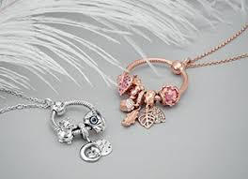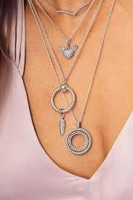
CHARMS : It is one of the most popular products of Pandora.
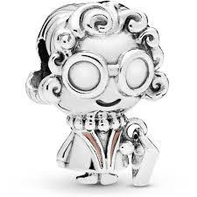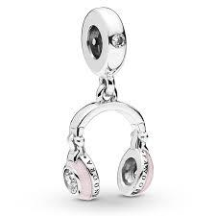
BRACELETS : It is available in gold, silver and leather with the works of small stones.
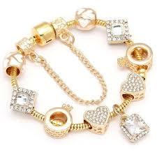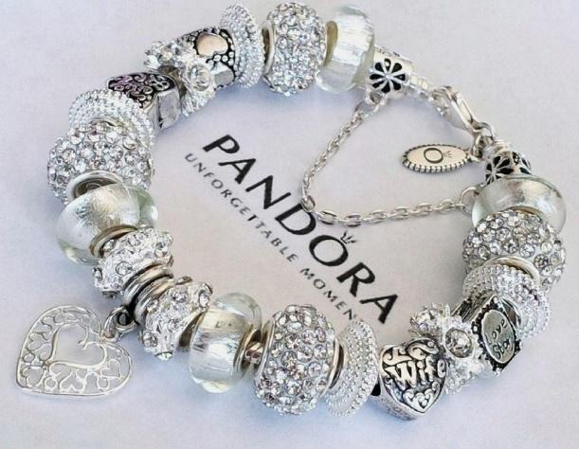
EARRINGS: It is made with metals like gold and silvers and are available in drops, hoops, studs and danglers.
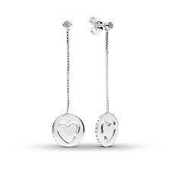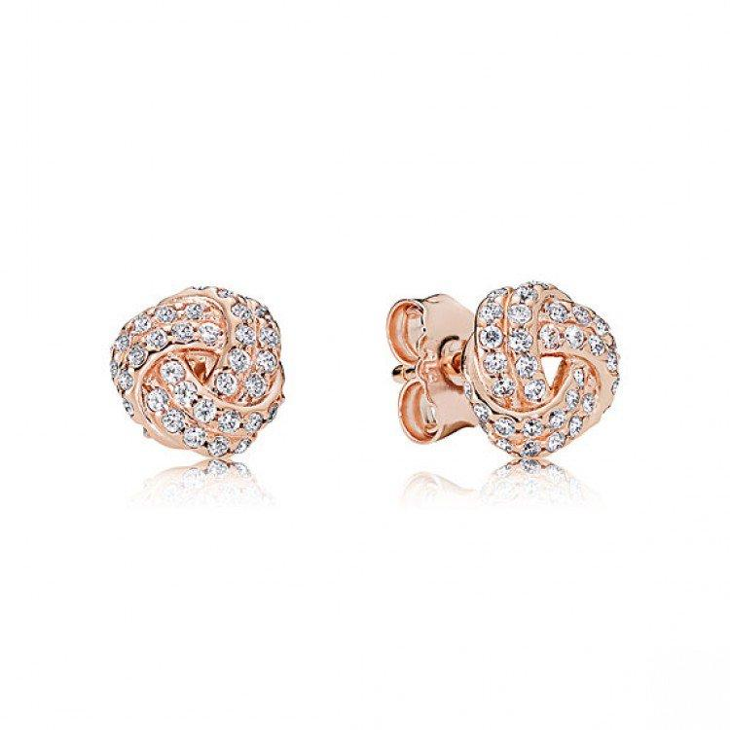
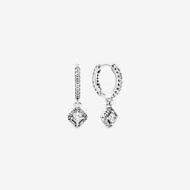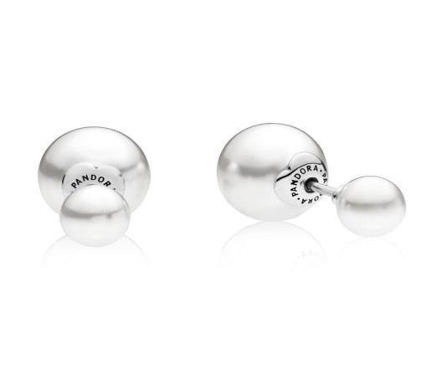
RINGS : These are created in different styles according to the preferences in color or birthstones.
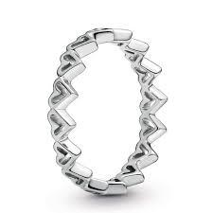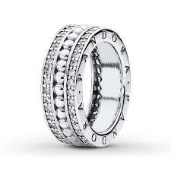
The Place refers to the distribution methods by which Pandora connects to its customers for delivering its products. Pandora uses both online and offline platforms for offering its products. Over the planet, company has already built multiple stores to gain attention of potential customers and to improve brand sustainability simultaneously. Company has its presence in several countries including Argentina, Australia, Canada, Chile, Colombia, Costa Rica, France, Denmark, Brazil and others to offer premium jewellery products items.
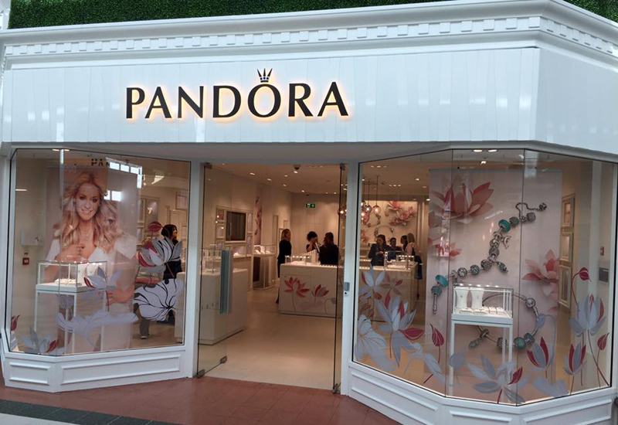
The Promotion refers to the advertising of the products offered by Pandora. It conducts online marketing with the help of social platforms like personal website, Facebook page, instagram page etc. The online marketing helps Pandora to reach out to millions of people within no time. It also conducts several campaigns through Twitter, Youtube and Facebook. Pandora greatly relies on fashion magazines and media along with some physical outlets for offline marketing.
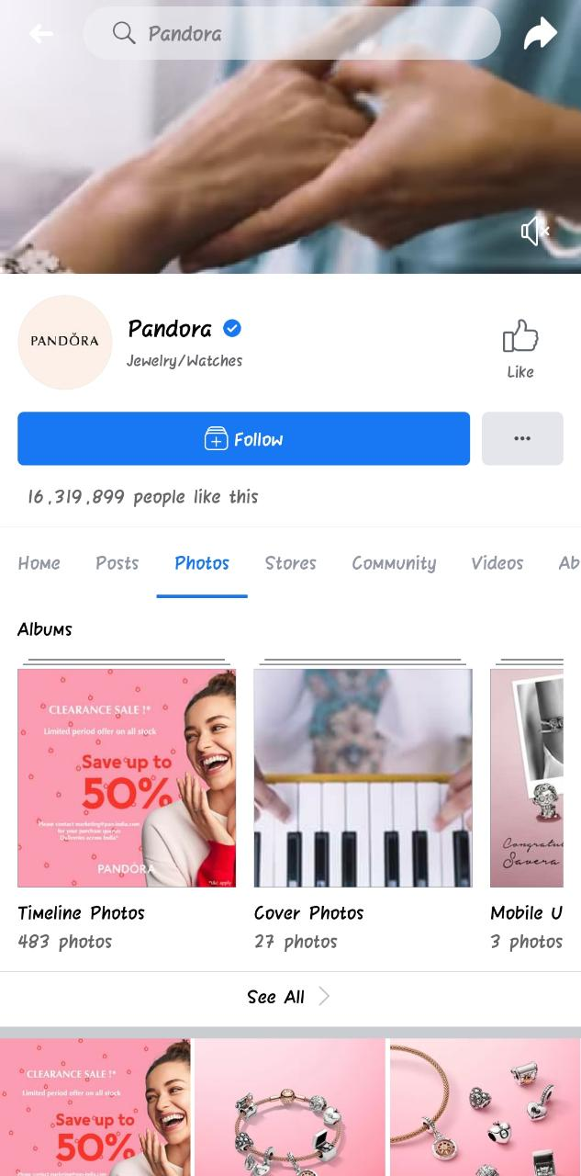

The Price is the pricing strategy implemented by Pandora. Pandora, being a versatile and unique jewellery brand, has always prioritised the premium quality of its products. Pandora has also implemented the market segmentation and targeting people on the basis of their income, status, and gender. Recently, Pandora, besides targeting the upper class and upper-middle class women has started targeting men as well to make them their customers. For marketing purposes, Lastly, Pandora has a tagline, ‘Unforgettable Moments’. It has also issued a guide which gives a detailed explanation of the materials used, making of the products, cleaning and maintaining its luster.

Pandora indeed sets an exceptional example in the jewellery industry. It gives preference to the quality of the product. It gives importance to its customer satisfaction which is a huge advantage of Pandora. It designs and manufactures its products keeping in mind the taste and choice of people.
Who is not going to love those cute and beautiful jewelleries that look classy at the same time?
Don’t forget to checkout their website us.pandora.net
Let me know if you liked this second blog about Pandora. Should I make more blogs like this? Let me know in the comments section!

Write a comment

References :
Funk, T., 2014. Advanced social media marketing: How to lead, launch, and manage a successful social media program. Apress.
Sterne, J., 2017. Artificial intelligence for marketing: practical applications. John Wiley & Sons.
Tharp, M., 2014. Transcultural marketing: Building customer relationships in multicultural America. ME Sharpe.
Rolston, C.P., Macy, A., Hutchison, T. and Allen, P., 2015. Record label marketing: How music companies brand and market artists in the digital era. CRC Press.
Smith, G.E., 2015. The Opt-Out Effect: Marketing Strategies that Empower Consumers and Win Customer-Driven Brand Loyalty. FT Press.
Spiller, L., 2020. Direct, Digital & Data-Driven Marketing. SAGE Publications Limited.
Kotler, P., Keller, K.L., Ang, S.H., Tan, C.T. and Leong, S.M., 2018. Marketing management: an Asian perspective. Pearson.
Tuten, T.L. and Solomon, M.R., 2017. Social media marketing. Sage.
French, J. and Gordon, R., 2019. Strategic Social Marketing: For Behaviour and Social Change. SAGE Publications Limited.
Baker, M.J. and Hart, S. eds., 2016. The marketing book. Routledge.

