
APPENDIX GA36d

Assessment Level 7
Student name: | MD LENIN ASHRAR NIXON | Student ID number: | 2505304
Programme: | MSc Mechanical Engineering
Module: | Engineering Design and Simulation
Assignment Title: | Optimisation of an Automatic Roll cage.
Lecturer: | Kelvin Lake | Internal Verifier:
Submission deadline: | 24/050/2026 | Submission date: | 24/05/2026

Executive Summary
This project investigated the optimisation of an automotive roll cage using Finite Element Analysis (FEA) and size-based optimisation techniques to achieve significant weight reduction while maintaining structural performance. A pre-modelled Nastran roll cage, representing a baseline configuration constructed from 50 mm diameter, 2 mm-thick mild-steel tubing, served as the starting point for analysis. The primary objective was to minimise total mass, with tube diameters and wall thicknesses defined as the design variables. Structural integrity was preserved through strict displacement-based constraints, including a global deformation limit of 17.6 mm and a local constraint applied at Grid 132.
Across five optimisation iterations, the solver rapidly converged to an efficient solution, reducing the roll cage mass from approximately 92.5 kg to 52.34 kg, representing a 43% reduction. Objective and constraint plots confirmed stable convergence, with constraint violations eliminated after the first cycle. Diameter and thickness evolution graphs demonstrated targeted material redistribution, reinforcing high-load paths while reducing non-critical members to near-minimum allowable dimensions.
Manufacturing considerations—including the use of CDS steel tubing, mandrel bending, TIG welding, and non-destructive testing—ensure that the optimised design remains practical and compliant with motorsport fabrication standards. Broader societal, environmental, commercial, and user-focused analyses further validate the design’s suitability for real-world application.
Overall, the project demonstrates the effectiveness of FEA-driven size optimisation in producing lightweight, structurally robust, and manufacturable roll cage designs. The results highlight the value of computational optimisation in modern engineering practice, delivering substantial performance improvements without compromising safety or regulatory compliance.

Contents
1. Introduction 4
2. Literature Review: Optimisation Tools in FEA 5
2.1 Types of Optimisations in FEA 5
2.2 Chosen tool and Why it’s Appropriate 8
3. Methodology 9
3.1 Provided Nastran Deck 9
3.2 Design Variables 9
3.3 Design Constraints 11
3.4 Design Variables 13
4. Results & Discussion 14
4.1 Optimised Roll cage 14
4.2 Discussion of Findings 17
5. Critical Evaluation of the Analysis 17
6. Manufacturing Recommendations 18
7. Societal, User, Business & Customer Needs 18
7.1 Health & Safety 18
7.2 Environmental Considerations 19
7.3 Commercial Considerations 19
8. Conclusion 20
References 21

List of Figures
Figure 1. Size optimization Example. 5
Figure 2. Shape optimisation example. 6
Figure 3. Topology optimisation process. 6
Figure 4. Parametric optimisation example. 7
Figure 5. Multi object optimisation example. 8
Figure 6. Provided Nastran Deck file. 9
Figure 7. Setting up Diameter design variable for optimization. 10
Figure 8. Design variable Wall thickness set in Design studio. 10
Figure 9. Displacement constraints set in Design Studio software. 11
Figure 10. Constraining both local and global displacement. 12
Figure 11. Objective setup in design studio. 13
Figure 12. The difference of weight between first and last iteration. 14
Figure 13.optimised diameter graph. 15
Figure 14.optimised thickness graph. 15
Figure 15. objective curve. 16
Figure 16. Constraints curve. 16

1. Introduction
Automotive structures need to balance strength and crash safety with weight reduction, as weight impacts fuel consumption, emissions, and performance. As lightweighting becomes a focus in vehicle engineering, optimising roll cage designs is crucial for achieving an ideal balance of stiffness, mass, and manufacturability. Research indicates that lowering structural mass while preserving stiffness enhances vehicle handling, energy absorption, and safety(Dr. John Doe, 2023).
In this assessment, a representative automotive roll cage provided as a Nastran finite element model is optimised to achieve equivalent torsional stiffness to a baseline configuration constructed entirely from 50 mm diameter, 2 mm-thick steel tubing, while minimising overall mass. Torsional stiffness is a widely used metric for evaluating roll cage and chassis performance because it directly influences vehicle handling, load transfer, and crash behaviour(Sodisetty et al., 2019). Finite Element Analysis (FEA) provides a robust framework for simulating these behaviours under controlled loading conditions, enabling engineers to evaluate deformation, stress distribution, and stiffness with high fidelity.
Modern FEA platforms integrate optimisation tools that automate the search for improved structural configurations by adjusting geometric, material, or topological parameters. Size optimisation, where tube diameters and thicknesses are varied within allowable limits, is particularly effective for tubular structures such as roll cages(Liu et al., 2023). In this study, the optimisation process is carried out using Design Studio, which interfaces with the supplied Nastran deck to perform iterative simulations under torsional loading. The objective is to identify a lightweight configuration that satisfies stiffness constraints while remaining manufacturable and structurally durable.

2. Literature Review: Optimisation Tools in FEA

2.1 Types of Optimisations in FEA
Finite Element Analysis (FEA) is a robust method for structural optimisation, allowing engineers to enhance performance through modifications in geometry, material distribution, or topology. The optimisation strategies in FEA include size, shape, topology, and parametric optimisation, each providing unique benefits based on design goals, computational capabilities, and the complexity of structures.
Size Optimisation
Size optimisation adjusts the cross-sectional dimensions, thicknesses, or material properties of structural members without altering the overall geometry. It is particularly useful for tubular structures like roll cages, where variables like tube diameter and wall thickness affect stiffness and mass. This approach is computationally efficient, preserves manufacturability, and avoids the need for remeshing, making it ideal for early-stage design. In this assessment, size optimisation aims to modify tube diameters and thicknesses to maintain equivalent torsional stiffness while reducing mass(Tyflopoulos & Steinert, 2020). Figure 1 shows the example of Size optimisartion.
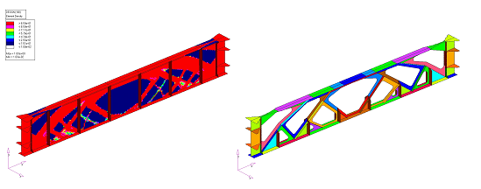
Figure 1. Size optimization Example.
Shape Optimisation
Shape optimisation involves modifying a structure's external contours to enhance performance metrics like stress distribution and stiffness. Unlike size optimisation, it changes the geometry and often requires mesh regeneration. This technique is particularly useful for components where curvature affects performance, such as suspension arms or crash structures. Although it can lead to significant improvements, shape optimisation is more computationally demanding and may pose manufacturing challenges(Bendsøe & Sigmund, 2004). Figure 2 shows the shape optimisation procedure.
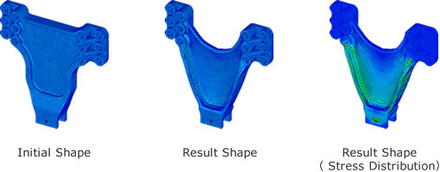
Figure 2. Shape optimisation example.
Topology Optimisation
Topology optimisation identifies the best material arrangement within a specified design space, often yielding organic or lattice structures. It is particularly beneficial in lightweighting for aerospace and motorsport, focusing on structural efficiency. The process eliminates unnecessary material while preserving load paths, leading to optimised geometries that may necessitate additive manufacturing. However, it is less effective for tubular roll cages due to regulatory and manufacturing constraints(Deaton & Grandhi, 2014). Figure 3 shows how topology optimisation take place.
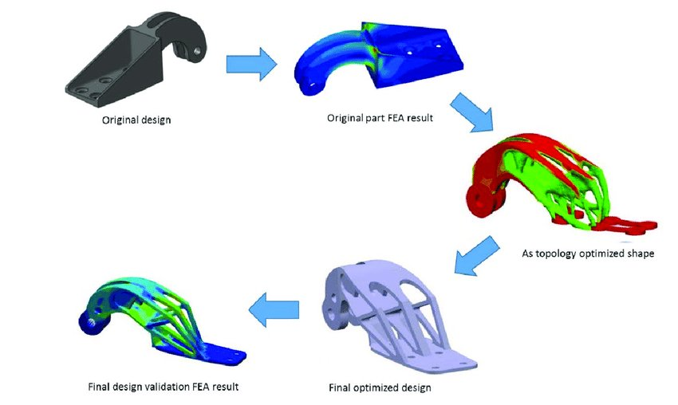
Figure 3. Topology optimisation process.
Parametric Optimisation
Parametric optimisation involves adjusting design parameters like angles and lengths to assess their impact on performance, often used alongside Design of Experiments (DOE) or surrogate modelling as shown in Figure 4. It is particularly useful when structural performance is related to geometric relationships. In roll cages, this method can help modify node positions or tube orientations, though it may conflict with regulatory constraints or necessitate significant redesign.
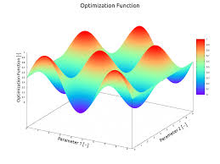
Figure 4. Parametric optimisation example.

Multi-Objective Optimisation
Many engineering challenges include conflicting objectives, like minimising mass while maximising stiffness or safety. Multi-objective optimisation techniques, such as Pareto front analysis and evolutionary algorithms, help designers navigate these trade-offs, particularly in automotive design, balancing structural performance, cost, and manufacturability. This assessment focuses on a single-objective optimisation (mass minimisation) with a stiffness constraint, reflecting principles akin to multi-objective frameworks(Szklarek & Kotelko, 2025). Figure 5 shows an example of multi-objective optimisation.

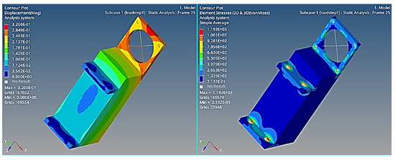
Figure 5. Multi object optimisation example.

2.2 Chosen tool and Why it’s Appropriate
Size optimisation is the most appropriate method for this roll cage study because the design objective of reducing mass while maintaining equivalent torsional stiffness depends directly on adjusting tube diameters and wall thicknesses. Unlike shape or topology optimisation, size optimisation preserves the existing roll cage geometry, ensuring compliance with motorsport regulations that restrict node positions and tube layouts. This makes it both structurally effective and practically feasible. Additionally, size optimisation avoids remeshing, reducing computational cost and improving numerical stability, which is particularly advantageous for beam-element models. Research shows that size-based optimisation is highly effective for tubular structures, achieving significant mass reduction without compromising stiffness or safety. It also aligns well with conventional manufacturing processes, as varying tube sizes are easily achievable using standard bending and welding techniques. For these reasons, size optimisation provides the best balance of performance, manufacturability, and regulatory compliance(Ou et al., 2018).

3. Methodology

3.1 Provided Nastran Deck
The optimisation study is based on a pre-modelled automotive roll cage as shown in Figure 6. The provided file contains a complete representation of the roll cage geometry, material properties, element definitions, and boundary conditions required for torsional stiffness evaluation. As stated in the assessment brief, the model represents a roll cage constructed from 50 mm diameter, 2 mm-thick mild steel tubing, which serves as the baseline configuration for stiffness comparison. The document specifies that the roll cage is to be “optimised so that it has the same stiffness as if all the tubes were manufactured from 50 mm diameter tubing which is 2 mm thick and made from Mild Steel when tested in torsion."
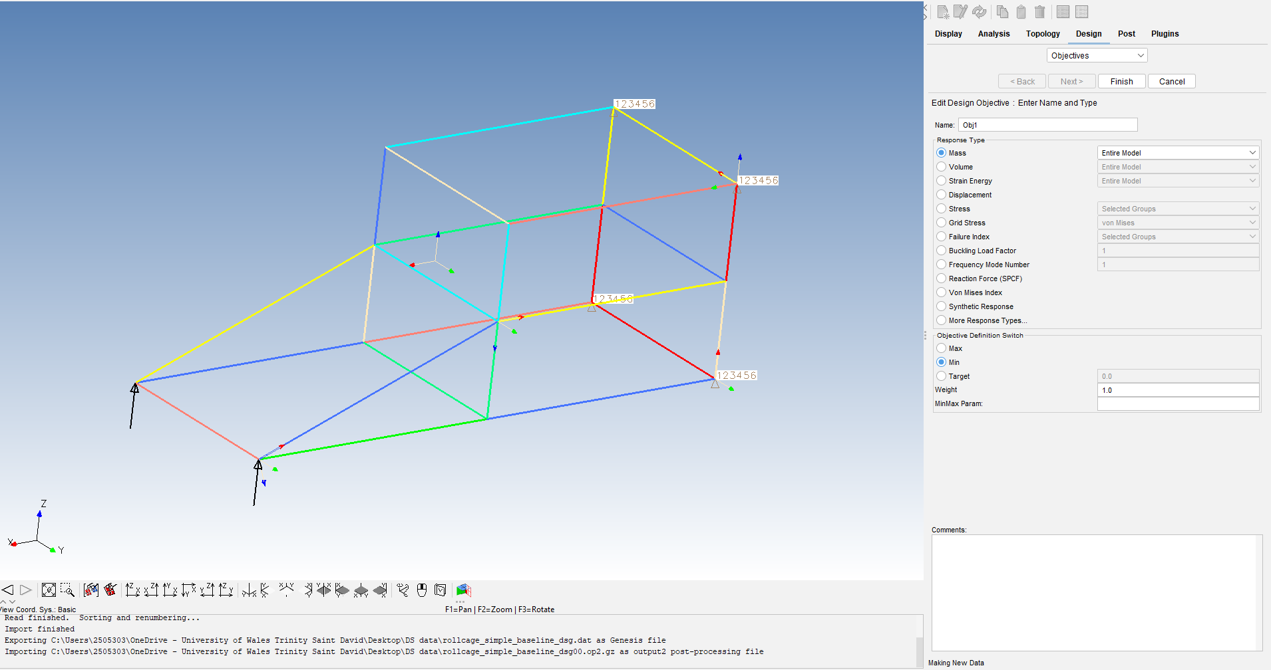
Figure 6. Provided Nastran Deck file.

3.2 Design Variables
The optimisation problem is defined by two primary design variables: tube diameter and tube wall thickness, as specified in the assessment brief. These variables directly influence both the mass and torsional stiffness of the roll cage, making them suitable parameters for size-based optimisation.
Tube diameter is varied within a realistic range (40-60 mm) that maintains manufacturability and compliance with motorsport regulations. Larger diameters increase bending stiffness and torsional rigidity, while smaller diameters reduce mass but may compromise structural performance.
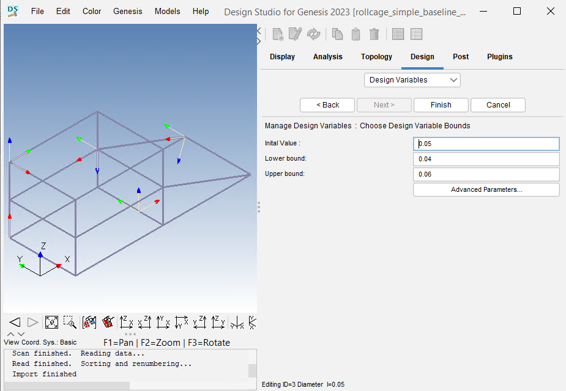
Figure 7. Setting up Diameter design variable for optimization.
Tube wall thickness (1-3mm) is similarly varied, with thicker sections providing increased local strength and stiffness, and thinner sections contributing to weight reduction. By adjusting these two parameters across different members of the roll cage, the optimisation algorithm can redistribute material efficiently, reinforcing high-stress regions while reducing mass in less critical areas.
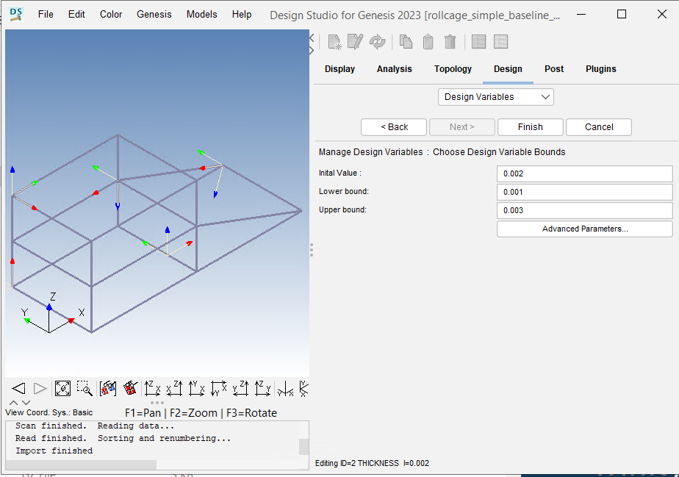
Figure 8. Design variable Wall thickness set in Design studio.
Both variables are implemented as continuous parameters within Design Studio, allowing the solver to explore a wide design space while ensuring that the final configuration maintains equivalent torsional stiffness to the baseline 50 mm × 2 mm mild-steel structure. This approach ensures a balance between structural performance, manufacturability, and material efficiency.

3.3 Design Constraints
The optimisation incorporates a maximum displacement constraint, implemented directly within Design Studio. As shown in Figure 9, the allowable upper bound for displacement is set to 17.6 mm, representing the maximum deformation permitted under the applied torsional load. This constraint ensures that the roll cage maintains adequate structural stiffness and prevents excessive twisting that could compromise safety or handling performance.
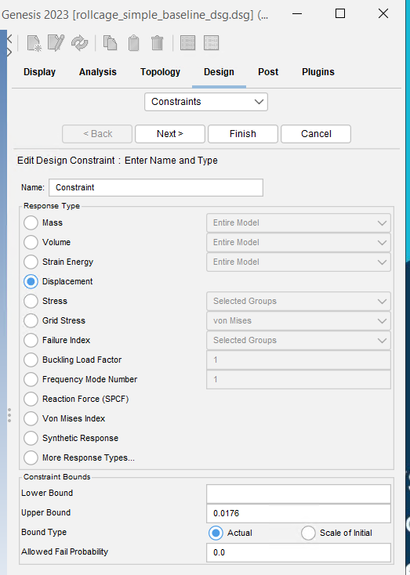
Figure 9. Displacement constraints set in Design Studio software.

A second constraint is applied at the grid level, where the displacement of a specific node, Grid ID 132, is monitored using the Translation Magnitude response shown in Figure 10. This ensures that local deformation at a critical point of the structure remains within acceptable limits. By constraining both global and local displacements, the optimisation maintains structural integrity across the entire roll cage.
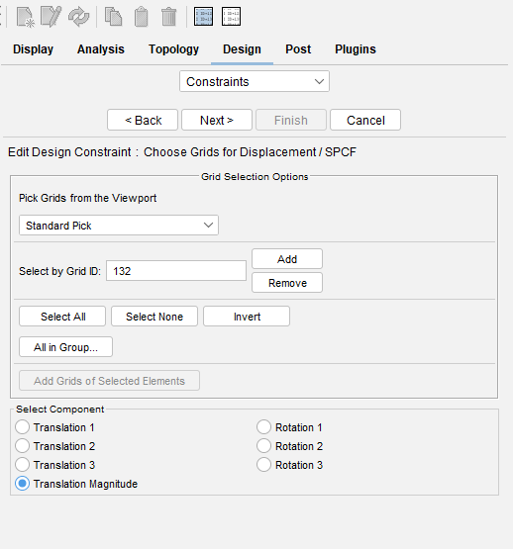
Figure 10. Constraining both local and global displacement.

3.4 Design Variables
The objective is set up in Design Studio by choosing Mass as the response type and configuring the objective description to Minimise, as illustrated in Figure 11. By prioritising mass as the target, the solution methodically minimises material consumption across the roll cage while adhering to all structural and geometric limitations.
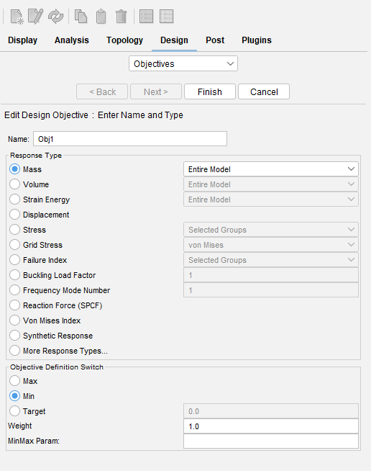
Figure 11. Objective setup in design studio.

4. Results & Discussion

4.1 Optimised Roll cage
The optimisation process successfully produced a significantly lighter roll cage while maintaining the required torsional stiffness defined by the displacement constraints. Across five iterations, the solver progressively reduced the total mass from an initial 92.5 kg to approximately 52.34 kg as shown in Figure 12, representing a substantial 43% reduction in structural weight. This improvement was achieved through size optimisation, where tube diameters (Figure 13) and wall thicknesses (Figure 14) were selectively reduced in regions experiencing lower stress, while stiffness‑critical members retained larger dimensions. The objective function plot (Figure 15) shows a steep reduction between cycles 0 and 1, followed by gradual convergence, indicating rapid identification of an efficient design space. Constraint violation (Figure 16) dropped to nearly zero after the first iteration, confirming that the displacement limit of 17.6 mm and the local constraint at Grid 132 were satisfied throughout the optimisation. The final design therefore achieves a more efficient material distribution while preserving the structural performance of the baseline roll cage.

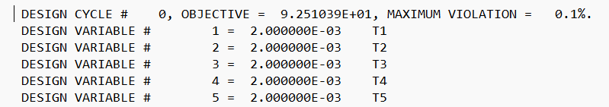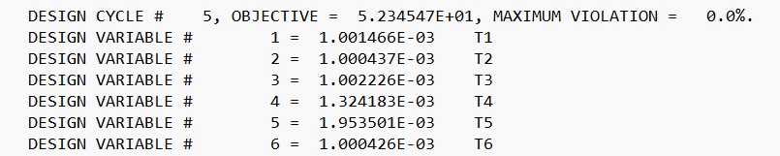
Figure 12. The difference of weight between first and last iteration.
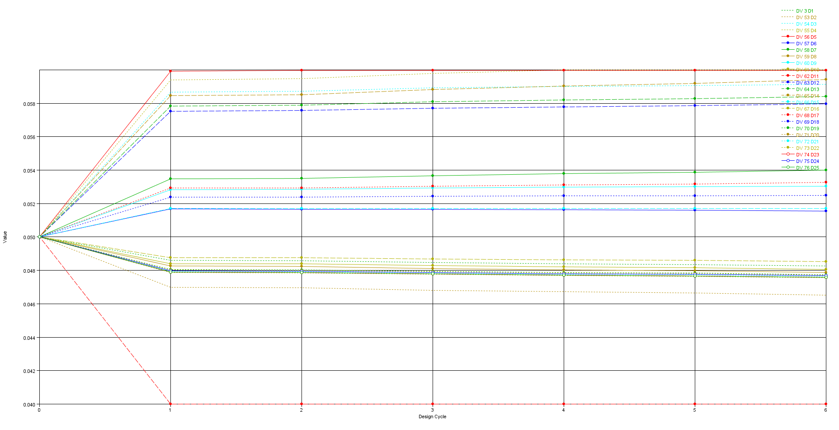
Figure 13.optimised diameter graph.
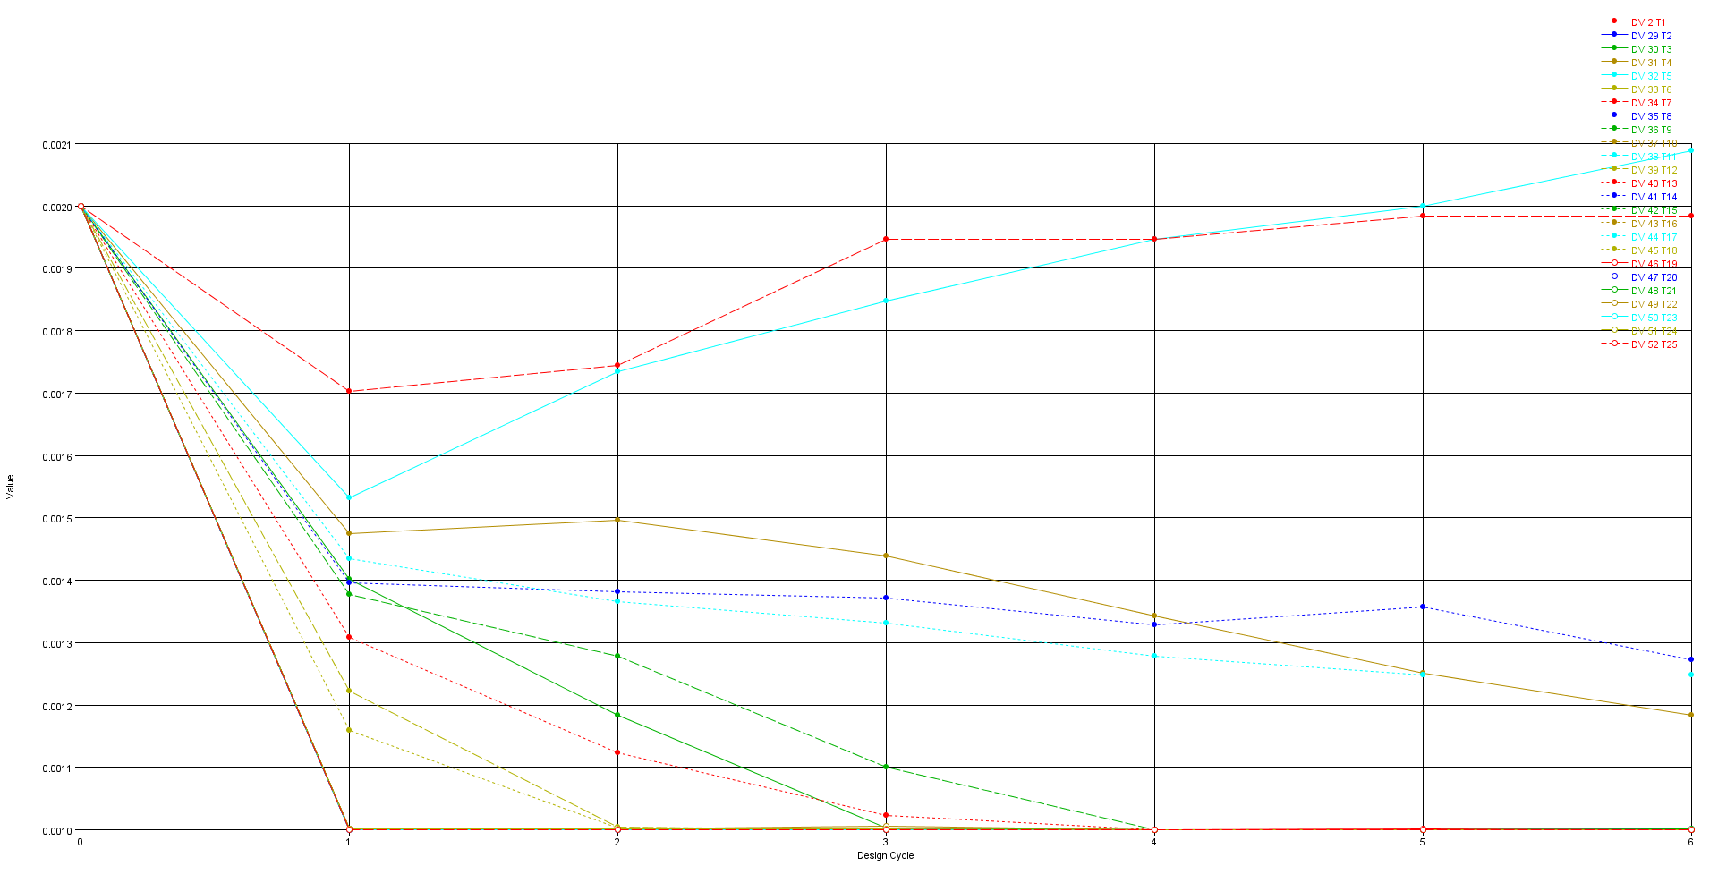
Figure 14.optimised thickness graph.
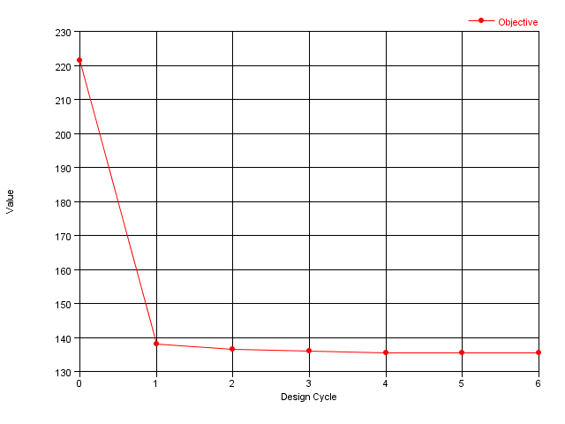
Figure 15. objective curve.

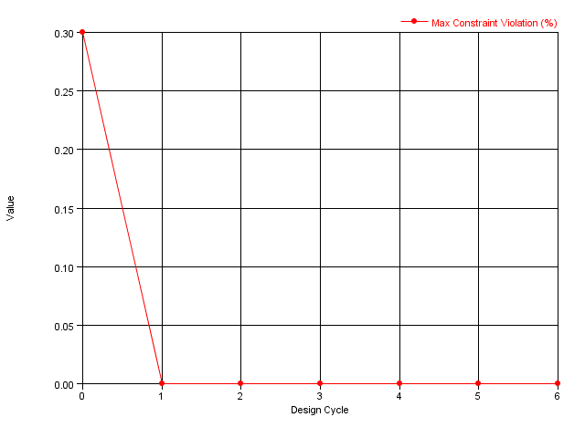
Figure 16. Constraints curve.

4.2 Discussion of Findings
The optimisation results demonstrate a clear and effective redistribution of material across the roll cage. The diameter and thickness evolution graphs show that most design variables stabilised early in the process, with only minor adjustments after the second iteration, indicating strong convergence behaviour. Tubes subjected to higher torsional loads retained larger diameters and thicker walls, while non-critical members were reduced to near-minimum allowable values, reflecting the solver’s ability to prioritise stiffness-dominant load paths. The rapid elimination of constraint violations confirms that the optimisation respected all structural limits, particularly the global displacement constraint of 17.6 mm. The significant mass reduction from 92.5 kg to 52.34 kg highlights the potential of size optimisation for lightweighting tubular structures without compromising safety or stiffness. Overall, the findings validate the suitability of the optimisation approach and demonstrate that substantial performance gains can be achieved through targeted geometric refinement.

5. Critical Evaluation of the Analysis
The study's optimisation led to a notable reduction in roll cage mass while meeting stiffness requirements. However, several limitations persist, including the reliance on beam elements that may overlook local effects like ovalisation and buckling. The model assumes linear elastic material behaviour and small deformations, which may differ from real crash conditions. The 17.6 mm displacement constraint serves as a stiffness target but doesn't evaluate energy absorption. Tube dimensions are treated as continuous variables, not accounting for standard sizes in manufacturing, which could affect the manufacturability of the design. Additionally, factors such as weld quality and joint stiffness were not included. The analysis, based on pure torsion, lacks coverage of other operational loads. Nonetheless, it establishes a solid basis for lightweight design and highlights the potential of size optimisation. Future studies should consider nonlinear material models and additional load cases for further validation.

6. Manufacturing Recommendations
Manufacturing the optimised roll cage requires fabrication methods that preserve structural integrity while accommodating variations in tube diameter and thickness. Cold-drawn seamless (CDS) steel tubing is recommended due to its superior dimensional accuracy and weldability(Niknamian, 2019). Tube bending should be performed using mandrel bending, which minimises ovalisation and thinning—critical for thinner, optimised tubes(Li et al., 2024). TIG welding is preferred for joint fabrication because it produces clean, high-quality welds with reduced heat-affected zones, improving fatigue resistance in safety-critical(Likhareva et al., 2026). High-stress nodes identified in the FEA should be reinforced using gussets or doubler plates to maintain stiffness. Dimensional accuracy should be ensured using jigs or fixtures, and weld quality verified through non-destructive testing (NDT) such as dye-penetrant or magnetic particle inspection. These practices ensure the optimised roll cage remains safe, manufacturable, and compliant with motorsport fabrication standards.

7. Societal, User, Business & Customer Needs

7.1 Health & Safety
Health and safety are central to roll cage design, as the structure directly protects occupants during rollover or impact events. Maintaining equivalent torsional stiffness ensures that the survival cell remains intact under load, supporting predictable deformation behaviour. Compliance with FIA or Motorsport UK regulations ensures that tube dimensions, weld quality, and structural layout meet minimum safety requirements. The use of CDS steel tubing and TIG welding enhances structural reliability, while NDT inspection reduces the risk of weld defects. Research shows that maintaining stiffness and continuous load paths significantly improves occupant protection in crash scenarios(Xu et al., 2023).

7.2 Environmental Considerations
The optimised roll cage contributes to environmental sustainability by reducing steel usage, which lowers embodied energy and CO₂ emissions associated with material production(Hertwich et al., 2019). Reduced mass also improves vehicle efficiency, lowering fuel consumption and operational emissions. Steel is fully recyclable, supporting circular-economy principles. Manufacturing processes such as mandrel bending and TIG welding generate minimal waste, and using standardised tube sizes reduces off-cut material. These factors collectively support a more environmentally responsible design.

7.3 Commercial Considerations
Commercial viability requires a balance between performance and cost. Size optimisation reduces material consumption, lowering raw-material costs. A major contributor to roll cage manufacturing expenses. Because the design remains compatible with conventional fabrication methods, no specialised tooling or advanced manufacturing technologies are required, keeping production costs manageable. Standardising tube sizes simplifies procurement and reduces supply-chain complexity. Demonstrating stiffness equivalence through FEA also strengthens the commercial case by providing quantifiable performance justification(Pradeep et al., 2024).

8. Conclusion
This study successfully demonstrated the effectiveness of size optimisation in improving the structural efficiency of an automotive roll cage while maintaining essential performance requirements. Using the pre-modelled Nastran deck as a baseline, the optimisation process systematically adjusted tube diameters and wall thicknesses across five design iterations, achieving a substantial reduction in total mass from approximately 92.5 kg to 52.34 kg, a 43% decrease. Additionally, this weight reduction was achieved without compromising torsional stiffness, as verified by the displacement constraint of 17.6 mm and the local control applied at Grid 132. The rapid convergence of the objective function and the elimination of constraint violations after the first iteration confirm the robustness of the optimisation setup.
The optimised roll cage exhibits a more efficient distribution of material, reinforcing high-load paths while reducing thickness in non-critical regions. This outcome aligns with both engineering best practice and motorsport safety requirements. Manufacturing recommendations, including the use of CDS steel tubing, mandrel bending, TIG welding, and NDT inspection, ensure that the optimised design remains practical and compliant with industry standards. Broader considerations relating to safety, environmental impact, commercial viability, and user expectations further highlight the value of the optimised solution.
Overall, the investigation demonstrates that significant performance gains can be achieved through targeted geometric refinement using modern FEA-based optimisation tools. The resulting roll cage is lighter, structurally equivalent, manufacturable, and aligned with societal and commercial needs, illustrating the powerful role of optimisation in contemporary engineering design.

References
Bendsøe, M. P., & Sigmund, O. (2004). Topology Optimization. Springer Berlin Heidelberg. https://doi.org/10.1007/978-3-662-05086-6
Deaton, J. D., & Grandhi, R. V. (2014). A survey of structural and multidisciplinary continuum topology optimization: post 2000. Structural and Multidisciplinary Optimization, 49(1), 1–38. https://doi.org/10.1007/s00158-013-0956-z
Dr. John Doe. (2023). Computational Methods for the Design of Lightweight Vehicle Structures. American Journal Of Mechanical Engineering And Technology, 4(4), 1–8. https://doi.org/10.71465/ajmet2075
Hertwich, E. G., Ali, S., Ciacci, L., Fishman, T., Heeren, N., Masanet, E., Asghari, F. N., Olivetti, E., Pauliuk, S., Tu, Q., & Wolfram, P. (2019). Material efficiency strategies to reducing greenhouse gas emissions associated with buildings, vehicles, and electronics—a review. Environmental Research Letters, 14(4), 043004. https://doi.org/10.1088/1748-9326/ab0fe3
Li, M., Stokes-Griffin, C., Holmes, J., Sommacal, S., & Compston, P. (2024). A Comparison of Internal Mandrel Designs for Rotary Draw Bend Forming of Carbon-fibre/Thermoplastic (PA6) Tubular Structures. Applied Composite Materials, 31(4), 1259–1273. https://doi.org/10.1007/s10443-024-10234-z
Likhareva, N., Ventzke, V., Federrath, T., Rigau, J., Dorn, F., & Kashaev, N. (2026). Fatigue characteristics improvement of the TIG-welded 316L specimens with T-joint geometry using laser shock peening. Materials & Design, 264, 115801. https://doi.org/10.1016/J.MATDES.2026.115801
Liu, L., Li, L., Guo, C., Ge, Y., & Zhang, L. (2023). A Study of the Mechanical Properties of Naturally-Inspired Tubular Structures Designed for Lightweight Applications. Applied Sciences, 13(11), 6519. https://doi.org/10.3390/app13116519
Niknamian, S. (2019). Investigation on the effect of cold drawing process on mechanical properties and structure of seamless steel (Ck60) tube. Journal of Applied Science, Engineering, Technology, and Education, 1(1), 13–23. https://doi.org/10.35877/454RI.asci1193
Ou, H., Tang, X., Xiao, J., Wang, Y., & Ma, Z. (2018). Lightweight Body-In-White Design Driven by Optimization Technology. Automotive Innovation, 1(3), 255–262. https://doi.org/10.1007/s42154-018-0032-x
Pradeep, S. A., Deshpande, A. M., Limaye, M., Iyer, R. K., Kazan, H., Li, G., & Pilla, S. (2024). A Perspective on the Evolution of Plastics and Composites in the Automotive Industry. In Applied Plastics Engineering Handbook (pp. 705–748). Elsevier. https://doi.org/10.1016/B978-0-323-88667-3.00016-3
Sodisetty, V. N. B. P., Pandey, A., Iyer, D. B., & Kumar, N. (2019, October 11). Torsional Stiffness Analysis of a Tubular Space-frame Chassis. https://doi.org/10.4271/2019-28-0033
Szklarek, K., & Kotelko, M. (2025). Multi-objective optimization of thin-walled hybrid frusta acting as collision energy absorbers. Advances in Science and Technology Research Journal, 19(12), 341–360. https://doi.org/10.12913/22998624/210152
Tyflopoulos, E., & Steinert, M. (2020). Topology and Parametric Optimization-Based Design Processes for Lightweight Structures. Applied Sciences, 10(13), 4496. https://doi.org/10.3390/app10134496
Xu, G., Liang, W., Cai, J., Xiao, J., Chen, X., & Gong, Y. (2023). Automotive Lightweight Design Modeling And Intelligent Optimization Learn Key Technologies. 2023 IEEE 10th International Conference on Cyber Security and Cloud Computing (CSCloud)/2023 IEEE 9th International Conference on Edge Computing and Scalable Cloud (EdgeCom), 381–386. https://doi.org/10.1109/CSCloud-EdgeCom58631.2023.00071

