An Analysis of Swansea Office Supplies
Madalina Blaglosov 2207678

Executive Summary
This business report has been comprehensively prepared that identify and highlight the usage of Microsoft Excel for analyzing the transactional business data and hence fetching meaningful insights. In the introductory part, the importance of Excel for data processing and analysis to make informed decisions has been stated while using functions such as If, Min, Max, Sum, SumIFs, and average some crucial insights are picked for further analysis of the profitability factors of the transactional data
The findings in the report using Excel depict the impact of Excel and the ability to distinguish profitable and non-profitable transactions, calculate total profits and loss incurred, and segment consumer-based profits, losses & averages of prices
Going further the Pivot analysis gives deep insight while providing an all-inclusive, wide-ranged, and detailed analysis of the existing correlation between the geographical states and the product categories. Pivot table helped surfacing loss-making transactions which could be the concern and eating up major profits and therefore provides an opportunity to rethink some of the products and the geographical locations while operating
Excel analysis has enabled cross-data examination of transactional data with a holistic approach while involving various factors together. This not only highlighted the loss incurred by the business but also pointed attention toward various contributing elements leading to such losses. Hence the report underscores the impact and role of Microsoft Excel for business wherein data is involved and can empower businesses to be well informed about the outcomes of their moves and to revisit the strategy in time for enduring profitability

Table of Contents
Executive Summary 1
1.0 Introduction: 3
2.0 Main Findings: 3
2.1 Excel 3
1. IF 3
2. Max 4
3. Min 5
4. Sum 5
5. Sum if 6
6. Sum IFS 7
7. Average IFS 7
8. CountIFS 9
9. Pivot Table 10
3.0 Conclusion: 12
4.0 Recommendation 13
5.0 Bibliography 14

Introduction:
Microsoft Excel stands tall as an indispensable tool in the landscape of modern business analytics, offering a multifaceted array of functions critical for preprocessing, analyzing, and deriving actionable insights from complex datasets. Excel's significance stems from its versatility, as it serves as the foundation for businesses seeking to uncover hidden narratives within their data. (My Experiences with Learning Excel – Gaurav Bansal [no date])
Excel's built-in functions IF, MAX, MIN, SUM, SUMIF, , COUNTIFS, and pivot tables—serve as a powerful arsenal, allowing businesses to distill raw data into meaningful trends and patterns. These functions are more than just tools; they serve as catalysts for informed decision-making by transforming complex data into actionable intelligence.
Excel functions' pre-processing capabilities assist in the identification of key parameters defining profitability, distinguishing between profitable and losing transactions. As an analytical engine, Excel contributes to unraveling extreme values, whether in order quantities or product margins and provides insights that shape strategic directions.
Excel's importance in business analysis cannot be overstated. Its functions are the foundation for organizations' understanding of market dynamics, consumer behavior, and operational efficiency. This report delves into the capabilities of these Excel functions, elucidating their role in identifying areas of business loss. It emphasizes the importance of a comprehensive data analysis approach, emphasizing Excel's critical role in developing informed strategies for long-term growth and success(Fairhurst [no date]).

Main Findings:

2.1 Excel

IF
IF is a logical function that evaluates a given condition and returns one value if it is TRUE and another value if it is FALSE (Moriarty et al.).
Use of IF to identify which transactions were profitable and which were not. In our case, we used the criteria for marking positive profit as “Profit” and negative profit as “Loss”
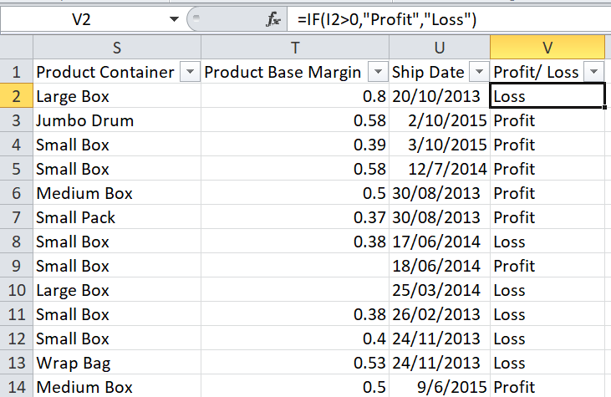

Max
Excel's MAX function is a statistical tool that assists in determining the greatest number in a series of data. It disregards logical values as well as text. Max function is used to identify highest order quantity ever made (Fairhurst [no date])
“Max” function is stated as Max(Range), here we selected the range as order quantity column since our objective was to identify maximum order quantity ever sold
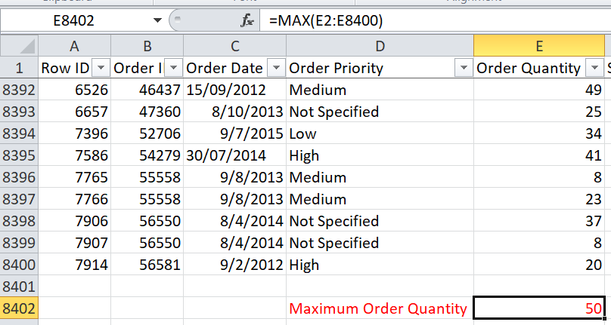

Min
The MIN Function is one of Excel's Statistical functions. MIN returns the smallest value in a given list of inputs (Data Analysis for Student using Microsoft Excel/ Spreadsheet [no date]).
It will return the least value from a provided list of numeric numbers. The MIN function, unlike the MINA function, ignores numbers, text, and logical values TRUE and FALSE, as well as text values (MIN Function - Formula, Examples. How to Use MIN Function [no date]).
Use to identify minimum product base margin amongst all the orders sold, since our objective is to identify minimum base margin on which the product is ever sold, by identifying this minimum base margin, we can then analyze more for this for example similarly minimum, maximum and average base margins can be calculated and then can see corresponding loss and profit for transactions below and above average base margins
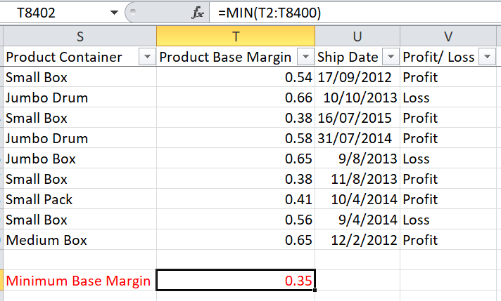

Sum
=SUM, arguably the most often used function in Excel (or any other spreadsheet application), performs just that (Basic Excel formulas & functions with examples [no date]).
It sums a column, row, or range of numbers, but it does more than that. It also adds, multiplies, divides, and employs any of the comparison operators to return a value of 1 (true) or 0 (false) (Excel formulas: The most popular functions and tools, with examples | PCWorld [no date][a]).
Used to calculate total profit for all the transactions, here we have used Profit as range to calculate total profit made
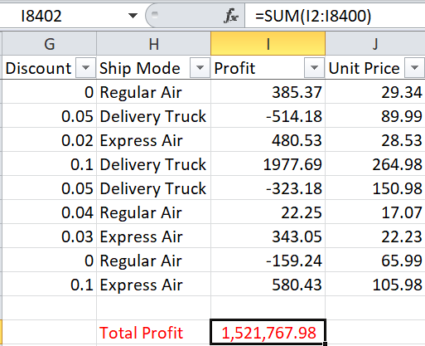

Sum if
The SUMIF formula is used to join cells that have similar features. SUMIF, for example, can be utilized when the data cells include a certain number or phrase (Learn 25 Advanced Excel Functions & Formulas | Educba [no date]).
specifying, for example, a certain product class or category. It may also be used to add information that is above or below a given number — or that amounts to a specific quantity — emphasizing outliers or grouping certain types of information together (Microsoft Excel Manual. [no date]).
SUMIF is a handy formula for obtaining summary information about sales, enrollment, or other total statistics for huge data sets containing a variety of data kinds (Bluttman [no date]).
Used to calculate profit for all corporate customers. In our case, Criteria Range is Customer segment from which the defined criteria will first be checked, the criteria we defined is to identify the transactions for Corporate and for Range we have used Profit, the formula used identifies and calculates the sum for profit earned for all corporate sales
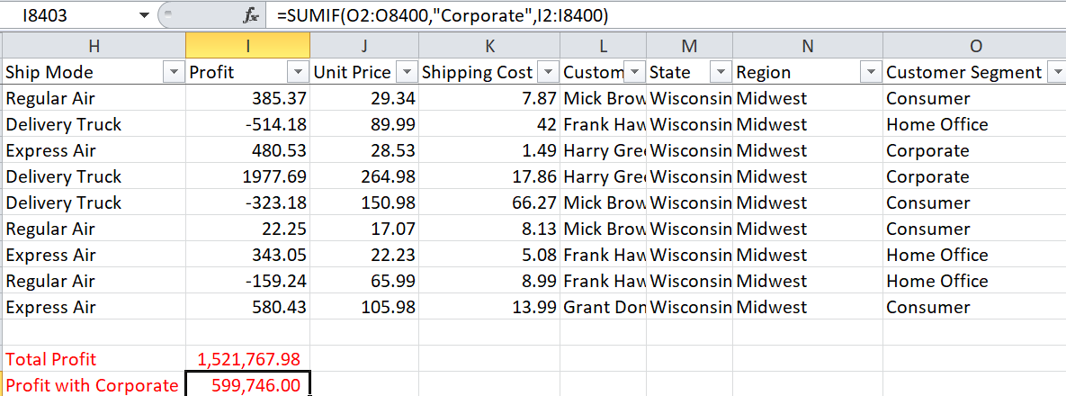

Sum IFS
SUMIFS in Excel is an aggregation technique in Excel that includes additional logical and conditional parameters that allow users to apply custom logic to business data and summarize the selected data in real-time based on criteria (Excel formulas: The most popular functions and tools, with examples | PCWorld [no date][b]).
In the case below Range is Profit, similarly Criteria Range is also profit and Criteria is value less than zero. This helped us to have a sum for all loss incurred
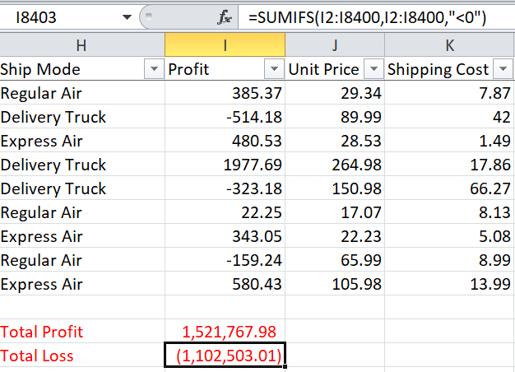

Average IFS
The Excel Average IFS function locates items in one or more arrays that meet a set of provided criteria and returns the average (i.e., the statistical mean) of the matching values in a second array (Divisi et al. 2017).
“Average IFS” function is stated as Average IFS (Range, Criteria Range, Criteria), here Range is discount, Range Criteria is Discount and Criteria is values less than zero. The end result is to find the average of discount given for all loss making transactions. This can be used as a benchmark for analyzing the discounts and its effect on profit and loss
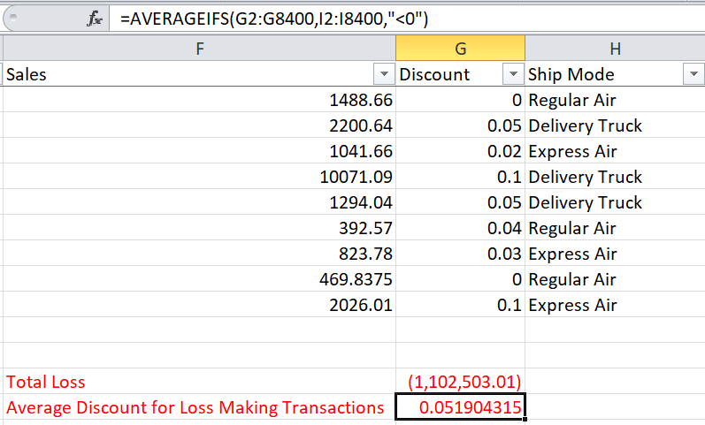
Similarly, can also calculate average order quantity for loss making transaction. Here we have used Order Quantity as Range, Profit/ Loss as Criteria Range and Loss is considered as Criteria
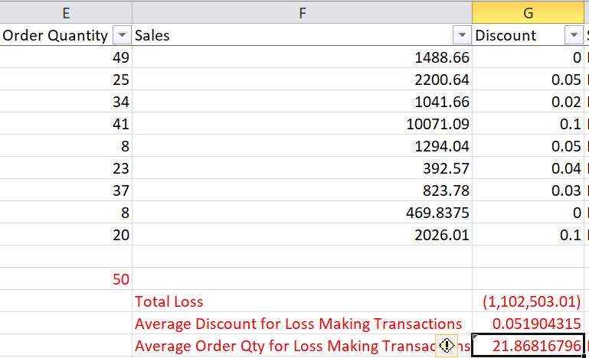
Likewise, also calculate average shipping cost for loss making transactions to identify that if the shipping cost is leading to loss. Here we have Unit Shipping Cost as Range, Profit/ Loss as Criteria Range and Loss as Criteria.
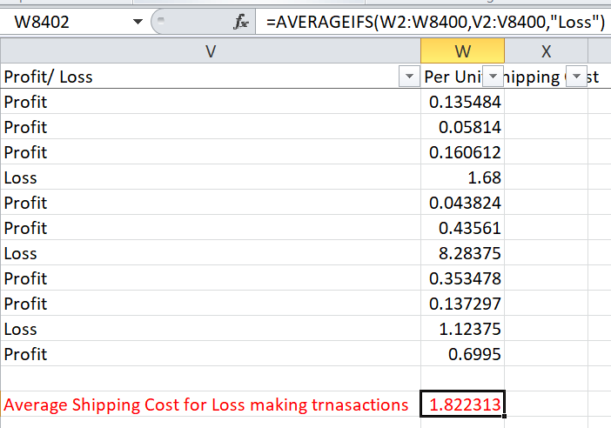

CountIFS
COUNTIFS is a helpful function that counts data only if it fulfills specified conditions. We may choose unique values using the advanced filter (as explained above) and then copy and paste them into a new spreadsheet (- [no date]; Getting Started - Using Microsoft Excel - Research Guides at University of Michigan Library [no date]).
To calculate the total number of loss-making transaction (Office Supplies as identified above with pivot table). It is stated as Count IFS (Range, Criteria), here Range is Product Category just to calculate the count and the criteria is Office Supplies as has been identified as potential loss incurring product below
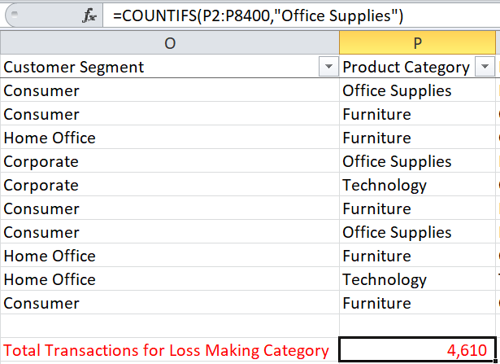
Here it is being identified that it only represents the fraction of total transactions

Pivot Table
A PivotTable report is an interactive approach to quickly summarize vast volumes of data. Researchers may use PivotTables to explore comparisons, patterns, and trends to answer unexpected questions about their data (Mcfedries 2019).
However, data should be on an Excel worksheet in a list or table style before creating a PivotTable report. It is critical that the data is properly configured (Brown et al.).
For holistic view and analysis while involving various factors, Pivot table is used here with the following application
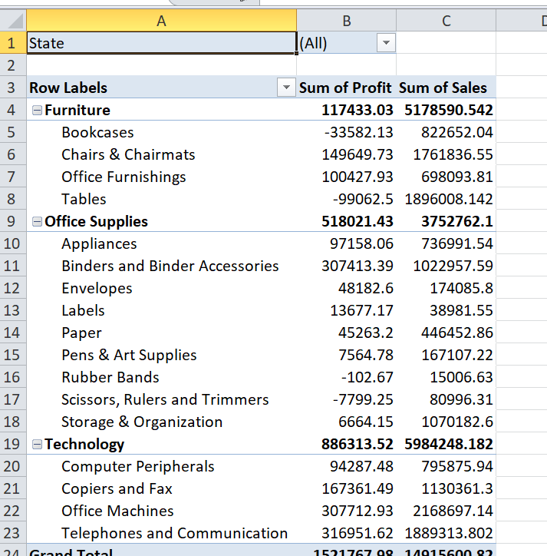
Sum of Profit and Sum of Sales are tabled against each product category and Product Sub Category just to have visibility of sum of all transactions for each case
Also above we have kept a filter for States and the above case can be analyzed for each State separately too
Here it is being observed that two product Categories are contributing to losses namely Furniture & Office Supplies. If we delve deep into this, for Furniture most loss making transactions are for Bookcases and Tables following them. Similarly, Scissors, Rulers & Trimmers as major contributors for the loss incurred in Office Supplies
Above analysis tjough in detail but alone can not be enough to give complete picture therefore it was necessary to consider ither factors too along with te above together. Since the product is sold in different states and regions therfore we analyzed the Sum of Profit for different States, few of them are mentioned below
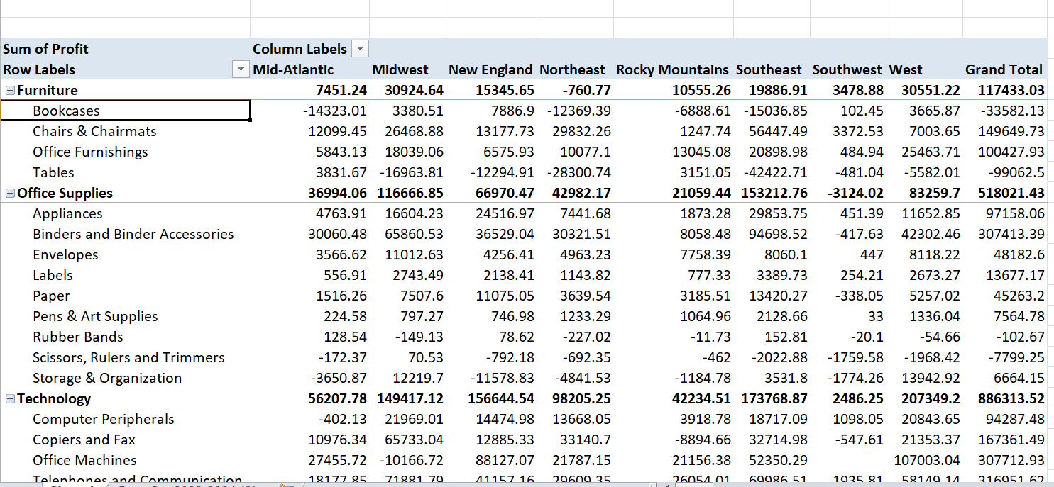
With the above, it is evident that Book cases and tables (as identified loss making above) Midwest, Northwest, Southeast & Southwest are the major regions which are incurring loss for Tables and Book cases not all the regions and they are contributing to profits in other regions
Similarly for Scissors, Rulers & Trimmers the regions where it is a loss are Mid Atlantic, Southeast & southwest
Another revelation here is that Storage & Organization is also making losses in few regions which were not visible when we saw sum of profits.

Conclusion:
Microsoft Excel's comprehensive use as an analytical powerhouse has been critical in dissecting and comprehending the transactional data. This meticulous analysis has revealed critical areas within the company where losses have occurred, indicating critical areas that require correction.
From IF's discrimination of gains and losses to MAX and MIN's revelation of extreme metrics, these tools have revealed the complexities in our sales data. Profits, losses, average discounts, and loss-making transactions were identified excel functions. These calculations not only highlighted issues, but also revealed opportunities for improvement. The pivot table analysis provided a comprehensive view, correlating product categories, regions, and profits, revealing critical insights such as specific loss-inducing products and previously unknown losses.
The data analyzed in this report has been instrumental in delineating where the company faces challenges. Yet, the key to effective rectification lies in the deeper exploration of additional data points, enabling us to uncover the specific levers affecting these losses. Excel's analytical prowess has paved the way for a clearer vision, but it's the pursuit of further insights that will truly empower us to undertake targeted and effective measures, steering the company towards enhanced profitability and sustainable success.

Recommendation
Although various functions and formulas used above gives a picture for the current status of the company’s performance and the extend of loss that has been incurred along with the use of Pivot table which have clearly identified potential areas and factors which are creating dent to the profitability However there is a need to gather more data for deep analysis and exact sorting of the problem for low profitability
More data which can be amalgamated with the above Pivot table could be unit cost, distances between the states and shipping origination, sourcing details. These when in corporate in Excel along with the existing data to be analyzed statistically through Pivot table and Pivot charts, probability runs and can lead to concluding identification of the problem which can then be rectified and hence evading chance of losses.

Bibliography
-, - ScholarSpace. [no date]. Research Guides: Using Microsoft Excel: Getting Started. Available at: https://guides.lib.umich.edu/c.php?g=283162&p=1886441 [Accessed: 22 December 2023].
Basic Excel formulas & functions with examples. [no date]. Available at: https://www.ablebits.com/office-addins-blog/basic-excel-formulas-functions/ [Accessed: 22 December 2023].
Bluttman, Ken. [no date]. Excel formulas and functions for dummies. Available at: https://www.wiley.com/en-us/Excel+Formulas+%26+Functions+For+Dummies%2C+6th+Edition-p-9781119839132 [Accessed: 22 December 2023].
Brown, C.C., Pan, D. and Wiersma, G. [no date]. Charleston Library Conference Advanced Data Analysis: From Excel PivotTables to Microsoft Advanced Data Analysis: From Excel PivotTables to Microsoft Access Access Advanced Data Analysis: From Excel PivotTables to Microsoft Access. Available at: http://www.thepress.purdue.edu/series/charleston.http://dx.doi.org/10.5703/1288284315592 [Accessed: 22 December 2023].
Data Analysis for Student using Microsoft Excel/ Spreadsheet. [no date]. Available at: https://abjournals.org/data-analysis-student-using-microsoft-excel-spreadsheet/ [Accessed: 22 December 2023].
Divisi, D., di Leonardo, G., Zaccagna, G. and Crisci, R. 2017. Basic statistics with Microsoft Excel: a review. Journal of Thoracic Disease 9(6), pp. 1734–1740. Available at: https://jtd.amegroups.org/article/view/13845/html [Accessed: 22 December 2023].
Excel formulas: The most popular functions and tools, with examples | PCWorld. [no date][a]. Available at: https://www.pcworld.com/article/402534/excels-top-12-most-popular-formulas-with-examples.html [Accessed: 22 December 2023].
Excel formulas: The most popular functions and tools, with examples | PCWorld. [no date][b]. Available at: https://www.pcworld.com/article/402534/excels-top-12-most-popular-formulas-with-examples.html [Accessed: 22 December 2023].
Fairhurst, D.S. [no date]. Using Excel for business and financial modelling : a practical guide.
Getting Started - Using Microsoft Excel - Research Guides at University of Michigan Library. [no date]. Available at: https://guides.lib.umich.edu/excel [Accessed: 22 December 2023].
Learn 25 Advanced Excel Functions & Formulas | Educba. [no date]. Available at: https://www.educba.com/advanced-excel-formulas-and-functions/ [Accessed: 22 December 2023].
Mcfedries, P. 2019. Microsoft Excel 2019: Formulas and Functions. Available at: http://www.microsoft.com [Accessed: 22 December 2023].
Microsoft Excel Manual. [no date]. Available at: www.umw.edu/tess [Accessed: 22 December 2023].
MIN Function - Formula, Examples. How to Use MIN Function. [no date]. Available at: https://corporatefinanceinstitute.com/resources/excel/min-function/ [Accessed: 22 December 2023].
Moriarty, B., Held, Bernd. and Richardson, Theodor. [no date]. Microsoft Excel Functions and Formulas, Sixth Edition : With Excel 2021 / Microsoft 365. p. 538. Available at: https://books.google.com/books/about/Microsoft_Excel_Functions_and_Formulas.html?id=FKBxEAAAQBAJ [Accessed: 22 December 2023].
My Experiences with Learning Excel – Gaurav Bansal. [no date]. Available at: https://blog.uwgb.edu/bansalg/statistics-data-analytics/my-experiences-with-learning-excel/ [Accessed: 22 December 2023].

