Business Plan
Of EMS Experience Group
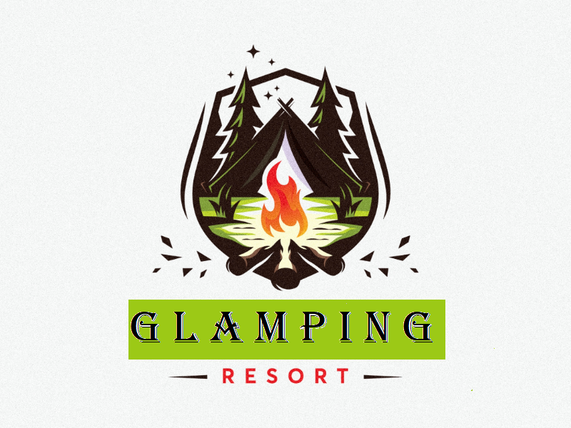

BA International Hotel Management
Entrepreneurship
M5X01926
Lecturer: Dr David Jenkins
Created by: Elza Soares (1815430)
Monuar Moni (1818185)
Stilyana Mincheva (1816276)
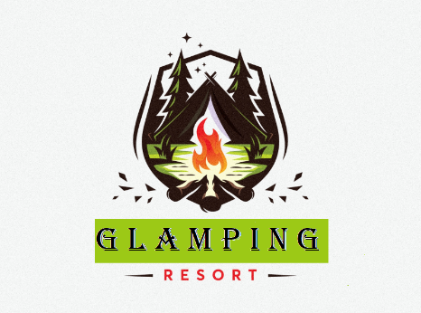
1. Executive Summary

This report focused on evaluating a business idea named ‘EMS Experience Group’. The business is planning to offer luxury and exciting camping experience to its customers. The construction process of the camping will be ultimately environment friendly. Further information about the business has been discussed in the second section of this report. A survey has been conducted to get information related to market segmentation for the company. Lastly, financial analysis has been performed to estimate the case required for operating the business. At the same time, the expected profit that will be obtained from the company also presented in that section.

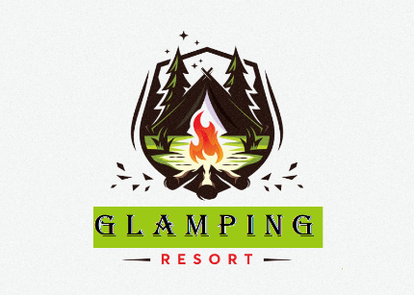
Table of Contents

2. Outline of The Business Idea 4
3. Customers and Markets 5
3.1 Market Segmentation 5
3.2 Marketing Mix 8
4. Financial Plans 10
4.1 Cash Budget 10
4.2 Profit Budget 11
5. Summary or Conclusion 11
References 13

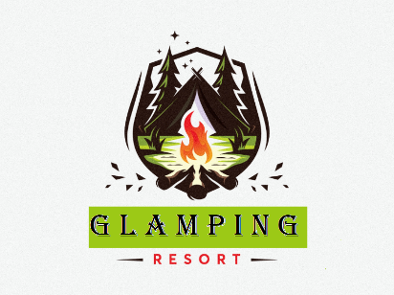
2. Outline of The Business Idea
Camping is one of the most popular activities performed by travellers. However, few established companies are involved in offering superior camping services. In this high demand situation, the company named as ‘EMS Experience Group’ is aiming towards providing luxurious and glamorous camping experiences to every customer. Here EMS stands for three core persons of the business Elza, Monuar and Stilyana. On the other hand, the term Glamping comes from a combination of two different words that are ‘glamorous’ and ‘camping’. The mission of the business is to offer a first-rate camping experience to each customer who will book service. On the other side, the vision of this business is to reach the top of the camping industry in Scotland, specifically in the Stonehaven area.

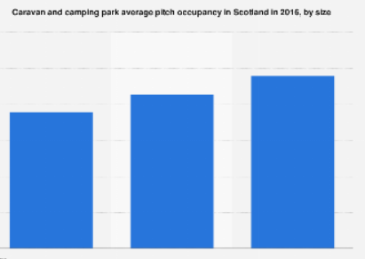
Figure 1: Occupancy in a camping park in Scotland during 2016
(Source: Statistics.com, 2020)
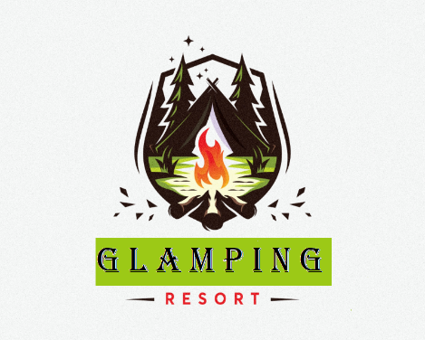
Initially, the business will be in a start-up phase in which only three people will be there associated with the business. The company has aimed to hire 100 employees from its first year of inception. The company is also pointing towards expanding the business by opening new brands. The total investment required for the business will be generated from two different sources. 60% of the total investment will be made from internal sources, and 40% will be generated from external investors. A plot of land will be rented initially to operate the inhouse jobs, buying five fully furnished tents will be one of the company’s significant investments. Gust pick up and drop services will be available, to ensure this service collaboration with a minibus, rented car service providing companies will be done. For ensuring food for guests, cooperation with hotels and restaurants will be done as well. Information related to the target customer; financials will be listed in the following part.

3. Customers and Markets

3.1 Market Segmentation
A survey has conducted to determine customer opinion about this future business. Seven different questions have been asked to 30 respondents who are very much travelling enthusiastically from Scotland itself.

Questionnaire
1. What is your age group?
1. 20 to 30
2. 31 to 40
3. More than 40
2. What destination do you prefer the most?
1. Hill station
2. Forest
3. Seaside
3. How often do you travel in a year?
1. Less than 3
2. 3 to 6
3. More than 6
4. Do you like to stay at the camp?
1. Yes
2. Don’t Know
3. No
5. How much are you willing to pay to get camping service?
1. Less than £ 30
2. £30 to £60
3. More than £60
6. Would you like to be an EMS club member?
1. Yes
2. Don’t know
3. No
7. Are you concerned about safety measures during travel in this COVID pandemic?
1. Yes
2. No
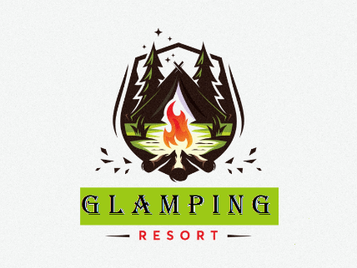
Table 1: Questionnaire

Figure 1: Survey Analysis
In the first question of the survey, the age group of the participants have been asked. Three different age groups or options have been provided to respondents. Those age groups are 20 to 30, 30 to 40 and more than 40. A study by Mulley et al. (2018) stated that people who are more than 40 years old do not like to travel that much.
Based on the survey results, it can be determined that most of the respondents belong to the age group of 30 to 40. In other words, middle age will be the target group for this business.
In the next question, information related to destination preference has been asked. Again, three different alternatives offered to the participants.
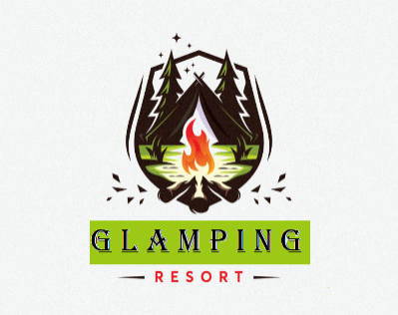
As per the results obtained from the survey, it can be determined that majority of the people who have been served like to visit the hill station. And camping related activities mostly take part in hill stations; therefore, most of these participants can be considered as target customers for this business.
Travel frequency related information has asked in the third question. As per the results obtained from the survey, it can be determined that 70% of the total sample size visit 3 to 6 times in different travel destinations in a year. In such a case, if three is set for any traveller, then that traveller visits a place every four months. If he or she visited four times in a year, then he/she visit in every three months. If a person visits six times in a year, then the person can be considered as a persistent visitor who visits a new place in a gap of only two months. Hence, frequent visitors are the target customer for this business.
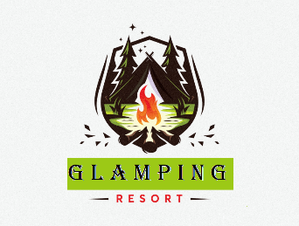
Whether people like to stay in the camp or not, has been asked in the fourth question of the survey. In response to this question, it has been found that 90% of the total population has stated they like to stay in the camp when they travel. Based on that observation, it is quite clear that there is a significant amount of demand for the service. At the same time, this survey also proved that the people who are aged between 30 and 40 mostly like to visit the hill station. Moreover, they want to stay in the camp. For the current company construction of the tent will follow the principle of ecological development and sustainability, like Green energy, recycling waste, water from natural resources and others. That will be the USP of EMS Experience Group.
Price is one of the significant aspects behind buying decisions (Ramya and Ali, 2016). By keeping the same thing in mind, the fifth question has been asked to the participants. Three different price ranges have been provided to the participants. Those price ranges are ‘less than £ 30’, ‘£30 to £60’ and ‘more than £ 60’. As per the survey results, it has been found that most of the people are comfortable to spend £ 30 to £ 60 to get camp service. Here the price refers to one-night camp, in which maximum six people are allowed to stay. This particular question helped the management team to get a preferred price range among customers who 30 to 40 years are old like to visit hill stations and want to opt for camp services.
The company will launch a new membership in which several free services will be offered. In the sixth question, the researcher asked whether people are interested in opting for that EMS club services or not most of them said they ‘Don’t know’. The primary reason behind this answer is lack of information about the membership program.
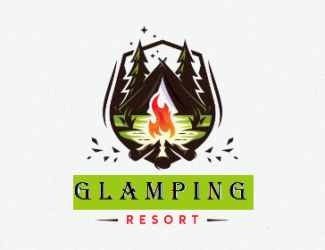
EMS club will be a membership program which is aimed to deliver the best possible services at the lowest possible cost to the repeat customer. Customers who want to join the club need to pay a small amount of money during registration. Getting a luxurious range of outdoor accommodation is the USP of that membership. Apart from that, exclusive coupon codes will be provided to the members of this club.
During this COVID19 pandemic, it is challenging to visit one location to another (Nepal, 2020). That is one of the most challenging times for a frequent traveller as well. In this regard, another question has developed, in which how much people are connected to their health safety during travelling has been asked. Based on the answers, it has been found that the majority of the respondents (93.3%) people are concerned about their health safety. By keeping this thing in mind, a number of health safety-related initiatives have been taken into ‘EMS Experience Group’. Temperature measurement, oxygen pressure measurement device, sufficient amount of sanitiser, gloves, masks are some standard components that have been taken into account by the management team of EMS glamping in order to defend against COVID19 (Gössling, Scott and Hall, 2020).
As per the above analysis, it can be clearly determined that people aged between 30 years to 40 years are the target customer of this business. At the same time, it has been found that people of this age group like to travel hill stations more than any other travel destination. Customers who are willing to pay £ 30 to £ 60 per night for a camp will be the target customer for this business. At the same time, people who occasionally travel will not be considered as target customers for this business, in other words, people who frequently visit different travel destinations will be considered as target customers for this business.

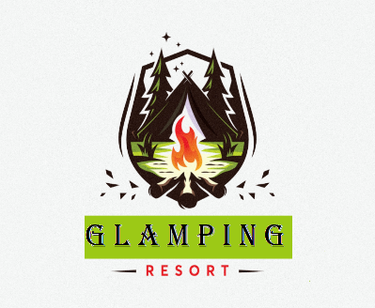
3.2 Marketing Mix
For EMS Experience Group, a 4P analysis has been listed in the following section. According to Kingsnorth (2019), the company’s marketing strategy can be easily determined by the application of the 4P model.

Product | Price
- Different types of camps  - Camp using ecological aspects like Green energy, recycling waste  - Additional features inside the tent-like AC and heater  - Quality food from the restaurant  - Pick up and drop service from the airport  - Personal rented vehicle service  - Health and safety-related services on a 24x7 basis | - The company will charge a price for different services  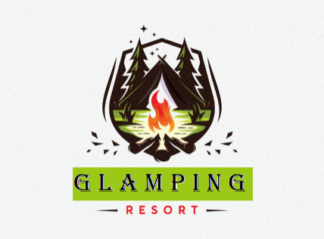  - The camp will be priced between £ 30 to £ 60 per night for a maximum of 6 people  - Food £ 10 to £ 20 per person for each time  - £ 40 to £ 50 for opting pickup and drop services  - Initially, the company will opt for a price penetration strategy, and as time passes, pricing strategies will be changed (Baker and Hart, 2016). Prices will be increased to a greater extent according to industry standards.
Place | Promotion
- Initially, the company is planning to start its business in Scotland.  - In future, the company, also planning to expand its business in different locations of the United Kingdom  - The company will take a booking from both online and offline | - Social media marketing will be the critical promotional medium used for promoting this business.  - Apart from social media, a website for the company will be developed. All information related to the next travel plan, prices, routes will be available on that website only.  - EMS club will be another promotional strategy. That is a loyalty program for customers. Members who will enlist their name in this club will get additional benefits in their service.  - Many SEO experts will be hired to increase the visibility of the business on the internet.
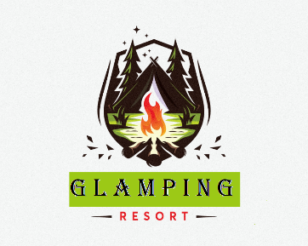
Table 2: 4P of EMS Glamping

4. Financial Plans
It assumed that the company would start its operation from the coming month august. Therefore, the budget has been prepared for that month only. All figures presented in the next budget is in £.

4.1 Cash Budget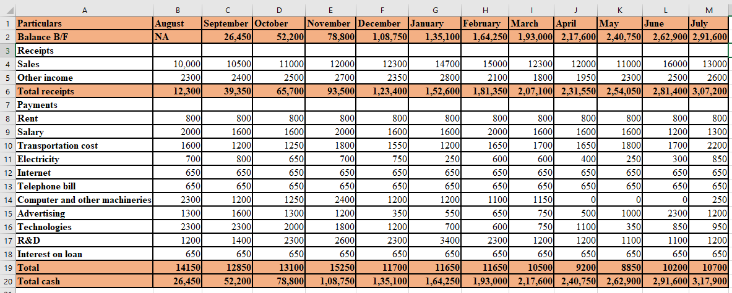
Table 3: Cash Budget

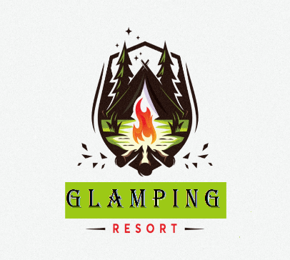
4.2 Profit Budget
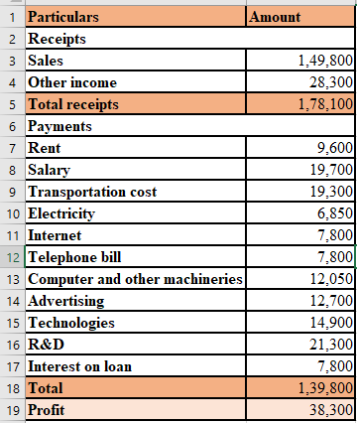
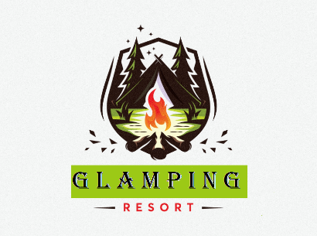
Table 4: Profit Budget

5. Summary or Conclusion
As per the above discussion, it has been found that the three different individuals are planning to start a new business called ‘EMS Experience Group’. The company will be offering luxurious camping services to the people who are very much travelling enthusiastically. A survey has been conducted in order to get an idea about market segmentation of the business, as per the survey it has been found that the company will target people that are aged between 30 to 40 years. At the same time, people that are very much into travelling to hill station will be the target customers. People who are willing to pay £ 30 to £ 60 for camp each night will be the target customers as well. Analysis part also discovered that a loyalty system would be there, which will help the company to approach new customers into long term relationships. Discussion part has also found information about COVID19 pandemic. Several health and safety measures have been considered like sufficient sanitiser, gloves and mask for travellers, periodic temperature tests and others.
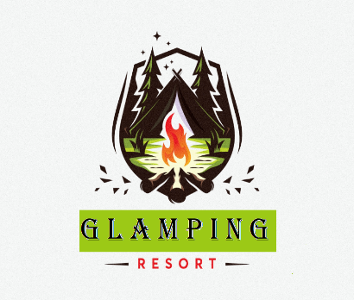
A 4P analysis has been conducted based on avoidable information of the business, as per the 4P report it can be determined that quality food from a restaurant, designed camp, pick up and drop service, rented vehicle are some standard services will be offered by the firm. The company will initially follow principles of price penetration strategy to attract new customers. Booking will be made from both online and offline sources. Lastly, social media and SEO are some conventional promotional approaches that will be used by the marketing team of the company to make the company more visible to the public.
In the financial part, a 12-month cash budget and a 12-month profit budget has been developed. Based on the information presented in that table, it can be found that the company will achieve a profit of £ 38,300 in its first 12 months.

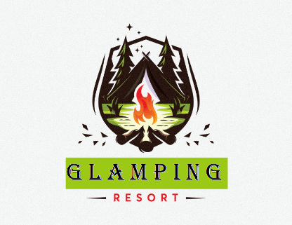
References
Books
Baker, MJ and Hart, S. eds., (2016). The marketing books. Abingdon, UK: Routledge.
Kingsnorth, S. (2019). Digital marketing strategy: an integrated approach to online marketing. London, UK: Kogan Page Publishers.
Journals
Gössling, S., Scott, D., and Hall, C.M., (2020). Pandemics, tourism, and global change: a rapid assessment of COVID-19. Journal of Sustainable Tourism, pp.1-20.
Mulley, C., Ho, C., Ho, L., Hensher, D. and Rose, J., (2018). Will bus travellers walk further for a more frequent service? An international study using a stated preference approach. Transport policy, 69, pp.88-97.
Nepal, SK (2020). Travel and tourism after COVID-19–business as usual or opportunity to reset? Tourism Geographies, pp.1-5.
Ramya, N. and Ali, S.M., (2016). Factors affecting consumer buying behaviour. International journal of applied research, 2(10), pp.76-80.
Website
Statistics.com (2020). Camping occupancy in Scotland. Available at: https://www.statista.com/statistics/426766/monthly-occupancy-rate-of-touring-caravan-and-camping-parks-in-scotland/ [Accessed on 21st July 2020]

