Entrepreneurship {SBMA7111}

Assessment 2
ON
A coffee shop in UK near Queen’s house

BY- SANDHYA THAKUR

{1705903}

RICHARD SMALL

Table of Contents
Introduction: 2
Business idea: 2
Products and services offered by the company: 2
Coffee shop industry in UK: 3
Competitors: 4
PEST analysis: 5
Target market analysis: 7
Financing strategies: 7
Start Up cost and Financial Estimates: 9
Conclusion: 10
References: 11

Introduction:
Entrepreneur can be referred as the innovator who is the source of new and innovative ideas for developing business by taking financial risk to achieve success in the competitive market. The entrepreneur takes risks for developing small business in order to gain higher returns from the investments. The entrepreneurship is termed as the overall process through which the individual entrepreneur develops new venture or project in order to gain profit from the business (Fuzi, 2015). The entrepreneur mainly seeks opportunity from the current market environment, competitions and demands of the local customers in order to develop the business growth. UK is the large pool of opportunities for investors as well as entrepreneurs to develop business growth. With the rapid globalization of industry, the competitions among the organizations have been increased. With the rapid increasing number of demands of the tourists and changing lifestyles of people in UK has brought a number of opportunities for Coffee shop in developing growth and success of the business in competitive market (Burgoine and Harrison, 2013). This particular business plan is mainly focuses upon development of new coffee shop in the UK near the Queen’s house. In order to successfully development the business plan, this particular report has demonstrated on the business idea, products and services, industry analysis, competitors, PEST analysis, attracting visitors and financial projection.

Business idea:
The prime objective of this business plan is to start up a new coffee shop in the UK market new Queen’s house. The rapid changing lifestyle, taste and preferences of the customers have led to increasing demands of the coffee shop in UK market. The customers can take a break from their monotonous daily routine to spend some time in coffee shop which also has lead to increasing demands for the coffee shop. The increasing number of tourists in UK who prefers coffee and snacks also has led to development of the coffee shop in UK market.

Products and services offered by the company:
Products and services are the main attractions for developing growth and success of the business firm. Therefore, in order to set up a new business the entrepreneur must focus upon the products and services which should be unique to attract a number of customers. The prime product of the new coffee shop is the various types of coffee including black coffee, cold coffee, Irish coffee, Cappuccino, Long black and Macchiato. The coffee shop will offer a superior quality of the ambience with soothing music according to mood of the customers (Lloyd and Payne, 2014). The ne coffee shop also will offer comfortable seating arrangement and ability to accommodate at least 50 people at a single time. The coffee shop also will offer a number of value added services such as free Wi-Fi, discount coupons and entertainments which will help to attract a number of customers across the UK. The new coffee shop also will offer a number products rather than coffee such as snacks, desserts and sandwiches.

Coffee shop industry in UK:
According to the statistical data of coffee industry market in UK it is evident that the number of outlets of coffee shop in UK has been increased from 643 to 7,421 in 2017. It is also evident from the report that the coffee industry in UK has enjoyed a higher growth from the last few years that denotes a positive sign for the entrepreneur to set up the new coffee shop in the UK market new the Queen’s house. It is also evident from the statistical report that over the years, the coffee market chain of UK has been increased by 37% which also provides a large opportunity for the new coffee shop in order to set up their business for the UK market. According to statistical report presented by Allegra it is evident that the annual turnover of the coffee market in 2011 was £2.4 billion which has been increased by £3.4 billion in the year 2016. Therefore, it can be said that the coffee industry market of UK is very competitive. The coffee shop market industry of UK has been increased by 7.3% in turnover during the year of 2017 to £9.6bn which has made the coffee market as most robust sectors in UK.
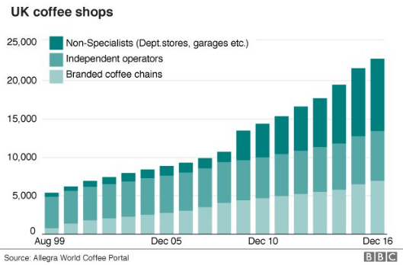
It is evident from the above graph chart that the UK Coffee comprises of three different types such as non-specialist, independent and branded coffee chain (Grant and Perrott, 2011). From August 1999 to Dec, 2016 the growth of independent operators have been rapidly increasing which provides an opportunity for the new start up coffee shop in the UK market near Queen’s house.
According to the new report presented by the Allegra in 2018, it is observed that the coffee shop market of UK has added more than 1215 stores in last 12 months which has increased the number of coffee shops by 24,061 and represents the overall growth of the coffee shop by 5.3%. Costa Coffee, cafe Nero and Starbucks are the prime competitors in the UK coffee shop market which dominates the overall coffee market of UK. These thee coffee chain in UK together has achieved 52.9% market share in the coffee market of UK.

Competitors:
In order to set up a new business in the new market, the investors as well as the entrepreneur should analyze the competitors of the business within the market industry. It is evident from the various statistical reports that the coffee shop market in UK is the most robust sectors which provide a number of opportunities for the coffee shop to develop their growth and success in the competitive market. The prime competitors of the coffee shop in UK market are Costa, Starbucks, Cafe Nero, Coffee republic and coffee#1.
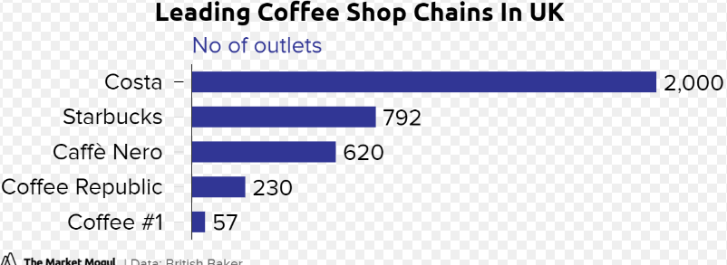
According to the above graph chart it is evident that Costa has 2000 coffee shops and Starbucks has 792 retail outlets, Cafe Nero has 620 coffee shops, Coffee republic has 230 outlets and Coffee #1 has 57 outlet chains in UK. Costa Coffee, cafe Nero and Starbucks together have acquired more than 52.9% market share in the coffee industry of UK (Beuchelt and Zeller, 2013). Therefore, from the above competitor analysis it is evident that the new start up coffee shop has a lot of opportunities for achieving its growth and success in the competitive market for attracting a number of local customers and the visitors in UK.

PEST analysis:
In order to successfully develop the new start up business within a market, the entrepreneur should properly analyze the external factors of the current market which influences the operating activities of the firm. The PEST framework provides a detailed analysis about political, economic, social and technology factors which influences the operations of the organization. The PEST framework for developing growth of coffee shop in UK market is as summarized below;
Political factors:
Political factors are one of significant external factors which may impact on the developing growth of the business in a market. The various political factors of UK that may influence in setting up new coffee shop in the UK market are as listed below;
- The political situation of the UK is said to be stable which have positive influence for developing growth of coffee shop in UK market.
- The various business policies and regulations introduced by the government of UK is in favor of doing new business which also have positive impact for developing growth of the coffee shops in UK market (Wray, 2011).
- The UK leaving EU countries due to Brexit in 2016 has restricted the accessing of UK with the EU countries which may have negative impact for developing business of new coffee shop in the UK market.
Economic factors:
There are a range of economic factors which also influences the operational growth of the business firm within a market. The different kinds of economic factors that may influence the development of new startup of coffee shop in UK market are as summarized below;
- The stable economy of UK has brought a number of opportunities for the business firm to develop their growth and success in the competitive market.
- The increasing rate GDP growth in the UK may create positive impact on developing growth of operations of the coffee shops in UK.
- The new start up should be prepared for any kinds of negative impacts of economic factors such as financial crisis, increasing fuel price, economic fluctuations and inflations for the UK market.
Social factors:
Social factors are other important external factors which also influences the operational growth of the business firm within an industry market. The various social factors that may influence the operational growth of new coffee shop for the UK market are as listed below;
- The changing lifestyle, culture, taste and preference of the customers have created positive sign for the new coffee shop to attracting a number of customers in the UK market (Plourde, 2014).
- The increasing rate of high income level group and visitors in UK also have created positive influence for developing new coffee shop in the UK market.
Technological factors:
The technological factors also play a key role for developing growth of operation of the business firm within a new market industry. The different kinds of technological factors which influences in developing new start up coffee shop for the UK market are as explained below;
- The UK has witnessed a rapid growth in technology and innovation which has created a positive sign for the new start up coffee shop in the UK market.
- The various upgraded technologies used in the coffee chain of UK market will help the new coffee shops to improve their operations within the UK market.

Target market analysis:
For successfully developing the business plan for a particular market, the organization should focus upon their market to attract them. The potential customers of a business are the individuals for whom the products and services of the organization will be developed. The UK is one of the most attractive tourist destinations across the globe (Mullins, 2012). Therefore, the visitors, local people, working professionals, couples and young generation who wants to spend some time with their partners are the targeted customers for the new coffee shop of UK near Queen’s house. The coffee shop also will target the young couples to offer their quality products and services in order to maintain long term relationship with them.

Financing strategies:
Attracting a large number of investors is one of the prime tasks for the entrepreneur which helps to maintain sustainability of the business. Adequate funding and proper financing strategies are very important for developing new business. With the help of effective financing strategies, the organization can develop its growth and sustainability in the competitive market. The various financing strategies which will be applied for set up the new coffee shop in UK market near Queen’s house are as summarized below;
Equity funding from angel investors or venture capitalists:
Equity funding from angel or venture capitalists are the shareholders or inventors who invest in the company in return of a certain percentage of share of the company. This will provide the much needed equity funding in the project and fulfillment of funding requirements required in the project.
Loans form financial institutions:
This is another financing strategy through which the financial institutions like bank will provide loan by taking mortgage as a security which has to be paid by the company (Hiebeler and Ketteman, 2012). In order to set up the new coffee shop business in UK, the company will take loan from the bank.
Personal savings:
Personal savings are other financing strategy which is used for investment for set up a new business.
Equity investment from friends and families:
The entrepreneur also can use equity investment from and families in order to set the new coffee shop business in the UK market.

Start Up cost and Financial Estimates:

The initial startup cost required for the established of the coffee shop business are depicted below
cost heads | Amount (in £)
Yearly rent of the commercial space | 100000
Kitchen development | 30000
Crockeries and utensils | 10000
IT costs | 5000
Initial human resource costs | 200000
Interior decorations (furniture) | 50000
Lightings and fixtures | 20000
license fees | 10000
initial procurement of raw materials | 5000

The financial projects of revenue which is estimated from coffee shop business for next 5 years are mentioned below:
Year | Estimated revenue (in £)
Year 1 | 400000
Year 2 | 440000
Year 3 | 484000
Year 4 | 532400
Year 5 | 585640

Notes: Yearly increase in revenue considered as 10%.

Conclusion:
It is evident from the business plan that Coffee shop has a higher growth in the UK market. This business plan has focused upon the business idea and products and services offered by the coffee shop. This particular business plan also has analyzed the current industry market of coffee chain in UK and market analysis. The financing strategy, target market analysis and financial projection for set up the new coffee shop also have been evaluated in this particular business plan. This business plan has a very good impact in the growth rate as compared to the last few years which has inspired me to take this plan. Mostly the visitors in the UK near the target area is going to approach the business not only the visitors but also the international students who wish to see the most popular destination and the mandatory place to visit so, which is directly gives the approaches to the customers without any kind of marketing which gradually increases the sale on daily basis.

References:

Fuzi, A., 2015. Co-working spaces for promoting entrepreneurship in sparse regions: the case of South Wales. Regional Studies, Regional Science, 2(1), pp.462-469.
Burgoine, T. and Harrison, F., 2013. Comparing the accuracy of two secondary food environment data sources in the UK across socio-economic and urban/rural divides. International journal of health geographics, 12(1), p.2.
Lloyd, C. and Payne, J., 2014. ‘It’s all hands-on, even for management’: Managerial work in the UK cafe sector. human relations, 67(4), pp.465-488.
Mullins, J., 2012. The new business road test: What entrepreneurs and executives should do before writing a business plan. Pearson UK.
Grant, J. and Perrott, K., 2011. Where is the café? The challenge of making retail uses viable in mixed-use suburban developments. Urban Studies, 48(1), pp.177-195.
Beuchelt, T.D. and Zeller, M., 2013. The role of cooperative business models for the success of smallholder coffee certification in Nicaragua: A comparison of conventional, organic and Organic-Fairtrade certified cooperatives. Renewable Agriculture and Food Systems, 28(3), pp.195-211.
Wray, F., 2011. Rethinking the venture capital industry: relational geographies and impacts of venture capitalists in two UK regions. Journal of Economic Geography, 12(1), pp.297-319.
Plourde, L., 2014. Cat cafés, affective labor, and the healing boom in Japan. Japanese Studies, 34(2), pp.115-133.
Hiebeler, R., Kelly, T. and Ketteman, C., 2012. Best practices: Building your business with customer-focused solutions. Simon and Schuster.

