Module: Environmental Planning & Policy (ACBA7004)
Joseph Julian Blackmore (1702858)
Uwtsd | sa1 1ne
Environmental Impact Assessment Evaluation- Mynydd Y Gwhryd Solar Farm


Programme: M.Sc.: Conservation & Environmental Management
(Hanover Conservancy, 2020)

Contents

- Introduction
- Environmental Impact Assessments- The Fundamental Purpose of Completing an EIA
2.1. Structure of the EIA process
2.2. Policy Guiding EIA Standards and Legal Requirements in Wales
3. Mynydd Y Gwhryd Solar Farm
3.1. Location
4. The Environmental Assessment For Mynydd Y Gwhyrd Solar Farm
4.1. Considerations Made For Construction Phase
4.2. Landscape & Visual Impact
4.3. Phase 1 Habitat Survey
5. Conclusion
6. References

Introduction

Within the planning and policy surrounding built developments, there are a wide array of potential impacts that must be considered in order to facilitate the mitigation of negative environmental and anthropogenic impacts. The environmental impact assessment (EIA) process should involve a holistic approach to gathering knowledge surrounding the scope of the development and the potential ways in which the environment may be affected by it. Each development will have unique characteristics and potential for environmental impacts dependant on the type of development, along with the scale, purpose, and the location. Whilst the EIA process itself should have a common goal of identifying the environmental risks associated with a development, the variety of proposed developments that EIA’s can be applied to results in a wide variation in how individual EIA’s can be structured. There remains debate whether the EIA process can be considered as a scientifically objective approach to identifying the associated environmental impacts of a development, this is perhaps as a result of the variation between EIA’s and the inevitable political influence in the granting of permission for large scale developments in particular (Cashmore & Richardson, 2013). Nevertheless, good practice within an EIA can be established in regards to how thoroughly the specific environmental risks associated with the development in question have been identified, along with the manner in which mitigation options have been presented. A systematic and thorough approach to considering the relationship between the development in question with the natural environment, human health and the surrounding areas can have a tangible effect on the success of planning and construction. The completion of a high quality EIA can increase the likelihood of developments meeting legal environmental requirements whilst maintaining a positive impact for the communities that they are designed to serve.
The regulations that an EIA will be expected to consider can vary depending on the type of development under consideration and the national significance of the project. In this report an EIA of a Welsh solar farm proposal will be evaluated, considering examples of both good and bad practise, in order to discuss both the positive attributes and limitations of the specific EIA in question. The influence of policy and regulation in relation to EIA’s will be discussed, including a consideration of political and legal developments historically and within a more contemporary context. Recent developments within EIA guidelines and policy will be evaluated in order to determine the potential for improvements in conducting an EIA.

Environmental Impact Assessments

The Fundamental Purpose of Completing an EIA

Environmental impact assessments can be considered to be linked to both sustainable development and planning practise. In essence, an EIA can be considered as a planning tool that when implemented effectively, encourages developments in infrastructure to become more sustainable in their utilisation of the natural environment (Steiner, 1995). Within the planning of a development a goal of either of no net loss (NNL) or net gain of biodiversity can be set relative to a predetermined baseline in order to encourage the developer to consider the environmental footprint of their project as a guiding principle throughout its design, planning, construction and use.

By establishing the potential environmental risks that are posed by a development proposal this can inform the relevant authority whether permission for the development should be permitted, perhaps under the condition of required mitigation or enhancement, or refused outright. Following the completion of the EIA, and environmental impact statement (EIS) can be published publicly so that the environmental risks associated with the development are presented and available to all relevant stakeholders in a transparent manner (Sheate, 2014). The broad purpose of an EIA should be to exchange information, techniques and methods, which are of value for environmental management. EIAs involve individual assessments of all aspects of the environment, such as the potential health implications to human populations in addition to the landscape, heritage, air, climate, soil, water, fauna, and flora likely to be significantly affected by a proposed project. This process should require developers to consider the environmental, social and economic impacts of their projects, thereby discouraging developments that are severely damaging to the environment and surrounding communities. Some of the principle purposes of an EIA can be considered as follows:

- To produce a statement guiding relevant decision makers.
- To publish a clear statement of identified impacts with an indication of their significance (especially if any are irreversible).
- To advise on problem mitigation, gather data, feed into future impact assessment, improve damage control and discourage over exploitation of the natural environment.
- To systematically evaluate all environmental impacts associated with the development whilst considering their relationship between social and economic impacts.
- To increase the accountability of the developer.
- To facilitate an objective and independent review of any results collated.
- To facilitate public participation.
- To identify the legal responsibilities of the developer and consider regulatory boundaries and environmental law in recommendations made.
(Barrow, 1999).

A hierarchy of environmental mitigation measures can also be applied to the EIA, so that the environmental impact of the proposed development is considered as a fundamental area of concern when producing a guide for the developer and relevant authority. A proposed mitigation hierarchy may be considered as in the following diagram:
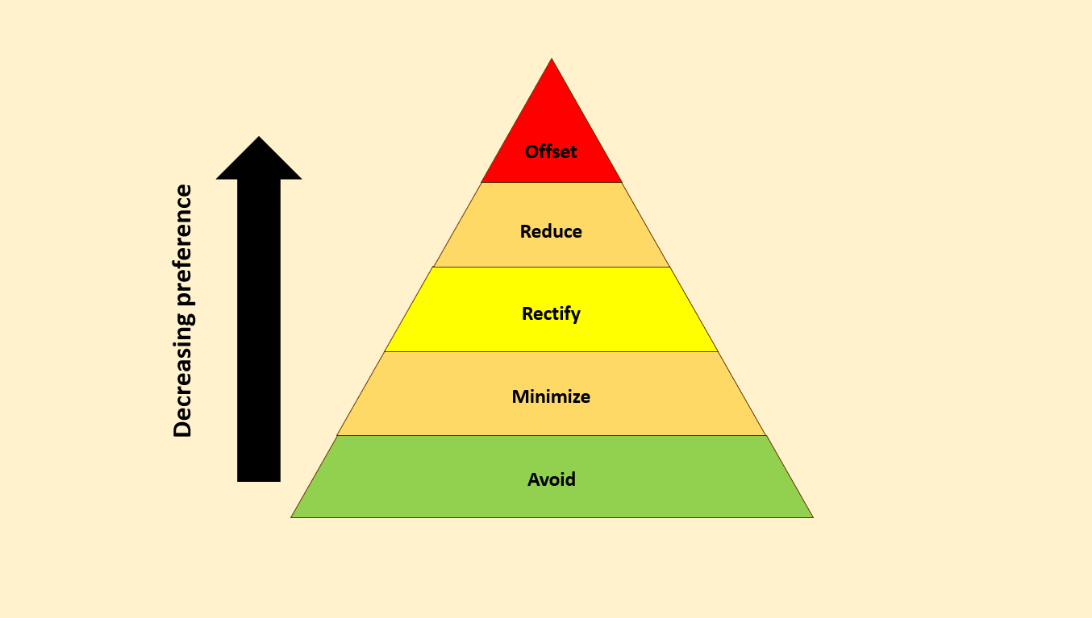

Figure 1: A 5 step mitigation hierarchy for environmental impacts.
(Babu, 2016).

The hierarchy begins with the most beneficial form of mitigation through to the least beneficial from the perspective of environmental conservation, or in some cases potential for biodiversity improvement, in the following order;

- Avoidance- This can be considered the preferred form of mitigation as this can prevent any environmental harm from occurring in the first place. This could include avoiding impacts on biodiversity by screening potential risks prior to project design and selecting an alternate development site.

- Minimise- The second step of the hierarchy requires that prior to and during development, impacts are minimised, such as by using more environmentally friendly construction methods as an example. This approach recognises that environmental impact cannot be completely prevented, however provisions can be put in place to reduce the environmental impact as much as feasibly possible.

- Rectify- This implies that an environmental impact has already occurred in some capacity, therefore efforts to rectify any damage caused should be considered. This can include actions such as requirements that biodiversity loss is remediated within the footprint of the development, which could include actions such as reseeding affected land or developing a breeding program for affected species during and after project completion. -

- Reduction- In a scenario where environmental damage cannot be completely rectified, suggestions for impact reduction should be presented. This can include changes to the operation of a site in order to reduce emissions or putting provisions in place to reduce the risk posed to the surrounding eco-systems.

- Offset- This stage requires that any residual impacts not captured by the first four steps of the hierarchy are offset elsewhere, such as by contributing funding or time to contributing to conservation efforts such as wetland restoration schemes or by supporting the removal of invasive species from ecologically important areas. This can be considered as a form of compensation in order to contribute to achieving no net loss or even a net gain in biodiversity. This form of mitigation is surrounded in controversy as some argue that large developers can use this as a method of ‘buying their way out’ of environmental responsibility by causing environmental harm in their projects, but using their wealth to meet the loose definition of ‘no net environmental loss’. It is desirable for offsets to fund new protected areas and their management as this can be used as a catalyst to fund practical actions that have the potential to contribute significantly towards efforts in conservation. However, unless these offset-funded protected areas are tallied separately — and alongside the losses that trigger them, the proliferation of using offsets as a form of environmental impact mitigation can pose a significant threat to biodiversity, particularly in the presence of corporate and governmental corruption (Maron, et al., 2015). (Arlidge, et al., 2018).

Additionally, a hierarchy amongst the perceived potential environmental impacts themselves can be produced by applying the definition of impact as;

Impact = Effect x Sensitivity (Boughton, et al., 1999).

Where effect is considered as the pressure placed on the ecosystem in question and sensitivity is the ability of the ecosystem to withstand the pressure. The accuracy of grading impacts utilising this approach will be dependent on the quality of both quantitative and qualitative data recorded in the EIA, along with the judgement and level of knowledge surrounding the specific site in question held by the person responsible for grading the perceived threat of the potential environmental impacts (Jacob, et al., 2016). By highlighting the most threatening environmental risks posed by a development, such as a risk of damaging the habitat of a European protected species (EPS) for example, this can more clearly inform the developer and relevant authority about the most significant legal and moral responsibilities that must be considered. The potential effect of any environmental impacts can also be contextualised from a local, national and global perspective. By considering the scale of the environmental impact, along with moral and legal requirements from local, national and international authorities, this can allow for a better understanding of how to present and plan mitigation for the issues raised.

Structure of the EIA Process

Each individual development proposal will have unique characteristics and present different challenges from the perspective of constructing an EIA and EIS, however, a common structure for completing an environmental assessment can be considered as follows:
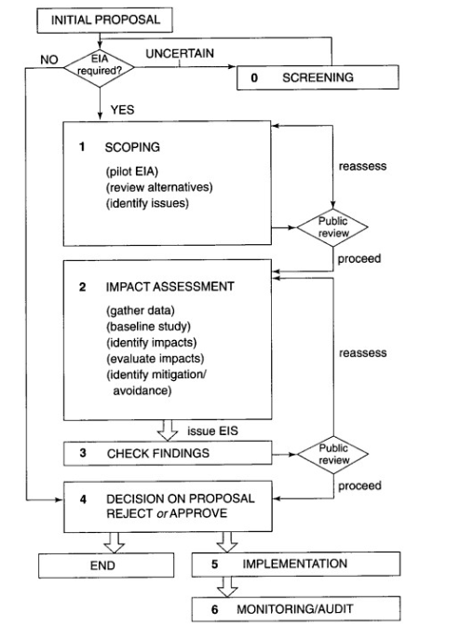

Figure 2: A diagram of the typical stages involved in completing an EIA and EIS. Phases 0-6 are presented in an idealised order.
(Barrow, 1999).

In order for an environmental assessment to be considered systematic and thorough, it is vital that the relevant phases are completed in an appropriate order, however, some processes may require continuous adjustment as a more detailed appraisal is achieved progressively throughout the assessment process. Where the requirement for an EIA has been established following the identification of possible significant environmental impacts in the screening of the initial proposal, the key procedures to consider are as follows;

Scoping & Baseline Studies

This can be considered as the essential first step in assessing the development in question as the scoping phase defines the potential environmental impacts before identifying the most important impacts and their key receptors. Any obvious legal barriers can be discussed with the developer in this early stage of the development in order to reduce complications later in the planning process. A line of communication can also be established between developers, consultants and any other relevant interest groups in order to encourage sharing of information relevant to the project in terms of environmental concerns.
The scoping exercise should provide a base plan for subsequent steps by making a preliminary assessment of:

• The potential impacts on component receptors, estimated from the project description (including size, construction requirements, operational features and secondary developments such as access roads) and the nature of components and receptors

• The impact area/zone where impacts are likely occur, estimated from the impact types and the nature of the surrounding area and environmental components, e.g. impacts on air quality from particulate pollution may occur at distances of up to 2 miles from the project site

• Possible mitigation measures

• Is there potential for monitoring?

•The methods and levels of study required to gather reliable baseline data that can be used to evaluate the baseline conditions, produce accurate impact predictions, and formulate appropriate mitigation measures and monitoring procedures.

• Effective methods for collecting, analysing and presenting information

• The resource requirements and timing considerations for activities such as field surveys.

• Limitations such as available time and monetary resources.

(Morris & Therivel, 2009).

The baseline study can be considered as the continuation of the scoping process, where relevant information is collected firstly from a desk study in order to collect any relevant data that has previously been collected, before investing resources in collecting necessary primary data. The evaluation of the baseline study should include a clear presentation of the methods used and the results gained, indications of limitations and uncertainties relating to the accuracy of data gathered and an assessment of key receptors to the environmental impacts and their sensitivity.

Impact Assessment

Impacts can be categorised as the following;
- Direct/primary
- Indirect/Secondary
- Cumulative

Some impacts may be deemed as beneficiary or neutral whilst other can be negative. The interaction between impacts should be considered along with their severity, spatial extension and timescale. Some impacts may be deemed as having a temporary influence, such as during the construction phase, whereas others may have a long term or even irreversible influence on the environment (Beanlands & Duinker, 1983). It is important to consider that the measurements of some impacts may rely on qualitative data, whereas other impacts such as greenhouse gas emissions may be able to be recorded and presented in a quantitative form, e.g. tonnes of CO2 emitted per year (quantitative), a high risk of interference with bat behaviour (qualitative).
A well informed impact prediction and evaluation can produce more focussed suggestions for mitigation.

Environmental Impact Statement (EIS)

Following the impact assessment, an EIS should be produced in a manner that clearly illustrates to stakeholders and decision makers what the most relevant impacts are, particularly any that may be considered severe enough to consider condemning permission for the project to commence within an ecological risk assessment (ERA) (Claassen, 1999). In order to carry out this process, the significance of assessed impacts should be determined, then clearly presented. Significance determination is presented in the following infographic;

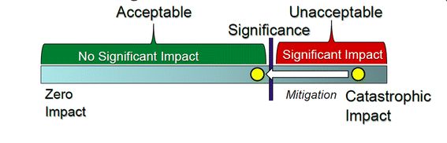

Figure 3: The significance determiner decides where on the spectrum a predicted impact (shown as the yellow circle) falls, and weighs the effect of mitigation measures (shown as the arrow) on impact significance.

(Ehrlich & Ross, 2015).

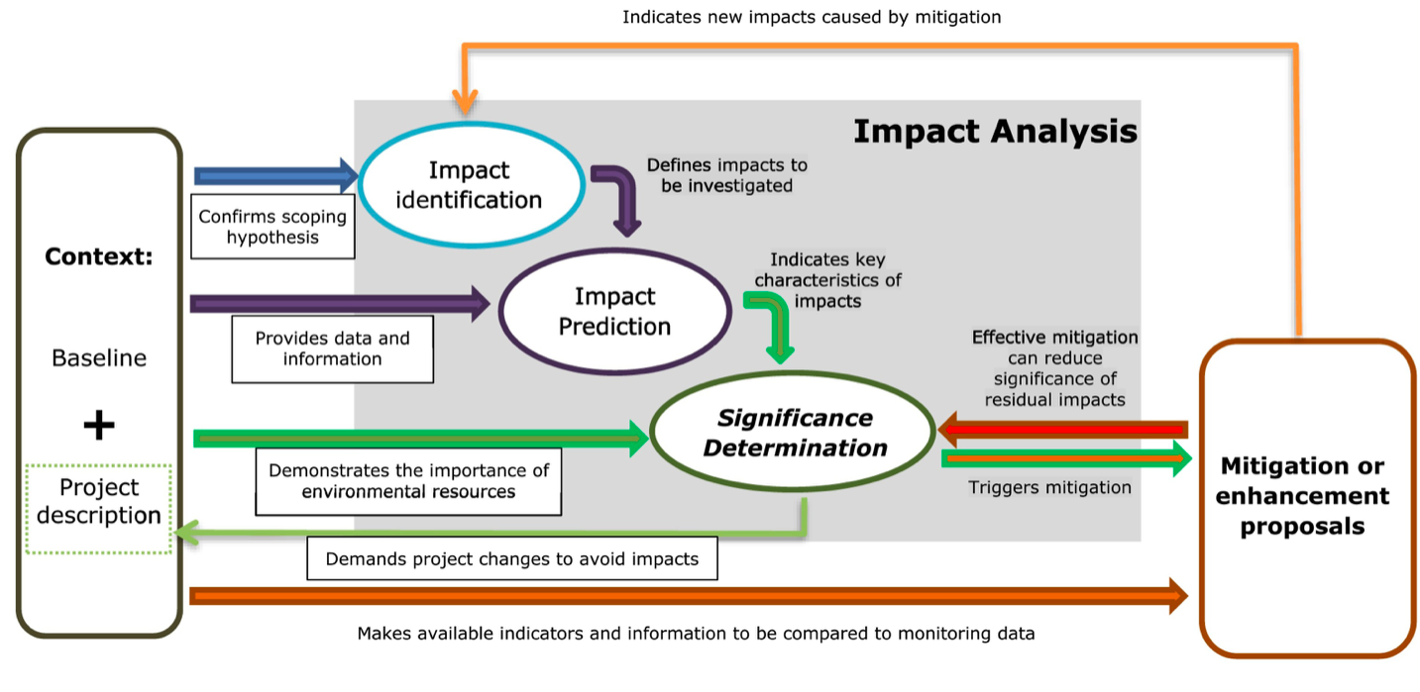
Presenting the significance of impacts and determining whether their perceived risk can be considered “acceptable” is considered by some academics to be the guiding principle in the construction and presentation of the EIS as this is the basis for granting approval (Lawrence, 2007). The potential for mitigation measures to present new impacts must also not be ignored, whether or not they are considered to be of reduced significance. The following diagram represents how significance determination is central to the EIS process in addition to the presence of feedback loops in updating and further informing the mitigation and enhancement proposals;

Figure 4: The centrality of significance determination in the EIS process
(Duarte & Sánchez, 2020).

The determination of impact significance should be presented coherently by providing the information relating to each impact within clearly defined sections. The significance of impacts are merely presumed in the scoping process, however the determination of the significance should be confidently confirmed within the EIS in order for the mitigation and enhancement proposals to be deemed compelling. (Perdicoulis & Glasson, 2009). Limitations in presenting the significance of impacts can result from the subjective nature of the term ‘significance’, particularly in reference to environmental impacts that rely on qualitative information in their determination. One persons significant impact could be perceived as negligible to another, especially in the absence of measurable and compatible data sets. Authors Quivy & van Campenhoudt suggested seven steps for completing qualitative research, by following this guide the significance of impacts can be presented more clearly, hence reducing the risk of misunderstanding surrounding the significance of impacts given that the steps are carried out in detail and presented coherently;
(1) set the initial research questions, (2) explore the related literature, (3) specify the problems within the context of the development, (4) build a model of analysis, (5) collect data, (6) analyse data and information, and (7) set the conclusions.
(Quivy & Van Campenhoudt, 2008)

Policy Guiding EIA standards and Legal Requirements in Wales

As the EIA that is being evaluated in this report is for a proposed solar farm development in Wales, it is important to understand the expected standard and legal requirements for such a development in wales specifically. The origins of the EIA process can be traced back to 1969 in the USA, with the passing of the National Environmental Policy Act (NEPA), which mandated assessment of the environmental outcomes of development projects. The EIA process was quickly adopted by governments and legislatures across the globe, including in Japan (1972), Hong Kong (1972), Canada (1973), Australia (1974), the Philippines (1977), Taiwan (1979) and the People's Republic of China (1979) to name a few (Tullos, 2009). EIA’s were formally introduced in the UK in 1988 through inclusion in the Town and Country Planning Regulations for England and Wales (UK Government , 1990) and in Environmental Assessment Regulations for Scotland and Northern Ireland, based on European Directive 85/337/EC (Jha-Thakur & Fischer, 2016). Prior to the UK leaving the European Union, policy surrounding EIA’s have been influenced significantly by European directives. The European EIA Directive (85/337/EEC) amended three times in 1997, 2003 and 2009 and consolidated in 2011 formed the basis of EIA practice in the UK (Arts, et al., 2012). In 2014, a new Directive was published which required implementation by 2017. This represents how pivotal the EIA Directive has been in influencing EIA guidance in the UK. Following the more recent amendments made to the EIA Directive, climate change has been required to be explicitly addressed both, in terms of carbon dioxide emissions associated with the proposed project (mitigation), as well as adaptation to a changing climate. The consideration of heritage aspects, both historical and cultural was strengthened from a UK perspective following the 2014 EIA Directive amendment.
Based on voluntary accreditation provided through the UK Institute of Environmental Management and Assessment's (IEMA's) EIA quality mark, rigorous and continuous examinations are made to EIA’s in order for them to acquire gain accreditation. The EIA Quality Mark is built on seven commitments (referred to as COMs). These are formally signed up to by a senior figure responsible for each registrant's EIA practice. The commitments focus on EIA-management; team capabilities; legal compliance; EIA context and influence; EIA content; EIA presentation; and improvement of EIA practice. The EIA Quality Panel consists of independent experts that evaluate the submitted EIA’s in each of the aforementioned commitments in order to conclude whether the EIA is worthy of accreditation. Within the UK it is considered good practice for an EIA to attain IEMA accreditation as this is considered as evidence of regulatory compliance and procedural competence.

The required standards of individual EIA’s can be influenced by numerous bodies of control, some examples of authorities that can influence EIA implementation and their expected standard are represented in the following table;

Table 1: Control mechanisms influencing EIA standards

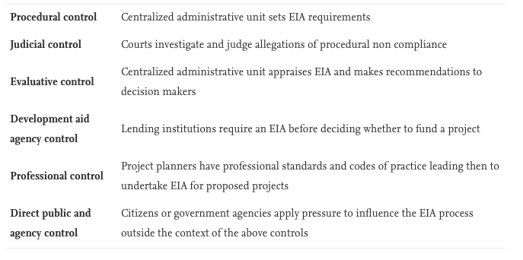
(Bond, et al., 2017)

Particular consideration must be made if a project is within, or likely to have an impact on a European protected site. The European Union (EU) Habitats Directive protects certain species of plants and animals that are considered particularly vulnerable. The Directive specifically relates to Special Protection Areas (SPAs), Special Areas of Conservation (SACs) and ‘Ramsar’ sites, also referred to as Natura 2000 sites. If this is the case there may be a legal requirement to complete a Habitats Regulations Assessment (HRA) as set out within Article 6 of the EC Habitats Directive 1992, and interpreted into British law by the Conservation of Habitats & Species Regulations (Amended in 2017) ( East Hampshire District Council and South Downs National Park Authority, 2012).
A Habitats Regulations Assessment (HRA) refers to the several distinct stages of Assessment which must be undertaken to determine if a plan or project may affect the protected features of a habitats site before deciding whether to undertake, permit or authorise it. European Sites and European Offshore Marine Sites identified under these regulations are referred to as ‘habitats sites’ in the ‘National Policy Planning Framework’. A ‘Habitats Regulations Assessment screening’ should be completed in order to take into account the potential impacts both of the plan/project itself and in combination with other plans or projects on protected species (Ministry of Housing; Communties and Local Government, 2019). Despite the UK leaving the European Union in 2020, legislation protecting European sites has been maintained within the Conservation of Habitats and Species Regulations (2017).
If a HRA is required to be completed for a project located within Wales, Natural Resources Wales (NRW) should be consulted and any relevant advice offered by NRW should be included within the HRA itself.

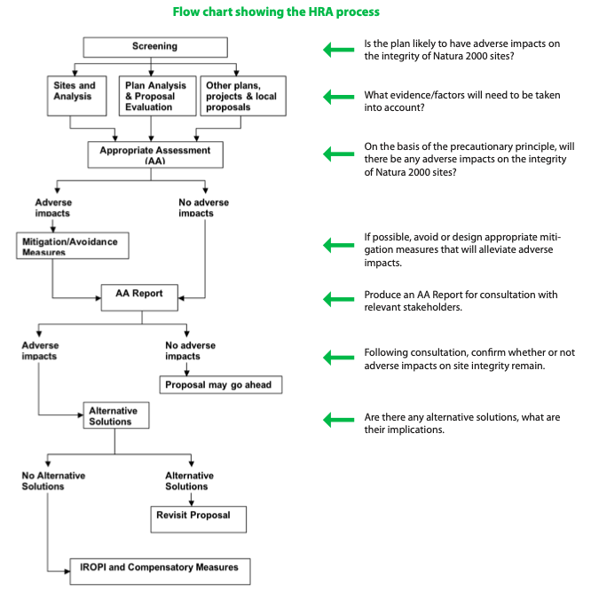

Figure 5: A diagram of the typical stages within the HRA process
( East Hampshire District Council and South Downs National Park Authority, 2012).

Mynydd y Gwhryd Solar Farm

As prescribed in ‘The Town and Country Planning (Environmental Impact Assessment) Regulations 2017’, for all schedule 1 large scale projects an EIA is compulsory. Schedule 2 sites can include smaller scale projects where an EIA may be required at the discretion of the Lasting Power of Attorney (LPA). Within the aforementioned regulation, developments applicable to the definition of ‘schedule 2’ include any industrial installation for the production of electricity where the area of construction exceeds 0.5 hectares (UK Government , 2017). The proposed development in question comprises a ground-mounted photovoltaic (PV) solar farm located on approximately 4 hectares (ha) of agricultural grazing and semi-improved land, therefore the development can be defined as a schedule 2 project.

Location
The Environmental assessment in question accompanies a planning application for a solar farm, including battery storage, electrical and associated civil infrastructure, that is up to 2.23 Megawatts (MW) in capacity on land known as Mynydd Gwyrhyd. The land in question is a moorland area situated between the villages of Tairgwaith/Gwaun Cae-Gurwen and Cwm-twrch Uchaf within Neath Port Talbot county, South Wales. The site is marked by two operational community wind turbines, owned and operated by Awel Aman Tawe (AAT). The proposed development site is not located within any recognised national area protected for landscape, ecology, hydrology or archaeology. The Welsh Government’s predictive Agricultural Land Quality tool indicates that the Site is covered by Grade 5 very poor quality agricultural land. The EIA shows clear consideration of the geographical features of the site, this is good practise as this can be used to inform mitigation suggestions that are suitable for the sites specific characteristics.
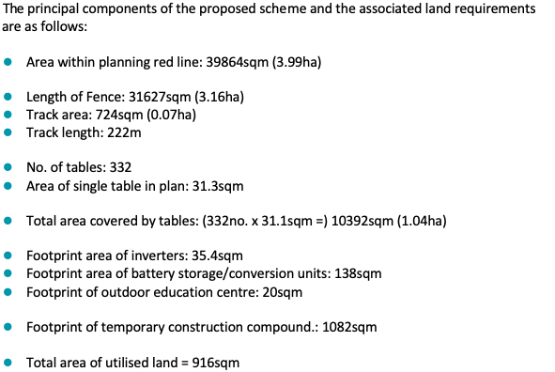
Table 2: List of land use required (Dulas Ltd., 2019).

A map of the proposed site can be found on the following page-

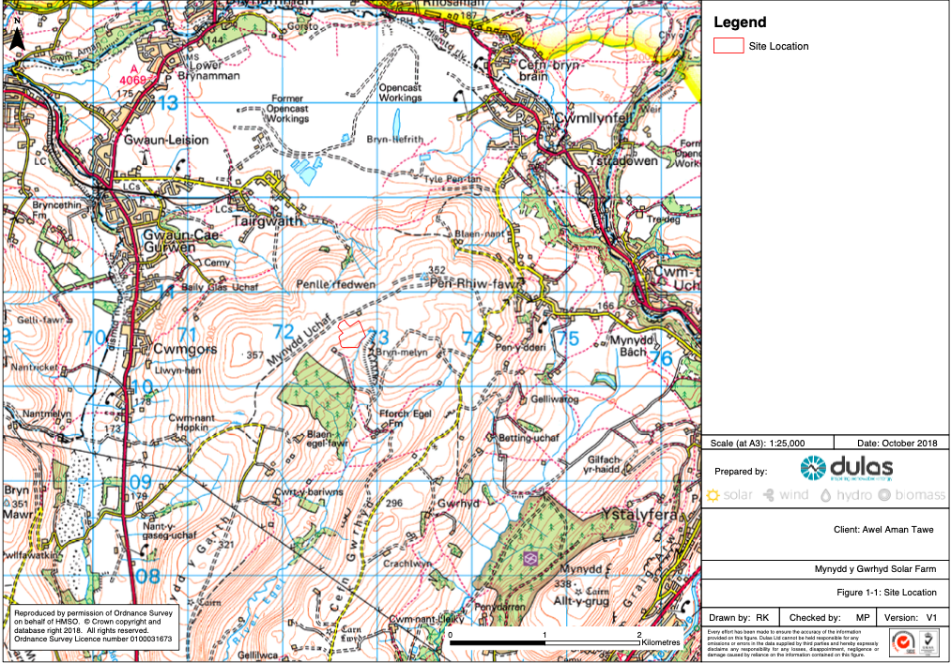

Figure 6: The proposed area of the development is outlined in red near the centre of the map.
(Dulas Renewable Energy, 2018).

Solar Array

The plan proposes that high quality poly-crystalline silicon photovoltaic modules would be installed at the solar farm, harnessing the diffuse nature of light and direct sunlight. Each of the approximately 6972 panels are expected to measure 1m x 1.67m. The solar cells are expected to be dark blue/black in colour and the panels would have an anti-reflective coating to maximise light absorption and minimise glare or reflection. The mounting frames are likely to be fabricated from extruded aluminium, installed on galvanised steel piles driven approximately 1.5 metres into the ground. The development proposal includes the incorporation of battery storage units at the site, measuring approximately (6.1m long x 2.9m high x 2.4m wide) and a single inverter/transformer station.

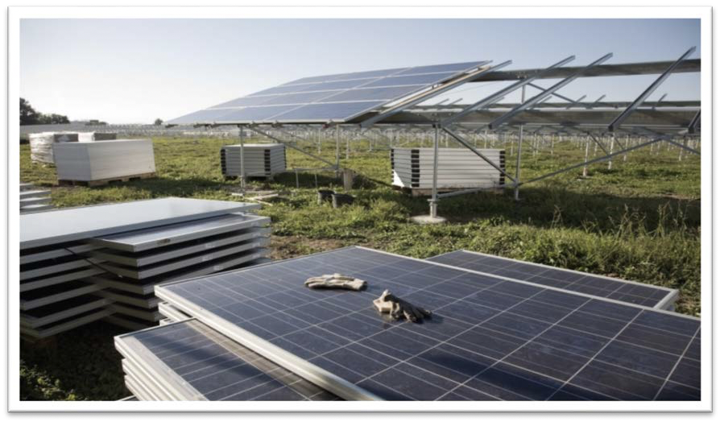

Figure 7: Aluminium frame photovoltaic cells (Dulas Ltd., 2019)

The Environmental Assessment for Mynydd Y Gwhyrd Solar Farm

The Assessment of environmental impacts for the proposed solar farm was completed by Dulas Ltd, A Welsh renewable energy installer and consultancy agency. The version evaluated in this section was published on the 9th of January 2019. The key sections of the report include;
- Introduction
- Planning Policy Context
- Description of Proposed Development
- Landscape and Visual Assessment
- Preliminary Ecological Appraisal
- Archaeology and Cultural Heritage Assessment
- Hydrology and Hydrogeology
- Traffic and Transport
- Glint and Glare
- Noise
The report will be evaluated in the following section in order to discuss the quality and methods of environmental assessment with a principle focus on chapter 5.

Considerations Made For the Construction Phase
The potential for environmental impacts during the construction phase of a project, even if they are considered temporary, are important to consider. The construction phase is estimated to last 12 weeks (weather permitting). Reference is made to some construction phase impacts and control measures within the description of the proposed development:

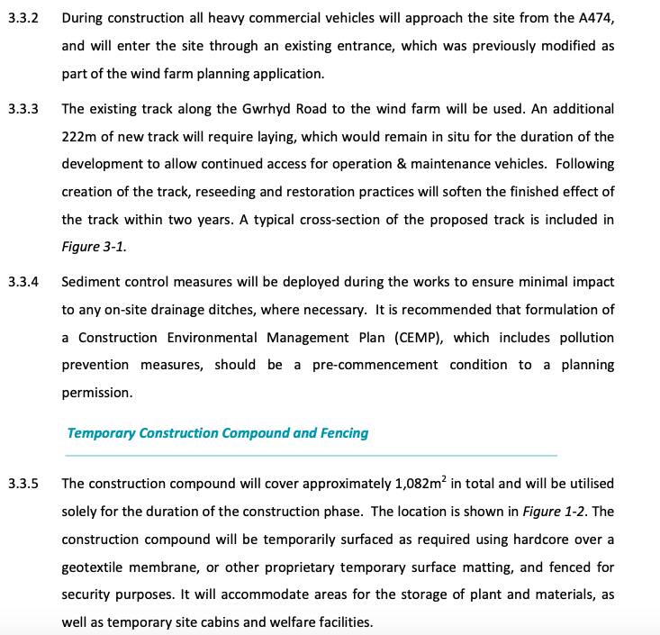

(Dulas Ltd., 2019)

Within this section reference is also made to incorporating gaps underneath temporary fencing to allow for small mammals to enter and exit the site area, this is in addition to the following considerations made;
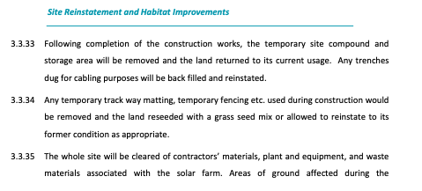

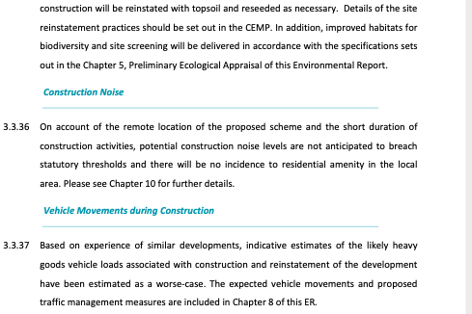
(Dulas Ltd., 2019)
The reference made to the requirement of a Construction Environmental Management Plan (CEMP) presents a commitment to mitigating environmental impacts throughout the construction phase of the project. Following the construction, plans to reinstate the site back to its natural state through reseeding and refilling of ditches illustrates intentions to consider mitigation, even in response to arguably low risk environmental impacts. Estimations of expected heavy goods vehicle loads in a worse-case scenario represents a positive consideration of the precautionary principle in the planning of the project (Josimović, et al., 2021).

On the opposite end of the project life cycle, consideration for decommissioning and the environmental impact of the solar farm after the cells have surpassed their usable life has also been demonstrated in the report. Whilst PV cells typically have a life of around 30 years, they contain numerous recyclable materials such as glass, semiconductor material, steel, aluminium and copper. When the solar plant reaches the end of its operational life, these component parts can be dismantled and recycled. Reference is made to the Waste Electrical & Electronic Equipment (WEEE) EU Directive, illustrating a considered approach to the life cycle environmental impact of the scheme;
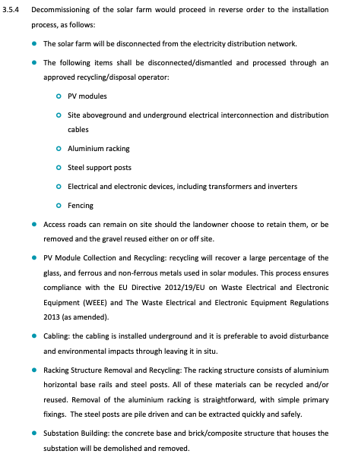

(Dulas Ltd., 2019)

4.2. Landscape & Visual Impact

A summary of the landscape and visual impacts and their determined magnitude are clearly presented in a table within the report. Due to the location and nature of the project the visual and environmental impact on the landscape itself was determined to be relatively minimal. This section of the assessment also utilised Natural Resources Wales landscape character area (LCA) maps in order to determine the types of landscape found at the proposed site and the potential impacts of the project on them. Discussion around significant landscapes surrounding the proposed site was also presented, showing that the surveyor has considered the potential impact not only of the site in question, but of surrounding areas.

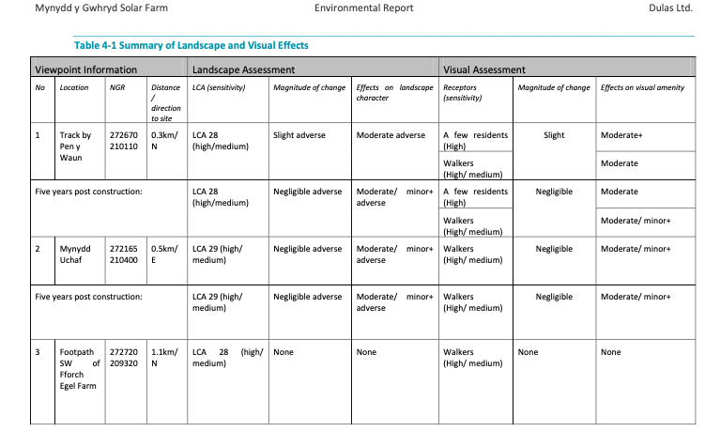
Table 3: (Dulas Ltd., 2019)

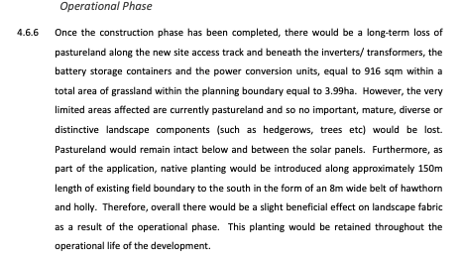

Suggesting environmental enhancement for the site landscape in the form of planting native species around the solar farm is an example of good environmental impact assessment practise within the report

4.3. Phase 1 Habitat Survey

A desk study was completed in order to compile background information on the site and its immediate surroundings. As suggested previously in this report, this can be considered good practise in environmental assessments as this can save resources on completing unnecessary field studies whilst utilising expert knowledge relating to the area in question. All habitats present on the site were searched for signs of faunal activity to determine any presence of badger setts, mammal tracks, bat roosts, herpetofauna basking and any water bodies suitable for amphibians. South East Wales Biodiversity Record Centre (SEWBReC) information relating to protected species and sites of statutory designation were used in order to plan for any mitigations required in relation to preservation of biodiversity. SEWBReC identified a local Site of Interest for Nature Conservation (SINC) within a 1km radius of the site known as Tiroedd Comin Cwm Amman Uchaf. SEWBReC also returned a record of 44 protected and priority species in the area, the majority being birds such as Lesser Redpoll, Skylark, Golden Plover, Cuckoo, Linnet, Dunnock and Song Thrush with one record for Common Lizard 500+ meters from the site. There were 6 records of species of local conservation concern, the nearest being 160m from the site, all of which were bryophytes except for one vascular plant. Survey information on UK protected species should be provided, prior to the determination of a planning application, although there may be certain circumstances where some surveys may be undertaken as a condition of a planning approval. For any European Protected Species, however, sufficient information must be provided before the application is determined.
European Protected Species include (EPS):
Bats (all species)
Dormice
Great Crested Newts
Otters
Shore Dock
Fen Orchid
When completing species surveys an important aspect to consider is the influence of seasonality, some species have optimum periods for surveying as outlined by the
Glamorgan Biodiversity Advisory Group & Gwent Biodiversity Action group:

Table 4: Optimum times for surveying species in Wales (Glamorgan Biodiversity Advisory Group; Gwent Biodiversity Action Group, 2010)
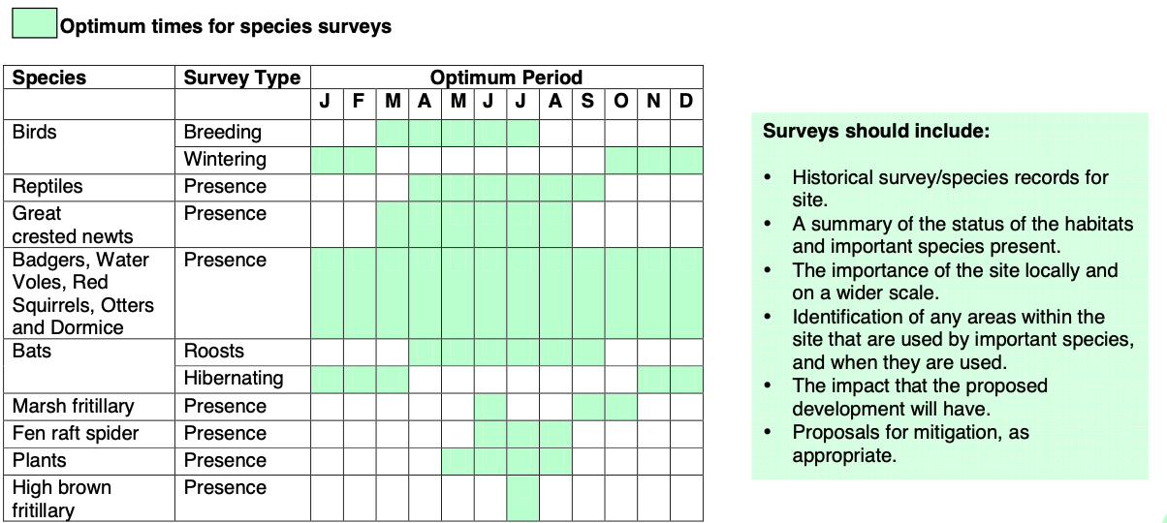

The results of the ecological survey suggest that no EPS are present at the site, however impact significance was assessed for the sites features using a 3 stage process consisting of an assessment of ecological value, magnitude of likely impacts and a determination of impact significance based on a combination of ecological value and magnitude of impact. The criteria for determining significance used the following table:

Table 5: Criteria for determining significance of impacts (Dulas Ltd., 2019).
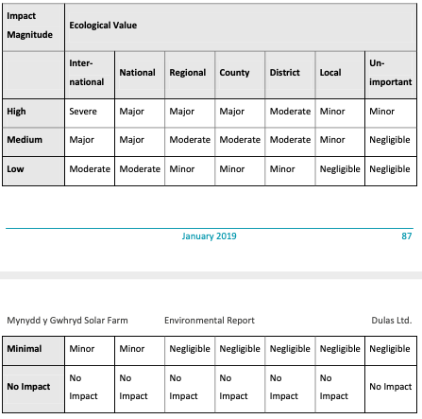

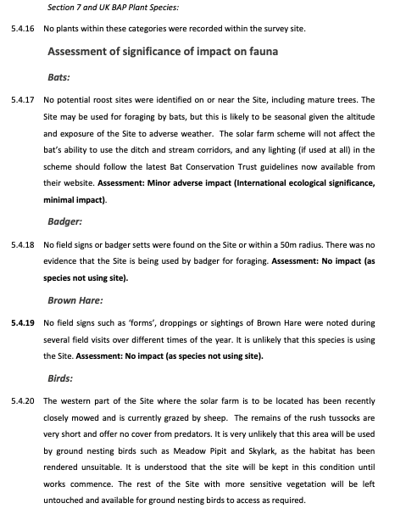
The determined impact significance on specific species was then assigned following a brief statement such as in the following examples:

(Dulas Ltd., 2019)

Within the impact significance assessment, consideration is made towards the potential of surface runoff at the site to enter the drainage system that feeds the hydrological cycle at Bury Inlet, a Site of Special Scientific Interest 17km to the south-west. Control and regulation of potential spillages of hazardous waste and/or sediment runoff during any construction phase is suggested in order to mitigate the risk of adverse impacts. This is an example of good practise as the assessment is considering the potential impacts on the wider locality, and acknowledgment of the interdependencies of different areas in regards to natural processes such as water runoff. The impact determination is clearly presented and justified and practical solutions for mitigation are presented. However, there are some weaknesses within the methodology of the impact determination of this site as potential impacts are not presented in order of significance and the consideration of seasonality within the habitat survey is not clearly presented. As the habitat survey is collected from a respected third party as part of the desk study, it is likely that seasonality was considered within the survey of EPS, however, this is not clearly demonstrated within the report itself. However, despite the determination of the project having a relatively low impact on flora and fauna, some precautionary mitigation measures including all construction works taking place when amphibians and reptiles are active i.e. April to September rather than in the hibernation period and all lighting fixtures following the latest Bat Conservation Trust guidelines located on their website are commendable efforts to mitigate environmental impacts.

Conclusion

The EIA in question contains multiple examples of good practise in assessing potential impacts and presenting practical mitigation solutions. The potential impacts on flora and fauna are investigated in detail utilising appropriate historical data from the desk study and flood risks are considered using a Digital Terrain Model (DTM). This approach also demonstrated clear consideration on the impact on surrounding sites of ecological importance within the habitat survey. The report presented a variety of potential impacts and mitigation measures throughout the construction, operation and eventual decommission of the solar farm. The mitigation measures presented also followed the hierarchy of mitigation measures as the measures suggested aim to avoid environmental impact where possible. Some fundamental processes that are indicative of a high quality EIA as suggested in the academic literature were not present however. The EIA did not demonstrate consideration of seasonality in the habitat survey, there was no accreditation from an independent body such as IEMA, and no public participation such as surveys or meetings were discussed (Roque De Oliveira & Partidario, 2020). Considering these findings, determining the quality of the Mynydd Y Gwhryd Solar Farm EIA is a discussion that is subjective. Using some of the key principles demonstrated in academic literature can be used as a basis to judge the quality of an EIA, however, as illustrated by the example used in this report, each EIA must be considered on an individual basis due to the variability in development proposals. By judging the example used in this report by the standards discussed previously, this may present as an EIA of limited detail. However, when the relatively low environmental risk posed by the project is put into context, the efforts of the assessors can be regarded as sufficiently considered and detailed in approach.

References
East Hampshire District Council and South Downs National Park Authority, 2012. A quick guide to the Habitats Regulations Assessment. [Online]
Available at: https://cdn.easthants.gov.uk/public/documents/HRA%20guidance.pdf
[Accessed 31 March 2021].
Arlidge, W. N. S. et al., 2018. A Global Mitigation Hierarchy for Nature Conservation. Bioscience, 68(5), pp. 336-347.
Arts, J. et al., 2012. The Effectiveness of EIA as an Instrument for Environmental Governance: Reflecting on 25 Years of EIA Practice in the Netherlands and the UK. Journal of Environmental Assessment Policy and Management, 14(1), p. 1250025.
Babu, S., 2016. Mitigation Hierarchy: Levels of mitigation in Environmental Impact Assessment. [Online]
Available at: https://eco-intelligent.com/2016/12/11/levels-of-mitigation-in-environmental-impact-assessment/
[Accessed 24 March 2021].
Barrow, C. J., 1999. Environmental management principles and practice. London : Routledge .
Beanlands, G. E. & Duinker, P. N., 1983. An Ecological Framework for Environmental Impact Assessment in Canada , Dalhousie: Institute for Resource and Environmental Studies Dalhousie University, Federal Environmental Assessment Review Office.
Bond, A., Fischer, T. B. & Fothergill, J., 2017. Progressing quality control in environmental impact assessment beyond legislative compliance: An evaluation of the IEMA EIA Quality Mark certification scheme. Environmental Impact Assessment Review, 63(1), pp. 160-171.
Boughton, D. A., Smith, E. R. & O'neill, R. V., 1999. Regional Vulnerability: A Conceptual Framework. Ecosystem Loss, 5(4), pp. 312-322.
Cashmore, M. & Richardson, T., 2013. Power and environmental assessment: Introduction to the special issue. Environmental Impact Assessment Review, 39(1), pp. 1-4.
Claassen, M., 1999. Ecological risk assessment as a framework for environmental impact assessments. Water science and technology, 39(10), pp. 151-154.
Duarte, C. G. & Sánchez, L. E., 2020. Addressing significant impacts coherently in environmental impact statements. Environmental Impact Assessment Review, 82(1), p. 106373.
Dulas Ltd., 2019. Mynydd y Gwhryd Solar Farm Environmental Report, Machynlleth : Dulas Ltd..
Dulas Renewable Energy, 2018. Site Location. [Online]
Available at: http://awel.coop/wp-content/uploads/2018/11/E05419-DWP-Figure-1-1-Site-Location-v1.pdf
[Accessed 31 March 2021].
Ehrlich, A. & Ross, W., 2015. The significance spectrum and EIA significance determinations. Impact Assessment & Project Appraisal, 33(2), pp. 87-97.
Glamorgan Biodiversity Advisory Group; Gwent Biodiversity Action Group, 2010. Quick Reference Guide for Planning Officers. [Online]
Available at: https://www.merthyr.gov.uk/media/1244/think-wildlife-think-protected-species.pdf
[Accessed 1 April 2021].
Hanover Conservancy, 2020. Hanover Conservancy Annual Meeting featuring Prof. Rich Howarth. [Online]
Available at: https://www.hanoverconservancy.org/event/environment-society-hanover-conservancy-annual-meeting/
[Accessed 25 March 2021].
Jacob, C., Pioch, S. & Thorin, S., 2016. The effectiveness of the mitigation hierarchy in environmental impact studies on marine ecosystems: A case study in France. Environmental impact assessment review, 60(1), pp. 83-98.
Jha-Thakur, U. & Fischer, T. B., 2016. 25years of the UK EIA System: Strengths, weaknesses, opportunities and threats. Environmental Impact Assessment Review, 61(1), pp. 19-26.
Josimović, B., Cvjetić, A. & Furundžić, D., 2021. Strategic Environmental Assessment and the precautionary principle in the spatial planning of wind farms. Renewable & sustainable energy reviews, Volume 136.
Lawrence, D. P., 2007. Impact significance determination—Back to basics. Environmental impact assessment review,, 27(8), pp. 755-769.
Maron, M. et al., 2015. Conservation: Stop misuse of biodiversity offsets. Nature, 523(7561), pp. 401-403.
Ministry of Housing; Communties and Local Government, 2019. Guidance on the use of Habitats Regulations Assessment. [Online]
Available at: https://www.gov.uk/guidance/appropriate-assessment
[Accessed 31 March 2021].
Morris, P. & Therivel, R., 2009. Methods of environmental impact assessment. 3rd Edition ed. London: Routledge .
Perdicoulis, A. & Glasson, J., 2009. The causality premise of EIA in practice. Impact Assessment & Project Appraisal, 27(3), pp. 247-250.
Quivy, R. & Van Campenhoudt, L., 2008. Manual de Investigação em Ciências Sociais. 5th ed. s.l.:Lisboa Gradiva.
Roque De Oliveira, A. & Partidario, M., 2020. You see what I mean? – A review of visual tools for inclusive public participation in EIA decision-making processes. Environmental Impact Assessment Review, 83(106413).
Sheate, W., 2014. Unit 1 Introduction to Environmental Impact Assessment (EIA). [Online]
Available at: https://www.soas.ac.uk/cedep-demos/000_P507_EA_K3736-Demo/index.htm
[Accessed 27 March 2021].
Steiner, F., 1995. Introduction to environmental impact assessment. Landscape and urban planning, 32(3), pp. 197-198.
Tullos, D., 2009. Assessing the influence of environmental impact assessments on science and policy: An analysis of the Three Gorges Project Author links open overlay panel. Journal of Environmental Management, 90(30), pp. 208-223.
UK Government , 1990. Town and Country Planning Act 1990. [Online]
Available at: https://www.legislation.gov.uk/ukpga/1990/8/contents
[Accessed 31 March 2021].
UK Government , 2017. The Town and Country Planning (Environmental Impact Assessment) Regulations 2017. [Online]
Available at: https://www.legislation.gov.uk/uksi/2017/571/schedule/2/made
[Accessed 31 March 2021].

