Project Planning

LECTURER NAME:
DIOLA BIJLHOUT
STUDENTS NAME:
Maria Melania Ruican(1605367)
Cristina Cosma(1605407)
Florina Anghel(1605361)
Daniel Teleaga(1605390)
Telma Pires(1604712)

JANUARY 09/2018

Table of Contents
INTRODUCTION 1
REASONS FOR RELOCATION OF BUSINESS 1
SMART TARGETS 1
PROJECT PHASE 1
MARKET ANALYSIS 2
SKILL DEVELOPMENT 3
GANTT CHART 4
PROJECT PLANNING 4
ESTIMATED COST OF THE PROJECT AND TOTAL BUDGET 5
STAKEHOLDERS ANALYSIS 6
COMMUNICATION CHANNEL 7
RISK ASSESSMENT 8
REFERENCES 10

Table of figures
Figure 1Project Life cycle 2
Figure 2Network Diagram 6
Figure 3Gantt Chart 7

Telma Pires(1604712)

INTRODUCTION
Starbucks was founded in 1971, Pike Place Market, Seattle, Washington, United States by three students from University of San Francisco. English teacher Jerry Baldwin, history teacher Zev Siegl and a writer Gordon Bowke. Alfred Peet was the inspiration for selling whole coffee because he taught the roasted bean style. The company was selling high quality roasted whole coffee purchased directly from growers, the brewed coffee prepared in the store was only free samples not for sale.
The company was working for 10 years without leaving the area (seattle). One year after meeting the company's founders, Howard Schultz joined Starbucks as a marketing director and became the international face of modern coffee. Starbucks only sold whole coffee beans and not coffee drinks. While traveling to some countries (Italy, Milan) and knowing many products and coffee shops, Howard suggested that whole coffee beans and coffee drinks be sold, but the founders did not accept their proposal very well because they already had business to sell whole coffee beans. In 1984, after much insistence, they decided to try to serve coffee drinks, which quickly was a success bringing hundreds of people a day.
The Starbucks logo was a mermaid with breasts showing and two tails, as ancient mermaids in Greek mythology attracted sailors for the sinking and the founders believed that, with that logo, they attracted coffee lovers from various places to their shop. In 1987, the Starbucks logo underwent many changes because Howard wanted a polished corporate appearance and feel for this business.
Terry Heckler created the Starbucks logo, a mermaid with hair covering her breasts and two tails inspired by maritime books.

REASONS FOR RELOCATION OF BUSINESS
The main reason of relocating a business to different location is due to availability of opportunities in that location. Starbucks, a renowned coffee chain is planning to relocate its store in Krnington Parkdue to the new set of demand arising near that place. It has been estimated that the company will be able to generate higher revenues in the comparison to its present location. Another, reason for relocation of store is that the company is not able to cover up its working capital with the existing profits generated in the present store and it is expected that the new location will help in fulfilling the demand of profits of the entity in better way.Moreover, it has been estimated that the costing of the enterprise will significantly fall and revenues will rise with the shift (Hwang and Ng, 2013). Hence, it has been planned by all the members of the organization to shift its location to Krnington Park.

Maria Melania Ruican(1605367)

SMART TARGETS
Based on the relocation decision of Starbucks to Krnington Park. Following smart targets have been formulated by the project planners:
- To increase the revenue of Starbucks by 20%.
- To reduce the cost of Starbucks by 12.5%.
- To increase the number of customers at the coffee shop by 25%
- To invest 10% more in marketing activities with the aim to promote the new store of Starbucks at Krnington Park.

PROJECT PHASE
There are basically four phases of project life cycle. These are:
- Initiation:It is the first step to any project, as the strategy is prepared so that the project can be made to reach at the desired results.A project manager is appointed at this phase with the aim to effectively perform these functions.
- Planning:It is the planning phase of the project which includes detailed breakdown of requirements from beginning to end. It also includes the phase of risk assessment and management technique for successful completion of each task (Kaiser, Arbi and Ahlemann, 2015).
- Execution:It is the execution phase of the project which helps in proper execution of the activitieswhich were formed in planning phase of the project.
- Closure:This is the last and final stage of project phase where written formal project reviewreport will be prepared by the project manager addressing all the aspects of relocation of Starbucks.
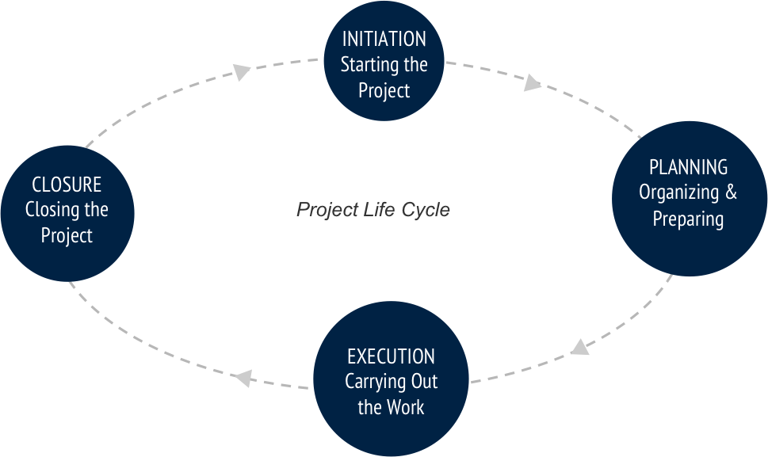
Figure 1Project Life cycle
(Source: What is the Project Life Cycle?.2016)

Cristina Cozma (1605407)

MARKET ANALYSIS
Starbucks is oneof the most renowned coffee chain house in the world. It is considered as premium retailer of variety of coffee and beverages both hot and cold inclusive of snacks and sandwiches as well. It is currently functioning in 37 countries with more than 10000 coffee shops.
It has been assessed that there is high degree of competition in retail beverage segment which can have strong impact on the profit margins of Starbucks. Based upon the macro factors, PESTLE analysis can be performed on Starbucks in the following manner:
- Political:Globalization have been the major driving force where company need to frame and alter its policies as per the prevailing political environment in the country. Starbucks has been able to manage the diverse political environment in different countries and has been able to take steps accordingly in various countries.
- Economic:Since, Starbucks is considered as a premium coffee house, increase in the interest rates can affect the investment plan of the company (Kerzner, 2013).
- Social:It is important to understand the taste and preference of thecustomersand encourage the stores in the country to opt for their menu that is best suited as per the environment.
- Technological:Starbucks uses advanced technology for preparation of its menu in least possible time. The stores are equipped with latest technology coffee machines to fulfil the requirementsofthe customers.
- Legal:Different legislations are followed by the countries. Hence, Starbucks must be aware of product and trade restrictions. Moreover, they make sure that no law is broken and every norm is effectively followed.
- Environmental:There are various factors that are considered by Starbucks. It includes,pollution,planning permission, waste disposal etc (Mir and Pinnington, 2014).

SKILL DEVELOPMENT
In order to establish a store in Krnington Park in UK, it is important to develop following skills in the staff members. Some of the skill development techniques and requirements are discussed as under:
- Experienced staff: It is important that the type of staff working in the store are effective enough that can fulfil the requirements ofthe customers. They must be able to understand the requirements by market research and convey it to the top-level management for bringing change in the current set up of the store.
- Training and development: it is important that the staff is trained enough to serve the needs of Krnington Park’s consumers. They must understand the language and culture in appropriate manner so that the best can be delivered to the customers.

GANTT CHART
Task Mode | Task Name | Duration | Start | Finish | Predecessors
Auto Scheduled | Starbucks | 22 days | 12/28/2017 | 1/26/2018
Auto Scheduled | Initiation phase | 10 days | 12/28/2017 | 1/10/2018
Auto Scheduled | Ascertaining the target goal for Starbucks | 7 days | 12/28/2017 | 1/5/2018
Auto Scheduled | Ascertainment of risk | 2 days | 12/28/2017 | 12/29/2017
Auto Scheduled | Setting the expectations of the shareholders | 5 days | 12/28/2017 | 1/3/2018
Auto Scheduled | Proper documentation of contracts and agreements | 3 days | 1/8/2018 | 1/10/2018 | 3,4
Auto Scheduled | Preparation of communication plan | 3 days | 1/1/2018 | 1/3/2018 | 4
Auto Scheduled | Planning phase | 18 days | 12/28/2017 | 1/22/2018
Auto Scheduled | Planning for operations | 10 days | 1/4/2018 | 1/17/2018 | 5
Auto Scheduled | Identification of resource requirements | 5 days | 12/28/2017 | 1/3/2018
Auto Scheduled | Planning and managing risks | 3 days | 1/18/2018 | 1/22/2018 | 9
Auto Scheduled | Decision of structure | 7 days | 12/28/2017 | 1/5/2018
Auto Scheduled | Execution and controlling phase | 22 days | 12/28/2017 | 1/26/2018
Auto Scheduled | Collecting funds | 7 days | 1/18/2018 | 1/26/2018 | 9
Auto Scheduled | Hiring of expertise team | 6 days | 1/4/2018 | 1/11/2018 | 10
Auto Scheduled | Relocating the store with all the material and equipment | 2 days | 1/11/2018 | 1/12/2018 | 6
Auto Scheduled | Continuous monitoring or work | 5 days | 1/4/2018 | 1/10/2018 | 5
Auto Scheduled | Regular reporting | 3 days | 1/1/2018 | 1/3/2018 | 4
Auto Scheduled | Conducting meetings | 1 day | 12/28/2017 | 12/28/2017
Auto Scheduled | Analysis of risks | 1 day | 1/11/2018 | 1/11/2018 | 17
Auto Scheduled | Examination of the progress by comparing the performance with the targets | 2 days | 1/11/2018 | 1/12/2018 | 17
Auto Scheduled | Altering the plan | 2 days | 1/4/2018 | 1/5/2018 | 18
Auto Scheduled | Closure phase | 19 days | 12/28/2017 | 1/23/2018
Auto Scheduled | Contract closure | 5 days | 1/15/2018 | 1/19/2018 | 21
Auto Scheduled | Completion of all the contractual agreements | 6 days | 12/28/2017 | 1/4/2018
Auto Scheduled | Post-project appraisal and review | 2 days | 1/22/2018 | 1/23/2018 | 24
Auto Scheduled | Submission of final report to the manager | 1 day | 1/5/2018 | 1/5/2018 | 25

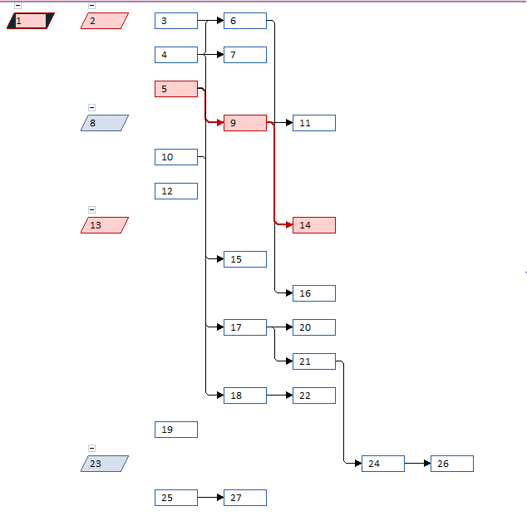
Figure 2Network Diagram

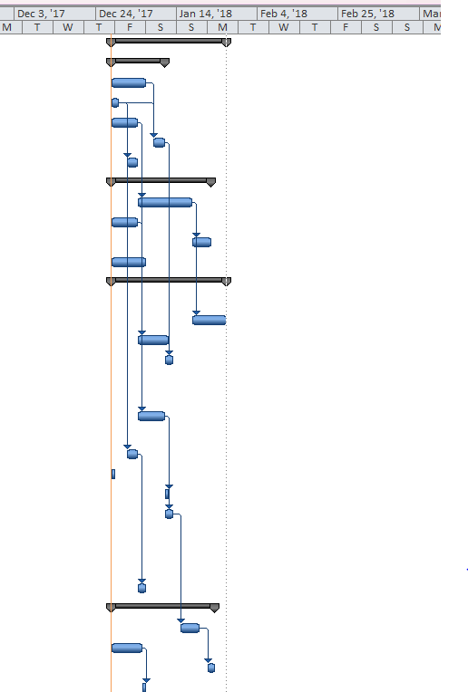
Figure 3Gantt Chart

PROJECT PLANNING
Resource requirements:
- Location
- Land and building
- Infrastructure
- Interior designing
- Adequate amount of funds
- Experienced staff members
Cost: The total cost required so as to meet all the specified requirements of the project is 36000. The cost includes requirements of all the tangible resources for the project of relocating Starbucks store (Pemsel and Wiewiora, 2013).
Duration:Total estimated duration so thatall the important aspects of the project is covered required approximately 88 days.
Roles and responsibilities:
Tasks | Responsible person | Roles and responsibilities
Introduction | Thelma | The responsibility of Thelma is to understand the variables that are responsible for store relocation. Moreover, the role will cover to assess the requirement for Starbucks to change its location.
Smart targets | Melania | The mail goal of Melania is to prepare smart targets. The member will then be responsible to achieve it for newly located store. To perform this task, Melania will require to analysethe market and reach toprudent targets for Starbucks.
Scheduling tools | Cristina | Cristina is responsible to analyse the market trend, based on which decision will be taken by the top-level management. Moreover, she is also responsible for assess the requirements of skill development.
Shareholders analysis and assessment of communication channel | Daniel | The responsibility of Daniel is to analyse who are the stakeholders of Starbucks. Moreover, he is also responsible for establishing communication channel for the new store as well.
Risk Assessment | Florina | Florina is responsible for assessing the risk and ascertaining that how it can be reduced to minimum for the present project of Starbucks.

ESTIMATED COST OF THE PROJECT AND TOTAL BUDGET
Budget helps in measuring the requirements of funds and assess how much monetary funds will be incurred so that all the necessity of the store can be fulfilled. It is the framework of finance which helps in designing and developing new store of Starbucks that will be located at Krnington Park in UK.
Particulars | Amount
Purchase of land and building | 12000
Interior designing | 3000
Collection of raw material | 6000
Purchase of modernized equipment | 4500
Purchase of furniture | 2500
Human resource salary | 8000
Miscellaneous expenses | 1000
Total | 37000

Objectives:
- To complete the project of relocating Starbucks in stipulated time period
- To complete the project effectively within 37000which includes all the cost of purchase of land and building, interior designing, purchase of furniture, human resource salary, purchase of modernized equipment etc.
- To maintain adequate amount of care while shifting the location from one another as some of the important things can itself be utilized in the new store as well (Serra and Kunc, 2015).
- To monitor various functions of management and ensure that all the resources purchased for the project are optimally utilised
- To monitorthe activities performed and ensure that the objectives of the project is fulfilled.

Daniel Teleaga(1605390)

STAKEHOLDERS ANALYSIS
The present project is regarding relocation of store at Krnington Park in UK. There are various shareholders who will have direct impact of functioning of this project. Some of the shareholders includes the following:
- Employees: The highest impact of relocation will be borne by the employees. It can be difficult for them to commute and reach to the new store as a part of their job. There are two options that are available in front of project manager (Anderson,Buchko and Buchko, 2016). Either lay off existing employees and higher newer and more experienced people with expertise in their work or shift the existing staff from the old store to the new one.In the first option, it can increase the costing of recruitment for the company. However, in the send option presented for the same requires special arrangements for commutation for the employees.
- Customers: These are the end users of the products that are extended by Starbucks. It is important to assess the taste and preferences of the customers so that the best can be delivered to them. In that case, it is important for the project manager to analyze the taste and preference of the customers which can help in better availability of then products. In this manner Starbucks will be able to generate higher revenues and profits in comparison to the old store.
- Investors:The investor tend to invest in the project that can help them in recovering the cost being initiated in the project. Hence, it is important that the project in which they are investing is profitable enough (Bronnenmayer, Wirtz and Göttel, 2016). Hence, the investors are required to be updated with every bit of the information and proceedings in case of developmentof the project being formulated for Starbucks.

COMMUNICATION CHANNEL
Method of communication | Target | Channel of communication | Time | Stakeholders | Deliverables
Kick-off meetings | To discuss the plan of the project, scope and other targeting strategies | Meeting in the conference hall | Once per fortnight | Project manager | Agenda
Conduction of team meetings | It helps in examining the progress at work and assist in taking remedial measures for the project. | Conducting in the form of meeting at the conference hall | Once in a week | All the members of projects team | Project scheduling  Minutes of the meeting  Agenda
Meeting on interior designing | Examination and revision of the interior design framed so that everything can be rightly placed in the store | Face to face meeting | Asper the requirements | Interior designer  Contractor  Project manager | Meeting minutes  Agenda
Project status report | The main aim is to communicate regarding the performance of the project to the project manager. | E mails  Video Conferencing | Every month | All the members of project team are invited for the same | Project schedules  Working reports

Florina Anghel (1605361)

RISK ASSESSMENT
There are various types of risks that are directly associated with the project of relocation.However, appropriate techniques used by the project manager can help in managing and controlling the involved risks to an extent. In the present project, the main focus of the project manager in to shift Starbucks to a new location, that is, at Krnington Park in UK. Since, it is a new location and implementation of a project is not easy. Some of the common risks that are involved in the project are as follows:
- Loss of customers:It is obvious that with theshift in location, the store will not be able to retain its old loyal customers. Even the company also get to involved in new marketing and advertising techniques as it may not prove to be beneficial in case of people who are residing at the new location (Walger, Roglio and Abib, 2016).
- Difficulties in staff recruitment: All the staff members may not be ready to work on the new location. Hence, it requires a new recruitment drive for selection of experienced and expertise staff members. It can add up to the cost of the entity.
- Unacceptance of customers at the new location: The main objective of shifting the outlet from one location to another is due to inadequate revenues and profits to the company. If the company is not accepted at the new location then it can lead to a problematic situation for Starbucks
- Lack of resources:it is another important aspect where unavailability of adequate amount of resources can hinder the functions of the project.
- Quality: if the employees are not expertise in their work, it can affect the quality of the deliverables that is ultimately delivered to the end consumer (Eriksson and Ingelsson, 2016).
Monitoring techniques
The above risks can be managed by the project manager in the following manner:
- Tracing identified risks: Tracing and tracking the risk can help in formation of better plan and executing it so that the impact of risk on the project can be reduced to minimum.
- Risk Audits:Examining risk so that the planning techniques of the project can be adequately improved by the project manager.
- Assessment of current market: researching about the market can help in better assessment of the risk and opt for options that can ultimately help in delivering the best to the customers. Further, it can also help in ascertaining the taste and preferences of the customers (Aregbeshola, 2016).
- Optimum utilization of resources: it is important that the resources that has been selected for the project are optimally utilised so that the scenario of unavailability of resources can be reduced to the minimum.

REFERENCES
Books and journals
Anderson, E., Buchko, A. A. and Buchko, J. K., 2016. Giving negative feedback to Millennials: how can managers criticize the "most praised" generation.Management Research Review.39(6).
Aregbeshola, A. R., 2016. The role of local financial market on economic growth – a sample of three African economic groupings.African Journal of Economic and Management Studies.7(2).
Bronnenmayer, M., Wirtz, B. and Göttel, V., 2016.Determinants of Perceived Success in Management Consulting - An empirical investigation from the consultant perspective.Management Research Review.39(6).
Eriksson, M. and Ingelsson, P., 2016.Building an organizational culture when delivering commercial experiences- the leaders' perspective.International Journal of Quality and Service Sciences.8(2).
Hwang, B.G. and Ng, W.J., 2013. Project management knowledge and skills for green construction: Overcoming challenges. International Journal of Project Management. 31(2).pp.272-284.
Kaiser, M.G., El Arbi, F. and Ahlemann, F., 2015. Successful project portfolio management beyond project selection techniques: Understanding the role of structural alignment. International Journal of Project Management. 33(1).pp.126-139.
Kerzner, H., 2013. Project management: a systems approach to planning, scheduling, and controlling. John Wiley & Sons.
Mir, F.A. and Pinnington, A.H., 2014.Exploring the value of project management: linking project management performance and project success. International journal of project management. 32(2).pp.202-217.
Pemsel, S. and Wiewiora, A., 2013.Project management office a knowledge broker in project-based organisations. International Journal of Project Management. 31(1).pp.31-42.
Serra, C.E.M. and Kunc, M., 2015.Benefits realisation management and its influence on project success and on the execution of business strategies. International Journal of Project Management. 33(1).pp.53-66.
Walger, C., Roglio, D. D. K, and Abib, G., 2016. HR managers’ decision-making processes: a “reflective practice” analysis. Management Research Review.39(6).
Online
What is the Project Life Cycle?.2016. [Online]. Available through < https://www.mavenlink.com/resources/what-is-the-professional-services-project-life-cycle>.
- Designhill. (2018). Starbucks Logo – An Overview of Design, History and Evolution.
- Starbucks Coffee Company. (2018). Company Information.

