Word count: 3282
Task 1: Lunchtime learning session
Rebecca Carruthers 1802066

Learning Session: Detailed Notes
Slide 1:
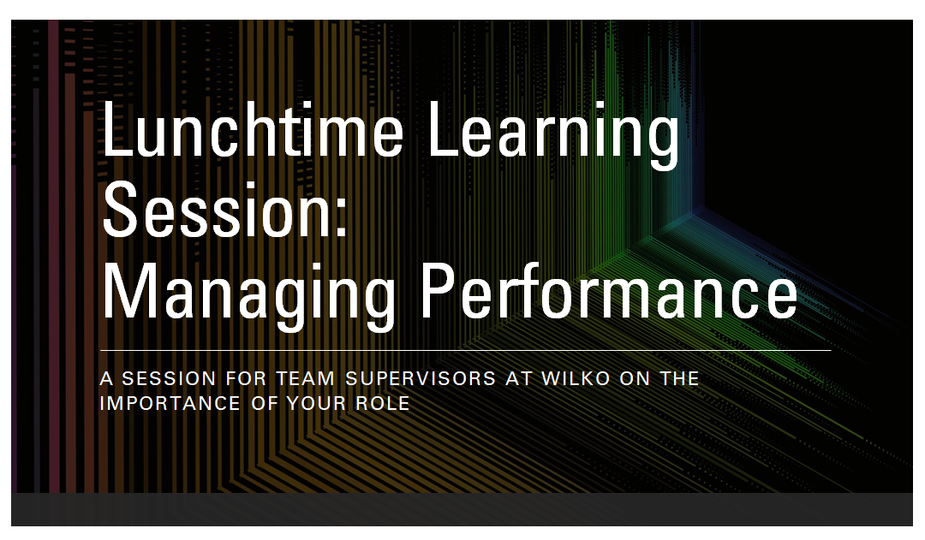Slide 2: 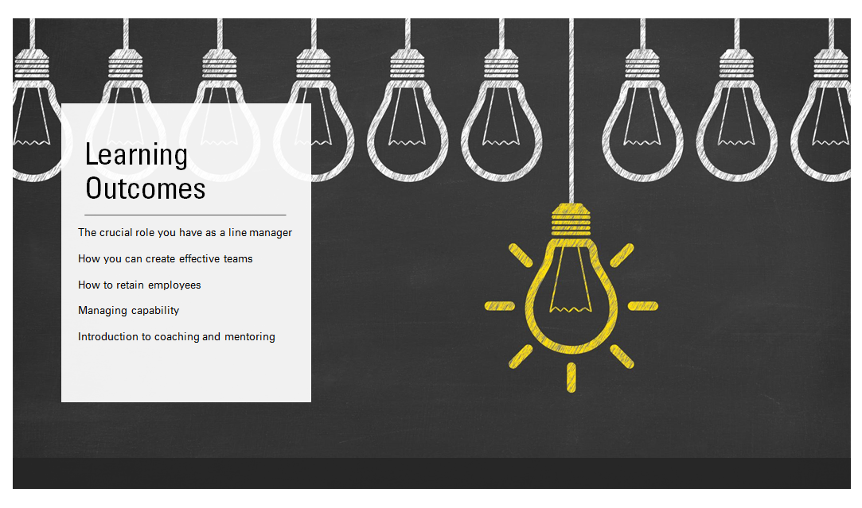
Slide 3:
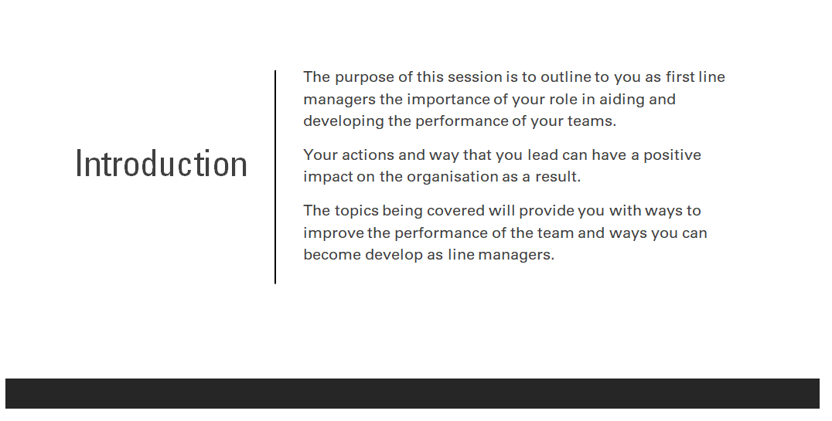
Slide 4:
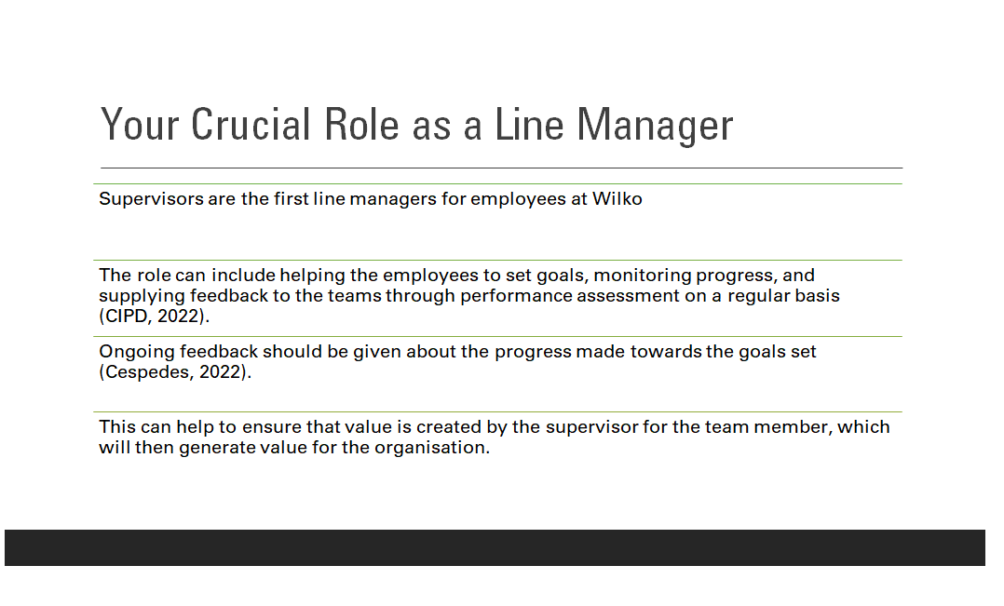
Within Wilko the team supervisor is important in influencing performance as these are the first line managers responsible for the level one employees. The assessment and recognition of performance is part of the role. This can include helping the employees to set goals, monitoring progress, and supplying feedback to the teams through performance assessment on a regular basis (CIPD, 2022). This agrees with the assessment made by Cespedes (2022), which says that to continue having a positive impact on employee performance, ongoing feedback should be given about the progress made towards the goals set. This can help to ensure that value is created by the supervisor for the team member, which will then generate value for the organisation.
Slide 5:
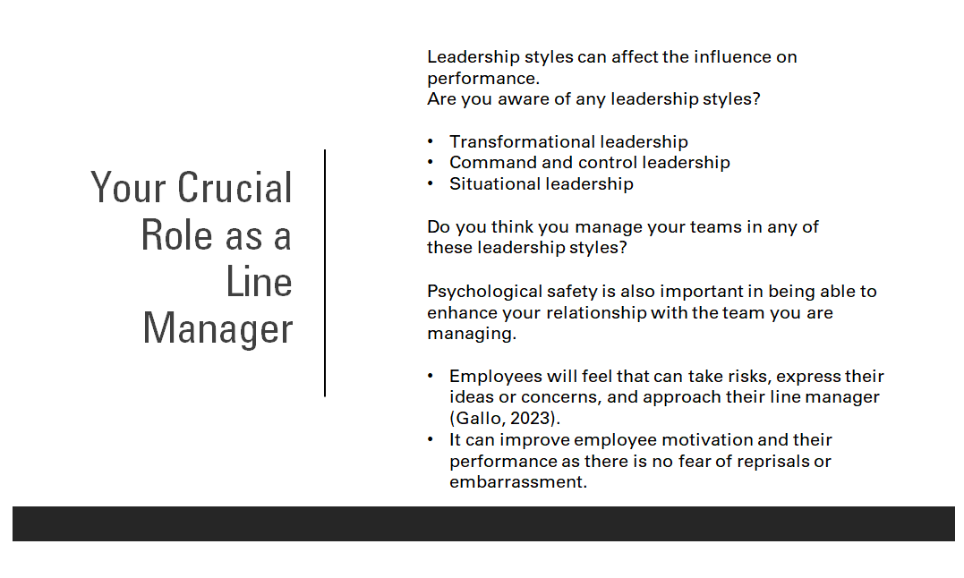
Here some examples of leadership styles are discussed. Learners would be asked if they know anything about different leadership styles.
Transformational leadership: this leadership style can help progress people and systems in a positive direction. Some characteristics include encouraging the team you are leading, providing support and recognition, and making employees see the value in what they do, this can help to reach the ideal performance levels an organisation desires (Moradi-Korejan and Shahbazi, 2016).
Command and control: this leadership style is the exercise of authority and direction of one person and what they say is done, this is a leadership style that can limit employee performance (Adams et al., 2017). There is no allowance for the ideas of others and this impact employees negatively as they may fear doing something wrong or not performing as needed.
Situational leadership: this leadership style is adapted by the line manager depending on the situation they are in or to meet the needs of the team, with research undertaken by Wuryani et al. (2021) that shows that this style can improve employee motivation. This approach can enable line managers to coordinate and manage the team according to employee strength or tasks that need to be completed, which would be beneficial for a varied team seen within Wilko.
By ensuring that there is psychological safety within the workplace, supervisors will be able to enhance the relationship that they have with the team that they are managing. The employees will feel that they are able to take risks, express their ideas or concerns, and approach their line manager (Gallo, 2023). This is something that is desired in the workplace as it improves employee motivation and their performance as there is no fear of reprisals or embarrassment, you want employees to focus on having good relationships within their workplace (Cespedes, 2022).

Slide 6:
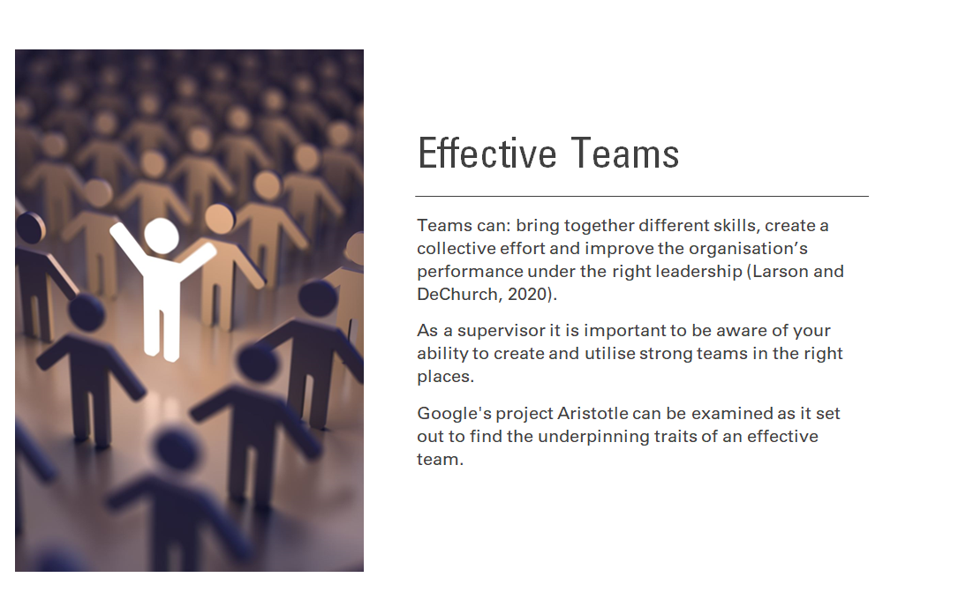
Ask why do we need teams in the workplace?
The reasons that teams are used in the workplace can include the bringing together of different skills and creating a collective effort which can help improve the organisation’s performance with the right leadership (Larson and DeChurch, 2020). This is seen within Wilko as teamwork is a vital aspect of the operation on a day-to-day basis. It is important that the supervisors are aware of their ability to put together strong teams and use them in the right places.
An example of understanding an effective team is Google's project Aristotle in 2012. It firstly differentiated a work group from a team, whereby a work group have little independence and are based on a managerial hierarchy, compared to a team which is independent and needs the team members to achieve the goals set out (Google re:Work Team, no date).
The research found that there are traits that help create an effective team these are psychological safety, dependability, structure, and clarity, meaning, and impact. It was about how the team worked together instead of who was part of the team. The team had clear roles, the work meant something to the team members, they felt their work mattered, and were able to take risks (Google re:Work team, no date).
The research found that co-location, workload, individual performance level and seniority did not have an impact on the effectiveness of the team.
Slide 7:
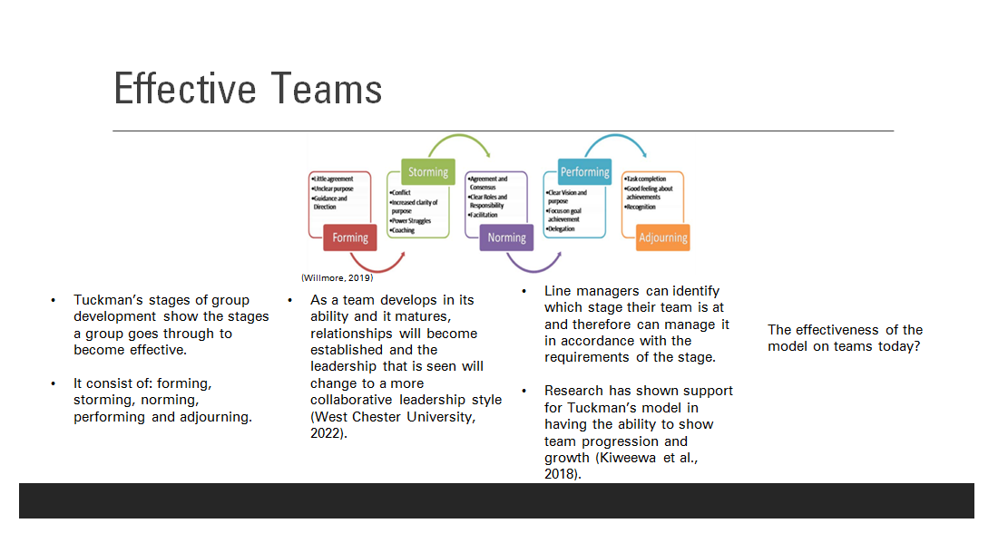
To understand the development that a team goes through to become effective, there is a model that can be used to show this process. Tuckman’s stages of group development consist of, forming, storming, norming, performing and adjourning. The model explains that as a team develops in its ability and it matures, relationships will become established and the leadership that is seen will change to a more collaborative leadership style (West Chester University, 2022).
The advantages to an organisation of using this model are that it can allow a line manager to identify which stage their team is at and will enable them to manage it in accordance with the requirements of the stage. As the relationships with the team members progress, they will have a greater bond and understand what role they have, they will be more likely to be productive because of this (Natvig and Stark, 2016). Additionally, research has shown support for Tuckman’s model in having the ability to show team progression and growth (Kiweewa et al., 2018).
There have been criticisms of the model and its usefulness in looking at the effectiveness of teams as they develop. When this model was derived it looked at small teams, however in recent years teams have become much larger, and recent trends include multi-location teams (Chimruang and Yampinij, 2021), and virtual teams that have to work effectively, therefore this model may be difficult to apply to these.
Slide 8:
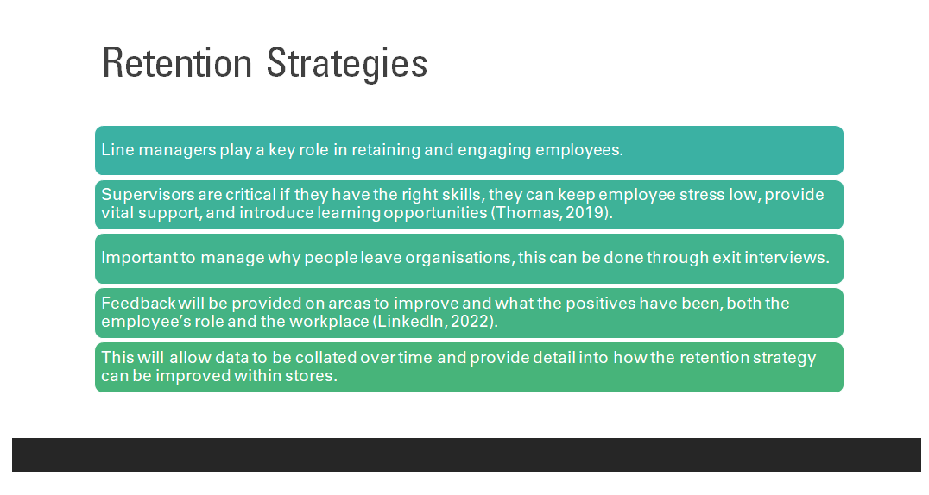
Line managers play a key role in retaining and engaging employees, this is key to Wilko as retailers often have higher turnover due to levels of pay, contract size and similar roles being found often with competitors. Thomas (2019) comments that supervisors are critical, if they have the right skills, they can keep employee stress low, provide vital support to their teams, and introduce learning opportunities.
It is important to find out why employees leave the organisation in the first place. This can be addressed through the introduction of exit interviews with the level one employees, as currently only store managers conduct exit interviews when a supervisor leaves.
An exit interview consists of gathering information as to why the employee is leaving the organisation, the employee will provide feedback on areas where improvements need to be made and what has been positive about their job role (LinkedIn, 2022). This will allow data to be collated over time and provide detail into how the retention strategy can be improved within stores. As Wilko sees a higher level of turnover of level one employees compared to supervisors, it would be a beneficial tool to use as supervisors already conduct performance reviews for these employees.
However, some exit interviews have been seen to not work due to factors such as inconsistency with completing exit interviews, the quality of data not being relevant and questions being too rigid which does not allow for trends to be found (Spain and Groysberg, 2016).

Slide 9:
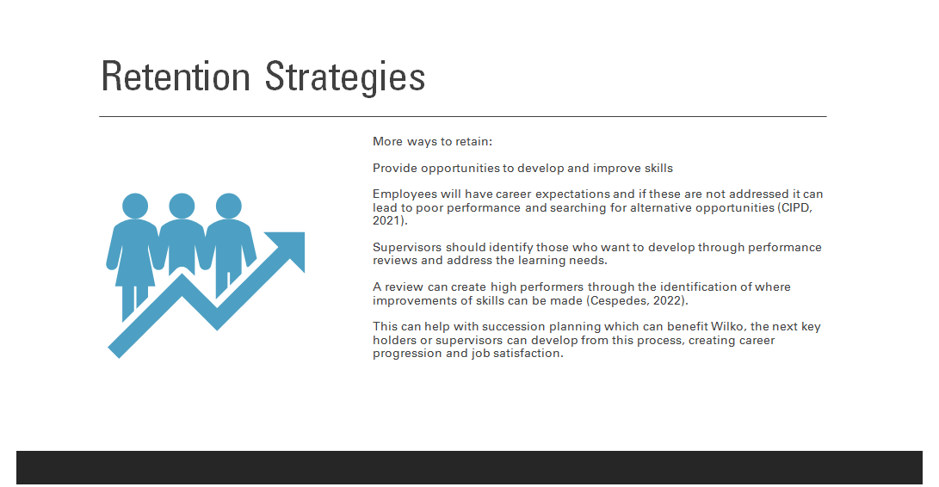
Another way to retain employees is through providing them with opportunities to develop and improve their skills. Employees will have career expectations, if these are not being addressed then it can lead to poorer performance and looking for opportunities elsewhere (CIPD, 2021). Identifying those who want to develop can be done through performance reviews, addressing what it is the employee wants to learn and how to implement this. Cespedes (2022) comments that a review can create high performers through the identification of where improvements of skills can be made. This can help with succession planning for the organisation also, where the next key holders or supervisors can be developed as a result.

Slide 10:
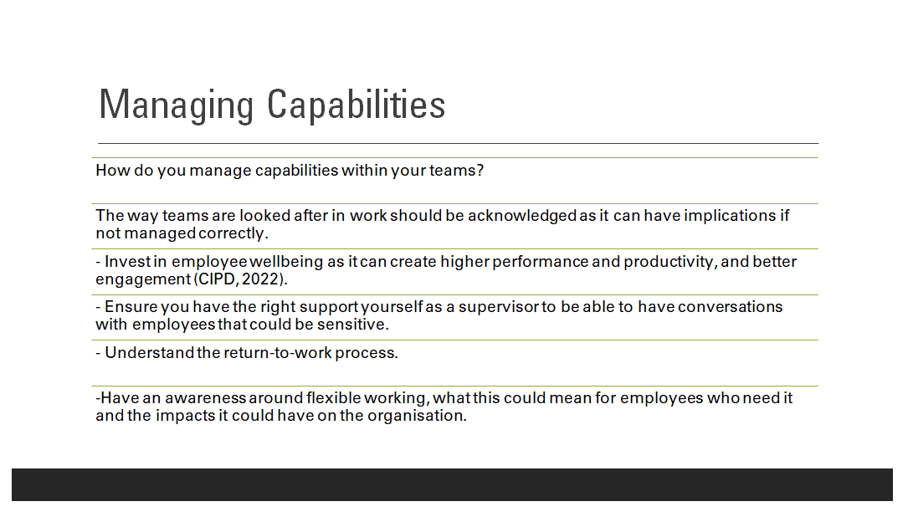
Before covering the information, the supervisors would be asked if they currently do anything in their roles to manage the capabilities within their teams? This would provide various answers as the supervisors will come across different capabilities and levels of performance as they manage different teams, for example, an evening delivery team and a shopfloor team.
To have a positive impact on the organisation through performance, the way in which our teams are looked after at work has to be addressed as this can have implications if not managed correctly.
Through having an organisation that invests in employee wellbeing, it can create better employee engagement, and increased performance and productivity (CIPD, 2022). Wilko does provide access to free health and mental health helplines for its employees; however, leadership teams could use better wellbeing initiatives to support employees. Line managers must have the right support themselves to be able to have potentially sensitive conversations with employees to make sure they can guide them to the right help if needed.
The absence management strategy should be known by supervisors so that they are able to deal with employee absence when it occurs. The return-to-work process at each stage should be understood and ensured that it is completed when an employee returns. This will make sure that the employee is fit to return, to see if any support is needed, and consider an occupational health referral depending on the circumstances (Acas, 2023). Any support that an employee needs to conduct their job role after returning from an absence should be put in place by the supervisors as this will help the employee to stay in work instead of off absent, this will benefit the overall performance of the organisation as a result.
Additionally, Wilko could adopt a flexible working policy whereby employees are able to work in a way that suits their needs, for example flexible start and finish times or set working days. This is a current changing process with more employees than ever wanting flexible work and as a result the creation of the Employment Relations (Flexible Working) Bill in 2022 (Morrall and Smout, 2023). This could encourage more parents who need school hours to apply for job roles, who potentially would help the organisation with their skills, if flexible working was adopted, creating a larger talent pool. M&S has created a flexible working policy for its store managers through job share, compressed hours, and parttime availability (Findlater, 2022), which can be argued that if this can be done for organisational leaders, why can it not be done for all employees? However, due to the nature of retail and needing numerous shift patterns to be covered, it could be difficult to have a team where there are many employees working on a flexible basis.
Slide 11:
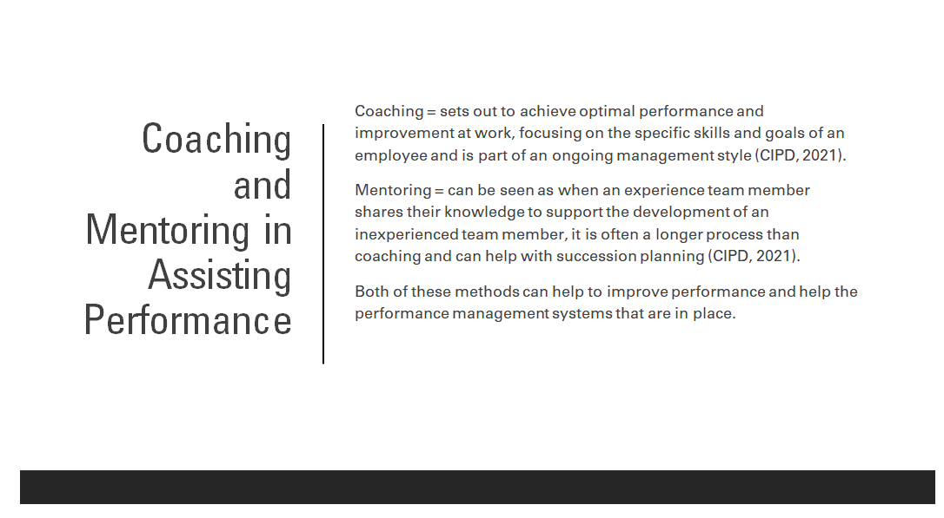
Coaching sets out to achieve optimal performance and improvement at work, focusing on the specific skills and goals of an employee and is part of an ongoing management style (CIPD, 2021).
Mentoring can be seen as when an experience team member shares their knowledge to support the development of an inexperienced team member, it is often a longer process than coaching and can help with succession planning (CIPD, 2021).
Both methods can help to improve performance and help the performance management systems that are in place. These can help employee performance over a period as some employees do work hard but do not have the capabilities to improve on their own (Cespedes, 2022), therefore identifying that coaching or mentoring could be the appropriate way to resolve this.
This can be applied practically to a team member who is already a key holder but would like to progress to a supervisor level. The team supervisor, as their line manager would be able to coach them through this development and what they need to do to achieve this.
Slide 12:
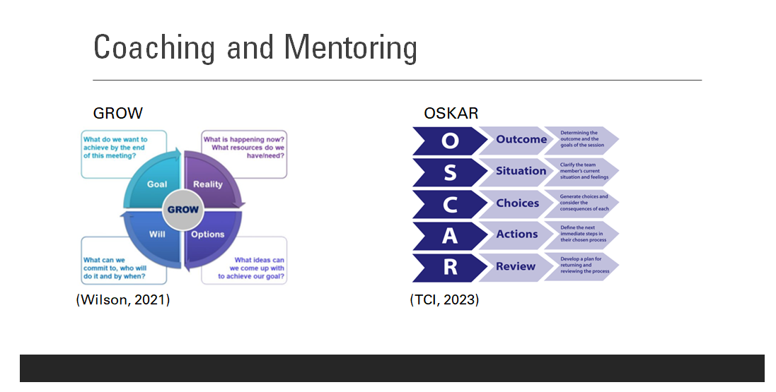
The GROW model of coaching is something that can be used in conversations, meetings and day-to-day leadership to help drive employee performance (Wilson, 2022). This is a simple model that supervisors can apply to performance management conversations without undertaking a specific course to provide coaching. There are four key stages to the model:
G- goals and aspirations
R- current situation
O- options/obstacles
W- way forward
It has been argued however that this model is limited in what it can provide and needs more depth to the stages, considering further factors than the four that are set out (Bishop, 2016). Additionally, the model can be said to be too rigid, with there not being the need to cover some of the stages with certain employees who are already at a different stage with their coaching (Lucas, 2015). Although this model overall is a good starting point for supervisors to start coaching conversations.
Another model that can be used is the OSKAR model and this builds on the previous GROW model, it focuses on solutions rather than the problems being identified. It is most effective for providing a framework on reaching action milestones and is more suitable for longer-term coaching (Pearce and Patent, 2021).
The stages of the model are:
O- outcome
S- scale
K- know-how
A– affirm and action
R- review
The benefit of using this model is that it is collaborative with the employee being coached, it looks at what they want, and feel is achievable but also ensures that as a line manager, you get the outcome that is desired (Mind Tools, 2023). It is also a motivating method of coaching which can provide intrinsic reward for employees, which is an aspect desired by higher performers (Cespedes, 2022). This can ensure that they are performing well, benefitting the organisation.
However, there is the possibility of overanalysing the aspects that the employee needs to improve, taking away from the positives that they have achieved, which could impact their performance negatively (Passmore and Sinclair, 2020).
Slide 13: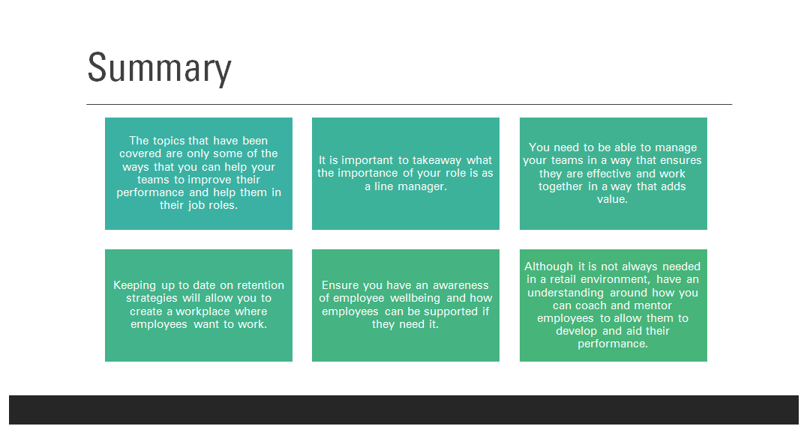

Slide 14:

Slide 15-18:
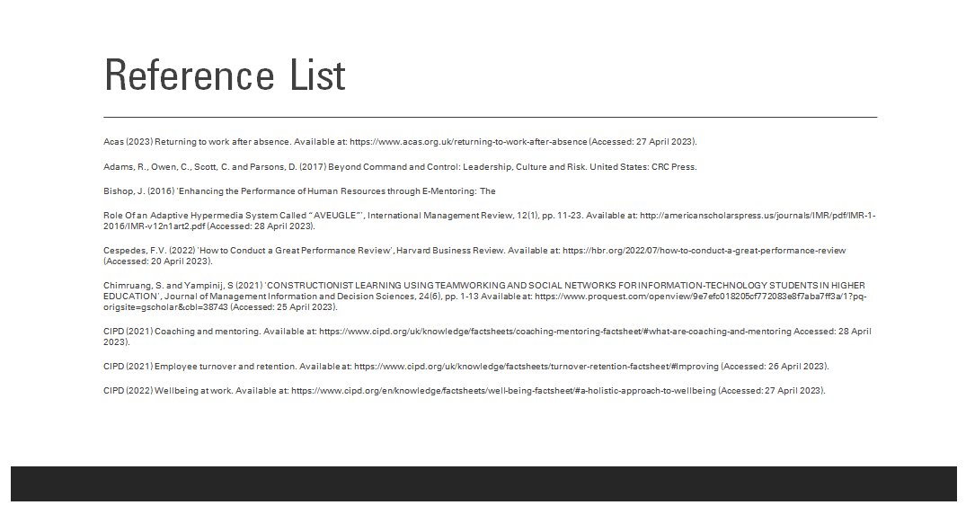





Reference List:
Acas (2023) Returning to work after absence. Available at: https://www.acas.org.uk/returning-to-work-after-absence (Accessed: 27 April 2023).
Adams, R., Owen, C., Scott, C. and Parsons, D. (2017) Beyond Command and Control: Leadership, Culture and Risk. United States: CRC Press.
Bishop, J. (2016) 'Enhancing the Performance of Human Resources through E-Mentoring: The
Role Of an Adaptive Hypermedia System Called “AVEUGLE”', International Management Review, 12(1), pp. 11-23. Available at: http://americanscholarspress.us/journals/IMR/pdf/IMR-1-2016/IMR-v12n1art2.pdf (Accessed: 28 April 2023).
Cespedes, F.V. (2022) 'How to Conduct a Great Performance Review', Harvard Business Review. Available at: https://hbr.org/2022/07/how-to-conduct-a-great-performance-review (Accessed: 20 April 2023).
Chimruang, S. and Yampinij, S (2021) 'CONSTRUCTIONIST LEARNING USING TEAMWORKING AND SOCIAL NETWORKS FOR INFORMATION-TECHNOLOGY STUDENTS IN HIGHER EDUCATION', Journal of Management Information and Decision Sciences, 24(6), pp. 1-13 Available at: https://www.proquest.com/openview/9e7efc018205cf772083e8f7aba7ff3a/1?pq-origsite=gscholar&cbl=38743 (Accessed: 25 April 2023).
CIPD (2021) Coaching and mentoring. Available at: https://www.cipd.org/uk/knowledge/factsheets/coaching-mentoring-factsheet/#what-are-coaching-and-mentoring Accessed: 28 April 2023).
CIPD (2021) Employee turnover and retention. Available at: https://www.cipd.org/uk/knowledge/factsheets/turnover-retention-factsheet/#Improving (Accessed: 26 April 2023).
CIPD (2022) Wellbeing at work. Available at: https://www.cipd.org/en/knowledge/factsheets/well-being-factsheet/#a-holistic-approach-to-wellbeing (Accessed: 27 April 2023).
CIPD (2022) Line managers' role in supporting the people profession. Available at: https://www.cipd.org/uk/knowledge/factsheets/line-managers-factsheet/#:~:text=Line%20managers%20have%20responsibility%20for,of%20those%20employees%20or%20teams. (Accessed: 25 April 2023).
Findlater, S. (2022) Worklife: Our new flexible working offering Available at: https://corporate.marksandspencer.com/worklife-our-new-flexible-working-offering (Accessed: 27 April 2023).
Gallo, A. (2023) ‘What Is Psychological Safety?’, Harvard Business Review. Available at: https://hbr.org/2023/02/what-is-psychological-safety (Accessed: 25 April 2023).
Google re:Works Team (no date) Guide: Understand team effectiveness. Available at: https://rework.withgoogle.com/guides/understanding-team-effectiveness/steps/introduction/ (Accessed: 26 April 2023).
Kiweewa, J.M., Gilbride, D., Luke, M. and Clingerman, T. (2018) 'Tracking Growth Factors in Experiential Training Groups Through Tuckman’s Conceptual Model', The Journal for Specialists in Group Work, 43(3), pp. 274-296. Available at: https://doi.org/10.1080/01933922.2018.1484539
Larson, L. and DeChruch, L.A. (2020) 'Leading teams in the digital age: Four perspectives on technology and what they mean for leading teams', The Leadership Quarterly, 31(1), pp. 1-18. Available at: https://doi.org/10.1016/j.leaqua.2019.101377
LinkedIn (2022) What is an Exit Interview and How to Handle One. Available at: https://www.linkedin.com/pulse/what-exit-interview-how-handle-one-get-ahead-by-linkedin-news (Accessed: 26 April 2023).
Lucas, M. (2015) Coaching – using the GROW model - love it or hate it? Available at: https://www.linkedin.com/pulse/coaching-using-grow-model-love-hate-michelle-lucas (Accessed: 28 April 2023)
Moradi-Korejan, M. and Shahbazi, H. (2016) 'An analysis of transformational leadership theory', Journal of Fundamental and Applied Sciences, 8(3), pp. 452-461. Available at: https://doi.org/10.4314/jfas.v8i3s.192
Morrall, S. and Smout, S. (2023) Flexible working: the new rules. Available at: https://www.peoplemanagement.co.uk/article/1811683/flexible-working-new-rules (Accessed: 27 April 2023).
Natvig, D. and Stark, N.L. (2016) 'A Project Team Analysis Using Tuckman's Model of Small-Group Development', Journal of Nursing Education, 55(12), pp. 675-681. Available at: https://doi.org/10.3928/01484834-20161114-03
Passmore, J. and Sinclair, T. (2020) Becoming a Coach. Available at: https://link.springer.com/book/10.1007/978-3-030-53161-4 (Accessed: 28 April 2023).
Pearce, A. and Patent, V. (2021) Everyone Can Learn to Coach! Coaching with the OSCAR Model. Available at: https://www.open.edu/openlearn/health-sports-psychology/psychology/everyone-can-learn-coach-coaching-the-oscar-model (Accessed: 28 April 2023).
Spain, E. and Groysberg, B. (2016). ‘Making Exit Interviews Count’, Harvard Business Review. Available at: https://hbr.org/2016/04/making-exit-interviews-count (Accessed: 26 April 2023).
TCI (2023) Different Coaching Models. Available at: https://tciurbanhealth.org/courses/coaching-essentials/lessons/different-coaching-models/ (Accessed: 28 April 2023)
Thomas, J. (2019) Retaining talent with leadership that cares. Available at: https://www.hrmagazine.co.uk/content/features/retaining-talent-with-leadership-that-cares (Accessed: 26 April 2023).
West Chester University (2022) TUCKMAN'S STAGES OF GROUP DEVELOPMENT. Available at: https://www.wcupa.edu/coral/tuckmanStagesGroupDelvelopment.aspx#:~:text=These%20stages%20are%20commonly%20known,more%20collaborative%20or%20shared%20leadership. (Accessed: 25 April 2023).
Willmore, Y. (2019) Is the latest technology the key to your team’s success, or is there something else? Available at: https://devblogs.microsoft.com/premier-developer/is-the-latest-technology-the-key-to-your-teams-success-or-is-there-something-else/ (Accessed: 28 April 2023).
Wilson, C. (2022) The GROW Model. Available at: https://www.coachingcultureatwork.com/the-grow-model/ Accessed: 28 April 2023).
Wuryani, E., Rodlib, A., Sutarsib, S., Dewib, N. and Arifb, D. (2021) 'Analysis of decision support system on situational leadership styles on work motivation and employee performance', Management Science Letters, 11(2), pp. 365-372. Available at: http://dx.doi.org/10.5267/j.msl.2020.9.033

Task 2: Report for HR manager
Word count: 1618
Rebecca Carruthers 1802066

Performance Management: the Effectiveness of Performance Appraisals
Executive Summary
The organisation that is being referred to in this report is Wilko. The organisation conducts employee reviews on an annual basis and involves the store supervisors conducting the appraisals for the employees, whilst the store manager conducts the supervisor appraisals. The report looks at some the types of performance management approaches that are available for organisations to use and the impacts that they can have. It also covers the debate on the overall value of performance appraisals and the alternative to using the traditional appraisal approach. The report provides a recommendation for the organisation as to how it should progress with the performance management system that is currently being used.
Introduction
Performance appraisals form a part of the broader element of performance management, they can be used to discuss administrative aspects of the workplace such as rates of pay or redundancies and can be used to help develop professional growth and improvement (CIPD, 2022). There has been a debate about the effectiveness of this type of performance management, and that potentially more informal approaches should be considered as an alternative. However, it is still a key factor within the performance management cycle which offers a continuous sequence of activities that managers can use to feedback to employees on their performance (Mone, 2018). Within Wilko, the way in which performance appraisals are undertaken need to be assessed to see if they are effective, for both the employees and managers, and what can be done to improve the process.

Main Findings
Performance management approaches:
The table below highlights some of the performance management approaches that can be used and the impacts that they can have.
Approach | Key points | Impact
Punitive | This approach focuses on punishing employees when they have not performed as managers would have liked, low performers are more often punished creating a bias from managers in the appraisal (Yu et al., 2021). Managers could have certain likes and dislikes about employees, and this can affect the appraisal given.  The ways employees are punished can include trying to remove incentives or reducing hours of work for example. However, this should not be done as it could lead to constructive dismissal (KYC, no date). | The impact of using this approach has little benefit. It can limit the growth of employees as punishment will not make an employee actively put in more effort to improve, as the negatives have been focused upon (Franco-Santos and Otley, 2018).  Additionally, it will create a negative association with performance appraisals as employees may fear having not performed well and then receiving some form of discipline (Franco-Santos and Otley, 2018). This can also limit relationships between the employees and supervisors as a result.
Collaborative | This approach looks at how employees are performing as a collective and working towards an overall formal performance goal (Choi and Moynihan, 2019). This can be seen as a trend of moving away from individual performance management into the collaborative approach.  It encourages active participation and opinions from management and employees to help achieve goals set together (Indeed, 2022). | This process provides continual feedback to all members of the team due to managers, supervisors and employees working together (Indeed, 2022). As a result of this, all areas can perform to their best ability and make improvements to the process at a faster rate due to the continual feedback, when compared to annual appraisals.  However, this involvement of employees in setting targets does not agree with the trend identified by the CIPD (2017), which challenges the need for employees to be involved.
Reward | This approach can provide employees with intrinsic or extrinsic rewards. These can be financial payments based upon performance or the satisfaction received from performing the job role, a sense of contribution (ACCA, 2022). The reward system that is used should support the goals of the organisation and be consistent with the strategy. | The impact of this approach is that it can be simple to apply in organisations that have data that can be monitored with employee performance, such as KPIs. However, in organisations whereby one manager is conducting an appraisal, it can be difficult to use for the issue of bias (CIPD, 2022).  It can be a difficult approach to use as the system aims to influence human behaviour (ACCA, 2022). Although this is a good method of motivating employees to improve performance, both financial and non-financial rewards.

The value of appraisals:
The value of appraisals has become a debated topic, with Cespedes (2022) commenting that from the perspective of the employees, appraisals are non-existent or unfair, creating attitudes and a defensive approach taken towards future performance meetings. In addition to this, it has been said that appraisals that try to formally rate employees do not seem to improve employee performance or create a competitive advantage (Pulakos et al., 2019). This is a clear feature within Wilko as employee appraisals conducted by the supervisors give employees a ranking from one to five on different performance aspects and competencies. If no further development is taken from these ratings, it could be seen that these are simply HR exercise that must be completed, agreeing with the statement made by Pulakos et al. (2019) that appraisals have become a tick box process. Whilst appraisals are undertaken to look at performance, there has been no creation of a rating system that can clearly identify the high performers versus the low performers (Woolston, 2019). Therefore, the case is made against the validity of appraisals if there is no set metric that will benefit the employees and their performance.
However, it can be argued that using appraisals that are the same throughout the organisation provides an insight into performance levels across the workplace (Brown et al., 2019), this can then highlight any problem areas and allow for action to be taken to resolve these issues based on this data. This can be seen within the stores at Wilko, as store statistics are published per region that show employee performance and engagement. The highest performing stores can then feedback their performance data and what is working well to create shared learning for other stores that need to improve.
When performance appraisals are conducted correctly, they can reward and motivate employees through recognition of their work in the feedback provided, creating skill development opportunities, and career progression guidance (Armstrong, 2019). If employees are prepared for the appraisal and know what it is going to consist of, they will feel more at ease about potentially difficult conversations. This agrees with the points made by Cespedes (2022) that mention making it clear to the employees what the standards by which their performance will be judged and what is expected. At present, this is not something that Wilko as an organisation does, the employees are not aware of what is going to be discussed in the appraisal which could create some form of anxiety about the process.
Although it has been argued that performance reviews can improve employee performance and give managers a structure for having necessary conversations with their employees (Cespedes, 2022), some organisations have removed performance appraisals from their HR strategy. Annual performance appraisals are a part of how employees at Wilko are assessed and this is done through a rating system discussed with the supervisors in a formal discussion. However, IBM have redesigned their performance management method that allows employees to have control over their development through check-ins, feedback requests and goal setting (Bloznalis, 2021). This removes the formality of the performance appraisal and allows employee development that is relevant to them, unlike an appraisal system that forces employees to fit into the model used.
The change that IBM have made to their performance management approach is in line with the trend of performance appraisals should be done more continually (CIPD, 2017), and not once a year whereby the points made to the employee are not worked upon and left until the next appraisal the following year. By doing this, the smaller check-ins with the employees calls for continuous development to be made, creating value in the conversations being had.
People professionals:
The use of people professionals as business partners could allow for innovative approaches to be used if the organisation decided to implement a different performance management system. They can provide their level of people expertise to provide guidance for managers when implementing people approaches (CIPD, 2023). This can help to ensure that managers get the process right and it is beneficial to the employees’ development and motivation.
These professionals can also introduce models of influence such as McKinsey's change management model. This can help to navigate the way that people, processes and outcomes when an organisation introduces a change that is completely different to the previous method used (Galli, 2018). This can be beneficial if alterations were implemented to the way the organisation conducts performance appraisals as there would be a model to follow that can support the change process.
Conclusion
In conclusion, the value of performance appraisals can be seen when they are undertaken in the correct way and add value to an employee’s performance (Bloznalis, 2021). However, the change that is being seen is that annual appraisals are being transformed into ongoing performance conversations with employees to ensure they are on track with their own development and goals, not only what the organisation set out to check in earlier ‘tick box exercise’ approaches. Therefore, there is still value in appraisals, they are simply being approached in a different way that benefits the employee, line manager, and organisation.
Recommendation
After reviewing the value of appraisals and the approaches that can be taken, a recommendation has the been generated for the organisation.
It would be recommended to move away from the annual employee appraisal that is currently being used. Instead, Wilko should conduct ongoing performance conversations that can keep employees on track with their development throughout the year. This is especially beneficial to the employees who want to progress their career as they will receive constant feedback on their performance. However, training will need to be provided to the supervisors to ensure that they conduct meaningful reviews that can motivate the employees and help to improve the organisation’s performance through the performance of the employees.
Wilko will have to ensure that the HR department allow for this training and that stores are able to commit time to the employees to have these more frequent performance conversations.

Reference List
ACCA (2022). Reward schemes for employees and management. Available at: https://www.accaglobal.com/gb/en/student/exam-support-resources/professional-exams-study-resources/p5/technical-articles/reward-schemes-for-employees-and-management.html (Accessed: 18 April 2023).
Armstrong, M. (2019) Armstrong's Handbook of Reward Management Practice: Improving Performance Through Reward. Kogan Page.
Bloznalis, S. (2021) Driving a Cultural Transformation: IBM’s Performance Development Journey. Available at: https://www.workhuman.com/blog/driving-a-cultural-transformation-ibm-s-performance-development-journey/ (Accessed: 22 April 2023).
Brown, T. C., O'Kane, P., and McCracken, M. (2019) 'Performance Management: A Scoping Review of the Literature and an Agenda for Future Research', Human Resource Development Review, 18(1), pp. 47-82. Available at: https://doi.org/10.1177/1534484318798533
Cespedes, F. V. (2022) 'How to Conduct a Great Performance Review', Harvard Business Review, (8 July). Available at: https://hbr.org/2022/07/how-to-conduct-a-great-performance-review (Accessed: 20 April 2023).
Choi, I. and Moynihan, D. (2019) 'How to foster collaborative performance management? Key factors in the US federal agencies', Public Management Review, 21(10), pp. 1538-1559. Available at: https://doi.org/10.1080/14719037.2019.1571275
CIPD (2017). Changing trends in performance management. 19 July. Available at: https://www.youtube.com/watch?v=PfXEceZzND0 (Accessed: 22 April 2023).
CIPD (2022) Performance reviews. Available at: https://www.cipd.org/uk/knowledge/factsheets/appraisals-factsheet/#The (Accessed: 20 April 2023).
CIPD (2022) Making reward more accessible and performance management fairer
Available at: https://www.cipd.org/uk/views-and-insights/thought-leadership/insight/reward-performance-management/ (Accessed: 18 April 2023).
CIPD (2023) HR Business Partner Roles. Available at: https://www.cipd.org/uk/the-people-profession/careers/roles/hr-business-partner/#:~:text=Influencing%20and%20building%20relationships%20with,of%20people%20and%20business%20issues (Accessed: 23 April 2023).
Franco-Santos, M. and Otley, D. (2018) 'Reviewing and Theorizing the Unintended Consequences of Performance Management Systems', International Journal of Management Reviews, 20(1), pp. 696-730. Available at: https://doi.org/10.1111/ijmr.12183
Galli, B. J. (2018). ‘Change Management Models: A Comparative Analysis and Concerns’ IEEE Engineering Management Review, 46(3), pp. 124-132. Available at: https://doi.org/10.1109/EMR.2018.2866860
Indeed (2022) Collaborative Management: Characteristics and Processes. Available at: https://www.indeed.com/career-advice/career-development/collaborative-management#:~:text=Collaborative%20management%20promotes%20a%20high,to%20succeed%20in%20their%20efforts. (Accessed: 18 April 2023).
KYC (no date) Discipline in the Workplace. Available at: https://www.kcyatlaw.ca/discipline-in-the-workplace/ (Accessed: 18 April 2023).
Mone, E. M. (2018) Employee Engagement Through Effective Performance Management: A Practical Guide For Managers. Routledge.
Pulakos, E. D., Handson, R. and Arad, S. (2019) 'The Evolution of Performance Management: Searching for Value', Annual Review of Organizational Psychology and Organizational Behavior, 6(1), pp. 249-271. Available at: http://dx.doi.org/10.1146/annurev-orgpsych-012218-015009
Woolston, C. (2019) Why appraisals are pointless for most people. Available at: https://www.bbc.com/worklife/article/20190501-why-appraisals-are-pointless-for-most-people#:~:text=The%20growing%20body%20of%20research%20questioning%20the%20value,at%20times%20fanfared%20in%20press%20releases%20and%20headlines. (Accessed: 20 April 2023).
Yu, S., Yoo, E. J. and Kim, S. (2021) 'The effects of performance evaluation on punishment in organisations', International Review of Administrative Sciences, 89(2), pp. 484-500. Available at: https://doi.org/10.1177/00208523211043362

