Alina Culea (1918156)

Professional Career Development
REFLECTIVE REPORT

Table of Contents

1. INTRODUCTION 2
2. Self-awareness – theory and reflection 3
3. Career Development 10
4. Conclusion 12
5. REFERENCES 13
6. APPENDICES 15

- INTRODUCTION

I have always wanted to study abroad, unfortunately, my possibilities were limited at that moment. By doing this course now, is like a dream come true for me, which I am grateful for and this is one of the main reasons that I will do my best to succeed and to put in practice everything that I have learned. I must admit that I already knew some information and had some previous experience with the Smart Goal and the Swot Analysis, but everything else – the Gibbs’s Learning Cycle, the Johari Window, the VARK questionnaire, the Honey & Mumford questionnaire and the Personal Development Plan were new and exciting things to learn.
My report will represent my reflection over myself, with a sparkle of theory along the way, just to prove some of my points. I will go through everything step by step. I will start by doing an analyse over myself using all the tools mentioned, because I need to know myself better so that the second part will be easier to put in practice. The second part of my reflection will be about my Smart goal and my Personal Development Plan.
The purpose of this report is to help me become more self-aware, because I truly struggle with this, and to help me find a better path for my career in a new country. In other words, this report is a fresh start for me.

- Self-awareness – theory and reflection

In this chapter I will analyse myself in depth, revealing some facts that I also did not know about myself, with the help of theory and personal experiences.
Firstly, I want to know what my strengths and my weaknesses are, and the perfect tool for this is the SWOT Analysis.
SWOT represents an acronym for Strengths, Weaknesses, Opportunities and Threats. It is an international used tool, perfect for a situation where a decision must be made. Firstly, it is divided in 2 big categories – internal and external – each of them divided in another two. For the internal part, there is Strengths and Weaknesses, which are directly linked to the individual or the company. On the contrary, the external part, which is divided in Opportunities and Threats, is represented by the outside factors, that are not coming from the individual or the company, but from the outside world (The SWOT Analysis: A key tool for developing your business strategy, 2015, p.6).
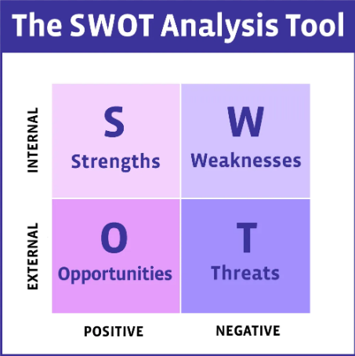
Figure 1. The SWOT Analysis Tool
My personal SWOT Analysis is represented in the table below:

Strengths  - Determination  - Organised  - Fast learner  - Passion for helping others  - Critical Thinking  - Humble  - Support from family  - Independent  - Perfectionist. | Weaknesses  - Time Management  - Lazy  - I get bored fast  - Too sensitive  - Too proud  - Pessimist  - I hardly accept the criticism  - Self-awareness  - Public speaking.
Opportunities  - Work from home jobs  - The certificate of Level 4 in Higher Education: Skills for the Workplace  - Possibility to learn further for Level 5 and above  - Academic career. | Threats  - No vacancies left  - Not enough money  - Economic crisis  - Pandemic  - My scholarship will not be approved.

It was challenging for me to come up with a proper SWOT Analysis because I am not too self-aware, and I usually tend to underestimate myself. It took me a lot of practice and time to be able to look at myself from an objective point of view, but in the end, I managed to succeed.
The second part of my reflection is represented by the Johari Window. This is one of the most used tools for personal development and self-awareness. It was developed by Joseph Luft and Harry Ingham in 1950, and it is still successfully used nowadays. The Johari Window has 4 perspectives:
- Open area – that represents what is known by the person about herself and it is also known by others.
- Blind area – that represents what is unknown by the person about herself, but it is known by others.
- Hidden area – that represent what is known by the person about herself, but it is unknown for others.
- Unknown area – that represent what is unknown by the person about herself and it is also unknown by others (Luft, 2014, p. 1).

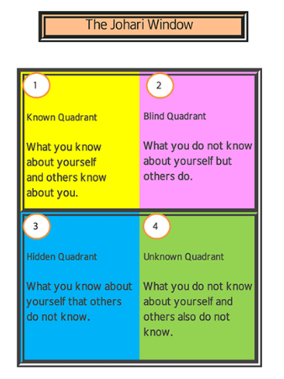
Figure 2. The Johari Window
My version of the Johari Window can be found in the table below, and for the Blind area I asked for thoughts from friends and family.
Open area  - I am friendly  - I am ambitious  - I am a perfectionist  - I have a passion for helping others  - I am too proud. | Blind area  - I have potential  - I am headstrong  - I get easily offended.
Hidden area  - I have a dark past  - I am sensitive  - I usually feel lonely  - I am stronger that it looks like. | Unknown area  - No one knows anything here.

It is hard for me to open up, that is the reason why I keep more serious thing in my hidden area. I prefer that people can know me as a friendly person who is always there, instead of an insecure person that need approval most of the time.
The next stage of my reflection is the Gibbs’s Learning Cycle. I chose to do my reflective report using Gibbs’ Reflective Cycle (1988) because I feel like it is more suitable for me in comparison with Kolb’s Model (1984), because I usually trust my feelings and they represent an important part of me, and also because this method push me to think more in depth and pay attention to a lot more details. The Gibbs’s Reflective Cycle from 1988 is a commonly used reflective tool that gives the possibility to do an in-depth reflection over an experience and describe it in 6 stages: Description, Feelings, Evaluation, Analysis, Conclusion and Action Plan (Gibbs, 2013, p. 22).
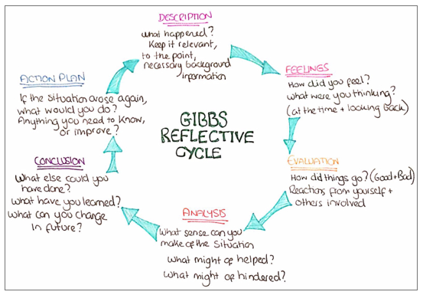
Figure 3. Gibbs Reflective Cycle
- DESCRIPTION

A few years ago, I made the difficult decision to leave my hometown to go study in the capital of Romania, Bucharest. My decision was based on how the things were in my family and how depressed I was. The only way to escape was to move to another city and start again from 0.
- FEELINGS
Looking back, I remember that I felt relieved when I moved out from my town. I have never felt freer. I was thinking that I will never go back to where I used to live and that I will always fight for my freedom and for my peace of mind. I was a bit scared to start being an ‚adult’ but eventually I managed to get used to the idea and actually enjoy it.
- EVALUATION
Life has a funny way to show us that not everything is pink. I managed to find a job, make friends and so on, but nothing was as I thought it was. I was indeed happy that I was free, but things got so bad at one moment. I did not have enough money to support myself and I spent almost two weeks without any money and barely any food. It was challenging. And the thing is that I did not told anyone about it. I just kept everything to myself because I wanted to prove to myself that I made the right decision. In my mind was that if I tell my family that something went wrong and I have difficult time, they will tell me that I did a mistake moving and they probably will call me home.
- ANALYSIS
It might have helped if I just asked for help from my friends and family. But looking back now, I feel that I did the right thing because it helped me grow and it made me realise a lot of things. It might have also helped if I would have taken the right decisions and not be so proud to recognise my failure.
- CONCLUSION
I have learned how to educate myself, how to be stronger and how to not let me down. I found out that I am good at finding solution, but I am not the best at taking decision. And I also found out that I am very determined to finish everything that I start.

- ACTION PLAN
First of all, I will never let myself be in that situation again. I have learned a lot about myself and I know that I will never go back in that moment. But if unfortunately, I will, this time I will ask for help and I will not do everything on my own because I am too proud to admit that I was wrong.

The final step of my analyse is the learning style. And the best effective way from where I can find what type of learner I am is by doing not one, but two questionnaires – VARK and Honey & Mumford.
- The VARK questionnaire:
The VARK questionnaire was developed in 1998 at the Lincoln University of New Zeeland and is represented by 3 principles:
- Everyone can learn, but just not the same.
- Each learned is motivated by his learning style.
- People can learn by utilising their senses and perceptions (J Clin Diagn Res, 2014).
The acronym VARK stands for Visual, Aural, Read/write and Kinaesthetic, which are the 4 types of learners. Visual means that a person learns better by looking at information through images and charts, Aural means that a person learns better by listening the information, Read/write means that a person learn better by reading or writing down the information and Kinaesthetic means that a person learns by experimenting in practice.
My result for the VARK questionnaire is like below:
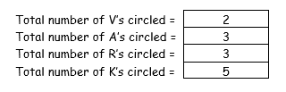
Figure 4. VARK questionnaire result

My result means that my type of learning is Kinaesthetic and that means that my best way to learn is to practice what I have learned, especially at work, I understand better if I do it by myself than if someone explain things to me.
- The Honey & Mumford questionnaire:

Peter Honey and Alan Mumford are the creators of the learning questionnaire with the same name. In 1986, they determined 4 learning styles:
- Activist – people who learn by doing.
- Reflector – people who learn by observing.
- Theorist – people who learn by understanding the theory behind the actions.
- Pragmatist – people who learn by experimenting new ideas.
My result for this questionnaire is:

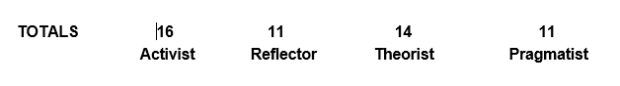
Figure 5. Honey & Mumford questionnaire result

My results say that I am mostly an Activist, and that means that I like to learn by doing thing. As the VARK questionnaire, this questionnaire was also accurate, showing exactly the type of learner that I am.

- Career Development

After I have done a reflection over myself, I have found out many useful things. First of all, with the help of the SWOT analysis, I have found out what are my strengths and weaknesses, opportunities, and threats. Next, with the help of the Johari Window, I got to know how others see me, and also what I hide from others. Additionally, with the Gibbs’s Learning Cycle, I described and analysed an important event from my life. Finally, with the VARK questionnaire and the Honey & Mumford questionnaire, I have found out that the best way for me to learn is by practice.
The next step that I have to do now that I gathered all the information that I need about myself, is to put them in practice and set up a SMART goal and create a Personal Development Plan to help me further in my career.
The difference between a goal and a SMART goal is made by all the meaning of the acronym: Specific, Measurable, Achievable, Relevant and Timely. Specific means that the goal must be clear, with as many details as possible. Measurable means that the goal must have indicators to show exactly when it will be achieved. Achievable means that the goal must be representative for the opportunities available. Relevant means that the goal must be achieved with the resources available. Timely means that the goal must have a specific date until can be achieved, and also, if possible, review dates (University of Glasgow, 2015, p.6).
My goal is to become a university teacher in the next 7 years, by achieving my bachelor’s degree and a teacher qualification, followed by a master and a PHD. The employability skills that I must develop during this time are public speaking, self-awareness, and time management.
My goal is SMART because is:
- Specific: ‘become a university teacher’.
- Measurable: ‘by achieving my bachelor’s degree and a teacher qualification, follow by a master and a PHD. The employability skills that I must develop … are public speaking, self-awareness and time management’.
- Achievable: I already started the courses at the University of Wales Trinity Saint David.
- Relevant: I need to develop my public speaking, self-awareness, and time management and then I will be more suitable for the job.
- Timely: My goal is due in 7 years from now, because I need to fully complete my studies.

The next and final step for my reflection is the Personal Development Plan. This is a tool used mostly by an individual or company when a goal or target must be reached, and is effective because it can also show the obstacles that might be encountered along the way, the date for review and gives space for constant feedback (Beausaert, 2011, p.19).

My Personal Development Plan is represented in the table below:
SKILL/BEHAVIOUR | ACTION NEEDED | RESOURCES NEEDED | DATE FOR ACTION | DATE FOR REVIEW
PUBLIC SPEAKING | Practice more public speaking, pe positive and engage with the audience. | Opportunities for me to speak in public and audience. | Every Monday and Tuesday at University. | The end of the first term.
SELF-AWARENESS | Perform daily self-reflection, practice meditation and write down my goals, plans and priorities. | Books about meditations, special apps for my phone and a journal. | Today. | Every 3 months.
TIME MANAGEMENT | TO-DO lists and learn how to say no. | Stephen Covey’s Time Management Matrix, Agenda Planner. | Today. | Every two weeks.
- Conclusion

After I have discovered myself with this project, I can honestly say that my self-awareness has grown a little. It was a needed exercise for me to find out my strengths and my opportunities, and now that I acknowledge them, I can focus more on my Personal Development Plan and how to transform some of my weaknesses in strengths. I have faced many challenges during this course, mostly to discover myself and admit out loud that I have made some wrong decisions, because being a proud person (maybe too proud for my own good) is complicated and it makes me to want to solve my problems alone and never require help.
This was a very interesting course, full of challenges for myself, but I have learn through reflection that I need to open myself more to people and that I need to focus more on my strengths and not on my weaknesses. I will, without doubt, put in practice everything that I have learned, because I truly feel like I have an opportunity to become who I want to be, and I will try my best to make it happen. I will integrate the Smart goal and the Swot Analysis in my life, and I will take it step by step and hopefully, after 7 years (or sooner), I will be able to become a university teacher.

- REFERENCES

- 50 Minutes (2015) The SWOT Analysis: A key tool for developing your business strategy (Management & Marketing). 50 Minutes Publisher.
- Beausaert, S. (2011) The use of Personal Development Plans in the workplace. Effects, purposes and supporting conditions. Maastricht: Datawyse.
- Broe, E. (2014) The Johari Window. Available at: http://richerexperiences.com/wp-content/uploads/2014/02/Johari-Window.pdf (Accessed: 08 June 2020).
- Cardiff Metropolitan University (2020) Reflective writing: Applying Gibbs’ (1988) Reflective Cycle. Available at: http://study.cardiffmet.ac.uk/AcSkills/Documents/Guides/AS_Guide_Reflective_writing_Gibbs.pdf (Accessed: 08 June 2020).
- Chapman, A. (2003) Johari Window. Available at: https://apps.cfli.wisc.edu/johari/support/JohariExplainChapman2003.pdf (Accessed: 08 June 2020).
- Clin Diagn Res, J. (2014) Using VARK Approach for Assessing Preferred Learning Styles of First Year Medical Sciences Students: A Survey from Iran. Available at: https://www.ncbi.nlm.nih.gov/pmc/articles/PMC4190729/ (Accessed: 09 June 2020).
- Elearn (2009) Managing Yourself. 2nd Ed. Hungary: Elsevier Ltd.
- Gibbs, G. (2013) Learning by Doing. 2nd Ed. Oxford: Oxford Centre for Staff and Learning Development.
- Manchester Metropolitan University (2018) Applying the Gibbs’ Reflective Model. Available at: https://www.mmu.ac.uk/media/mmuacuk/content/documents/careers/Applying-the-Gibbs-Model-2018.pdf (Accessed: 08 June 2020).
- Quigley, K. (2016) The Johari Window [Figure]. Available at: https://glister.uk.com/the-johari-window/ (Accessed: 08 June 2020).
- Rosewell, J. (2005) Learning Styles. Available at: https://www.open.edu/openlearn/ocw/pluginfile.php/629607/mod_resource/content/1/t175_4_3.pdf (Accessed: 09 June 2020).
- The Coaching Tool Company (2013) Coaching Tools 101: What, How and When to Use SWOT Analysis! (for Strengths & More) [Figure]. Available at: https://www.thecoachingtoolscompany.com/what-is-a-swot-analysis-everything-you-need-to-know/ (Accessed: 07 June 2020).
- University of Glasgow (2015) Guide to Writing SMART Objectives. Available at: https://www.gla.ac.uk/media/Media_454985_smxx.pdf (Accessed: 10 June 2020).

- APPENDICES

- The VARK questionnaire:

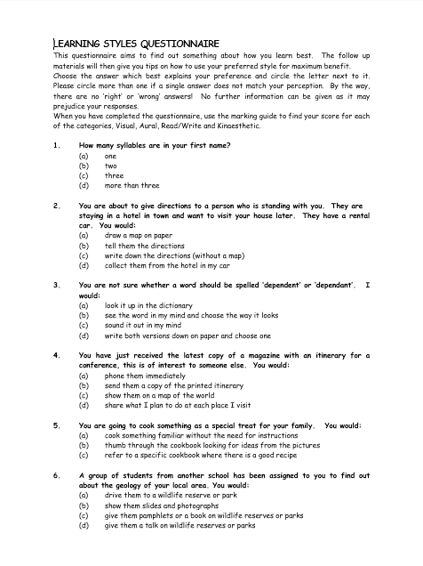

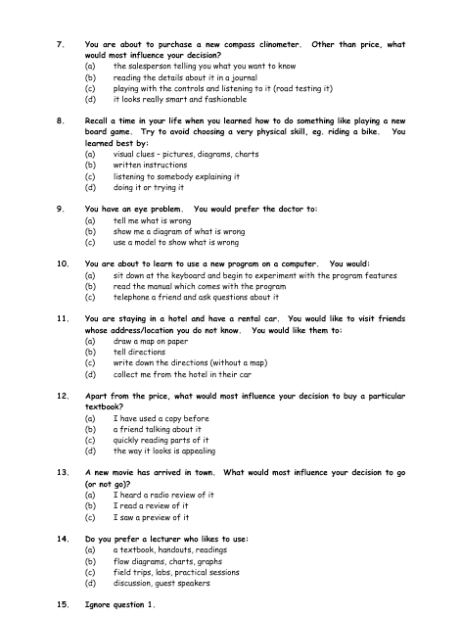

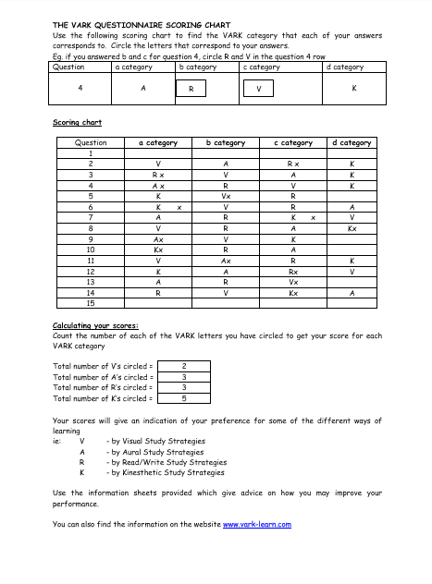
- The Honey & Mumford questionnaire:


