BA Leadership and Management
Coaching and Mentoring Skills for the Workplace
BMSW6105 - Task 3 – Written Reflection
Simona Pacuraru 2126931

Introduction
This reflective report examines my practical engagement with coaching and mentoring, applying Schön's (1983) reflective practice model to critically evaluate my experiences. Coaching is a structured developmental process aimed at enhancing performance and fostering personal growth through solution-focused dialogues (Ibarra and Scoular, 2019). Mentoring, in contrast, provides long-term guidance, support, and career development through relational exchanges (Zachary, 2019). While coaching often focuses on specific performance targets, mentoring facilitates broader professional and personal growth through experiential learning and information exchange (Kram and Ragins, 2007). According to Passmore (2021), effective coaching relies on active listening, powerful questioning, constructive feedback, and clearly defined goals. Successful mentoring, on the other hand, requires interpersonal skills, trust, and shared experience (Allen and Eby, 2007). In this report, I critically evaluate the GROW coaching model (Whitmore, 2017) and the Johari Window mentoring model (Luft and Ingham, 1955), reflecting on my participation and learning outcomes.

Coaching and Mentoring in the Workplace
Coaching and mentoring significantly contribute to organisational success by enhancing individual performance and personal growth (Allen and Eby, 2007). Coaching enables rapid performance improvement, goal alignment, and structured problem-solving, particularly through models like GROW (Whitmore, 2017). Mentoring, on the other hand, fosters leadership development, career progression, and organisational resilience (Zachary, 2019).
While coaching provides immediate benefits, mentoring supports long-term professional growth. According to Passmore (2021), coaching enhances productivity by setting clear objectives, while mentoring aids in succession planning, organisational adaptability, and staff retention through trust-based relationships (Kram and Ragins, 2007). The combination of both approaches helps organisations balance short-term performance gains with long-term leadership development (Ibarra and Scoular, 2019). According to Allen and Eby (2007), coaching and mentoring are two of the most important factors that contribute to the overall success of businesses through their ability to enhance the performance of individuals in the workplace, the personal growth of workers, and the overall success of enterprises. When it comes to offering help for the general running of businesses, these components are an essential requirement that requires immediate attention. According to Whitmore (2017), one of the reasons why coaching is beneficial to businesses is that it enables the rapid improvement of individual performance, the strengthening of goal alignment, and the resolution of performance-related difficulties through the utilisation of organised techniques such as the GROW model. This is just one of the many reasons why coaching is beneficial to businesses. One of the many reasons why coaching is valuable to organisations is because of just this. Coaching is beneficial to businesses for a multitude of reasons, and this is only one of the numerous explanations available to explain why coaching is beneficial. In order to effectively accomplish these advancements, the use of coaching as a technique of achieving anything was the means by which they were accomplished. When it comes to the development of leadership skills and the establishment of more robust relational connections among workers, Zachary (2019) asserts that mentoring is of significant assistance in both of these areas. He makes this statement due to the fact that, via mentorship, employees are able to develop stronger ties with one another. According to him, this is the case because mentoring gives employees the opportunity to strengthen their leadership abilities, which is the reason why this is the situation is the way it is. During the time when individuals are going through the process of transitioning through career changes, it offers aid to them, which contributes to the development of continued professional advancement. Moreover, there is an additional advantage that it provides.
According to Passmore (2021), the fact that coaching has a direct impact on production makes it advantageous to the organization's immediate objectives, which in turn makes it valuable to the company. This is because coaching has a direct influence on production. Due to the fact that coaching has a direct relationship with output, this is the case. Establishing clarity and alignment with regard to certain goals is one of the many ways that this advantage may be obtained. There are a number of other ways that this benefit can be obtained. According to Kram and Ragins (2007), some of the advantages that may be acquired from mentoring include the facilitation of long-term succession planning, the construction of organisational resilience, and the promotion of staff retention via trust-based developmental interactions. These are only some of the benefits that can be obtained. There are many more benefits that may be acquired, but these are only few of them. The benefits that have been discussed so far are only a few of the many of those that can be obtained. This is only a small selection of the many benefits that may be acquired through mentorship programmes. It is possible that there are many more. There is a great deal more to consider.
In spite of the fact that each and every one of these areas of study gives its own one-of-a-kind set of advantages with regard to learning, there are some times in which a number of unique fields of study are complimentary to one another. This is particularly true when it comes to the development of a heightened sense of self-awareness, confidence, and the capacity to interact with other people. According to Ibarra and Scoular (2019), the combination of coaching and mentoring helps organisations to achieve immediate performance benefits while simultaneously fostering future leaders, which eventually results in an increase in the organization's overall capacity. This leads to an increase in the organization's overall capacity. This has occurred as a result of the utilisation of both mentoring and coaching strategies in the professional development process. Consequently, as a direct consequence of this, organisations are in a position to reap the benefits of performance increases that are instantly evident.
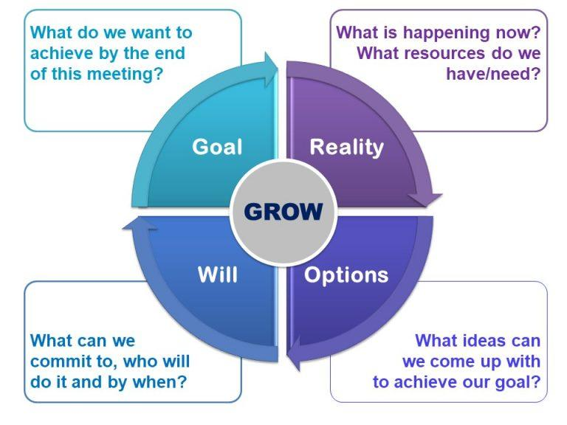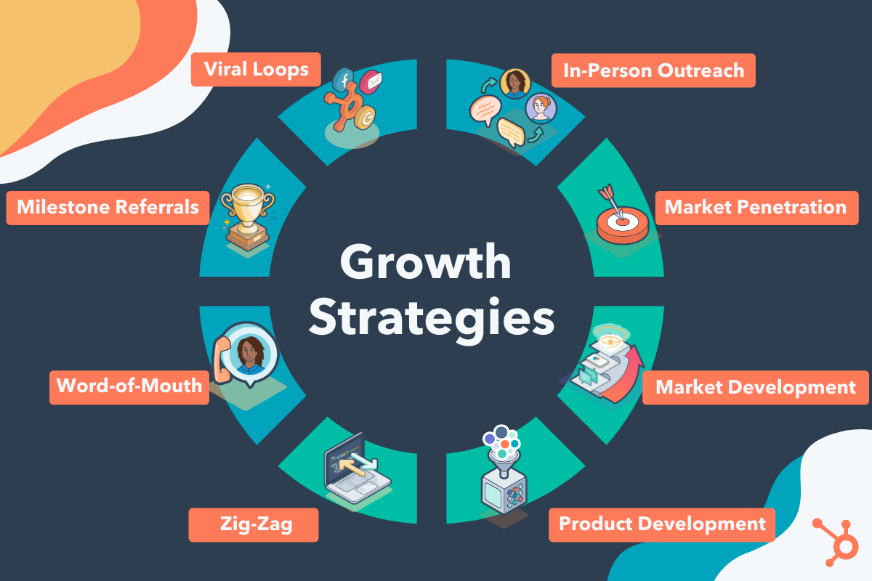
Application of the GROW Model in Coaching
Whitmore (2017) developed the GROW model, a structured coaching approach based on four stages: Goal, Reality, Options, and Will. This model helps coaches guide coachees toward clear, realistic, and achievable goals through systematic reflection and strategic questioning. One of its key advantages is its clarity and applicability to performance-related scenarios (Passmore, 2021). It fosters accountability and proactive problem-solving but may overlook emotional or motivational barriers (Ibarra and Scoular, 2019). Critics argue that its simplicity risks neglecting the complexity of behavioural change, particularly in scenarios requiring deeper psychological insight (Allen and Eby, 2007).
During my peer coaching session, I applied the GROW model to improve engagement in group discussions. My initial goal was to increase active participation. With my peer coach's guidance, I identified specific strategies, such as contributing gradually and seeking feedback. Strategic questioning helped me uncover underlying anxieties about participation. However, the session lacked deeper exploration of emotional barriers, highlighting the need for reflective techniques in future coaching sessions. Moving forward, incorporating reflective practices will enhance the depth and effectiveness of my coaching.
One of the most significant benefits of the GROW model, as stated by Whitmore (2017), is that it is clear, simple to comprehend, and transferable. This is one of the most crucial features. Due to the presence of these characteristics, it is far less difficult to engage in conversations that are focused and to accomplish goals that can be quantified. This strategy is a good choice for circumstances that are related with performance (Passmore, 2021). It helps coachees become more accountable for their actions and encourages them to take proactive measures to solve problems. The reason for this outcome is that both of these components are included in the organised element of this approach, which is the purpose of this strategy. However, there are certain limits, such as the risk of disregarding more significant emotional or motivational components that may have an influence on performance. This is one of the drawbacks. Among the constraints, this is one of them. One of the constraints is that this is one of the restrictions. Ibarra and Scoular (2019) state that many individuals who are opposed to the plan feel that it is so simple that it may allow it to neglect the complex human dynamics that are involved in the process of behaviour change. This is one of the reasons why they are opposed to the plan. By virtue of the clear character of the technique, the position that was previously articulated is given more credibility.
There are many different scenarios in which the GROW model might prove to be highly beneficial. Some of these scenarios include the evaluation of performance, the management of projects, and the cultivation of specialised skills. On the other hand, when dealing with scenarios that include more major difficulties relevant to personal growth or substantial changes in behaviour, it may be required to reinforce it using psychological techniques that are more comprehensive (Allen and Eby, 2007). This is because these situations will require more extensive psychological approaches.
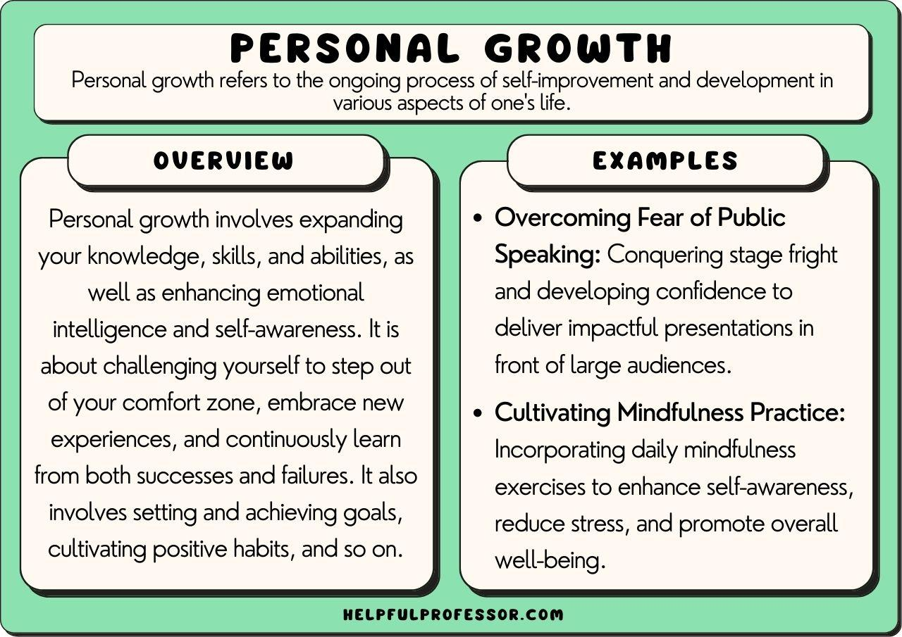
Reflections on Peer Mentoring and the Johari Window
Through peer mentoring, I gained insights into interpersonal dynamics, applying the Johari Window model to enhance self-awareness. I realised that while my contributions were structured, my passive engagement limited their impact. My mentor identified blind spots and reframed my uncertainty as an opportunity for growth. This shift in perspective increased my confidence and engagement. However, feedback delivery needed improvement; more specific and direct feedback would have enhanced the learning process. Effective feedback should balance constructive criticism with actionable recommendations to ensure clarity and usefulness. One thing that has to be taken into serious consideration is the fact that the GROW model is structured in such a way that it provides a large amount of aid in the process of establishing objectives that are not only comprehensible but also within the realm of possibility. My coach was able to discover the underlying difficulties that had been preventing me from communicating in a natural manner by purposefully questioning me during the course of our conversation. Fears like these have been keeping them from taking place the whole time. With the intention of accomplishing this objective, the strategy that was utilised was known as strategic questioning. In spite of this, it became instantly apparent that there was a limitation: the conversation that we had gone over had, to a certain extent, glossed over the possibility of emotional barriers that require more investigation. In order to overcome this limitation, it was necessary to take action.
Additionally, one of my key goals is to incorporate reflective methods into the coaching sessions that I will be doing in the years to come. This is one of my primary aims. At the end of the day, the use of these tactics will make it possible to carry out an analysis of emotional obstacles that is more extensive and in-depth, which will ultimately result in an increase in the comprehensiveness and efficiency of the coaching process.
Critical Thinking and Practical Application
Although my coaching and mentoring sessions were structured, deeper analysis and exploration of alternative options were needed. Encouraging diverse solutions and avoiding rushed conclusions would have enriched the discussions. Critical thinking plays a crucial role in coaching effectiveness, and developing this skill will improve my ability to assess situations from multiple perspectives. Additionally, improving my adaptability to coachees' needs will enhance engagement. Practical application of coaching techniques requires confidence and flexibility. Strengthening my ability to actively respond to coachee feedback and adjust my methods accordingly will enhance session effectiveness. Moreover, refining communication skills—including active listening, rapport-building, and adaptive coaching styles—will support both professional development and coaching effectiveness.

I was able to get substantial insights into the interpersonal dynamics that I faced as a result of my involvement in activities that involved groups of people. These realisations came about as a result of the process of peer mentoring, which I was allowed to participate in. It was via the use of the Johari Window paradigm, which was employed for the entirety of the session, that these realisations were accomplished. I arrived to the realisation that despite the fact that my structured contributions were substantial, the overall impact of those contributions was diminished as a consequence of my reluctance to participate. A revelation like this came about as a consequence of putting Schon's reflective practice approach into action. One of the things that I gradually came to understand was this particular aspect of the situation.
Not only did my mentor do an excellent job of shedding light on my blind spots, but he also brought to my notice the notion of my passive engagement style. This was one of the things that he did. He accomplished this by drawing my attention to the fact that I was in possession of one. My uncertainty was reframed as a possible area for making substantial adjustments as a result of this information, rather than as a defensive mechanism against criticism. This allowed me to reframe my uncertainty in a more constructive manner. Because of this, I observed a significant improvement in my performance. Due to the fact that this occurred, I was able to acquire a more profound comprehension of the implications that my uncertainty had. As a result of this, I was able to acquire a more comprehensive comprehension of the factors that contribute to my reluctance to acknowledge criticism. As a consequence of the mentoring session, I was able to considerably raise my professional confidence. This was made possible by the fact that it provided me with tangible techniques, such as gradually increasing the amount of involvement I was putting out and asking feedback from my other coworkers. As a direct result of my participation in the mentorship session, I was able to make this adjustment in my perspective.
But the session brought to light a problem that needs to be addressed: the mentor needs to deliver feedback in a manner that is both more specific and more direct. This is something that needs to be addressed. This is a matter that requires attention and will be handled. It is imperative that action be taken in order to discover a solution to this problem. It is important to note that this underscores the necessity of providing feedback in a manner that is both fair and balanced. This ensures that constructive criticism is communicated in a manner that is not only understood by the receiver but also useful to them. It is plainly clear that providing feedback is of significant relevance at this point in time, when all of these elements are taken into consideration in hindsight.

Conclusion
In this reflective report, I used Schon's reflective practice model to conduct an in-depth analysis of my experiences with mentoring and coaching. Mentoring through the Johari Window considerably improved both self-awareness and relational dynamics, while coaching, particularly through the GROW model, proved to be an important tool for clarifying goals and improving performance in an organised manner. These experiences brought to light the complimentary roles that coaching and mentoring play, highlighting the significance of striking a balance between the establishment of formal goals and the investigation of more profound affective experiences. Through the process of reflection, I was able to explain successful tactics for improving group involvement, raising my confidence, and finding potential for future growth, all of which contributed considerably to my professional development. My continued professional practice will be immediately influenced by these insights, which will result in increased efficiency and self-assurance in collaborative settings and in future leadership responsibilities.

References
• Allen, T. D. and Eby, L. T. (2007). The Blackwell Handbook of Mentoring: A Multiple Perspectives Approach. Wiley-Blackwell.
• Passmore, J. (ed.) (2021). Excellence in Coaching: The Industry Guide. 4th edn. Kogan Page.
• Ibarra, H. and Scoular, A. (2019). ‘The Leader as Coach’, Harvard Business Review, November–December, pp. 110–119.
• Kram, K. E. and Ragins, B. R. (2007). The Handbook of Mentoring at Work: Theory, Research, and Practice. Sage Publications.
• Luft, J. and Ingham, H. (1955). ‘The Johari Window: A Graphic Model of Interpersonal Awareness’, Proceedings of the Western Training Laboratory in Group Development. UCLA.
• Schön, D. A. (1983). The Reflective Practitioner: How Professionals Think in Action. Basic Books.
• Whitmore, J. (2017). Coaching for Performance: The Principles and Practice of Coaching and Leadership. 5th edn. Nicholas Brealey Publishing.
• Zachary, L. J. (2019). The Mentor's Guide: Facilitating Effective Learning Relationships. 3rd edn. Jossey-Bass.

