
Module One: On your marks

Timetable, Week 4, 2020-21

Mark Making & Trace

Trace
If everything has an impact on its immediate surroundings, then that impact is marked by the TRACE that object leaves behind. Whether it is our own personal impression on the environment, or the impact of a particular object on a surface on which it resides or moves across, the TRACE is an ephemeral, residual or permanent mark that inevitably references a permanent connection to its creator.

To leave a trace is to make a mark through an intervention in immediate surroundings, either deliberately or unintentionally. Even when deliberate and thought-through, the documentation or capturing of such marks or TRACES can be anything but uniform and expected.

Many artists have worked with the concept of TRACE in many of the ways mentioned above and more, with a huge variety of settings and objects, including environmental, political, investigative, personal and documentary. Some examples to research include:

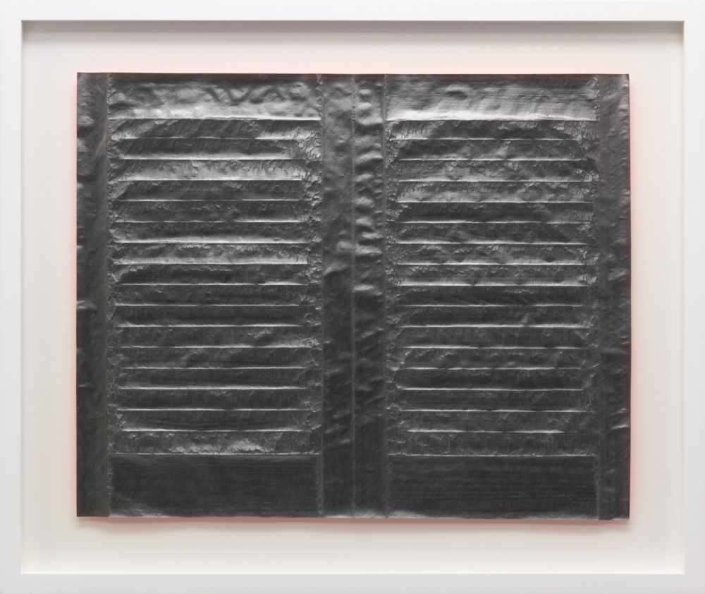

Anna Barriball Anna Barriball
Door (2004) Shutters with Fire Red (2011)

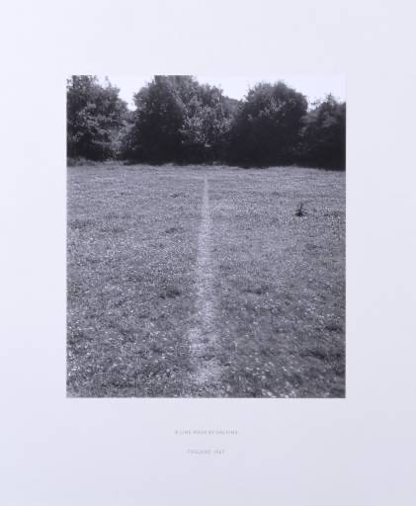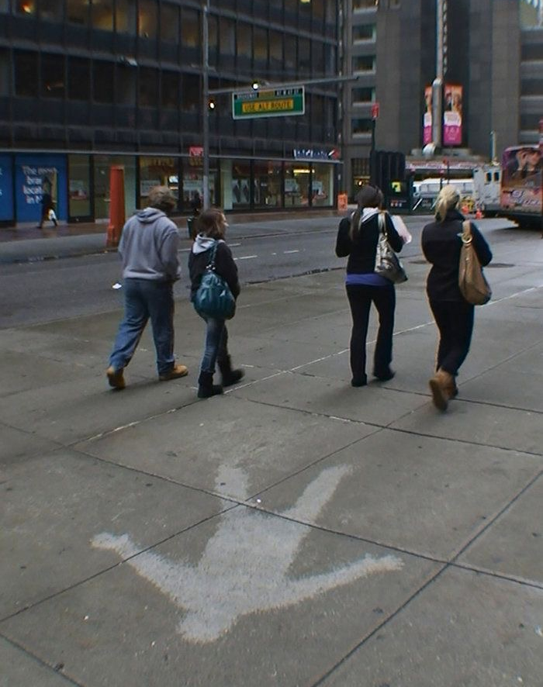

Richard Long Andy Goldsworthy
A Line made by walking (1967) New York Dirt Water Light (2010)

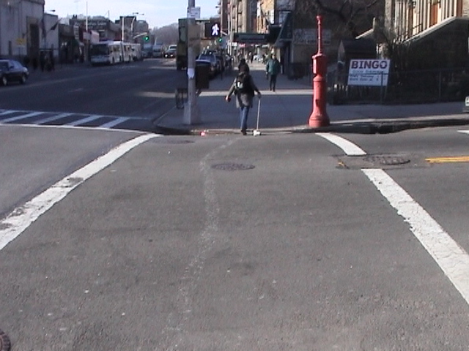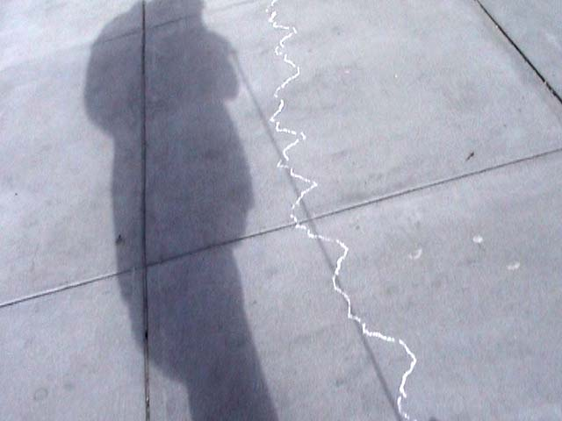

Maryclare Foá
Line Down Manhattan (2003)
A 16-mile drawing from Broadway to Battery Park: ‘My drawing on Manhattan was a trace of my presence, an exploration of the possibility of drawing on a static surface’.

An example of trace, found in the environment:

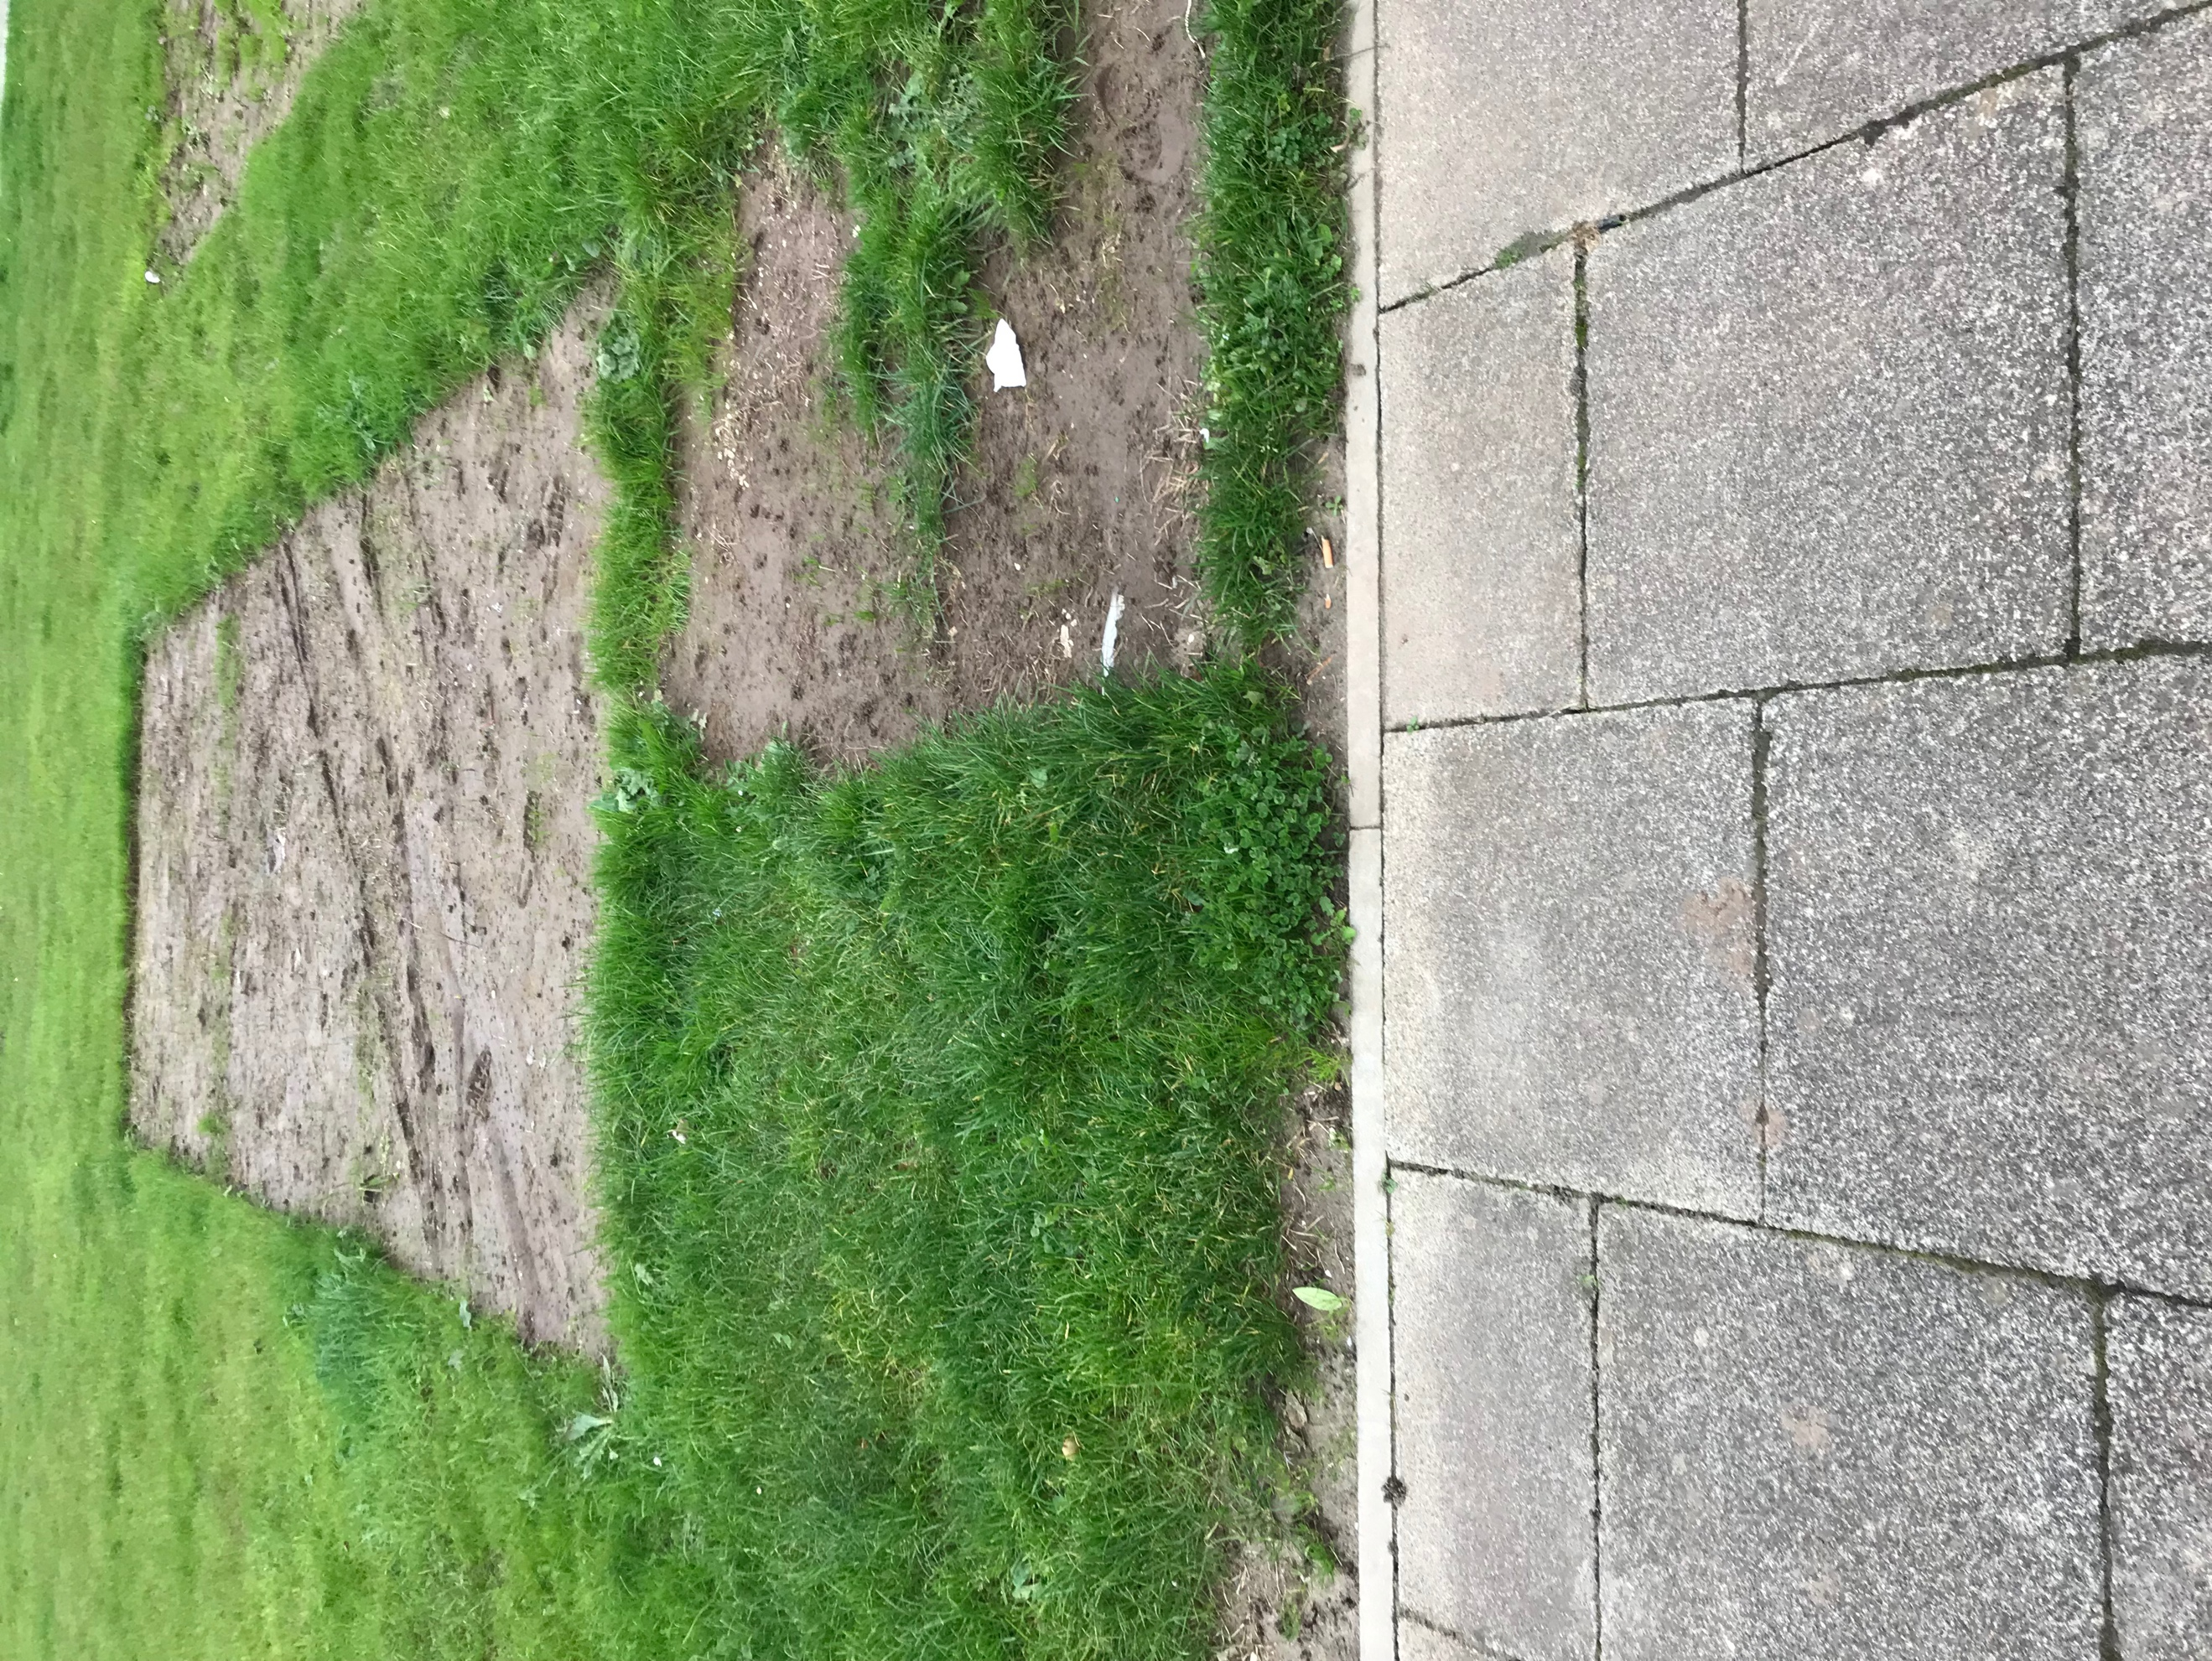
Monday | Task one: Find examples of ‘trace’  In between your assessment times, find your own examples of mark making involving ‘trace’, indoors and/or outdoors. This can be any kind of mark made which hints at an object which was once there, or a process that occurred which is now over.  Photograph the found ‘traces’.  Examples in the environment include:  Coffee cup rings, tyre marks, footprints, indentations, impressions etc.  Take inspiration from artists using ‘trace’ in their practice, such as;  MaryClare Foa: Line Down Manhattan (2003)  Richard Long: A Line Made by Walking (1967)  Andy Goldsworthy: Rain Drawings (2010)  Anna Barriball: Door (2004)
Tuesday morning  Tuesday afternoon | Continue Task one  Task two: Group work  In your groups (red, yellow or blue), meet up in Teams to share and discuss your examples of found ‘trace’.
Wednesday morning  Wednesday afternoon | Task three:  Document an object and its trace through your own selection of the following:  - Photograph the trace and the object  - Write a list or short description of the physical and/or emotional qualities of the object  - Write a list or short description of the physical and/or emotional qualities of the trace  - Draw the object  Taking inspiration from other artists using trace as part of their practice, create a new trace of your selected object (or a part of it, if it’s a large object) utilising any of the following:  - Tracing paper  - Foil  - Graphite rubbing  - Masking tape  - Sellotape  - Cling film  - Any other material/process of your choice  Be creative and use the artists suggested along with any you have researched yourself to inform the marks and the ‘traces’ you create.
Thursday morning  Thursday afternoon | Continue Task three  Meet in your group (red, yellow or blue) to critique each other’s responses to Task three.

Foa, M. (2005) What might ‘performance’ mean in the context of drawing? [online] Available at: www.lboro.ac.uk/microsites/sota/tracey/journal/perf/foa.html

