Task 1
Title: How Innovations are Impacting and affecting society - Artificial Intelligence
Reflecting Journal Content

What is the first thing coming into your mind when thinking about innovations? I will tell you what I am thinking. I am thinking about progression, things or products that make our life easier, and we are happier and healthier.
By definition, innovation is finding "new" and introducing this "new" in our life. Changes are inevitable in this modern world and are crucial to evolution by creating positive changes.
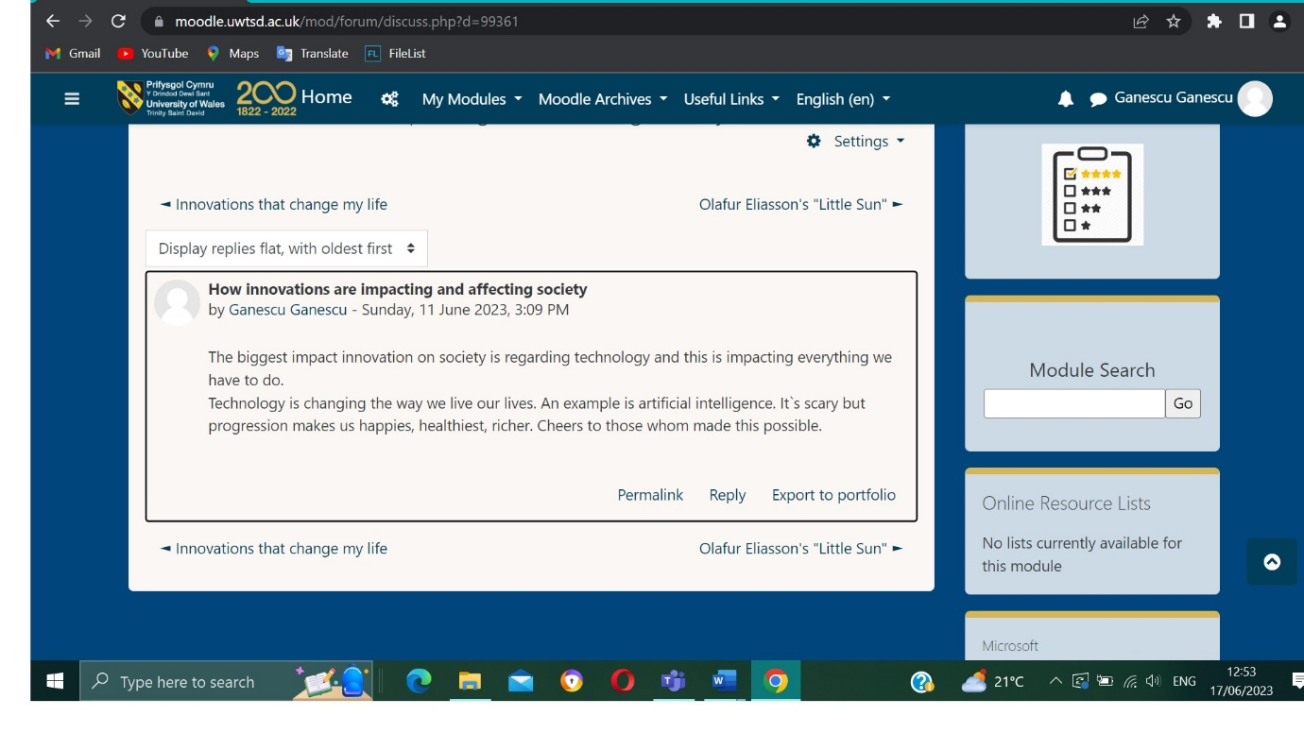
As mentioned in the forum, one of the greatest innovations is artificial intelligence.
Artificial Intelligence (AI) is a machine's ability to imitate human functions such as reasoning, learning, planning, and creativity.
AI allows technical systems to perceive the environment in which they operate, process this perception, and solve problems, acting to achieve a specific goal. The computer receives the data (already prepared or collected through its sensors, such as a video camera), processes it, and reacts.
AI systems can adapt their behaviour to some extent by analysing the effects of previous actions and operating autonomously.
Some AI technologies have been around for over 50 years. However, increased computing power, the availability of enormous amounts of data, and new algorithms have led to significant advances in AI in recent years.

Artificial intelligence is considered a central element of the digital transformation of society and has become a priority for the entire world.
Future applications are expected to bring enormous changes, but AI is already present in our daily lives.
Here are some features we use without always realizing they are applications of AI:
Online shopping and advertising
Artificial intelligence is widely used to provide personalized recommendations to Internet users, based on their previous searches or purchases, for example, or other online behavior. AI is enormously influential in the economy for product optimization, inventory planning, logistics, etc.
Internet search
Search engines learn from the considerable amount of data users enter to provide relevant results.
Personal digital assistants
Smartphones use AI to offer the most tailored and personalized products. Virtual assistants who answer questions, provide recommendations and help organize daily activities have become ubiquitous.
Automatic translation
Translation software, whether written or spoken, uses artificial intelligence to make the translations but also to improve them. The same goes for other features, such as automatic subtitles.
Smart homes, cities, and infrastructures
Smart thermostats learn from our behaviour to save energy, and competent city developers hope to control traffic to improve connectivity and reduce congestion.
Automobiles
Although autonomous vehicles are not yet the norm, automobiles are already using AI-based safety features. The EU has, for example, contributed to the funding of VI-DAS, automated sensors that detect possible dangerous situations and accidents.
Navigation is heavily based on AI.
Cyber security
AI systems help identify and combat cyber-attacks and other cyber threats based on continuous data input, recognizing patterns, and tracing attacks.
Artificial intelligence against Covid-19
In the context of the Covid-19 epidemic, AI is being used in thermal imaging at airports and elsewhere. In medicine, AI can help recognize infections through computed tomography of the lungs. It has also been used to collect data to track the spread of the disease.

Combating disinformation
Specific AI applications can detect fake news and disinformation by mining fake information posted on social media platforms, looking for sensational or alarmist words, and identifying official online sources.
AI will transform virtually all aspects of life and the economy. Here are some examples.
The health
Researchers are studying how AI can analyse large amounts of medical data and find patterns that could lead to medical discoveries and improved patient diagnosis.
For example, an AI program has been created to answer emergency calls, recognizing a cardiac arrest during the call faster and more frequently than the medical dispatcher. Another example is the EU-co-founded KConnect, which develops multilingual text search services to help people find the most relevant medical information.
Transport
AI could improve rail traffic safety, speed, and efficiency by minimizing wheel friction, maximizing speed, and enabling autonomous driving.
MANUFACTURING
AI can help European manufacturers become more efficient and bring factories back to Europe by using robots in manufacturing, optimizing sales, and anticipating maintenance or outages in intelligent factories.
SatisFactory is an EU-co-funded research project using collaborative and augmented reality systems to increase job satisfaction in intelligent factories.
Food and Agriculture
Artificial intelligence can be used to build a sustainable food system in the EU: AI can ensure a healthier diet by minimizing the use of fertilizers, pesticides, and irrigation, supporting productivity and reducing environmental impact. Robots could remove harmful plants, thereby reducing the use of herbicides, for example.
Many European farms already use AI to monitor their animals' movement, temperature, and feed consumption.
Administration and public services
Using a wide range of data and recognizing patterns, AI could provide early warnings of natural disasters, enabling adequate preparation and mitigation.
List of references:
- https://datafloq.com/read/how-innovation-is-impacting-society/
- https://digileaders.com/how-does-innovation-impact-society/
- https://en.wikipedia.org/wiki/Artificial_intelligence
- https://www.ncbi.nlm.nih.gov/pmc/articles/PMC7605294/
- https://library.kaust.edu.sa/AI
- http://csstoday.com/Topics/OTHERS/2022/06/23/17084710144.html

Task 2
Title: Change Making – the art of creating value
Reflecting Journal Content

Who and what are the Changemakers?
Changemakers are individuals or groups who takes initiative and work towards creating social, economic and environmental changes. Changemakers can be found in many fields and sectors , including social entrepreneurship, education, technology, healthcare, environmental, sustainability, etc.
Changemakers are characterized by their ability to identify problems or opportunities for improvement and take steps to bring meaningful changes. Changemakers can inspire others through their actions, ideas, and leadership. They may initiate projects and campaigns that promote positive change and they often collaborate with like-minded individuals to amplify their impact. Ultimately, Changemakers play a crucial role in shaping our society and driving progress toward a more sustainable and inclusive future.
For me, one of the important changemaker of our time is Elon Musk. He did so many great things that help us all in our daily life. I will talk about a few of his conceptions.
Zip2. Was a company that provides online city guide software for newspapers. Then he founded Paypal. Paypal is an online financial services and e-mail payment company that is used by millions of people every day because is simple and secure.
He founded Tesla, which is an electric car company, the most valuable electric car company with hundreds of thousands of models sold every year. I, personally own a Tesla and I can say that is amazing for the economy and for the charging stations everywhere. Overall, Tesla cars have gained popularity for their combination of sustainable technology, impressive performance, and sleek design. They have played a significant role in pushing the boundaries of electric vehicles and accelerating the adoption of sustainable transportation worldwide. In my opinion, this is one of the big changemaking Elon Mush has done because it has an enormous impact on the environment and passengers safety especially because Tesla patterns for engine and battery are used by the city busses and car makes.
Another changemaking company founded by Elon Musk is Starlink. Starlink is a satellite internet company that provides internet access coverage to over 55 countries. It also aims for global mobile phone service after 2023.
SolarCity is another project financed by Elon Musk in 2006 and now is the largest provider of solar power systems in the United States. Elon Musk has been an upholder of renewable energy and has promoted the development and implementation of sustainable energy solutions. Tesla factories have not only enabled the production of electric vehicle batteries but have also facilitated the development of energy storage solutions such as Powerwell and Powerback.
Neuralink and Brain computer interfaces is a company that Elon Musk invested in and focused on developing implantable brain computer interfaces. Neuraling wants to establish a direct connection between the human brain and a computer. His work in this field has the potential to revolutionize healthcare and improve the human condition. I know it sounds a little science fiction now but 20 years ago we did not think that laser eye surgery could be possible.
For all these things he did, for the way he thinks about technological innovations and human destiny, I believe he is a changemaker. He influenced my life with simple things that I use daily like PayPal and an electric car, and the way I’m thinking with Neuralink and SpaceX.

Task 3
Title: Funding your idea
Reflecting journal content

It is important to know that each funding idea has its own requirements, advantages, and challenges. You will have to consider carefully which ones align with your needs, goals and stage of development. Additionally, it is beneficial to create a solid business plan and be prepared to present your idea to potential investors or funding sources.
The most important types of funding ideas are:
Bootstrapping – refers to the practice of starting and growing a business or project with minimal external funding or financial assistance. It involves relying in personal savings, revenue generated by initial sales. Bootstrapping requires a long term perspective. Bootstrapping offers entrepreneurs greater control over their bussiness and avoids potential dilution of ownership.
Crowdfunding – is a method of raising funds for a bussiness or project through small contributions from a large number of people, usually facilitated through online platforms. It allows individuals or organizations to tap into a broad network of potential customers to finance their ideas or initiatives. It is important to understand and research the rules, regulations and fees associated with your chosen crowdfunding online platform.
Venture Capital – refers to a form of private equity investment provided to grow the bussiness in the early stages. Venture capitalists are professional investors who provide capital, expertise and guidance in exchange for an equity stake or a seat on the company board of directors. It is crucial for entrepreneurs to carefully consider their funding needs and compatibility with venture capital model before seeking such investment.
Seed Funding – also known as seed capital or seed investment, refers to the initial funding provided to early stages startups or entrepreneurs to support development and lunch of their business idea. It is typically the first significant round of external funding that a business receives.
Accelerator and Incubators – are programs or organizations that provide support and mentorship to early-stage startups to help them develop and grow their business. While both accelerator and incubators aim to nurture startups, there are some differences in their focus and approach. Incubators typically have a longer duration compared to accelerators. They may last several months to a couple of years providing startups with ongoing support and guidance throughout their early development stages. Incubators offer a range of resources including physical workspace, shared resources, mentorship, business coaching, legal and accounting services, industry connection and market research. Incubators usually operate in cohorts, meaning they accept a group of startups at the same time and guide them to the program together. Accelerators are usually more condensed and time-limited compared to incubators. They typically run for a fixed period of time, often around three to six months, during which startups receive intensive support and mentoring. Accelerator often provides business with seed funding or small investment in exchange for equity. The investment is usually accompanied by a structured program and support services. Accelerators may have a partnership with venture capital companies or angel investors increasing the chances of secure funding. Both Accelerators and Incubators can provide valuable support and resources to startups. The choice between the two depends on the stage of your startup, the specific needs of your business and the resources and support services offered by each program. It is important to research and evaluate different accelerators and incubators to find the one that aligns with your goals and can provide the most relevant support for your startups growth.

Understanding social enterprise – a social enterprise is an organization and business that operates with the primary goal of positive social and environmental impact. It combines the principles and practices of both business and social responsibilities to address social challenges while also creates revenue to sustain its operation. One important feature of social enterprise is commitment to using business strategies and approaches to achieve social objectives. A social enterprise has a clearly defined social or environmental mission at its core. it aims to address a specific social issue, such as poverty, education, environmental sustainability, or community challenges. Unlike a traditional non-profit organization, that relies on donations and grants, a social enterprise aims to generate income through business activities. They use entrepreneurial strategies and models to create sustainable revenue streams that support their mission.
Social impact: the primary focus of a social enterprise is to create positive social or environmental impact. It aims to bring out meaningful change and address society’s challenges through its products, services, and activities. While social enterprises prioritize social impact, they also aim to be financially sustainable. They strive to generate enough revenue to cover their operational costs and invest in their mission. Financial sustainability helps social enterprises become less reliant on external funding sources.
Social enterprises can take various legal forms, including nonprofit organizations, cooperatives, social purpose corporations, or hybrid models that combine aspects of both for-profit and non-profit entities. They are part of a growing movement that seeks to harness the power of business to address social and environmental challenges, driving positive changes in society.

