Cerith Edwards
Premier Forecourts and construction
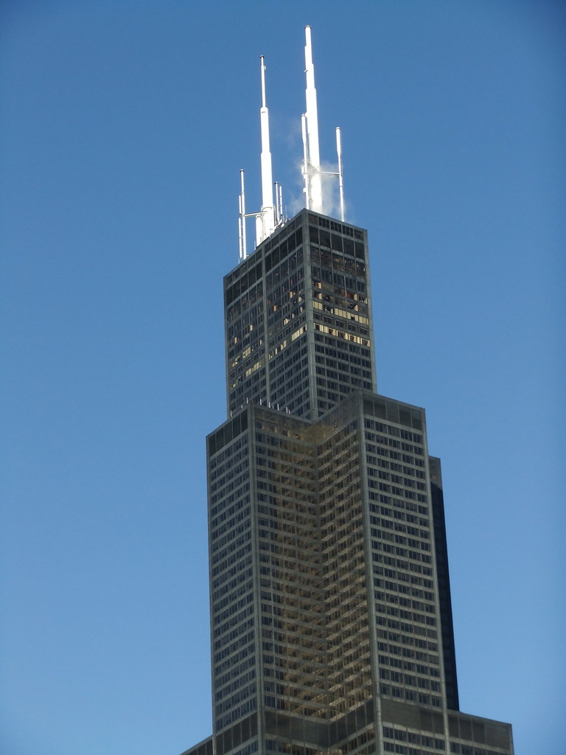
Material science and Building Services
Module Code – ACBA4006
A report focussing on:

Material science and Building Services
Construction Materials

Prepared for:

Mr Alan Nantel

Created by:
Mr Cerith Edwards (2219938) – Trainee Quantity Surveyor for Premier Forecourt and Construction

Date completed:
25/11/2022

Word Count: 2415 Module Code – ACBA4006

Table of Contents

Executive Summary 2
Terms of Reference 3
The principal focus are: 3
Procedure 3
Findings 4
Introduction 4
Steel Climate resistance, wind loading and gravity 5
Steel Durability 8
How Steel is made 9
Frame ease of assembly 12
Steel adaption to different shapes 13
Steel v concrete 14
Conclusion 15
References 16
Appendices 19

Executive Summary

In this report I will examine a habitable steel framed structure. It will be a habitable building. I will report on many aspects of the build including the frames durability, the steel production process, the environmental impact as well as the wind load.

Terms of Reference

The principal focus are:

    - .
    - .
    - The report is due by the 7/12/22

Procedure

This section identifies the research sources used.
- All the sources used in the report, including websites and images are listed in the references and bibliography.
- Notes taken in class also provided background to the research.
- This assignment is due 7/12/22

Findings

Introduction

The Willis Tower is a Skyscraper located in Chicago, Illinois in America. Formerly known as the Sears Tower (1970 – 2009) it changed its name in 2009 to the Willis tower, to match the company name that bought the building in 2004, Willis group holdings.
Sears Tower (no date) World's Tallest Towers. Available at: https://skyscraper.org/tallest-towers/sears-tower/ (Accessed: November 6, 2022).
Engineered by Fazlur Khan and designed by Bruce Graham in 1969 it was the worlds tallest building. The tower's building process began in 1970 and ended in 1974. Thousands of construction workers came together to build this steel structure, featuring a steel-framed bundled tube construction method. Measuring a whopping 442 metres,
108 stories it’s a beautiful structure, its currently the 3rd largest steel structured building in the world.
As one of the most popular tourist destinations in Chicago, it includes the ever-popular Skydeck observation deck which attracts more than 1.7 million visitors annually. It is the highest skydeck in America. The Willis Tower is one of the most well-known structures in the world, its appeared in a number of big-budget movies, including I.Robot and The Dark Knight Rises.

Steel Climate resistance, wind loading and gravity

Its frosty winters, moderate summers, various temperatures, and strong winds make Chicago's Weather unpredictable. Lake Michigan is forcing winds from the west coast of North America to reach 88 mph. “Chicago is nicknamed The Windy City is the strong wind that blows off the shores of Lake Michigan. Chicago's weather makes designing for a wind a common challenge for architects and engineers. Winds act as a horizontal force, pushing the building from the side. If buildings aren't constructed to withstand high winds, they will collapse” (Encyclopædia Britannica Accessed: November 6, 2022) Designing a Steel structure to withstand the weather of Chicago is not going to be an easy challenge and one that comes with immense responsibility, poor design would be catastrophic.
The two leading individuals responsible for the design of the Willis Tower were architect’s Bruce Graham and Engineer Fazlur Khan. Working collaboratively to design the tower they used Khans new tube structural system. It was implemented to address some of the major problems high rise structures encounter. The tube system allows the building to withstand the wind load, which is vital in Chicago. This ground-breaking technique lessens the tension placed on the Willis Tower, increasing its durability and resistance to climate change meaning, the Willis tower survives the wind load. Each of these tubes have a difference in height, which causes the wind to be disrupted, often known in the construction industry as “confusing the wind”. Chicago experiences minor earthquakes every few years, as well as the strong winds. Kahn’s design is created to withstand the climate of Chicago.

The steel design permits typical swaying without affecting the structural integrity of the building. The main reason it survives the wind is its shape and foundations. The nine tubes from Khans tubular design provide mutual support for one another, strengthening the entire structure. The variety in tube heights confuses the wind's force.

Khan’s steel frame design known as the bundled tube structure; a collection of tubes joined together to function as one unit. “is actually not one tower but nine rectangular square-based towers or prisms (called tubes) with the same base area but different heights. Two of the towers reach 50 storeys; two more reach 66 storeys; three reach 90 storeys; and the two remaining adjoining towers reach 108 storeys with a full height of 442 m. Here we can see the nine rectangular prisms that make up the tower.” (Amsi.org.au, No date) The highest floor (green below) is placed in the middle and acts like a spine to support the building.
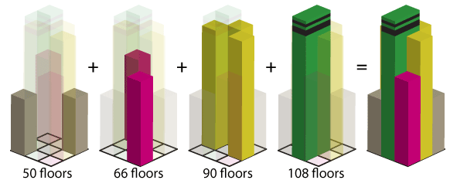
Source: (amsi.org.au, no date)

Safety and gravity- steel and foundations
The steel used helps with the safety of the building, along with a strong foundation it keeps the building upright. Skydeck.com (accessed 6/11/22) state “skyscrapers do sway in the wind. Their steel construction allows for normal swaying without endangering the building’s structural integrity nor the occupants inside. While some might find it unsettling to notice a tall building swaying in the wind, this natural movement is no cause for concern and means the skyscraper is working as designed”.

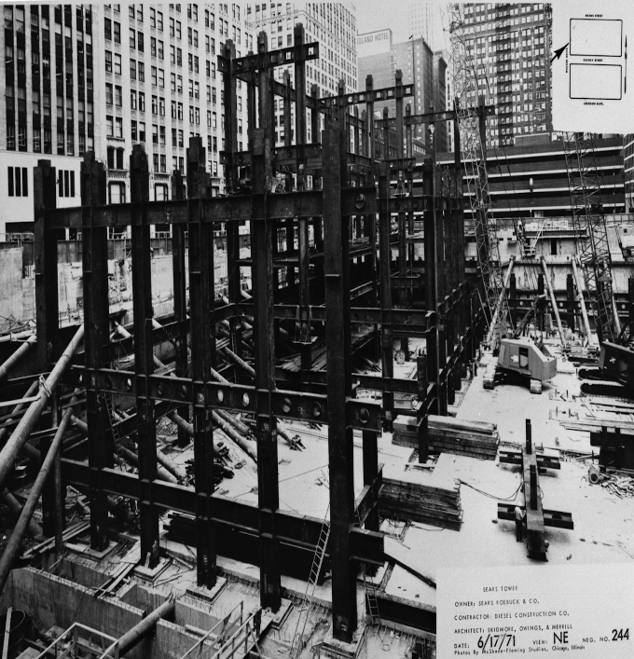
Historically, many buildings in Chicago including the city hall sunk and had to be demolished, this was due to being built on soft clay. Apart
Available at: https://interactive.wbez.org/curiouscity/willistower/ (Accessed: November 6, 2022).

from the design of the steel structure, one of the other main reasons that the Willis Tower doesn’t collapse is due to the foundations it’s built on. “The foundation for the Sears tower is a massive cement structure that is 100 feet deep. In addition, the foundation is surrounded by 200 circular caissons, which are huge cement-filled cylinders bored an additional 100 feet below and set in solid bedrock. These caissons add stability to the building so that it stands firm–no matter what the conditions at the top.” (Mansell B 2020). Based on my own research and the course materials, the finest basis to build on is solid bedrock.

The steel structure was constructed quickly. This was due to all the steel being prefabricated. Structural steel units called “Christmas trees” allowed for majority of the welding to be done offsite. As per image below “consisted of a two-story column with half-length beams welded to either side of the column. On site, the units only needed bolted splice plate connections between beams and web bolted connections for the column splices.” (khan.princeton, accessed 07/11/22) This rapidly sped up the build process and saved on the build cost.
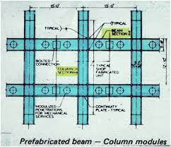
http://khan.princeton.edu/khanSears.html

Steel Durability

The main structure of the Willis tower is Steel. The company “American Bridge” fabricated and erected 78 thousand tons of steel (structural) for the tower. Steel was used as it was decided that it was the best material available, it has many positives. As per bakersteeltrading.co.uk, (accessed 6/11/22) here are 5 points that would have assisted in choosing steel as the structure for the Willis Tower.
- Steel is a robust Alloy
Steel is great for constructing the skeletal framework of buildings since it is considerably more durable and resistant to damage over time than most other building materials.

- Steel frame buildings are structurally sound
Steel can withstand all kinds of stresses and pressures. The structural integrity of structural steel will never be compromised, whether due to excessive human use or external environmental factors.

- Steel Buildings are weather resistant
Throughout their lifespans, buildings are subjected to a variety of climatic factors. Buildings with structural steel frames can remain intact while being exposed to extreme weather conditions such as high humidity, snowfall, rain, and storms. Steel is a very durable material that can bend without cracking, and it needs an abnormally high load to even begin to bend. You can also strengthen steel beams by applying corrosion protective primers such as zinc to extend its life cycle.

- Steel frame buildings are self-supporting
Because of its high strength-to-weight ratio, steel makes an excellent self-supporting material for structures.

- Steel is extremely durable
Steel outperforms other buildings greatly in terms of strength. Buildings made of steel are sturdy, resilient, and can survive decades longer than buildings made of other materials. They also retain their value better.

How Steel is made

Steel is one of the most common materials used in the construction sector, its extremely robust. Steel is an alloy of carbon and iron, often used for skyscrapers in the 70’s. As mentioned above steel can be strengthened, it is often coated before installation and has high moisture-resistant qualities helping it resist corrosion. All of this is paramount when constructing a steel framed skyscraper like the Willis tower.

A blast furnace or an electric arc furnace are primarily used to create steel. For a blast furnace, Iron ore and carbon are the two basic components used for manufacturing steel. Iron ore, limestone and coke are added to the furnace to create steel. The extreme heat of furnace (1650 degrees Celsius) helps form the steel. Below is an image of how steel is created, this also includes the more modern electric arc furnace method.
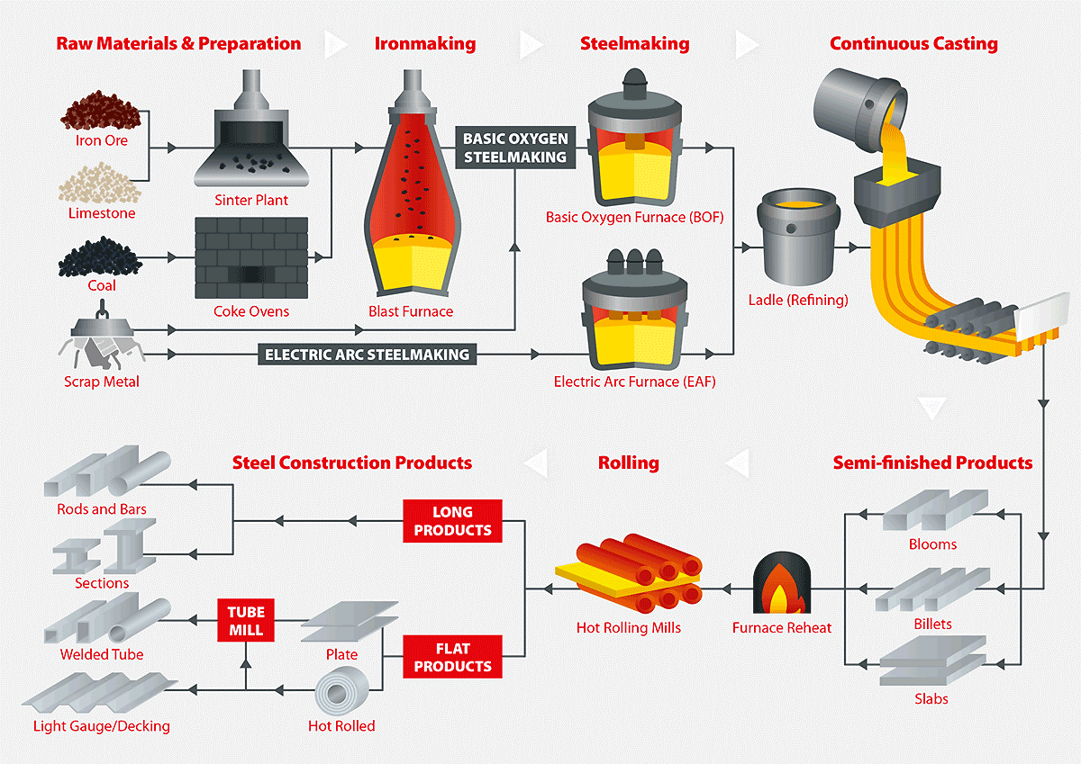
https://www.vepica.com/blog/steel-production-from-iron-ore-to-functional-industrial-products

Steel is produced all around the world. The leading country for producing steel is China. The rise in steel production is now 10 fold since 1950, rising from 189 million tons to 1950 million tons in 2021. Steel production is not good for the environment, greenspec.co.uk (accessed 8/11/22) state that “Steel production has a number of impacts on the environment, including air emissions (CO, SOx, NOx, PM2), wastewater contaminants, hazardous wastes, and solid wastes. The major environmental impacts from integrated steel mills are from coking and iron-making.” All of these have a negative impact on the environment, the main impact is the CO2 omissions that are often called ‘greenhouse gas emissions’ this contributes to the crisis that is global warming. Blast furnaces are constantly researching ways to lower emissions to help the environment. Some furnaces have started using hydrogen instead of carbon to assist with reducing the carbon footprint, although monitors and filters are now commonly found in furnaces to reduce and measure the release of CO2. The steel sector is the third largest global source of air pollution.

However, many people consider steel to be environmentally friendly. This is because steel, even poorly conditioned, is the most recycled metal globally. Steel has characteristics that prevent any degradation during recycling. This indicates that it can be melted down and recycled endlessly without suffering any degradation. Steel's ability to be recycled significantly reduces the environmental effect of its production from raw materials. Recycled steel is primarily done in an electric arc, often resulting in 75% less energy being used if was raw materials. To put it into perspective steel fabsercises (accessed 8/11/22) state that “Recycling 1kg of steel keeps 2kg of greenhouse gases out of the atmosphere. Recycling steel also diverts these products from landfill, and enables the material to be reprocessed, thereby conserving raw materials. For every tonne of steel recycled 1131 kg of iron ore, 633 kg of coal and 54 kg of limestone are saved.” Using recycled steel has a much greater impact on the environment compared to creating steel from raw materials, we should always look to used recycled steel before making it from scratch.

Frame ease of assembly
As per the design for the Willis tower, steel framed buildings are usually constructed quickly, this is because most of the large steel columns have already been assembled and built off site, before being transported ready for installation. The structure swiftly comes together if the weather is favourable and the right specialised installation team. The Willis tower was constructed in 3 years in the 70’s, without the use of modern-day technology or plant. The above factors were essential in meeting this time scale.
The process of erecting steelwork involves putting together steel parts on site to form a frame. The steel must be lifted and placed/aligned into position before being welded together or being bolted.
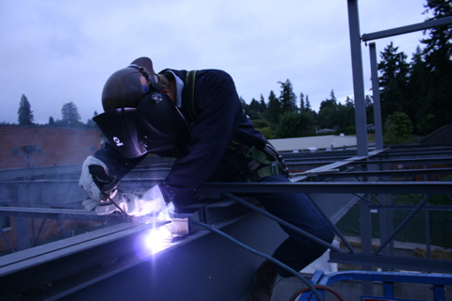
Source: https://www.millerwelds.com/

Steel adaption to different shapes

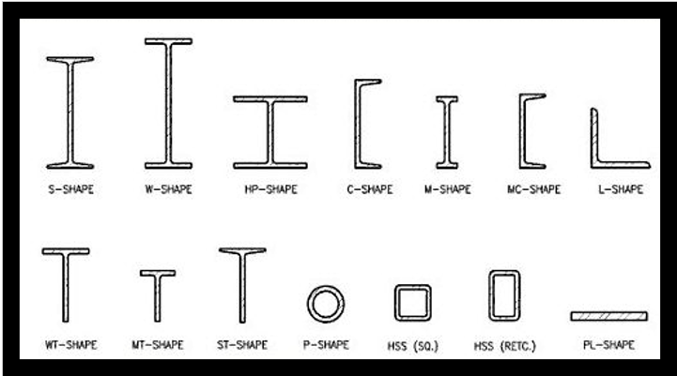
Source: Yena Engineering (accessed8/12/22)

Steel does come in many shapes and sizes as per above image. However, when a steel structure is erected, these shapes often form square, rectangles, triangles, or cross sections frames. These are also known as beams, angles, tees or channels. Steel also bends, offering unique design options/opportunities, this encourages architects to use their creativity to produce eye-catching structures from classic designs like the Eiffel tower to the latest football stadium. “Bending/rolling steel is the process of curving a steel member to a specified radius and arc length. Bending is commonly used to describe the process for a tighter radius bend, whereas rolling is used to describe a larger radius bend.” (www.aisc.org, accessed 9/11/22) Even when steel is bent/curved it still offers a smooth finish. Another positive with constructing steel is that once its served its purpose its easy to disassemble, often taking away steel sections one by one to be recycled. (recycled benefits mentioned above).

Steel v concrete
Many skyscrapers have a concrete structure. When comparing the two structures engineers will weigh up the advantages and disadvantages of each type. Cost wise steel is a cheaper alternative than concrete, its also quicker to install. Concrete can also be moulded to any shape and is more resistant to fire than steel. Due to its lower carbon impact, steel is more beneficial to the environment than concrete. Choosing a structure often comes down to location and durability, for example if you were in a location that has earthquakes you would use a steel frame due to its ability to move with the quake, while a concrete structure is more likely to crack. Concrete structures are more likely to be used in hotter countries because the material is more durable than steel. Please see the below tabled data (www.ny-engineers.com, accessed 8/11/22) highlighting the pros and cons of each structure.
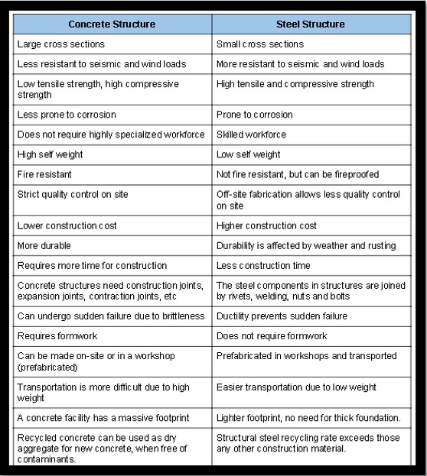

Conclusion
Fazlur khans design of the Willis tower was genius. To design, implement and build a structure the size of the Willis Tower in 4 years, in the early 70’s took absolute brilliance. Considering the weather in Chicago and the impact the wind would have on the building; khans tubular design was breakthrough and has helped shape the steel structure for skyscrapers for the future. The fact the structural design alongside creating the ideal foundations is essential to the buildings durability.
Steel as a material has truly amazed me. Making steel from raw materials to have the strength it does, alongside being able to shape it to your chosen design is a simple yet effective process. Although the creation of steel does harm the environment, the fact that when its recycled (whatever the steel’s condition) it doesn’t lose its strength when being re-used, also when being recycled the process is better for the environment/climate than being created originally.
The install of structural steel is a very simple process when complete with the correct install team. The install speed is time effective and depending on design is often a cheaper alternative. Again the engineer design was brilliant for the Willis tower with the “Christmas tree” structural steel allowed for a mass reduction of welding on site, again saving time and cost.
Concrete and steel both have their pros and cons, however its clear to see why steel was used for the Willis tower. In my opinion it was mainly chosen due to its location, alongside ease of assembly, strength, design with safety being paramount.

References
(no date) Student Resources - geometric drawings including representation of simple solids page 3. Available at: http://www.amsi.org.au/ESA_middle_years/Year7/Year7_2bS/Year7_2bS_R1_pg3.html (Accessed: November 6, 2022).
Available at: https://interactive.wbez.org/curiouscity/willistower/ (Accessed: November 6, 2022).
Baker, T. (1970) 01 Jun Everything You Need to know about steel frame buildings, Baker Steel Trading. Available at: https://www.bakersteeltrading.co.uk/understanding-steel-frame-buildings/ (Accessed: November 6, 2022).
Crude steel production in 2021 shifted from China to other countries amid supply chain chaos: US production spiked 15% (2022) Wolf Street. Available at: https://wolfstreet.com/2022/06/01/crude-steel-production-in-2021-shifted-from-china-to-other-countries-amid-supply-chain-chaos-us-production-spiked-15-as-chinas-fell/ (Accessed: November 8, 2022).
Do skyscrapers sway in the Wind?︱Skydeck Chicago (2021) Skydeck Chicago. Available at: https://theskydeck.com/do-skyscrapers-sway/ (Accessed: November 6, 2022).
Jesse Dukes, J.M. (no date) The Willis Tower in 150 years, WBEZ Interactive. Available at: https://interactive.wbez.org/curiouscity/willistower/ (Accessed: November 6, 2022).
Keskeys, A.P. (2022) Reviled to renowned: How the Eiffel Tower became the most treasured "temporary" structure in history - architizer journal, Journal. Available at: https://architizer.com/blog/inspiration/stories/reviled-to-renowned-the-eiffel-tower/ (Accessed: November 10, 2022).
Know about the wind-resistant architectural designs in Chicago including the bundled tube system used in Willis Tower (no date) Encyclopædia Britannica. Encyclopædia Britannica, inc. Available at: https://www.britannica.com/video/187613/discussion-designs-tube-system-Willis-Tower-Chicago (Accessed: November 6, 2022).
Mansell, B. (2020) A strong foundation, MindPerk. Available at: https://www.mindperk.com/one-minute-motivators/a-strong-foundation/ (Accessed: November 6, 2022).
Nieto, V. (no date) Steel production: From iron ore to functional industrial products., Steel production: from iron ore to functional industrial products. Available at: https://www.vepica.com/blog/steel-production-from-iron-ore-to-functional-industrial-products (Accessed: November 7, 2022).
Sears Tower (currently Willis Tower) (no date) Princeton University. The Trustees of Princeton University. Available at: http://khan.princeton.edu/khanSears.html (Accessed: November 7, 2022).
Sears Tower (no date) World's Tallest Towers. Available at: https://skyscraper.org/tallest-towers/sears-tower/ (Accessed: November 6, 2022).
Steel Production & Environmental Impact (no date) Greenspec. Available at: https://www.greenspec.co.uk/building-design/steel-products-and-environmental-impact/#:~:text=Steel%20production%20has%20a%20number,from%20coking%20and%20iron%2Dmaking. (Accessed: November 8, 2022).
Structural steel contractor extends run times, saves on fuel, reduces noise with new Trailblazer 325 EFI with Excel Power (2022) Miller Electric. Available at: https://www.millerwelds.com/resources/article-library/structural-steel-contractor-extends-run-times-saves-on-fuel-reduces-noise-with-new-trailblazer-325-efi-with-excel-power (Accessed: November 8, 2022).
Types of structural steel and shapes (2022) Yena Engineering. Available at: https://yenaengineering.nl/a-comprehensive-guide-to-structural-steel-2/ (Accessed: November 8, 2022).
Why steel (no date) AISC. Available at: https://www.aisc.org/why-steel/resources/bending-and-curving/ (Accessed: November 9, 2022).
Why Structural Steel is environmentally friendly (2021) Steel Fabrication Services. Available at: https://steelfabservices.com.au/structural-steel-environmentally-friendly/#:~:text=The%20recyclable%20nature%20of%20steel,producing%20them%20from%20raw%20materials. (Accessed: November 8, 2022).
Willis Tower, Chicago: All you need to know (no date) CivilEngineeringBible.com. Available at: https://civilengineeringbible.com/article.php?i=274 (Accessed: November 6, 2022).
World-steel-in figures 2021 Erschienen (no date) bvse. Available at: https://www.bvse.de/schrott-elektronikgeraete-recycling/nachrichten-schrott-eschrott-kfz/7308-world-steel-in-figures-2021-erschienen.html (Accessed: November 8, 2022).

Appendices

Appendix 4 – alternative picture of Khan’s tubular design
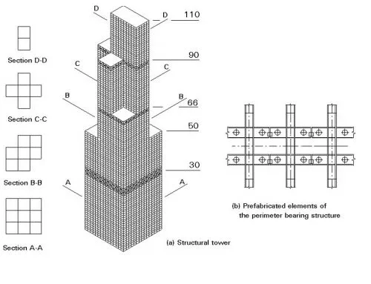

Appendix 2 – Steel production by country

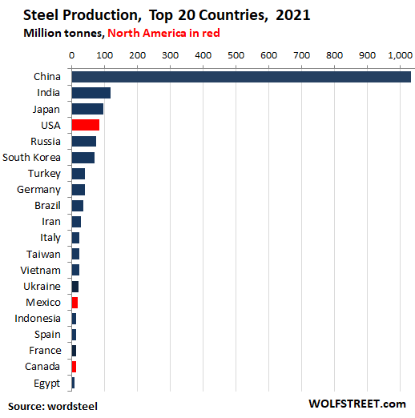

Source: wolfstreet.com (accessed 8/11/22)

Appendix 3 – the rise of steel

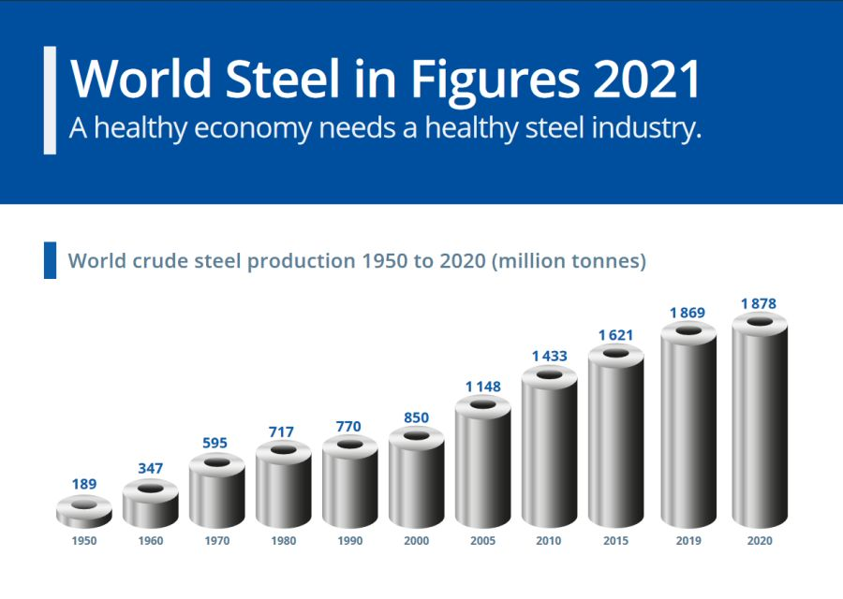
Source: https://www.bvse.de (accessed 8/11/22)

Appendix 4 – steel structure of the Eiffel tower

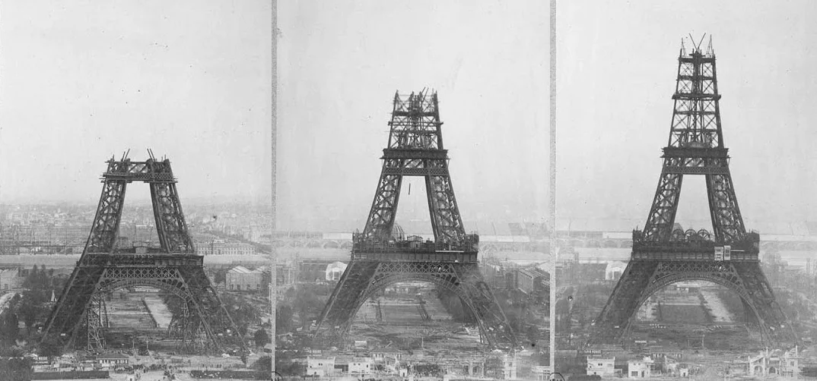

Source: https://architizer.com/blog (accessed 10/11/22)

