Student name: Shazan Begum
Student ID: 1712823
Module Tittle: Banking Financial Management & Financial Markets
Module code: LCMB 7012
Lecturers Name: Konstantina Mari

Table of Contents
Introduction 1
Lloyds Banking Group 1
Leading to the 2007-2008 Financial crisis. 2
Regulations and laws introduced pre and post financial crisis. 4
Basel I Accord 5
Basel II 6
Basel 2.5 Reform 6
Basel III 7
Dodd-Frank Regulation 9
A critical review of the financial system and the banking institutions post 2008 crisis. 10
Impact of the reforms and level of compliance in Lloyds Banking Group. 12
Conclusion 15
Reference 16

Introduction
The 2008 financial crises witnessed the collapse of the entire financial system predominantly the developed economies and is believed to have started in 2007 with the real estate market collapse started. With the spike of the crises delinquencies in the underwritten mortgage was witnessed and had led to serious recession. Many central bankers and government advisers decided to flood the market with money, other liquidity and stimulus packages in developed economies which has resulted to the value of the currencies falling while price of agricultural commodities rising. Several financial institutions had a significant mortgage exposure was diminishing and some were forced to merge with others, some received capital from other investors while others received government subsidies to avoid collapsing. To limit the impact of financial crises on the stakeholders involved in these financial institutions several reforms were enacted.
The author in this report will identify the key laws, regulations and contracts enacted post the 2008 financial crises by the UK, US, EU authorities and other key players in the financial system. A critical review of the extent to which these reforms have contributed towards stabilising the financial system and the banking institutions post the 2008 crises will be carried out. A public listed company Lloyds Banking Group will be analysed for the extent to which these reforms have had an impact on their business model and the level of compliance to these reforms by the company.

Lloyds Banking Group
The first and oldest bank, the Bank of Scotland, was founded on July 17, 1695. Lloyds Bank was founded in 1765 as Taylor & Lloyds in Birmingham. The Lloyds Banking Group was founded in 2009 and brings together many well-known brands. Some of the brands within the Lloyds Banking Group are Lloyds Bank, Halifax, Bank of Scotland, Scottish Widows, MBNA, Schroders Personal Wealth, Blackhorse, Lex Autolease, Birmingham Midshires, LDC, AMC, iWeb. The 13 unique brands are divided into three core areas: retail, commercial banking, insurance, and wealth. With a variety of services provided by the banking group, customers' financial needs can be met in one place. The Lloyds Banking Group has 30 million customers and 65,000 colleagues. Lloyds Banking Group's 2020 pre-tax statutory income was £ 1,226 million and after-tax statutory income was £ 1,387 million.
Lloyds holds a strong position in the UK financial service industry as a result they were able to gain additional streams of revenue and increase their profitability. The group held the largest branch network in the UK with presence in more than 210 locations in 2018 (MarketLine, 2020).
In recent years intellectual automation has transformed the financial services industry for better. Lloyds Banking Group has been one of the first financial service in the industry to adopt and take advantage at scale of automation to ease the burden on employees during particularly busy times (Lloyds Bank, 2020).

Leading to the 2007-2008 Financial crisis.
The Financial crisis started in 2007 and it is understood it has been the worst financial crisis since the 1930s. The crisis quickly expanded from the United States to other countries, and from the financial markets to the real economy. Financial institutions were collapsing; many had to be bailed out by the government, and several had to shut down entirely. Because, the financial industry was devastated by the crisis, financial institutions' risk management strategies have been heavily criticised. The crisis is said to have prompted fundamental changes in the way financial institutions are regulated.
The real estate had a huge input in the financial crisis. In the year 2000 house prices in the United States started to rise much faster than it had the previous ten years, due to the high demand for housing and a bubble in housing price. The contributing factor was the very low level of interest rates between year 2002 and 2005, furthermore the house price rise had largely stimulated by mortgage lending practices. Year 2000 to 2006 saw a substantial rise in subprime mortgages lending, this type of mortgage is more risky than average and are usually classified for second mortgages before year 2000. As financial institutions become more comfortable, they started to offer subprime first mortgage for families that previously had been considered not sufficiently creditworthy to qualify for a mortgage was now able to purchase a house and the increase in demand for real estate price rose. The rising housing price and more lending was very attractive to mortgage brokers and mortgage lenders, as the more lending there is the bigger the profit. The lending was well covered by the collateral by the rising house price furthermore if the borrower defaulted the foreclosure to the lender would be little or no loss. With the increase of housing price, it was getting difficult for people to afford housing and buy their first home, to attract new entrance to buying house the mortgage lenders further relaxed their lending standards. The lending percentage of the housing price increased, and Adjustable-Rate Mortgage were introduced where for first two to three years the low rate of interest was applied followed by rate that was much higher (Hull, 2012). After these two to three years of the initial mortgage people were unable to afford the mortgage as it had moved to a higher rate which was beyond their means and the price in real estate started to go down as these houses went back on sale for foreclosure and a burst in the bubble. People who had bought houses with 100% mortgage found themselves in negative equity as the price they bought the house was now worth less then original price and some of these people decided to handover the property to the banks by going into default with the payments. Because there were many foreclosures there was an increase in the supply of housing for sale but no demand for it. According to Corbae and Quintin (2015) experiments suggest that the high number of mortgages with minimum requirement prior to the crisis can explain the rise in foreclosure rate of over 60 percent.
Securitization was also a big aspect of the financial crisis, and a big portion of the US capital markets, despite the fact that it was mostly unregulated. In the 1990s, legal companies began trading pools of loans on the capital markets, as well as securities tied to pools of loans known as "special purpose vehicles" (SPVs). Asset-backed securities (ABS) or mortgage-backed securities (MBS) are the terms used to describe these securities. The SPV’s are the claimant to the cash flows from the pool of loans held (Gorton and Metrick, 2012).

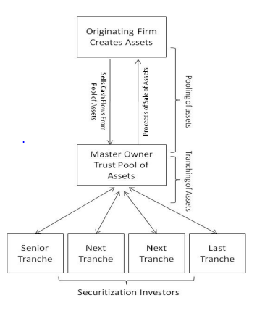
Figure 1. An overview of Securitization (Gorton and Metrick, 2012).
Internal control was enforced by the Federal Depository Insurance Corporation Improvement Act (FDICIA) in the early 1990s, which increased loan-loss provision validity, earning persistence, and cash-flow predictability, as well as reducing benchmarking-beating. Banks with assets under $500 million and non-US bank providers are exempt from the rules.
Research suggests greater auditor existence mitigates for internal control regulations (Journal of Accounting and Economics, 2010). The mandate had further contributed to the financial crisis in 2007-2008.
Scholarly material indicates the financial crisis was primarily caused by deregulation in the financial industry and implementation failure in risk management and corporate governance. A series of interviews with senior risk management experts from throughout the financial services sector were done to gain a better understanding of what caused the crisis and what lessons might be learned for the future.
Some of the common views were:
- There was implementation failure in risk management and corporate governance that was aligned with acceptable good practice.
- Weaknesses in corporate culture had played a major role. A sales culture that promoted rapid growth were the worst and most affected while the banks with traditional banking values like prudent and long-term view was least affected.
- Basic human culture and weaknesses in risk reporting and managing competency.
Although these were some of the additional factors leading to the financial crisis the main cause could have been that financial institutions found it difficult to stay away from some of the risker activities due to competitive pressure. The senior risk management professional further indicated there had been significant regulatory failures in design of regulatory framework (IGI Global, 2019).
Lehman Brothers Holdings Inc, a global financial services firm founded in 1847 was one of the fourth largest investment bank in the United States. The firm’s investment in MBS and the lending of subprime mortgage loans has led to the bankruptcy of the firm on 15th September 2008. It was the largest bankruptcy involving more than US$600 billion in assets.
Similarly in UK Northern Rock had a bank run and the bank was unable to pay its customers. The bank was then taken to public ownership instead of solvency or bankruptcy in 2008. Northern Rock was partly bought by Virgin Money and part of the bad asset was being sold under the government guidance.
According to the data collated in MarketLine (2013), it is believed alternative banks are profiting from the loss of trust in the big four. The Banking industry in UK has witnessed a loss of reputation and credibility after the banking scandals since the beginning of the recession period and had led to distrust among the consumers. These consumers are switching to alternative banks that set them apart from the major banks and UK is likely to see banking climate change permanently with more of these alternatives with ethically focused and member led organisations. The Co-operative Group was founded in 1844 as a consumer co-operative organisation involved in many different business areas. Profits of the group are shared between members, and it has a very specific ethical policy setting it apart from other banks, business areas are only dealt with if it deems to be ethically healthy. According to MarketLine (2013) The Co-operative Group has purchased 632 Lloyds branches furthermore it is likely to become the next major challenger to the UK retail “big four” banks.

Regulations and laws introduced pre and post financial crisis.
National regulators oversee banks in their own nations, although the majority of countries have adopted the Basel Committee's set of standards to achieve international consistency. The Basel Committee of Banks is submerged from the G10 countries, and they meet in Basel in Switzerland.
Regulations are introduced when there is a rise in market failure or fail to work appropriately. This can be the reference to “Market Failure”. There are many reasons for market failure however for the purpose of this section of the report focus will be on bank failure. When there is a rising problem from banks it falls into two category, externalities, and asymmetric information. Behaviours of a bank can give rise to two areas of concern, the possibility of contagion and consumer protection. Contagion means the problem can spread very rapidly. Contagion can occur from a combination of the fractional reserve system as well as when banks use deposits as means of payment. Banks can face liquidity risk when the depositors demand for cash which the banks is unable to meet. Banks generally rely upon confidence and trust by the depositor. When depositors feel that banks cannot pay there is a run-on bank, and many depositors are demanding an amount of cash that banks cannot pay. Moreover, when a bank undergoes a “run”, the public loses confidence in the system and can quickly withdraw cash from a bank that may be completely solid. Banks facing panicked cash demand need to find cash as quickly as possible. Banks then turn to the interbank market for overnight loans. If a bank withdraws or refuses to extend an interbank loan, there is a risk that the borrowing bank will be liquid and unable to meet customer demands. The second area of concern is consumer protected. Generally, it is the buyer’s obligation to check what is being bought and does it meet the purpose, though this is fine with buying simple product and well-informed buyers however it is not the case currently with many products in the market with complicated clues in it. Modern financial systems rely heavily on recruiting and maximising number of consumers to spread the banks internal risk therefore not all consumers are well information of the products descriptor. Additionally, governments are encouraging the consumers to use these intermediaries to open bank accounts and build up saving, this makes it convenient for public authority to pay benefits into. For these two reasons it is important to have regulations in place. Government cannot leave consumers to look after themselves some of whom maybe financially unsophisticated.
The Central Banks has a duty to maintain the stability of the currency and money supply for the group of countries or a country. In United Kingdom the bank of England has a set of roles in financial stability which include Risk Assessment, Risk Reduction, Oversight of Payment Systems, Crisis Management. Central Banks accomplish their goals through monetary policy therefore they are recognized as Monetary Authority. Central Banks implement the monetary policy by requiring private banks to maintain and deposit the required reserved deposit and therefore central banks are referred to as reserve bank. During a financial crisis or to divert a financial crisis the central banks perform the role of lender of last resort for the banking system. In addition to the country’s central bank there is the European Central Bank (ECB). The ECB came to existence in January 1999 and is responsible for implementing monetary policy for the member countries of the European Union (Fabozzi, 2014).
Customarily to analyse the performance of banks a set of ratios, net interest margin (NIM), return on average asset (ROAA), return on average equity ratio (ROAE) or cost to income was used. However, the financial crisis has proved that these measures are not enough to judge the financial institutions and performance should correlate with risk. Furthermore, these sets of ratios have been criticized for being insufficient to effectively measure the performance of banks credit risk, interest rate risk, foreign exchange risk, operational risk, leverage, and liquidity risk. Banks efficiency measures should include the effects of risks on measured profitability ratios and therefore all the previous measures have been revaluated to incorporate risk monitoring and processes for prudential regulations (Dinçer and Hacioğlu, 2014).

Basel I Accord
In 1974 The Basel Committee was formed consisting of representatives from Belgium, Canada, France, Germany, Italy, Japan, Luxembourg, the Netherlands, Sweden, Switzerland, the United Kingdom, and the United States. The committee met regularly in Basel in Switzerland. The international standards for bank regulation agreement were made in 1988 known as the Basel Accord. The Basel Accord later became known as Basel I. Basel I had no capital requirements defined for market risk. Soon regulators recognised the risks to a banking system with insufficient capital held for sudden large losses from huge exposures in the capital markets. During the mid-1990s amendment proposals were made to the 1988 Accord requiring additional capital above the minimum required for credit risk. The committee decided to set international risk-based standards for capital adequacy, all 12 members of the Basel Committee at the time signed the agreement for significant increase in the resource’s banks devoted to measuring, understanding, and managing risks. The key innovation of this accord was the bank’s total risk-weighted assets measures which considers credit risk exposures that are both on-balance-sheet and off-balance-sheet (Hull,2015). The accord focuses on risk asset ratio (RaR). Capital requirement in Basel I requires banks to keep capital equal to at least 8% of the risk-weighted assets. Capital has two components, Tier 1 capital, and Tier 2 Capital. Tier 1 capital consists of equity and noncumulative perpetual preferred stock. Tier 2 capital often referred to as supplementary capital, includes cumulative perpetual preferred stock. 99-year debenture issues and subordinated debt with a life of more than 5 years. The requirement is to have at least 50% of the required capital (4%) to be in Tier 1 and 2% of risk-weighted asset to be common equity. Further clarification has been made on common equity and definition of instruments that are eligible for Tier 1 capital in Basel III (Hull,2015).

Risk Asset Ratio Formula (Moodle Lecture slide 9).

Basel II
Basel I focused on asset default exposures, while Basel II also seeks to take into account market and operational risk. In 1998, a framework for capital adequacy against market risk was introduced. The Basel II Accord was developed to encourage rational motivation to take risks and monitor it with the help of an appropriate risk model for calculating value at risk (VaR) and daily capital requirements. (McAleer at el, 2013). Some critics have blamed the Basel II agreement for the 2007-2008 financial crisis. The move towards self-regulation (Hull, 2015) where banks had the freedom to use their own estimates of model inputs such as PD, LGD, EAD when calculating regulated capital.

Basel 2.5 Reform
The first framework for minimum capital requirements for market risk was introduced by the Basel Committee on Banking Supervision in January 1996. The purpose of this framework was to ensure that banks have minimal regulatory capital to absorb losses from market movements. However, bank losses during the 2007-2008 financial crisis have shown that the framework conditions for banks to survive such a serious market crisis are inadequate. Then, in July 2009, the Commission revised the market risk framework known as the Basel 2.5 Reform. The reforms addressed the most serious flaws in the framework, but it was acknowledged that many structural flaws that were not addressed during the crisis were identified. So, they conducted a thorough review of the Trading Book (FRTB). Banks have a portfolio of trading products for short-term profits, also known as trading books. Basel 2.5 was introduced on December 31, 2011.
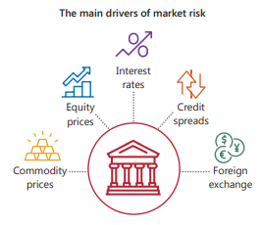

Figure 2. The contributing factors of Market risk (Market risk framework (BIS, 2019).
Based on the experience of mistakes in the development of the financial crisis, the purpose of the project was to develop stronger framework conditions. The Basel 2.5 Reform addressed the emergency measures needed for proper capital requirements for trade activities. Value at risk (VaR), an internal model risk indicator that underlies market risk capital requirements prior to the crisis framework, has been improved by the introduction of additional VaR-based capital requirements for emergency market conditions. rice field. The "Stressed VaR" matrix considers the losses that banks may incur in an emergency phase. The Incremental Risk Capital (IRC) framework has been introduced. Capital requirements for default risk and rating transition risk are defined in this framework. The securitization structure during the crisis caused considerable losses, and Basel 2.5 excluded trading book securitization positions from the internal model, which were consistent with banking book positions. The Basel 2.5 reform addressed some concerns but did not address key structural flaws in the market risk framework (BIS, 2017).
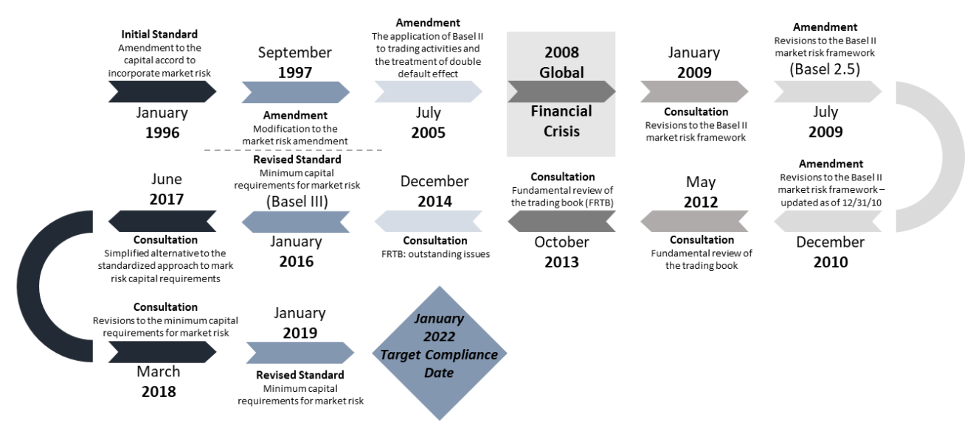
Figure 3. Capital requirement for Market Risk history (BIS, 2019).

Basel III
Basel III published in December 2010 and in 2016 revised the framework, was scheduled for implementation in 2019. This framework provides a capital increase that banks must hold for credit risk and strengthens the definition of capital. An important feature is the specification of liquidity requirements that banks must meet. However, in monitoring the implementation and impact of the new legal framework, the Commission observed ongoing challenges and issues in design and calibration. To direct these to the Governor's group and head of oversight, the Commission's supervisory body has extended the implementation date to 2022. This gave banks more time to expand their infrastructure.
After the 2007-2008 financial crisis, Basel III has a more comprehensive set of measures to protect banks, address the shortcomings identified in the Basel 2.5 Capital Requirements Directive, and improve the resilience of the financial system. Introduced capital and liquidity requirements. Basel III includes a framework for higher risk-based capital adequacy ratios and credit quality, and leverage ratios as a simple, transparent, non-risk-based approach to risk-based standards. US banks have long been the subject of less comprehensive leverage ratios that require capital only on on-balance sheet assets. This framework extends it by including off-balance sheet risk for derivatives and other transactions in the calculation of leverage. As a result, the leverage ratio of Basel III significantly increases the capital adequacy requirements of banks' derivatives businesses. The Basel Committee on Banking Supervision has designed the Basel III leverage ratio as a backstop for risk-based criteria. The framework defines Tier 1 capital as a percentage of total leverage exposure. The Basel Committee on Banking Supervision proposes a minimum leverage ratio of 3%, but US regulators have set a higher leverage ratio called the Supplementary Leverage Ratio (SLR). GSIBs incorporated into the United States for their own country must maintain a minimum of 5% SLR on a consolidated basis, and caretakers must maintain a minimum of 6% SLR (Haynes and McPhail, 2021)

Formular for Leverage ratio (Basel Committee in Banking Supervision, 2021).
In the UK the leverage ratio framework requires major banks and building society to have minimum Tier 1 leverage ratio of 3.25% on measure of exposures this excludes qualifying central bank reserves. The Financial Policy Committee (FPC) of UK are proposing in reflecting the risk-weighted asset (RWA) framework, three-quarters of the minimum requirement must be met with Common Equity Tier 1 (CET1) capital and the remaining additional Tier 1 capital instruments must have a conversion trigger of 7% minimum of risk-weighted CET1 capital to amount toward the leverage ratio minimum requirement. Leverage ratio framework in the UK includes regulatory buffers that must be met only with CET1. FPC is proposing an additional leverage ratio buffer for systemically important banks and a countercyclical leverage ratio buffer (Regulatory News, 2021). There will be further discussion on systemic risk and importance of avoiding it.
After banks were unable to properly measure, manage and monitor liquidity risk in 2007, the Basel Committee on Banking Supervision (BCBS) introduced two liquidity standards as part of Basel III. The first is the Liquidity Coverage Ratio (LCR), which is short-term resilience, and the second is the Net Stable Funding Ratio (NSFR), which allows banks to fund their operations with more stable sources of funding as well as a long-term resilience. Liquidity coverage rate (LCR) consists of two components. HQLA inventory under stressful conditions plus total net cash outflow. LCR is an extension of the traditional liquidity coverage ratio approach that banks use internally to assess exposure to contingent liquidity events.

Liquidity Coverage Ratio formula (Basel Committee in Banking Supervision, 2021).
NSFR ratio must be at least 100%. ASF is part of the capital and liabilities that remains in the bank for over a year. Due to the illiquidity of RSFs, assets or exposures need to be fully funded with stable funding. This framework is the minimum standard that applies to all internationally active banks. It must be adhered to continuously and banks are obliged to report quarterly.

NSFR formula (Basel Committee in Banking Supervision, 2021).

The concept of ‘systemic risk’ is fundamental to the regulatory framework established under Basel III and Dodd-Frank. The remit of the FSOC (Financial Stability Oversight Council) and FRB (Financial Reserve Bank) is to measure systemic risk and the policymakers have recently begun to develop the methodology to gauge this risk. Policymakers, economists, and central bankers have come to agreement on how to measure and define if a risk was systemic risk by considering the effects of disruptions in financial systems, if the disruption/event did not cause significant disruptions in the real economy then it is not a systemic risk event. The approach of systemic risk is when there is a collapse of financial intermediation that stops the flow of cash and credit to businesses and consumers which is the mechanism for economic output and growth. According to researchers there are two causes of systemic event identified, interconnectedness of financial institutions and simultaneous shock to financial systems through contagion. During and after the great financial crisis regulatory globally rescued many large failing institutions for the fear of the domino effect. Post GFC importance was given to the critical need for international coordination in the globally integrated financial system. Coordination needs to be systematized and formulised, a realization by authorities in the world’s major financial markets. FSOC was created by Dodd-Frank Wall Street Reform and Consumer Protection Act to coordinate systemic risk oversight and designated certain financial groups by vote as Systemically Important Financial Institutions (SIFIs). Voting members included the Treasury Secretary and federal financial regulators. The aim was to proactively detect and recommend measures to prevent potential risks to the stability of the financial system in U.S (Dill, 2020).
The United Kingdom accounts for 18.8% of the European banks industry value (MarketLine, 2020).
The prudential requirements of Basel framework are categorised to three pillars, Pillar 1: Minimum capital requirement, Pillar 2: Supervisory review process, Pillar 3: Market discipline.
The Bank of England (BoE) in the U.K oversees regulation and supervision of systemic risk. The Financial Policy Committee (FPC) of BoE with representatives from BoE, Financial Conduct Authority (FCA), Prudential Regulation Authority (PRA), external members and Treasury observer oversees systemic risk issues. European Systemic Risk Board (ESRB) in the EU is responsible for macro-prudential oversight of the EU’s financial system and prevent or mitigate systemic risks to financial stability (Dill, 2020).

Dodd-Frank Regulation
Another concept that Basel III / Dodd-Frank is trying to solve is TBTF (too big to fail). TBTF has become a public policy issue due to disagreements about its definition and the costs and benefits of running a TBTF agency. There were two questions about which counterparties were fully or partially protected, and whether the loss from relief was due to government or private funding. There has been much controversy over taxpayer-funded bailouts and has since been the driving force behind much of Dodd-Frank's TBTF regulation. TBTF applies to pledges where shareholders are unprotected, institutions go bankrupt, and assets are sold or liquidated. Uninsured creditors and depositors can be paid in full or partly. This loss allocation is determined by regulatory agencies considering other protection costs and the benefits of avoiding financial instability against moral hazard. Government and TBTF bailouts are inextricably intertwined, but TBTF does not necessarily involve the government. In addition, the Federal Reserve, the lender of last resort to provide liquidity loans for appropriate collateral from solvent financial institutions, is not a government bailout fund. One of TBTF's major regulatory mechanisms is FSOC, which is also one of Dodd Frank's devices that regulate shadow banking systems (Dill, 2020)

A critical review of the financial system and the banking institutions post 2008 crisis.
There are mainly four forms of banking regulation the reform bought to light:
- Regulating the structure and activities
- Regulations on banks liquidity (banks’ reserve ratio)
- Regulations of capital adequacy
- Clarity and accuracy of information (as part of consumer protection)
Table 1 Emphasise how the changes in capital requirements influence the standard deviations. The first column represents Basel III with a 15.5% capital requirement and the other two column represent Base II with 13% and 10.5% capital requirement
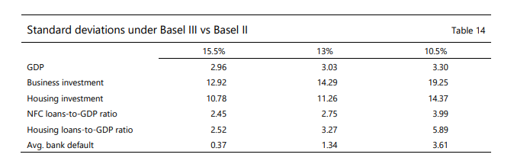
Table 1. Standard deviations under Basel III vs Basel II.
The unpredictability for all variable essentially moves down under Basel III compared to Basel II with both levels of capital requirements however the results are more substantial when compared to the regime with a capital requirement of 10.5%. The GDP is lower under Basel III, this is partly driven by a reduction in instability of investment, driven by lower insecurity of lending supported by a more established banking system. Reflecting the improved capital positions of banks, the volatility of the probability of banks failure is considerably lower under Basel III (Basel Committee on Banking Supervision, 2021).
The improvement to risk governance provided a positive economic benefit. Scholarly research material indicate after the risk governance changes the lower performing banks increased their number of independent directors, financial experts, and the number of risk committee meetings throughout the years. Years before the financial crisis lower performing banks had weaker risk governance than those in higher stock performance. These corrective actions taken to rebuild risk governance by lower performing banks were similar level to high performing banks. These lower performing banks have improved their risk management and increased stock performance (Chen et al, 2019).
There has been considerable success in developing uniform capital requirements in Basel III. This framework emphasizes the quality and quantity of core capital with the aim of maintaining the bank's capital buffer globally. To mitigate systemic risk, BCBS has developed a plan that includes liquidity requirements combined with a set of macroprudential tools to address the shortcomings of Basel I and Basel II. These reforms are expected to be costly, but capital is essential, and capital is expensive. Therefore, over the next few years, it will be very important for regulators to weigh the costs and benefits of Basel III at each stage of the new system introduced. To be successful under Basel III, banks' business models need to be modified to varying degrees around the world.
The cost of regulation can come in different form however on deciding how rigorous regulations should be, there are four main issues that must be considered; Moral hazard, Agency Capture, Compliance costs and Barriers to entry (Moodle, Lecture Note 9). Banks are required to comply with rigorous adequacy ratio to strengthen their capital structure however the capital adequacy ratio can influence competition and risk taking in various ways. The rigorously binding higher initial capital requirements can consequently impose entry barriers for new entrants. Furthermore, the higher overall capital requirements associated with higher fixed costs for running a bank, has resulted in fewer banks being able to afford these costs. This stringent requirement has further led banks to set firm acceptance criteria for granting new loans and banks are less risk taking (Wangi and Lin, 2014). Equally concerning factor for the banks is the increase on equity capital requirement will mean banks will find it difficult to achieve the returns on equity that they had pre crisis period. For growth in the economy loans is important to businesses and competition between banks to acquire customers is good, as this will give consumers more choice. Despite some of these disadvantages shareholders of the bank can be at comfort zone that banks stocks are less risky due to the extra capital (Hull, 2015).
According to Brazier (2019) post financial crisis a new buss phase emerged in economic policy makers; macroprudential policy. The policy aims to promote a financial system that is resilient to bad times but also efficient the rest of the time. As mentioned earlier in the report a Financial Policy Committee (FPC) was created after the financial crisis in the Bank of England. Within six years of its existence the FPC has boosted the flexibility of the banking system, the threat of pockets of credit growth was dealt with, limits were put in place on high loan-to-income mortgage lending, greater resilience to cyber-attack was built and further ensured the core of the UK financial system is resilient. Alex Brazier, The Executive Director for Financial Stability Strategy and Risk and Bank of England Member of the Financial Policy Committee believes the job now is to ensure the standards of resilience move with the time in the financial system. His theory is to keep pace with the changing economy by using cutting-edge research to monitor the development of debt level today and it can affect the severity of downturn in the economy in the future. Furthermore, he believes keeping pace with the changing financial system is important. New research is enabling FPC to imitate the effect of economic downfalls on the growing non- bank financial system however there are possible weak spot that need monitoring and some areas need new standards of resilience (Alex, 2019).

Impact of the reforms and level of compliance in Lloyds Banking Group.
UK legislation on ring-fencing was passed, enacted, and went alive on January 2019. This legislation was introduced after the financial crises to better protect the customers and the day-to-day banking service they rely on. The new ring-fencing rule requires large UK banks to separate personal banking services from risks in the other parts of the businesses like investment banking and complex wholesale (Lloyds Banking Group Annual report 2020).
The new ring-fencing rule had relatively limited effect for most of the Lloyds Group’s retail and commercial customers who hold current accounts, saving and deposits. Lloyds Banking Group’s approach to ring-fencing changes comprises of subdivision in the group as displayed below:
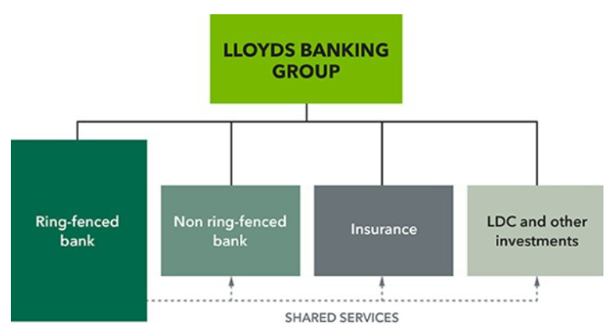
Figure 4. Lloyds Banking Group ring-fencing division (Lloyds Banking Group Annual report 2020).

According to the Managing Director, Head of Strategic Liquidity, Nick Burge of Lloyds Bank, the balance sheet of the bank needs to be optimised across four key metrics as illustrated below (Burge, 2016).
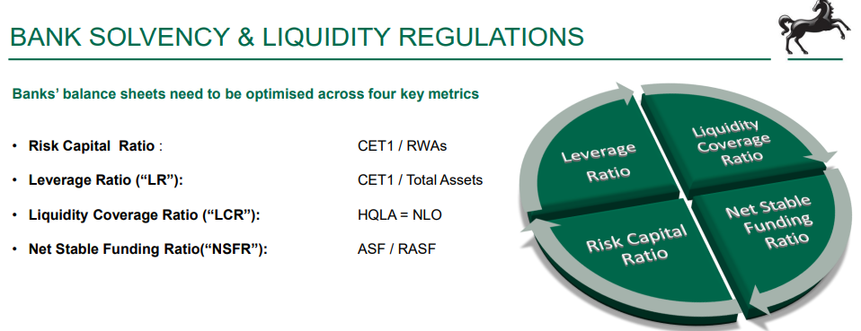

The images below indicate some of the ratios and the risk weighted asset figures of Lloyds Banking Group for year 2019 and 2020.
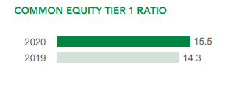
The Lloyds Banking Group's Tier 1 capital ratio of common stock, etc. increased from 14.3% in 2019 to 15.5% in 2020. The revised capital treatment introduced into intangible software assets has also significantly reduced the intangible assets withdrawn from capital.
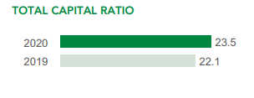
The Lloyds Banking Group's total capital adequacy ratio increased from 22.1% in 2019 to 23.5% in 2020. This is mainly due to the increase in Common Equity Tier 1 and the issuance of the new AT1.

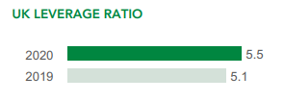
The leverage ratio of Lloyds Banking Group UK increased from 5.1% in 2019 to 5.5% in 2020. This is primarily a reflection of the fully hampered increase in Tier 1 capital positions. This is expected to be moderately offset by an increase in leverage exposure indicators that reflect securities financial trading and off-balance sheet position movements.
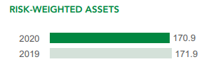
The Group’s Risk Weighted Assets (RWAs) reduced from £171.9 billion in 2019 to £170.9 billion during the year 2020.

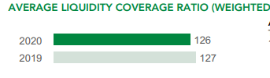
The Group’s liquidity ratio in 2020 was at 126 from 127 in 2019, still at a strong position.

The split of risk weighted assets of Lloyds Banking Group
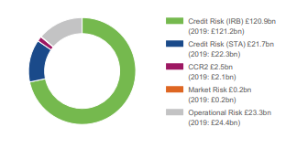
Figure 5. Risk Weighted Assets (Lloyds Bank plc, 2020).
Lloyds Banking Groups Capital Composition in figure 5 in comparison to some of the ratios and the risk weighted assets for 2019 and 2020, has demonstrated the bank has made significant improvement and further strive to maintain high level of compliance to the standard and guidelines set by the Banking Supervision of the Basel Committee.
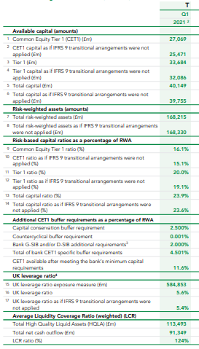
The table on the left illustrates some of the Lloyds Banking Groups ratios for first quarter 2021, aligned with the standards and guidelines set by Banking Supervision Committee.
- Minimum benchmark for Capital ratio is 8% as mentioned earlier, Lloyds Banking Group capital ratio is 23.6% for first quarter year 2021 which substantially high.

- Benchmark for leverage ratio is 3% set by Banking Supervisory Committee however, for UK it is 3.25%. Lloyds Banking Group has leverage ratio of 5.6%, much higher than the benchmark.

- The average Liquidity Coverage ratio benchmark is 100% set by the Banking Supervisory Committee, Lloyds Banking Groups LCR is 124% again a much higher percentage than the benchmark.

Lloyds Banks Interim Pillar 3 Report (Lloyds Bank plc, 2021).

Conclusion
The report started with an introduction following with an introduction to the chosen bank, Lloyds Banking Group. A brief history was given on the causes leading to the 2007-2008 financial crisis. Regulations and laws that have been introduced pre and post financial crisis, as they are interlinked, was discussed. These included Basel I, Basel II, Basel 2.5, Basel III, the Dodd-Frank regulations, and the ring-fencing act of UK. A critical review was undertaken of the reforms and contribution towards stabilising the financial system and the banking institutions post 2008 crisis. A review was conducted on the impact of the reforms and regulation and the level of compliance in Lloyds Banking Group. Throughout the report tables, diagrams, pia chart and formulas were presented to illustrate the findings. In conclusion Lloyds Banking Group had to make some changes to the structure to align with the ring-fencing act that was passed in UK furthermore they have implemented the regulations and adhered to the guidelines set by the banking supervisory committee. This is transparent in their financial report which illustrate Lloyds Banking Group has met and in fact are above the benchmarks set in Basel III for capital ratio, leverage ratio and average liquidity coverage ratio. In conclusion to the reform and contribution towards stabilising the financial system and the banking institutions post 2008 crisis, the regulations have to some extent helped stabilize it, but further analyses are needed to understand the level of benefits and deficit of the reform over time and at internal and external level. It is paramount that all countries that have signed the Basel Accord and are committee members to establish these reforms and regulations in their regional countries for it to work, as all member countries financial systems and banking institutions are interlinked therefore to avoid any contagion affect all should follow the same regulations and laws. Adoption of and adherence to comprehensive regulatory standards are prerequisites to financial stability. After further analyses by the committee and once Basel III is fully implemented there maybe a need to introduce Basel IV specially to cater for EU and Asian Banks that are experiencing capital shortfall.

Reference
The Global Financial Crisis 2007/2008 and Financial Risk Management(2019a), [Homepage of IGI Global], [Online]. Available: https://www-igi-global-com.ezproxy.uwtsd.ac.uk/gateway/chapter/213282 [2021, Dec 9,].
"Minimum capital requirements for market risk"(2019b). available at: https://www.bis.org/bcbs/publ/d457.htm. (Accessed Nov 23, 2021).
"Basel III: international regulatory framework for banks"(2017), available at: https://www.bis.org/bcbs/basel3.htm. (Accessed Nov 22, 2021).
"How does internal control regulation affect financial reporting?"(2010), Journal of Accounting and Economics, Vol. 49, No. 1-2, pp. 58-74. available at: https://www-sciencedirect-com.ezproxy.uwtsd.ac.uk/science/article/pii/S0165410109000354. (Accessed Nov 22, 2021).
Financial resilience and economic earthquakes - speech by Alex Brazier(a) Available: https://www.bankofengland.co.uk/speech/2019/alex-brazier-speech-at-university-of-warwick (Accessed Nov 5. 2021).
Helping Britain Recover: Annual Report 2020(b). Available: https://www.lloydsbankinggroup.com/investors/annual-report.html (Accessed Nov 5, 2021).
Alex Brazier (2019). "Financial resilience and economic earthquakes" available at: https://www.bankofengland.co.uk/speech/2019/alex-brazier-speech-at-university-of-warwick.
Burge Nick (2016). "Corporate Liquidity
Managing the Challenges Facing Treasurers", Commercial Banking, available at: https://www.treasurers.org/ACTmedia/Nick%20Burge,%20Lloyds%20Bank.pdf.
Chen, J., Cheng, C., Ku, C.Y. and Liao, W. (2019). "Are Banks Improving Risk Governance After the Financial Crisis?:", Journal of Accounting, Auditing & Finance, available at: https://journals-sagepub-com.ezproxy.uwtsd.ac.uk/doi/full/10.1177/0148558X19870099. (Accessed Nov 22, 2021).
Corbae, D. and Quintin, E. (2015). "Leverage and the Foreclosure Crisis", Journal of Political Economy, Vol. 123, No. 1-65 available at: www.jator.org.
Dill, A. (2020). BANK REGULATION, RISK MANAGEMENT, AND COMPLIANCE translated by Anonymous Taylor & Francis.
Dinçer Hasan and Hacioğlu Ümit (2014). Global strategies in banking and finance translated by Anonymous Business Science Reference, Hershey.
Fabozzi, F.J. (2014). Foundations of financial markets and institutions translated by Anonymous Pearson, Essex, England.
Hull C. John (2015), Risk Management and Financial Institutions, Fourth Edition ed., translated by Anonymous Wiley.
MarketLine (2013). "The Co-operative
Bank" available at: https://www.marketline.com/.
McAleer, M., Jiménez-Martín, J. and Pérez-Amaral, T. (2013). "International Evidence on GFC-Robust Forecasts for Risk Management under the Basel Accord", Journal of Forecasting, Vol. 32, No. 3, pp. 267-288. available at: https://onlinelibrary.wiley.com/doi/abs/10.1002/for.1269. (Accessed Jan 8, 2022).
Regulstory News , PRA and FPC Propose Changes to Leverage Ratio Framework in UK. Available: https://www.moodysanalytics.com/regulatory-news/jun-29-21-pra-and-fpc-propose-changes-to-leverage-ratio-framework-in-uk [2021, Nov 28,].
StockLight (2021). "Tesla Annual Report 2021", No. Form 10-K (NASDAQ:TSLA) available at: https://annualreport.stocklight.com/NASDAQ/TSLA/21598537.pdf.
Wang, M. and Lin, C. (2014). "Impact of Bank Operational Efficiency Using a Three-Stage DEA Model", International Journal of Risk and Contingency Management (IJRCM), Vol. 3, No. 4, pp. 32-50. available at: https://www-igi-global-com.ezproxy.uwtsd.ac.uk/article/impact-of-bank-operational-efficiency-using-a-three-stage-dea-model/120556. (Accessed Dec 9, 2021).

