UWTSD

COMMUNITY ENGAGEMENT: ASSIGNMENT 1
(LCBB4002)
BA BUSINESS MANAGEMANT
GROUP: 1

Lecture: TANJA NATHAN
Student Number: 1908490

Submission date: 04.12.2019

Executive summary

Community engagement is the process of working collaboratively with groups of individuals to ensure their wellbeing in the society. This can be address by many different forms sharing the same aim to improve the health of the community. It has discussed the impact of micro and macro environment on the performance of HSBC. Report evaluated the values, mission and vision of the company and expectations of customers. The report highlights the importance of employee role and discussed the HR manager impact over the organization. The required knowledge and skills for the HR manager role are also assessed in the report.

Table of content

Introduction 4
Organizational background 4
Discussion 5
Role of employees 5
Training and development and its importance 5
Role and its importance 6
Skills needed for the role 7
SWOT analysis 7
PESTEL analysis 9
Conclusion 12
Reference 13
Appendices 15

Introduction
Community engagement is the process of implementation of procedures to ensure members have access to valuable activities of the society and make sure that they are able to participate in those activities fully. This report evaluates the tole of HR manager and employees of the world largest multinational investment bank and financial services holding HSBC. Firstly, the report will discuss the mission, vision and values of the company, followed by examination of HR and employee's role. Finally, the report will examine the impact of macro and microenvironment on HSBC performance.

Organizational background
HSBC stands for Hong Kong and Shangai Banking Corporation and it was established in 1865 Today the corporation provides a variety of services commercial banking, investment banking, personal financial services etc. The main purpose of the bank was to help the trade between Europe and Asia. Even today the bank continues to describe itself as “Business bank that help entrepreneurs (HSBC,2019). HSBC is a public limited financial bank which successfully operates for over 154 years and now it is the second largest firm in terms of assets and one of the top five banking industry. Its major UK competitors are Royal Bank of Scotland and Barclays. Today the bank serves in 65 different countries with more than 40 million customers and over 85 000 employees in UK and 235 000 employees worldwide.

The vision of HSBC is to be leading international bank which help small business to operate by providing finance for them (HSBC,2019).
The mission of the corporation is to help businesses to develop and economic to prospect, helping individuals to make their dream becoming true and increasing their ambitious, (HSBC,2019).
HSBC value innovation of services, respect to employees, following business regulations. All their employees are required to follow those values in their day-to-day actions in order to build long-term personal relationship with their customers (HSBC,2019).
The company has a variety of customers including small and large corporation; therefore, employees are expected to always act ethical and making the right decisions, but without compromising a single ethical principal. Therefore, they have to work hard upon the company main ethical principal- being trustworthy.
HSBC main aim is to create a sustainable environment where employees have a secure job and customers have confidence in banks.

Discussion

Role of employees

Theorist argue employee engagements is the main factor for effectively achieving goals of an organisation. HSBC needs to make sure its employees are well equipped and they have availability to all resources needed in order to make sure is convenient for them to work. Skilled workers are main reason for the company grow because they meet deadlines which boost sales. These skills are important for employees of HSBC because as a company which mainly works with customers and still building trust, their customers are mostly attracted from outstanding customers service with responsible attitude.
As Ruck et al. (2017) argues employees are influential on growth of an organisation. Such as employee's role is to deliver their best effort to make sure company targets are achieved. HSBC employees play an important role to achieve company goals, therefore employees should be able to create innovative solutions to varied problems. Employee also have the role to follow legal framework of the organisation to maintain safe working environment.

Training and development and its importance
As argued by Noe et al. (2017), training of an employee addresses their weak areas and help them to develop their skills. Argues organisation should develop programs which will boost their employee's skills. HSBC are constantly making an improvement in the performance of their employees by providing them to participate in discussions about the organisation. As the banking sector is fast changing, HSBC employees are provided with training for every new product lounged. HSBC value its employees and providing different programs for their development. This help their employees by making them independent when they face any challenges to increase production.
Secondly Noe et al (2017) argues training and development programs motivate employees to perform better. In regards to this the constant investment which HSBC insert into its employees will create for them high skilled employees.

Role of HR manager and its importance

Human Resource Manager is one of the major important roles in the banking industry. Its responsibilities are creating an effective plan and implementing policies which will be obligatory for every employee. As argued by Banfield et al. (2018), HR manager has a duty in the process of recruitment and staffing in order to hire new talents for the workforce. Organisational development and establishing a unique a recruiting process in order to discover new talents from the employees is the major duty of the HR manager. In this context the HR manager of HSBC strongly shows they perform their duty since hiring procedures are always innovated in order to make sure they hire the best talent to improve their performance.

HSBC HR manager has an important role in supplying advice to managers in regards to regulations used by the corporation. Handling disputes is one of the major points at which HR manager are trying to create a universal policy to act upon. In addition, HR managers are also involved in providing advice to top management in the creation of strategic planning of the organisation. As Banfield et al. (2018) argue HR managers main role is to discover a method to maximise the worth of employees in companies and to make sure they work at high efficiency. HR managers are also responsible for employee related queries including payroll and training. The HR manager of HSBC has a role in ensuring that jobs get accomplished in full accuracy and efficiency training is provided to its employees which fits with all regulation's requirements.

Figure 1: Role of HR manager
(Source: Banfield et al. 2018)

Skills needed for the role of HR manager
Human Resource Manager role is complex, therefore there are various knowledge and skills required for this job. As optioned by Navimipour et al. (2015) the most principal ability for HR manager is leadership and communication.HR manager is required to communicate effectively with all the different levels of organizational structure both the employees and top managers. The great communication skills in hand with leadership in terms of strong coaching skills creates the balance needed for outstanding HR manager candidate.

Critical thinking and innovation framework are another required skills for an HR manager as they have to form decisions and perform innovative judgements. The ability to analyse situations critically and implements a decision is necessary for HR manager. The HR manager also need to show leadership skills in order to create a working environment where corporational goals can be easily achieved. HR manager is required to create strategic planning which requires leadership skills.

Figure 2: Skills of HR manager
(Source: Navimipour et al. 2015)

SWOT analysis
Strength | Opportunity
- Variety of services  - Skilled employees  - High capitalisation  - Follow health and safety regulations  - Environmental-friendly procedure | - Opportunity to open in new markets  - Opportunity to become the world largest bank  - Low inflation rate
Weakness | Threat
- Competitors hold high market value  - Negative press  - Financial crisis 2007-2008 | - New Arrivals  - Online services- losing personalisation
Table 2: SWOT analysis
Strengths:
During the years of long success in 1999 HSBC went through rebranding and the brand become well establish and now is one of the top five banks, holding high market power. In addition, HSBC is a global industry as they operate in Europe, South America and Asia which helps them to spread and reduce the risk. Furthermore, the bank is well capitalised which help the business to perform well against other banks in recent economic event. The level of capitalisation is important in this sector as it means the bank is trustworthy as the high level of capitalisation is showing the company is progressing well and they are unlikely to borrow capital from UK government. Lastly HSBC has 275 000 skilled employees.
Weaknesses:
The first major weaknesses of HSBC were the involvement with sub-prime market in US, where they had to write off large amount of debts which lead to loosing trust in many customers. HSBC have increased their mortgage rates which is likely to result negatively on the bank because their borrowers and potential borrowers might be affected negatively as it adds pressure to already depressed housing markets. Furthermore, another weakness in HSBC is the redundancy programme they have recently applied, this might affect negatively on morale among staff which is likely to lead in a lessen among staff loyalty and production. Demotivation of staff this might result in worsen customer service, which will cause losing loyalty customers. Also, in 2016 HSBC have reported 29% decrease in profits. This negative press can warm customers to withdraw their savings.
Opportunities:
The biggest opportunities of HSBC are their high level of capitalisation which allows them to acquire assets at a low cost. The bank holds a strong position in the market this provide them with the opportunity to help their competitors at an economic downturn. For example, the sufficient capital HSBC operates with have allowed them to purchase one of the strongest banks in Indonesia “Bank Economy” to continues its Asian expansion, this placed them in a strong position because it secure them for futures as if anything goes wrong they can help themselves without any help from external users.

Threats:
After the financial crisis's investors faced, they become more inclined to invest since they have lost trust in banks. The involvement of HSBC in subprime market undermine confidence customers have in the bank since customers believe if a product has been mis sold once it can happen again. Strict credit control required by government become the biggest threat to HSBC mainly because living costs have been increasing resulting in less cash being saved and therefore less customers are able to get credit. Lastly, another major threat faced by HSBC is the growth of online banking mainly because it cost the company a lot to ensure the protection of hackers, but also because customers are losing face to face communication

PESTEL analysis – macro and micro-environment
Components | Factors | Impact
Political | - Brexit  - Political uncertainly  - More Regulations | Positive and negative
Economy | - Interest rate has increased  - Growth in an economy has slower | Positive and negative
Social | - Rate of unemployment has decreased to 3.8(2019) compared to 4.2 (2018)  - Rate of gender inequality decreased to 8.6% (ons.gov.uk 2019)  - High lifestyle  - Climate change | Positive and negative
Technology | - New online platforms leading to closing down branches  - Increase in a cost structure | Positive and negative
Legal | - Data Protection Act 1998 (legislation.gov.uk, 2019)  - Equality Act 2010  - Financial Conduct Authority | Positive and negative
Environment | - Recycling policies  - Waste management policies | Positive and negative
Table 2: PESTEL analysis
There are a variety of external factors which affect the performance of financial sector and HSBC is subject to those factors:

Political analysis:

External factors affect the company negatively since they do not have any control over them. Major political factor faced by HSBC today is the uncertainly caused by Brexit, because the government become unstable. HSBC have tried to answer all customers question through creating a platform which address all customers uncertainly. HSBC has to make sure they follow regulations such as banks have to investigate from where their customers money come in order to prevent money laundering. However, in 2012 HSBC fail to address this and the US government fined them. Now HSBC have established their own defence strategies in order to strengthen their risk management.

Economic analysis:

This include competitions activities, changes in the interest rate and housing market. Since interest rates has increased slightly more this is likely to cause a decrease in borrowing. Therefore, as the banking industry become more competitive HSBC has to secure its economic strength. If HSBC charge the lowest rate on loans this will attract borrowers to HSBC.

Social analysis:

Decreasing in the unemployment rate and gender inequality rate has impacted company positively in facilitates the firm with skilled female and male employees. HSBC also runs many campaigns in order to do something for the society for example: HSBC rural children program.

Technological analysis:

This includes services like online and mobile banking which develops communication to become easy and faster, but on the same hand increases the operational cost of HSBC. This impact upon how the company operate on daily bases and lets to closing many branches.

Legal analysis

After the main issue faced by HSBC of mis-sold PPI as a result company lost many customers and capital since they repay millions of pounds for compensations. As a result, Financial Conduct Authority act was adopted to handle their PPI claims. New legislation posed are costly and time consuming for the company but they protect customers and employees' rights.

Environment analysis

HSBC was one of the first banking corporation to adopt carbon neutral in 2005 in order to become CSR responsible. Recently the bank is trying to reduce their carbon footprint by waste reduction and improving energy efficiently in their building. Such as they are adopting a green building programme by proving bank statements electronically in order to become paperless.

Conclusion
To conclude HSBC is a multinational investment bank and financial services provider. The report has evaluated the important of employee role for achievements of the organization goals and importance of the HR manager. The report has evaluated the vision, mission and values of the organization and its various type of customers. It has also evaluated the impact of micro and macro- environment on the performance of HSBC. The report had established the importance of employees over the positive performance of HSBC.

Reference

About.hsbc.co.uk. (2019). Community - About HSBC | HSBC UK. [online] Available at: https://www.about.hsbc.co.uk/hsbc-uk/community [accessed 12 Nov. 2019].
Atsdr.cdc.gov. (2019). Chapter 1: What Is Community Engagement? | Principles of Community Engagement | ATSDR. [online] Available at: https://www.atsdr.cdc.gov/communityengagement/pce_what.html [accessed 12 Nov. 2019].
Banfield, P., Kay, R. and Royles, D., (2018). Introduction to human resource management. Oxford University Press: Great Clarendon Street.
citizensadvice (2019) The Consumer Rights Act 2015. Available at: https://www.citizensadvice.org.uk/about-us/how-citizens-advice-works/citizens-advice-consumer-work/the-consumer-rights-act-2015/ [accessed on: 1.11.2019]
Business.hsbc.uk. (2019). Insights Hub: Using training effectively | HSBC UK. [online] Available at: https://www.business.hsbc.uk/en-gb/gb/article/using-training-effectively [accessed 19 Nov. 2019].
Hsbc.com.tr. (2019). Our Vision, Our Purpose, Our Values | HSBC. [online] Available at: https://www.hsbc.com.tr/en/about-hsbc/hsbc-turkey/our-vision-our-purpose-our-values [accessed 1 Nov. 2019].
gov.uk (2019) Income Tax: Personal Allowance and basic rate limit from 2019-20. Available at: https://www.gov.uk/government/publications/income-tax-personal-allowance-and-basic-rate-limit-from-2019-to-2020/income-tax-personal-allowance-and-basic-rate-limit-from-2019-20 [accessed on: 11.11.2019]
Kabir, I. (2019). Expansion strategy of HSBC in Bangladesh. [online] Dspace.bracu.ac.bd. Available at: http://dspace.bracu.ac.bd/xmlui/handle/10361/796 [accessed 30 Nov. 2019].
lNavimipour, N.J., Rahmani, A.M., Navin, A.H. and Hosseinzadeh, M., (2015). Expert Cloud: A Cloud-based framework to share the knowledge and skills of human resources. Computers in Human Behavior, 46, pp.57-74.
Statista. (2019). HSBC: number of employees 2010-2018 | Statista. [online] Available at: https://www.statista.com/statistics/258419/total-workforce-at-hsbc-from-2010/ [accessed 6 Nov. 2019].
Visual summary - Inflation Report August 2019. [online] Bankofengland.co.uk. Available at: https://www.bankofengland.co.uk/inflation-report/2019/august-2019/visual-summary [accessed 21 Nov. 2019].

Appendices
Appendix 1: UK Inflation rate
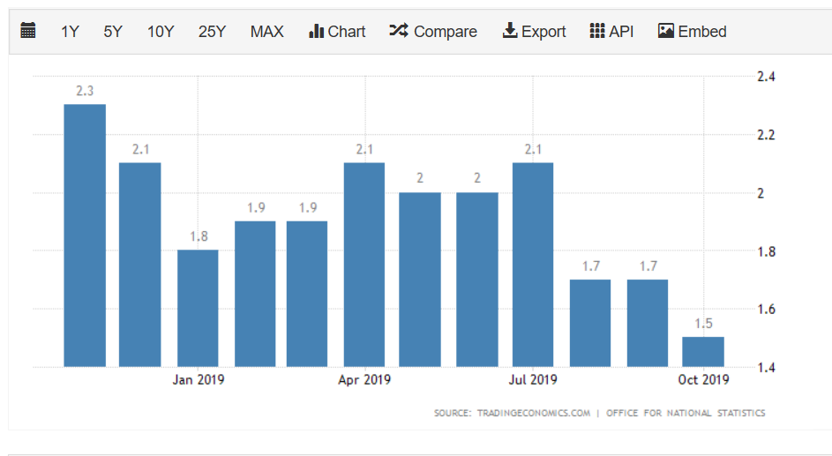
(Source: https://tradingeconomics.com/united-kingdom/inflation-cpi)

Appendix 2: HSBC profits from 2007-2018
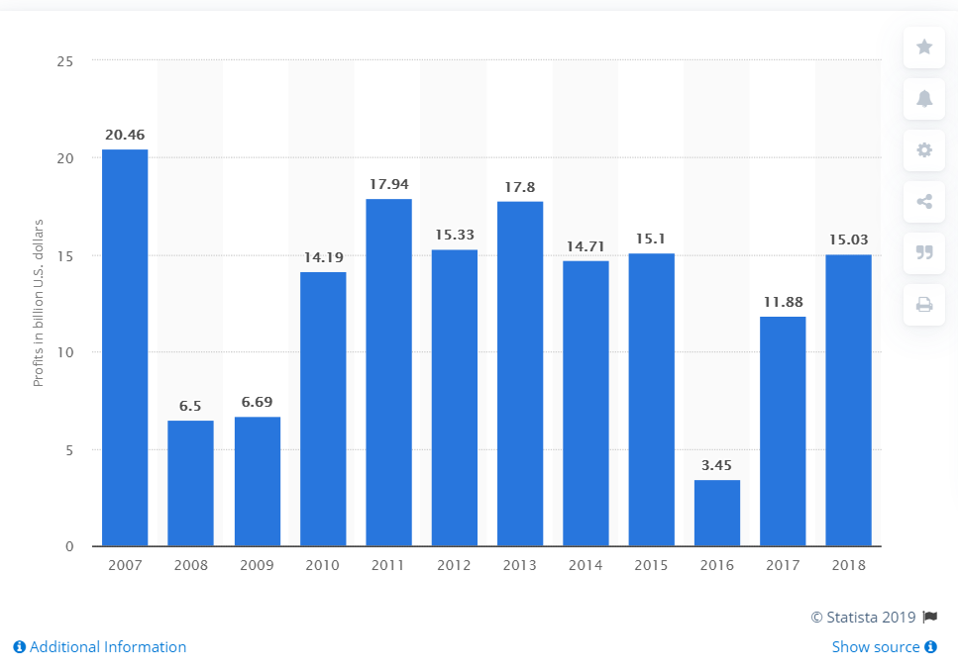
(Source: https://www.statista.com/statistics/224577/hsbcs-profit/)

Appendix 3:
TRAINING FOR FAST CHANGING FINANCIAL COMPANY:
Training goals:
- To ensure every employee act professional to each client in order to minimize complains.
- To ensure each employee has the required knowledge and skills and there is no shortage of required skills. Keep building knowledge in a crucial area.
- To ensure there is no part of the business which is under performing.

Results:
- Effective training will reduce the number of complains raise by customers and will build loyal customers due to efficient customer service.
- Effective training will motivate employees and will show them they are valued to the company as the organizations is willing to invest in them.

Skills covered in the training:
- Professional development
- Communication skills
- IT skills
Time | Length goals and results | Description | Equipment and material | Comments
2 weeks | Goals:  To motivate employees to act quickly and cheaply as possible. To show trainees how to communicate with clients right.  Results:  To let people, learn from their own footstep. And to boost new employee's communication skills. | Train employees to the all approaches to employment such as to teach them how to break information down. | In house training. Carried my employee who is able to technically do his work. | Well covered
1 week | Goals:  To ensure employees are keep up to date with all relevant information.  Results:  Employees remain professional to customers and are able to answer all customers queries. | Training employees on the best current professional practice when dealing with customers. | External training course carried out by a professional trainer | Well covered
1 week | Goals:  To gain knowledge of new products introduced in the company.  Results:  Increase the confidence employees have in their interpersonal skills, since they are well educated. | Teaching employees in a fast development industry that their knowledge should always be up to date. Teaching them effective communication is the keys for the success of the business. | Mentor from outside of the organization because employees can open more to outsiders. | All queries answered and well covered

