University of Wales Trinity Saint David
School of Engineering

Passive RC Filter Networks
Electrical & Electronic Principles
ACDB4002

Gethin Dyer Davies
2307576
02/2024
Contents
1 Abstract 1
2 Introduction 2
2.1 Low Pass Filter 2
2.2 High Pass Filter 3
3 Circuit Description 4
4 Experimental Results 7
4.1 Low Pass Filter Experiment Results 7
4.2 High Pass Filter Experiment Result 9
5 Theory Results 11
5.1 Low Pass Filter Theory Results 11
5.2 High Pass Filter Theory Results 14
6 Discussion 16
6.1 Low Pass Filter 16
6.2 High Pass Filter 17
7 Conclusion 18
8 References 19
9 Appendices 20

Abstract
This report is to show the findings of the practical experiment of building and analysing a low pass filter and a high pass filter stage and comparing to the expected theoretical results. Measuring and recording the voltage input and output with the different ranges of frequency from 100Hz up to 300kHz with a function generator and an oscilloscope to monitor. With the data collected and plotted on graphs, the determined cut-off frequencies of -3dB of both filters can be seen and compared. The low pass filter practical results are similar to the theory with cut off at -3dB achieved just above 28000Hz and below 30000Hz, this also is seen with the high pass filter where -3dB is achieved around the 1000Hz to 1200Hz.

Introduction

When signals are combined with unwanted interference noise or frequency, filters may then be used to remove the issue. High and low filters may use capacitors or inductors, in this experiment a capacitor and a resistor are used in both circuits. The cut-off frequency for both high and low filters can be calculated theoretically by using the formula $fC=\frac{1}{2πRC}$ . The expectance is that the low pass filter voltage will sustain a high voltage output, while increasing its frequency until it nears its cut-off point. When nearing its cut-off point a decrease in voltage is expected with the output voltage at 70.7% of the input voltage, with the attenuation following the same pattern reaching -3dB, as the frequency increases the voltage will continue to decrease and the attenuation continuing to decrease to the negative. The high pass filter expectance is that the voltage output will increase as the frequency is increased and that the frequency cut-off figure will align with the attenuation cut out of -3dB and the voltage output of 70.7%, which would be 3.535v expected in this experiment. As the frequency keeps increasing the output voltage will match the input voltage and the attenuation will level out on 0dB. (Warnes, 2003). This report will provide a greater understanding of the low and high filters, circuit purpose and use, before going into detail of the experiment itself providing:
- Experimental figures used and circuit diagrams.
- Results (graphs) and working out of the theory and practical experiment.
- Discussion of the findings, analysis, differences and what potential causes.
- Statement of findings

Low Pass Filter
A low pass filter has been designed to eliminate high frequency signals such as whistling and sirens while allowing lower frequency signals to pass through. This is carried out by allowing all frequencies below the cut-off point to pass, while attenuating frequencies higher than the cut-off point. Resistor and capacitor low pass filter circuits contain the resistor first on the voltage/signal input with the capacitor located after and connected to ground. This capacitor receives high frequency signals and directs them to ground, see Figure 1. This creates a short circuit effect (low impedance) meaning a low voltage will be measured at the output. (Izadian, 2023). Low Pass Filters are used in audio and image processing to remove high frequency noise, General Dynamics have low pass filters on their armoured fighting vehicle and are used for audio and data communication, reducing interference.
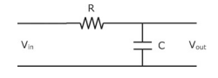
Figure 1 – Low Pass Filter Circuit (Izadian, 2023)

High Pass Filter
A high pass filter has been designed to remove low frequencies such as rumble or vocal plosives while allowing the higher desired signal to pass through. (Warnes, 2003). This is carried out by allowing the frequency above the cut-off point to pass and eliminate the signals below the cut-off point. The high pass filter works in the opposite to the low pass filter, and this reflects in the circuit set-up with the capacitor and resistor in the opposite locations, this means that the capacitor nearest to the input signal/voltage bridging the input to the output. See Figure 2. Meaning the ideal voltage measured at the output is the same as the input, the resistance of the capacitor is high at low frequencies and then acts as an open circuit and blocks the low frequency. (Izadian, 2023). High pass filters are used in microphones and speakers and other audio equipment, General Dynamics use high pass filters for the Public Announcement systems and crew communication kit in their armoured fighting vehicles.
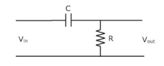
Figure 2 - High Pass Filter Circuit (Izadian, 2023)

Circuit Description
The experiment is to evaluate were the frequency cut of point is with the attenuation of -3dB, within both high pass and low pass filters. This is carried out by collecting the measurements/data (voltage) at different frequencies. For both filters the function generator supply voltage is set at 5v pk-pk for the entire experiment. The low pass filter is fitted with a 10KΩ resistor and a 560pF capacitor and the high pass filter is fitted with 15nF capacitor and a 10KΩ resistor Figure 3 below shows where the function generator is connected to supply both circuits, with the positive lead on the upper line marked in orange and the negative lead on the lower line marked in green.

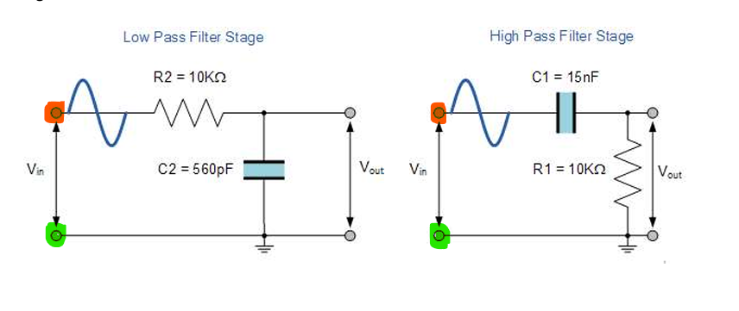
Figure 3 - Supply connection points in orange (UWTSD)

The frequency range is 100Hz then going up to 300kHz with the steps in-between varying, but with several closely spaced measurement taken around the response of the voltage change in the output measurement, to plot the response curve to determine the cut-off point. On the low pass filter the concentration of voltage data taken will be between 10000Hz up to 80000Hz and on the high pass filter the concentration of voltage readings collected is between 4000Hz down to 200Hz. For both filter experiments an oscilloscope is used to measure the voltage of ‘INPUT’ on channel 1, this is to show the true supply from the function generator and to ensure the working out for the result is accurate. See Figure 4 below of the connection locations of the oscilloscope leads for voltage input readings (Channel 1), with the positive lead on the upper line marked in orange and the negative lead on the lower line marked in green. Figure 5 shows the connection points for the output voltage readings at different frequencies, this data is measured and shown on the oscilloscope channel 2. The positive lead on the upper line marked in orange and the negative lead on the lower line marked in green.
Figure 4 - Connection points for input voltage readings (UWTSD)

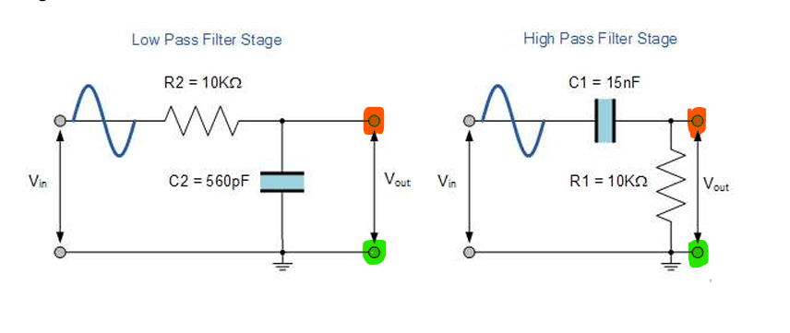
Figure 5 - Connection points for Output voltage readings.

These circuits are built on a breadboard and tested individually, below are diagrams of the breadboards. See Figure 6 for low pass filter and Figure 7 for high pass filter.
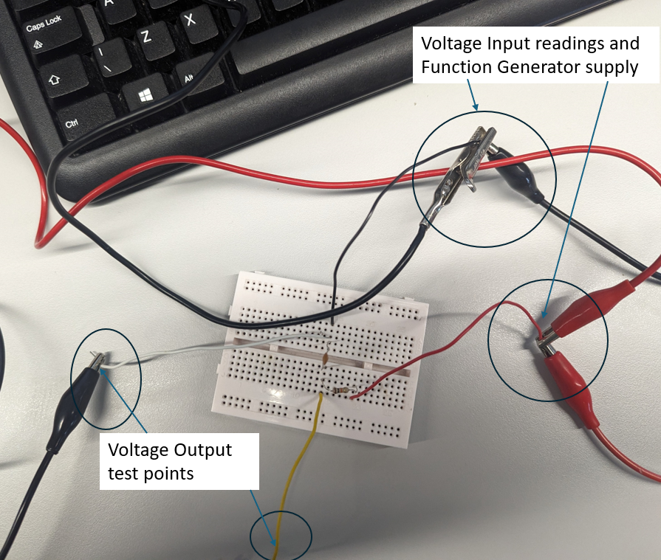
Figure 6 - Low Pass Filter circuit on breadboard and connected for experiment.

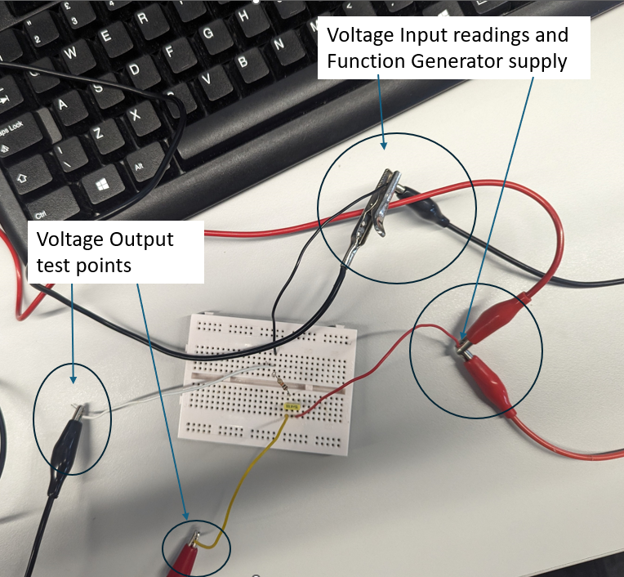
Figure 7 -High Pass Filter circuit on breadboard and connected for experiment.

Experimental Results

Below are the results of the experiment, all in graph form. To calculate the attenuation for each frequency selected, the voltage input and output was recorded, and Equation 1 was used to retrieve the attenuation. Tables that were used to collect the data are in the Appendices.

Equation 1 – Attenuation calculation (Google image, 2024)
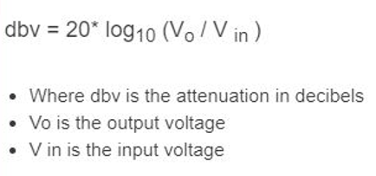

Low Pass Filter Experiment Results

Figure 8 shows the output voltage at different frequencies during the experiment via channel 2 of the oscilloscopes.

Figure 8 - Low Pass Filter Output Voltage Results
The data table for figure 8 and Figure 9 is Table 1 in the Appendices.

Figure 9 show the result of the attenuation carried out by using the voltage input and output data and applying them to Equation 1.

Figure 9 - Low Pass Filter Attenuation Results

High Pass Filter Experiment Result

Figure 10 shows the output voltage at different frequencies during the experiment via channel 2 of the oscilloscopes.

Figure 10 - High Pass Filter Output Voltage Results

You can see in Figure 10 a fluctuation in the voltage output at 5 Volts and higher.
The data table for Figure 10 and Figure 11 is Table 2 in the appendices.

Figure 11 show the result of the attenuation carried out by using the voltage input and output data and applying them to Equation 1.

Figure 11 - High Pass Filter Attenuation Results.

Figures of oscilloscope reading of the input and output voltages and behaviour in time delay as different frequency are selected can be seen in the appendices, see figure 19 and Figure 20.

Theory Results

Here are the formulas used for the theory results.
- $fC=\frac{1}{2πRC}$ to find the expected cut-off points.
- $x_{c}=\frac{1}{2πfc}$ to find the capacitive reactance. To be able to input the value in equation 2 for the output voltage.
- f = Frequency (Hz)
- c = Capacitance (F)
- Equation 2 for the output voltage calculation. See below.
- Equation 1 with Voltage input, always at 5v. This formula is for attenuation (dB).

Equation 2 - Output Voltage Calculation (Rai, 2018)
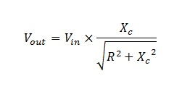

Low Pass Filter Theory Results
Expected Cut-Off point = 1/2π(10000x560x10^-12) = 28421Hz

Figure 12 shows the capacitive reactance as a function of frequency. This carried out with the equation, $x_{c}=\frac{1}{2πfc}$ . Note that the low pass filter capacitor is 560pF.

Figure 12 – Low Pass Filter capacitive reactance

The data table for Figure 12, Figure 13 and Figure 14 is Table 3 in the appendices.

Figure 13 shows the results of Equation 2. This shows the expected output voltage as the frequency value change, see below.

Figure 13 - Low Pass Filter Theory Voltage Output

Figure 14 shows the attenuation as a form of frequency with Equation 1 applied.

Figure 14 - Low Pass Filter Attenuation Theory

High Pass Filter Theory Results

Expected Cut-Off point = 1/2Pi(10000x15x10^-9) = 1061Hz

Figure 15 shows the capacitive reactance as a function of frequency. This carried out with the equation, $x_{c}=\frac{1}{2πfc}$ . Note that the high pass filter capacitor is 15nF.

Figure 15 - High Pass Capacitive Resistance

The data table for Figure 15, Figure 16 and Figure 17 is Table 4 in the appendices.

Figure 16 shows the results of Equation 2. This shows the expected output voltage as the frequency value change, see below.

Figure 16 - High Pass Filter Voltage Output Theory
Figure 17 shows the attenuation as a form of frequency with Equation 1 applied.

Figure 17 - High Pass Filter Attenuation Theory

Discussion
The results show that the low pass filter works in the opposite compared to the high pass filter, for the low pass filter, as the frequency increases up to 10000Hz the voltage drops. This is because as the frequency gets higher, the capacitor starts to bridge to ground until maximum path is achieved, creating a short circuit effect reducing the voltage at the output. In contrast due to the capacitor in the high pass filter is the path to the output meaning until a higher frequency is achieved, an increase in voltage is achieved until 10000Hz to input voltage matches the output voltage. There are slight differences in the findings of the experiment compared to the theory data, these slight differences are only due to the equipment tolerances for example the function generator was producing over 5v and fluctuating during the experiment and that can be seen on Figure 8 and Figure 10 as both graphs show the output voltage above 5v, the fluctuation can be more clearly identified in Figure 10. The components that are being tested also have tolerances and the resistor is a good example of this as it is marked on the component. The resistor used in this experiment Figure 18 had a gold band signifying a tolerance of up 5%, this means that the resistance value of the resistor could be between 9.5kH to 10.5kH. Other factors to consider with experimental readings are impedances within the equipment, for example the test leads. The attenuation graphs have less a mitigating factor as the input voltage and the output voltage that was recorded in experiment are included in the formula for attenuation as a function of frequency.
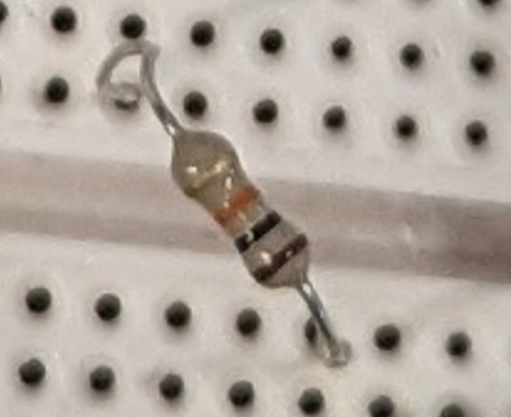
Figure 18 - Resistor image from experiment

Low Pass Filter

When comparing the low pass filter attenuation graphs Figure 9 and Figure 14, they both correspond with each other as they show the drop starting after 1000Hz with the curvature increasing in sharpness from 10000Hz with the curve become more of a straight line at 40000Hz. The cut-off point of -3dB is achieved just above the frequency of 28000Hz in Figure 9 and this corresponds with Figure 14 where the cut-off point is between 25000Hz and 30000Hz and the low pass cut-off point calculation of 28421Hz.
When comparing the voltage output graphs Figure 8 and Figure 13, the experimental Figure 8 voltage starts to drop below 5v later than the theory Figure 13, this due to the function generator tolerance as the component is suppling more than 5v as its input voltage for the complete experiment. (peak input voltage was 5.24v) Figure 8 drops below 5v at 5000Hz were Figure 13 drops below 5v at 1500Hz. The experiment and theory both show that the curve of the voltage drops starts at 5000Hz and at the approximate frequency of 28421Hz on Figure 8 is 3.6v note that the input voltage was above 5v in the experiment. Were as in Figure 13 its 3.5v, with all this the voltage drop follows the same pattern in both graphs.

High Pass Filter
When comparing the high pass filter attenuation graphs Figure 10 and Figure 17, they both correspond with each other as they show the drop starting as the frequency decreases below 10000Hz with the curvature increasing in sharpness as the frequency is reduced to 5000Hz with the curve straightening at 800Hz as it keeps decreasing. The cut-off point of -3dB is achieved just above the frequency of 1000Hz in Figure 11 and Figure 14. These both graphs correspond to the calculation for the cut- off point of 1061Hz.
When comparing the voltage output graphs Figure 10 and Figure 17, the experimental Figure 10 voltage starts above 5V drop below 5v later than the theory Figure 17, this due to the function generator tolerance as the component is suppling more than 5v as its input voltage for the complete experiment (peak input voltage was 5.16v). Figure 10 drops below 5v at 5000Hz when the frequency is decreasing, were as Figure 17 drops below 5v at 20000Hz. The experiment and theory both show that the curve of the voltage drops starts drop off sharper at 5000Hz as the frequency decreases. At the approximate cut-off frequency of 1061Hz on Figure 10 is 3.4v, note that the input voltage was 5.04v in the experiment. Were as in Figure 17 its 3.5v, with all this the voltage drop follows the same pattern in both graphs.

Conclusion

In this experiment it has been determined that the results followed the expected pattern as calculated theoretically and gathered experimentally, with differences in values able to be explained due to equipment and component tolerances and impedances. This is shown as the low pass filter cut-off -3dB point was theoretically calculated at 28421Hz and the experiment shown the cut-off point at just above the frequency of 28000Hz. The high pass filter cut-off point theoretically is 1061Hz and the experiment reading for the cut-off point is achieved just above the frequency of 1000Hz.

References

H, Rai. (2018) Handbook of Basic Electrical Engineering Formulae: For Engineering Students, Practising Engineers, Engineering Supervisors and Instructors, New Deli: CBS

Izadian, A. (2023) Fundamentals of modern electric circuit analysis and filter synthesis: a transfer function approach. Second edn. Cham: Springer.

Warnes, L. A. A. (2003) Electronic and electrical engineering: principles and practice. 3rd edn. Basingstoke: Palgrave Macmillan

Appendices

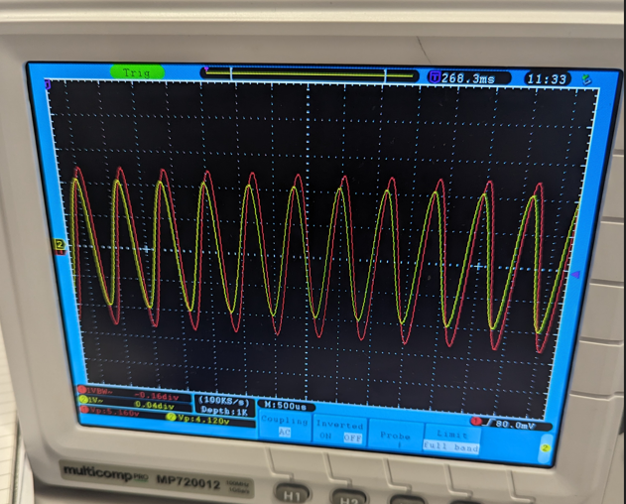
Figure 129 - Oscilloscope image from experiment.

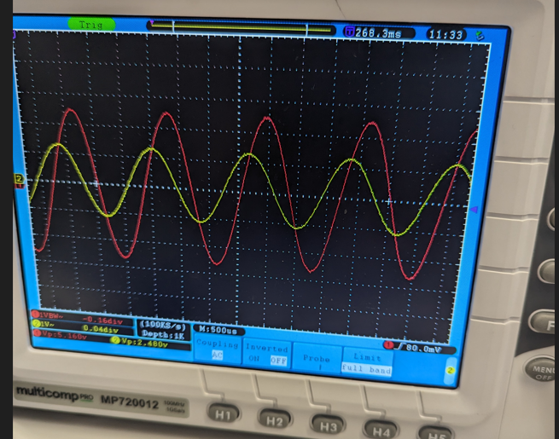
Figure 20 - Oscilloscope image from experiment.

Table 1 - Low Pass Filter Experiment Data
 | Low Pass Filter
Frequency (Hz) | V In (V) | V Out (V) | Atten (dB)
100 | 5.12 | 5.04 | -1.37E-01
500 | 5.12 | 5.04 | -1.37E-01
1000 | 5.12 | 5.04 | -1.37E-01
5000 | 5.14 | 4.98 | -2.75E-01
10000 | 5.12 | 4.76 | -6.33E-01
12000 | 5.08 | 4.6 | -8.62E-01
14000 | 5.12 | 4.52 | -1.08E+00
16000 | 5.08 | 4.36 | -1.33E+00
18000 | 5.08 | 4.24 | -1.57E+00
20000 | 5.12 | 4.16 | -1.80E+00
22000 | 5.08 | 3.96 | -2.16E+00
24000 | 5.08 | 3.88 | -2.34E+00
26000 | 5.08 | 3.72 | -2.71E+00
28000 | 5.08 | 3.6 | -2.99E+00
30000 | 5.08 | 3.48 | -3.29E+00
32000 | 5.08 | 3.4 | -3.49E+00
34000 | 5.08 | 3.24 | -3.91E+00
36000 | 5.08 | 3.16 | -4.12E+00
38000 | 5.12 | 3 | -4.64E+00
40000 | 5.12 | 2.96 | -4.76E+00
45000 | 5.12 | 2.76 | -5.37E+00
50000 | 5.12 | 2.52 | -6.16E+00
60000 | 5.16 | 2.2 | -7.40E+00
80000 | 5.2 | 1.8 | -9.21E+00
100000 | 5.24 | 1.48 | -1.10E+01
120000 | 5.24 | 1.24 | -1.25E+01
140000 | 5.24 | 1.08 | -1.37E+01
160000 | 5.24 | 0.96 | -1.47E+01
200000 | 5.2 | 0.8 | -1.63E+01
250000 | 5.16 | 0.64 | -1.81E+01
300000 | 5.16 | 0.52 | -1.99E+01

Table 2 - High Pass Filter Experiment Data
 | High Pass Filter
Frequency (Hz) | V_{IN} (V) | V_{OUT} (V) | Atten (dB)
100 | 5.08 | 0.52 | -1.98E+01
150 | 5.04 | 0.72 | -1.69E+01
200 | 5.08 | 0.96 | -1.45E+01
300 | 5.08 | 1.4 | -1.12E+01
400 | 5.08 | 1.76 | -9.21E+00
500 | 5.08 | 2.16 | -7.43E+00
600 | 5.04 | 2.44 | -6.30E+00
700 | 5.08 | 2.76 | -5.30E+00
800 | 5.08 | 3 | -4.57E+00
900 | 5.04 | 3.2 | -3.95E+00
1000 | 5.04 | 3.4 | -3.42E+00
1200 | 5.04 | 3.76 | -2.54E+00
1400 | 5.04 | 4 | -2.01E+00
1600 | 5.04 | 4.16 | -1.67E+00
1800 | 5.04 | 4.32 | -1.34E+00
2000 | 5.04 | 4.4 | -1.18E+00
2500 | 5.04 | 4.64 | -7.18E-01
3000 | 5.04 | 4.72 | -5.70E-01
3500 | 5.04 | 4.8 | -4.24E-01
4000 | 5.04 | 4.84 | -3.52E-01
5000 | 5.04 | 4.92 | -2.09E-01
10000 | 5.04 | 5 | -6.92E-02
50000 | 5.12 | 5.08 | -6.81E-02
100000 | 5.2 | 5.16 | -6.71E-02
150000 | 5.2 | 5.16 | -6.71E-02
200000 | 5.16 | 5.12 | -6.76E-02
250000 | 5.16 | 5.12 | -6.76E-02
300000 | 5.16 | 5.16 | 0.00E+00

Table 3 - Low Pass Filter Theory Data
Frequency (Hz) | X_{c} (Ω) | V_{out} Low Pass (V) | Atten (dB)
100 | 2.84E+06 | 5.00E+00 | -5.38E-05
1000 | 2.84E+05 | 5.00E+00 | -5.37E-03
1500 | 1.89E+05 | 4.99E+00 | -1.21E-02
2000 | 1.42E+05 | 4.99E+00 | -2.15E-02
2500 | 1.14E+05 | 4.98E+00 | -3.35E-02
3000 | 9.47E+04 | 4.97E+00 | -4.81E-02
3500 | 8.12E+04 | 4.96E+00 | -6.54E-02
4000 | 7.11E+04 | 4.95E+00 | -8.52E-02
4500 | 6.32E+04 | 4.94E+00 | -1.08E-01
5000 | 5.68E+04 | 4.92E+00 | -1.32E-01
5500 | 5.17E+04 | 4.91E+00 | -1.60E-01
6000 | 4.74E+04 | 4.89E+00 | -1.89E-01
6500 | 4.37E+04 | 4.87E+00 | -2.21E-01
7000 | 4.06E+04 | 4.85E+00 | -2.56E-01
7500 | 3.79E+04 | 4.83E+00 | -2.92E-01
8000 | 3.55E+04 | 4.81E+00 | -3.31E-01
8500 | 3.34E+04 | 4.79E+00 | -3.72E-01
9000 | 3.16E+04 | 4.77E+00 | -4.15E-01
9500 | 2.99E+04 | 4.74E+00 | -4.60E-01
10000 | 2.84E+04 | 4.72E+00 | -5.07E-01
15000 | 1.89E+04 | 4.42E+00 | -1.07E+00
20000 | 1.42E+04 | 4.09E+00 | -1.75E+00
25000 | 1.14E+04 | 3.75E+00 | -2.49E+00
30000 | 9.47E+03 | 3.44E+00 | -3.25E+00
35000 | 8.12E+03 | 3.15E+00 | -4.01E+00
40000 | 7.11E+03 | 2.90E+00 | -4.74E+00
45000 | 6.32E+03 | 2.67E+00 | -5.45E+00
50000 | 5.68E+03 | 2.47E+00 | -6.12E+00
55000 | 5.17E+03 | 2.30E+00 | -6.76E+00
60000 | 4.74E+03 | 2.14E+00 | -7.37E+00
65000 | 4.37E+03 | 2.00E+00 | -7.95E+00
70000 | 4.06E+03 | 1.88E+00 | -8.49E+00
75000 | 3.79E+03 | 1.77E+00 | -9.01E+00
80000 | 3.55E+03 | 1.67E+00 | -9.51E+00
85000 | 3.34E+03 | 1.59E+00 | -9.98E+00
90000 | 3.16E+03 | 1.51E+00 | -1.04E+01
95000 | 2.99E+03 | 1.43E+00 | -1.09E+01
100000 | 2.84E+03 | 1.37E+00 | -1.13E+01
150000 | 1.89E+03 | 9.31E-01 | -1.46E+01
200000 | 1.42E+03 | 7.03E-01 | -1.70E+01
250000 | 1.14E+03 | 5.65E-01 | -1.89E+01
300000 | 9.47E+02 | 4.72E-01 | -2.05E+01

Table 4 - High Pass Filter Theory Data
Frequency (Hz) | Xc (Ω) High Pass | V_{out} High Pass (V) | Atten (dB)
100 | 1.06E+05 | 4.69E-01 | -2.06E+01
200 | 5.31E+04 | 9.26E-01 | -1.46E+01
400 | 2.65E+04 | 1.76E+00 | -9.05E+00
600 | 1.77E+04 | 2.46E+00 | -6.16E+00
800 | 1.33E+04 | 3.01E+00 | -4.41E+00
1000 | 1.06E+04 | 3.43E+00 | -3.28E+00
1200 | 8.84E+03 | 3.75E+00 | -2.51E+00
1400 | 7.58E+03 | 3.98E+00 | -1.97E+00
1600 | 6.63E+03 | 4.17E+00 | -1.58E+00
1800 | 5.89E+03 | 4.31E+00 | -1.30E+00
2000 | 5.31E+03 | 4.42E+00 | -1.08E+00
2500 | 4.24E+03 | 4.60E+00 | -7.19E-01
3000 | 3.54E+03 | 4.71E+00 | -5.12E-01
3500 | 3.03E+03 | 4.78E+00 | -3.82E-01
4000 | 2.65E+03 | 4.83E+00 | -2.95E-01
4500 | 2.36E+03 | 4.87E+00 | -2.35E-01
5000 | 2.12E+03 | 4.89E+00 | -1.91E-01
5500 | 1.93E+03 | 4.91E+00 | -1.59E-01
6000 | 1.77E+03 | 4.92E+00 | -1.34E-01
6500 | 1.63E+03 | 4.93E+00 | -1.14E-01
7000 | 1.52E+03 | 4.94E+00 | -9.87E-02
7500 | 1.41E+03 | 4.95E+00 | -8.61E-02
8000 | 1.33E+03 | 4.96E+00 | -7.57E-02
8500 | 1.25E+03 | 4.96E+00 | -6.71E-02
9000 | 1.18E+03 | 4.97E+00 | -5.99E-02
9500 | 1.12E+03 | 4.97E+00 | -5.38E-02
10000 | 1.06E+03 | 4.97E+00 | -4.86E-02
15000 | 7.07E+02 | 4.99E+00 | -2.17E-02
20000 | 5.31E+02 | 4.99E+00 | -1.22E-02
25000 | 4.24E+02 | 5.00E+00 | -7.82E-03
30000 | 3.54E+02 | 5.00E+00 | -5.43E-03
35000 | 3.03E+02 | 5.00E+00 | -3.99E-03
40000 | 2.65E+02 | 5.00E+00 | -3.05E-03
45000 | 2.36E+02 | 5.00E+00 | -2.41E-03
50000 | 2.12E+02 | 5.00E+00 | -1.96E-03
55000 | 1.93E+02 | 5.00E+00 | -1.62E-03
60000 | 1.77E+02 | 5.00E+00 | -1.36E-03
65000 | 1.63E+02 | 5.00E+00 | -1.16E-03
70000 | 1.52E+02 | 5.00E+00 | -9.98E-04
75000 | 1.41E+02 | 5.00E+00 | -8.69E-04
80000 | 1.33E+02 | 5.00E+00 | -7.64E-04
85000 | 1.25E+02 | 5.00E+00 | -6.77E-04
90000 | 1.18E+02 | 5.00E+00 | -6.04E-04
95000 | 1.12E+02 | 5.00E+00 | -5.42E-04
100000 | 1.06E+02 | 5.00E+00 | -4.89E-04
150000 | 7.07E+01 | 5.00E+00 | -2.17E-04
200000 | 5.31E+01 | 5.00E+00 | -1.22E-04
250000 | 4.24E+01 | 5.00E+00 | -7.82E-05
300000 | 3.54E+01 | 5.00E+00 | -5.43E-05

