Sophie Meyrick-Vernon
2221762
Networking and Cyber Security
ACCA4022
Computer Architecture and Operating Systems
Operating Systems

Table of Contents
Introduction 3
Key functions of general Operating Systems 3
Task manager 4
Reliability Monitor 6
Event viewer 7
Device Manager 8
File explorer 9
Use of windows OS CLI commands 10
Use of Linux OS CLI commands 14
Use of Windows OS scripts 16
Use of Linux OS scripts 17
Conclusion 19

Introduction
Operating systems (OS) serve as the backbone of computing devices, providing an interface for users to interact with hardware and software resources efficiently. Among the most widely used OS platforms are Windows and Linux, each offering unique functionalities and command-line interfaces (CLI) for managing system operations. This report explores the key functions of general-purpose operating systems, specifically focusing on Windows and Linux, exploring their respective CLI capabilities and scripting languages.

Key functions of general Operating Systems
An operating system (OS) is crucial software component that serves as an intermediary between computer hardware and user applications. The OS manages all the resources of the computer and provides the users with a graphical user interface to interact with to perform operations on the computer [1]. The OS facilitates communication between the user, applications, and hardware components of the computer [2].
The kernel is the core of the operating system, it is the central manager of programs and processes. The kernel oversees the allocation and deallocation of memory and time for processes. It handles the process creation and termination [3].
Job scheduling is the process of allocating resources to tasks within an operating system. It involves handling job queues that require CPU time and prioritising which jobs to select and how much time to allocate [4].
There are many types of operating systems, some examples include Windows, iOS, and Mac OS. The two prominent operating systems covered in this report are Windows Operating Systems, and Linux Operating Systems.

Linux Operating System
Linux is an open source operating system, it has many different distributions varying in usefulness to the user. As it is an open source software, this enables the user to view and modify its code. Developers use Linux due to its freedom with customization. It has the same capabilities as windows, it has a Graphical User Interface(GUI) and the same software such as word processors [5].

Windows Operating System
Windows is an operating system designed by Microsoft. It is often preloaded on most new computers; it makes it possible to complete everyday tasks on the computer through its Graphical User Interface (GUI) [6].

Task manager
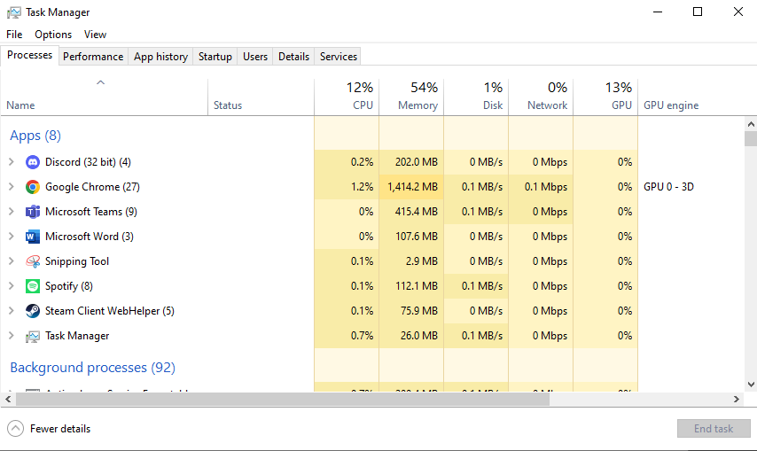
[figure 1] Displaying the task manager processes tab.
The task manager is a windows operating system component, it displays a list of all running processes indicating their CPU and memory usage. This is useful for users to identify performance issues and troubleshoot bottlenecks. Administrators can terminate processes that are putting a load on the system. It can also be used to identify programs that should not be running such as spyware and end them.

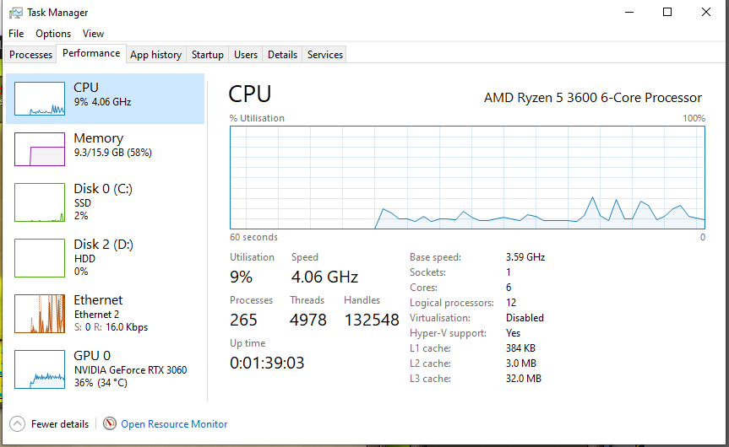
[figure 2] Displaying the task manager performance tab.
The performance tab is a real time display of the hardware performance in the system.

Reliability Monitor
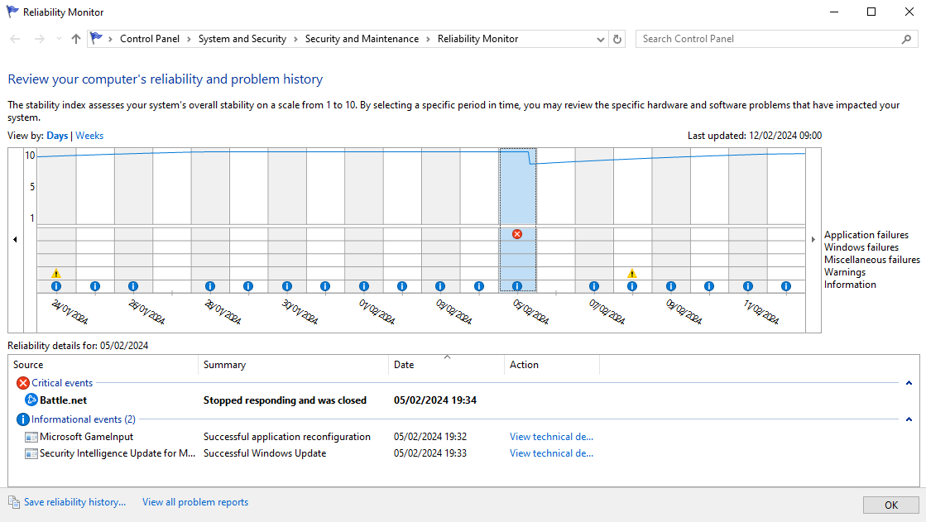
[figure 3] Displaying the Reliability Monitor.
The reliability monitor in windows is used to show the systems reliability history. It shows a timeline of any crashes and keeps a log of information related to updates, installations, and hardware issues. WinDbg tool can be used to further explore errors and performance issues using a dump file taken from the reliability monitor.

Event viewer
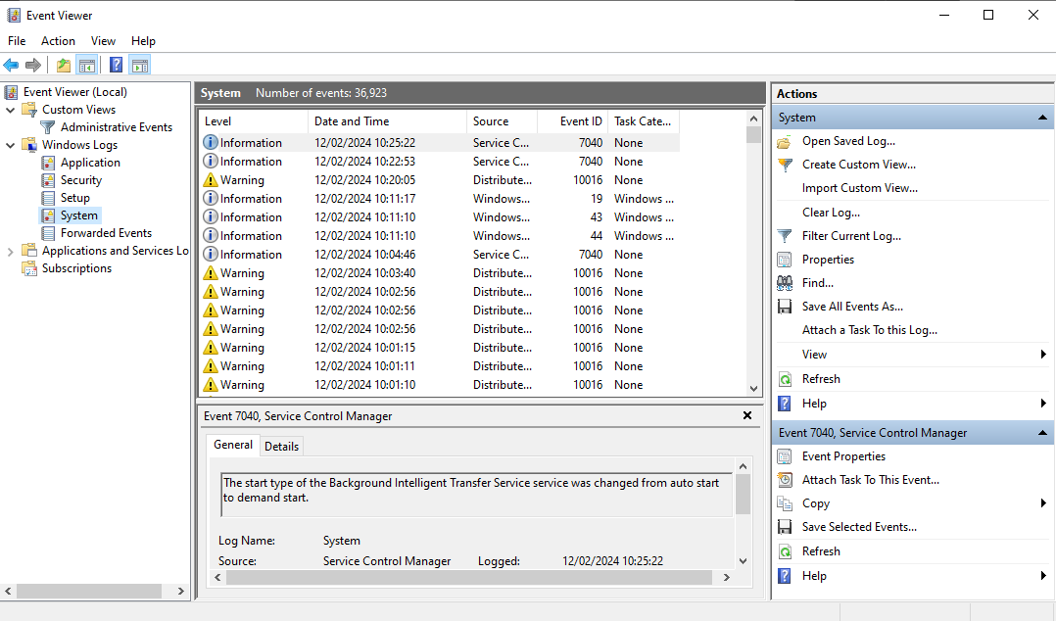
[figure 4]

Device Manager
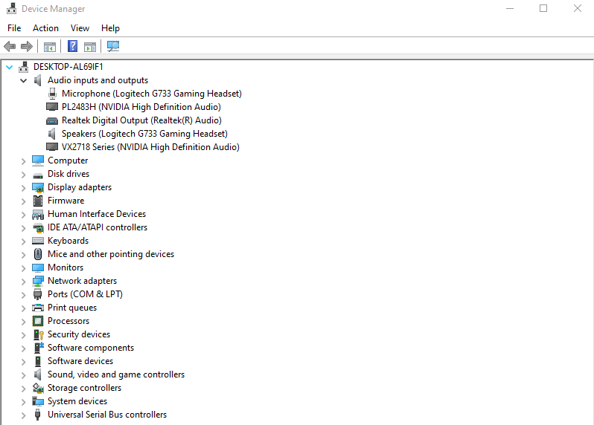
[figure 5]
Device management involves configuring and controlling hardware devices. It has capabilities to detect and identify connected devices such as storage devices, monitors, and speakers. Users can perform device maintenance checking if the software requires updating. The device manager allows users to adjust settings for connected devices, allowing the user to enable/disable them [5]. Users can manage connected devices through Device Manager in Windows, System Information in macOS, and commands like lspci and lsusb in Linux.

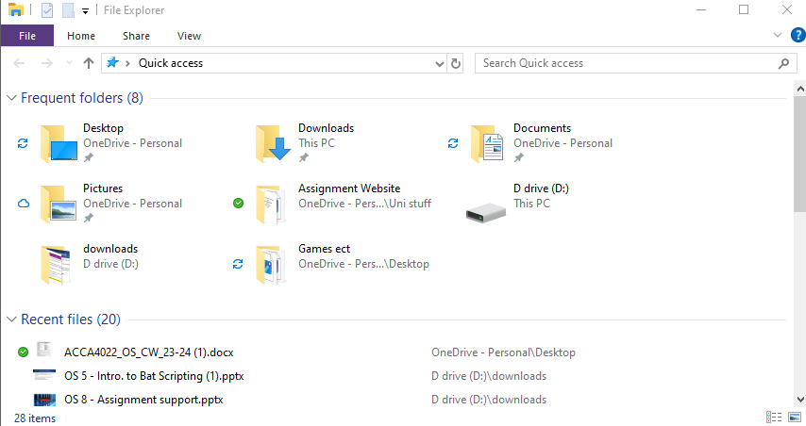
File explorer
[figure 6]
File system management is an easy way to access stored files on the user’s computer. Users can use the File Explorer in windows to organize and manage files. Users can compress files to reduce the size of them and save on disk space. Users may require to protect files from unauthorized access, for this file encryption is useful to password protect the documents in certain files [8].

Use of windows OS CLI commands
Batch scripting in Windows allows users to automate tasks and execute commands sequentially one after the other. Some common uses for Batch scripting are automating activities such as deleting unwanted files, this is useful for repetitive tasks. Batch files which have a .bat extension can be executed in the command prompt [7]. This report will explore commonly used Batch commands along with their functionalities.
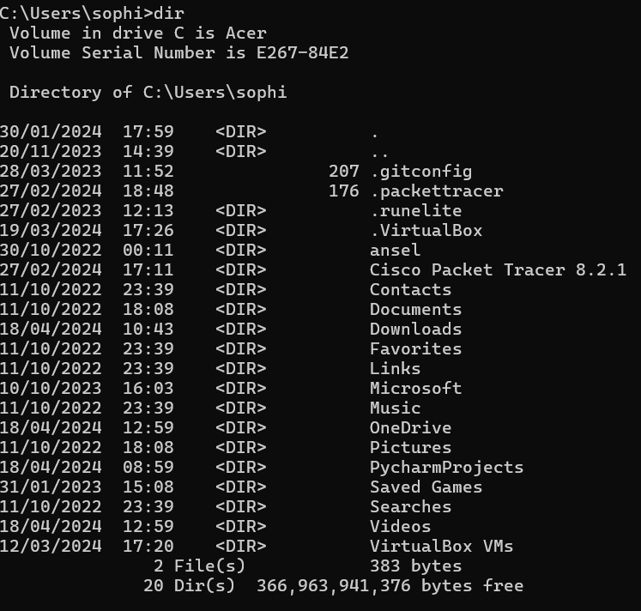
The ‘dir’ command displays a list of all files and directories in the current directory.
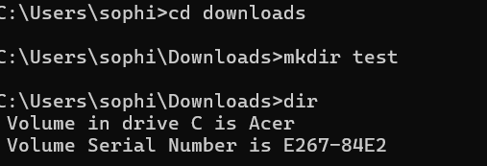
‘cd’ changes the current directory.
‘mkdir’ creates a new folder with the file name test. It can be located using ‘dir’.
Files can be deleted by using ‘rmdir’
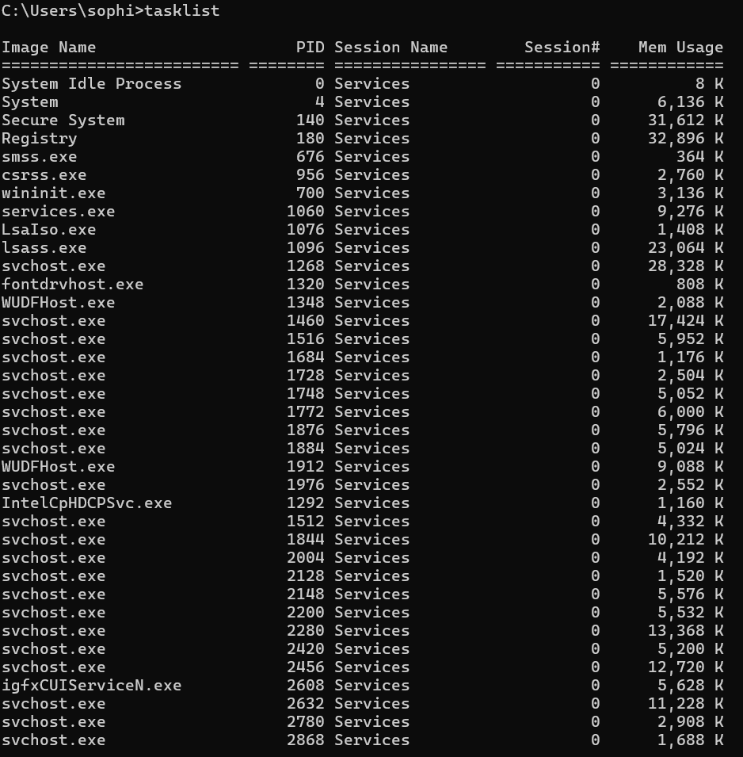
The ‘tasklist’ command displays all the current running processes along with their IDs and memory usage.
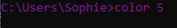

Changes the colour of the text in the command prompt window
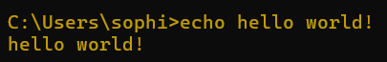
‘echo’ displays a message typed after the command.
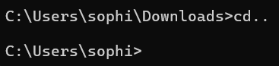
‘cd..’ takes you back up a directory
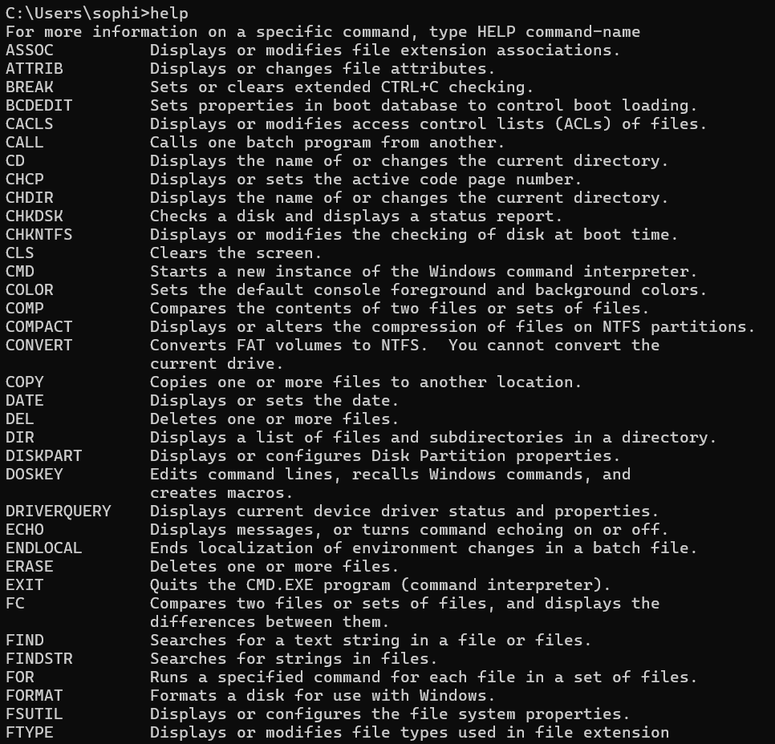
‘help’ displays a list of commands and what each of them do.

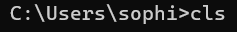
‘cls’ command clears the command prompt window.
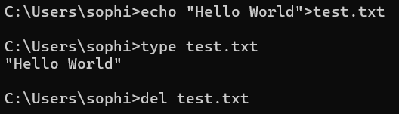
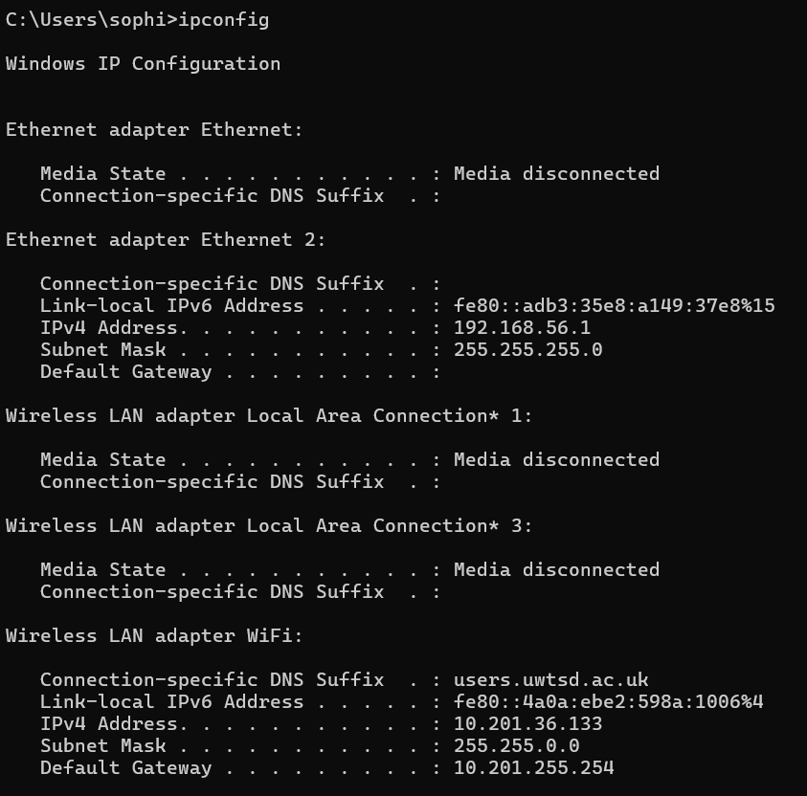
‘ipconfig’ is a command line tool that can be used to manage and display the network settings on a Windows computer. This is a useful tool for users to access information about the current network configuration, users can easily access their IP address, subnet mask, default gateway, and DNS servers. This information can then be used to troubleshoot network issues such as connectivity problems [10].

Use of Linux OS CLI commands
Bash (Bourne Again SHell) is the default command-line interpreter for operating systems such as Linux. It provides users with an interface to interact with the operating systems components through the terminal. This report will explore ten commonly used Bash commands along with their functionalities.

‘cd/’ is used to change the /root directory.
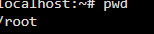

‘pwd’ displays the present working directory.

‘ls’ the list command is used to view all the subdirectories.
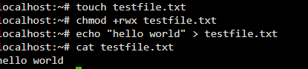

‘touch testfile.txt’ creates a new file.
‘chmod +rwx testfile.txt’ adds all permissions to the owner of the file.
‘echo “hello world” > testfile.txt’ inputs text into the new file.
‘cat testfile.txt’ outputs the content of the text file.
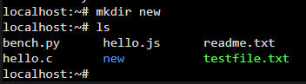

‘mkdir’ creates a new directory which can be found using the ‘ls’ command.
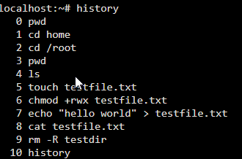

‘history’ can be used to output all previously used commands.
‘clear’ to clear the CLI.

Use of Windows OS scripts
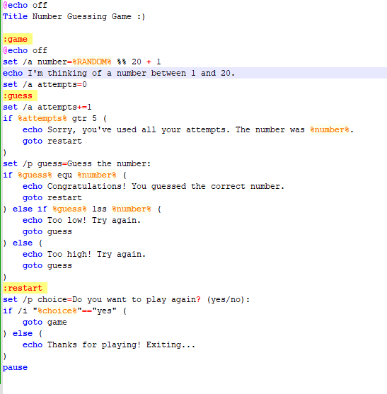

This script is a simple number guessing game where the user has five attempts to guess a randomly generated number between one and twenty. The script is written in Batch scripting language on Windows OS.
User interaction – it prompts the user to enter their guess using the ‘set /p’ command. Each time the user guesses a number the number of attempts increases by 1. User input has been used to type ‘yes’ if they would like to play again.
Looping – this is achieved with the use of the ‘goto’ statement the game allows user to make multiple guesses looping back to the guessing section until the correct answer is guessed or the five attempts have been depleted. A ‘goto’ statement has also been used to give the user the option to restart the game as many times as they would like.
Nested IF statement – the nested if statement helps the user know if their guess is too high or too low.
Function – ‘:game:’, ‘:guess:’ and ‘:restart:’ are the three functions used, these can be called multiple times throughout the script if needed.
Random number generation – a number between 1 and 10 is generated using the ‘%RANDOM%’ environment.

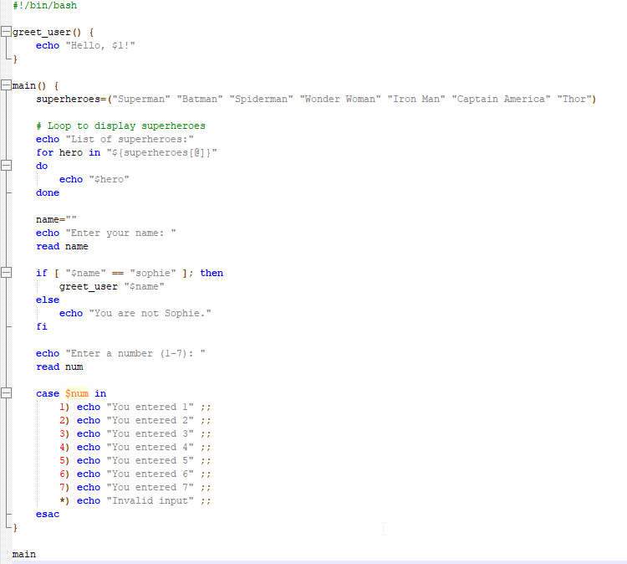
Use of Linux OS scripts

Variables: In the script, the variable ‘name’ is used to store the user's input.
if statement: The if statement allows for conditional execution of commands. It evaluates a condition and executes a set of commands if the condition is true. In the script, an if statement is used to check if the user's name is "Sophie".
Case statement: In the script, a case statement is used to handle user input. The case statement is a way to perform multiple conditional checks using pattern matching. It can be used as an alternative to multiple if statements.
A Loop: In the script, a for loop is used to iterate over the array of superheroes and display each superhero's name.
Array: In the script, an array named superheroes is used to store the names of various superheroes. An array allows for multiple values in the variable superheroes.
Function: In the script, a function named ‘greeting’ is defined to display a greeting message to the user. A function allows you to reuse code as many times as needed throughout the program.
User Input: The read command is used to read input from the user. In the script, read is used to prompt the user to enter their name and a number.

Conclusion
Operating systems serve as an integral part of every day computing, providing a platform and interface for users to interact with hardware and applications effectively. Specifically throughout this report we have explored key functionalities of Windows and Linux operating systems. The tools explored in the Windows Command Line Interface and Batch scripting offers the user powerful tools for system management and automation.

References

[1] | Unknown, “What is an Operating System?,” Geeks for Geeks, [Online]. Available: https://www.geeksforgeeks.org/what-is-an-operating-system/. [Accessed 12 Feburary 2024].
[2] | G. L. Team, “What is an Operating System (OS)?,” Great Learning, 22 January 2024. [Online]. Available: https://www.mygreatlearning.com/blog/what-is-operating-system/. [Accessed 12 February 2024].
[3] | “Kernel in Operating System,” Geeks for Geeks, [Online]. Available: https://www.geeksforgeeks.org/kernel-in-operating-system/. [Accessed 12 February 2024].
[4] | M. Rouse, “Job Scheduling,” Technology Expert, 14th March 2017. [Online]. Available: https://www.techopedia.com/definition/7882/job-scheduling. [Accessed 15 April 2024].
[5] | “What is Linux?,” Opensource.com, [Online]. Available: https://opensource.com/resources/linux. [Accessed 18 April 2024].
[6] | “All about Windows,” GCF Global, [Online]. Available: https://edu.gcfglobal.org/en/windowsbasics/all-about-windows/1/#. [Accessed 18th April 2024].
[7] | “Device Management in Operating System and Why It Matters,” Hasonss, [Online]. Available: https://hasonss.com/blogs/device-management-in-operating-system/. [Accessed 18 April 2024].
[8] | M. Dham, “File Management in Operating System,” PrepBytes Blog, 20 June 2023. [Online]. Available: https://www.prepbytes.com/blog/operating-system/file-management-in-operating-system/. [Accessed 18 April 2024].
[9] | “Batch Script - Quick Guide,” Tutorials point, [Online]. Available: https://www.tutorialspoint.com/batch_script/batch_script_quick_guide.htm. [Accessed 17 04 2024].
[10] | “Understanding Ipconfig and Ipconfig Commands,” WhatIsMyIP.com, [Online]. Available: https://www.whatismyip.com/ipconfig/#:~:text=Ipconfig%20is%20used%20to%20view,problems%20or%20incorrect%20IP%20addresses. [Accessed 18th April 2024].

Appendices




