Sadeka Gani Dhali 2122280

BSc Health and Social care

Introduction to Physiology

BMHP5003_BIRM

Lecturer: Gillian Weaver

Assessment 1- Individual Academic Poster Presentation

Digestive System
Food is broken down in the stomach and combined with enzymes and acid. The meal is cut up into significantly smaller bits as a result. Our bodies obtain the nutrients they require to maintain our health and provide us with energy in this way. For semi-solid food to travel from the stomach into the small intestine.
The liver's two primary functions in digestion are to produce bile and release it, as well as to process and purify blood that contains recently absorbed nutrients from the small intestine.
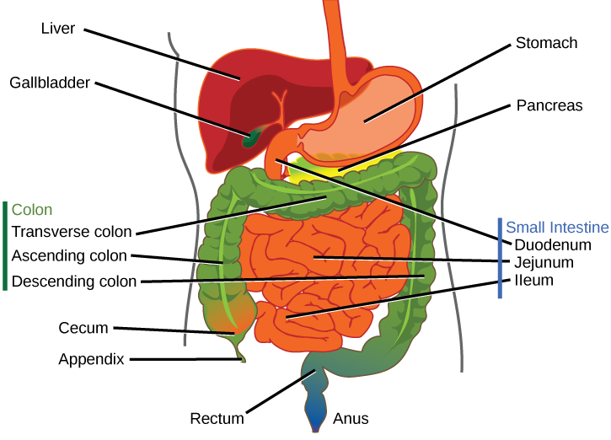

Bile from the liver is concentrated and stored in the gallbladder, where it aids in breaking down fat during digestion.

The colon's function is to dehydrate the food that is still there and turn it into faeces. It accomplishes this by gradually absorbing water and electrolytes while the waste is being moved by its muscular system. In the meantime, bacteria in your colon feed on the waste and further breakdown it, finishing the chemical phase of the digestion process.

The pancreas produces insulin and other hormones related to digestion; the pancreas also secretes digestive juices.

Cecum a pouch the forms the first part of the large intestines.

The small intestine's functions include digestion, absorption of nutrients for the body, and elimination of waste products.

The appendix produces immune early defences that help prevent serious infections in human

When you have a bowel movement, your rectum, which holds faeces, pushes the stool out of your anus.

The anus is the last part of the digestive tract it Identify the liquid, gas, or solid contents of the rectum, and then regulate when your body should and should not expel stool.

Reference:

Andersen. (2015) Anatomy and physiology. Unit 13, The digestive system. Bozeman Science.
Lautenschlager, S.A. et al. (2023) Lifestyle factors associated with inflammatory bowel disease: Data from the Swiss IBD Cohort Study, BMC gastroenterology. Available at: https://pubmed.ncbi.nlm.nih.gov/36907848/ (Accessed: 01 June 2023).
Li, C. et al. (2022) Biological factors controlling starch digestibility in human digestive system, Food Science and Human Wellness. Available at: http://www.sciencedirect.com/science/article/pii/S2213453022001495 (Accessed: 02 March 2023).
Nduma, B. et al. (2023) ‘The use of cannabinoids in the treatment of inflammatory bowel disease (IBD): A review of the literature’, Cureus [Preprint]. doi:10.7759/cureus.36148.
OpenStax (2013) Anatomy and Physiology https://openstax.org/books/anatomy-and-physiology/pages/1-introductionchoi, David (2022) Risankizumab-rzaa: A New Therapeutic Option for the Treatment of Crohn’s Disease, saga journals. Available at: journals.sagepub.com/doi/10.1177/10600280221130450 (Accessed: 01 June 2023).
Picariello, G. et al. (2023) Structural properties of food proteins underlying stability or susceptibility to human gastrointestinal digestion, Current Opinion in Food Science. Available at: https://www.sciencedirect.com/science/article/pii/S2214799323000061?casa_token=8aYhg8sG1NgAAAAA%3ARufXA2f27GVmFWqziunJOEJOw5iOS_-XUTWfHjJLMR_m0pAKOdY-k266FOzpwdTV2U-Zy1SqZhgd (Accessed: 11 June 2023).
Pudipeddi, A. et al. (2019) Safety of drugs used for the treatment of crohn’s disease, Expert opinion on drug safety. Available at: https://pubmed.ncbi.nlm.nih.gov/31026401/ (Accessed: 01 June 2023).
Shehab, M. et al. (2023) Impact of tumor necrosis factor antagonist combination and anti-integrin therapies on body mass index in inflammatory bowel disease: A cross-sectional study Mohammed, Frontiers in medicine. Available at: https://pubmed.ncbi.nlm.nih.gov/36687448/ (Accessed: 01 June 2023).
The Digestive System: Gallbladder, Pancreas, And Liver. (2013). Medcom.

This Photzxckkljl;xcccccxcxcxcxcxcxcxcxcxcxcxcxxcxxxxcxcxcxcxcxcxcxcxcxcxcxcxcxcxcxcxcxcxxxcxcxcxcxcxcxcxcxccxcxcxxxxxcxcxcxcxcxcxcxxo by Unknown Author is licensed under CC BY

This Photo by Unknown Author is licensed under CC BY
This Photo by Unknown Author is licensed under CC BY
This Photo by Unknown Author is licensed under CC BY
This Photo by Unknown Author is licensed under CC BY

