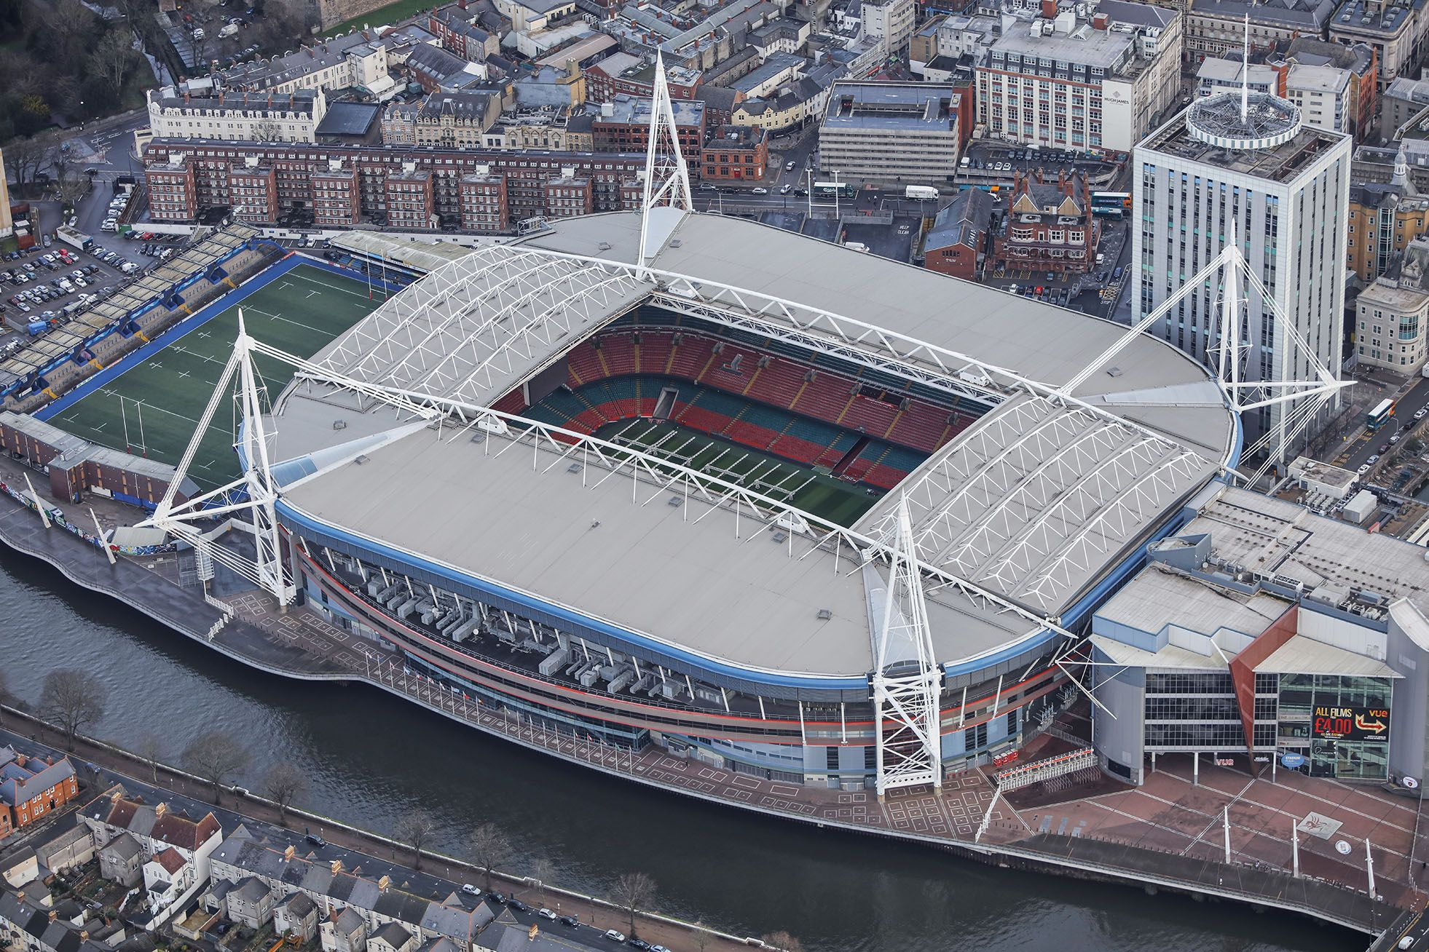
(Pinterest, 2022)

Crisis Management Communication Review

Natalie Morgan (2000728)
Content Page

Introduction………………………………………………………………………………………2
Preparation……………………………………………………………………………………..2-4
Crisis Scenario Review……………………………………………………………………..5-8
Conclusion…………………………………………………………………………………………8
Recommendations…………………………………………………………………………..8-9
Appendix …………………………………………………………………………………….10-12
Appendix 1………………………………………………………………………………………………….10
Appendix 2………………………………………………………………………………………………….10
Appendix 3………………………………………………………………………………………………….11
Appendix 4………………………………………………………………………………………………….11
Appendix 5………………………………………………………………………………………………….12
Bibliography…………………………………………………………………………………13-15

Introduction
All organisations and destinations can be presented by an unexpected crisis that could potentially cause negative impacts. A crisis is defined by Hermann (1972, pg.13, cited by Milburn et al, 1983, pg.1143) as a situation that places an organisation under high levels of stress due to being unpredictable, particularly as it threatens high priority goals and reduces the amount of time available to respond to a crisis, making the level of danger difficult to resolve. Due to this, crisis management and risk management procedures must be in place among public and private sectors to mount an effective response to lessen any damage that may be caused by a crisis (Hayes, 2022).
The following academic review is based upon the evaluation of an interactive real life crisis management scenario. The personal role the participant played, in terms of their actions and responses towards the crisis scenario will be discussed, along with the application of risk models to consider the issues.
In light of the notion “a culture of continual improvement, a growth mindset that focuses on learning from crises rather than apportioning blame from failings, and careful knowledge management are all necessary for crisis preparedness and resilience in the Tourism Sector” (World Travel and Tourism Council, 2022) clear conclusions will be made with the consideration of key strategic recommendations that should be addressed for the future.
The crisis scenario intended to provide participants with an immersive experience through experiential learning, of which is stated by Kolb as being an effective form of learning whereby “knowledge is created through the transformation of experience” (Kolb, 1984, pg.38, cited by Mcleod, 2023). The scenario was based on the UEFA Champions League Final in Cardiff 2017, which featured different qualifying teams of Liverpool Vs Bayern Munich that have a history of conflict. Various crises were posed that required immediate resolutions based upon the 2017 London Bridge attack. This was because the events that happened was supposed to be for the Cardiff Champions League Final on the same day, but due to strong security measures and communication the city prevented it from happening, which is why London was then targeted. This information was confidentiality informed as part of the exercise. To prevent a crisis, various groups oversaw different emergency roles and responsibilities to manage the incidents the practical scenario presented.

Preparation
Prior to the crisis scenario, individuals were arranged into different response groups by following the Gold-Silver-Bronze command structure for delivering strategic, tactical, and operational responses to incidents (GOV.UK, 2021, pg.6). The participant was assigned to the bronze command group, along with four other people which meant the group had the responsibility to “take the operational decision necessary to accomplish the silver commanders tactical plan” (GOV.UK, 2021, pg.11). This command is crucial as they are on the forefront of the event to control the resources to respond immediately to incidents (Future Learn, 2023).
Teamwork is a fundamental component of effective crisis response and the key to “managing interdependencies.” This is a result of consistent, and rapid communication to reduce the possibility of any poor decisions (Immersive Labs, 2021), particularly when utilising the four phases of Emergency Management.
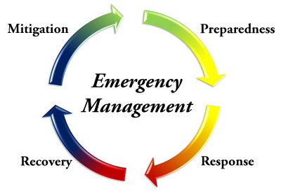

(Island Health, 2023)

This model is divided into the categories of prevention and mitigation, preparedness, response, and recovery (Yang et al, 2013, pg. 912) that the bronze group had to consider when dealing with operational controls to foresee solutions and develop plans (Eastern Kentucky University, 2022). The better prepared the command were, the easier it was to prepare a response to an incident. The bronze group was unprepared before the immersion scenarios had even begun because they had not previously held meetings to assign different roles to each member. This meant that instead of concentrating on crises, a significant amount of time was spent organising roles the morning of the scenario.
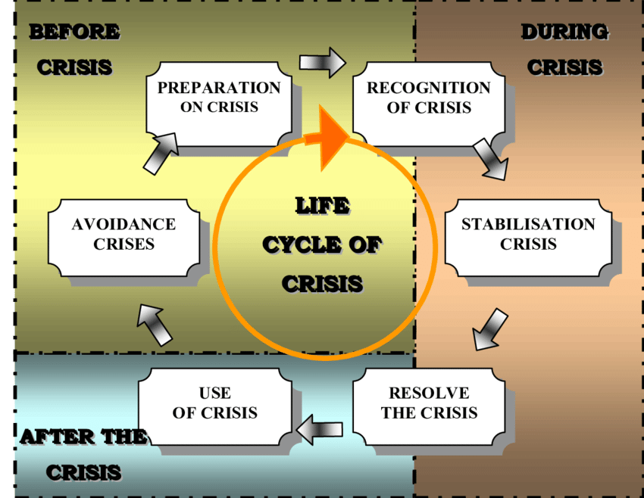

(Kadarova, 2016, pg.59)

Furthermore, as shown above, the Life Cycle of Crisis also states that before any crisis, or potential crisis, there must be preparation, thereby all commands received a 3-week warning to prepare and gather information regarding Cardiff, its main targeted attractions and to create a one slide PowerPoint presentation. This was to discuss a topic of choice based on an area of the city, in this case the participant chose the Principality Stadium.
As shown in appendix 1, the presentation identified the risks and provided solutions on how to manage a crisis regarding that area, for instance terrorist attacks are a risk, therefore, anti-terrorism and evacuation protocols must be in place, along with thorough checks on attendees entering the stadium that must be effectively communicated between employees. The key risks were successfully identified, however, there should have been greater detail into the risks of terrorist attacks which would have helped with recognition and resolving crises on the day.
On the day of the scenario, all commands were shown a series of videos in an immersive room in preparation of what was going to be faced. This created a sense of fear on what could happen if the commands did not implement certain procedures, thereby it led to a greater understanding of the importance of crisis management protocols.
The participant chose to oversee the Principality Stadiums operations and implement procedures in response to different incidents. Other roles in the bronze command consisted of supervising emergency services, fan zones, cordons, and transport. Working as a team cooperatively for Cardiff City's operational side while carrying out individual roles allowed for thorough planning of various areas in Cardiff. This enabled to mitigate the impacts and effectively address the crisis and increase responsiveness through effective measures to ensure all areas were dealt with immediately (World Travel and Tourism Council, 2023).

Crisis Scenario Review
As seen in appendix 2, the first scenario presented was having important dignitaries attend the event. Due to the additional security measures and different emergency response protocols that must be in place, the bronze command faced additional challenges. Bronze command decided that admission for dignitaries into the Principality Stadium would be an hour before the gates opened to the public to ensure they are not targeted threats. They would enter and exit through the underground access with enhanced security around the stadium and police reinforcements in the Ring of Steel. With these precautions in place, it means no harm should come to the individuals.
The silver command liaised to bronze that dignitaries could enter via a boat on the River Taff located next to the stadium, however, the bronze command quickly realised that due to the closure of river traffic in the 2017 Cardiff Champions League (FAW Cymru, 2017), the river may not be open for use. This would make a boat on the water suspicious and a likely target, thereby this response and communication between commands allowed for prevention of a major crisis.
In the case of an emergency, the bronze group collaboratively suggested that all employees must be equipped to lead dignitaries to escape routes safely (Health and Safety Executive, 2023). Through effective and regular communication among employees with the use of code words, dignitaries would be evacuated immediately so no danger would be brought to them. Rapid communication between employees determines the outcome of every situation (Holtom et al, 2020), therefore they must know their roles and responsibilities to ensure positive outcomes.
Although bronze command identified effective protocols, the group originally stated that the dignitaries could be placed in a hospitality box during the event. It became evident that this would not be a sufficient security measure as the public can easily see into the hospitality boxes which would make them an easy target if an attendee wanted to provoke an attack. As a result, the group revaluated the situation and identified that they could be placed in private function rooms instead, increasing the security measures, demonstrating strong teamwork skills as an issue was quickly mitigated.
At 12 o’clock, a 999 call was received that there was a bomb in Cardiff Castle. The bronze command agreed that silver command, or bomb disposal would be contacted immediately to investigate whether the 999 call was real or if it was a hoax. It is vital to check 999 calls before taking measures as emergency services frequently get hoax calls; between 2019 and 2021, the Police alone received 3,502 of them, according to ITV (2020). If it turns out that the call was fake, it wastes time and resources that the emergency services, and the bronze command could have used elsewhere.
While waiting for a response, the bronze group decided that they would place additional security in crowded areas and quietly evacuate the area around the Castle without panicking the public. This protocol was carefully thought about so there was no hooliganism amongst fans which would escalate the situation, making it harder to deal with.
If the 999 call was true, then the city would be evacuated immediately, with lockdown of the pubs and stadium as there would not be enough time to evacuate the fans. The bomb disposal and armed response would be called to respond to the crisis. The call ended up being a hoax, so no further investigations were needed.
It became clear that the bronze commands response was effective but had areas of improvement. The command suggested that the castle and city should be evacuated when waiting for a response of the call, however, this should not be the case. The command should have had faith that the security checks prior to the event was successful as the event would not go ahead if the operations team evacuated the area without clarification of the call. There should have been investigations into where the phone call came from, CCTV checks for suspicious activity and a discrete area check before any evacuation procedures were implemented.
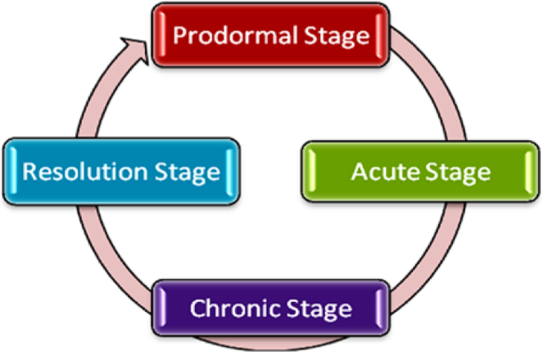

(Albattat & Ahmad, 2013, pg.5)

As seen in appendix 2, at 3pm it was reported that there were counterfeit tickets for entry into the Principality Stadium. In relation to Fink (1986) Crisis Model above, the first stage “prodromal stage” was identifying the fake tickets, thereby the bronze group decided to increase security checks on gates to proactively monitor, prevent and limit the situation. To accomplish this, all tickets must be scanned using a digital technology system, with constant communication among employees. If there was an issue where a fake ticket was identified, it moves onto the acute stage of the Fink Model where staff members must implement crisis management plans. In this case, the bronze group collectively decided that extra security should be present at the gates to ensure crowd management principles are in place to keep attendees safe (Health and Safety Executive, 2023) if any violent conduct occurred from people who were turned away for having fraudulent tickets. The participant successfully contributed that names appear on purchased tickets so security should check the name on the ticket and compare it to identification or proof of purchase if a ticket was flagged up, this is a crucial security measure to help manage the situation.
Due to the bronze group’s preparations on the Champions League Final in 2022, 70% of the tickets presented to the Stade de France were fake, so the bronze command was prepared to admit a quick response. The group successfully prevented the admission of visitors using counterfeit tickets, although the group did not realise that there should be three security checks in different areas incase any fake tickets managed to get through the first check.
Scenario four, as seen in appendix 2, presented conflict between fans that issued the bronze command to send police reinforcements to the area armed with shields and battens in an effort to intimidate fans to settle down. It was made known to the group that this was not the right protocol because it would worsen the situation by igniting a riot; rather, the riot team should be on standby and only enforced if it is absolutely required. Given that the bronze group was supposed to be aware of this problem, this demonstrates a lack of preparation prior to the crisis scenario.
Furthermore, as stated in appendix 2, there was also a suspicious van in the Ring of Steel. The bronze command received effective and rapid instructions from the silver command to send security to investigate the vehicle while looking into CCTV and contacting the council. Due to the thorough planning done before the training scenario, communication between various commands was prompt as they were aware of the risk of suspicious vehicles due to the 2017 London Bridge attacks (BBC, 2019). Given that the public was aware of this terrorist attack, the bronze command acted immediately to reassure them that the crisis was being managed and that there was no danger.
The last scenario presented took all participants out of their comfort zones as it was fast paced compared to previous scenarios, with many crises occurring. The information was only relayed to gold command, so they had to inform bronze that they were now only overseeing the inside of the Principality Stadium. During this time, the bronze group effectively instructed their security to implement crowd control principles and regularly observe entrances and exits. Stewards were placed around the pitch to surround the ground level, while emergency services on standby incase of an emergency, for example fire brigade due to the fireworks.
The bronze command was aware that the city was a target for a major terrorist attack due to the previous attack on London Bridge meant for Cardiff in 2017. As a result, the bronze group knew to add extra security in all areas of the stadium, effectively mitigating a crisis.
During the time of 10:02 pm to 10:16pm, a terrorist attack did occur of a suicide bomber, stabbings, and a van ploughed into pedestrians, just like the London Bridge attack, however this information was not relayed to the stadium as bronze command was only told to lockdown the stadium with limited justification as to why. Although thorough details of the information regarding the terrorist attack did not need to be provided to bronze as “selective sharing of information is designed to help manage information over-load for staff” (Erikson, 2021, pg.479), it made it difficult while being under pressure. This is because it was challenging on what to instruct employees to do while keeping fans distracted and in good spirits.
Due to the limited communication, the group found it hard to implement the necessary protocols quickly, however, once the silver and gold command dealt with the crisis, information was delivered to bronze command quickly. This enabled for a quick response of implementing emergency services and departing fans due to receiving clarity. Additionally, the bronze group realised that after the training scenario ended, they did not evacuate dignitaries which should have been an immediate protocol. This was a significant error as the bronze group endangered them by making them target for danger.

Conclusion
In conclusion, the bronze command group made effective decisions in implementing procedures to ensure the safety of fans at the event by successful working as a team. This is particularly evident as there was consideration of different emergency procedures to respond to different incidents, such as security measures against counterfeit tickets, and lockdown procedures. Although, there were some weaknesses in preparation which bronze command should have been aware of, for example ensuring all dignitaries had strict security and evacuation protocols. Additionally, communication between the gold, silver and bronze command was weak which could have resulted in a major crisis if incorrect information was relayed, or no information at all. The interactive scenarios allowed for improvement, growth mindset and careful knowledge on the importance of crisis preparedness and resilience in the tourism sector.

Recommendations
The following recommendations provides preparedness and resilience in the tourism sector for future crises:
- To be better prepared by researching past case studies and emergency protocols, along with delegating roles in commands prior to the crisis training scenario. This will allow for an immediate response to prevent a crisis or prevent one from worsening.
- To have better communication between gold, silver, and bronze commands so there is clarity on different incidents and what emergency procedures must be implemented.
- Increase knowledge on how to protect and carry out emergency protocols regarding dignitaries so they are not in risk of any danger.
- To prepare future managers and leaders to manage numerous unanticipated situations in a fast-paced setting, they should undergo the same experiential learning method. This would enable to diffuse crises quickly and prevent damage.

Appendix
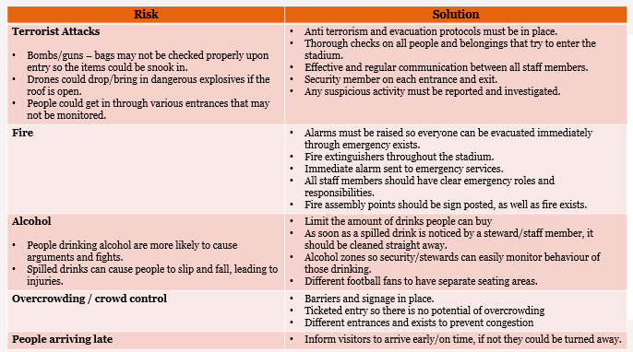
Appendix 1

Appendix 2
A table on the management of scenarios that were presented on the day of the training scenario, of which are discussed and evaluated throughout the review.
Scenario | Description
1 | Important attendees are attending the event, this includes members of the Royal Family (the Prince, and Princess of Wales and their two eldest children), as well as the Prime Minister, First Minister, and German Prime Minister.
2 | 999 call was received that there was a bomb in Cardiff Castle.
3 | Reported that there were counterfeit tickets for entry into the Principality Stadium.
4 | Scuffles reported in Cardiff Bay between the Liverpool and Bayer Munich fans with the use of flares.
5 | 999 received a large number of calls that a Cardiff City van was parked within the Ring of Steel that is now open to the public, the van was empty, but it was running with the keys left in the ignition which is worrying the fans.
6 | Van ploughed into pedestrians on Cardiff bridge before launching a knife attack.

Appendix 3
Seating map of the Principality stadium, Cardiff.
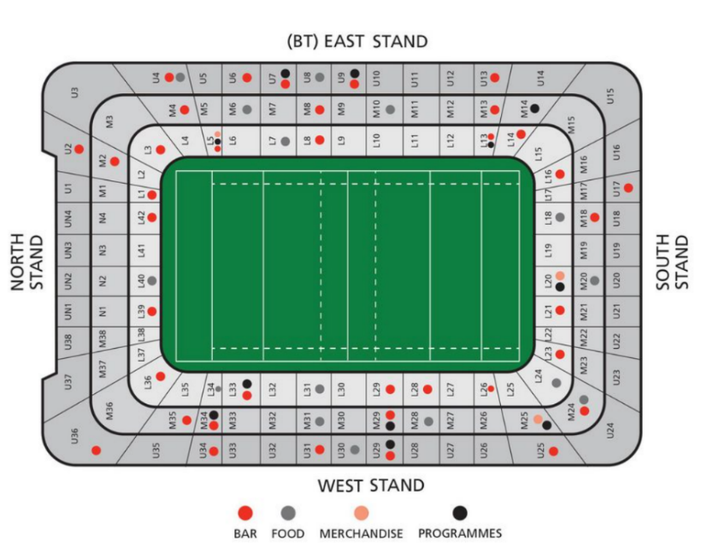

(Principality Stadium, 2023)

Appendix 4
A map of the Principality Stadium, Cardiff,
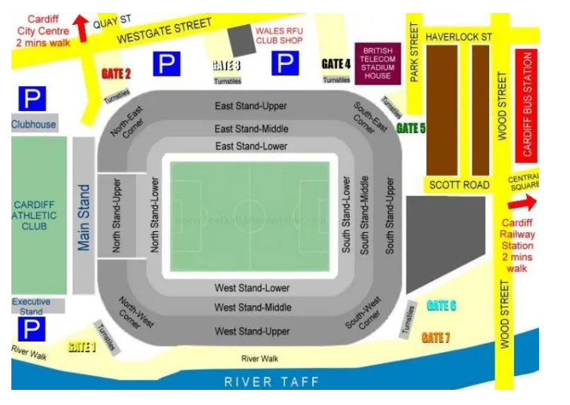

(Stadium Guide, 2022)

Appendix 5
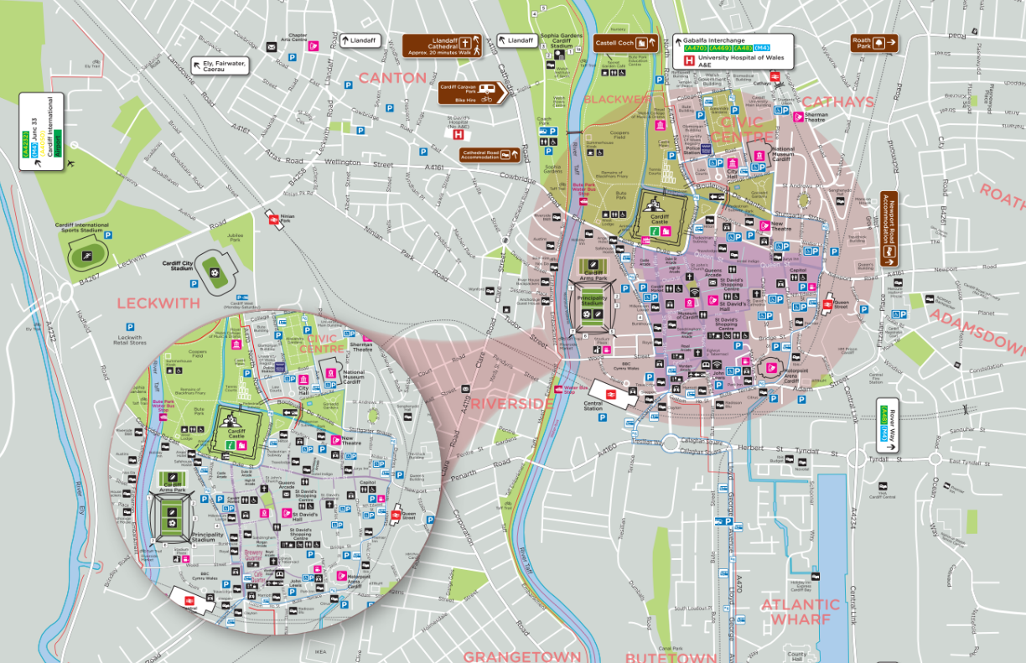
A map of Cardiff City and its main attractions.
(Visit Cardiff, 2023)

Bibliography
Albattat, A.R and Ahmad, P.M.S. (2013) Emergency Preparedness for Disasters and Crises in the Hotel Industry. Sage Open. 3. 10. 10. Available at: (PDF) Emergency Preparedness for Disasters and Crises in the Hotel Industry (researchgate.net) (Accessed: 04/05/2023).
BBC News (2019) London Bridge attack: What happened. Available at: London Bridge attack: What happened - BBC News (Accessed: 02/05/2023).
Birt, J (2022) Crisis Communication: The 3 stages (plus examples and tips). Available at: Crisis Communication: The 3 Stages (Plus Examples and Tips) | Indeed.com (Accessed: 30/04/2023).
Eastern Kentucky University (2022) What are the phases of emergency management? Available at: What Are the Phases of Emergency Management? | EKU Online (Accessed: 01/05/2023).
Employment Hero (2022) 10 tips for communicating with employees during a crisis. Available at: Communicating with employees during a crisis | Employment Hero (Accessed: 03/05/2023).
Erikson, S (2021) Communication in a Crisis and the Importance of Authenticity and Transparency. Journal of Library Administration. Volume 61:4, 476-483. Available at: Communication in a Crisis and the Importance of Authenticity and Transparency (tandfonline.com) (Accessed: 03/05/2023).
FAW Cymru (2017) Security. Available at: Security | Cardiff 2017 (faw.cymru) (Accessed: 27/04/2023).
GOV.UK (2013) Emergency response and recovery. Available at: Emergency response and recovery - GOV.UK (www.gov.uk) (Accessed: 01/05/2023).
GOV.UK (2021) Critical incident management. Version 13.0. Available at: National critical incident management guidance (publishing.service.gov.uk) (Accessed: 28/04/2023).
Hayes, A (2022) Crisis Management: Definition, How It Works, Types, and Example. Available at: Crisis Management: Definition, How It Works, Types, and Example (investopedia.com) (Accessed: 28/04/2023).
Health and Safety Executive (2023) Assess crowd safety risks and identify hazards. Available at: Event safety - Crowd-management - Assess crowd safety risks and identify hazards (hse.gov.uk) (Accessed: 01/05/2023).
Health and Safety Executive (2023) Planning for incidents and emergencies. Available at: Event safety - Planning for incidents and emergencies (hse.gov.uk) (Accessed: 01/05/2023).
Holtom, B., Edmondson, A.C and Niu, D. (2020) 5 Tips for Communicating with Employees During a Crisis. Available at: 5 Tips for Communicating with Employees During a Crisis (hbr.org) (Accessed: 01/05/2023).
Immersive Labs (2021) Interdependence and teamwork: managing crises effectively. Available at: Interdependence and teamwork: managing crises effectively - Immersive Labs (Accessed: 01/05/2023).
Indeed (2023) What is risk assessment and why is it important? Available at: What Is Risk Assessment and Why Is It Important? | Indeed.com Singapore (Accessed: 30/04/2023).
Island Health (2023) Emergency Management. Available at: Emergency Management | Island Health (Accessed: 04/05/2023).
Kadarova, J (2016) Corporate Management in the conditions of crisis. Available at: CORPORATEMANAGEMENT.pdf (Accessed: 04/05/2023).
Martin, S (2020) Communicating in a Crisis: What, When, and How. Available at: Communicating in a Crisis: What, When & How | CCL (Accessed: 01/05/2023).
Mcleod, S (2023) Kolb’s Learning Styles and Experiential Learning Cycle. Available at: Kolb's Learning Styles and Experiential Learning Cycle (simplypsychology.org) (Accessed: 04/05/2023).
Milburn, T.W., Schuler, R.S. and Watman, K.H., (1983) Organizational Crisis. Part I: Definition and conceptualization. Human relations, 36 (12), pp.1141-1160. Available at: Organizational Crisis. Part I: Definition and Conceptualization (leadership-resources.com) (Accessed: 28/04/2023).
Mosalski, R (2017) This is everything we know about security at the Champions League final in Cardiff. Available at: This is everything we know about security at the Champions League final in Cardiff - Wales Online (Accessed: 27/04/2023).
Ndlela, M.N (2018) Crisis Communication. A Stakeholder Approach. Available at: Crisis Communication: A Stakeholder Approach - Martin N. Ndlela - Google Books (Accessed: 29/04/2023).
Pinterest (2022) Principality Stadium Cardiff. Available at: Principality Stadium in Cardiff #aerialphotography #CommissionAir #football #Cardiff | Millennium stadium, Stadium architecture, Football stadiums (pinterest.co.uk) (Accessed: 28/04/2023).
Principality Stadium (2022) Principality Stadium Home. Available at: Principality Stadium | Home (Accessed: 01/05/2023).
Principality Stadium (2023) Fanzones and Facilities. Available at: Principality Stadium | Fanzones & Facilities (Accessed: 04/05/2023).
Stadium Guide (2022) Cardiff Principality Stadium Seating Plan Rows, Parking Map, Ticket Prices. Available at: Cardiff Principality Stadium Seating Plan Rows, Parking Map, Ticket Prices (stadiumsguide.com) (Accessed: 04/05/2023).
Visit Cardiff (2023) Cardiff. Available at: 0001132 RC 885x930 English map Feb2020 (visitcardiff.com) (Accessed: 04/05/2023).
World Travel and Tourism Council (2022) Enhancing Resilience. To drive sustainability in destinations. Available at: WTTCxICF-Enhancing_Resilience-Sustainable_Destinations.pdf (Accessed: 29/04/2023).
World Travel and Tourism Council (2023) Crisis Preparedness, Management & Recovery. Available at: Crisis Preparedness, Management & Recovery | Initiatives | World Travel & Tourism Council (WTTC) (Accessed: 01/05/2023).
Yale University (2023) We know teamwork is important, but how important? Available at: We know teamwork is important, but how important? | It's Your Yale (Accessed: 01/05/2023).
Yang, S., Chung, H., Lin, X., Lee, S., Chen, L., Wood, A., Kavanaugh, A.L., Sheetz, S.D., Shoemaker, D.J. and Fox, E.A. (2013) PhaseVis1: What, when, where, and who in visualizing the four phases of emergency management through the lens of social media. In ISCRAM. Available at: Microsoft Word - 183 (iscram.org) (Accessed: 01/05/2023).

