

BMSW4013

Academic Skills for the Digital Era

Evidence of Learning

Student Name: Florina Rautu
Student ID: 2439468
Lecturer: Jaliya De Silva

Table of Contents
Component 1: Research and Planning 3
Source Exploration 3
Key Challenge for Students 4
Key Opportunity for Students 4
Planning Your Report 4
Component 2: Report 6
1. Introduction 6
2. Challenges Students Face 6
3. Opportunities Digital Tools Provide 7
4. How Students Can Adapt to Succeed 7
5. Conclusion 8
Component 3: Reflective Presentation (5 Minutes) 9
Slide 2 – Reflection on Research Process 10
Slide 3 – Reflection on Writing Process 11
Slide 4 – Challenges and Successes 12
Slide 5 – Looking Forward 13
Slide 6 – Conclusion 14
References 16

Component 1: Research and Planning

Source Exploration
Source: Selwyn, N. (2021). Should Robots Replace Teachers? AI and the Future of Education. Cambridge: Polity Press.
Main Idea / Finding:
Selwyn (2021) analyses how the high adoption rate of digital technologies, especially artificial intelligence (AI), is transforming higher education. He believes that, although digital tools may enhance accessibility, flexibility and personalised learning, they also bring about issues of privacy of data, lack of human contact, and excessive dependency on automation. The book points out that technology must not eliminate but help support the critical and contemplative side of learning.
Reason for Selection:
I chose this source because it provides a reasonable and research-grounded discourse on the opportunities and challenges students encounter during the digital age (Turner, Hicks and Zucker, 2020). It is a new book by an established scholarly writer and publishing house, which qualifies it to be used in the analysis of higher-education settings. The source is as per the CRAAP test:
- Currency: Published in 2021 — highly relevant to current educational technology.
- Relevance: Directly addresses digital learning issues faced by university students.
- Authority: Selwyn is a recognised researcher in education and technology.
- Accuracy: Evidence-based and referenced to peer-reviewed studies.
- Purpose: Analytical — to inform and question assumptions about digital transformation.
Contribution to Main Question:
This reading aids in responding to the question What are the challenges and opportunities of students in the digital age, and how can they adjust and succeed? By offering academic information on what has become advantageous about digital learning (greater access, flexibility) and what has been disadvantageous (distraction, inequity).

Key Challenge for Students
Information overload is one of the major problems facing students in the digital era. Having extensive online materials and content created by AI systems, students usually have a difficult time evaluating the credibility and relevance of the sources. Both Selwyn (2021) and Cottrell (2019) state that unlimited access to information can be a barrier to deep learning and a cause of anxiety because students risk spending time filtering valuable information and false data. To have an example, during the process of researching assignments (Bawden and Robinson, 2020).

Key Opportunity for Students
One of the other great advantages of the digital era is flexibility and collaboration. Digital tools, such as Microsoft Teams and Google Workspace, make group projects a much more productive and flexible experience for group members. These digital tools provide not only real-time communication, sharing of materials, and feedback from peers to advance knowledge-building. Moreover, Van Emden and Becker (2022) noted that online collaboration builds employability skills like communication and problem-solving skills and offers students the possibility of working with peers from around the world or around the corner. One of the other great advantages of the digital era is flexibility and collaboration. Digital tools, such as Microsoft Teams and Google Workspace, make group projects a much more productive and flexible experience for group members.

Planning Your Report
- Focus: I plan to discuss both challenges and opportunities equally, to show how students can balance the risks and benefits of digital tools.
- Examples / Digital Tools: Microsoft Teams, Google Drive, AI learning assistants, and Pomodoro time-management apps.
Planned Structure for Component 2:
- Introduction
- Challenges (information overload, distraction)
- Opportunities (collaboration, flexibility)
- Strategies for Adaptation (time management, responsible AI use, digital literacy)
- Conclusion

Component 2: Report

1. Introduction
Learners in the digital age are changing how they learn, what they learn, and how they communicate, and learners are now equipped to organise their learning in new ways. The rise of online platforms and collaborative tools, along with artificial intelligence (AI), has created new and exciting ways to connect with educational institutions and other learners, now and live. This paper will discuss the two significant challenges (i.e., information overload and digital distraction) and two significant opportunities (i.e., collaborative learning and flexibility of access), as well as a few practical examples and recommendations for moving through life and learning successfully in the digital age.

2. Challenges Students Face
Information Overload: One of the most serious challenges in education today is information overload. The massive availability of digital resources has made it possible for students to be inundated with amounts of data, opinions, and materials found on the internet (Masrek and Baharuddin, 2023). Each time one searches for sources, they are likely to find hundreds of results, and cross-referencing sources can be difficult while ensuring related quality. Being able to sort through and eventually find credible and relevant information takes time and skill. Often, students rely on quick summaries or non-academic websites, and this likely limits the depth of student understanding.
Digital Distraction: Another obstacle is the persistent distraction of digital connections. Students receive notifications, messages, or fun distractions, which a distractions. If a student is shifting back and forth from a learning behaviour to social interaction on social media, the student will quickly become less engaged and ultimately more productive (Mondal, 2024). If that shift occurs often over time, learning and studying practices will decrease even more and again, produce little or shallow work. Digital distractions increase the level of stress and anxiety, as students then tend to procrastinate and put themselves in a position to then rush to complete the work at the last minute. Digital distractions now consume as much time as competing interests to studying.

3. Opportunities Digital Tools Provide
Collaborative Learning and Communication: Digital resources have become a strong platform for collaboration. Online meeting platforms, shared documents, and group chat functions can facilitate students working together in real time while still not being present with one another. The opportunities to collaborate can increase, which supports the teamwork in the group (Abbas et al., 2022). Technologies that support collaboration allow students to share their ideas quickly and allocate work among themselves while communicating about their work. It also mirrors an important aspect of many of their future work experiences and types of teamwork they might encounter after graduation - collaborative digital spaces.
Flexible and Personalised Learning: Enhancements in technology have provided increased flexibility for students in the learning process. This technology includes recorded lectures, online libraries, and even notetaking apps, which all provide students with the opportunity to engage with the material when it works for them, and to study and/or understand the material at the time and pace that applies to them when it explores the complexity of that material (Pyörälä et al., 2019). The need for flexibility is felt even more greatly for students who have competing demands of work or family, as this flexibility allows them to study within the time they feel most applicable.

4. How Students Can Adapt to Succeed
Develop Strong Time-Management Skills: Effective time management is always the foundation of what will yield success in online learning. Breaking larger tasks into smaller goals and working in focused "sprints" are also strategies that can facilitate sustained focus and motivation (Appoh et al., 2022). Students can implement relatively simple systems, such as creating a list of things they want to accomplish each day, or intentionally work in patient "work and break" periods to keep their energy levels up and limit distractions. Becoming aware of, and framing, work in terms of important and urgent can also provide an effective framework for avoiding "last-minute" work behaviour too often.
Use Technology Responsibly and Ethically: While technology has many benefits, students must use it ethically. AI and writing assistance tools may assist with grammar or summarisation, but always defer to your efforts to engage with the course material and understanding (Sadigzade, 2025). Ethical use means checking all recommendations, rewriting recommendations in your own words, and properly citing where the recommendations were generated from. Using digital tools ethically and ensuring responsible behaviour helps to build trust with your instructor based on the premise that your work reflects your intellectual endeavours.
Strengthen Digital Literacy: Digital literacy is the ability to find, evaluate, and use information to achieve a variety of goals. This includes selecting and using information for study purposes, and it can be developed with the directed practice of navigating the university library’s online resources, attending workshops, and learning to distinguish quality resources from substandard resources. Other features of digital literacy include protecting personal information, managing one's online persona, and participating in professional communication in a digital context (Kateryna et al., 2020). Becoming skilled at these abilities will connect students with their academic mission of learning and will also prepare them for future experiences in a technology-rich workplace.

5. Conclusion
The digital world offers a variety of issues and advantages to college students alike. The experiences surrounding information overload and digital noise can prove detrimental if they are not effectively monitored. However, the opportunities of digital collaboration and flexibility of content are significant means of empowering the independence and understanding of course learning. These benefits centre upon students' ability to manage the workflow, ethically manage the technology utilised and develop their digital literacy.

Component 3: Reflective Presentation (5 Minutes)
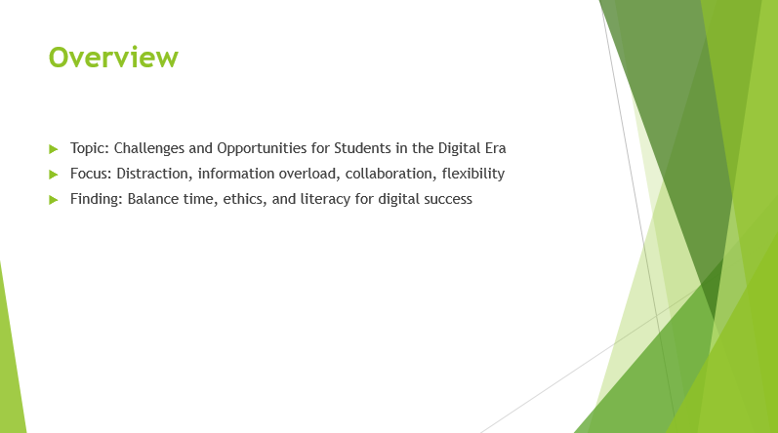
Slide 1 – Overview
Content
- Topic: Challenges and Opportunities for Students in the Digital Era
- Focus: Distraction, information overload, collaboration, flexibility
- Finding: Balance time, ethics, and literacy for digital success
Speaker Notes
In this presentation, I focused on how technology provides opportunities for flexibility and collaboration, and distraction as well. Ultimately, my conclusion was that time management and developing digital literacy skills are essential for a successful and balanced learning experience in the digital environment.
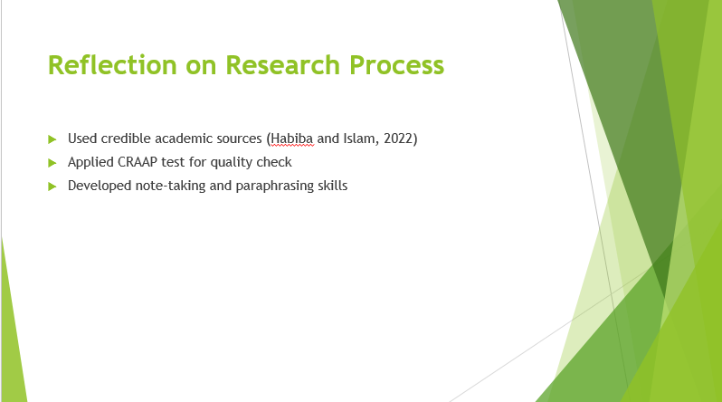

Slide 2 – Reflection on Research Process
Content
- Used credible academic sources (Habiba and Islam, 2022)
- Applied CRAAP test for quality check
- Developed note-taking and paraphrasing skills
Speaker Notes
During my study, I utilised academic databases and employed the CRAAP test, which included Currency, Relevance, Authority, Accuracy, and Purpose, to check the sources of information. In doing so, I advanced my critical evaluation skills in the process. While it was difficult to find recent studies about students’ challenges with digital education.

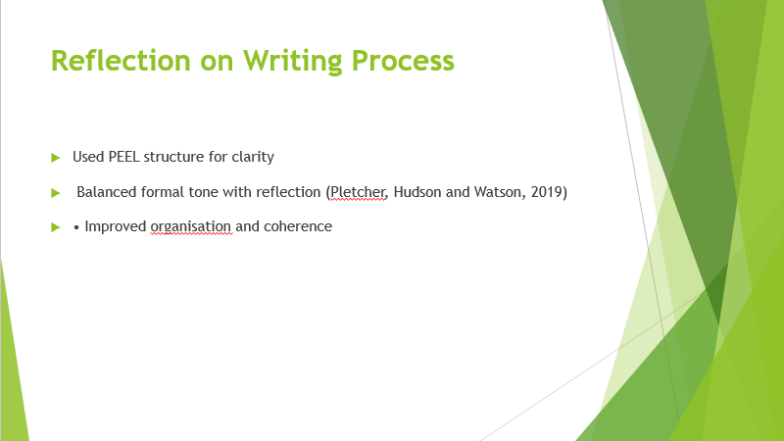

Slide 3 – Reflection on Writing Process
Content
- Used PEEL structure for clarity
- Balanced formal tone with reflection (Pletcher, Hudson and Watson, 2019)
- Improved organisation and coherence
Speaker Notes
I arranged the paragraphs accordingly to the structure of PEEL—Point, Evidence, Explanation, and Link for smoothness and logical order. At first, I did find it a little tricky because I wanted to maintain an academic tone while adding an aspect of reflection, but in the revision process, I found my way. I also found that using subheadings helped with organisation in terms of quality as well as expression of my thinking in a professional and coherent writing style.

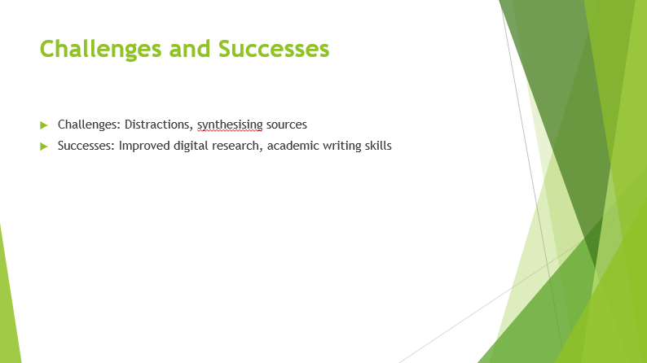

Slide 4 – Challenges and Successes
- Challenges: Distractions, synthesising sources
- Successes: Improved digital research, academic writing skills
Content
Taking care of distractions caused by digital tools and systems while researching online can be difficult. I managed using the Pomodoro Method and breaking my time into study-slots and blocks. Synthesising the source material was a hard but satisfying process. The main learning that occurred for me was to sharpen my research skills digitally and to develop confidence in my academic writing and referencing tool use.

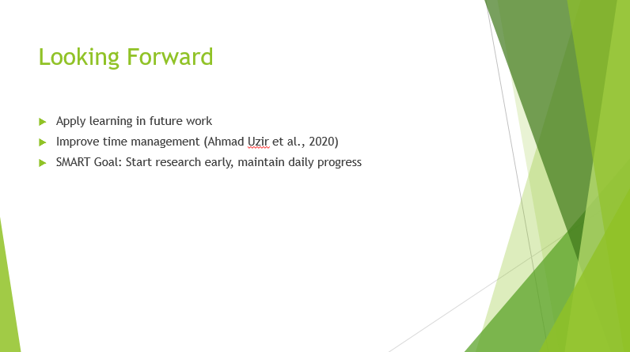

Slide 5 – Looking Forward
- Apply learning in future work
- Improve time management (Ahmad Uzir et al., 2020)
- SMART Goal: Start research early, maintain daily progress
Content
I will also use technology for time tracking. Time management technology will assist with keeping me accountable for my time management, help keep me from procrastination, and organise and balance my use of technology in my academic life.

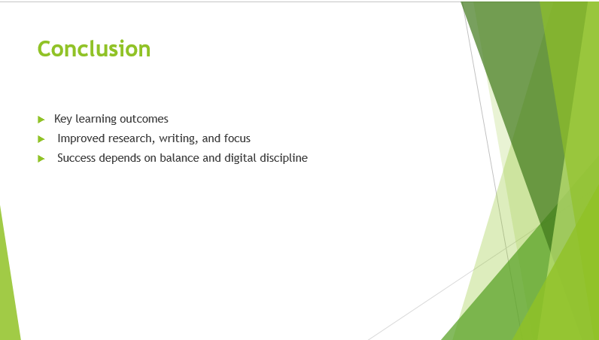

Slide 6 – Conclusion
Content
- Key learning outcomes
- Improved research, writing, and focus
- Success depends on balance and digital discipline
Speaker Notes
In conclusion, this experience taught me not only how to research effectively and write professionally, but also how to maintain discipline in digital spaces. I learned that success in the digital age requires balance; to use technology to deliver the expected results and avoid getting distracted. Overall, I have become more confident, independent, and ethical in addressing challenges with digital learning.

References
Abbas, Y., Martinetti, A., Rajabalinejad, M., Schuberth, F. and van Dongen, L.A. (2022). Facilitating digital collaboration through knowledge management: A case study. Knowledge management research & practice, 20(6), pp.797-813.
Ahmad Uzir, N.A., Gašević, D., Matcha, W., Jovanović, J. and Pardo, A., 2020. Analytics of time management strategies in a flipped classroom. Journal of Computer Assisted Learning, 36(1), pp.70-88.
Appoh, M., Frempong, D., Akinboboye, O., Okoli, I., Afrihyia, E., Umar, M.O., Umana, A.U. and Omolayo, O. (2022). Agile-based project management strategies for enhancing collaboration in cross-functional software development teams. Journal of Frontiers in Multidisciplinary Research, 3(2), pp.49-64.
Bawden, D. and Robinson, L., (2020). Information overload: An overview.
Habiba, U. and Islam, M.E., (2022). Assessing the quality and credibility of scholarly information resources: an investigation into information behaviours of university faculty members. The Electronic Library, 40(3), pp.237-255.
Kateryna, A., Oleksandr, R., Mariia, T., Iryna, S., Evgen, K. and Anastasiia, L. (2020). Digital literacy development trends in the professional environment. International Journal of Learning, Teaching and Educational Research, 19(7), pp.55-79.
Masrek, M.N. and Baharuddin, M.F., (2023). Screens, streams, and stress: a qualitative study on how distance learning students cope with information overload. International Journal of Membrane Science and Technology, 10(5), pp.47-58.
Mondal, P.K. (2024). Exploring the Impact of Digital Distraction on Learning: A Qualitative Analysis of University Students' Experiences and Strategies.
Pletcher, B.C., Hudson, A.K. and Watson, K., 2019. “I want to learn from them as much as I want them to learn from me”: Finding a balance of coaching and consulting through the analysis of a literacy coach’s conversations. Reading Horizons: A Journal of Literacy and Language Arts, 58(1), p.4.
Pyörälä, E., Mäenpää, S., Heinonen, L., Folger, D., Masalin, T. and Hervonen, H., (2019). The art of note-taking with mobile devices in medical education. BMC medical education, 19(1), p.96.
Sadigzade, Z. (2025). AI-Powered Feedback in ESL Writing Classes: Pedagogical Opportunities and Ethical Concerns. Journal of Azerbaijan Language and Education Studies, 2(4), pp.5-17.
Turner, K.H., Hicks, T. and Zucker, L. (2020). Connected reading: A framework for understanding how adolescents encounter, evaluate, and engage with texts in the digital age. Reading Research Quarterly, 55(2), pp.291-309.

