Introduction
The purpose of this section is to analyse the data collected from the questionnaire which was given to police officers within the South Wales police force with an expected time of completion being no longer than 10 minutes. This was achieved and took an average of 8 minutes and 31 seconds to complete (Figure 1). The questionnaire was sent to police officers of South Wales Police via an internet link, this was disseminated using WhatsApp messenger in an information group whereby police officers from South Wales Police can ask for and receive information with relevant requests by senior staff.
The target response for participants undertaking the questionnaire was 50, but upon analysis, the questionnaire received a total of 96 responses, which included qualitative and quantitative results available for analysis (Figure 1). The last question of the questionnaire has provided 28 responses of qualitative results. The topic selected to undertake contains relevant questions that police officers deal with daily which provides relevance and realism to a police officer's routine (Figure 2).

Main body
Participants
Questions one to three of the questionnaire are implemented in order to gain an understanding of the participating audience’s age, length of service, and gender. The group with the largest proportion of participants was 0-2 years of service with 29 individuals, followed closely by 6-10 years of service with 24 participants, followed by 3-5 years of service with 23 participants, and lastly 11+ years with 20 participants. The participants who were male have been identified as 58 and female 38, non-binary and others have produced a result of 0. The age range of officers completing the questionnaire has ranged from 18-41+ with the majority being from the age category of 30-40 (Figure 3). This meant that the results from this questionnaire are representative of a wide range of participants from different length of service, ages and gender, therefore gaining understanding in experiences from different police officers.

Interactions
Question four utilises how many police officers have had interactions within multicultural communities whilst in the course of their duty. The result of this showed that all 96 participants had identified that the makeup of modern-day policing is heavily involved in multicultural communities (Figure 4). Therefore, identifying and confirming that police officers have regular contact within multicultural communities, highlighting the importance of this topic and how relevant it is to modern day policing.

Barriers and training
Question eight identifies the importance of language services during interactions with individuals of multicultural communities whereby the English language is often the second language choice, this found that 46 participants of the questionnaire find language services somewhat useful with 36 participants finding language services extremely useful in comparison to 1 person finding the services not useful. Question 9 also aids in this and shows that South Wales Police officers find that the language services are easily accessible (Figure 5).
Hunter et al (2022) have found that second-language English speakers often find mistreatment unjust when language barriers are in place and promote miscommunication within the criminal justice process. Questions 15 and 16 identify that a majority of South Wales police officers who participated in this questionnaire feel that they have not had sufficient training in relation to language services and their beneficial uses in multicultural communities. 46 participants agree and 36 strongly agree that it would be beneficial for training to be implemented by South Wales Police to assist them in their understanding of the services and the additions they can add to the experience of those involved in police contact (Figure 6).
The above questions have identified that although language services are easily accessible and when used are useful, there is however a majority feeling that training within South Wales Police force is lacking. The participants have also identified that more training would be beneficial in understanding how to use language services during interactions with multicultural communities which correlates with the research conducted by The Bell Foundation (2023).

Conclusion
This topic area provided a questionnaire that allowed a wide range of data collection and analysis from police officers within South Wales Police. It assisted in gathering responses and understanding from officers of all ages, genders, and length of service showing a broad range of results. The data analysis has allowed the identification of areas for future development within areas such as training provided to police officers in the implementation of language services when dealing with individuals in the criminal justice process from multicultural communities.
Bibliography
- Hunter G, et al. (2022). Language barriers in the criminal justice system. [Online]. Institute for Crime & Justice Policy Research. Last Updated: 7th March 2022. Available at: https://www.bell-foundation.org.uk/criminal-justice-programme/research/language-barriers-in-the-criminal-justice-system/#:~:text=Key%20findings&text=Patchy%20provision%20of%20language%20support,which%20is%20protected%20in%20law [Accessed 1 February 2024].
- The Bell Foundation. (2023). Victims and Prisoners Bill. [Online]. U.K. Parliament. Last Updated: 22nd June 2023. Available at: https://publications.parliament.uk/pa/cm5803/cmpublic/VictimsPrisoners/memo/VPB22.htm [Accessed 1 February 2024].

FIGURES
Figure 1: Participants and response times

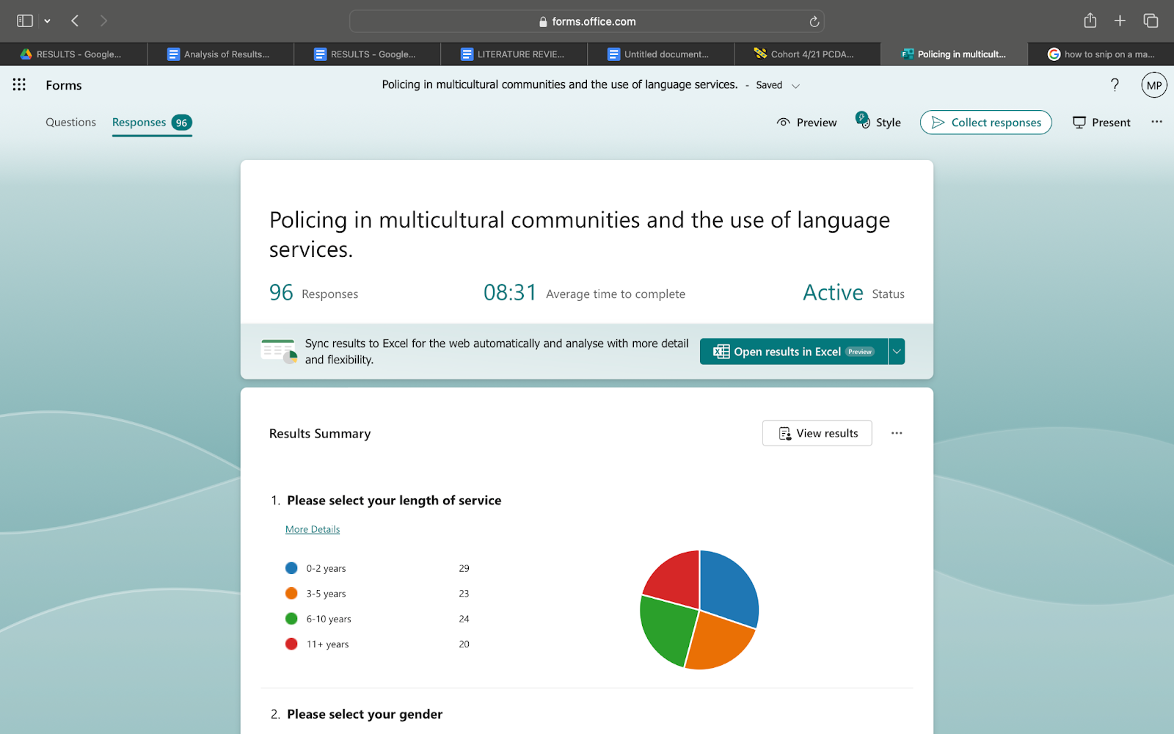

Figure 2: Quantitative responses

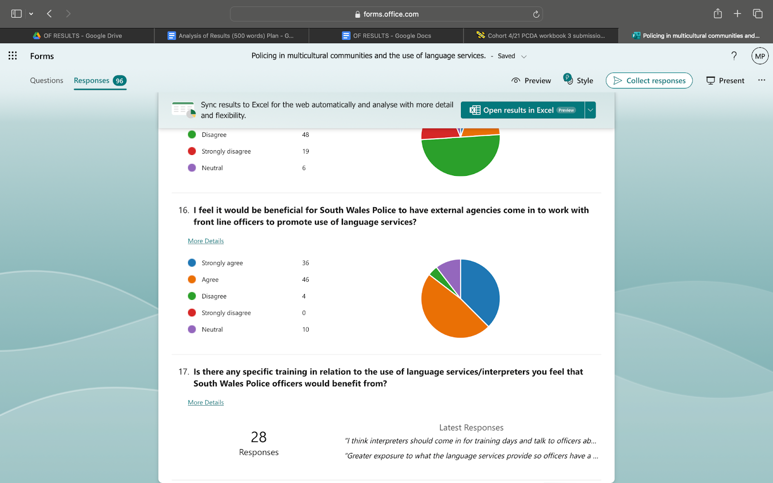

Figure 3: Participating audience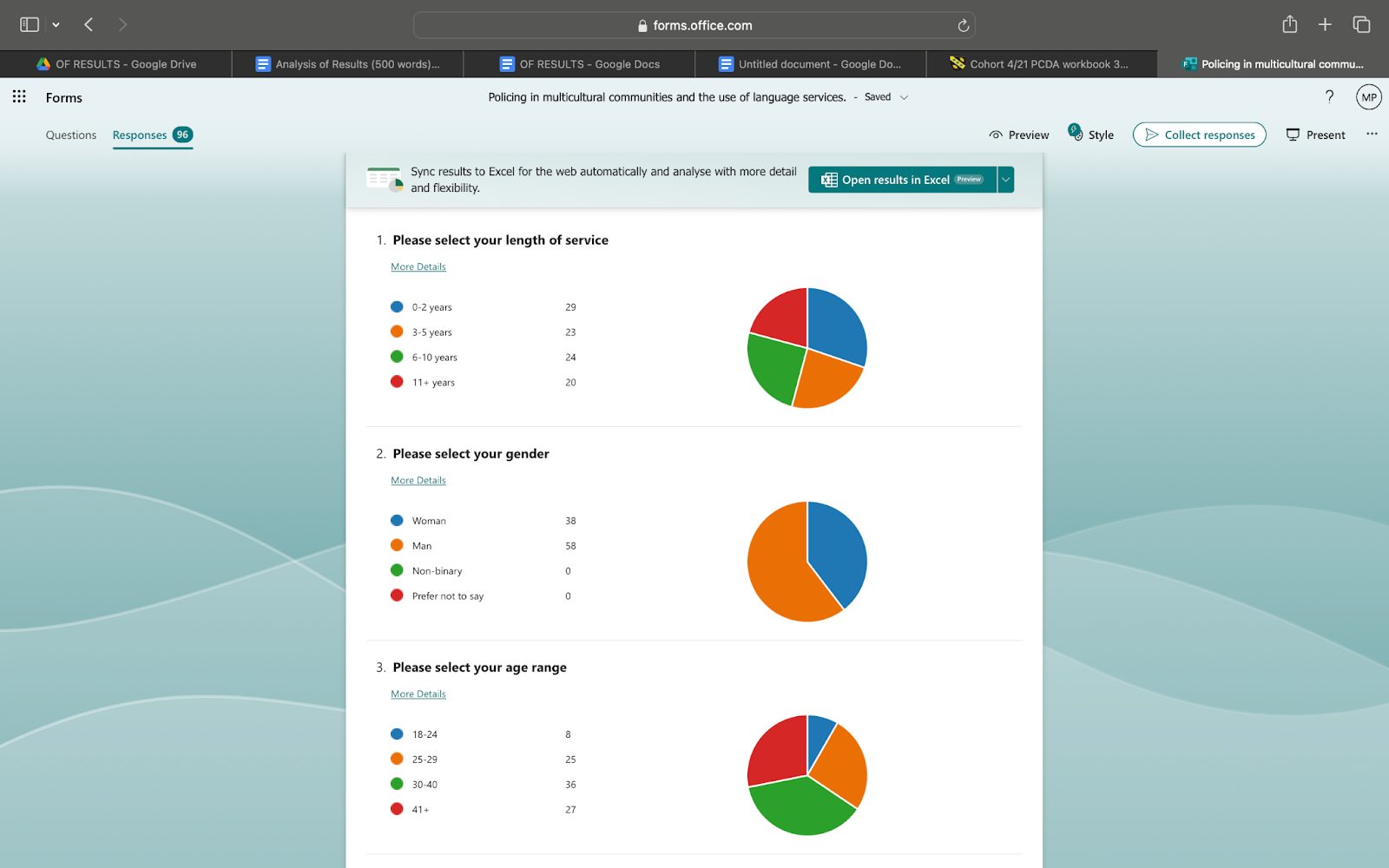
Figure 4: Multicultural community interactions 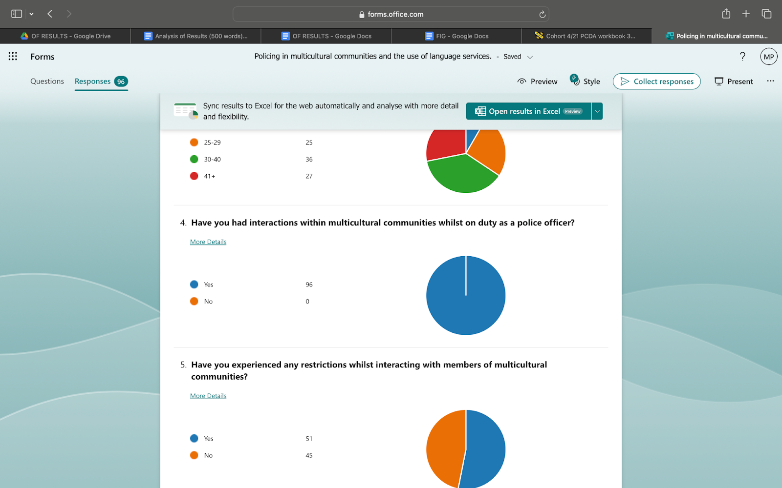

Figure 5: Accessibility of language services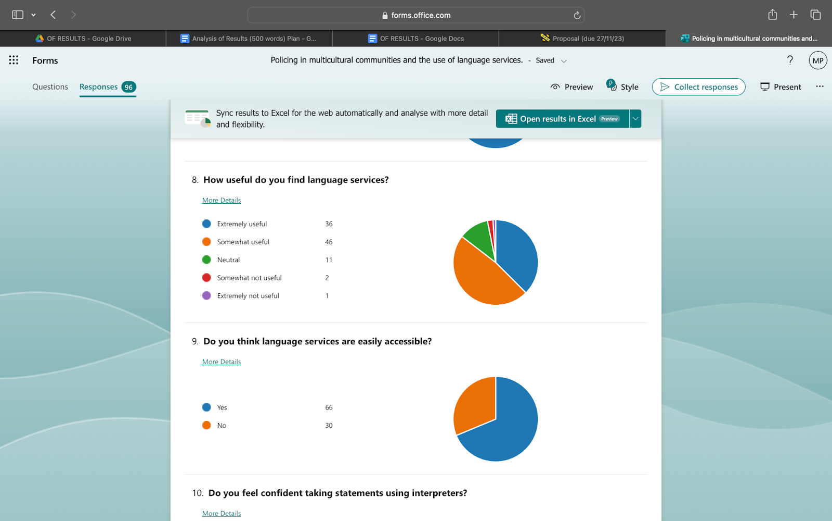

Figure 6: insufficient training with language services 

