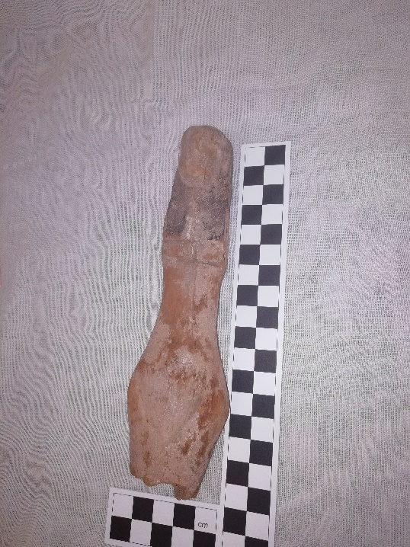
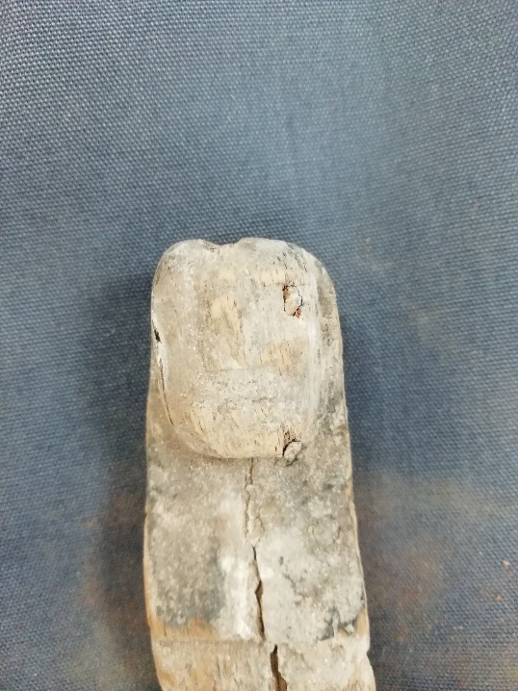
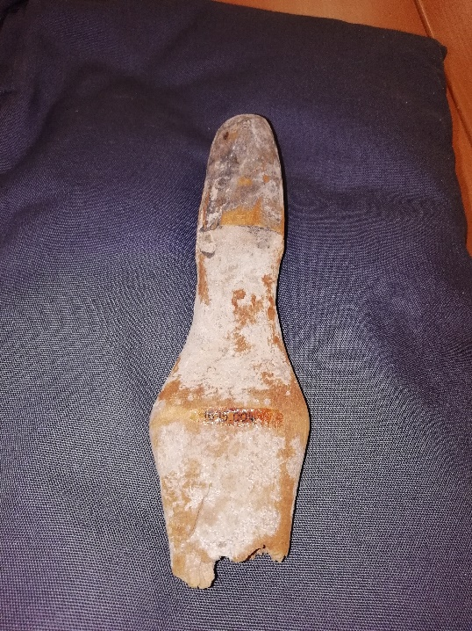
General Information
Figure 1 Back view of Female Figurine, CCM 1695.004, photo by Anna Matthews 2020, UWTSD
Figure 2 Front view of Female Figurine, CCM 1695.004, photo by Anna Matthews, UWTSD
Figure 3 Close up of the head of the Female Figurine, CCM 1695.004, photo by Anna Matthews, UWTSD
Object Name: Female Figurine
Cyfarthfa Castle, Merthyr Tydfil - CCM (thought to be 1695.004)
Object type: Wooden Female Figurine
Material: Soft wood, thought to be palm wood or lime wood
Period: Pharonic?
Provenance: Could be anywhere in Egypt, or two areas of Egyptian influence from Egyptian expansion (Nubia or Sinai)
Dimensions: Approximately:
- 16-17cm in length, with the jagged bottom being the reason for the discrepancy in length,
- Between 2.5cm and 3.5cm in width
- Depth
Object analysis by Anna Matthews

Description
The female figurine is a broken wooden figurine representing a female, as shown by the pubic triangle that is only shown on women to show in figurines that the figurine is a female. There is a dent on the top of the head, which could signify a potential headdress that is missing, or that it could connect to something else. Additionally, the figurine is also missing both arms, as there are two holes on each of the sides of the figurine for arms to be stuck into. Considering there are two sets of holes (so a total of four holes), it brings up the thought that the upper set of holes could be for wings and the lower set for the arms. The figurine also has a crude face, and there are no distinguishing features to discern if it is meant to be a specific woman or goddess.
There are many ideas on what the female figurine was used for. It could be for either everyday uses or for funerary use. As the female figurine is from unknown origins, meaning we do not know where it was discovered or who found it, it therefore cannot be easily deciphered.
If it were to be an everyday item, there are chances it could be a toy, however, the two arm holes would disagree. Two arm holes could mean the arms are immobile, and consequently not the best thing for a child to play with. Or, there are wings on the figurine and that would likely mean that the figurine is a goddess, and the chances of children playing with figurines of goddesses would be very low.
Another idea of what it could be is a magic item, which can be used for various events. For example, it could be to increase fertility in a woman, as the main reason for divorce was the inability to provide children. Or it could be to heal any other problem within a person’s body, like a snake bite. Moreover, “some anti-venom spells call for objects like a rpyt Ast m xt n sDt, a ‘female figure of Isis in firewood’ (BM EA 9997 + 10309, V, 3: Leitz 1999: 8 - 11)”, which proves that it could definitely be a magic item or represent Isis in some way. If it is a magic item, then the likelihood is that it would be owned by a priest or a magician, who were mostly men. To support this, it is said that female figurines have been excavated as part of a magician’s kit. Additionally, the female figurine would be made to be generic but still obviously a goddess, so they could serve as any goddess as needed, and to also protect the goddess from receiving the ailment they are supposed to be healing. Thus, for the female figurine to be used by priests or magicians (or just any healer, male or female) would be very believable.
Alternatively, it could even be a curse item, to be used on the female enemies of Egypt, like how Queen Nefertiti has been shown to smite the female enemies of Egypt just as a Pharaoh would smite the male enemies of Egypt. This would also fit into the ownership of the female figurine, as “In their role as defenders of the faith, they [priests] were also expected to be able to display the power of their god against those of any other nation.” There is also a chance that it could be owned by a priestess, rather than a priest, to corroborate the fact that only females could smite or harm the female enemies of Egypt, as there is no known instance that the Pharaoh would smite the female enemies, only the males. Therefore, the idea that females could use the female figurines to help the Egyptian state is most definitely possible, however not widely believed.
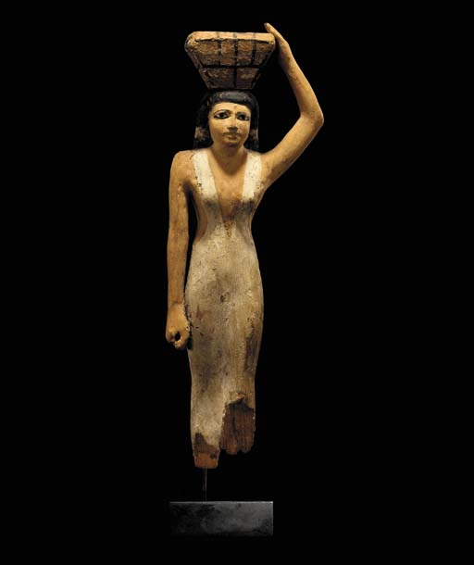
Conclusively, it is most convincing for the female figure to be representing a goddess, as this is the most accommodating answer to what the female figurine is supposed to represent as there would be many uses for a female figurine, even a wooden one. As a generic female figurine representing a goddess, there are many uses for it. For instance, everyday rituals within the household. The household would sacrifice a portion of their daily food for protection, making the relationship between the gods and humans a quid pro quo relationship, much like the Greeks and Romans after them. This is shown in Figure 4, which is described as a wooden servant holding a box of offering on her head, supposedly from around the Middle Kingdom (dated around 2040 – 1783 BC). However, being used for household rituals for protection would not necessarily explain the break if it is intentional. So, if the object is considered to be for a ritualistic use, the break would be coincidental. Therefore, the most apparent use for this specific female figurine, considering the break around the hips/upper thighs, would be a magic item of some description, whether used for healing or to curse the enemies. Thus, the ownership of the female figurine is most likely a male magician or a priest, rather than a female magician, female healer or a priestess.
Figure 4 Egyptian Wood Offering Bearer, taken from https://www.christies.com/lotfinder/Lot/an-egyptian-wood-offering-bearer-middle-kingdom-3831642-details.aspx

Bibliography
- Christies, (2001), An Egyptian Wood Offering Bearer, available at: https://www.christies.com/lotfinder/Lot/an-egyptian-wood-offering-bearer-middle-kingdom-3831642-details.aspx (accessed 06/03/2020)
- Fowden, G., (1993), The Egyptian Hermes: A Historical Approach to the Late Pagan Mind, New Jersey: Princetown University Press
- Mark, J., (2017), Magic in Ancient Egypt, available at https://www.ancient.eu/article/1019/magic-in-ancient-egypt/ (accessed 05/03/2020)
- Matic, U., (2017), Archaeologies of Gender and Violence, (chapter five: “Her striking but cold beauty”: Gender and Violence in depictions of Queen Nefertiti smiting the enemies) available at https://www.academia.edu/11609987/Mati%C4%87_Uro%C5%A1._2017_Her_striking_but_cold_beauty_Gender_and_violence_in_depictions_of_Queen_Nefertiti_smiting_the_enemies._In_Uro%C5%A1_Mati%C4%87_and_Bo_Jensen_eds._Archaeologies_of_gender_and_violence._Oxford_Oxbow_Books_103-121 (accessed 25/02/2020)
- Pinch, G., (2006), Magic in Ancient Egypt, London: British Museum Press available at: https://pdfs.semanticscholar.org/6d20/70130304d07e03ed28f0710e2dd62fd61b0f.pdf?_ga=2.172791971.1494792390.1583403631-2088137384.1583403631 (accessed 05/03/2020)
- Waraksa, E., (2008), Female Figurines (Pharonic Period), UCLA Encyclopedia of Egyptology 1(1), available at https://escholarship.org/uc/item/4dg0d57b (accessed 05/03/2020)

Waraksa, E., (2008), pg 2-3
Pinch, G,. (2006), pg 131
Waraksa, E., (2008), pg 3
Matic, U., (2017), pg 103-104
Mark, J., (2017), available at: https://www.ancient.eu/article/1019/magic-in-ancient-egypt/
Fowden, G., (1993), pg 81

