An Archaeological Perspective on St. Fagans’ Buildings
While the Museum is still seen as a triumph of community effort and to Welsh Heritage, the choice to move these historic buildings has effectively erased this history from the original locations, and furthering this, it is shocking an archaeologist was who advised it.
St. Fagans poses a unique perspective debate on if buildings moved from one place of the same land to another could call for repatriation, due to the removal of local history in more modern areas. The morality of this choice to the local people is not considered when the building owners have given permission.
Ethics and Morality
Purpose and Development

History
St. Fagans is the realised idea of Iorwerth Peate, who was inspired by the many open-air museums in Sweden, of which it became the first in the UK. The community raised £50,000 towards the earliest reconstructions around the donated land.
The museum’s community effort conveys that, at the time, the people believed in the project.
St. Fagans was originally just the Elizabethan castle and land owned by the Earl of Plymouth in the town of the same name, of whom donated it in 1946 to allow Iorwerth Peate, on the advisory of archaeologist Sir Cyril Fox to develop the idea of ‘the Welsh Folk Museum’, its old pseudonym.
Fox was the Director of the previous National Museum of Wales and ended his term the same year that Peate became ‘Head’ of the Welsh Folk Museum in 1948.

Fig. 5: Peate outside of newly opened Penrhiw Chapel, 1956.
“…create a museum… which uses the past to link up with the present to provide a strong foundation and a healthy environment for the future of their people.’
(Iorwerth C. Peate, 1948).

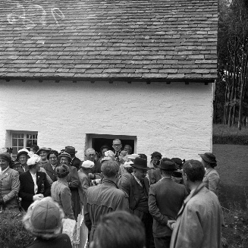
At St. Fagans, many buildings are used to exhibit daily life, how it would’ve looked within them. Yet, many go unused for long periods. On a visit, these photos of ‘Gorse Mill’ present how, despite the money and effort poured into St. Fagans, there is a lack of life that may have still existed if the buildings hadn’t been relocated.
The spiked axle at the side of the Mill had to be entirely remade, only to end up as Fig. 3.
Usage of the Buildings

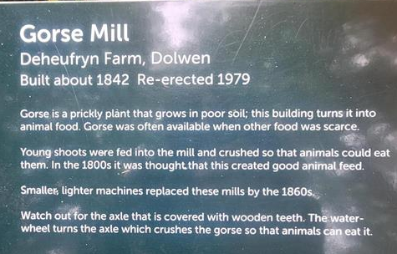
Humanity through Physicality

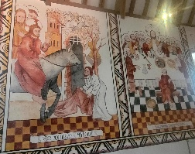
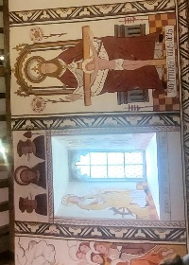
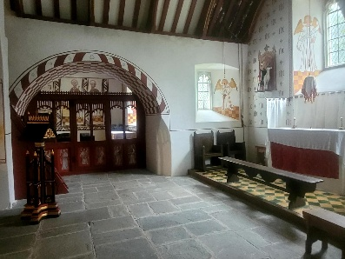
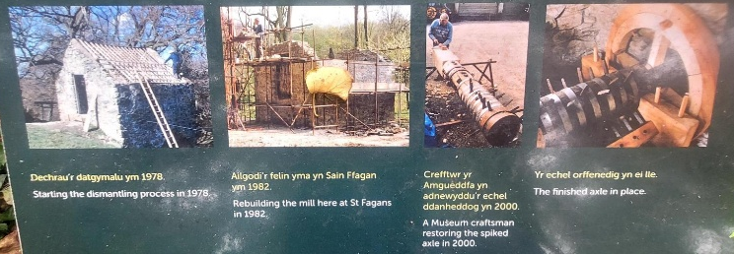
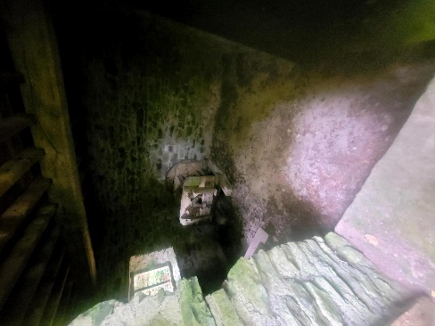
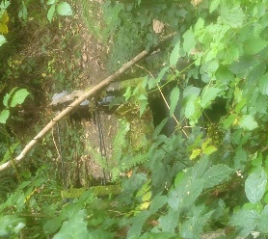
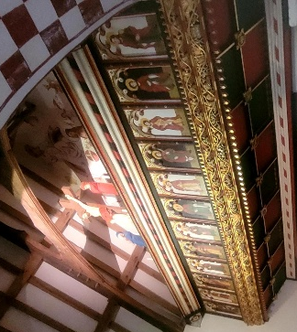
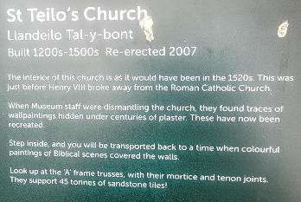
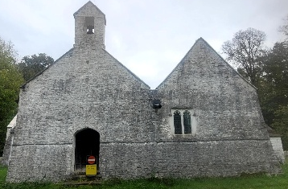
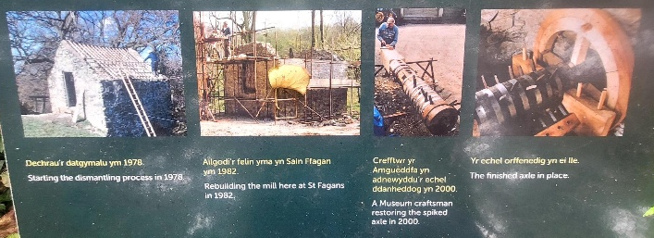
Whilst the Museum is attempting to become more ‘activist’ with its interactive creations inside the main building, removing the culture around Wales is something they cannot escape. It may be true that many of these buildings may have ended up barren, destroyed and/or built upon, but why should they not have had the chance to? When it comes to cultural history, these building are no longer physical, but an extension and legacy of the people it was built by. On a spiritual level, the same could be said for St. Teilo’s church, whose removal also removed its consecration and original paintings.
Fig. 11: Paintings, one of ‘The Last Supper’, personal photo.

Fig. 1: Gorse Mill information, personal photo.
Fig. 2. Gorse Mill Interior, personal photo.
Fig. 3: Gorse Mill information pictures, personal photo.
Fig. 4: Gorse Mill spiked axle, personal photo.
Fig. 6: St. Teilo’s Chuch information, personal photo.
Fig. 7: St. Teilo’s Church exterior, personal photo.
Fig. 8: Art above the rood screen, personal photo
Fig. 9: Wall paintings by window, personal photo.
Fig. 10: Second rood screen with benches, personal photo.

