University of Wales Trinity Saint David

School of Engineering

Engineering Design Project Drill Press Main Sliding Unit

By

Nathan Scott Morgan

(1902731)

Bachelor of Engineering inc Foundation: Energy & Environmental Engineering

19th May 2021

BEng (Hons) Engineering Portfolio

L4 – Engineering Design

ACMA4008

Contents
List of Figures / List of Tables 2
1.0 Introduction 3
2.0 Carbon Fibre Reinforced Polymer (CFRP) 4
2.1 Background 4
2.2 Material Charts (CFRP) 4
2.2.1 Strength – Density (CFRP) 4
2.2.2 Young’s Modulus – Density (CFRP) 5
2.3 CFRP Negatives 5
3.0 304 Stainless Steel 6
3.1 Background 6
3.2 Material Charts (Steels) 7
3.2.1 Strength – Density (Steels) 7
3.2.2 Young’s Modulus – Density (Steels) 8
3.3 304 Stainless Steel Negatives and Positives 8
4.0 Design Specification 8
4.1 Customer Safety 8
4.1.1 Labour Force Safety 9
5.0 Discussion 9
6.0 Conclusions 11
7.0 Standards 11
Bibliography 12

List of Figures / List of Tables
Figure 1 - Strength - Density Chart 4
Figure 2 - Young's Modulus - Density Ratio 5
Figure 3 - Estimated Price of Steel Per USD/lb. Provided by SolidWorks. 6
Figure 4 - Strength - Density Chart 7
Figure 5 - Fe/Fe₃C Phase Diagram (Steel), Between 0-2% Carbon 7
Figure 6 - Young's Modulus - Density Chart 8
Figure 7 - Design Specification 8
Figure 8 - Cost Estimation Per Part (Milling) 10
Figure 9 - Side View of Final Design Concept 10
Figure 10 - Top View of Final Design Concept 11

1.0 Introduction
The aims of this report are to evaluate business, customer and user needs including the wider engineering context, public perception, and aesthetics. Investigate problems, and identifying constraints including environmental and sustainability limitations; ethnical, health, safety, security, and risk issues; intellectual property; codes of practice and standards. Consider the costs and evaluate outcomes.
An investigation will be made into the existing ‘concept’ design of the “DPMSU” component. Through analysing “DPMSU” a list has been created to point out current issues surrounding the relationship between structural and customer satisfaction.
The current issues identified with “DPMSU” as followed:
- Does not securely hold drill in place.
- No machinery protection for Customer.
- No specified material choice.
- Stress acting on the seatpost clamp.
Throughout this report, solutions will be provided to improve current ‘concept’ and meet customer requirements.
Other considerations will be addressed throughout the report, as followed:
- Anticipate Customer Needs
- Functional Requirements
- Aesthetic Considerations
- Serviceability Requirements
- Any Relevant Ethical Considerations
- Any Relevant Codes of Practice

2.0 Carbon Fibre Reinforced Polymer (CFRP)

2.1 Background
Carbon fibre reinforced polymer has recently accelerated in demand over the last decade across the world in multiple industries such as aerospace and automobile, being the many few to adopt such material. This is due to their high strength and low weight capability as well as performing exceptionally well. Furthermore, CFRP mechanical properties excel in reference to modulus and fatigue strength, tensile strength, fracture toughness and can withstand temperatures up to 3000. The strength of said material comes from the carbon fibre, which is bound together by a polymer resin which allows them to strengthen.

2.2 Material Charts (CFRP)
The current conceptual design features many flaws within the structure and shape. Regarding the seatpost clamp where the drill can be placed, the stresses acting on the part can correlate to stresses acting on a beam. Using merit functions, specific materials can be determined for the application.
$$\frac{σ_{f}^{\frac{2}{3}}}{ρ}$$
Equation 1 – Merit Function for Beam Applications

2.2.1 Strength – Density (CFRP)
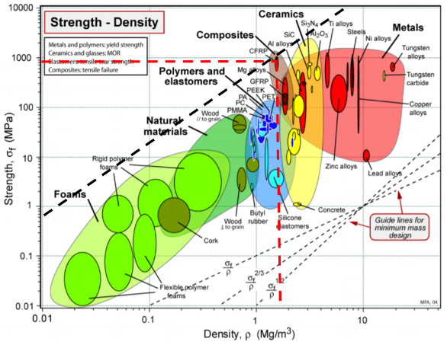
Figure 1 below, displays a strength – density chart. As shown by the black thick dashed line, the appropriate material choose would be a CFRP. The thick dashed red line points out the strength and density units to which CFRP is measured.
CFRP has the best strength – density out of all the materials. CFRP is located within the group of composites.
Figure 1 - Strength - Density Chart
Due to high acting forces on the sliding unit, strength is highly desired to resist deformation. This ensures the longevity of the product and its performance.

2.2.2 Young’s Modulus – Density (CFRP)
Figure 2 below, displays a young’s modulus – density chart. CFRP has the best low density, high modulus capability. This establishes information about the materials limits before plastic deformation or failure.

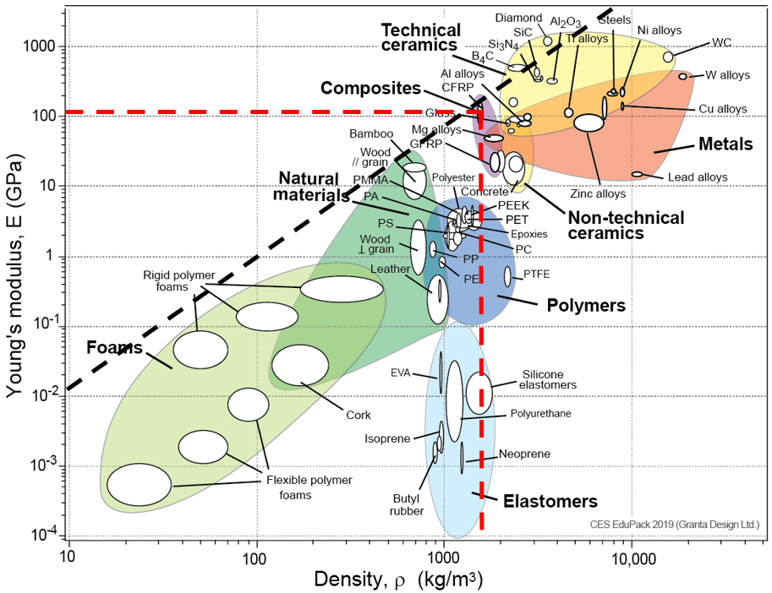
Figure 2 - Young's Modulus - Density Ratio

2.3 CFRP Negatives
CFRP has many negative values, including:
- Extremely expensive cost.
- Damaging environmental impact.
- Non-sustainable.
CFRP averages at £7.09 per 4.54 kg. Compared to 304 stainless steel at an estimated £1.09 per 1 kg shown below in Figure 3.
CFRP cannot be recycled without extra cost, so at the end of its product life, it is either buried underground at designated places or sent over to facilities such as Roth International [1]. Also, CFRP cannot be repaired when damaged, shortening its product life.
This leads CFRP to be non-sustainable for industries to compete without forfeit of profit.
CFRP manufacturing is also energy intensive, with CFRP with 50% fibre volume using 800 MJ/kg compared to steel only using 50 MJ/kg [2].

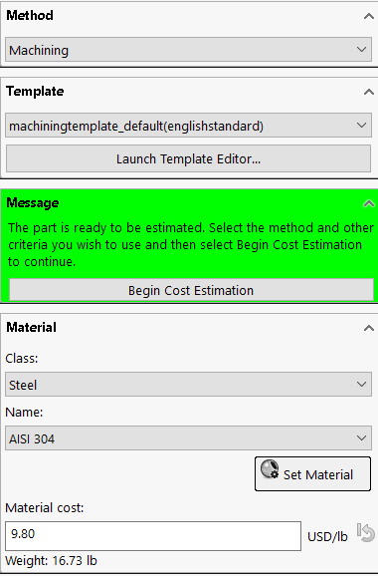
Figure 3 - Estimated Price of Steel Per USD/lb. Provided by SolidWorks.

3.0 304 Stainless Steel

3.1 Background
304 stainless steel is used in industries and appliances all over the world due to its versatility. This is because of its alloys (Nickel and Chromium) which allows the steel to be less corrosive [3]. This is aesthetically pleasing to consumers as it has a great finish which sustains for years. Steel is an iron-carbon alloy which is later, combined with other alloys such as nickel, chromium, manganese, nickel, silicon, tungsten and much more depending on the mechanical properties wanted/needed.
Iron is very soft due to the number of dislocations within the lattice. Through material processing, carbon is added to gain strength by reducing ductility. This chemical interaction is called Ionic bonding.
For our application we do not want a carbon content above 2% as the steel would become too brittle [4]. Other alloys are then added to combat corrosion, conductivity, magnetism and more.
Grade 304 has a melting point between 1400-1450 ͦC
Steel is 100% recyclable through magnetic separation even through pre-consumer scrap and post-consumer scrap [5] and because of this, it has a price to it. Stainless steel 3/6, and 18/8 on average in the U.K range in price between £0.61-£0.92 per kilo [6].

3.2 Material Charts (Steels)
Focusing on the functional requirements, the drill will be held vertically, parallel to the shaft. The consumer will put a downward force onto the drill creating a vertical cut. Therefore, a denser material may be desired as it will assist. Using the same merit function Equation 1.

3.2.1 Strength – Density (Steels)
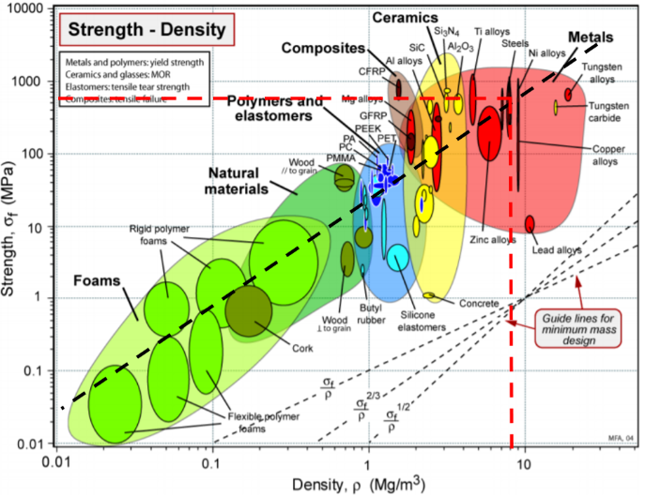
Steels have comparable strength values as CFRP, however being considerable denser. Steels are located within the groups of metals.
Figure 4 - Strength - Density Chart
Strength is required within a sliding unit to withstand forces acting on it. Other alloys such as tungsten and copper are added to increase the strength further as well as adding machinability, thermal conductivity, and electrical conductivity.
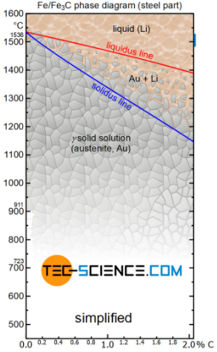
This diagram displays the melting point of steel. As shown by figure 5, the more carbon added, the more unstable steel becomes to heat. Therefore, lower carbon steel is beneficial in this way too.
Figure 5 - Fe/Fe₃C Phase Diagram (Steel), Between 0-2% Carbon

3.2.2 Young’s Modulus – Density (Steels)
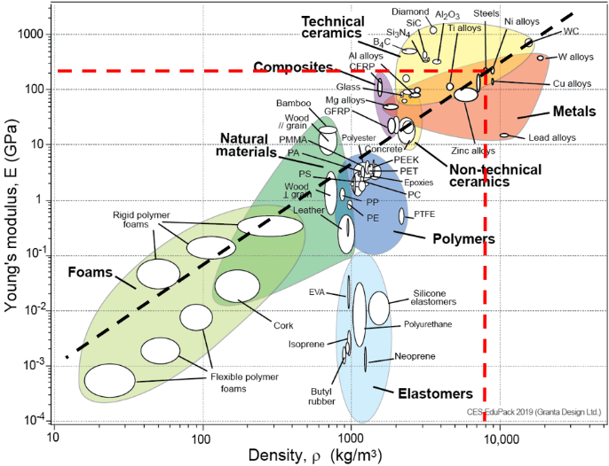
Steels have a slightly higher young’s modulus compared to CFRP. This is due to the Iron, adding ductility. This is needed within a sliding unit as levels of vibration will occur when being used. The more resist to deformation the longer the product will last for, which equally will provide customer satisfaction.

Figure 6 - Young's Modulus - Density Chart

3.3 304 Stainless Steel Negatives and Positives
304 stainless steel has a few negatives, including:
- The loss of ductility increases brittle fracture.
- Steel is heavier and more expensive to transport.
- Production cost relatively expective compared to other metals.
However, steel has many positives, including:
- Corrosive resistant
- Can be recycled.
- Strength, hardness, and ductile (Low Carbon 304 Stainless Steel)
- Can be easily repaired.
- Has a premier price on being scrapped

4.0 Design Specification
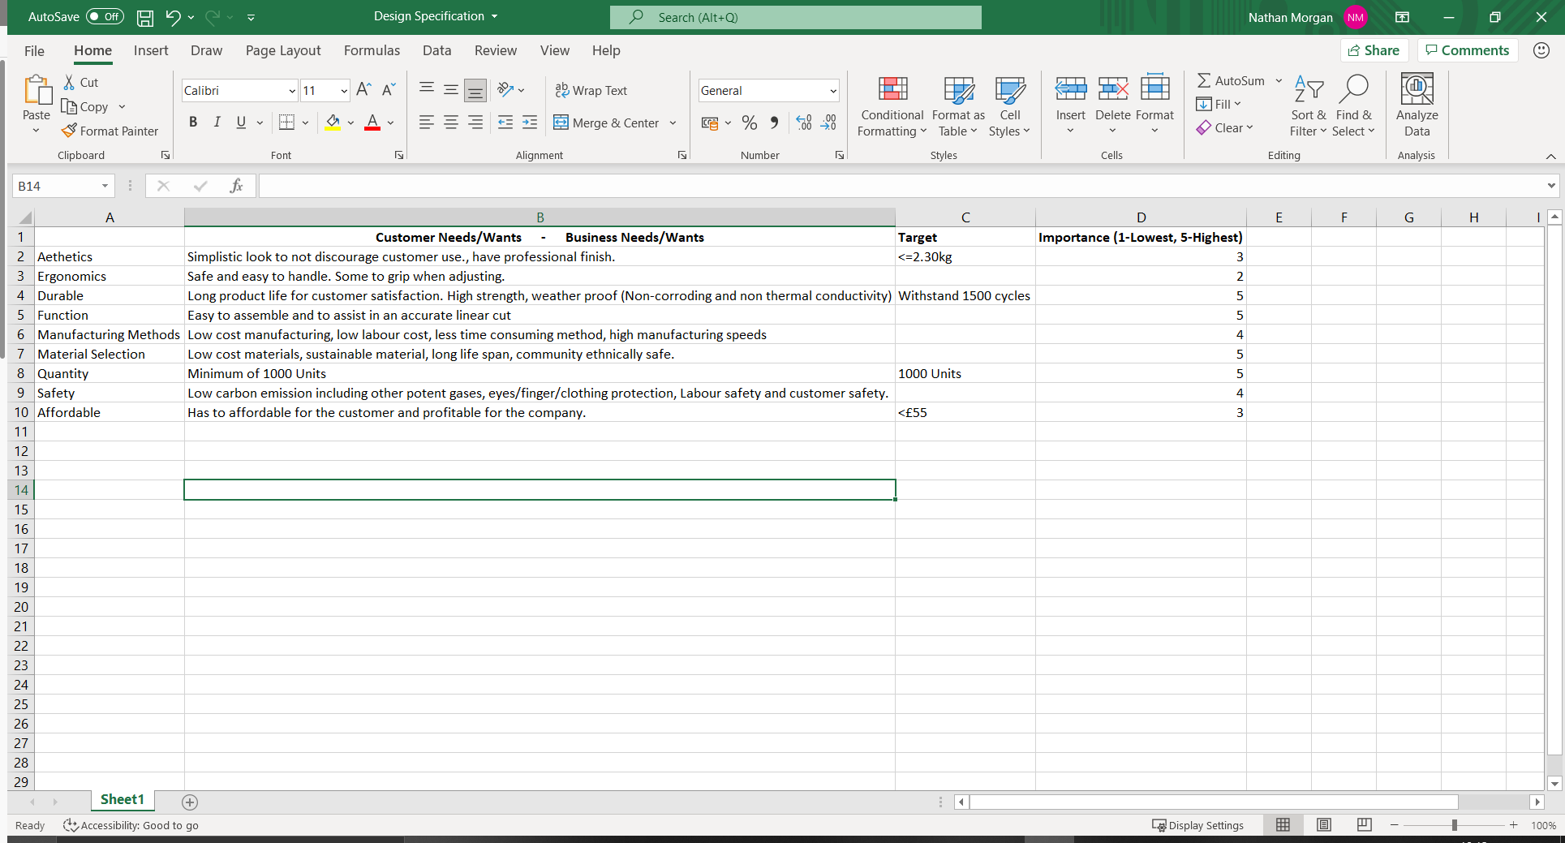
Figure 7 - Design Specification

4.1 Customer Safety
Customer safety must be implemented by evaluating current or new features and adapting them to limit harm to a minimum. Design safety features:
- Drill piece guard
- Curved edges
- Wire holder
A drill piece guard would be helpful to ensure the safety of customers, by protecting their eyes from material projectiles and fingers or clothing from rotating drill pieces.
Curved edges protect the customer from cutting themselves.
Wire holder allows customers to move their wire from the drill to the side to prevent the wire from getting tangled up in the drill piece or protecting the customer from being distracted by the task.

4.1.1 Labour Force Safety
Labour force safety is extremely important. Not just to consumers but to the industry. Making sure from beginning to end that employees receive a high standard of human rights, and other ethical standards. Performing risk assessments, consulting the work force, provide training and providing first aid kit are all especial parts to the labour force safety [7].

5.0 Discussion
Manufacturing is a huge cost decision when creating products. The final design concept will be made through a process of ‘Sand Casting’. This is due to 304 stainless steel being a great material to cast as well as the product not having any complex geometry. Due to the product being relatively small, the ‘Sand Caster’ will be able to produce many per day. This will increase production, drive down the labour costs, decrease material waste and decrease energy usage.
Design costs drivers were considered within conceptual designs. Picking ways to remove material where necessary while retaining the structural strength of the product and over complicating the products geometry. Implementing way to combined ergonomics with driving down the cost. Adding areas where wires can safely be placed is a subtle example of removing material but gaining customer satisfaction. Indented finger holes, for customer to use when adjusting the sliding unit is another example.
Through solid works cost estimation, with milling the cost would average at £35.90 per part. However, due to casting not wasting material, less labour, and lower energy used. The estimated cost would lower by £7.50.
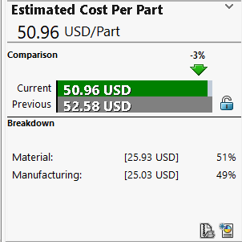
Figure 8 - Cost Estimation Per Part (Milling)
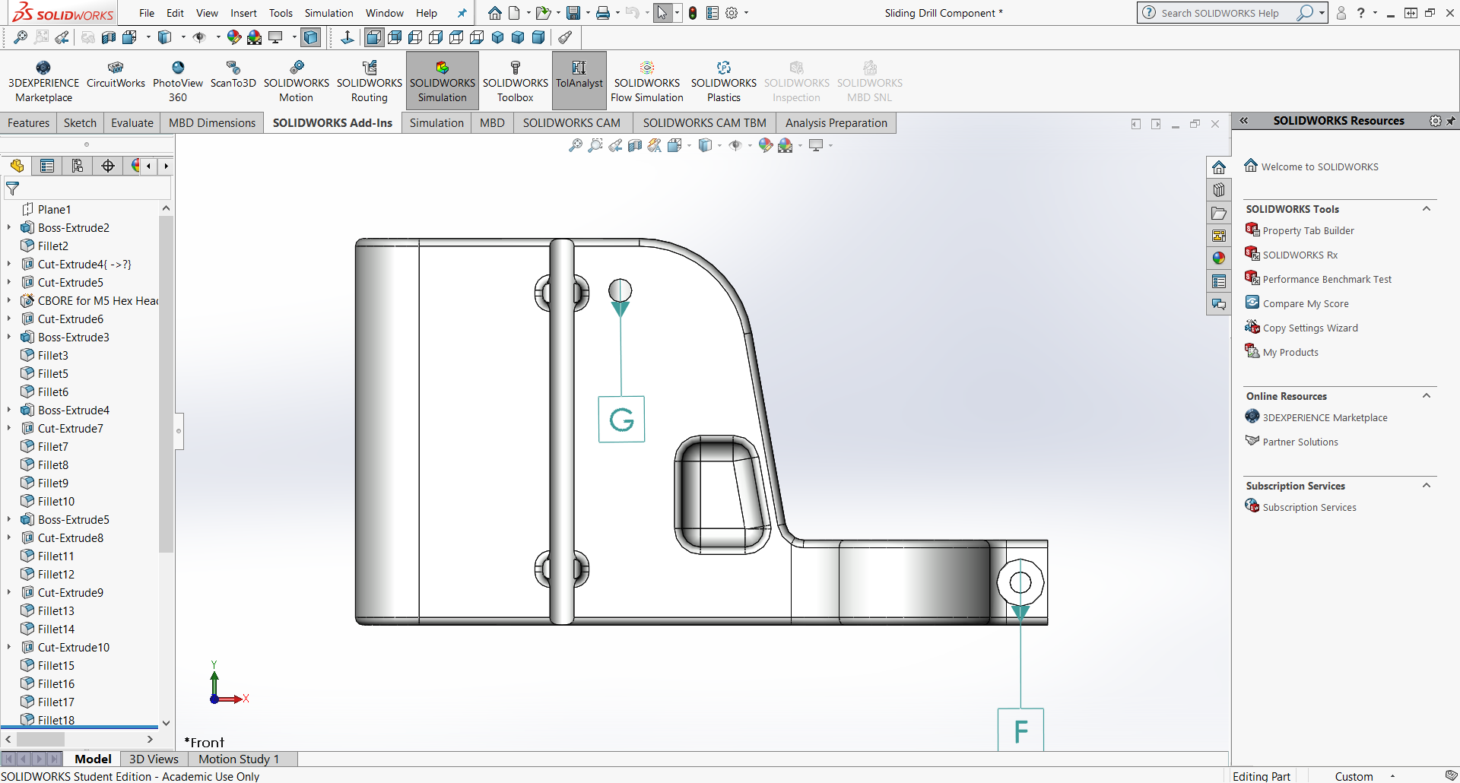
Figure 9 - Side View of Final Design Concept
Comfortable finger grip, use for adjusting unit. Smooth curves and edges, so chip damage does not occur increasing durability as well as being safe.

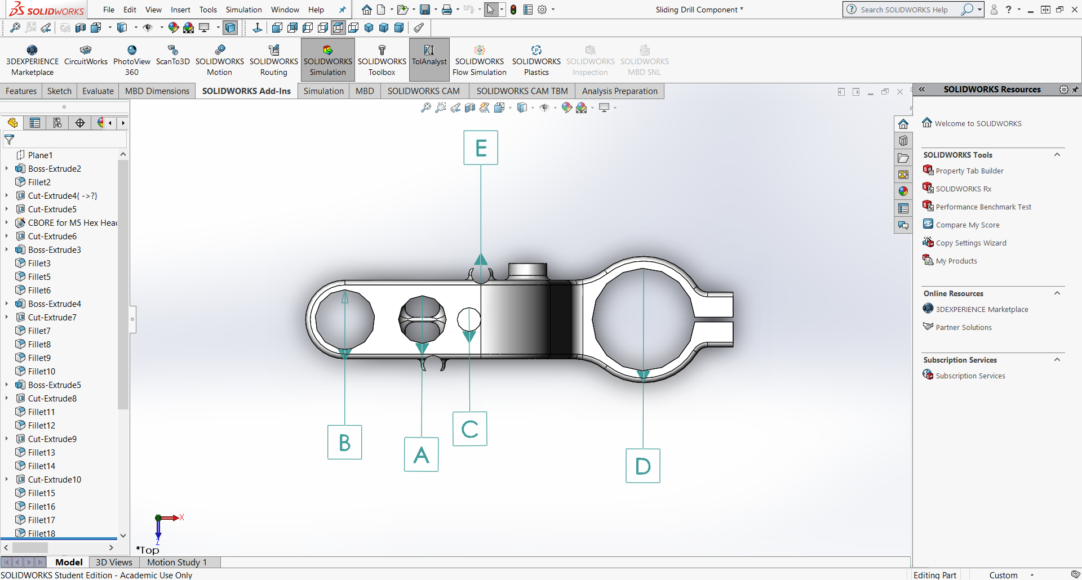
Figure 10 - Top View of Final Design Concept
Wire holder, for safer operational use.

6.0 Conclusions
In conclusion, steel is a great material within manufacturing due to its versatility, as well as it is versatility with other alloys. The mechanical properties that 304 stainless steel has makes it an incredible match for outdoor use between trade professionals and home improvers. The overall safety is incredible too, other than the weight. However, the environmental damage that steel would be saving is extremely good not forgetting steel being recyclable and repairable.
Most of the design specification targets were achieved other than cost which might increase depending on the profit, wanting to be made by the machine tool manufacturer.

7.0 Standards
BS EN 16228-1 Drilling and foundation equipment – Goes through the common requirements with drill safety
BS, EN and ISO standards are voluntary and are not regulations.
Further standards can be found on the British drilling association website [8].

Bibliography

[1] "Recycling of CFRP / GFRP - ROTH International", Roth-international.de, 2021. [Online]. Available: https://www.roth-international.de/en/recycling-recovery/recycling-of-cfrp-gfrp/. [Accessed: 16- May- 2021].
[2] Bandwidth Study on Energy Use and Potential Energy Saving Opportunities in U.S Carbon Fibre Reinforced Polymer Manufacturing, 1st ed. U.S Department of Energy, 2017.
[3] U. Standards and T. Grade 304 Stainless Steel Properties, "Grade 304 Stainless Steel Properties, Tensile Yield Strength, Thermal Conductivity", Theworldmaterial.com, 2021. [Online]. Available: https://www.theworldmaterial.com/type-304-grade-stainless-steel/#:~:text=Type%20304%20Stainless%20Steel%20Physical%20Properties%20%20,%20%202.5%20%208%20more%20rows%20. [Accessed: 16- May- 2021].
[4]"Microstructure formation of steels during solidification - tec-science", tec-science, 2021. [Online]. Available: https://www.tec-science.com/material-science/iron-carbon-phase-diagram/microstructure-formation-during-solidification/. [Accessed: 17- May- 2021].
[5]"How Sustainable Is Steel? - Clarify Green", Clarify Green, 2021. [Online]. Available: https://clarifygreen.com/how-sustainable-is-steel/#:~:text=There%20are%20two%20main%20sources%20of%20recycled%20steel%2C,prepared%20%28for%20example%20by%20shredding%20and%20baling%29.%20. [Accessed: 16- May- 2021].
[6]"Scrap Metal Prices in the UK [2021 Updated] | Scrap Metal Pricer", Scrap Metal Pricer, 2021. [Online]. Available: https://www.scrapmetalpricer.co.uk/#:~:text=Often%20steel%20and%20stainless%20steel%20can%20be%20sold,steel%20are%20some%20of%20the%20most%20profitable%20forms. [Accessed: 16- May- 2021].
[7]"Guidance on health and safety at work - HSE", Hse.gov.uk, 2021. [Online]. Available: https://www.hse.gov.uk/guidance/index.htm?utm_source=hse.gov.uk&utm_medium=refferal&utm_campaign=guidance&utm_content=home-page-info. [Accessed: 17- May- 2021].
[8]"BDA Standards | British Drilling Association | Eurocode Standards", British Drilling Association, 2021. [Online]. Available: https://www.britishdrillingassociation.co.uk/technical/standards/. [Accessed: 18- May- 2021].

