Content page:
- Introduction
- BMW Group – MINI Cooper
- Communication – definition and models
- Integrated Marketing Communication
- Promotion
- Promotional strategies
- New Promotion Strategies
- Brand and Brand Equity
- Keller`s Brand Equity
- Advantages and disadvantages of Keller`s Brand Equity model
- Customer Journey
- MINI Customer Journey Map
- Strengths and Weaknesses of MINI Customer Journey MAP
- Touchpoints
- Total Engagement Model
- Conclusion

- Introduction
This report will cover a description and analysis of the main marketing strategies of BMW Group LTD, based especially on the MINI Cooper brand. I structured the report into 7 chapters, that will contain key points about BMW Group and MINI Cooper’s activity, the company`s promotion strategies, brand and brand equity using Keller`s Brand Equity model, also I will identify the advantages and disadvantages of the model named above. For a better understanding of BMW’s business, I will create and analyze the customer journey map, I will identify and review the company`s touchpoints. The report will finish with some conclusions and recommendations.
- BMW Group – MINI Cooper
Bayerische Motoren Werke AG, commonly referred to as BMW, is a German multinational manufacturer of luxury vehicles and motorcycles headquartered in Munich, Bavaria, Germany. The corporation was founded in 1916 as a manufacturer of aircraft engines, which it produced from 1917 until 1918 and again from 1933 to 1945.
Automobiles are marketed under the brands BMW, Mini and Rolls-Royce, and motorcycles are marketed under the brand BMW Motorrad. In 2017, BMW was the world's fourteenth-largest producer of motor vehicles, with 2,279,503 vehicles produced. The company has significant motor-sport history, especially in touring cars, sports cars, and the Isle of Man TT.
BMW is headquartered in Munich and produces motor vehicles in Germany, Brazil, China, India, Mexico, the Netherlands, South Africa, the United Kingdom, and the United States. The Quandt family is a long-term shareholder of the company (with the remaining shares owned by public float), following investments by the brothers Herbert and Harald Quandt in 1959 which saved the company from bankruptcy.
The company operates under the slogan "Ultimate Driving Machine". I found this the perfect phrase that explains BMW's automobile wizardry.
MINI was established in 1959, and from then until 2000 it was produced by English-based manufacturer British Motor Corporation. However, in 2000, BMW bought MINI—adding the influence of another giant of European automotive history to influence the growth of the MINI brand. The main purpose of British Motor Corporation was to develop a revolutionary compact car, with lots of space inside and minimum dimensions outside, with seats for 4 passengers, impeccable driving characteristics, superior fuel economy and a very affordable price. Now a MINI can be bought in 109 different countries worldwide, since 1959 over 10 million MINIs have been sold.
- Communication
Comunication is one of the essential skills that a manager should have and that must be sought and develop in employees. Communication can help in crisis situations or even in its prevention, by supporting the adequate reactions, succeeding to minimize the loss and to finally obtain positive results. By positive influence of the organizational climate, of the organizational culture and of inter human relations, the communication, especially the internal one, helps to solving the problems and to inserting the organization's needed changes. The efforts needed to the management for building quality relations with the employees through supportive communication, are paid back with employees' loyalty and involvement in solving the organization's problems, the employee being the best lawyers of the organization's reputation. (Chitescu, Razvan Ion. Valahian Journal of Economic Studies; Targoviste Vol. 6, Iss. 1, (2015): 65-72.)
Comunication - is the sending and receiving of information and can be one-on-one or between groups of people, and can be face-to-face or through communication devices. Communication requires a sender, the person who initiates communication, to transfer their thoughts or encode a message. This message is sent to the receiver, a person who receives the message, and finally, the receiver must decode, or interpret the message. This sounds simple enough but is more complicated.
Communication Model
Communication models refer to the conceptual frameworks or theories that explain the way of human communication. It also represents the entire process of communication between the sender and the receiver. The communication model tries to answer the 5Ws and 1H questions; for example, what is communication? Who is involved in this process? When does it happen? Where does it take place? Why does it occur? And finally, How does the communication happen?
Furthermore, communication models explain the elements of the communication process, for example, context, sender, receiver, encoding, decoding, channel, message, feedback, and noise. These are the components of communication that describe the entire process of communication. However, some communication models do not have all these elements or features. I found the Shannon – Weaver model of communication one of the best communication model as its include all necessary elements and can be used in diverse environments.
Shannon-Weaver model of communication
Shannon-Weaver model of communication was established by two American scholars, Shannon and Weaver, in 1949. The Shannon-Weaver model is called the mother of all communication models. Shannon and Weaver did not include feedback; therefore, it is a linear communication model. However, Norbert Weiner added feedback to the model in responding to the criticism. At first, this model was designed to articulate the technical communication process. Later, it was used to discuss all types of communication. The Shannon-Weaver model represents six essential communication elements: information source, transmitter, channel, receiver, destination, and noise source. This model does not represent feedback; therefore, it is a linear communication model. Later, this model was criticized by many other scholars for not having feedback. Feedback is vital in making the communication process more interactive and effective. However, Norbert Weiner added the Feedback element to the model.

Shannon and Weaver Model of Comunication
Message
Signal Received
Message
Signal Sent
Information Source
Receiver
Destination
Channel
Transmitter
Noise

Importance of Models of communication
Communication models are essential tools for understanding the communication processes. It presents detailed information regarding the communication process and illustrates the flow of information. Therefore, they have a tremendous positive impact on the research by introducing many conceptual frameworks of communication processes. Additionally, the model introduces the elements of the communication process. Furthermore, the communication model provides tips on how communicators can communicate effectively. They represent the barrier or noise that obstacle the process of communication. They also explain the complexities of the communication system. Finally, the model proposes improving the communication process to avoid conflict.
- Integrated Marketing Communication
Integrated marketing communication (IMC) can be defined as the process used to unify marketing communication elements, such as public relations, social media, audience analytics, business development principles, and advertising, into a brand identity that remains consistent across distinct media channels. It allows public and private organizations and businesses to deliver an engaging and seamless consumer experience for a product and/or service, and to optimize an organization’s image and relationship with stakeholders. Professionals with a background in integrated marketing communications might pursue employment throughout the marketing and communications industries, in areas such as social media marketing, digital media, journalism, market research and consulting, public relations, non-profit and government, entertainment, television and radio, and other related fields.
By using IMC theories and strategies, marketing specialists, public relations directors, brand managers, digital media associates, social media marketers, and other media professionals can create, execute, and track multi-channel advertising and communication messages that target and influence specific audiences. IMC’s influence can be seen throughout modern society, in website display advertisements, enterprise blogs, search engine optimization, newspaper editorials, outdoor billboards, magazine advertisements, and more

- Promotion
- Promotional Strategies
Promotion refers to any type of marketing communication used to inform target audiences of the relative merits of a product, service, brand or issue, most of the time persuasive in nature. It helps marketers to create a distinctive place in customers' minds, it can be either a cognitive or emotional route. The aim of promotion is to increase brand awareness, create interest, generate sales or create brand loyalty. It is one of the basic elements of the market mix, which includes the four Ps, i.e., product, price, place, and promotion.
The promotional mix
The basic promotional mix consists of advertising, sales promotions, personal selling and public relations. When the concept of the promotional mix was first developed, these were the only elements available to marketers, but during the years more promotional methods have appeared which do not easily fit withim these four categories. The promotional mix works effectively when al its elements are put together at the right time in the right quantity. The figure bellow shows how the mix operates. Messages from the company about its products and itself are transmitted via the elements of the promotional mix to the consumers, employees, pressure groups and other publics. Because each of these groups is receiving the messages from more than one transmitter, the elements of the mix also feed into each other so that the messages do not conflict.
The promotional mix (Essentials of marketing, Jane Martin, p. 204)
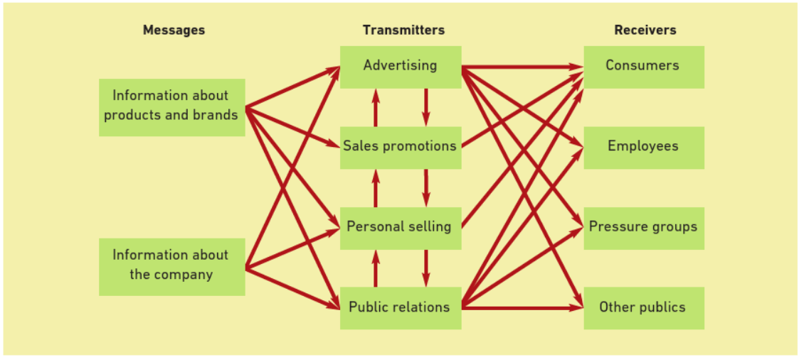

The next figure will show the elements of the promotional mix, according to the nowadays reality.

As Bayerische Motoren Werke AG is a established company, with a strong marketing strategy, most of promotional strategies are implemented and applied every day since long time.
- New promotional strategies
Promotion as a basic element of the marketing mix should be in permanent changing and equally oriented towards all the stakeholders. As I noticed the most of attention goes to the customers, in this report I`ll try to suggest some promotion strategies intended to suppliers and employees.
Online promotion for Suppliers
- Sending by email the prototypes of new model of cars, using 360° view or 3D models.
- To open a new section on the official website destinated for the suppliers.
Offline promotion for Suppliers
- Events for existing suppliers as reward for collaboration with the purpose to maintain the working relationships.
- Events for potential suppliers, with the purpose to discover new, creative and innovative companies.

Online promotion for Employees
- Informative emails about future business strategies of the company.
- Recapitulatory emails about team building meetings (related to the offline promotion), that way all employees will be in touch with events in the company.
Offline promotion for Employees
- Training in Personal Branding for Employees, that will help every employee to feel more confident.
- Thematic team building events based on historical developing of the brand. Every meeting should be oriented on period of time. That way the employee will have a better understanding of challenges that the company had thru the time.

- Brand and Brand Equity
- Keller`s Brand Equity
Keller`s Brand Equity Model was first developed by marketing professor, Kevin Lane Keller. The concept behind the Brand Equity Model is simple: in order to build a strong brand, it`s important to shape how customers think and feel about the product. It`s mandatory to build the right type of experiences around the brand, so that customers have specific, positive thoughts, feelings, beliefs, opinions and perceptions about it.
A strong brand equity means customers that will buy more, rest loyal and recommend the product to others.

Forward figure will show the four steps to follow for a strong brand equity.

Keller`s Brand Equity Model

2. Meaning
What are you?
3. Response
What about you?
4. Relationships
What about You and Me?
- Identity
Who are you?

- Identity – Who are you?
The name
The name MINI Cooper originally belonged to the sports version of the original MINI. The name comes from John Cooper, a designer of Formula 1 cars, who created the sporty version of the MINI in 1961
Logo – Meaning, Shape, Color
The Mini logo, used since 2001, is inspired by earlier logos and features the brand name, written in uppercase letters, placed inside an elegant black circle, which is embedded between the silver wings that symbolize speed and freedom of expression.
The black circle with the company name is adorned with silver and black rings, creating an impressive image. The wings, stretching on either side of the central part, feature razor-shape design and horizontal 3D lines. All that makes the logo look edgy and stylish.
The current Mini emblem is designed in several shades of black and silver colors. While the silver color is quite popular with car manufacturers and highlights sophistication and grandeur, the black adds elegance, strength and excellence to the logo.
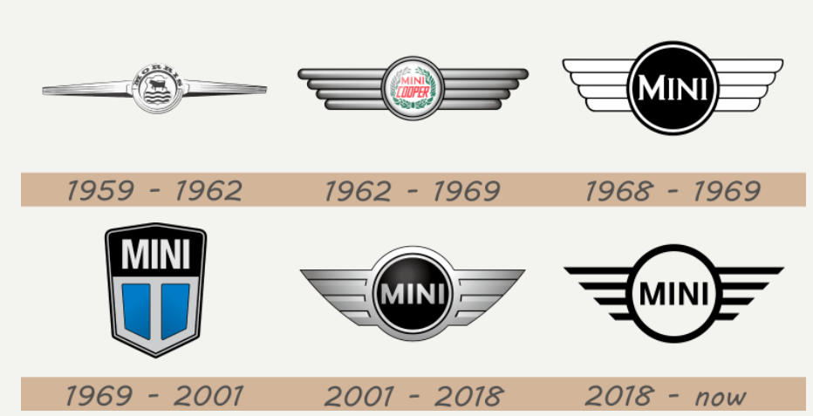

- Meaning - What are you?
Mini Brand is associated with its physical style and quality. Talking about non-product-related attributes, the main intangible asset is brand based on the symbolic appeal, “fun, energetic, cheeky, stylish, self-confident, reliable and exciting”, edited with an “It’s a MINI adventure” storyline giving it a sense of the adventure car. These are the values shared by the young people and Mini adopted a strategy of corresponding to the trends among its target audience. (Dahlen et al., 2010, p.275).
Mini brings functional benefits to its customers due to its technical features; it is a fast small car. Dominantly it is relevant for the urban areas where there has been always a problem of parking a car. As to the experimental and symbolic benefits, Mini brings a value to its customers by its symbolic historical image and modern iconic perceptions of its brand.
Mini’s customers most of all perceive Mini as a sporty, fun, and fashionable brand in addition to an historical iconic association. These attitudes are what distinguish the Mini brand from the others, and this is how the brand image of Mini is valued by its customers.
- Response – What about you?
Mini is famous for a strong brand awareness throughout its history since 1957 when it was a “compact British everyman car” and nowadays it comes as an iconic, cool, and luxurious car. As it can be observed, Mini’s brand awareness nowadays is still linked with the strong iconic brand of Mini, which is a large benefit. After Mini’s repositioning in terms of re-launching the brand in 2001 in the audience’s perception reliability, quality and practicality appeared in addition to ‘an icon’. Brand awareness is connected with recognised quality and brand associations. Mini took a strategy to improve its quality after BMW took it over, and according to Pitney, they brought highly innovative technology and quality to Mini.
That means that in addition to an iconic image, Mini got good quality which is important because customers prefer long-living cars which do not need to be driven to the service centre every few months. As to the brand associations, that is one of the most important factors for Mini, as its audiences value the historic image. On the other side, that can work out in the UK, or even in Europe, but it is completely different in the US, the MINI USA General Manager, in the US the strategy is more inclined towards making Mini a brand of excitement and fun. That means that the branding strategy is not universal for all the markets, and it is concentrated on the associations the audiences have or may have.
- Relationships – What about you and me?
Relationship in the Mini Brand case is all about: emotional attachment, loyality, and community (more than 12 million followers on Facebook).
- Advantages and disadvantages of Keller`s Brand Equity model

Keller`s Brand Equity Model
Advantages | Disandvantages
- The brand resonance pyramid is reviewed as a means to track how marketing communications can create intense, active loyalty relationships and affect brand equity  - With Keller`s Brans Equity model strongest brand excel in all 6 of the brand building block therefore to be successful brands can use this.  - Brands that are able to achieve resonance and affinity with customers reap a host of valuable benefits such as greater price premiums, and more efficient marketing programmes | - Because feelings are subjective, did not play a role in the industrial marketing context and suggested resonance, may need modifications to be more relevant  - Company representatives play a role in building brand equity, thus indicating a need for this human element to be recognised in a B2B brand equity model

- Customer Journey
Customer Journey refers to the path of interactions an individual has with the brand, product and/or services. It describes both direct interactions such as contacting a customer service team, to indirect interactions such as hearing about a brand at an event.
Because the customers are very different, also their experiences with the brand are different due to personal emotions, expectations, and objectives. By mapping the customer journey from the consumer`s perspective, the company can gain insight into the individual interactions that make up their experience from beginning to the end.
- MINI Customer Journey Map
Forwards I will build a customer journey map, based on a purchase of a MINI Convertible by a 22 years old Amy.
Amy just received her driver`s license and is determined to buy a new, compact, beautiful car. Amy decided to buy a MINI because she always was impressed to see on the road beautiful women driving MINIs, after she consulted the web page and visited one of MINI`s showrooms she decided to buy a MINI Convertible. In the showroom, with the help of the consultants she found a lot of information about all the features of that car. After that she decided to book a test – drive via MINI`s web site. After all researches she done, it was time for the purchase. Amy has the possibility to <build the MINI>, by choosing all the details about the car, the color, the wheels, the engine capacity and much more. Also the consultant informed her about financing facilities. After the car was bought, Amy was able to enjoy the pleasure to drive a new, high-quality, beautiful and comfortable car. Now that Amy is an MINI`s customer, she regularly receive messages and invitations about company`s events and presentations.

MINI Customer Journey Map
Customer Journey Map | Awareness | Discover | Purchase | Use | Bond
Website |  | 4.She started to analyze the models online  6.Amy booked an test drive
Store |  | 5.Amy visited the MINI`s store | 7.Amy make the purchase transaction in the store
Personal thinking | 1.Amy decided she need a car
Call Centre
Social Media |  | 3.Amy starts to follow the official page of MINI on Instagram
Web Forums
Mobile Phone
Word of mouth | 2.She wants a MINI because she loved how they look on the road.
Email |  |  |  |  | 9.Amy received an thank you email.  10.Amy receive invitation for every car presentation or MINI event
The Product |  |  |  | 8.Amy is happy with her new car because of great quality

- Strengths and Weaknesses of MINI Customer Journey Map
One of the strengths in MINI Customer Journey Map is the web site. https://www.mini.co.uk/en_GB/home.html is an easy to navigate with a very clear and attractive interface web site, beside that the best part of the web site is about the facilities provided, the costumer can easily see all models of cars and compare them. If a costumer decide to buy a car he can design he`s own car and see the result immediately with a 360° tour of the car. Also the possibility of a test drive is an huge benefit for the company. When the costumer has the certitude of the quality before the purchase, the thing are going much easier, because the quality of the product works by itself, that`s an another key point in the strengths – high-quality of the product.
The weaknesses of the MINI Customer Journey Map refers to the absence of the feedback from the costumer to the company, another thing are the advertising emails and the invitations to MINI events. That can be sometimes too much and to irrelevant for the customer as buying a car isn`t an day to day activity.

- Touchpoints
A company interacts with customers on many levels and at many places. These interactions are necessary for a company to carry out its marketing, branding, and sales strategies.
A customer touchpoint is any interaction of the potential customer or customer with the brand before, during, or after he purchases something from the brand.
In simple terms, a customer touchpoint is any point of interaction of the brand and the customer. These interactions take place at various places (online and offline) and at various times. (https://www.feedough.com/customer-touch-points/)
Based on the MINI customer journey map I will identify the customer touchpoints.
Before purchase touchpoints
- Word of mouth – When Amy decided to buy a car, and it was time to chose a model she do not had to think to much because was already inloved with beautiful MINIs she see on the road every day.
- Website – Because she was curious to discovere more about that brand she became online research and the website hep her to fout out a lot of useful information about the car
- Social-media – Another thing she did, was to follow the MINIs’ official pages on Instagram and Facebook, seeing with regularity their post on her, made her be more attracted to those cars.
During purchase touchpoints
- Product demonstration – Amy was able to make a test drive of the desired car car.
- Sale service – a well-looking sale assistant makes the customer feel safe and confident during the purchase.
- Purchase option – Amy had the possibility to “build” her own car, she chose and matched by herself the color of the car, engine size, interior color and material, and a lot of other features.
After purchase touchpoints
- Thank you message – Amy received an thank you email that made her fell important and valued.
- Feedback survey – by email Amy received an invitation to share her experience with MINI brand.
- Follow up email – After purchase, Amy continues to receive emails from MINI with different occasion.
Amy as a customer of MINI brand hand only successful interaction. That way the MINI brand received a new satisfied customer who will share her good experience with friends, colleagues and relatives.
- Total Engagement Model
The total Engagement Model is the ongoing cultivation of a relationship between the company and consumer that goes far beyond the transaction. It's an intentional, consistent approach by a company that provides value at every customer interaction, thus increasing loyalty. https://www.outreach.io/blog/what-is-customer-engagement

Total Engagement Model
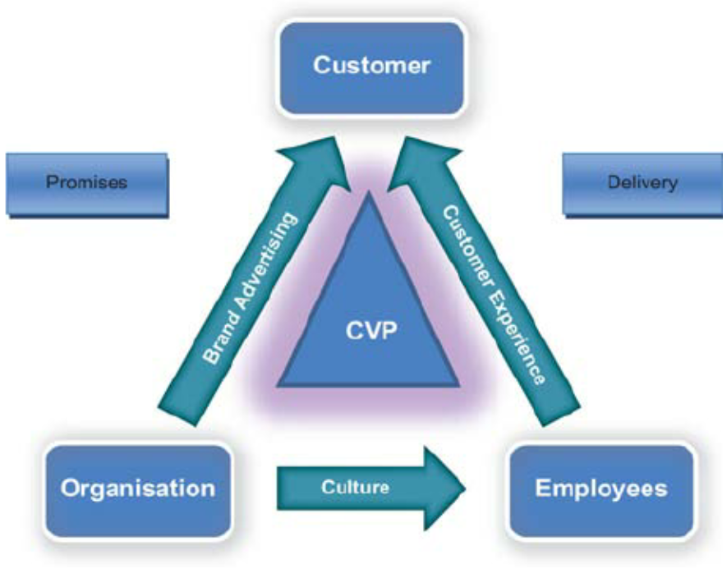
https://www.researchgate.net/figure/The-total-engagement-model_fig2_49513186

Customer
The MINI Customer fall into four categories: brand enthusiasts, who relish the car's British racing roots; design aficionados, who like the car's simple elegance; social butterflies, who want to be part of the Mini community; and gas misers, who crave the Mini's fuel efficiency.
The company’s strategy is based on sustainable business relationships with the customers. The company seeks to re-invest for growth and innovation. The company is committed to continuous development of its processes to improve the overall customer experience and loyalty. For example, the company has a retailer incentive programme known as the Voice of the Customer which focusses on delivering customer needs. Additionally an e-Retail selling platform has been developed to allow customers to transact the entire vehicle purchase online. The company aims to become the natural choice for customers by providing personalised products and services.
Organisation
MINI Organizationl belives are the following:
- Economic - The UK operations make a substantial contribution to the local and national economy. The company directly employ more than 24,000 people and support more than 46,000 jobs through our supply chains.
- Community - As well as stimulating economic development in their localities, all three MINI production plants are playing their part in supporting their communities through numerous cultural and social activitie
- Giving Something Back - All plants actively fundraise for chosen charity, which changes every two years.
- Looking after young people - The development of young people is also a key theme for the company. MINI offer work experience placements for young people from local schools and support university student exchange programmes and partnerships.
Employees
MINI employees are the foundation of the brand success. Their professional qualifications and commitment are outstanding. In return, the company offers attractive jobs, comprehensive opportunities for personal development and the opportunity to gain further qualifications.
All employees receive a base salary, have access to a range of flexible benefits, and are eligible for a bonus payment on an annual basis to promote personal performance, collaboration and the assumption of entrepreneurial responsibility. The bonus is based on personal achievement and achievement of the targets of the company as a whole, 70% based on Company targets and 30% based on BMW Group targets.
https://www.mini.co.uk/en_GB/home/why-mini/mini-uk-production/values.html

- Conclusion
The report covered the main marketing tools and related them to the MINI Brand. Using examples of company strategy and analyzing them I`ve built a customer journey map and I identified the customer touchpoints, for a better understanding of the relationship between the brand and the customers.
The MINI website was very helpful in founding all pieces of information I needed about the present MINI marketing strategy and in general about MINI business activity.
Bayerische Motoren Werke AG is an established company with a strong promotional strategy, because of that was challenging to found new promotional strategies. For MINI brand I decided to suggest some new promotion strategies oriented on employee and suppliers as I found those two categories of stakeholders the least targeted.



