
Skills for the Workplace
Module Assignment Submission
Student Name: | Toni-Louise Cooper
Student Number: | 1815681
Module No: | BMSK4003
Module Title: | Digital Skills and Research Methods

Statement of Confirmation of Authenticity
By the act of making this submission, the student declares that this is the work of the student named above. The work has not, in whole or in part, been knowingly presented elsewhere for assessment, or where assessment has been built on a previous assessment, this has been identified. Where materials have been used from other sources it has been properly acknowledged. If this statement is untrue, the student acknowledges that an assessment offence has been committed.
Attention is drawn to the plagiarism and unfair practice policies of both the University and of ILM.
Permission for ILM to use this script
ILM uses learners’ submissions – on an anonymous basis – for assessment standardisation. By submitting, both the centre and the learner agree that ILM may use this script on condition that identifying information is removed. However, if you are unwilling to allow ILM use this script, please refuse by ticking the box: □

Table of Contents
What has been the impact of 21st Century Technologies on the modern workplace? 3
Research the use of modern technologies and social media in the workplace generally 3
Explore the use of modern technologies and social media in own workplace 4
LinkedIn Profile 5
Research LinkedIn and other social media platforms to enhance networking and career prospects 5
References 7
Appendix 1 8
Appendix 2 9

What has been the impact of 21st Century Technologies on the modern workplace?

In the current 21st century a mass of business if not all currently rely on technological devices in their workplaces. The use of technology helps to manage their day to day workload and business also to help to monitor their progress, sales targets and profitability. Technology develops and upgrades vastly so technology often need to be updates in the workplace for instance the latest mobile phone or laptop for the business to keep up to date with the newest features, models and apps. The use of technology in day to day living by everyone not only in the workplaces/businesses but people in their own personal lives such as smartphones which are mobile and can be used on the go with the most popular brands being Samsung and iPhone or Tablets. People Can engage in many forms of communication on Smartphone and tablets such as Phone calls, Text Messaging, Messaging Apps – WhatsApp, Snapchat, Facetime, Skype and Emails etc. With The likes of Smartphones People are also able to manage their workload, check in at work, Engage in virtual meetings, for example a manager of a business could order stock instantly at the simple click of a button instead of having to make a lengthy phone call and waiting for the call to be answered or the manager could have a work meeting via Teams, Skype or Facetime whilst away from the office. Technology in the workplace has dramatically evolved over the last couple of decades. I think it has a positive impact on businesses with how advance technology has evolved –
Efficiency and Increased Productivity – Time management would be optimized efforts into everyday tasks lightened. Employee productivity and efforts will be improved.
Increased Collaboration – Levels of communications never seen before with how advanced technology is, being able to connect and communicate with one another not matter what the distance of time difference.
Improved Cost management – Achieve and manage profitability, Encouraged Finance able to manage and monitor income and losses and meet targets more easily.
Businesses and Workplaces have Social Media accounts making it easier for clients to book appointments, ask for quotes, promote their business to gain a more variety of new clientele depending on what sector of expertise the business is in. Social Media is a Free way for business to advertise their work or business many Businesses offer discounts or run promotions in order to gain more likes or followers. Businesses can monitor how many profile views they have daily they are also able to see how many people have viewed their posts. Businesses can select which age range target they want to meet and certain living areas for example Swansea, Cardiff etc within a certain mile radius.

Research the use of modern technologies and social media in the workplace generally

As mentioned above Modern Advancing Technologies and Social media platforms are used by a vast majority of businesses and workplaces to manage the workloads, meet the targets and to monitor profitability, to communicate amongst employers, employees, investors, management etc. All modern-day workplaces would have course have a telephone line some businesses like a call centre or customer service hotline would rely directly on to the telephone line. The telephone line would be a vital necessity and if they were to ever fail there would be huge problems for the business. Not just call centres or Customer service hotlines but all businesses would have a telephone line which would be used to make appointments, make orders, discussions, arrange meetings, discuss queries or complaints depending on what the business is.

Computer, Laptop or Handheld Computing Tablet –

A Computer, Laptop or Handheld Computing Tablet plays an important roll in the workplace. It would be paramount for device to be kept up to date and to have some security features installed on to the system. Regular updates should be kept up to date in order for the device to run smoothly and have all the latest features which would be available, The device would also need to have good memory in order to store work documents, customer information etc and to ensure that documents and work of whatever form are stored safely and efficiently. Memory would also be needed to install the use of Apps for example Teams or Skype for Virtual/ on the go meetings.
WIFI (Internet Access) –

Without the use of WIFI many businesses would be very outdated and stuck in a time of an older generation. WIFI is Vital for all technologies to run effectively and to manage Social Media. A Mobile Phone could be manageable for a lone self-employed person but not for a busy workplace with more than a handful of employees.
Accounting System –

An Accounting system software would be a helpful for businesses as it would enable business to manage their expenses, monitor profitability, check for loses and to address areas which needs improving. The software would be able to let employers know which areas they are overspending in and which need more focusing on.
Facebook, Twitter, Instagram –

Businesses and workplaces would use the social media platforms to help to promote their businesses, to show the clients or potential clients what services or products they offer and also to make bookings or to arrange appointments for free quotes or estimates depending on what work sector the business is in. Social Media platforms are a free way in which businesses can promote themselves and business for free without any cost. There are of course optional extras if businesses wish to promote their page or a particular post for a small fee the cost of the promotion varies on the business and the audience they select to advertise to. Businesses are also able to monitor how many likes or follows their pages have, how many views a post or their page has had over a period of the day or week it also lets the business know if their page is down views or if a post is failing to meet their regular amount of views. With so many people using social media daily in their personal lives this is a great way to gain new custom for the business.

Teams, Skype, WhatsApp, Email –

These are Apps which businesses can use to communicate. These apps can be installed on to a mobile phone device or on to a Laptop, Computer or a Handheld Computing Tablet. They are virtual ways to communicate for meetings, simple catch ups or chats, on the go in the office practically anywhere. Simple, Fats and effective ways of communicating when needed instantly delivering important information if needed at the simple click of a button.

Explore the use of modern technologies and social media in own workplace

In my own personal workplace which is a Flying Start Nursery based in a Community Primary School, We only use one form of Social Media due to confidentiality and with being in a School setting but we have a variety of Technology available to use for Staff members and Children.

Class Dojo –

This is the Social Media platform we use in the setting. The App allows us to Engage with parents and vice versa, it also allows parents to see what their child has got up to during the session. Staff upload photos of the children on to their personal profile and on to the home page where all parents can see what the whole class has got up to as well as small group time. To gain access on to the app the children’s parents are each given an individual code that only they have access to. Parents and Staff can engage via messaging on the app for example if a child is unwell instead of the child’s parents ringing the setting they could simply click the app on their mobile and message us that way which will come straight through on to the settings laptop as well as the managers computer in her office so if we manage to somehow miss the notification the manager would come in and notify us that a particular child would not be attending session today or if the parents have any questions, or worries they are always welcomed to message us if they prefer to use that method instead of calling.

Smartboard and Projector –

An interactive smartboard and projector which can transform images from the settings laptop on to the interactive smart board. The interactive smartboard can also work independently without the need of Wi-Fi or the laptops projection system. Children can draw, colour, design, play games, Educational work, watch slideshows, or Play virtual musical instruments or play Music straight from the Smart board.

Telephone/ Mobile Phone –

We use the phone in the setting to contact parents, communicate to the Schools which children will be transitioning to when they become of School age, Multi agencies for example Health visitors, Social workers, we make appointments, find out information etc also parent use the phone to contact us if needed. We use the Mobile Phone for the photographs for the Class Dojo app we take Photos of the children and of the children’s Artwork and efforts in tasks. All photographs are deleted from the mobile phone once they are uploaded on to class dojo.

Laptop and Printer –

The use of the Laptop and Printer is not used much by staff in the classroom setting apart from the use of worksheets for the children and for the classroom display boards. The Laptop and printer is mainly used by the settings manager who monitors the intake of children and has access to all the children on the waiting lists details, it is also used for checking in to regular training for staff when needed. The classroom setting also uses the laptop to play music within the setting for the children and for the interactive smart board and at festive times or Culture celebrations the laptop is used for Movies which the children can sit and enjoy if they wish or can engage in craft tasks.

LinkedIn Profile
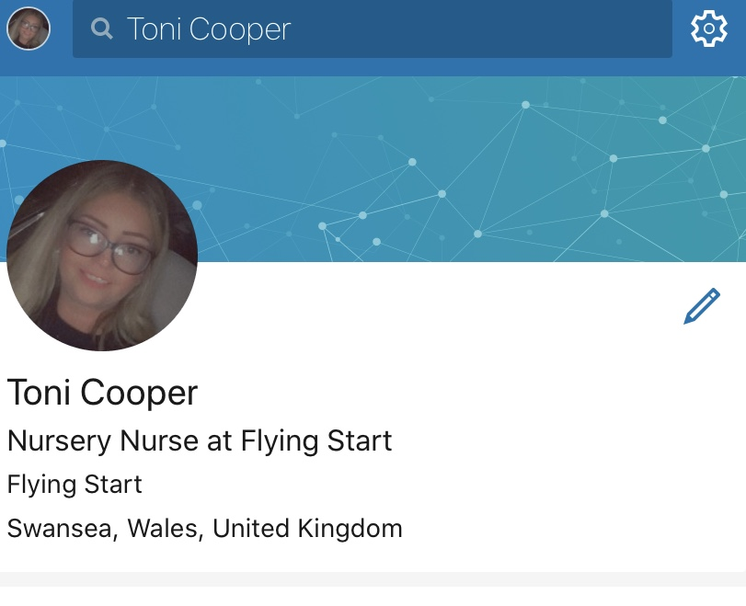

I have created myself a LinkedIn Personal Profile in September. Since I made my LinkedIn profile, I have made a few connections. There are a variety of positive bonuses to having a professional profile on Social Media platforms not only on LinkedIn but many others. Potential Managers would search up on LinkedIn for future employees who they could potentially be employing to their business so to keep a profile providing your qualifications, certificates and relevant training as well as stating where you studied is paramount. If your self-employed to have a LinkedIn account could also give you bonus points in customers searching you up and seeing for themselves that you are professional and that you have gained great knowledge and skills from your studies and qualifications. You could also build great friendships with people who have the same interests or job roles as yourself guiding each other through workloads and struggling offering advice if needed.

Research LinkedIn and other social media platforms to enhance networking and career prospects

Many use Social Media just for Leisure or Communicating, but it is also a recruitment tool. A LinkedIn profile will detail all relevant professional experiences and qualifications as well as educational history which you then use to connect with companies and people who are like minded to yourself. LinkedIn has over 66 Million users, this platform of Social media can help enhance your chances of finding a new job or future employees. Facebook now has a jobs section where companies can upload their job adds aiming the add are particular age groups, genders and if people have on their profiles their particular area of expertise then it will aim the job add directly at them the site reports that it can reach 40 million people through advertisement. Although Facebook is used my many as a leisure profile and it is the nation’s most popular platform instead of making a professional profile like LinkedIn people arestill able to apply for a job through the Facebook job section. Twitter is also an able social media platform to apply for jobs although it doesn’t have a built in job search feature it is becoming more popular for business to fine ambitious people twitter has a more relaxed approach to social networking.

References

https://www.prospects.ac.uk/career-advice/getting-a-job/social-media-an-job-hunting - Social Media and Job Hunting, Emma Knowles, May 2019

Appendix 1

Appendix 2

