Design, conduct and report a research study to explore predictors of work motivation.

Abstract
This study aimed to investigate how conscientiousness and agreeableness predict work motivation in university students. A sample size of 19 participants, comprised of University of Wales Trinity Saint David students and currently in paid employment. The age range of participants were between 18 to 47 years old. Data were collected using two types of scale instruments that were the Work Extrinsic and Intrinsic Motivation Scale and the Big Five Inventory personality measure. The data were analysed using multiple regression. The hypothesis was tested and findings showed that there was no statistically significant relationship between work motivation and both agreeableness and conscientiousness personality traits.

Introduction
At the workplace, the personality of a worker is critical to reaching an organisation's goals (Youshan & Hassan, 2015). Work motivation is a sort of vigorous strengths that comes from a person's presence that can initiate working performance and influence its style, direction, intensity and duration (Pinder,1998).
Costa and McCrae (1992) defined conscientiousness as an individual who able to plan, organise and think critically for the target and able to fulfil a task successfully. Barrick and Mount (1991) also believed that people who present well in conscientiousness are accountable, dependable, self-discipline and determined.
According to Costa and McCrae (1991), a major feature of people performing well in agreeableness is pleased to help other people. When applied to work states, the parallel to be pleased to help other people may be that these people are pleased to help the company to be better; so, they would be more dedicated to work (Naquin & Holton, 2002). However, Judge and Ilies (2002) found that agreeableness showed a weaker correlation with work motivation.
Hence, this research study was conducted to investigate how conscientiousness and agreeableness predict work motivation. Hypothesis in this study will be participants who score highly in conscientiousness will score higher on intrinsic motivation than participants who score highly on agreeableness.

Methods
Participants
Population of this research basically referred to the total numbers of students at the University of Wales Trinity Saint David. 30 participants from the University of Wales Trinity Saint David currently in paid employment were expected to participate in this research. However, a total of 22 participants from the University of Wales Trinity Saint David accessed the questionnaire and only 19 participants’ data were used as part of the study. Participants, comprised of 16 females and three males. There were three participants were removed from the results. A female participant was removed from the results due to incomplete results, she only answered the personality questionnaire completely. During data analysis, two participants’ data had to be removed as they had not checked both consent boxes. Standard deviation, mean and range for ages of participants in this research were 9.27, 29.89 and 18 to 47respectively.
Design
The design of this study was regression and data analysed using multiple regression analysis. Dependent variable in this study was work motivation. Work motivation can be measured by scoring on the Work Extrinsic and Intrinsic Motivation Scale. Independent variables in this study were Conscientiousness and agreeableness. Both conscientiousness and agreeableness can be measured by scoring on the Big Five Inventory. Hypothesis in this study will be participants who score highly in conscientiousness will score higher on intrinsic motivation than participants who score highly on agreeableness. The subject was designed as a survey with two sets of questions to be distributed. Firstly, questionnaires related to conscientiousness and agreeableness will be asked. Then, the second part will be questionnaires related to work motivation to be asked. In this study, a personality questionnaire completed first, to remove any potential demand characteristics or guesswork as to the nature of the study if the work questionnaire placed first.
Materials
In this research, an online questionnaire was created using Qualtrics and distributed via the Experiment Management System. A consent page will be included in questionnaire contained a brief description of the nature of the study, informed the participants of their right to withdraw from the study any time without penalty and how the data they provided will be used and stored. Participants had to select that they were over 18 years of age and currently employed or they will be removed from the questionnaire.
Work motivation will be measured using the Work Extrinsic and Intrinsic Motivation Scale (WEIMS: Tremblay, Blanchard, Taylor, Pelletier & Villeneuve, 2009). The full scale consisted of six subscales and a total of eighteen items and each of them will be asked to rate by participants. This scale included items such as 'Because it allows me to earn money.' and 'For the satisfaction I experience when I am successful at doing difficult tasks.'. WEIMS used as a seven-point Likert scale anchored from 1=Does not correspond at all to 7=Correspond exactly. This questionnaire was selected as it focused specifically on whether the participants were extrinsically or intrinsically motivated, which the researchers would like to measure. Internal reliability for the extrinsic and intrinsic work motivation in this study was initiated to be 0.151 and 0.881 respectively (APPENDICE I).
The predictors of conscientiousness and agreeableness in participants will be measured using the Big Five Inventory personality measure (BFI: John & Srivastava, 1999). The full scale included 44 items, however, only items related to the two selected personality traits were used in this study. A total of 18 items which nine items related to conscientiousness and another nine items related to agreeableness were specifically targeted. This scale included items related to conscientiousness such as 'I see myself as someone who does a thorough job' and 'I see myself as someone who is a reliable worker'. Items related to agreeableness such as 'I see myself as someone who tends to find fault with others' and 'I see myself as someone who starts quarrels with others' were also included in this scale. BFI used as a five-point Likert scale anchored from 1=Disagree strongly to 7=Agree strongly with scores subsequently ranging from one to five for each item, making final scores obtained from this scale between nine and 45 in each personality trait. This scale contained four negatively worded items for conscientiousness and four negatively worded items for agreeableness that required reverse-scoring prior to analysis. Internal reliability for the conscientiousness scale and agreeableness scale in this study was initiated to be 0.898 (APPENDICE I).
A debrief form will be presented immediately after the participants completing the study. In this form, participants will be thanked for taking part in this study. Contact information of lead researcher and supervisor will also be included for participants have any questions.
Procedure
Firstly, the researchers needed to get ethical approval to conduct the study. Participants were recruited opportunistically through the university’s experiment management system. Participants were offered credits as part of a module for taking part in the survey, these were given whether they completed the study or not. There was no coercion in taking part in the survey. After signing up for the study, students were presented with a link to access it.
A consent page was presented on the first page. Participants were required to tick two boxes; one giving consent, and another one confirming that they were currently in paid employment. If the participant did not select these boxes, they were redirected to a page informing them that they were not eligible for the study. If participants ticked both boxes, the next page would ask them for their demographic data. Gender and age recorded. For the gender part, there were four answers to be chosen which were male, female, other and prefer not to say. Redirected if other to give details.
After that, the first questionnaire related to personality will be conducted in ABAB format. The questionnaire spread over three pages with six items on each page. Answers were given by selecting the box that they felt they most agreed with. There were five boxes ranging from disagree strongly to agree strongly can be chosen. The second questionnaire related to work motivation will be conducted. Responses were recorded by using a slider for each question. There was a seven-point scale where 1 = does not correspond at all, 4 = corresponds moderately and 7= corresponds exactly.
Lastly, a debrief form will be presented immediately after the participants completing the study. In this form, participants will be thanked for taking part in this study. Contact information of lead researcher and supervisor will also be included for participants have any questions.

Results
A multiple regression was conducted to assess whether variables of intrinsic motivation towards agreeableness and conscientiousness whish one was more effective to intrinsic motivation. Table 1 summarises the means, standard deviations for each variable, with scores ranging between 5 and 38.
Table 1
Means and standard deviations of all variables included in analysis
 | M | SD | N
Intrinsic Motivation | 37.26 | 12.29 | 19
Agreeableness | 18.74 | 5.79 | 19
Conscientiousness | 20.00 | 7.05 | 19

Correlations between the predictor variables and dependent variable are highlighted in table 2. As can be seen, results showed the Sig. (one-tailed) for agreeableness and intrinsic motivation value is bigger than 0.05 (p>0.05) which is only .156 (Appendix. Therefore, there was no statistically significant relationship between agreeableness and intrinsic motivation. Results also showed the Sig. (one-tailed) for conscientiousness and intrinsic motivation value is bigger than 0.05 (p>0.05) which is .492 (Appendix. Therefore, there was also no statistically significance relationship between conscientiousness and intrinsic motivation.
Table 2
Correlations between variables
 | Intrinsic Motivation | Agreeableness | Conscientiousness
Intrinsic Motivation | - | -.245 | -.005
Agreeableness | -.245 | - | .562
Conscientiousness | -.005 | .562 | -

The regression analysis showed that as an overall model, the set of independent variables (agreeableness and conscientiousness) were not significant: F (2,16) = .750, p>0.001 and produced an adjusted R-squared value of -.029.
Table 3 shows the coefficients for the separate IV’s in the analysis. The variables of agreeableness and conscientiousness were not statistically significant in contributing to the prediction of intrinsic motivation with Beta value of -.354 and .194 respectively (p>0.05).
Table 3
Beta coefficients for independent variables on the dependent variable intrinsic motivation.
Variable | Beta Value
Agreeableness | -.354
Conscientiousness | .194

Discussion
This research was focused to investigate how conscientiousness and agreeableness predict work motivation in university students. The hypothesis in this study was participants who score highly in conscientiousness will score higher on intrinsic motivation than participants who score highly on agreeableness. After the data analysis, the researchers explored the Sig. (one-tailed) for agreeableness and intrinsic motivation value is bigger than 0.05 (p>0.05) which is only .156 (APPENDICE I) indicated that there was no statistically significant relationship between agreeableness and intrinsic motivation. Results also showed the Sig. (one-tailed) for conscientiousness and intrinsic motivation value is bigger than 0.05 (p>0.05) which is .492 (APPENDICE I). Therefore, there was also no statistically significant relationship between conscientiousness and intrinsic motivation.
Currently, there was no journal supported these research findings of the reason why there was no statistically significant relationship between work motivation and both agreeableness and conscientiousness personality traits. A possible limitation in this research was the size of the sample whereby there were only 22 participants taking part in this study and there were three participants be removed from the results. At last, there were only 19 participants took part in this study. It is insufficient to generalize from the sample to the population as it was a small sample could have a possibility in providing results that lack potential significance.
Besides, the research relied on the honesty from the participants in filling the questionnaires by themselves without researcher observation which could have a possibility in gaining the results with an inaccurate answer from the participants. Their answer might not reliable to conduct the study.
To improve the research study, future researchers should conduct a bigger sample size in the sampling procedure because the bigger sample size may lead to a more accurate result. Bigger scope of view of the research study can be gained as it can cover a large group of people with diverse background thus the finding of the research able to generalise to the population.
Lastly, future researchers should include a more detailed section in the research. There were only two sets of questionnaires be asked in this study. If there are more detailed questions be asked in the sections and different scales be used to examine it, the more accurate results might be produced.

References
Barrick, M. R., & Mount, M. K. (1991). The Big Five Personality Dimensions and Job Performance: A Meta-Analysis. Personnel Psychology, 44(1), 1-26.
Costa, P. T., & McCrae, R. R. (1991). The NEO Personality Inventory: Using the Five-Factor ModeI in Counseling. Journal of Counseling & Development, 69(4), 367-372.
Costa, P. T., & McCrae, R. R. (1992). Revised NEO Personality Inventory and the Five-Factor Inventory professional manual. Odessa, FL: Psychological Assessment Resources.
John, O. P., & Srivastava, S. (1999). The Big-Five trait taxonomy: History, measurement, and theoretical perspectives. In L. A. Pervin & O. P. John (Eds.), Handbook of personality: Theory and research, 2, 102–138. New York: Guilford Press.
Judge, T. A., & Ilies, R. (2002). Relationship of Personality to Performance Motivation: A Meta-Analytic Review. Journal of Applied Psychology, 87(4), 797-807.
Naquin, S. S., & Holton, E. F. (2002). The Effects of Personality, Affectivity, and Work Commitment on Motivation to Improve Work Through Learning. Human Resource Development Quarterly, 13(4), 357-376.
Pinder, C. C. (1998). Work Motivation in Organizational Behaviour. Upper Saddle River, NJ: Prentice Hall.
Tremblay, M. A., Blanchard, C. M., Taylor, S., Pelletier, L. G., & Villeneuve, M. (2009). Work Extrinsic and Intrinsic Motivation Scale: Its Value for Organizational Psychology Research. Canadian Journal of Behavioural Science/Revue Canadienne des Sciences du Comportement, 41(4), 213-226.
Youshan, B., & Hassan, Z. (2015). The Effect of Employees Personality on Organizational Performance: Study on Insurance Company. International Journal of Accounting and Business Management, 4(2), 187-196.

Appendices I

Intrinsic Motivation

Descriptive Statistics
 | Mean | Std. Deviation | N
Total Intrinsic Score | 37.2632 | 12.28749 | 19
Total Agreeableness Score | 18.7368 | 5.79120 | 19
Total Conscientiousness Score | 20.0000 | 7.04746 | 19

Correlations
 |  | Total Intrinsic Score | Total Agreeableness Score | Total Conscientiousness Score
Pearson Correlation | Total Intrinsic Score | 1.000 | -.245 | -.005
Pearson Correlation | Total Agreeableness Score | -.245 | 1.000 | .562
Pearson Correlation | Total Conscientiousness Score | -.005 | .562 | 1.000
Sig. (1-tailed) | Total Intrinsic Score | . | .156 | .492
Sig. (1-tailed) | Total Agreeableness Score | .156 | . | .006
Sig. (1-tailed) | Total Conscientiousness Score | .492 | .006 | .
N | Total Intrinsic Score | 19 | 19 | 19
N | Total Agreeableness Score | 19 | 19 | 19
N | Total Conscientiousness Score | 19 | 19 | 19

Variables Entered/Removedª
Model | Variables Entered | Variables Removed | Method
1 | Total Conscientiousness Score, Total Agreeableness Score^{b} | . | Enter
a. Dependent Variable: Total Intrinsic Score
b. All requested variables entered.

Model Summary^{b}
Model | R | R Square | Adjusted R Square | Std. Error of the Estimate
1 | .293ª | .086 | -.029 | 12.46215
a. Predictors: (Constant), Total Conscientiousness Score, Total Agreeableness Score
b. Dependent Variable: Total Intrinsic Score

ANOVAª
Model |  | Sum of Squares | df | Mean Square | F | Sig.
1 | Regression | 232.803 | 2 | 116.402 | .750 | .488^{b}
1 | Residual | 2484.881 | 16 | 155.305
1 | Total | 2717.684 | 18
a. Dependent Variable: Total Intrinsic Score
b. Predictors: (Constant), Total Conscientiousness Score, Total Agreeableness Score

Coefficientsª
Model |  | Unstandardized Coefficients |  | Standardized Coefficients | T | Sig. | 95.0% Confidence Interval for B |  | Correlations |  |  | Collinearity Statistics
 |  | B | Std. Error | Beta | T | Sig. | Lower Bound | Upper Bound | Zero-order | Partial | Part | Tolerance | VIF
1 | (Constant) | 44.573 | 10.564 |  | 4.219 | .001 | 22.179 | 66.966
1 | Total Agreeableness Score | -.751 | .613 | -.354 | -1.224 | .239 | -2.051 | .549 | -.245 | -.293 | -.293 | .684 | 1.462
1 | Total Conscientiousness Score | .338 | .504 | .194 | .670 | .512 | -.730 | 1.406 | -.005 | .165 | .160 | .684 | 1.462
a. Dependent Variable: Total Intrinsic Score

Collinearity Diagnosticsª
Model | Dimension | Eigenvalue | Condition Index | Variance Proportions
 |  |  |  | (Constant) | Total Agreeableness Score | Total Conscientiousness Score
1 | 1 | 2.908 | 1.000 | .01 | .01 | .01
1 | 2 | .054 | 7.332 | .70 | .00 | .64
1 | 3 | .038 | 8.751 | .29 | .99 | .35
a. Dependent Variable: Total Intrinsic Score

Residuals Statisticsª
 | Minimum | Maximum | Mean | Std. Deviation | N
Predicted Value | 28.6571 | 43.2597 | 37.2632 | 3.59632 | 19
Residual | -21.47537 | 20.78441 | .00000 | 11.74942 | 19
Std. Predicted Value | -2.393 | 1.667 | .000 | 1.000 | 19
Std. Residual | -1.723 | 1.668 | .000 | .943 | 19
a. Dependent Variable: Total Intrinsic Score

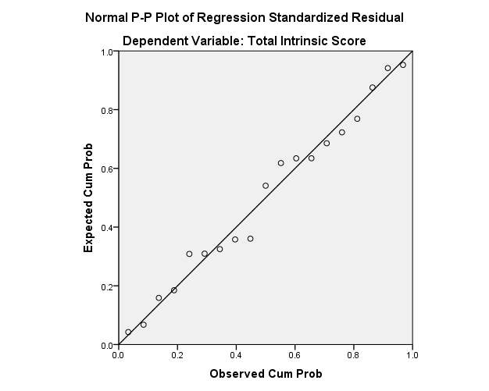

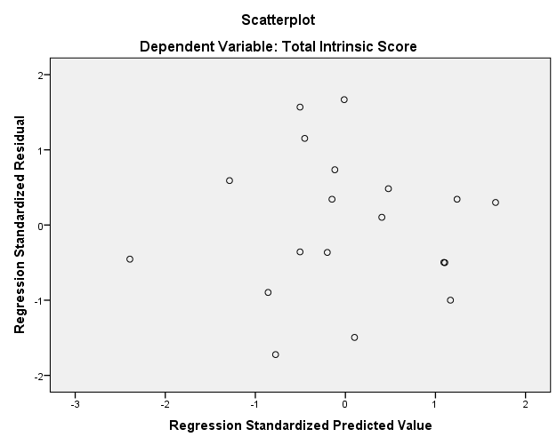

Extrinsic Motivation

Descriptive Statistics
 | Mean | Std. Deviation | N
T_Extrinsic | 40.1579 | 6.03934 | 19
Total Agreeableness Score | 18.7368 | 5.79120 | 19
Total Conscientiousness Score | 20.0000 | 7.04746 | 19

Correlations
 |  | T_Extrinsic | Total Agreeableness Score | Total Conscientiousness Score
Pearson Correlation | T_Extrinsic | 1.000 | .066 | .170
Pearson Correlation | Total Agreeableness Score | .066 | 1.000 | .562
Pearson Correlation | Total Conscientiousness Score | .170 | .562 | 1.000
Sig. (1-tailed) | T_Extrinsic | . | .394 | .244
Sig. (1-tailed) | Total Agreeableness Score | .394 | . | .006
Sig. (1-tailed) | Total Conscientiousness Score | .244 | .006 | .
N | T_Extrinsic | 19 | 19 | 19
N | Total Agreeableness Score | 19 | 19 | 19
N | Total Conscientiousness Score | 19 | 19 | 19

Variables Entered/Removedª
Model | Variables Entered | Variables Removed | Method
1 | Total Conscientiousness Score, Total Agreeableness Score^{b} | . | Enter
a. Dependent Variable: T_Extrinsic
b. All requested variables entered.

Model Summary^{b}
Model | R | R Square | Adjusted R Square | Std. Error of the Estimate
1 | .173ª | .030 | -.091 | 6.30880
a. Predictors: (Constant), Total Conscientiousness Score, Total Agreeableness Score
b. Dependent Variable: T_Extrinsic

ANOVAª
Model |  | Sum of Squares | df | Mean Square | F | Sig.
1 | Regression | 19.712 | 2 | 9.856 | .248 | .784^{b}
1 | Residual | 636.814 | 16 | 39.801
1 | Total | 656.526 | 18
a. Dependent Variable: T_Extrinsic
b. Predictors: (Constant), Total Conscientiousness Score, Total Agreeableness Score

Coefficientsª
Model |  | Unstandardized Coefficients |  | Standardized Coefficients | t | Sig. | 95.0% Confidence Interval for B |  | Correlations |  |  | Collinearity Statistics
 |  | B | Std. Error | Beta | t | Sig. | Lower Bound | Upper Bound | Zero-order | Partial | Part | Tolerance | VIF
1 | (Constant) | 37.670 | 5.348 |  | 7.044 | .000 | 26.333 | 49.006
1 | Total Agreeableness Score | -.044 | .310 | -.042 | -.142 | .888 | -.702 | .614 | .066 | -.036 | -.035 | .684 | 1.462
1 | Total Conscientiousness Score | .166 | .255 | .194 | .650 | .525 | -.375 | .707 | .170 | .160 | .160 | .684 | 1.462
a. Dependent Variable: T_Extrinsic

Collinearity Diagnosticsª
Model | Dimension | Eigenvalue | Condition Index | Variance Proportions
 |  |  |  | (Constant) | Total Agreeableness Score | Total Conscientiousness Score
1 | 1 | 2.908 | 1.000 | .01 | .01 | .01
1 | 2 | .054 | 7.332 | .70 | .00 | .64
1 | 3 | .038 | 8.751 | .29 | .99 | .35
a. Dependent Variable: T_Extrinsic

Residuals Statisticsª
 | Minimum | Maximum | Mean | Std. Deviation | N
Predicted Value | 38.9301 | 42.7556 | 40.1579 | 1.04647 | 19
Residual | -10.02953 | 17.97047 | .00000 | 5.94799 | 19
Std. Predicted Value | -1.173 | 2.482 | .000 | 1.000 | 19
Std. Residual | -1.590 | 2.848 | .000 | .943 | 19
a. Dependent Variable: T_Extrinsic

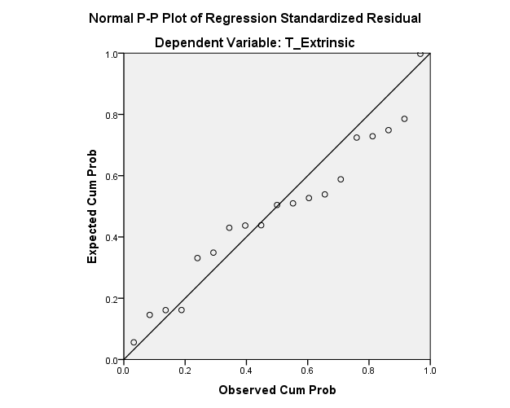

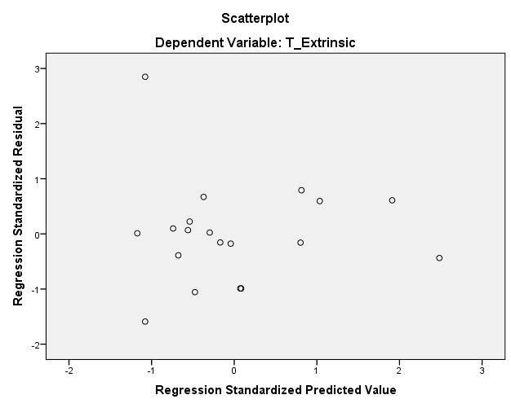

Cronbach’s alpha BFI

Reliability Statistics
Cronbach's Alpha | Cronbach's Alpha Based on Standardized Items | N of Items
.898 | .908 | 18

Cronbach’s alpha Intrinsic

Reliability Statistics
Cronbach's Alpha | Cronbach's Alpha Based on Standardized Items | N of Items
.881 | .879 | 9

Cronbach’s alpha Extrinsic

Reliability Statistics
Cronbach's Alpha | Cronbach's Alpha Based on Standardized Items | N of Items
.151 | .114 | 9

Appendices II

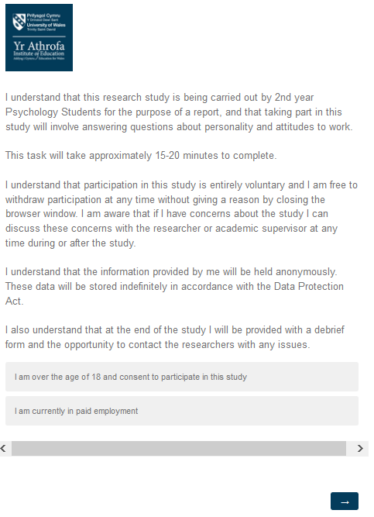
Consent Page

Study

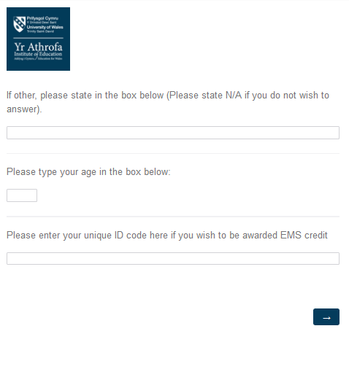
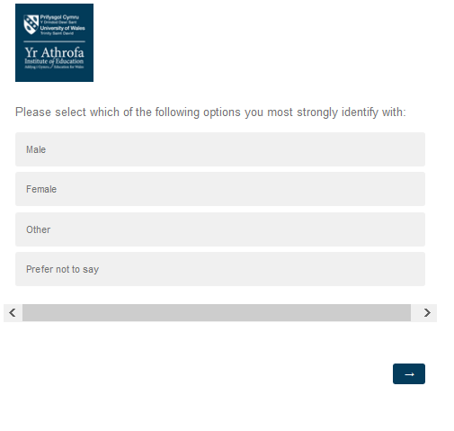

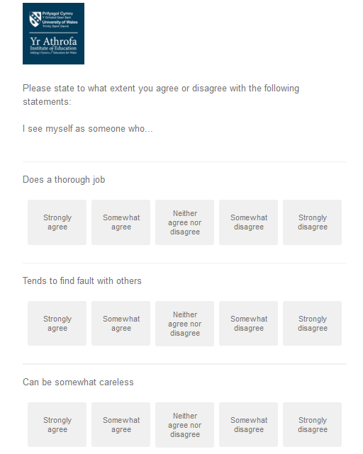
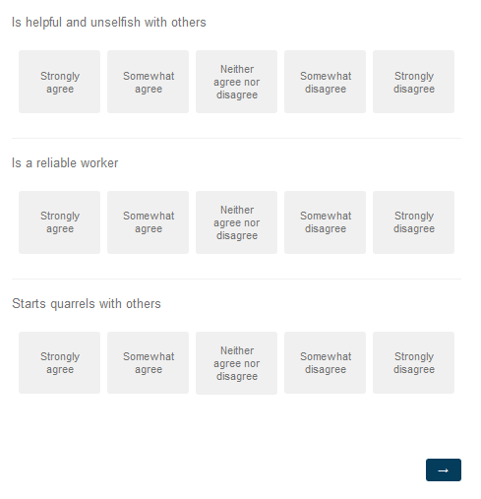

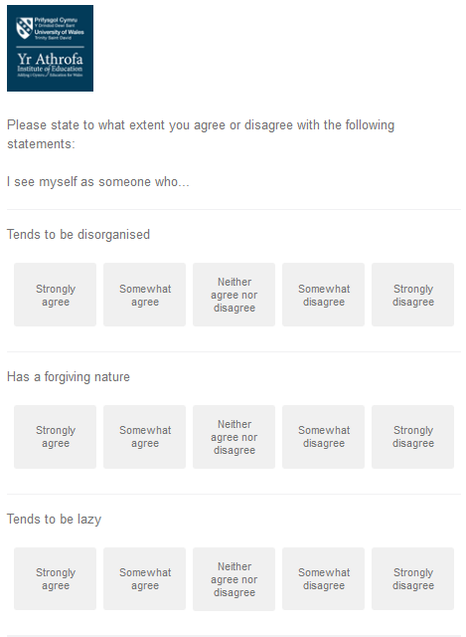

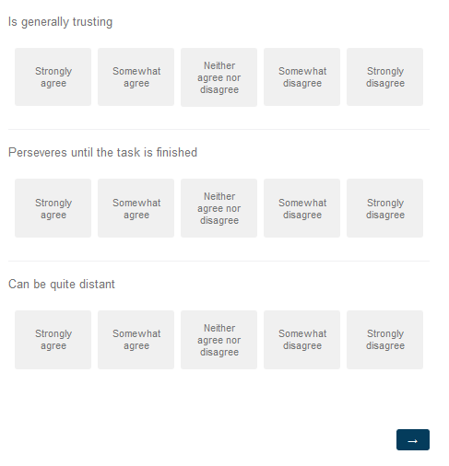

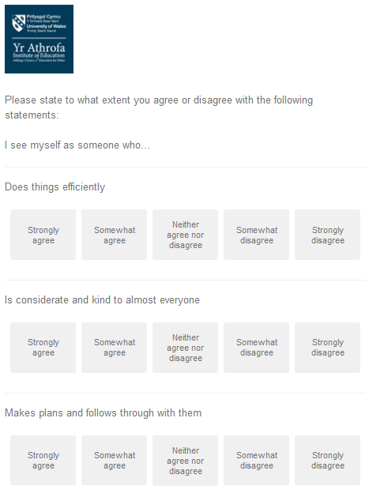
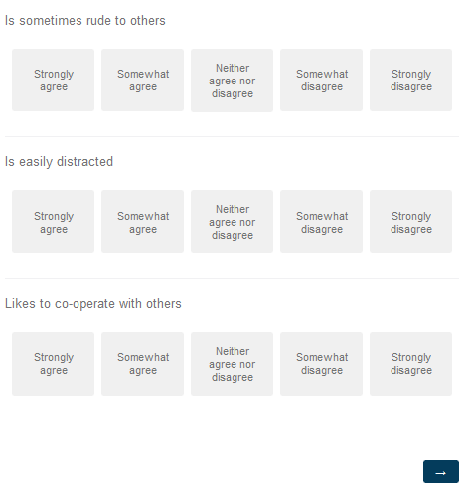

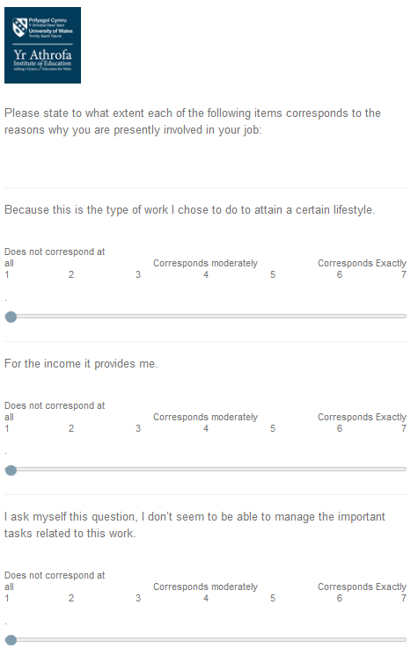

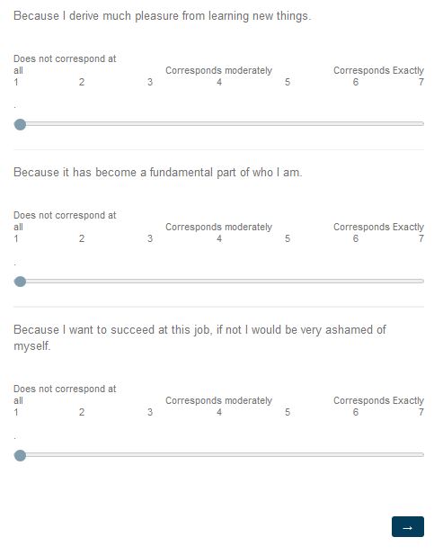

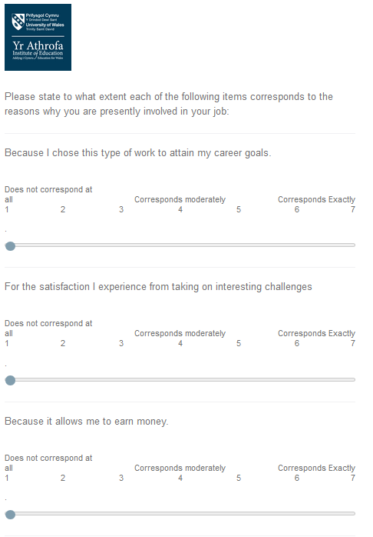
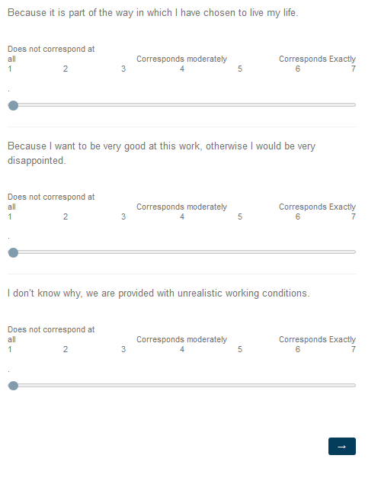

Debrief Page


