LEVEL 5 ASSESSMENT SPECIFICATION
Student name: |  | Student ID number:
Programme: | BA (Hons) International Hotel Management
Module: | Sustainable Hospitality & Tourism Management
Module code: | BMIH5006 | Contribution to Overall Module Assessment (%): | 50%
Lecturer: | Kathryn Roberts  Dr Huw Thomas | Internal Verifier: | Daniel Payne
Assignment Title: | Essay | Word count (or equivalent): | 2000 (+/-10%)
Submission deadline: | 11.55 pm Friday 2nd February 2024 | Return date of provisional marks & written feedback: | Provisionally 1st March 2024

Implement circular economy within the Corporate Social Responsibility Policy of Marriott

Introduction
Recently business organisations have focused on environmental and societal wellbeing to ensure sustainable business practice. This concern is mostly seen in hospitality firms. Due to the different operational activities of hospitality firms, the environment is facing certain negative impacts. In this case, the hospitality firms are considering this factor and ensuring sustainable business practices. Here, focusing on the circular economy by these firms can ensure the wellbeing of the environment and communities (Ghosh & Eduljee, 2023). This paper will work on the implementation of a circular economy within the CSR policy of Marriott. Here, Marriott is one of the largest hotel chains having a presence in more than 135 nations and this organisation has a direct presence in CSR activities around the world.

Explaining circular economy
The circular economy is a concept that tries to ensure the reuse of materials and products. In this case, the organisations that practice circular economy, ensure that a particular product is used in different forms and different areas so that the best benefit can be achieved from that particular product or material. This concept aims at minimising product waste and ensuring the maximum benefit from a particular product. The circular economy also works to stop the easy disposal of a particular product and maintain long usability (Danish & Senjyu, 2023). This concept is like a circle that uses a particular material to make a usable good and then dispose of that good in a form similar to the primary material so that reuse can be ensured. Certain factors are connected and related to the concept of circular economy. One of the major factors is product design. In this case, the circular economy focuses on product design so that the final product can be used for an extended period. Moreover, it also avoids designs that are quickly discarded. Further, the circular economy also focuses on the leasing model (Karjanen, 2022). According to this concept, an organisation does not have to own a particular asset to use it. Here, that organisation can take that asset as a lease and use it for product delivery. Reuse is a major concept of circular economy. Here, going for refurbishment can extend the lifespan of a particular product which ensures sustainability. Recycling is also considered in the circular economy concept. After reaching the end of the product life cycle, this concept tries to recover the leftover value and make it usable.
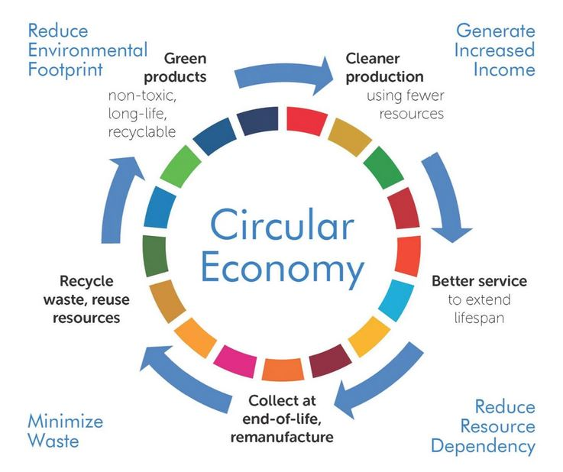
Figure 1: Concept of circular economy
Source: (Boas, 2021)
An organisation can obtain certain benefits by using the circular economy concept. In this case, reducing environmental impact is one of the major ones. In the hospitality business, hotels are impacting the environment negatively and the use of a circular economy can support the hotels to protect the environment. Further, economic growth is also possible due to a circular economy. Reuse and refurbishment of products can support a business to reduce costs and improve profitability. Furthermore, resource security is also achieved due to the circular economy. Here, the use of a circular economy reduces the dependency on virgin resources (Karjanen, 2022). The use of new resources will be lowered after using the circular economy. Business organisations can use different methods to make a particular product reusable to ensure resource security.

The ways circular economy fits into CSR
The circular economy is directly connected with CSR. The steps of circular economy can support an organisation in making it fit with CSR initiatives. In certain ways, the circular economy can be fit with CSR initiatives. Here, a circular economy ensures environmental responsibility. The use of a circular economy within the organisation can directly impact the reduction of environmental pollution (Blowfield & Murray, 2023). This concept works on the reduction of waste generation and resource wastage. Moreover, it also works on mitigating climate change through environmental initiatives. The resource conservation concept of the circular economy also protects the environment which directly showcases the environmental responsibility. A circular economy can also create a social impact. The circular economy can create new jobs for individuals. Here, reuse or recycling requires manpower from organisations that can directly impact social wellbeing (Modak, 2021). Moreover, the circular economy directly contributes to the economic welfare of organisations and also ensures social wellbeing.
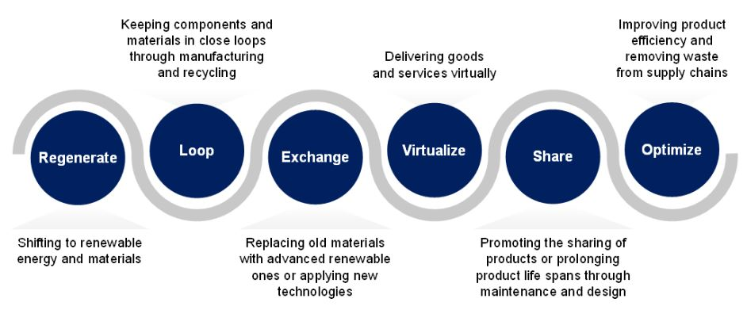
Figure 2: Circular economy fitting to CSR by ensuring sustainability
Source: (Filho & Frankenberger, 2022)
The use of circular economy concepts in business organisations can also ensure stakeholder engagement. Here, a circular economy can ensure collaboration among different parties within the organisation. It can engage suppliers, communities, consumers and other individuals to ensure sustainable sourcing and sustainable distribution for the organisations. Engagement with different parties of an organisation can contribute to the CSR initiatives for that organisation. Stakeholder engagement can also ensure transparency and encourage trust among different individuals within the organisation that can contribute to CSR initiatives. With the help of a circular economy, an organisation can also ensure sustainable value creation. Here, circular economy focuses on the long-term use of a particular resource. For generating extra profit at a time, this concept does not encourage the damage of a particular resource. In this case, sustainable use of products is possible with the help of sustainable value creation (Ketenci, 2023). Further, this can also ensure proper resource management that can reduce wastage and ensure the sustainability of a particular product. Here, the use of a circular economy can support sustainable value creation which can impact the CSR initiatives for a particular organisation. Therefore, the use of a circular economy can ensure the CSR of an organisation.

Reviewing and evaluating the CSR policy of Marriott
Marriott is one of the largest hotel chains that are directly contributing to different CSR initiatives and therefore, this organisation has been focusing on CSR policies and making necessary developments regularly. The CSR policy of this firm is “Serve360: Doing Good in Every Direction.” This policy has been working to improve the environmental and societal development within the hospitality industry. One of the major areas of this policy is empowering people. In this area, Marriott works on human resource development within the organisation. It ensures diversity and practice inclusion in major decisions (Filho & Frankenberger, 2022). Further, it also focuses on community engagement which is a major initiative taken by this firm. A huge amount is also invested by Marriott in preventing human trafficking. Supporting the planet is another major aim of the policy of Marriott. Here, this organisation has been working to improve the environment by reducing waste and ensuring energy conservation within the hotel. Moreover, it is also focusing on sustainable sourcing which is a major initiative taken by this firm.

Figure 3: Serve 360 policy by Marriott
Source: (Nourick, 2021)
Strengthening the community is one of the major goals of this CSR policy of Marriott. This organisation has been contributing to education development by ensuring a major investment. Further, it is also focusing on disaster relief so that people can get a quick recovery after natural climatises. Focusing on responsible tourism efforts is also considered under community strengthening of the CSR policy of Marriott. Encouraging responsible tourism is also practised through the CSR initiative of Marriot (Danish & Senjyu, 2023). This organisation focuses on building a culture that encourages responsible travelling for an individual and improves understanding among guests. Here, this CSR policy of Marriott focuses on community development and environmental protection. In this case, some measurable outcomes have been set by this organisation which is directly contributing to the wellbeing of the people and the environment of the firm. Therefore, the CSR initiatives of Marriot are properly justified.

The alignment of CSR policy of Marriott with the circular economy
The CSR initiatives of Marriot properly align with the circular economy. One of the major examples in this case is reducing the waste by 50%. Marriott has been considering that the hotel will reduce the waste generated by this hotel within 2025. In this case, the firm has been working to reduce the waste and proper training opportunities have been provided to the employees so that they can support in waste reduction of the firm (Blowfield & Murray, 2023). This waste reduction policy of Marriot properly aligns with the circular economy as this concept also focuses on waste reduction. Again, the commitment of Marriot to increasing the product life cycle is another major example that ensures the alignment of the CSR initiatives of Marriott with the circular economy. Here, this organisation is committed to ensuring sustainable sourcing and product design that supports the longevity of the products. This makes sure that the organisation is focusing on a circular economy.
Encouraging the reuse of products and materials within Marriott is another major CSR initiative that ensures the alignment of the circular economy. Here, Marriot took the initiative that donate the food items that remain leftover to the local communities so that those food items are consumed by others and are not wasted. Further, this hotel also focuses on repurposing different amenities like furniture so that economic wellbeing can be ensured (Villiers, 2023). These initiatives taken by Marriott ensure a proper alignment of the CSR initiatives taken by this firm with the circular economy. Fostering collaboration can also ensure the alignment of the circular economy with the CSR initiatives of Marriott. In this case, the hotel aligns with different local communities so that sustainable sourcing can be ensured and the benefits for local communities can be achieved. These activities of Marriott properly align with the circular economy and ensure effective corporate social responsibility.

Industry examples of firms embodying the circular economy
Different organisations within the hospitality sector are directly connecting with the circular economy with their CSR initiatives. In this case, the activities of AccorHotels are very common. This hotel chain has initiated the Planet 21 program which is dedicated to reducing the environmental impact of hospitality operations. Further, this initiative is also focused on reducing water and energy consumption (Boas, 2021). Again, Scandic Hotels is another example of embodying the circular economy. This organisation has introduced an AI-generated food management system that is very useful in reducing food waste. This hotel also focuses on circular amenities. In this case, different products are sourced from the local community so that sustainability is ensured within the hotel.
Minor Hotels is also focusing on the circular economy through its different CSR activities. Here, this organisation is using waste to convert it into wealth. With the use of leftover food items, this organisation is generating organic compost that is used for farming activities. Again, plastic reduction is also ensured by this hotel to improve environmental sustainability (Tuladhar & Iatridis, 2022). Yotel is also focusing on the circular economy through its different initiatives. Here, this hotel is focusing on preparing compact rooms so that a large number of hotel rooms can be prepared in small areas in busy cities. This can ensure the best use of resources.

Conclusion
Business organisations are accepting the concept of circular economy to ensure their CSR initiatives. Since a circular economy comes with different ideas that directly align with CSR activities, considering the factors of a circular economy also ensures the implementation of corporate social responsibility by the firms. In this case, hospitality firms need to focus on certain factors. Here, the firms should consider product design that can ensure the longevity of the products. Further, the products should also consider sustainable sourcing so that reuse can be ensured and the use of virgin resources can be reduced (Stahel & MacArthur, 2022). The implementation of the circular economy should be from the core so that the circular economy can become the system of that hotel. In this case, the CSR practices of Marriott are properly aligned with the circular economy.

References
Blowfield, M. and Murray, A. (2023) ‘Corporate Social Responsibility Reporting’, Corporate Social Responsibility [Preprint]. doi:10.1093/hebz/9780198797753.003.0010.
Boas, S.H. (2021) Circular economy: Denmark as a circular economy solution hub. Kbh.: State of Green.
Danish, M.S. and Senjyu, T. (2023) ‘Shaping the future of sustainable energy through AI-Enabled Circular Economy Policies’, Circular Economy, 2(2), p. 100040. doi:10.1016/j.cec.2023.100040.
Filho, L.W. and Frankenberger, F. (2022) International Business, Trade and Institutional Sustainability. Cham, Switzerland: Springer.
Ghosh, S.K. and Eduljee, G. (2023) The Circular Economy: Meeting Sustainable Development Goals. Cambridge: Royal Society of Chemistry.
Gond, J.-P. and Moon, J. (2021) Corporate Social Responsibility. London: Routledge.
Karjanen, D.J. (2022) ‘Working in the hospitality industry’, The Servant Class City [Preprint]. doi:10.5749/minnesota/9780816694624.003.0004.
Ketenci, N.S. (2023) Circular economy: Multidisciplinary approaches from Turkey. Lanham: Lexington Books.
Modak, P. (2021) ‘Business models in a circular economy’, Practicing Circular Economy, pp. 209–238. doi:10.1201/9781003107248-8.
Nourick, S. (2021) Corporate Social Responsibility: Partners for Progress. Paris: Organisation for Economic Co-operation and Development.
Stahel, W.R. and MacArthur, E. (2022) The Circular Economy: A User’s Guide. London: Routledge.
Tuladhar, A. and Iatridis, K. (2022) ‘History and evolution of the circular economy and circular economy business models’, Circular Economy and Sustainability, pp. 87–106. doi:10.1016/b978-0-12-819817-9.00031-4.
Villiers, C. (2023) ‘Corporate law, Corporate Power and Corporate Social Responsibility’, Perspectives on Corporate Social Responsibility [Preprint]. doi:10.4337/9781848443792.00008.

