Screenshot 1: RRAS running
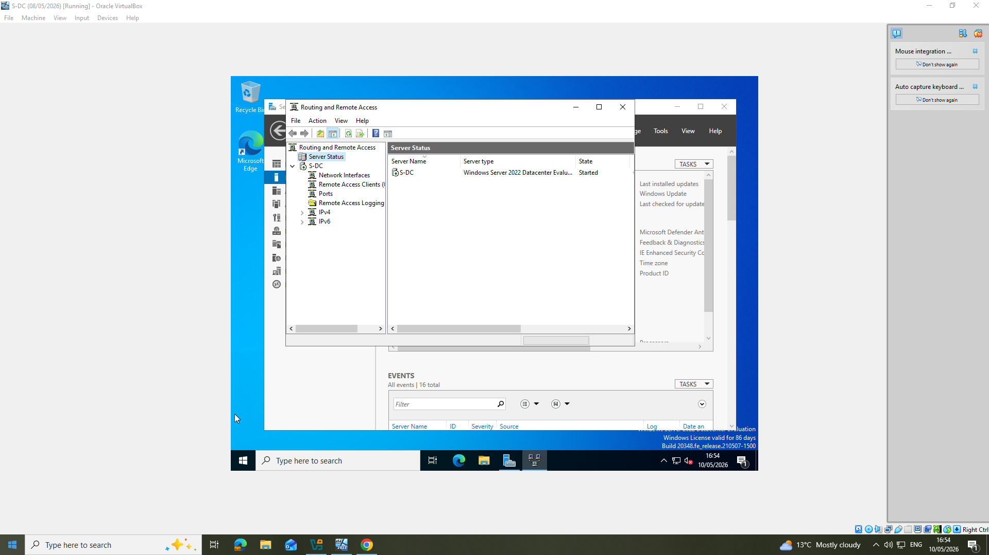
Screenshot 2: RRAS configuration and IPv4 configuration
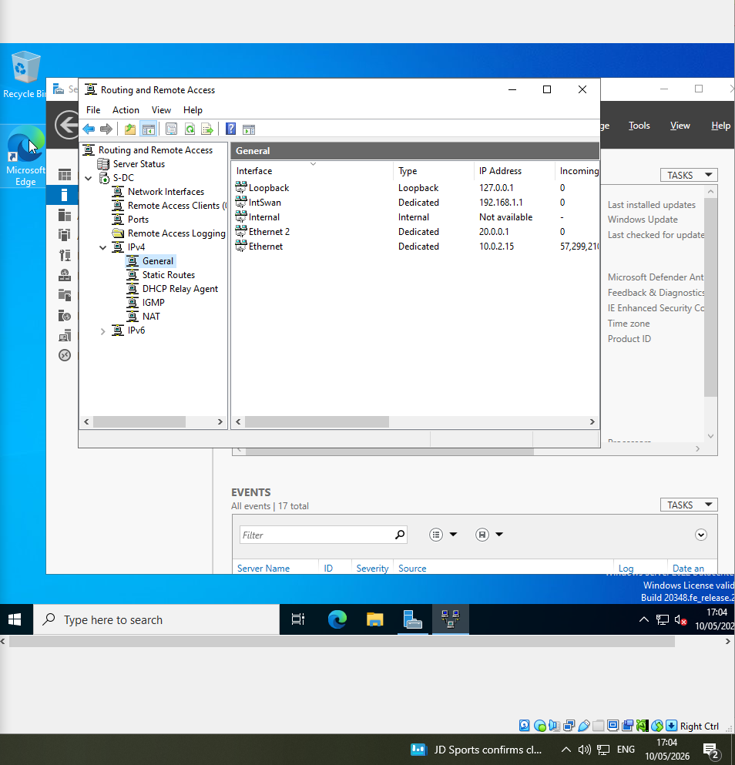

Screenshot 3/4: ICMP Firewall rule
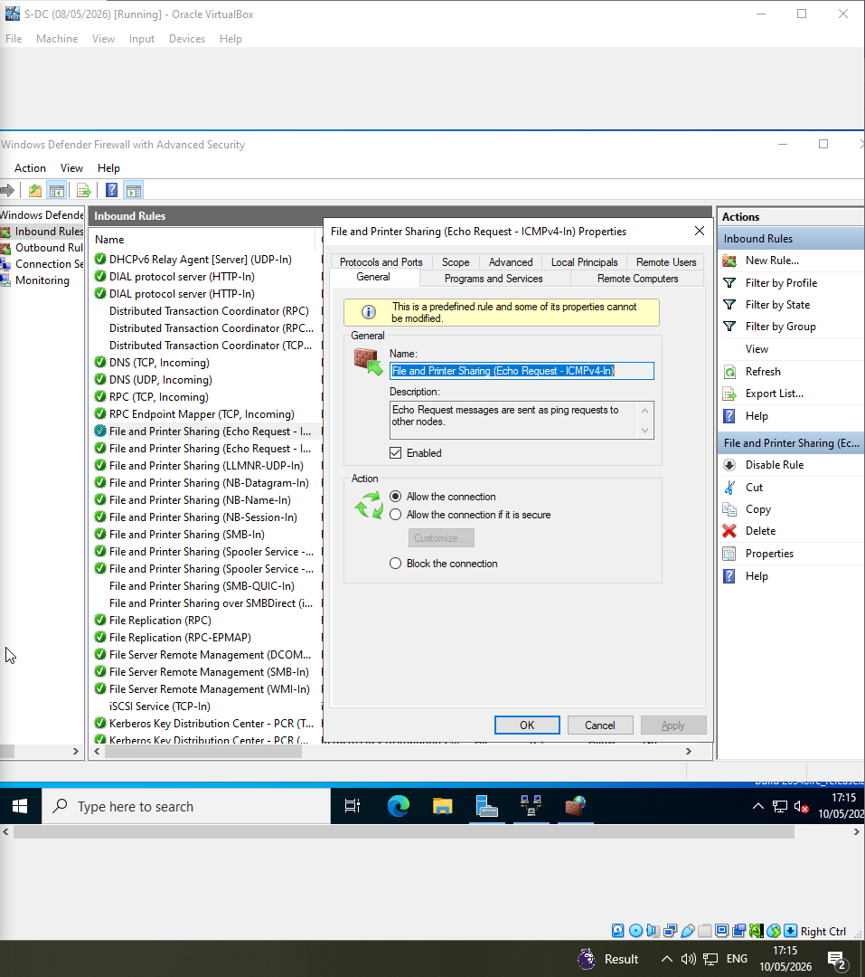
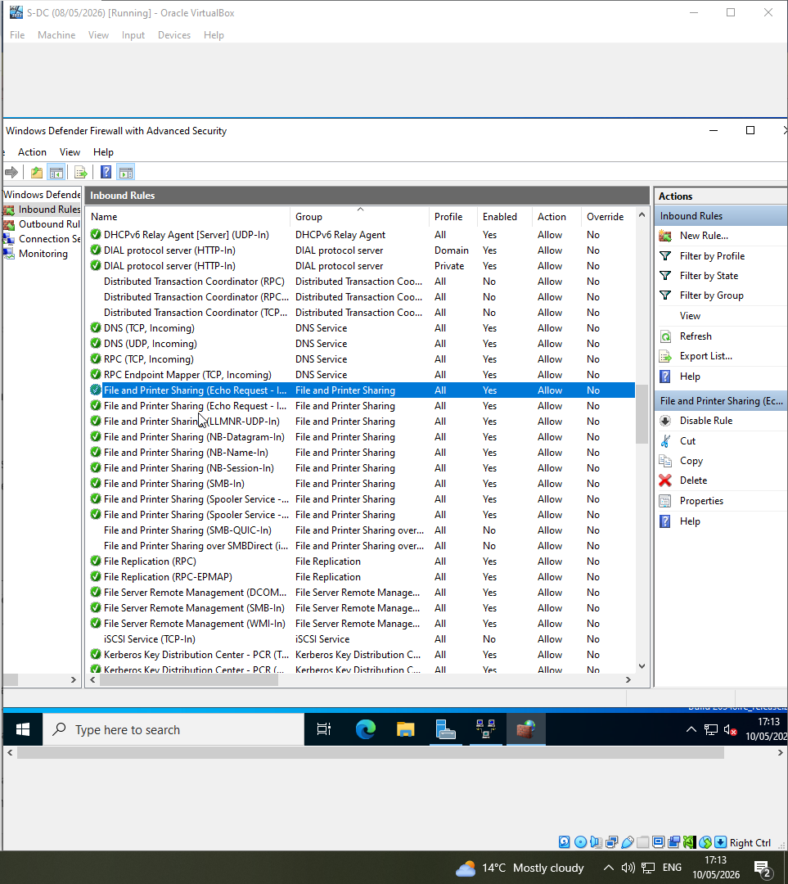

Screenshot 5: Successful ping from Swansea server (S-DC) to London server (L-DC)
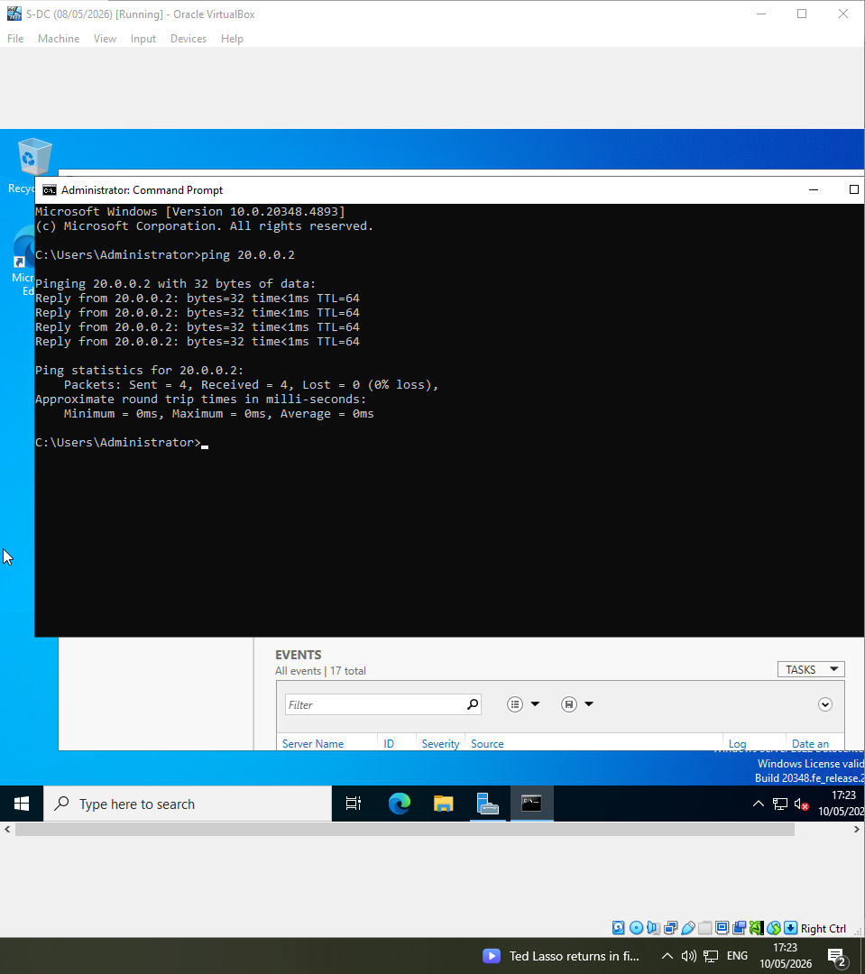

Screenshot 6: London server (L-DC) pinging the Swansea server (S-DC)
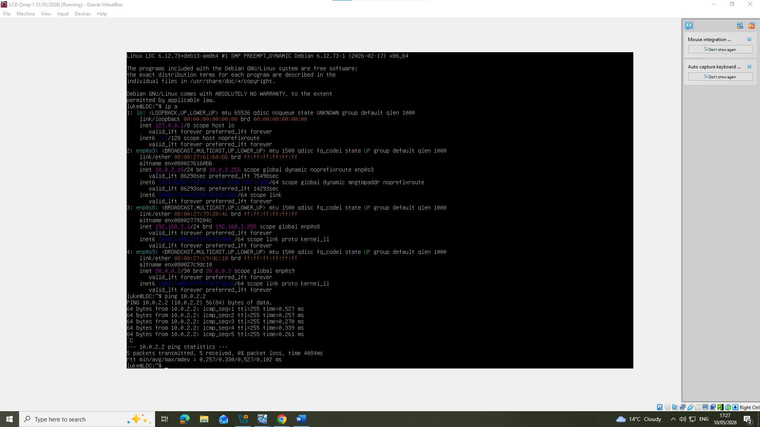
Screenshot 7: IP forwarding on Linux enabled
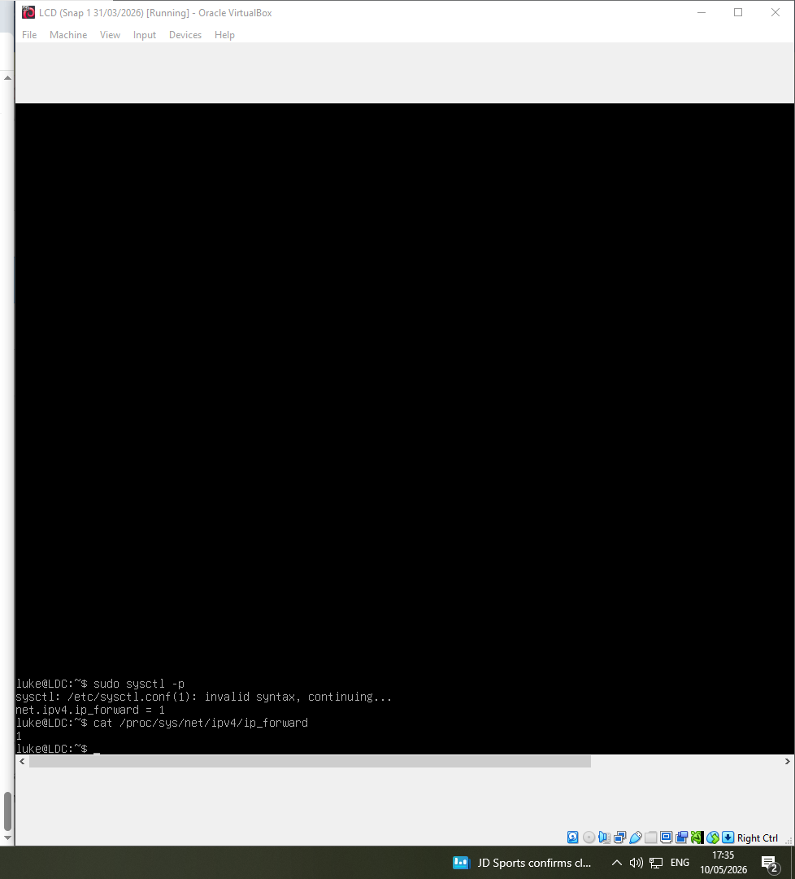

Screenshot 8: Linux Routing
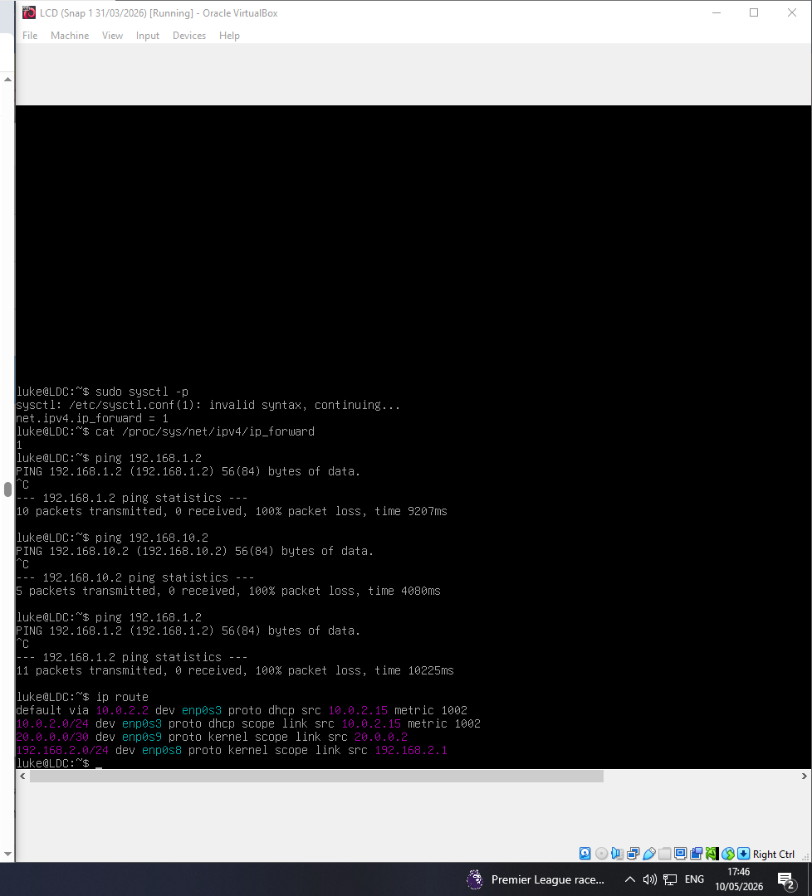

Screenshot 9: Active directory Domain Services installed
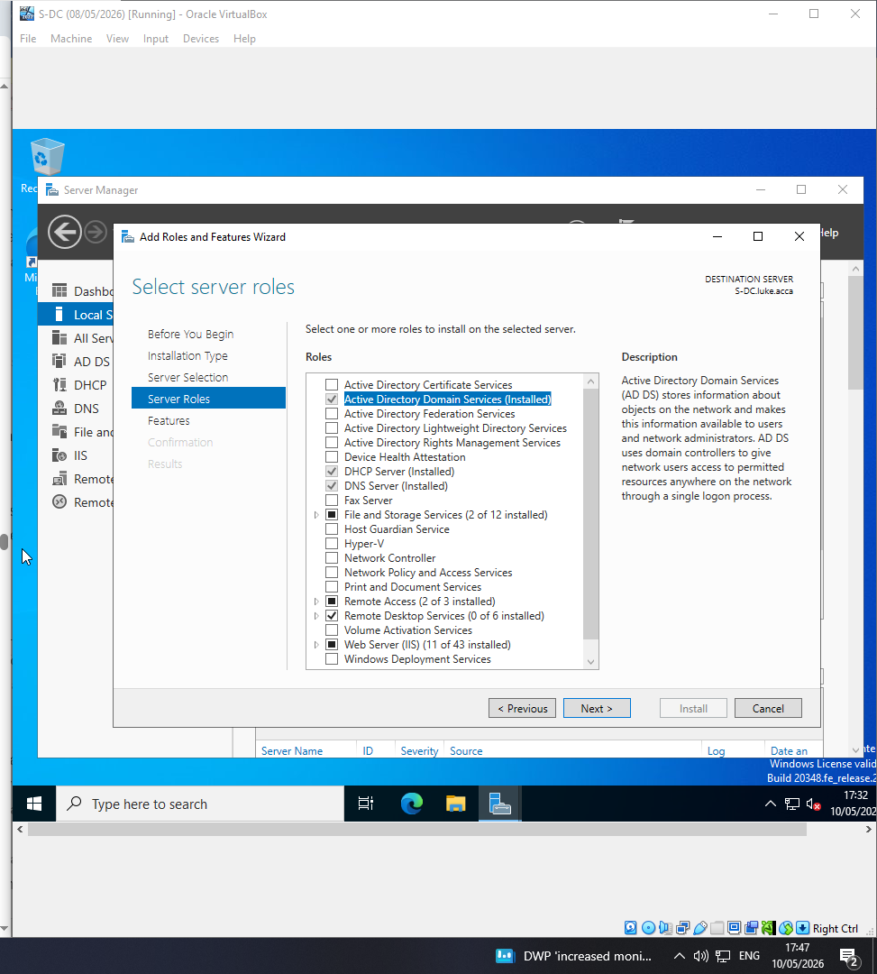

Screenshot 10: Domain name Luke.acca
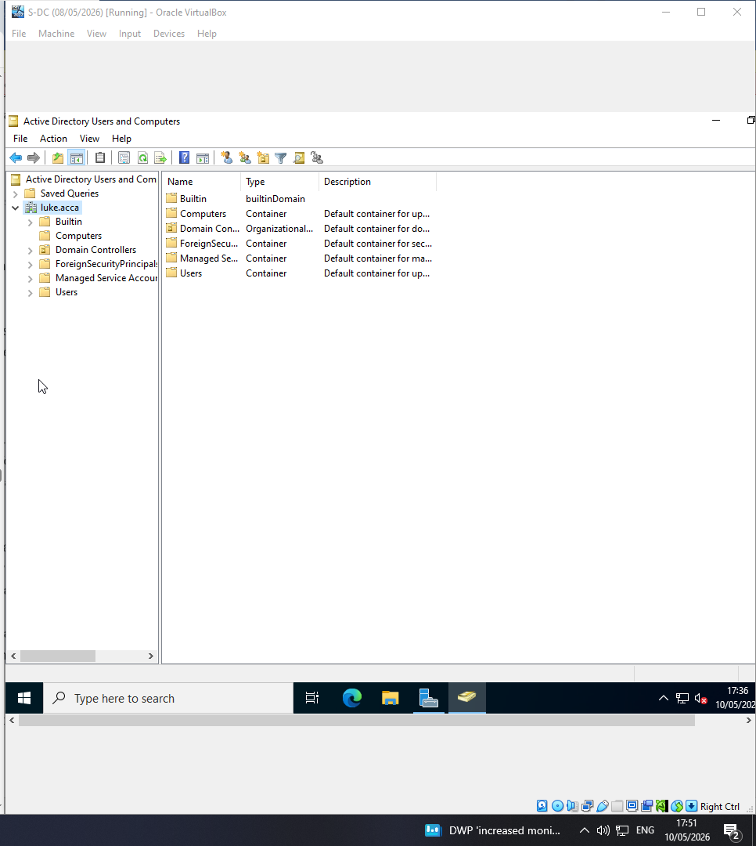
Screenshot 11: Get-ADDomain command run in PowerShell showing details of my domain 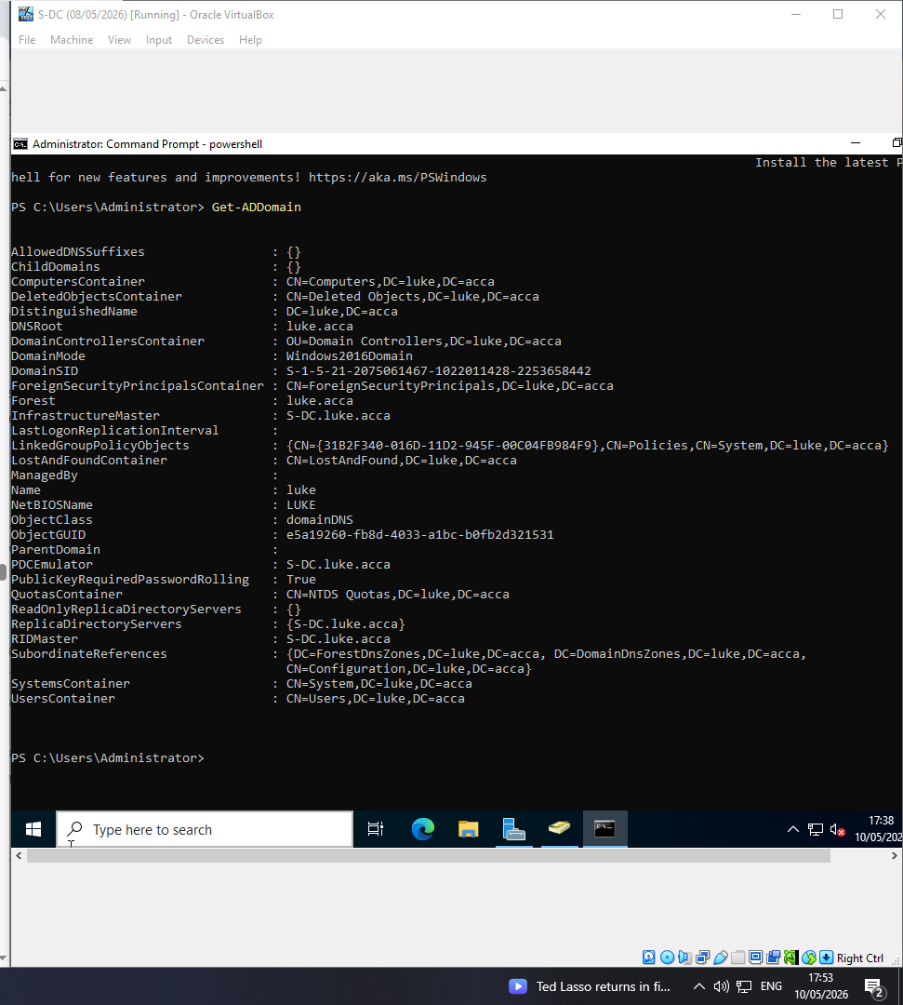
Screenshot 12: Foward lookup zones
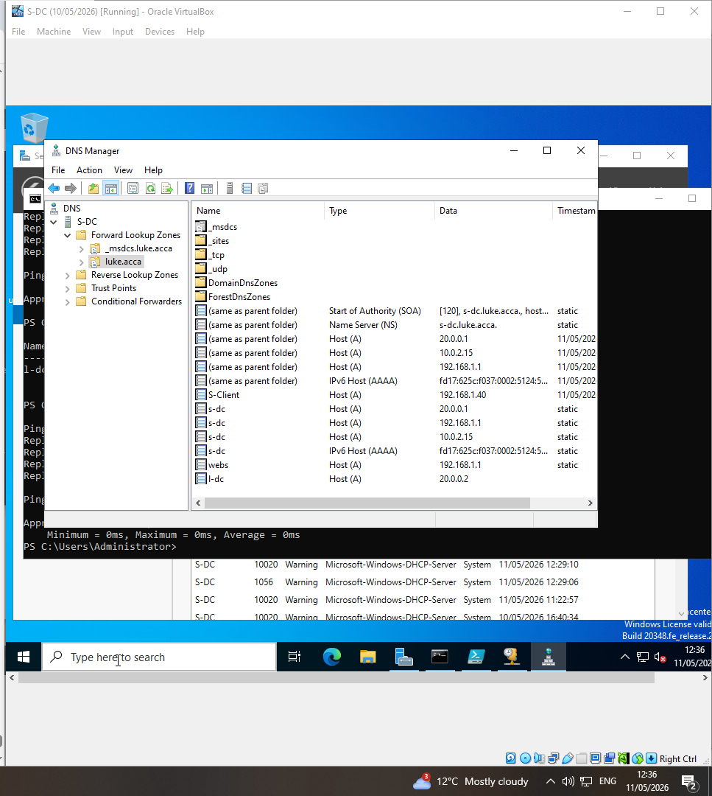

Screenshot 13: Reverse lookup zone
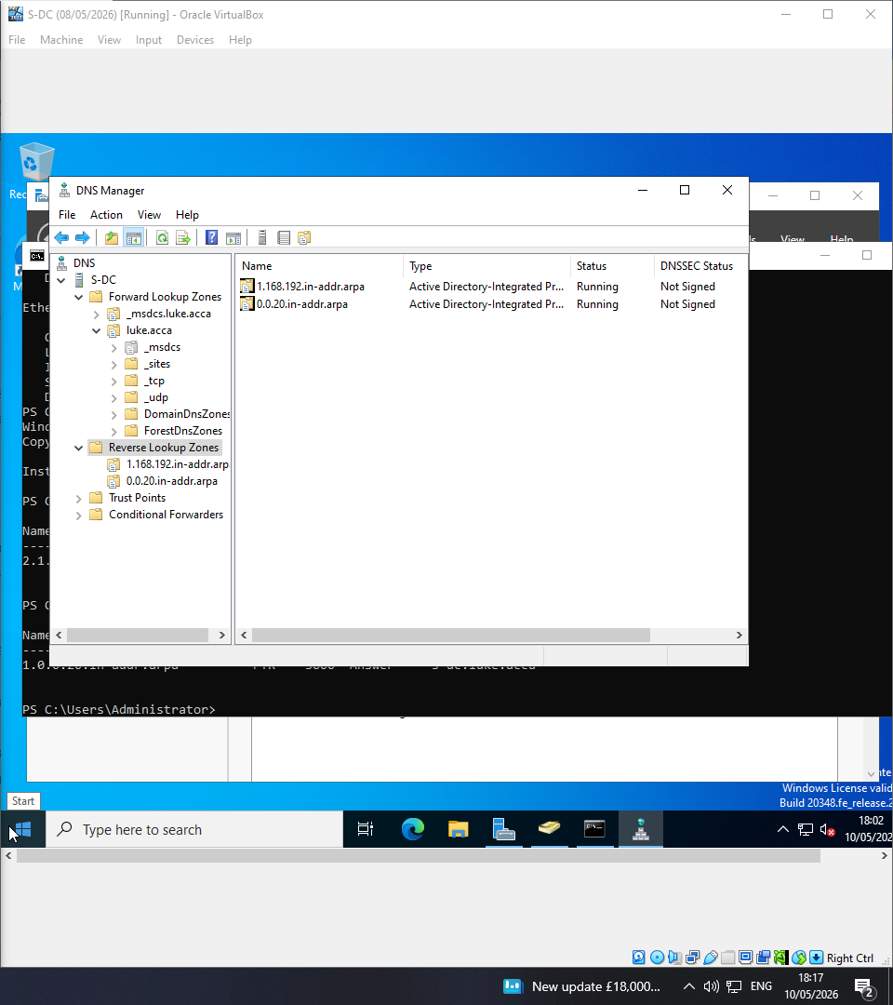
Screenshot 14/15: PTR records
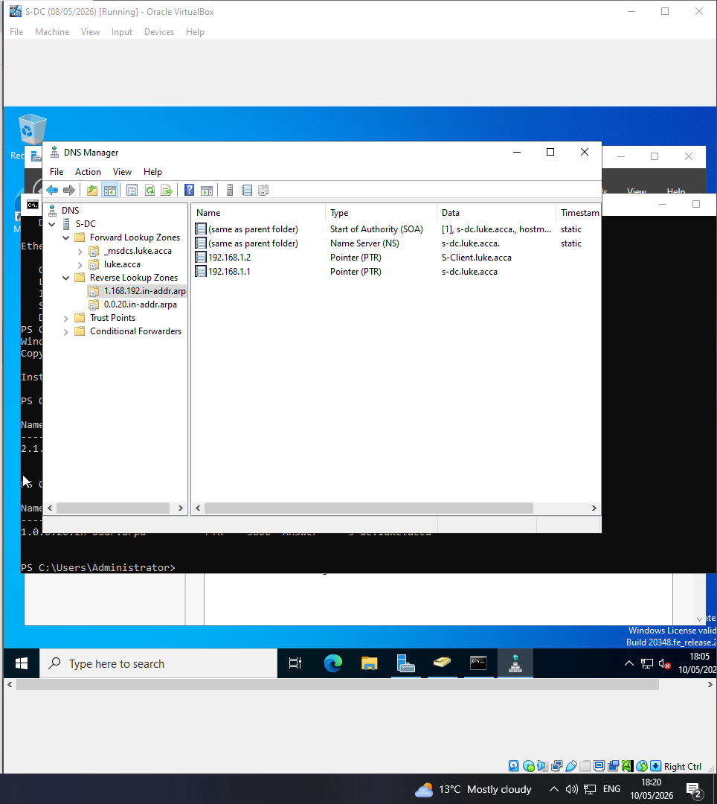
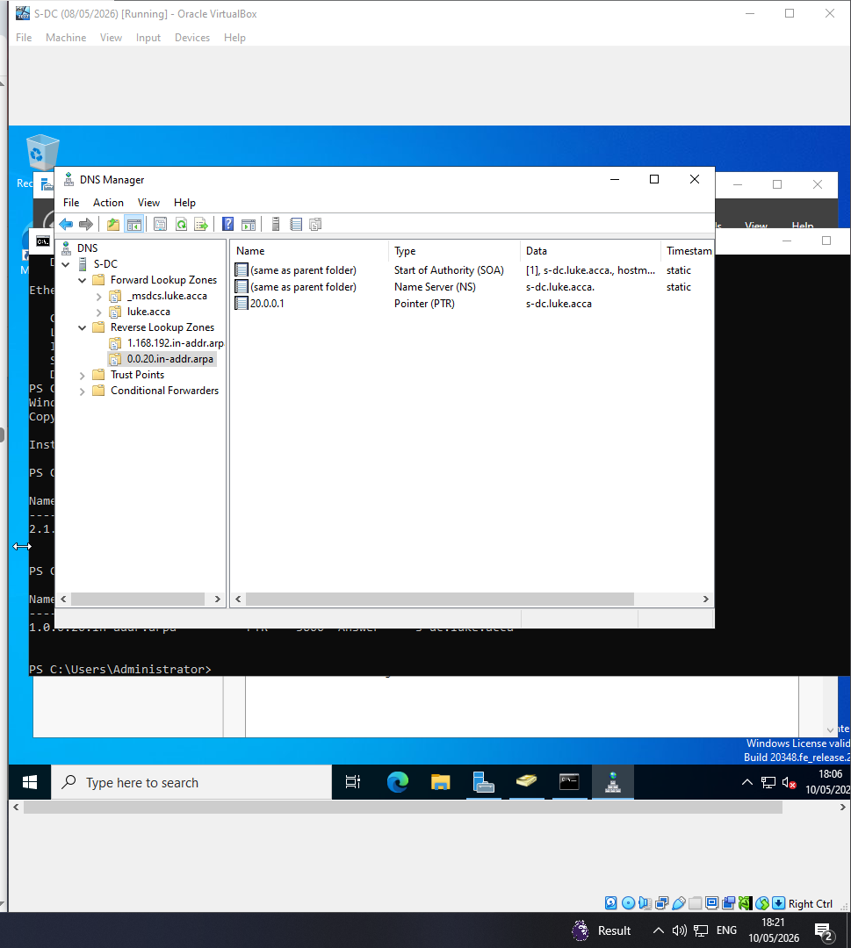

Screenshot 16: Reverse DNS Test:
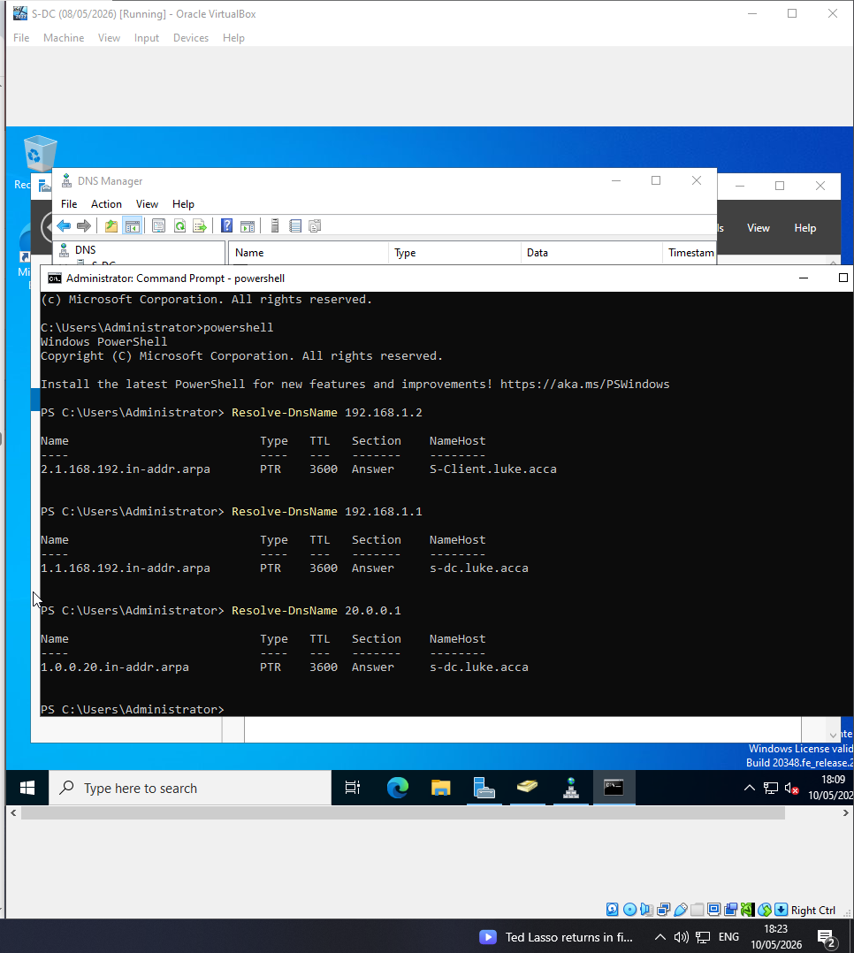
Screenshot 17: VPN working
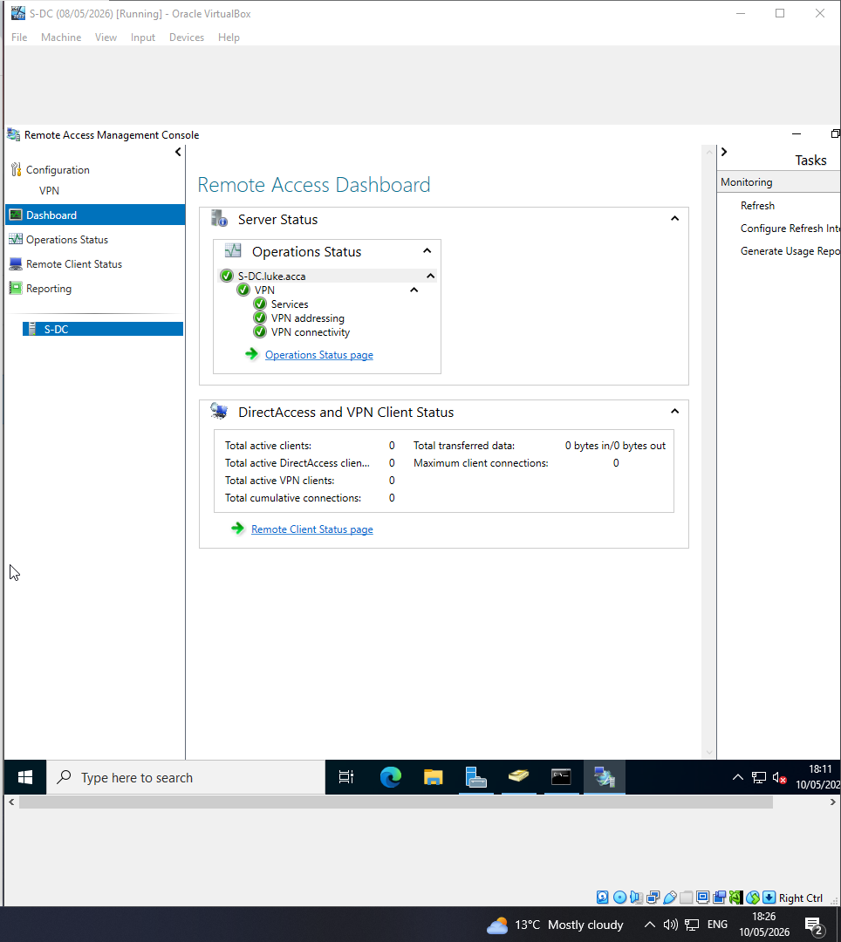
Screenshot 18: Cross network ping (Swansea pinging London)
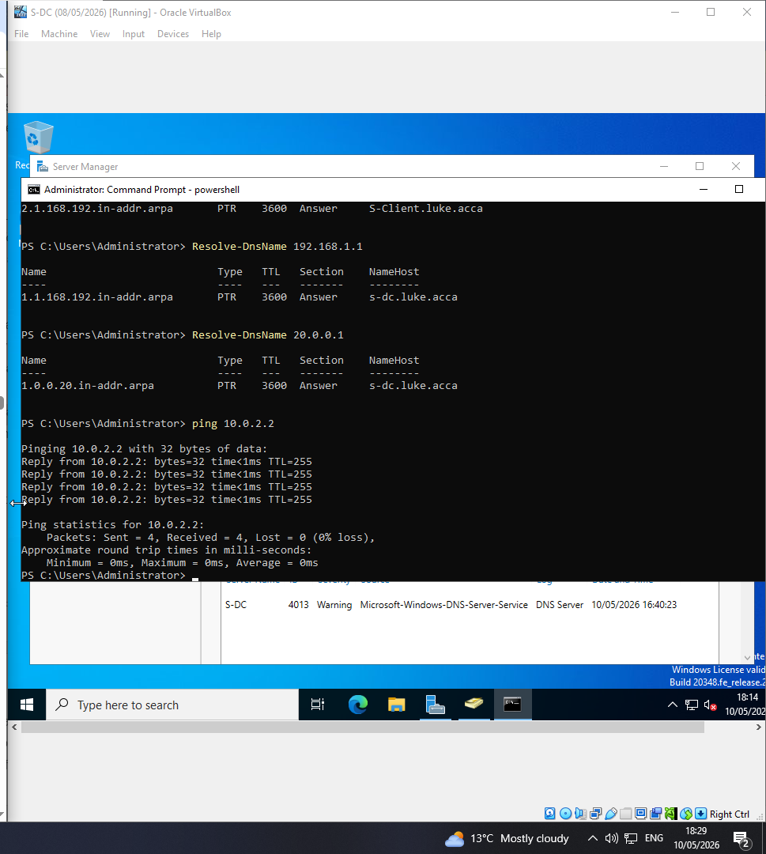
Screenshot 19: route print on Windows server
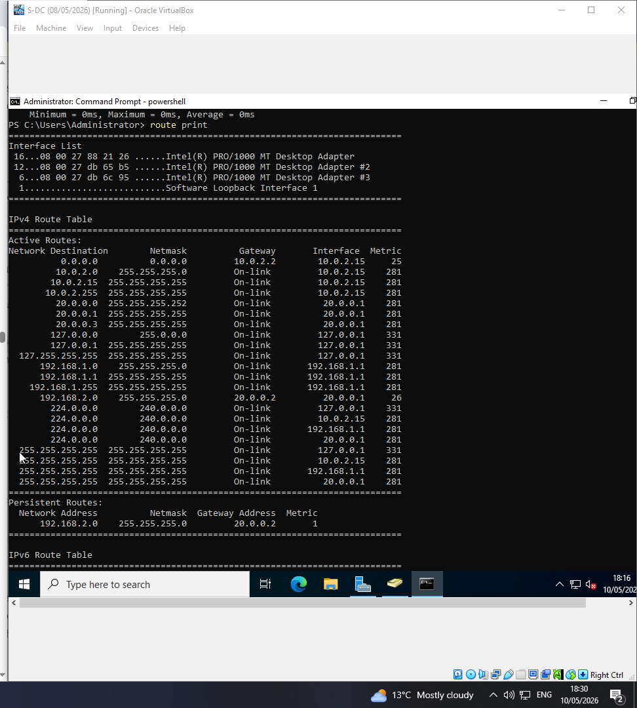

Screenshot 20: IP route on Linux server
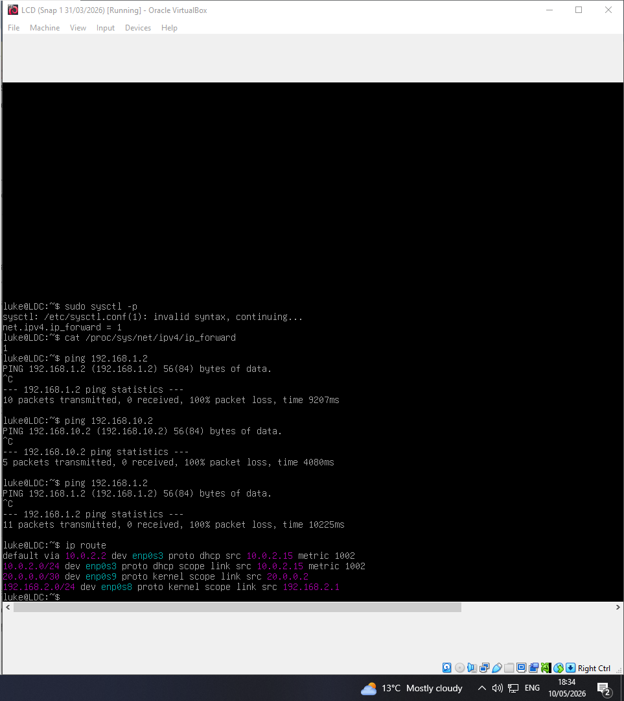

Screenshot 21: Evidence that the windows client is in the luke.acca domain
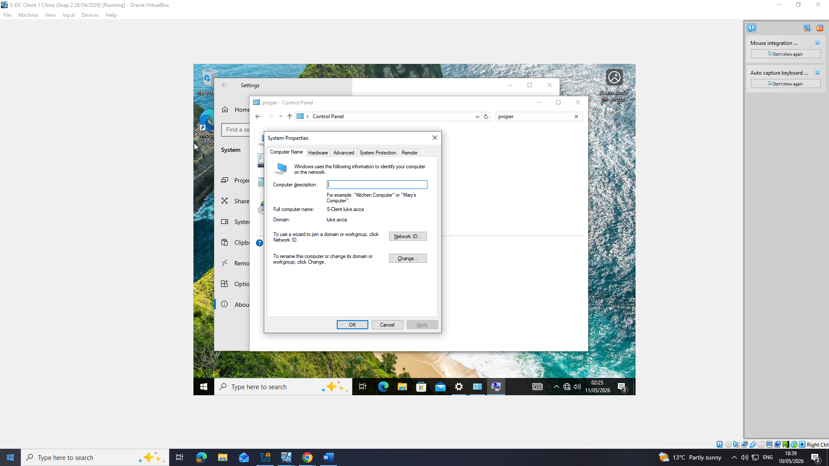
Screenshot 22: users being created using a PowerShell script
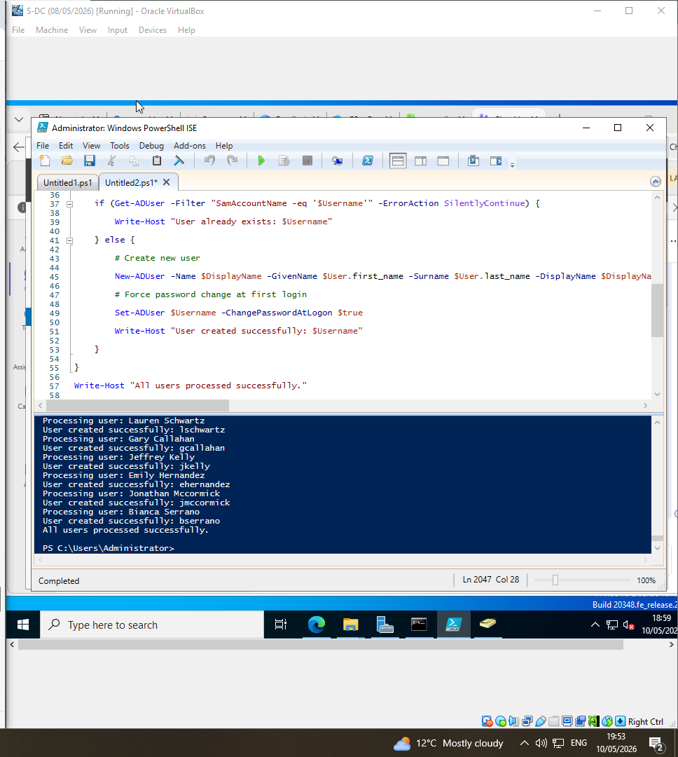

Screenshot 23: list of the users in the AD
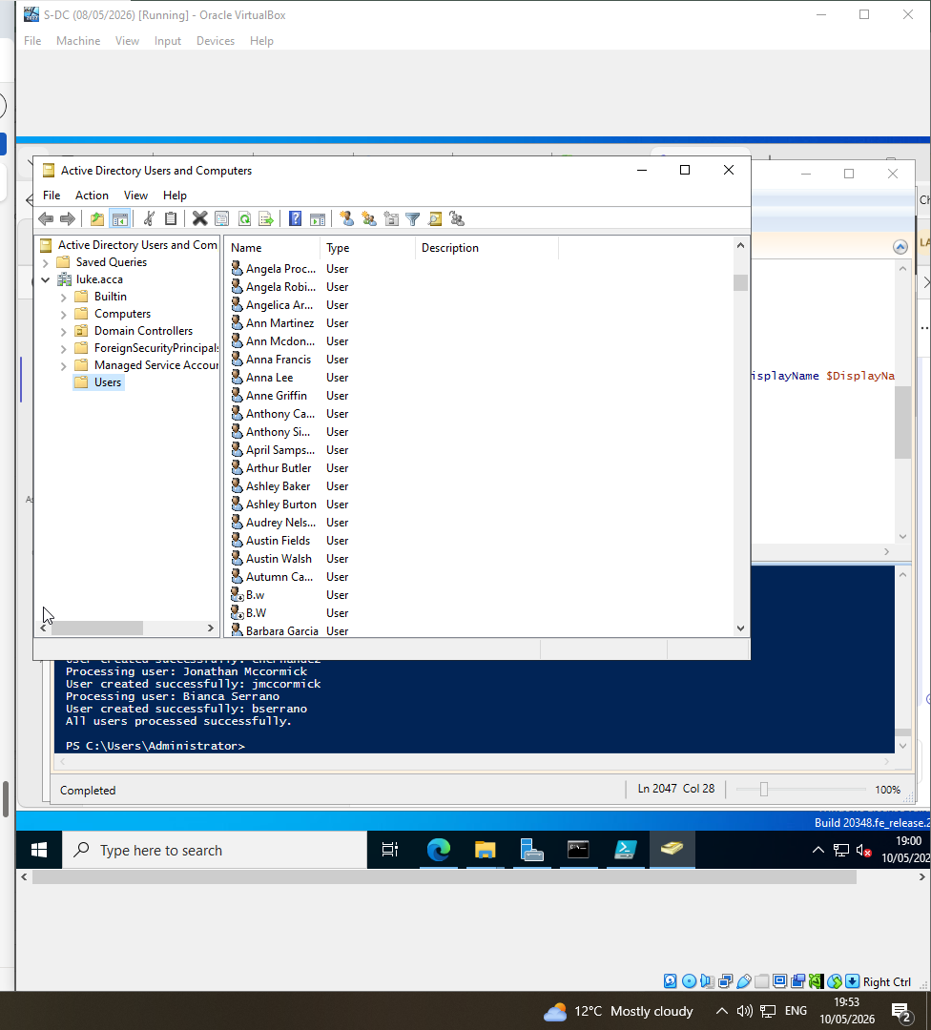

Screenshot 24/25: information on the users
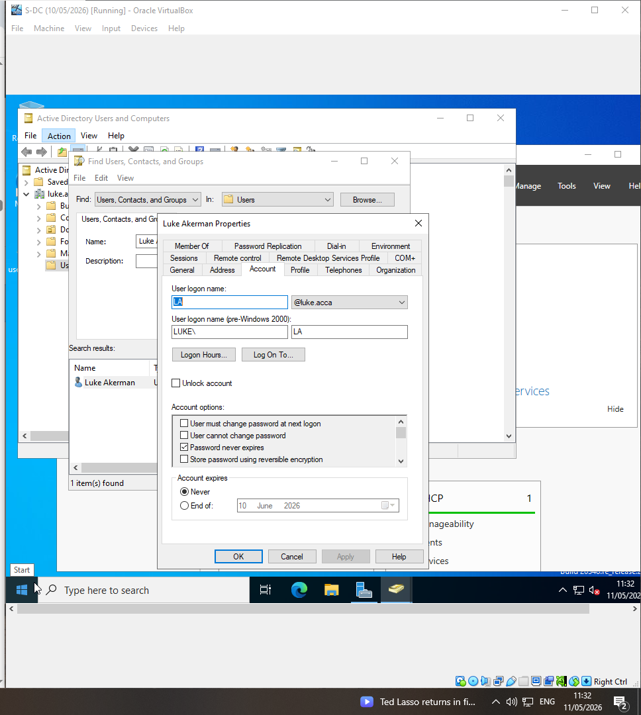
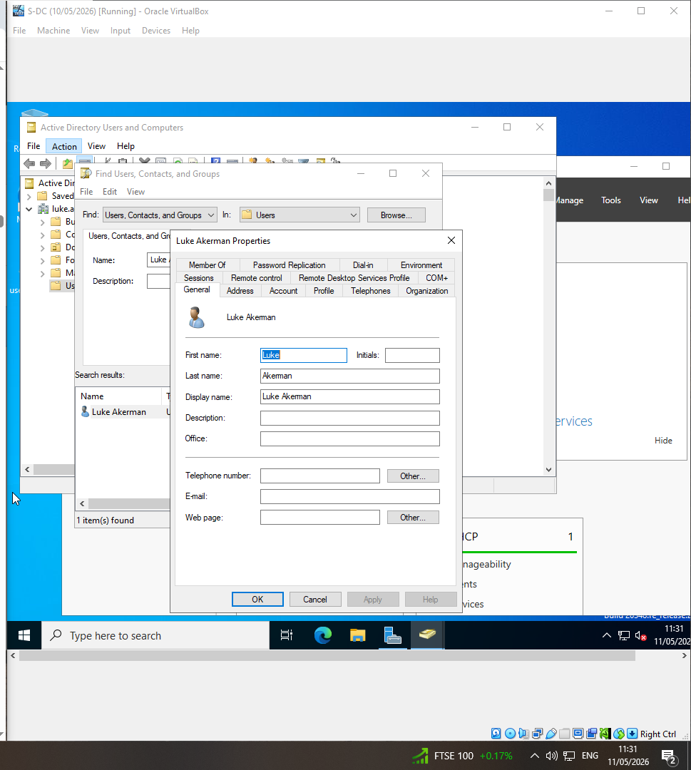

Screenshot 26: DHCP server installed and visible on server manager
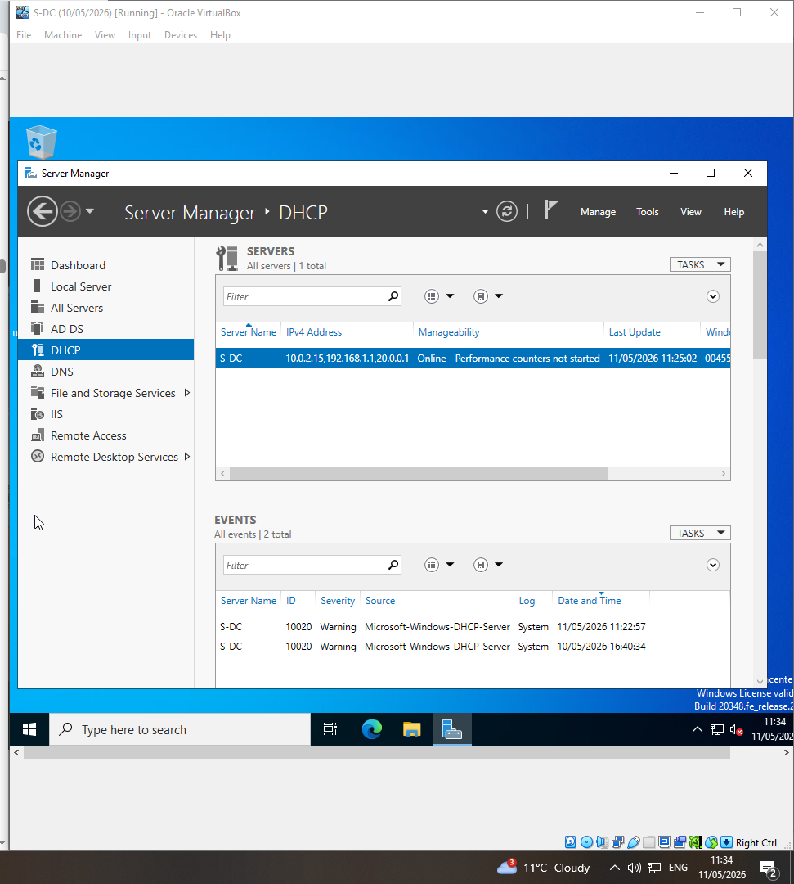

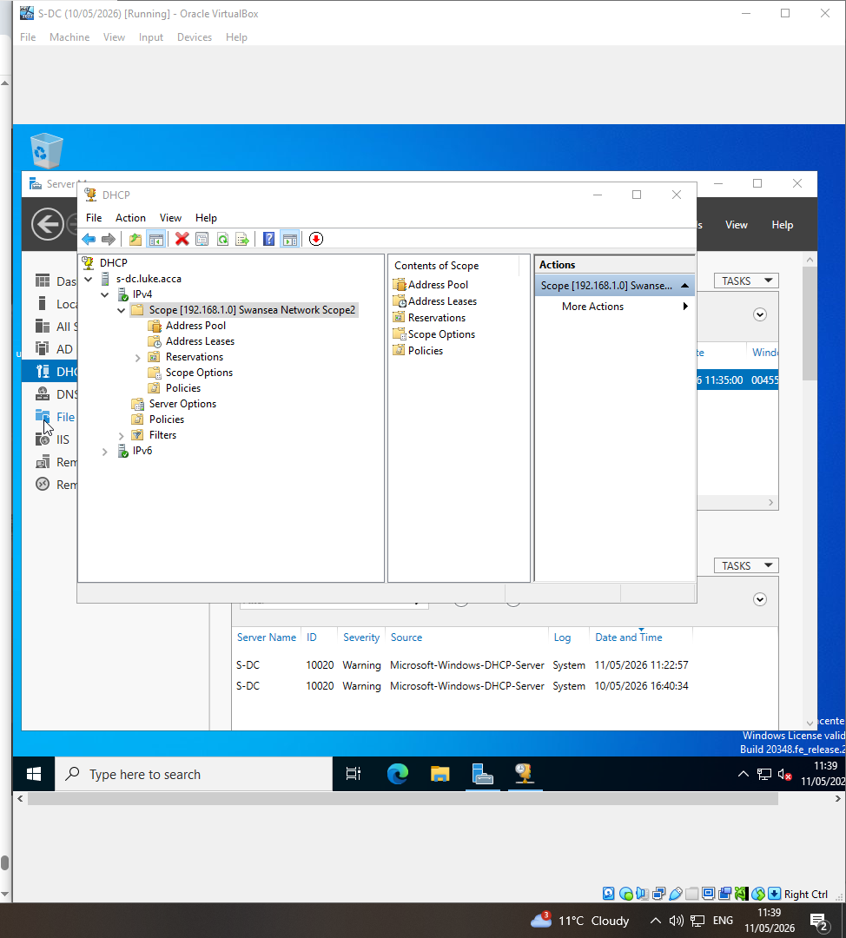
Screenshot 27: DHCP scope

Screenshot 28: DHCP scope options
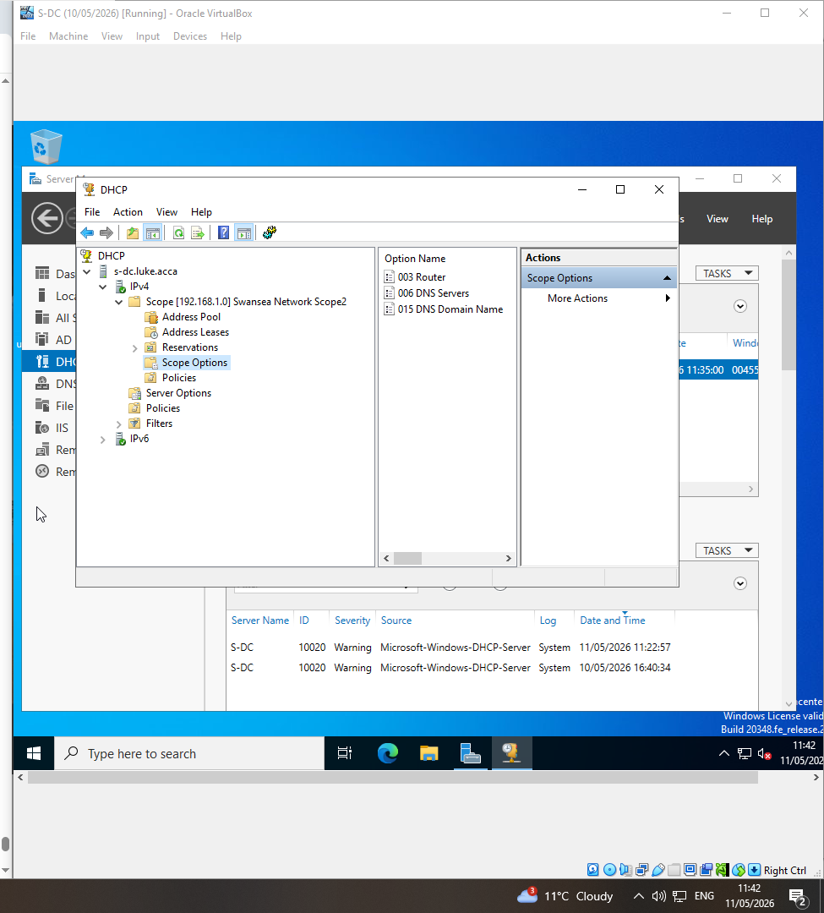
Screenshot 29: DHCP leases
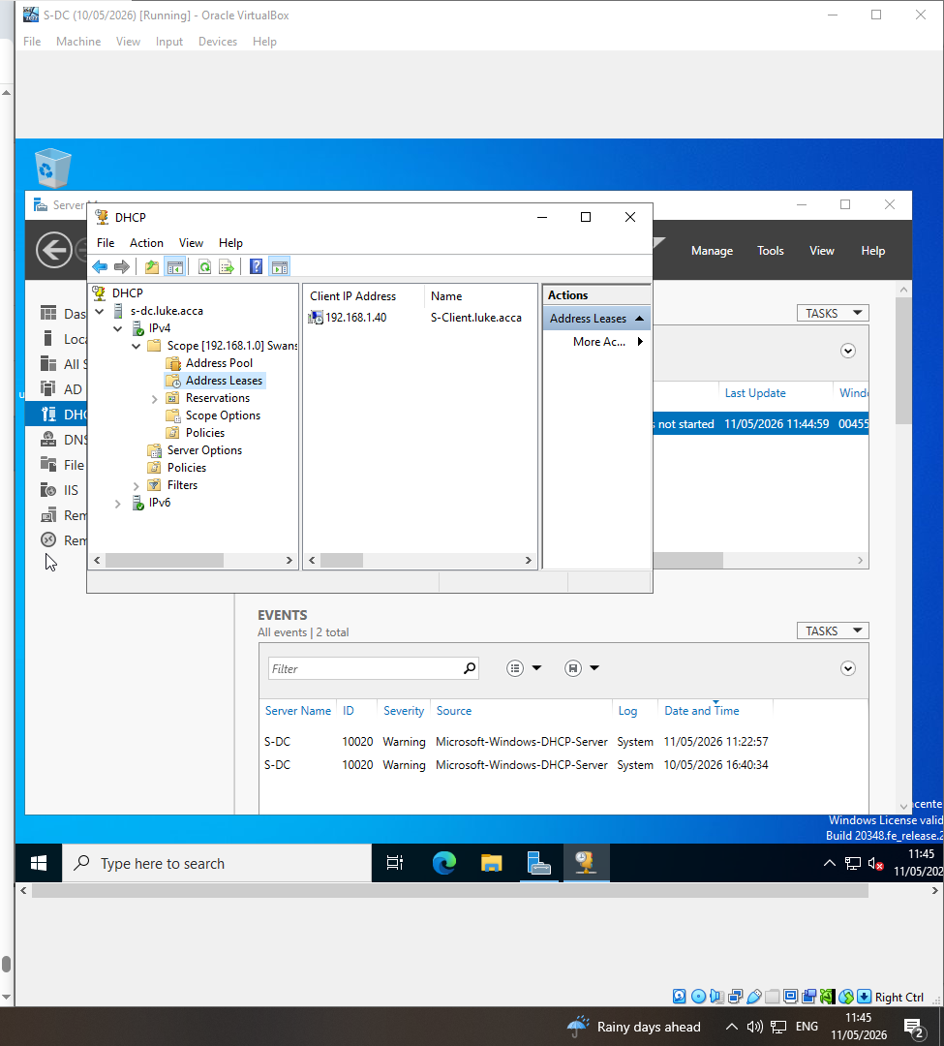

Screenshot 30: Client DHCP evidence
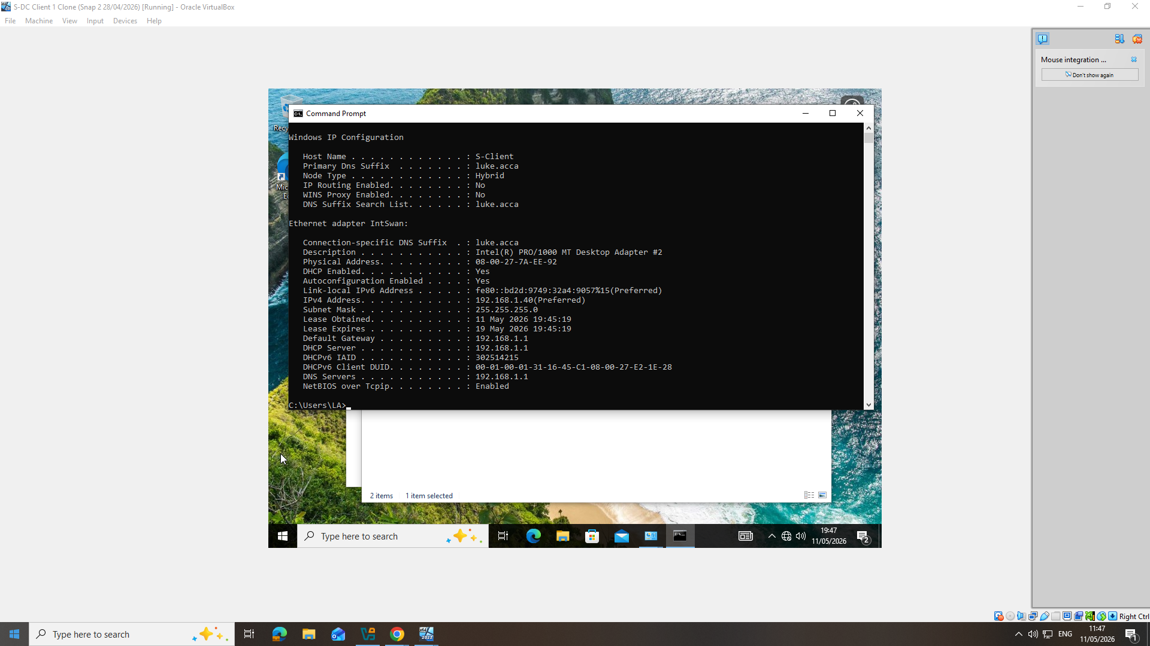

Screenshot 31: DHCP active on Linux
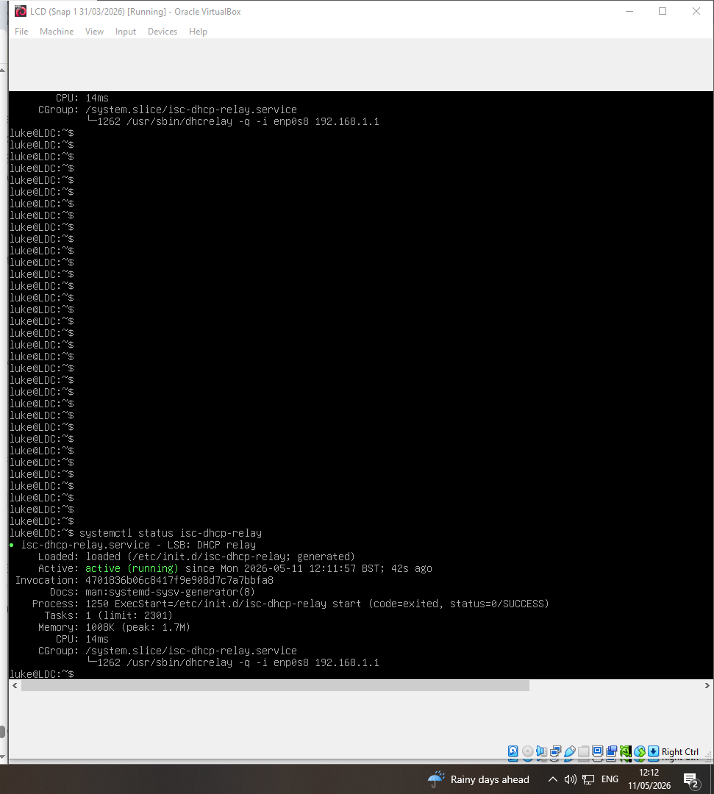

Screenshot 32: relay configuration
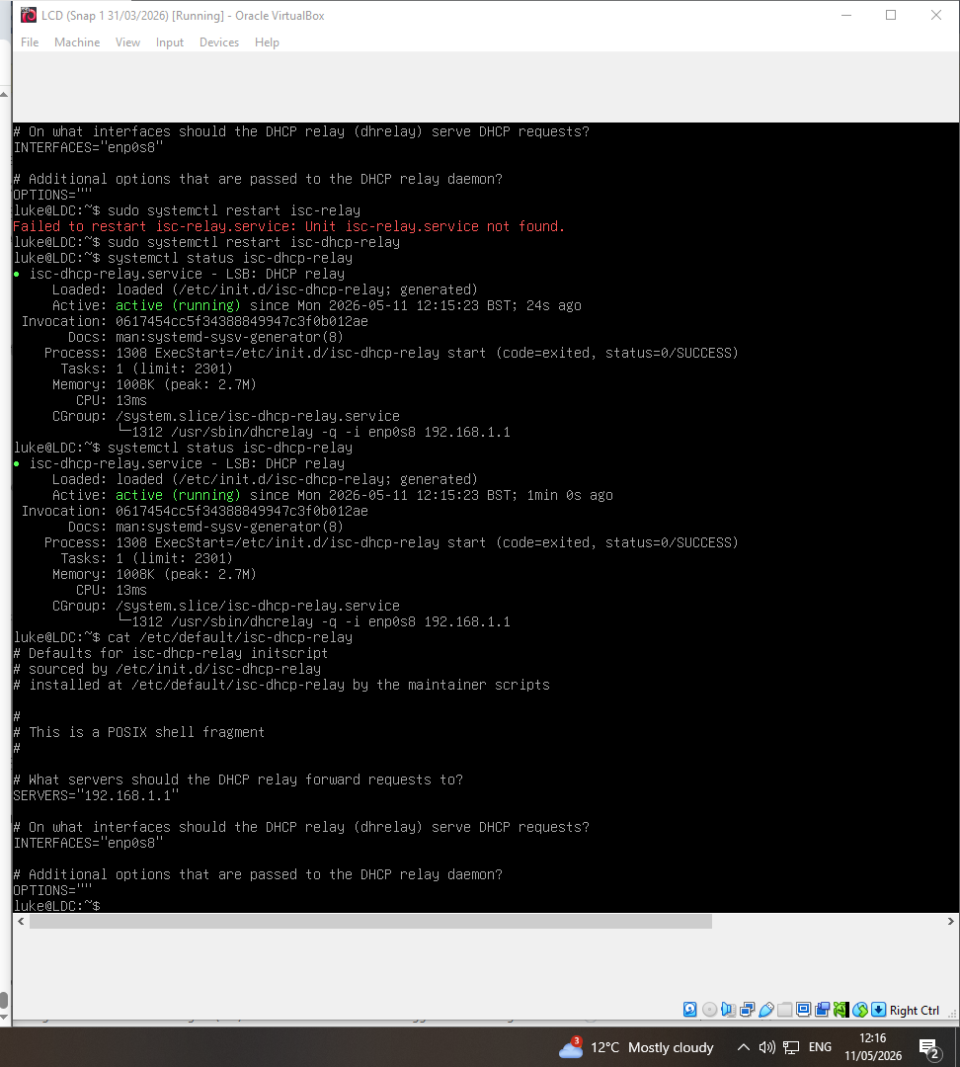

Following screenshots show the testing part of the brief

Screenshot 33: Ping s-dc
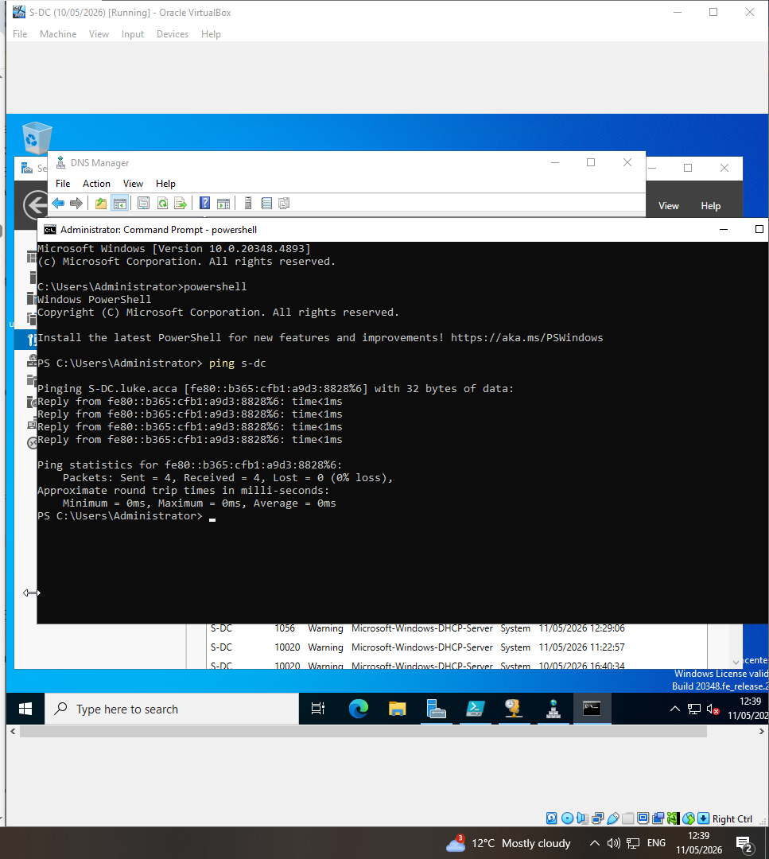

Screenshot 34: ping l-dc
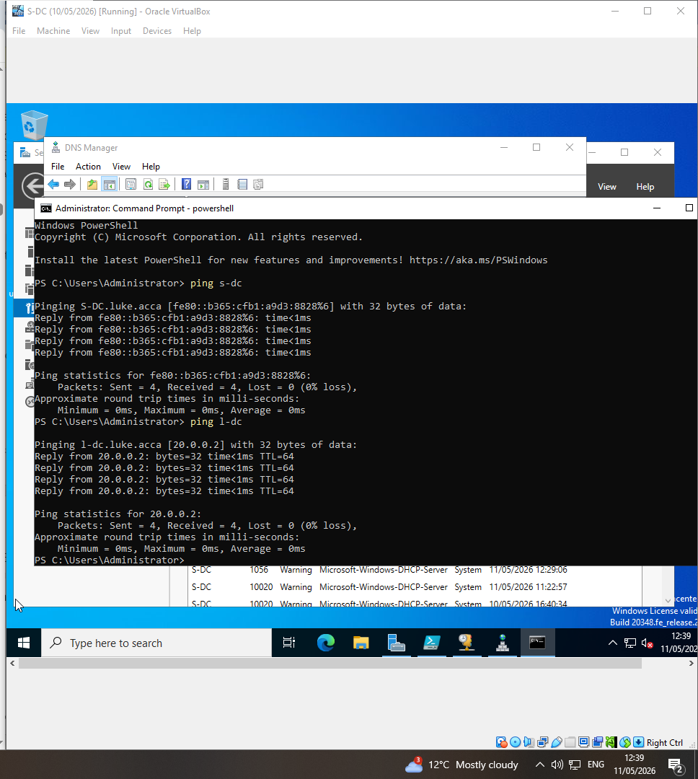

Screenshot 35: ping s-client
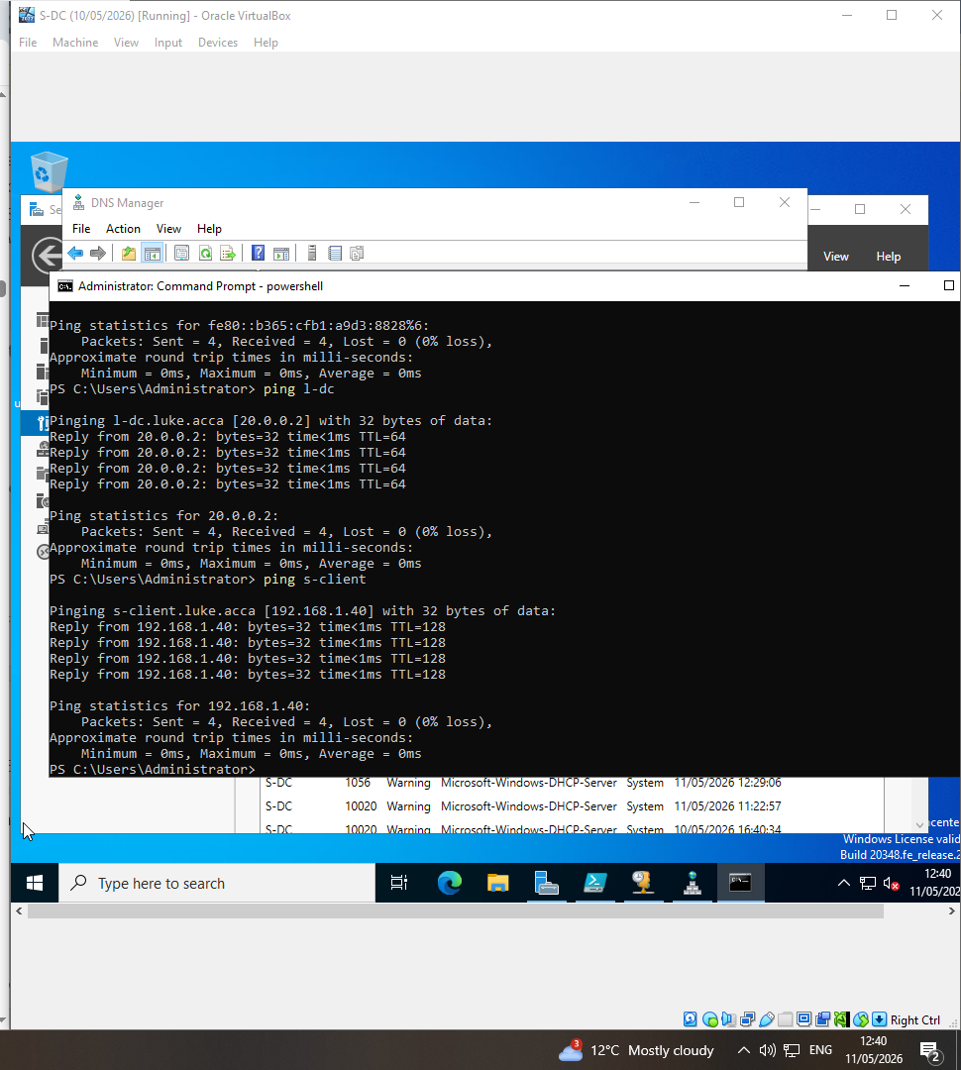

Screenshot 36: DNS test
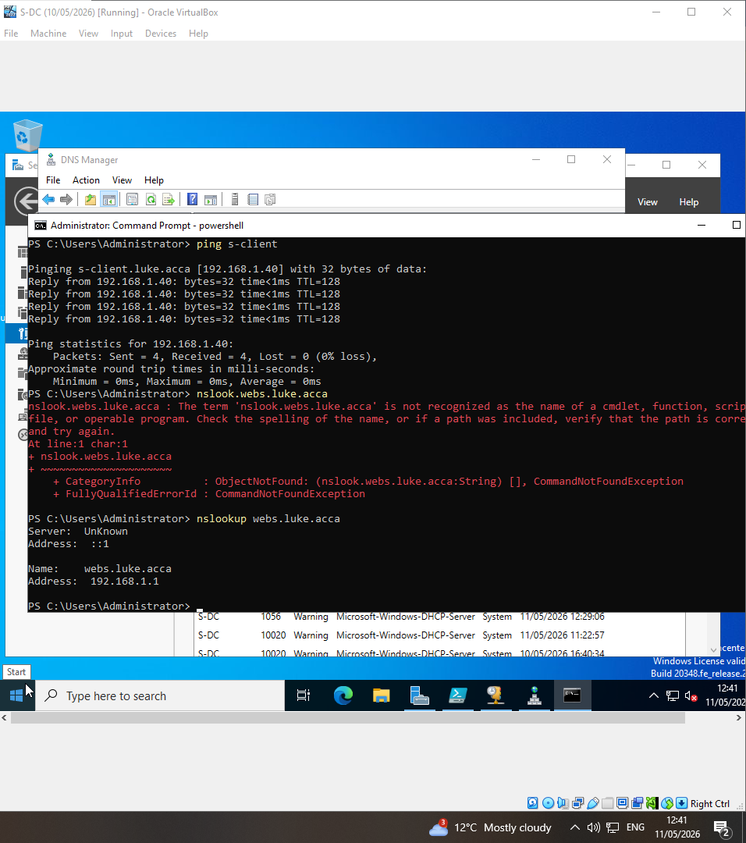
Screenshot 37: IIS website
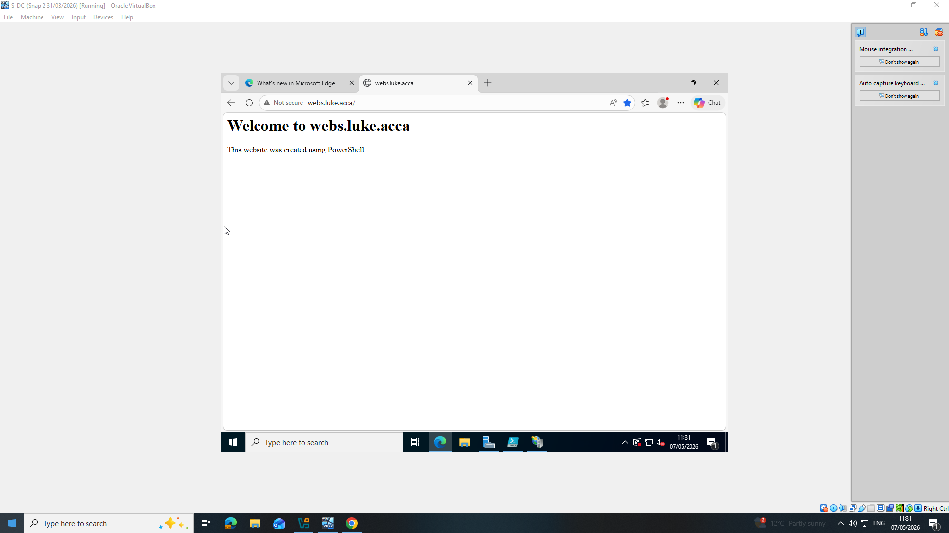

IIS website

Screenshot 38: IIS Manager
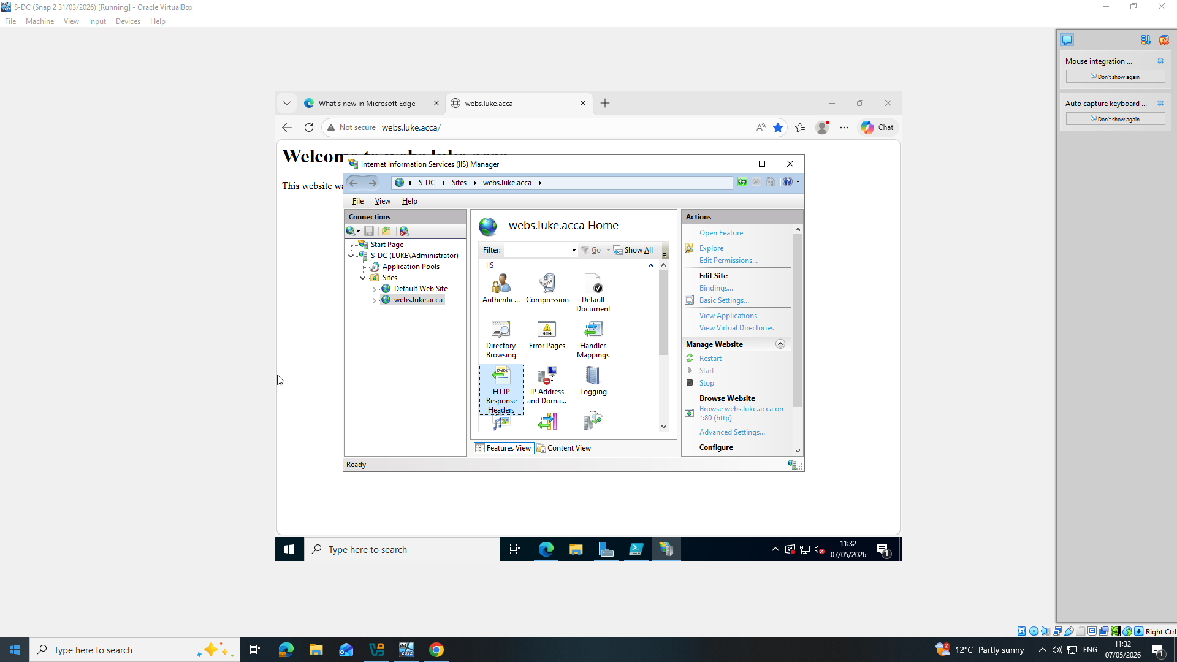

Screenshot 39: IIS manager authentication Tab
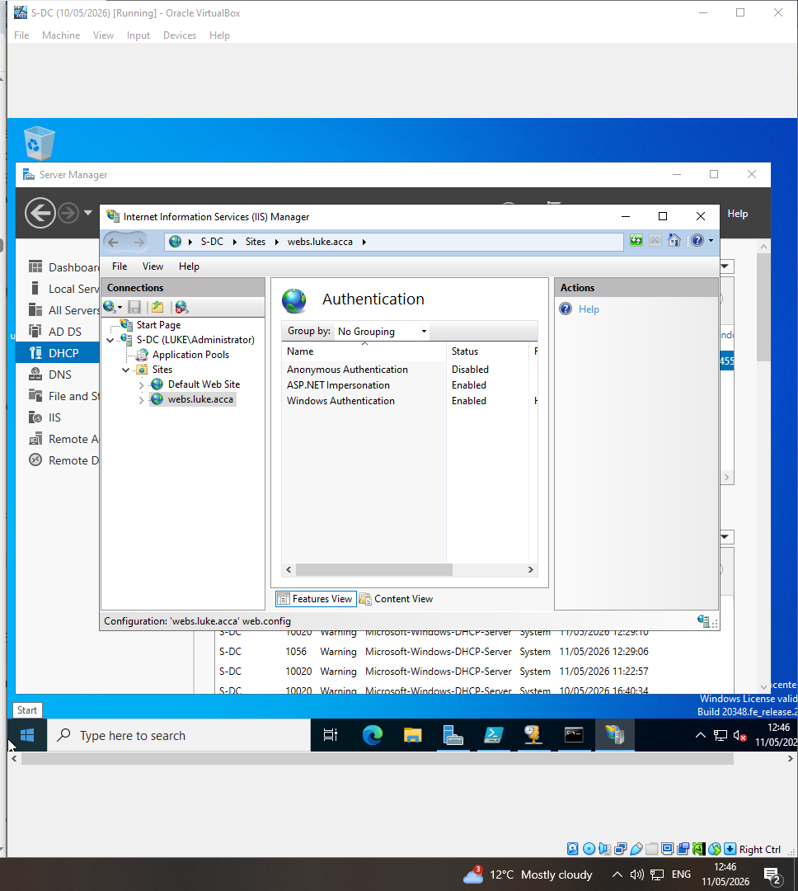
S

Screenshot 40: Remote desktop service overview
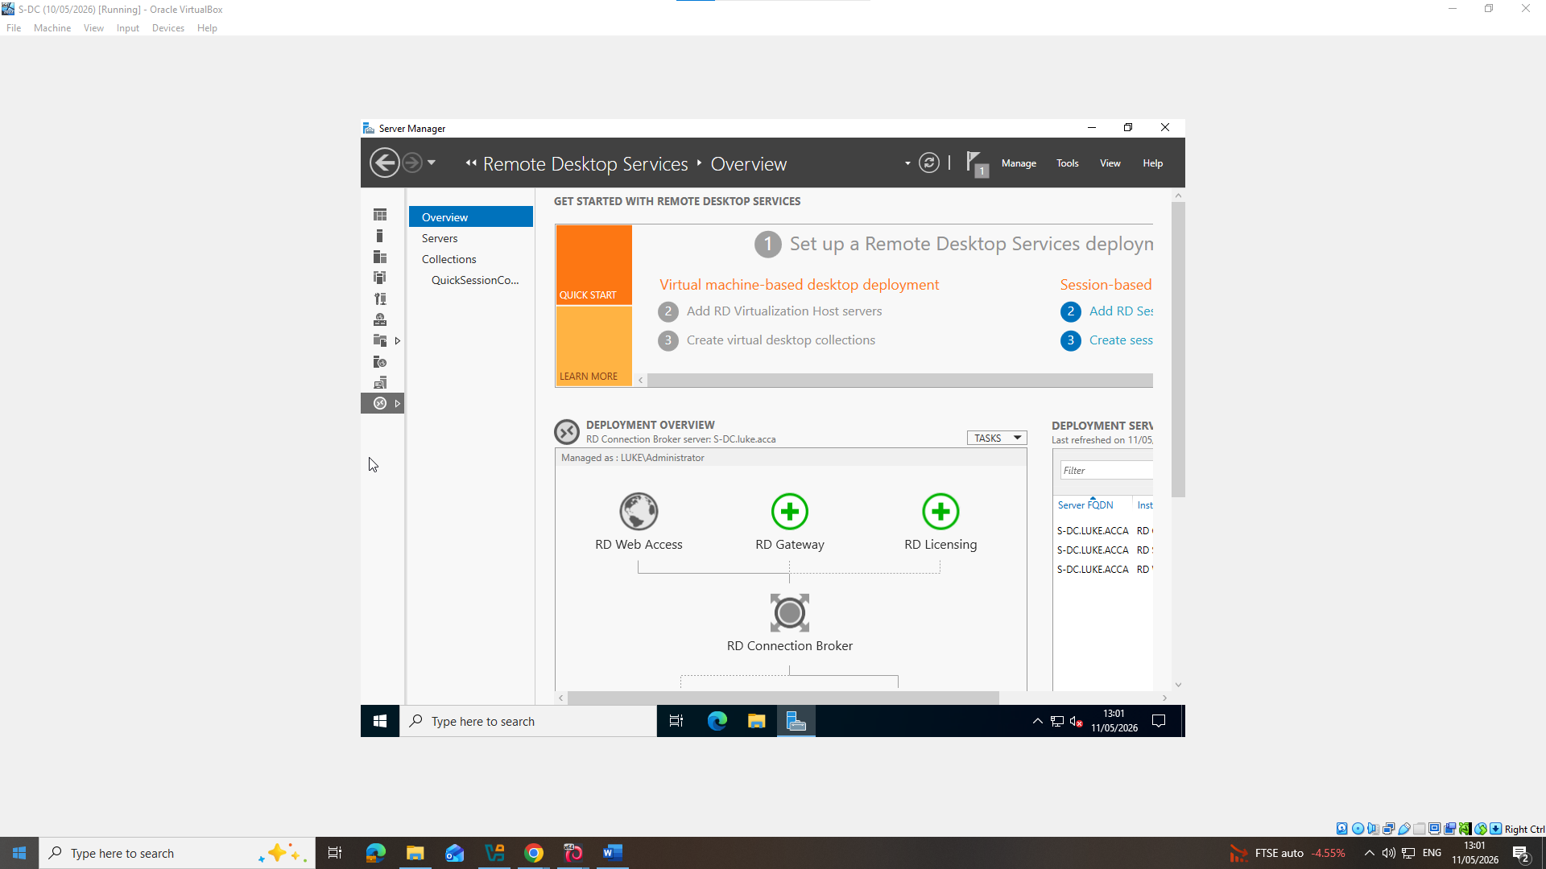
Screenshot 41: Remote Desktop enabled
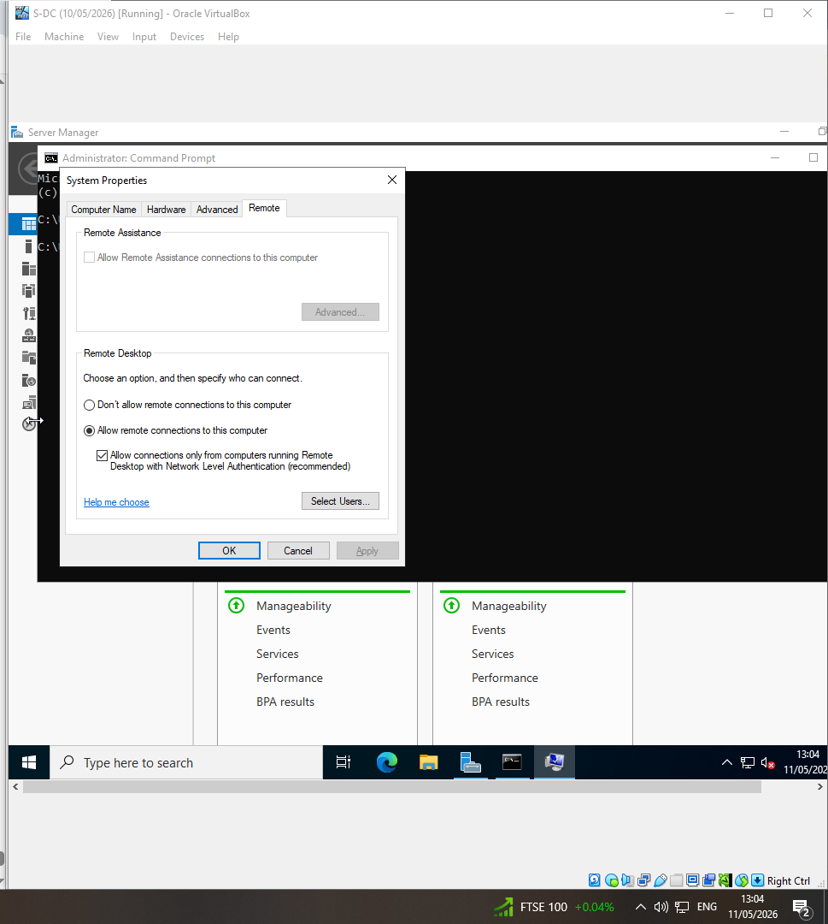

Screenshot 42: connecting to the windows S-DC server using remote desktop access on my S-Client machine.
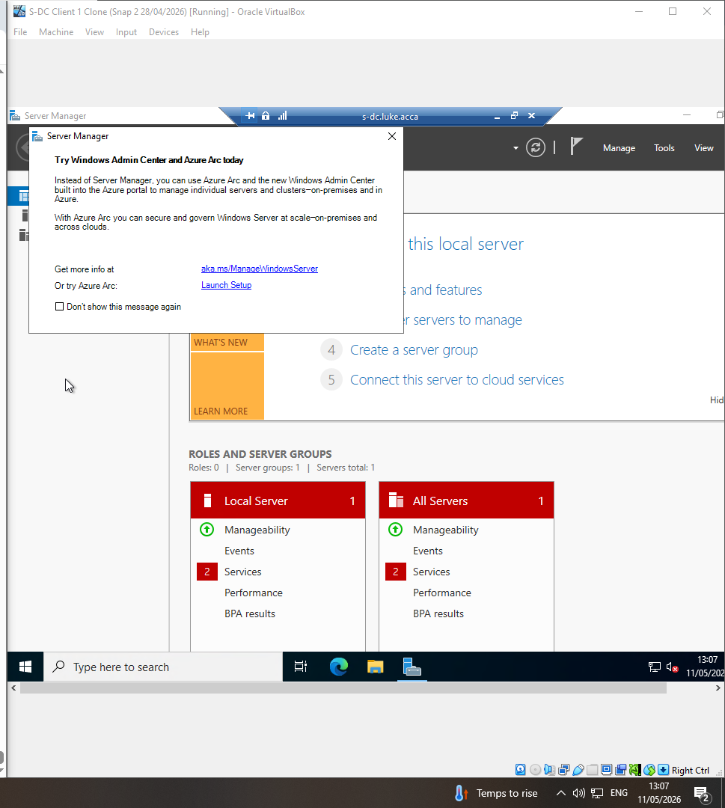

Screenshot 43: Remote Desktop Web access HTTPS enforcment
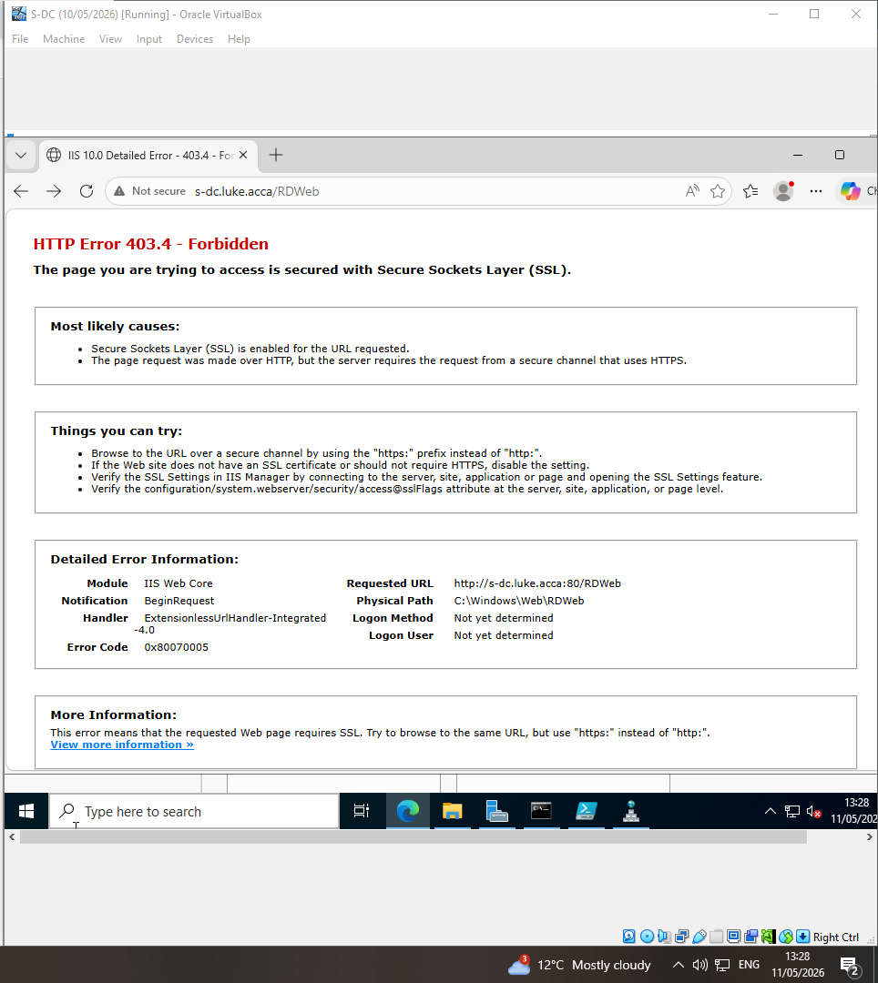

Screenshot 44: E drive shown
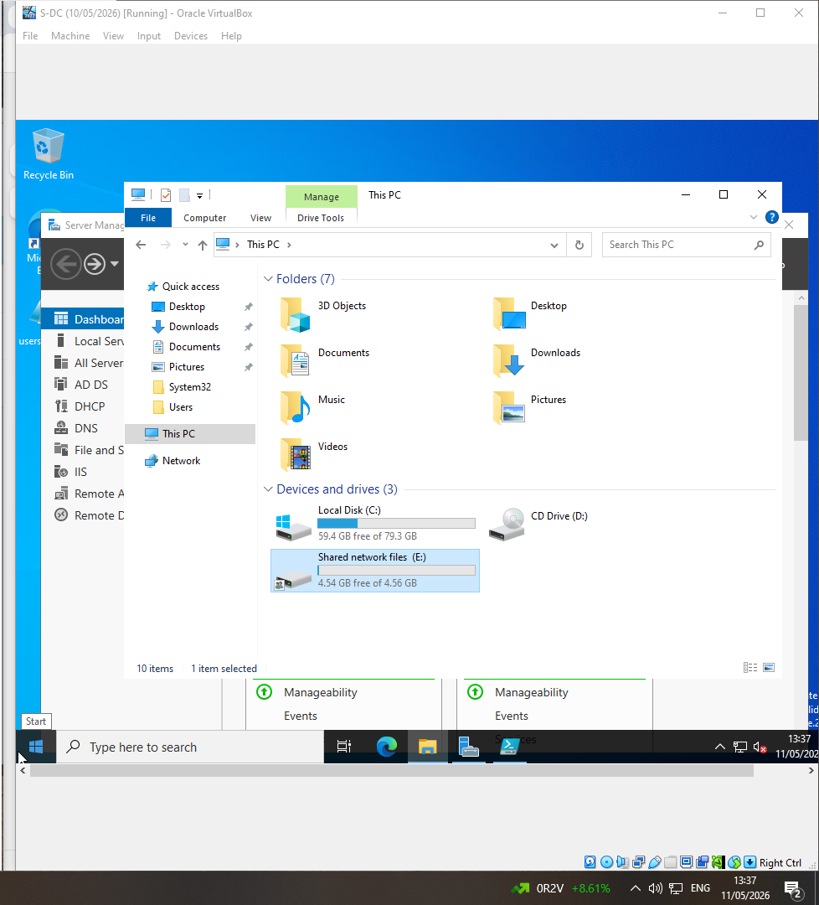

Screenshot 45: Swansea files
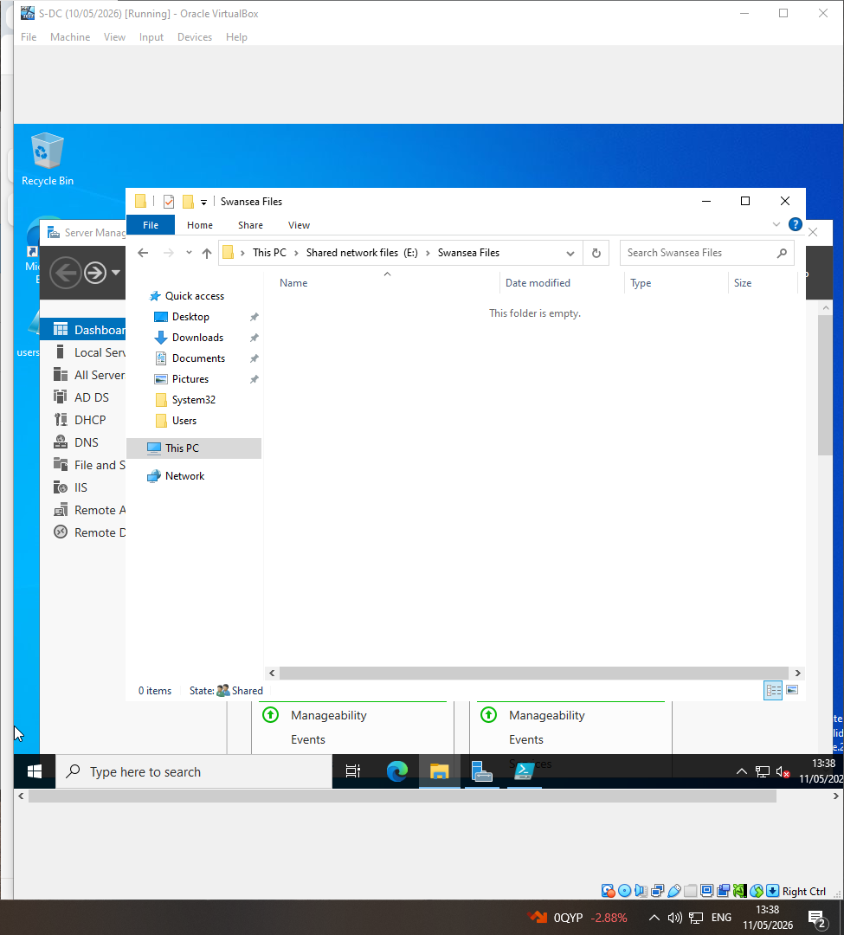
Screenshot 46: Swansea files sharing
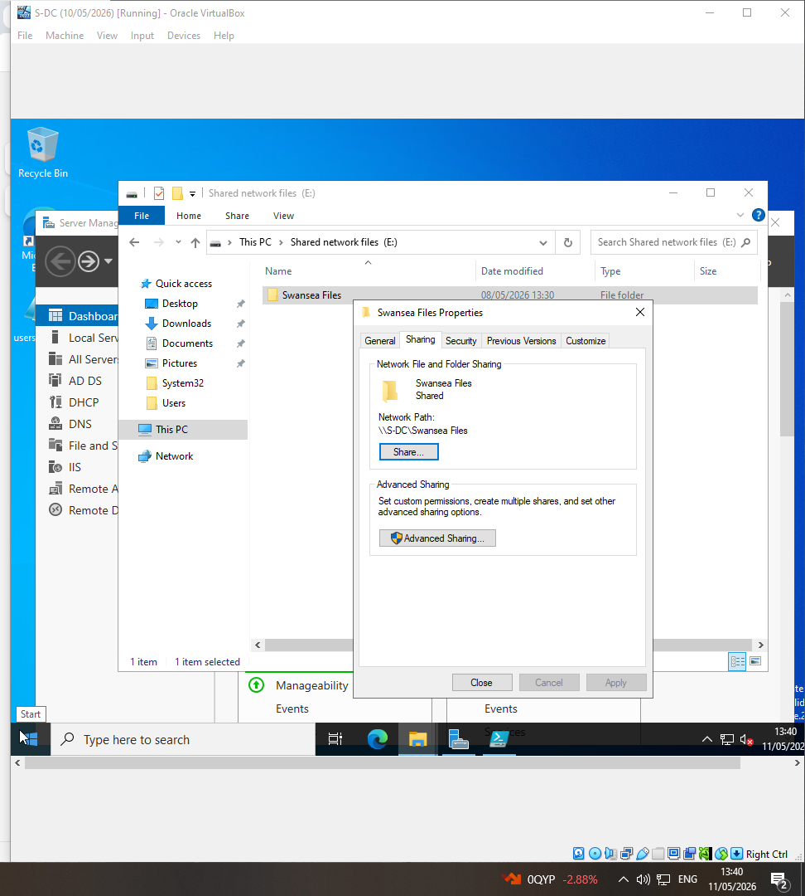
Screenshot 47: sharing permissions; Domain users have full control.
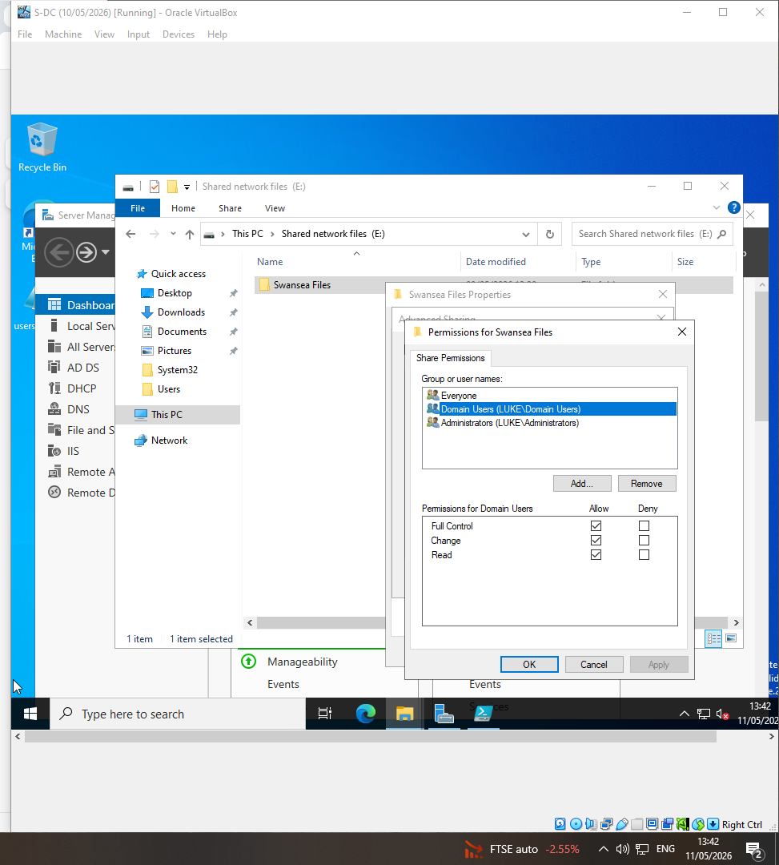

Screenshot 48: Security tab showing who has access to the E/ disk
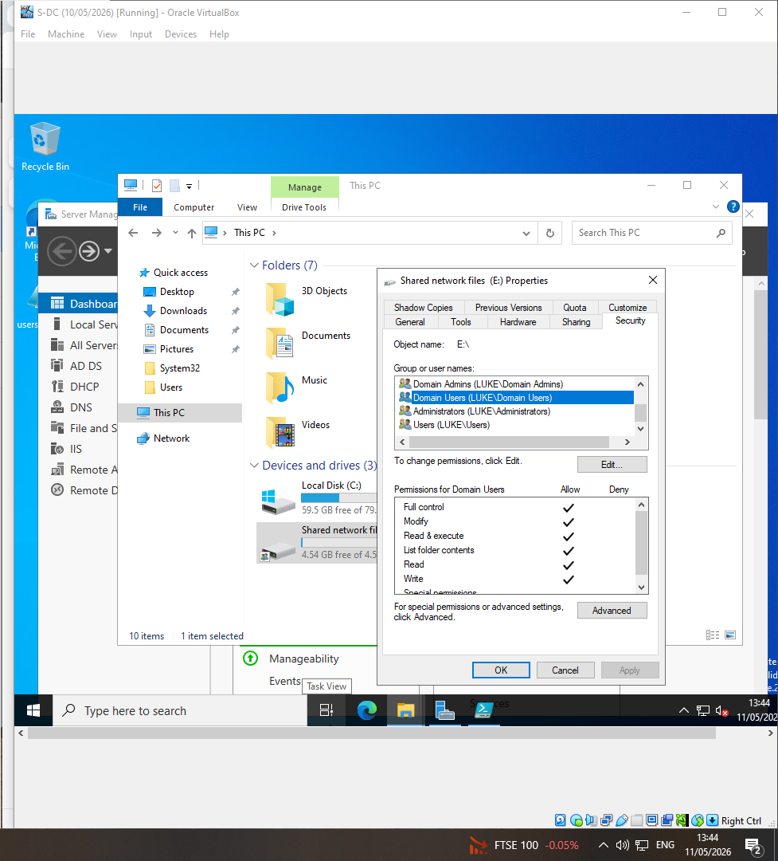

Screenshot 49: Advanced sharing tab on the e/ disk


