

Accounting Fundamentals
Coursework: Essay

Module Code:LCBB4001
Lecturer: Nadeem Mirza
Student Name: Roman Grigoriev
Student ID:2229684

Table of contents
Introduction………………………………………………………………………………........3
QUESTION 1:- Analysis of given statements. 3
Comment 1:- 3
Comment 2:- 3
Comment 3:- 4
Comment 4:- 4
Comment 5:- 4
Comment 6:- 5
QUESTION 2:- Preparation of P&L statement of Wales plc. 5
QUESTION 3:- Preparation of financial ratios of Sweets plc. 7
a. ROCE:- 7
b. ROE:- 8
c. Earnings per share:- 8
d. Net profit margin:- 9
e. Asset turnover:- 9
f. Stock holding days:- 10
g. Debtors collection period:- 10
h. Current ratio:- 11
i. Gearing ratio:- 11
j. Interest cover:- 12
Analysis of the financial position of the company. 12
Conclusion 13
Reference List 14

Introduction
This project aims to analyze different prospects of accounting. For that cause, different kinds of concepts and theories of accounting will be discussed in the first core section of the study. This will also include a discussion about the purity of the given statements. In the next core section, the analysis of the financial statement of Wales plc will be done. It means that in this segment the analysis of the income statement of Wales plc will be done. After that, the analysis of different kinds of financial ratios will be done. These ratios aim to estimate the financial health of Sweet plc company in the given financial year.

QUESTION 1:- Analysis of given statements.

Comment 1:-
The statement of financial position is all about the financial statement, which is meant to track the change in the financial position of a company. In simpler words, this statement is meant to demonstrate the year-end balance of the assets, liability, and owner fund of a company at the end of an accounting year. This statement of finance is also commonly known as a balance sheet statement. Due to that fact, this statement provides a snapshot of the financial health of a firm in a year-ending position. However, this statement is not capable of demonstrating the change in the cash balance of an organization. This task is done by using the statement of cash flow. In simpler words, the cash flow statement is responsible for demonstrating the change in the cash balance in an organization (Schwab, 2023). Due to that, the provided statement is not true.

Comment 2:-
The term non-current assets refers to the resources of an organization, which are not easily convertible in cash. In simpler words, the non-current assets are the business assets that cannot be converted into ash within a single financial year (Xero, 2023). These kinds of investments are also meant for generating income for an organization. Some of the fixed assets of an organization are long-term investments, cars, machinery, and many more. The aspect of copyrights is also a part of the fixed assets of an organization. This kind of resource is placed on the assets side of the balance sheet statement. Many different fixed assets are immovable such as buildings, plants, and many more. However, different kinds of fixed assets can easily move such as cars. Due to that reason, the statement that is made in this segment is partially true.

Comment 3:-
Financial accounting has many different users in the business environment. In simpler words, an organization has to publish its financial statement in the market to give details of its financial status at the end of a certain period. These parties are known by the stakeholders of an organization. This can also be segmented into internal and external stakeholders of the business (Sherman, 2019). The internal stakeholders are parties that directly work for an organization. On the other hand, the external stakeholders are the parties that do not directly work for an organization. Some of them are investors, suppliers, government, lenders, and many more (Luca, 2008). Those parties can use the financial statements of an organization to understand different aspects of the financial status of an organization. For example, the government body is using financial information to charge income taxes. Due to that cause, the managers have to present their financial status to all the business stakeholders.

Comment 4:-
The aspect of accrual accounting is one of the important financial concepts. Under this concept, the accruals and prepayments of the financial transactions are recorded in the current books of accounting. It means that the financial transactions have to be recorded in the period of occurrence (Tiron-Tudor, 2017). Due to that fact, this type of accounting is different from cash-based accounting, where the business transactions are recorded at the time of the cash transaction. This kind of business accounting is essential for anticipating the financial revenue of an organization (Schmidt, 2023). This accounting principle is also essential for anticipating the future expenditures of an organization. Due to that fact, this kind of accounting is essential for an organization. From this statement, it can be concluded that the analysis of the accrual and prepaid are an essential part of financial accounting. This is necessary for estimating the future income and debts of an organization.

Comment 5:-
The regulation in financial accounting is also one of the essential factors. This means that financial regulations can set guidelines that can be followed by an organization for preparing financial statements (Degirmenci, 2021). Due to that the financial guidelines are essential for preparing the accounting statements. One of the key impotence of the aspect is to maintain the integrity of the accounting process. In simpler words, the accounting guidelines are helpful for accountants to maintain integrity in the process of accounting statement preparation (Gummi, 2015). This aspect an also helpful for preventing accounting misconduct. Due to that, the aspect can also help increase the reliability of accounting statements. This aspect can also be helpful for the accounting world in maintaining a standardized accounting process. Due to that, this can also improve the comparability of the financial statements. Due to that the given statement in this segment is not true.

Comment 6:-
The aspect of the trial balance is all about the financial statement, which is made for summarizing the closing balance of all the general ledgers of the book of accounting. The aim of this is to ensure the accounting purity of the financial accounting in the primary book of accounting. For that reason, this statement is important before preparing the final accounts of an organization. This statement is also meant to ensure whether or not an organization properly maintains the double-entry bookkeeping system. This statement is also divided into two different sides (Team, 2023). Those are the debit and credit sides (Gurskaya et al., 2020). The accounting process of the general ledger is also essential for a company. This is meant to separate the business transactions into different sections. In simpler words, this statement is meant to provide the records of all the financial transactions. This information is used for preparing the statements of accounting. Due to that fact, the given statement of this segment is true.

QUESTION 2:- Preparation of P&L statement of Wales plc.
The aspect of profit and loss statement is all about a set of records that are used for measuring the net earnings of the business. In simpler words, the aspect of the income statement is calculated by the accountants to understand the profit earned by an organization after a certain period (Obasi and Ekweme, 2009). This statement is also one of the key reports of accounting. The statement also distributes the debts and overheads of an organization in different segments (Fuadi et al., 2022). This statement also contains many different advantages for the users. Some of them are presented below.
- One of the primary advantages of the P&L statement is to evaluate the financial performance of an organization. In simpler words, the statement of income can categorize the overheads and expenses of a business (Affinity, 2023).
The preparation of this statement for Wales Plc is done below.
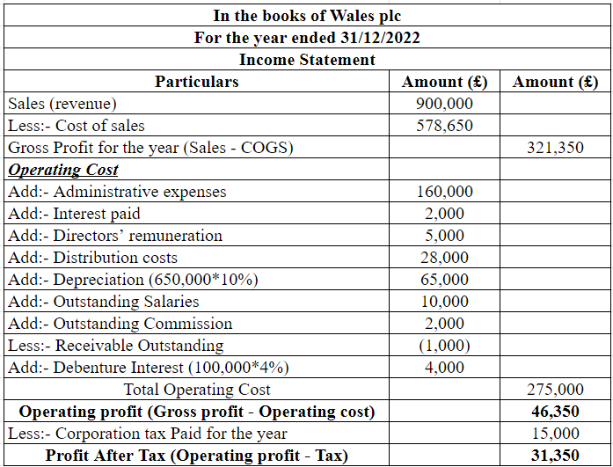
Table 1:- Calculation of P&L account for Wales Plc.

In the above statement of accounting the analysis of the net profit earned by the company is done. From the detailed analysis of the statement, the total profit earned by the company at the end of the 2022 financial year is about 31,350 pounds. Detailed workings of the statement are done below.
Workings:-
Estimation of gross profit for the year:- The gross profit value can be estimated by calculating the difference between the values of sales and direct costs such as cost of sales. In this case, the company has generated sales of about £900,000, and the value of the cost of sales of the company is about £578,650. From that the value of gross profit for the year is (£900,000 - £578,650) = £321,350.
Estimation of operating profit:- The general approach to calculating the operating profit is to deduct the value of operational overheads from the pre-calculated gross profit value. In this scenario, Wales Plc has the Σ of Operating overheads worth £(160,000 + 2,000 + 5,000 + 28,000 + 65,000 + 10,000 + 2,000 + (1,000) + 4,000) = £275,000. From that, the total value of the operating profit of the company is about (£321,350 - £275,000) = £46,350.
After that, the value of the tax is deducted from the value of the operating profit of Wales Plc to estimate PAT value. The calculation of this is (£46,350 - £15,000) = £31,350.

QUESTION 3:- Preparation of financial ratios of Sweets plc.
The analysis of the financial ratios of Sweet Plc is done below.

ROCE:-
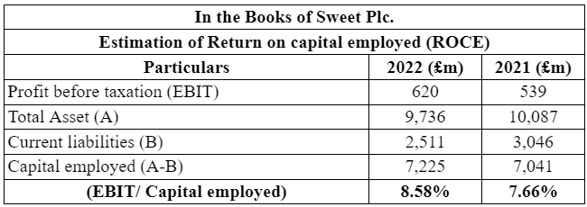
Table 2:- Calculation of ROCE.

This above ratio is meant to demonstrate the ability of a business to generate profit for an organization. This ratio is also categorized as one of the key statements for measuring the profitability of an organization (Team, 2023a). This ratio is usually utilized by investors to understand the possibility of return on investing in an organization. The formula of this ratio is (EBIT/ Capital employed)%. In this case, the value of the ROCE is about 8.58 percent in the 2022 financial year, and 7.66 percent in the 2021 financial year.

ROE:-
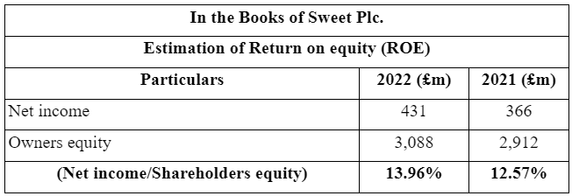Table 3:- Calculation of ROE.

The aspect of ROE is also one of the key ratio analyses for the investors of an organization. This calculation aims to compare the total income of an organization with the value of net equity. A higher percentage of the ROE indicates that an organization has more capability of generating profit for its stakeholders. Due to that, this ratio is calculated by the investors to understand the value of revenue earnings. In this case, Sweet plc has an ROE percent in 2022 is about 13.96%. In 2022 the value of this ratio was 12.57%.

Earnings per share:-
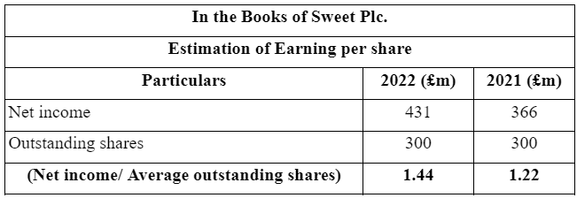
Table 4:- Calculation of EPS.

The analysis of the EPS is also one of the key analyses of the business profitability. In simpler words, this ratio is meant to calculate the total value of profitability in an organization. This calculation is done by (The net earnings of the business/ Average shares) (Gartner, 2023). In this case, the value of EPS in the 2022 and 2021 financial years were 1.44 and 1.22.

Net profit margin:-
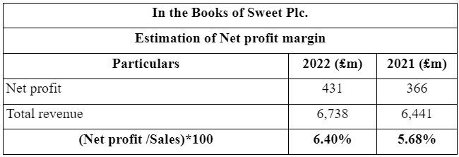
Table 5:- Calculation of NP ratio.

The analysis of the net profit ratio is one of the key profitability ratio analyses. This is done to understand the profit-earning capability of a business in comparison to the sales. The formula for this aspect is (Net earnings after tax/ Net revenue)% (Bragg, 2023). In this scenario, the value of the NP ratio of Sweet Plc in 2022 and 2022 is 6.40 percent and 5.68 percent.

Asset turnover:-
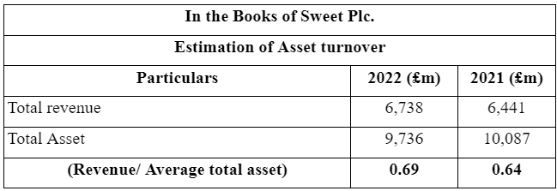
Table 6:- Calculation of Assets turnover ratio.

This ratio represents the way to determine the ability of an organization to generate efficient income by using its assets. In simpler words, this ratio is meant to evaluate the efficiency of an organization in generating sales and income by using its resources. The formula for this is (Revenue/ Σ of assets) (Luther, 2022). From the above table, the value of this ratio is 0.69 (in 2022), and 0.64 (in 2021).

Stock holding days:-
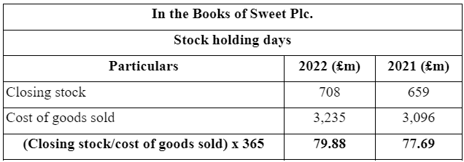
Table 7:- Calculation of Stock turnover ratio.

This ratio is meant to demonstrate the holding period of stock before using it to generate income. In simpler words, this ratio is made to show the days of inventory holding before selling them (Luther, 2022). In this table, the inventory days of Sweet plc in 2022 were 79.88 days, and in 2021 it was 77.69 days.

Debtors collection period:-
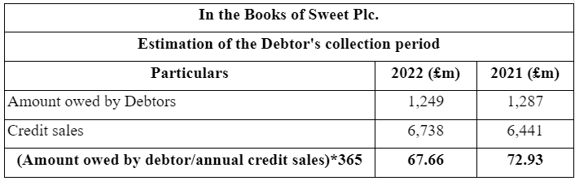
Table 8:- Calculation of Debtors turnover ratio.

This ratio is meant to demonstrate the average collection period from the debtors of a company. In simpler terms, this ratio can demonstrate the total number of times a company receives its payment from its debtors. The formula for the calculation is (Tread receivables/ Credit sales) (Luther, 2022). In this table, the debtor days of Sweet plc in 2022 were 67.66 days, and in 2021 it was 72.93 days.

Current ratio:-
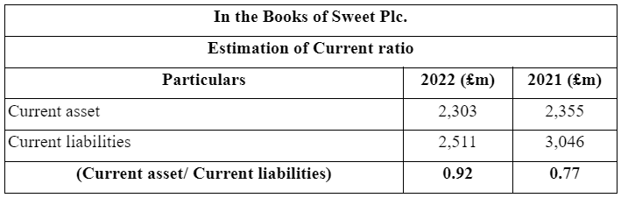
Table 9:- Calculation of Current ratio.

This ratio is estimated by an organization to understand its ability to meet its short-term debts. Due to that fact, this calculation is necessary for an organization, which can be done by comparing the Σ of current assets and Σ of current debts and liabilities. The formula for this is (Current resources/ Current debts) (Rochim and Ghoniyah, 2017). In this table, the current ratio of Sweet plc in 2022 was 0.92, and in 2021 it was 0.77.

Gearing ratio:-
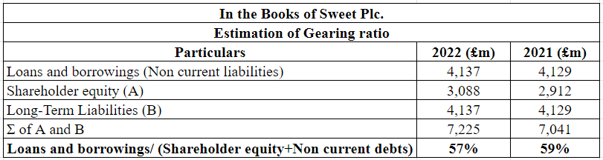
Table 10:- Calculation of Gearing ratio.

The above figure has been prepared for evaluating the gearing ratio of the sweet plc. The ratio is part of the financial ratio. The ratios are evolved by the company to measure their profitability in the company (Harris and Mawardi, 2023). From the analysis, it has been found that the company ratio has increased from the previous year. The ratio in 2022 is 57%.

Interest cover:-
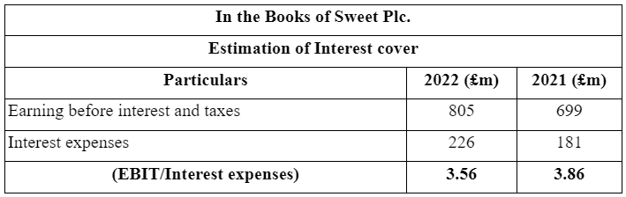
Table 11:- Calculation of interest cover ratio.

This ratio is made to understand the ability of an organization to meet its payments of interest. It also means that this calculation can analyze the capability of an organization to pay its interest debts, which are part of the business liabilities. The formula for this calculation is (EBIT/ Interest). In this table, the interest ratio of Sweet plc in 2022 was 3.56, and in 2021 it was 3.86.

Analysis of the financial position of the company.
Particulars | 2022 (£m) | 2021 (£m) | Comment
ROCE | 8.58% | 7.66% | Increased in the current year.
ROE | 13.96% | 12.57% | Increased in the current year.
Earnings per share | 1.44 | 1.22 | Increased in the current year.
Net profit margin | 6.40% | 5.68% | Increased in the current year.
Asset turnover | 0.69 times | 0.64 times | Decreased in the current year.
Stock holding days | 79.88 days | 77.69 days | Decreased in the current year.
Debtors collection period | 67.66 days | 72.93 days | Increased in the current year.
Current ratio | 0.92:1 | 0.77:1 | Increased in the current year.
Gearing ratio | 57% | 59% | Increased in the current year.
Interest cover | 3.56 | 3.86 | Decreased in the current year.
In the above statement of Sweet Plc, it can be seen that the efficiency of the company has increased in the debtor's collection period. Due to that, the company can effectively collect funds from the debtors of the company in 2022. However, the inventory turnover will increase in 2022. Due to that, the company has to hold its inventory for a longer period. The current ratio of the company also improved in the 2022 financial year.

Conclusion
This study concludes that the analysis of the different kinds of financial statements was completed in the second and third core sections. The analysis of the different kinds of concepts of accounting was discussed in the first core section of the project. From the analysis of the P&L statement of Wales Plc, the company generated profit in the given financial year. The comparison of the results of ratios of Sweet Plc was also discussed in the last core section.

Reference List
Affinity. (2023) What is an income statement and why it is so important? [2023], Affinity Associates Limited. Available at: https://www.affinityassociates.com/what-is-an-income-statement-why-it-is-so-important/ (Accessed: 28 November 2023).
Bragg, S. (2023) Net profit ratio, AccountingTools. Available at: https://www.accountingtools.com/articles/net-profit-ratio (Accessed: 28 November 2023).
Degirmenci, A. (2021) What is financial regulation and why is it important?, Leasing Life. Available at: https://www.leasinglife.com/industry-news/what-is-financial-regulation/?cf-view (Accessed: 28 November 2023).
Fuadi, M.Z., Brusa, J.O., Ilham, R.N. and Sinta, I., (2022). ANALYSIS OF COMMON SIZE PROFIT AND LOSS STATEMENTS PT. SIANTAR TOP PERIOD 2020-2021. Journal of Accounting Research, Utility Finance and Digital Assets, 1(2), pp.154-160. http://jaruda.org/index.php/go/article/view/25.
Gartner. (2023) Definition of earnings per share (EPS) - gartner finance glossary, Gartner. Available at: https://www.gartner.com/en/finance/glossary/earnings-per-share-eps- (Accessed: 28 November 2023).
Gummi, M.U., (2015). Financial regulations and Nigeria’s banking sector. Journal of Research in Business and Management, 3(11), pp.5-13. https://www.researchgate.net/profile/Umar-Muhammad-Gummi/publication/325551714_Financial_regulations_and_the_Nigeria's_banking_sector/links/5c0fa8f7a6fdcc494febf882/Financial-regulations-and-the-Nigerias-banking-sector.pdf.
Gurskaya, M., Kuter, M. and Bagdasaryan, R., (2020), May. The structure of the trial balance. In International Conference on Integrated Science (pp. 103-116). Cham: Springer International Publishing. https://link.springer.com/chapter/10.1007/978-3-030-22493-6_11.
Harris, R.M. and Mawardi, W., (2023). The Influence Of NPF, Bopo, Current Ratio and Gearing Ratio On Financing Company Performance (Comparative Study Of Financing Companies In Indonesia Before and During The Covid-19 Period). Jurnal Ilmiah Sosial Teknik, 5(2), pp.132-145. https://jurnalequivalent.id/index.php/jequi/article/view/144.
Luca, M., (2008). Regarding the users of financial statements and their information needs. Studies and Scientific Research. Economics Edition, (13), pp.49-55. http://sceco.ub.ro/index.php/SCECO/article/view/17.
Luther, D. (2022) Top efficiency ratios: Operational, asset, inventory and more, Oracle NetSuite. Available at: https://www.netsuite.com/portal/resource/articles/accounting/efficiency-ratios.shtml (Accessed: 28 November 2023).
Obasi, R. and Ekweme, M., (2009). Thematic Analysis of Income Statement. Available at SSRN 2062510. https://papers.ssrn.com/sol3/papers.cfm?abstract_id=2062510.
Rochim, R. and Ghoniyah, N., (2017). Analysis of the effect of current ratio, cash flow from operation to debt, firm size and return on equity on stock return. IJIBE (International Journal of Islamic Business Ethics), 2(3), pp.41-51. http://jurnal.unissula.ac.id/index.php/ijibe/article/view/4302.
Schmidt, J. (2023) Accrual accounting, Corporate Finance Institute. Available at: https://corporatefinanceinstitute.com/resources/accounting/accrual-accounting-guide/ (Accessed: 28 November 2023).
Schwab. (2023) 3 financial statements to measure a company’s strength, Schwab Brokerage. Available at: https://www.schwab.com/learn/story/3-financial-statements-to-measure-companys-strength (Accessed: 28 November 2023).
Sherman, F. (2019) Who are the internal & external users of a company’s financial statements? Small Business - Chron.com. Available at: https://smallbusiness.chron.com/internal-external-users-companys-financial-statements-70132.html (Accessed: 28 November 2023).
Team, C.F.I. (2023) Trial balance, Corporate Finance Institute. Available at: https://corporatefinanceinstitute.com/resources/accounting/trial-balance/ (Accessed: 28 November 2023).
Team, C.F.I. (2023a) Return on capital employed (ROCE), Corporate Finance Institute. Available at: https://corporatefinanceinstitute.com/resources/accounting/return-on-capital-employed-roce/ (Accessed: 28 November 2023).
Tiron-Tudor, A., (2017). Accrual accounting. Global Encyclopedia of Public Administration, Public Policy, and Governance, pp.1-6. https://www.researchgate.net/profile/Adriana-Tiron-Tudor/publication/315831286_Accrual_Accounting/links/622eeed697401151d218df6a/Accrual-Accounting.pdf.
Wall Street Prep. (2023) Interest coverage ratio (ICR), Wall Street Prep. Available at: https://www.wallstreetprep.com/knowledge/interest-coverage-ratio/ (Accessed: 28 November 2023).
Xero. (2023) What are non-current assets? Xero. Available at: https://www.xero.com/us/glossary/non-current-assets/ (Accessed: 28 November 2023).

