

MARKETING MANAGEMENT ASSESSMENT 1

LECTURER: TUSHARA BALENDRAN
STUDENT NAME: MANAV AKSHAY GANDHI
STUDENT ID: - 2225500
MODULE: - LCMB7001

Table of Contents

- Introduction 4
- Communication 5
  - Shannon-Weaver communication model 5
- Integrated marketing communication 8
- New promotional strategies for Tesco 8
  - Online promotion 9
  - Offline promotion 9
- Branding and brand equity 9
  - Branding 9
  - Brand equity 10
- Keller’s brand equity model 10
  - Advantages of Keller’s brand equity model 12
  - Demerits of Keller’s brand equity model 13
- Customer Journey 13
- Customer touch points 14
  - Pre-purchase 14
  - Purchase 14
  - Post-purchase 14
- Customer journey map 15
  - Critical evaluation of the customer journey map of Tesco 15
  - Strengths of the customer journey map of Tesco 16
  - Weakness of the customer journey map of Tesco 16
- Total engagement model 16
- Recommendations 17
- Conclusion 17
Reference List 18

Introduction

Every business organization has to experience different types of challenges and opportunities in a competitive and crowded Marketplace. Some of the crucial challenges in the modern changing business environment include the continuously increasing popularity of digitalization, increasing brand loyalty and brand awareness, managing brand reputation, increasing expectations of the consumers, information management and several others. To maximize the satisfaction of customers business organizations have mostly emphasized touch points but by doing so it can divert their attention from the most important issue which is the end-to-end journey of the customer. Keeping this fact in mind the present study will critically analyze the way one of the famous retail companies in the UK named Tesco can create innovative marketing strategies today is brand awareness along with managing customer journeys across several communication channels.
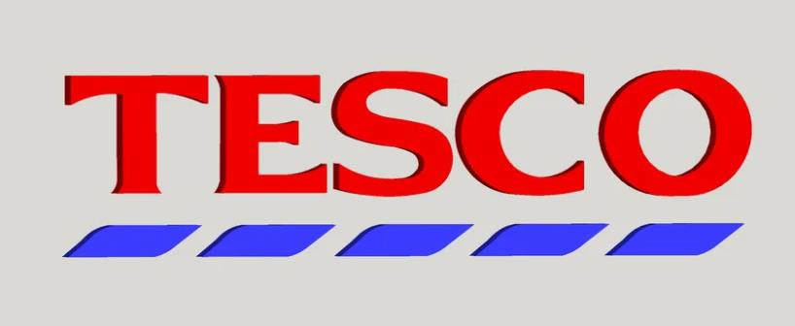

Figure1: Company Logo
(Source: tesco,2023)

Tesco is a popular multinational retail company in the UK which has its headquarters situated in England. The company has expanded its business in the international market since the year 1990 and currently, it has been operating in approximately 11 other countries than the UK across the whole world. At present the company has been offering a wide range of services including supermarkets, convenience shops, hypermarkets, superstores and several others (Tesco,2023). According to the recently revealed annual reports it has been noticed that in the year 2022, the company earned annual revenue of approximately 61 billion British pounds along with an operating income of approximately 3 billion Pounds in same year.
almost 3 lakh employees are currently associated with this particular business organization across the whole world. The main divisions of this company include Tesco Stores Limited, Tesco Mobile, Tesco Ireland, Tesco Bank and many more.

Communication
In the context of business, communication can be described as a particular process of exchanging information and data between employees and people outside of the business organization. management authority and the employees of every business organization 10 to interact with each other through an effective channel of communication to accomplish predetermined organizational goals. The main objective of the communication process in every business is to reduce errors in organizational tasks along with enhancing the overall performance of the company. Communication can be broadly categorized into two types suggest direct communication and indirect communication.

Direct communication
Direct communication can be described as a particular way to convey transparent and clear instructions or messages. This involves sharing the feelings and thoughts of a particular individual without the possibility of confusing the other person. In the organizational Work place direct communicational way, she clarifying the point of view of the authority who has been giving instruction.

Indirect communication
By considering the indirect style of communication again this statement that this particular communication style tends to camouflage or hide the speaker's true intentions. More Specifically speaking, indirect communication is nothing but acting out rather than directly confusing the actual thoughts and the feelings of the individuals and the entire process of indirect communication is associated with different types of facial expressions, gestures as well as the tone of voice.

Shannon-Weaver communication model
This particular model is specifically designed for developing effective communication between the receiver and the sender. Shannon and Weaver had found the factors which have been affecting the entire process of communication and they have turned it into noise. The following diagram depicts the entire model. According to the basic approach of this particular model, it has been argued that human communication may be broken down into 6 fundamental concepts such as sender, encode channel, noise, Decoder and finally receiver. The developers of this particular theory have targeted the fundamental problem of communication which is associated with reproducing a particular message sent from a specific point either exactly or approximately to another different point
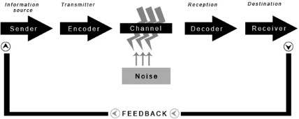

Figure2: Shannon-Weaver Model of Communication
(Source: Adamsetal. 2019)

Sender: A sender can be described as the main original particular message or information.
Encoder: An encoder can be described as a transmitter which has the capability of converting the message into some signal. This has to be noted in this context that the message sent by the Centre is converted into some signal such as binary data or waves which his highly compatible with transmitting messages through sate limescales. For example, in the case of the telephone, the voice of a human being is converted into some wave signals and then transmits through a cable line.

Decoder: As commented by Al-azzamand Al-Mizeed (2021), decoder can be described as the reception place of the signal which converts the signals into a particular message. more specifically speaking Decoder is just the opposite process of the encoder.

Channel: Channel can be referred to as a particular medium through which the data and information are transferred from sender to receiver. Some effective examples of channels can be email, movie, phone and several others.

Noise: The message is transferred from the encoder to Decoder through a particular channel. while the occurrence of this particular process the messages can be distracted or affected by some physical noise such as sounds of horns, crowd noise, Thunder and several others. Such kindofdestructionistermedasnoisewhichcanhampertheentiretransmissionprocessofdata along with deteriorating the quality of communication flow and it may so happen that the receiver finally gets a wrong message from the sender.

Receiver: According to Ali (2022), the receiver can be described as the final destination of the message sent from the center. Depending on the decoded message the receiver tends to give their feedback to the respective sender. In case the message has been used by the sender or the receiver has been distracted by some noise then this will affect the entire flow of communication between the receiver and the sender.
Moreover, this is to be remembered in this connection that the model is more effective in the case of a person-to-person communication in comparison to communication among a mass or group audience.

Integrated marketing communication

Integrated Marketing Communication can be described as a particular planning process which has been designed to assure the fact that all contacts of a brand received by an individual customer or some prospect of a product, service or business organization are highly relevant to that individual and will always be consistent over time. In other words, this can be described as a particular process through which a business organization can carefully integrate and coordinate all of its communication channels significantly to deliver a consistent, clear and compelling message regarding the respective business organization and the products and services offered by them to its customers. As stated by Bob et al. (2020), IMC may be associatedwithseveralcommunicationelementsofmarketingsuchassocialmediaplatforms, public relations, audience analytics, principles of business development, advertising and severalothers.Thisparticularapproachhasthecapabilityofallowingprivateandpublicsector businessorganisationstodeliveraseamlessandengagingcustomerexperienceforaparticular product or service to optimize the overall image of the company along with improving its relationship with the stakeholders.

New promotional strategies for Tesco

Tesco has strategically designed a significant personalised promotional and marketing policy to attract its target market. The existing advertisement and promotional tools used by this company include the presentation of high-profile meetings, conducting promotional events in premium hotels and many more. As commented by Deepak and Jeyakumar (2019), Recently thecompanyhasalsofocusedonsocialmediamarketingstrategyByusingseveralsocialmedia platforms such as Facebook, Instagram, YouTube, Twitter and several others. The company hasbeenregularlyprovidingseveralattractiveofferstotheirclientssuchas'buyonegetone”and many more. The company has also introduced an option of availing their club cards. The club card owners can get points which can be redeemed for climbing additional discounts on their next purchase. Sophisticated marketing and promotional strategies have helped the company terms of achieving and maintaining its leadership position in the retail market in the UK. Despite getting such success there are still many options to improve their promotional strategy in near future.

Online promotion

Video advertising can be considered to be as one of the latest trends which have been positively by most of the bigger companies across the whole world. Customers are observed to be more attracted towards video advertisements in comparison to any other advertisement categories. Tesco can consider the biggest video platform Youtube in this regard. As stated by Loxtonet al. (2020), the shorter the advertisements, the greater will be the reach of the customers in the modern times. Live-video streaming has become extremely popular these days.
According to Desai and Vidyapeeth (2019), personalized advertising is considered to be another effective form of promotional strategy through which the company can bring about changes in their product range based on the customers’ taste and preferences.

  - Offline promotion
Creating flyers and pamphlets can be considered an effective way of attracting new customers to Tesco and in those Pamphlets, the company can publish attractive offers and discounts on their products and services.

Branding and brand equity

Branding

As stated by Olson et al. (2021), branding can be described as a particular process of giving Specific meaning to a particular organisation, commodities or services by developing and shaping the respective brand in the mindset of the consumers. Simultaneously a brand can be described as a particular set of intangible and tangible attributes at developing identity and awareness as well as establishing reputational features of a specific product, place or a particular business organisation. Activities such as commodity innovation as well as Marketing Communication is undertaken for achieving these goals are termed branding.

Brandequity

In the context of marketing, brand equity is described as the net worth of a specific brand. In this case, the net worth implies the social value of a popular brand name. The actual owner of the popular brand name may generate more profitability and revenue simply from the respectivebrandrecognitionbecausetheconsumerstendtopursuethecommodityofthatbrand as better than those of less popularly known brands. As stated by Rosnizamet al. (2020), The aggregate of the behavioural patterns and all attitudes accumulated in the mind of the stake holders which willim prove the future prophets as well as the cash flow over the long term can be termed brand equity. Most of the popular business organisation share observed to conduct high-quality campaigns for improving brand awareness. In this regard to use a variety of media platforms for promoting their products and services including printing media, television media, and internet platforms. Among most of the media platforms the latest popular trend is improving the digital presence of Tesco..a huge proportion of money has been invested in digital marketing in the case of Tesco.

Keller’s brand equity model

Keller's brand equity model is also referred to as the consumer-based brand equity model which was originally established by Kevin Lane Keller. According to the basic phenomena of this particular model, the actual motion behind the pyramid model is that intending to build a powerful brand, every business organisation including Tesco needs to conceptualise the feelings and thoughts of its customers regarding their products and services and this can be done by establishing the right type of experience around its brand. As stated by Budiman and Alajmi (2020), a strong level of brand equity implies that the customers of TESCO will purchase more from their company and they will also recommend this company to their friends, family members and others. As a result, powerful brand equity can create strong Brand loyalty among potential customers of Tesco.

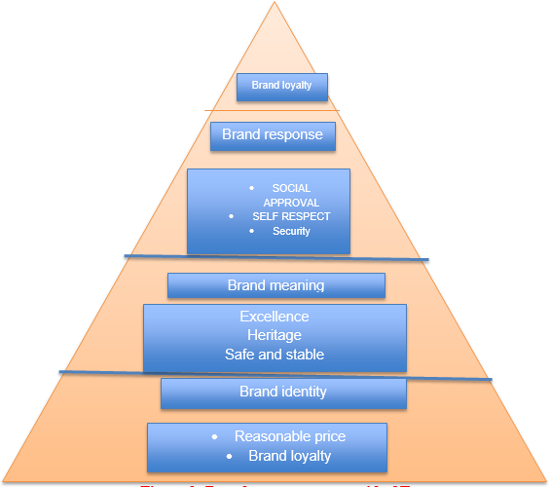

Figure 3: Brand Loyalty Pyramid
(Source: Author)

Since the very beginning of its business, Tesco has been trying to improve its customer servicing efforts. From the efforts of customer servicing to avoid arrange of varied commodities and services, the company has to doubt success fully for their devotion to their customers above all else (SpangenbergandLorek,2019). Although the company is observed to be evolved with time, the main salient of the brand holds strong. The main strategy of their business is to gain sustainable profitability across their businesses, channels as well as product ranges. A powerful brand can create long-term value and keeping this in mind they are aimed at serving their customers at the best possible level.

Brand loyalty
The leadership and management authority of this company has been organising the brand Loyalty program which is extremely popular across the whole world and approximately 16 million active members are associated with this particular program.

Brand performance
This has to be remembered in this connection that the value of Tesco has been fluctuating over the past few years. Till the year 2022, the entire Supermarket chain of the UK has a brand value of approximately 9.91 billion US dollars but this has decreased from the value of 11.3 billion in the year 2021. Grand value can be described as the total amount contributed by Tesco to the overall Corporation value.

Brand imagery
Tesco is known as one of the most famous retail companies across the whole world which has been operating in Approximately 12 countries around the globe. it is known as a true symbol of a successful supermarket because of having a positive Brand image worldwide.

Advantages of Keller’s brand equity model

- As stated by Steward et al. (2019), the pyramid of brand resonance is mainly used as a particular tool for evaluating the effectiveness of promotional Communication on brand equity through the establishment of relationships and brand loyalty. brand resonance of Tesco is extremely powerful and for this particular company, the word-of-mouth Strategy is observed to play a key role in expanding their business.
With the help of a successful application of this particular model, the company is capable of gaining a certain degree of competitive advantage in the market because the company has the capability of utilizing its resources to the maximum possible extent. By using the economy pricing strategy, the company has become successful in terms of attracting a wide range of customers.
- ThisspecificmodelhasalsohelpedTescointermsofestablishingastrongbrandbyshaping the way their clients feel and think about them.
- Moreoverthishashelpedthecompanyintermsofidentifyingthereputationoftheir brand in the respective market in the UK and they have also become successful in terms of understanding what more they are required to do for further growth of their business.

Demerits of Keller’s brand equity model

As stated by Wibowoetal. (2020), Brand resonance need alteration to be extremely relevant. in many instances it has been noticed that the feelings and thoughts of customers do not play any part in terms of inducing business growth for Tesco. however, this may not be the case for Tesco because in this case it has been noticed that customers have strong faith on the products and services sold by their company.

Customer Journey

The journey of a customer can be described as an end-to-end experience of that particular individual with a specific brand. this experience is classified into five stages and they are awareness, research, consideration, purchase and finally support. In the stage of awareness, the customer first discovered the brand Tesco. As stated by Yao et al. (2019), in the phase of journey, the customer has been considering purchasing one or more products from this company. in the phase of consideration, the customers are actively undertaking the process of purchasing the productor service from Tesco. The stage of purchase is all about the process in which customers are making their purchasing decision. In the face of support, the customers have been making use of the product or the service along with engaging with the business enterprise. In this particular stage, the customers also decide whether or not to purchase from that company once more. Finally in the face of loyalty, the customers Main additionally refer to other individuals about the products and services from Tesco.

Customer touchpoints

Pre-purchase

In this particular stage, the customers of Tesco try to find out the possible alternative in the market. in this stage, they also try to collect sufficient information regarding the advantages and risks of purchasing the required product from different companies. As stated by Zamrudi and Il-Hyun (2022), after comparing all of these factors they can make the final decision of purchasing. In this particular stage, the Expectations and need the individual consumer are extremely important because these are the factors which can influence what alternative they will ultimately consider. For example, while identifying the alternative options in the retail market in UK, consumers mostly go for social media surfing because most of the companies have official social media account and pages in the modern time.

Purchase

In this specific stage, the consumers are completely ready to purchase their needed product from Tesco because they have already gathered the required resources and information. For example, in this particular stage, the consumers can participate in the official events organized by the respective business organization. This will help them in terms of becoming confident about their purchasing decision regarding whether to purchase from Tesco or not.

Post-purchase

This is the final stage of the purchasing decision of the consumer journey in which the customers end to evaluate their satisfaction level with the purchase and in this particular phase they also decide whether they want to stay loyal or not for Tesco in near future. For example, in this specific stage, the consumers can have conversations with the company representatives regarding their actual experiences while using the Tesco products.

Customerjourneymap

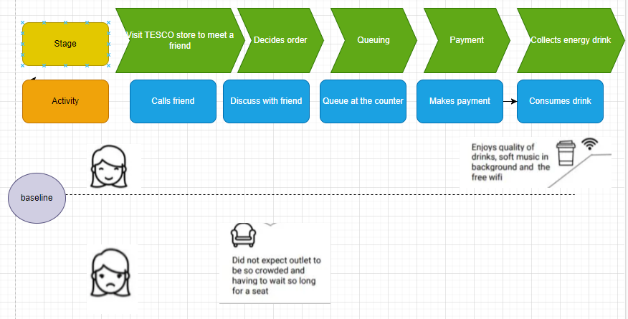
Figure 4: Customer Journey Map
(Source: Author)

Critical evaluation of the customer journey map of Tesco

Tesco has a positive reputation for conducting in generous Advertising campaigns. With the help of those advertising Campaigns, The customers of this company can become aware of their products and services. Selling high-quality products and services at an affordable price is considered to be the main USP of this company. This is known as the stage of consideration. After that in the stage of acquisition, the company teams to guide its customers smoothly by giving them several types of options. After that with the help of providing high quality customer servicing the company tries to improve the rate of retention of its customers.

Strengths of the customer journey map of Tesco

The main strength of them of the customer journey of Tesco is that the company comprises a wide range of efficient employees who are always ready to give their best to satisfy the needs of their customers.

Weakness of the customer journey map of Tesco

As stated by Zamrudi and Il-Hyun (2022), the main weakness of the map of the customer journey of this company is that the consumers have a wide range of options from other retail companies available in their market. so there is very little scope for increasing the price level of any product or service to gain some more profit.

Total engagement model

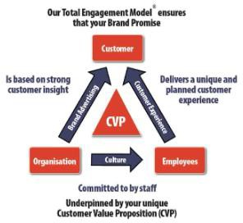

Figure 5: Total Engagement Model
(Source: ZamrudiandIl-Hyun, 2022)
According to the basic approach of these specific models and engaged consumer can be described as an individual who is extremely loyal to a particular focal brand and who can actively recommend the brand too the respectively. With the help of a successful application of this particular model, Tesco can improve its customer engagement level.

Recommendations

By considering the challenges faced by the company it can be recommended that the company should invest more money in research and development so that it can come up with high-quality innovative technology to be applied in its physical outlet. high-quality Technology innovation can also help the company in terms of improving the quality of its official website as well. The company can also be suggested to get associated with some effective partnerships with other established retail companies in the UK to earn more revenue and reach more customers.

Conclusion

At the end of the entire study, this may be concluded that Tesco is known as one of the successful retail companies in the UK which has currently been focusing on the digital transformation of its marketing strategy to make it more innovative and to attract a wide range of customers within the shortest possible period. Intending to do so, the leadership and management department of this company is required to organise a high-quality training and development programmed for enhancing the skills and knowledge of their employees. By keeping in mind the increasing popularity of social media usage, the company has been trying to use a combination of traditional marketing methods and digital marketing techniques to increase its reach in the market.

Reference List

Adams, P., Freitas, I.M.B. and Fontana, R.,2019. Strategic orientation, innovation performance and the moderating influence of marketing management. Journal of Business Research, 97, pp.129-140.
Al-azzam, A.F. and Al-Mizeed, K., 2021. The effect of digital marketing on purchasing decisions: A case study in Jordan. The Journal of Asian Finance, Economics and Business, 8(5), pp.455-463.
Ali, S.A., 2022. Role of Digital Marketing in Covid-19. Informative Journal of Management Sciences (IJMS), 1(1), pp.1-7.
Bob, F., Jumadil, S. and Marlena, G., 2020. Communication strategy planning in influencing the intention to visit: An implication to marketing management. Polish Journal of Management Studies, 22(1), pp.117-133.
Deepak, R.K.A. and Jeyakumar, S., 2019. Marketing management. Edu creation Publishing. Desai, V. and Vidyapeeth, B., 2019. Digital marketing: A review. International Journal of Trend in Scientific Research and Development, 5(5), pp.196-200.
Loxton, M., Truskett, R., Scarf, B., Sindone, L., Baldry, G. and Zhao, Y., 2020. Consumer behaviour during crises: Preliminary research on how coronavirus has manifested consumer panic buying, herd mentality, changing discretionary spending and the role of the media in influencing behaviour. Journal of risk and financial management, 13(8), p.166.
Olson, E.M., Olson, K.M., Czaplewski, A.J. and Key, T.M., 2021. Business strategy and the management of digital marketing. Business horizons, 64(2), pp.285-293.
Rosnizam, M.R.A.B., Kee, D.M.H., Akhir, M.E.H.B.M., Shahqira, M., Yusoff, M.A.H.B.M., Budiman, R.S. and Alajmi, A.M., 2020. Market opportunities and challenges: A case study of Tesco. Journal of the Community Development in Asia (JCDA), 3(2), pp.18-27.
Spangenberg, J.H. and Lorek, S., 2019. Sufficiency and consumer behaviour: From theory to policy. Energy Policy, 129, pp.1070-1079.
Steward, M.D., Narus, J.A., Roehm, M.L. and Ritz, W., 2019. From transactions to journeys and beyond: The evolution of B2B buying process modeling. Industrial Marketing Management, 83, pp.288-300.
tesco.com2023. Tesco. Available at<https://www.tesco.com/>[Accessed on 16.4.2023] Wibowo, A., Chen, S.C., Wiangin, U., Ma, Y. and Ruangkanjanases, A.,2020. Customer behavior as an outcome of social media marketing: The role of social media marketing activity and customer experience. Sustainability, 13(1), p.189.
Yao,B., Shanoyan, A., Peterson,H.H., Boyer, C.and Baker, L., 2019.The use of new media marketing in the green industry: Analysis of social media use and impact on sales. Agribusiness, 35(2), pp.281-297.
Zamrudi, M.F.Y. and Il-Hyun, B., 2022. Social Media Marketing Strategies In The Global Halal Industry. COMSERVA: Jurnal Penelitian Dan Pengabdian Masyarakat, 2(1),pp.71-80

