LCHS4003 Introduction to Health and Social Care

Student name: | Mojisola Abatti
Student ID number: | 2515877
Lecturer: | Christiana Melam
Assignment title: | Component 1: Portfolio – Two Tasks
Task 1: | Poster: Ambulance services
Task 2: | Essay: Domiciliary care services

Ambulance Services
The front door of urgent and emergency care in the United Kingdom
Student Name, LCHS4003 Introduction to Health and Social Care, Email Details Go Here
WHAT ARE AMBULANCE SERVICES?  NHS ambulance services are the emergency medical arm of the UK’s health system: they answer 999 calls, assess and treat patients at the scene or over the phone, and convey those who need hospital care, 24 hours a day, free at the point of use. Ten regional NHS trusts provide the service in England, with separate national services for Wales, Scotland and Northern Ireland (National Audit Office, 2017). It is not just about transporting patients, the service is increasingly diagnosing and treating patients without transferring them and is described in the NHS Long Term Plan as “at the heart of the urgent and emergency care system” (Nuffield Trust, 2026).  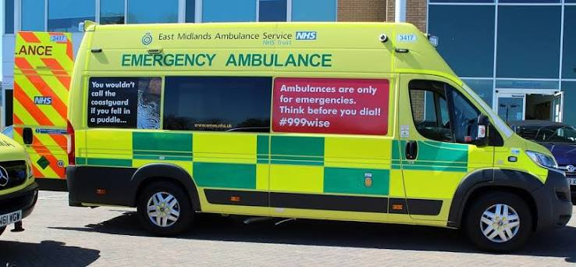 |  |  | A BRIEF HISTORY OF THE SERVICE  The UK pioneered the world’s first emergency telephone number, 999, in 1937 (Niland, 2012). Ambulance provision became the responsibility of local councils and was frequently provided by voluntary organisations like St John Ambulance from 1948 under the National Health Service Act 1946. The NHS took over in 1974. After a national review (Department of Health, 2005), England’s 31 local ambulance services formed 12 larger regional services in 2006-07 (AACE, 2011), and since 2017-18, the ambulance response programme has used the present clinical category 1-4 system (Nuffield Trust, 2026).  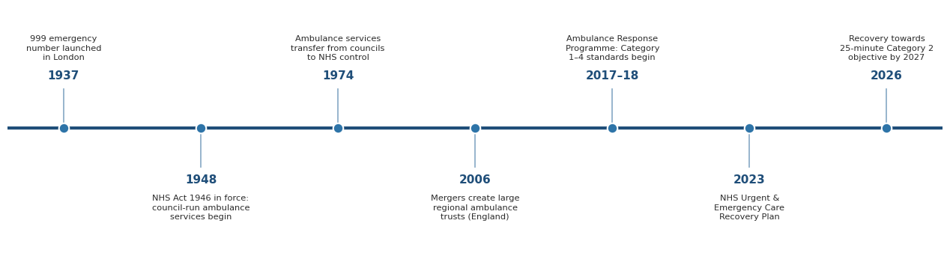  Figure 1: Milestones in the history of UK ambulance services (sources: Niland, 2012; Department of Health, 2005; AACE, 2011; Nuffield Trust, 2026).
HOW THE SERVICE FUNCTIONS TODAY  Every 999 call is answered in an Emergency Operations Centre and triaged using an approved clinical triage tool (such as NHS Pathways) into one of four response categories (Table 1). Not all calls result in the dispatch of a vehicle, with many patients treated by telephone (hear and treat), many treated at the scene (see and treat), and approximately 50% transported to an emergency department. At West Midlands Ambulance Service, for example, just 46% of 999 patients go to A&E, and over 20% are resolved by phone (WMAS, 2026). The NHS England performance against national standards is reported on each month and is published by the Nuffield Trust (2026).  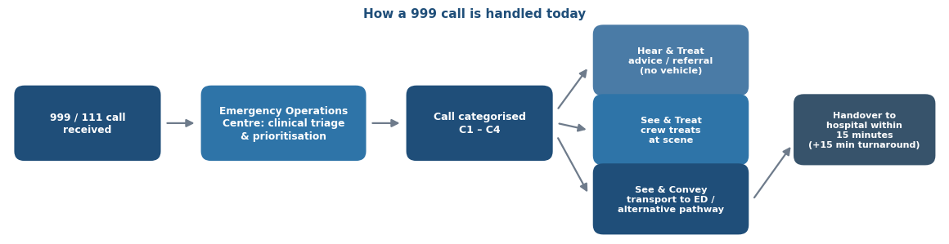  Figure 2: The patient journey through a modern ambulance service. |  |  | AMBULANCE RESPONSE CATEGORIES  Table 1: NHS ambulance response categories and national standards, England (source: Nuffield Trust, 2026).
  Category | What it means (examples) | National standard
  C1 – Life-threatening | Cardiac or respiratory arrest, airway obstruction, unconscious with abnormal breathing | Mean 7 minutes; 90% within 15 minutes
  C2 – Emergency | Stroke, heart attack, sepsis, major burns; may need urgent transport | Mean 18 minutes; 90% within 40 minutes
  C3 – Urgent | Needs treatment to relieve suffering (e.g. pain relief) and possible transport | 90% within 120 minutes
  C4 – non-urgent | Assessment (face-to-face or telephone) and possibly transport | 90% within 180 minutes
PERFORMANCE AGAINST NATIONAL STANDARDS  In December 2022, the mean wait for Category 2 service had reached crisis point, with 1 hour and 33 minutes. Average time in 2025/26 was met with 29 minutes 59 seconds which achieved the interim 30-minute target (NHS England, 2023), but none of the four constitutional standards have been achieved (Nuffield Trust, 2026).  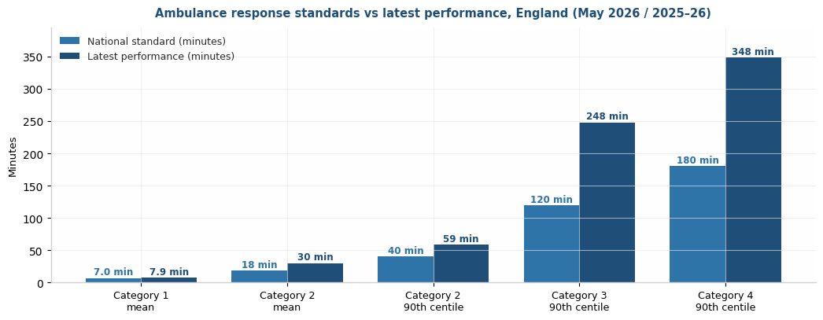  Figure 3: National standards vs latest performance (source: Nuffield Trust, 2026). |  |  | CHALLENGE 1: Rising demand and missed response standards  Demand keeps climbing as the population ages. Calls and NHS 111 transfers rose from 7.9 million in 2009–10 to 10.7 million in 2015–16 (National Audit Office, 2017). The 18-minute Category 2 standard has only ever been met in April and May 2020, during the first Covid-19 lockdown; today one in ten emergency patients still waits up to 59 minutes for help (Nuffield Trust, 2026). Most trusts also have a problem of recruiting and retaining paramedics and call handlers, and burnout exacerbates attrition (National Audit Office, 2017). The recovery phased objective is to improve to a 25-minute average by March 2027, which is a Category 2 standard, indicating the full standard is not expected soon (NHS England, 2023).  CHALLENGE 2: Hospital handover delays  Ambulances should hand patients over within 15 minutes, but emergency department crowding (exit block) leaves crews queueing for hours. In May 2024 alone, delays over one hour cost 48,000 ambulance hours which is ten times five years earlier with an estimated 32,000 patients potentially harmed and some 101,000 response cycles lost, about 16% of face-to-face capacity (AACE, 2024). Delayed admission is also linked to higher 30-day mortality i.e. one extra death for every 82 patients delayed six to eight hours (Jones et al., 2022). Delays thus endanger both the patient in the ambulance and the next 999 caller.
REFERENCES  AACE (2011) Taking healthcare to the patient 2: A review of six years’ progress. London: AACE.  AACE (2024) Ambulance sector data on handover delays. aace.org.uk (Accessed: 16 July 2026).  Department of Health (2005) Taking healthcare to the patient: Transforming NHS ambulance services. London: DH. |  |  | Jones, S. et al. (2022) Emergency Medicine Journal, 39(3), pp. 168–173.  National Audit Office (2017) NHS ambulance services. HC 972. London: NAO.  National Health Service Act 1946, c. 81. London: HMSO.  NHS England (2023) Delivery plan for recovering urgent and emergency care services. London: NHS England.  Niland, L. (2012) ‘30 June 1937: 999 and the launch of the first emergency telephone calls’, The Guardian, 29 June.  Nuffield Trust (2026) Ambulance response times. nuffieldtrust.org.uk (Accessed: 16 July 2026).  WMAS (2026) 20 years of transformation at WMAS. wmas.nhs.uk (Accessed: 16 July 2026).

Task 2: Domiciliary care services within the community
Introduction and History
Domiciliary care, or personal care and practical support provided in the home, dates back to the charitable visiting movement and district nursing of the nineteenth century but it was established on a statutory basis after the second world war. Local authorities became responsible for the welfare of older people and those recovering from illness when the National Assistance Act 1948 came into force, and home help services, originally for new mothers, grew slowly during the 1950s and 1960s as an explicit preventive alternative to residential institutions (Means and Smith, 1998). This domiciliary tradition was further strengthened by the formation of social services departments in 1971 that brought together the various professions in local authority social work.
The turning point was the NHS and Community Care Act 1990, which came into force in 1993, shifting local authorities from being sole providers of care to the role of care managers and introducing a quasi-market in the provision of care at home. This purchaser-provider divide resulted in the majority of provision moving to independent providers and the service user becoming a service consumer in a mixed economy of care. Two decades of limited funding and increased demand followed and constricted this market, until the Care Act 2014 re-focused adult social care on a statutory commitment to promoting individual wellbeing, prevention and person-centred outcomes.
Importance of Domiciliary Care to Individual Wellbeing and Independence
Today, domiciliary care is the growth engine of adult social care in England. The number of regulated non-residential locations has increased by 72 per cent from 2018 to 15,232, with about 595,000 staff employed (Skills for Care, 2025). Most provision is commissioned by local authorities from the independent sector, with the independent sector providing about four-fifths of the social care workforce (House of Commons Library, 2025). The flexibility of the model, however, is undermined by a fragile workforce, with vacancy rates in domiciliary care more than double those in residential care at 9.7 per cent (The King's Fund, 2026); 42 per cent of domiciliary care workers are employed on zero hours contracts; and turnover is approaching one in four staff each year (Skills for Care, 2025). Thus, continuity of care, which is the most important aspect valued by service users, is structurally compromised, and fee pressures have become commonplace, which conflicts with dignified and unhurried care (House of Commons Library, 2025). Directors of adult social services spent £774 million in 2024 just to comply with statutory requirements (ADASS, 2026) and meaningful reform is now in the hands of the Casey Commission and the long-awaited National Care Service (Department of Health and Social Care, 2025).
Nevertheless, domiciliary care is high on the list of significance for quality of life. It helps people stay in their familiar surroundings, where identity, relationships and autonomy are not lost, and comes at the heart of the Care Act 2014. The reality of this importance is reflected every day with a care worker enabling a person with dementia to continue with their routine at home, or a reablement team helping a patient recover from a hip fracture and retain abilities that they might otherwise have lost. Home-based support also helps with prevention, reablement and timely discharge from hospital, which will support the Government's plans to move care from hospital to home and communities (Department of Health and Social Care, 2025). Effective domiciliary care for service users is therefore not just a service, it is a practical way of ensuring independence, dignity and citizenship in later life and disability.
Conclusion
The history of domiciliary care in England today is a shift from charitable visiting to a marketised, professionally regulated system, which most people experience first before any other type of care. Resolving the contradictions in its workforce and funding is the key to its future credibility, as the law currently fails to enable it to provide the wellbeing it promises to each and every citizen.

Reference
ADASS (2026) Adult social care in 2025: What changed, what didn't and what it means for the year ahead. Available at: https://www.adass.org.uk/adult-social-care-in-2025/ (Accessed: 16 July 2026).
Association of Ambulance Chief Executives (AACE) (2011) Taking healthcare to the patient 2: A review of six years' progress. London: Association of Ambulance Chief Executives.
Association of Ambulance Chief Executives (AACE) (2024) Latest UK NHS ambulance sector data shows there can be no complacency over hospital handover delays as 32,000 people estimated to have come to potential harm in May 2024. Available at: https://aace.org.uk/news/latest-uk-nhs-ambulance-sector-data-shows-there-can-be-no-complacency-over-hospital-handover-delays-as-32000-people-estimated-to-have-come-to-potential-harm-in-may-2024/ (Accessed: 16 July 2026).
Care Act 2014, c. 23. Available at: https://www.legislation.gov.uk/ukpga/2014/23/contents/enacted (Accessed: 16 July 2026).
Department of Health (2005) Taking healthcare to the patient: Transforming NHS ambulance services (The Bradley Report). London: Department of Health.
Department of Health and Social Care (2025) Independent commission into adult social care: terms of reference. Available at: https://www.gov.uk/government/publications/independent-commission-into-adult-social-care-terms-of-reference/independent-commission-into-adult-social-care-terms-of-reference (Accessed: 16 July 2026).
House of Commons Library (2025) Adult social care workforce in England. Research briefing CBP-9615. London: House of Commons Library.
Jones, S., Moulton, C., Swift, S., Molyneux, P., Black, S., Mason, N., Oakley, R. and Mann, C. (2022) 'Association between delays to patient admission from the emergency department and all-cause 30-day mortality', Emergency Medicine Journal, 39(3), pp. 168–173. doi: 10.1136/emermed-2021-211572.
Means, R. and Smith, R. (1998) From Poor Law to community care: The development of welfare services for elderly people 1939–1971. 2nd edn. Bristol: Policy Press.
National Assistance Act 1948, c. 29. Available at: https://www.legislation.gov.uk/ukpga/Geo6/11-12/29/contents (Accessed: 16 July 2026).
National Audit Office (2017) NHS ambulance services. HC 972, Session 2016–17. London: National Audit Office. Available at: https://www.nao.org.uk/reports/nhs-ambulance-services/ (Accessed: 16 July 2026).
National Health Service Act 1946, c. 81. Available at: https://www.legislation.gov.uk/ukpga/Geo6/9-10/81/contents (Accessed: 16 July 2026).
NHS England (2023) Delivery plan for recovering urgent and emergency care services. Available at: https://www.england.nhs.uk/publication/delivery-plan-for-recovering-urgent-and-emergency-care-services/ (Accessed: 16 July 2026).
NHS and Community Care Act 1990, c. 19. Available at: https://www.legislation.gov.uk/ukpga/1990/19/contents (Accessed: 16 July 2026).
Niland, L. (2012) '30 June 1937: 999 and the launch of the first emergency telephone calls', The Guardian, 29 June.
Nuffield Trust (2026) Ambulance response times. Available at: https://www.nuffieldtrust.org.uk/resource/ambulance-response-times (Accessed: 16 July 2026).
Skills for Care (2025) Domiciliary care services in the adult social care sector 2024/25. Leeds: Skills for Care.
The King's Fund (2026) Social care 360: workforce and carers. Available at: https://www.kingsfund.org.uk/social-care-360 (Accessed: 16 July 2026).
West Midlands Ambulance Service University NHS Foundation Trust (2026) 20 years of transformation at WMAS. Available at: https://www.wmas.nhs.uk/20-years-of-transformation-at-wmas/ (Accessed: 16 July 2026).

