The cost of living: The effects on the standard of living, mental health and wellbeing, and what is being done to help with these issues.

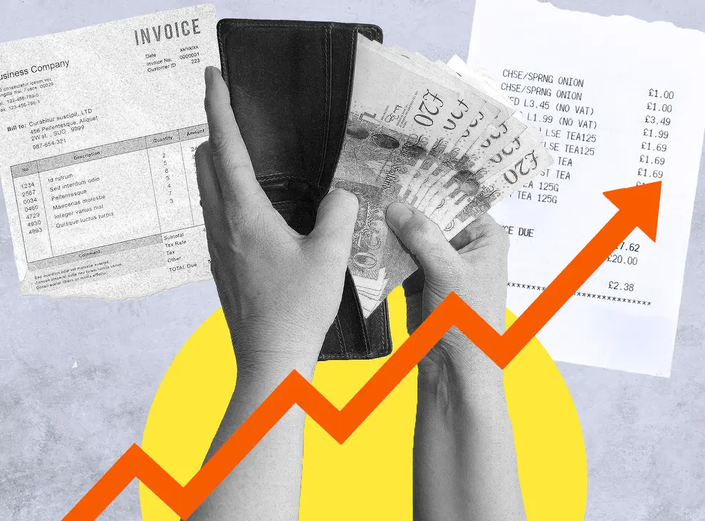
(source: Independent,2022)

Contents.
 | Pages
Introduction. | 3
Supporting data and information. | 4-5
The media. | 6
What has been the response. | 7-8
How effective has the response been. | 9
Recommendations. | 10
Conclusion. | 11
Appendix. | 12-15
References. | 16-18

Introduction.
Within this report the increase in the cost of living, including rises in the price of fuel, food, gas and electric will be investigated, highlighting what effects they have had on the public including, increase in food banks, individuals being unable to afford heating, and even individuals becoming homeless due to increasing mortgage costs. The impact on mental health and general wellbeing of the population will also be highlighted.
The main factors contributing to the current financial difficulties the UK is experiencing started at the beginning of 2021. The yearly proportion of inflation hit 10.1% as of September 2022, culminating a “40 year high” influencing the price of produce and amenities for families and individuals. Between September 2021 and September 2022, the household cost of gas rose by 96% and electricity by 54% (Francis-Devine et al, 2022). Normandeau (2022) explained that “brexit, inflation, supply chain issues and the global squeeze on energy prices” have been reasons behind the price of everyday life rising in the UK. From the beginning of Covid-19, costs have grown quicker than during the previous 30 years and salaries are unable to match these increases in prices. BBC news (2022) produced an article highlighting seven causes for the increase in living prices across the globe. The causes include increase in fuel and power, the price of oil decreased at the beginning of Covid-19, now life is returning to normal demand for fuel has reached the highest for seven years. Shortfalls in products and merchandise. These shortfalls mean items such as “plastic, concrete and steel” have risen in cost. Wood has increased by 80%. Transportation prices increased and this increased product prices. The changes in weather have caused there to be a shortage with oil due to damage caused. Brexit and new measures in place have lowered what is imported from EU to UK by approximately a quarter at the start of 2021. Pandemic finances, higher spending, and loans worldwide, increased tax, and no change to salaries. The cost of living has impacted on mental health with a survey conducted by YouGov finding 59% of adults stating the increase in costs has a “negative impact on their mental health”. Also 1 in 5 individuals feeling inadequately equipped to manage the increase in costs (money and mental health, 2022).

Supporting data and information.
Food was found to not be easily accessible, which was highlighted by a survey produced by the food foundation (2022) (See figure 1) which discovered “one in seven (7.3 million) adults” within the UK and “2.6 million children” during April 2022. These issues were accentuated by the EU showing the growth within the countries of the EU is decreasing in 2022 “from 4% to 2.7% and this will continue to decrease in 2023 to 2.3%. These percentage will mean a decrease in salaries, increased loss of employment, and increase in likelihood of matters to remain uncertain or getting worse. The increase in the everyday price of living within the UK has been linked to alterations regarding earnings and the “mental health and wellbeing” of individuals. Investigations carried out described a surge in deprivation in England from 2015 to 2020 were related to above 10,000 extra children going into care (Health, T. L. P., 2022). Marmot (2022) described how the inability to maintain a warm home can result in poor health. Living in a cold home can produce issues with lungs and negatively affect mental health as well as “development issues” within children and young people. Health issues for adults include issues with lungs and “cardiovascular system”. The pressure of being able to afford all necessities amplifies the possibility of “mental illness”, hence forth leads to the detriment of “children’s health” and maturing. It has been verified that the higher amount of occasions a child lives in deprivation by 14 years of age, they are more likely to be overweight, and more likely to become depressed (UNICEF office of Research, 2020). The countries most vulnerable including children, elderly and those with existing health issues or even terminal illnesses are also at higher risk due to the increase in cost of living and can also increase likelihood of developing certain health issues (Appendix 1). Limb (2022) described how Macmillian Cancer Support reported that from December 2021 24% of individuals who have cancer have had to keep costs down by not purchasing as much food or having fewer cooked meals, this percentage includes 26% of individuals who are presently undergoing therapy. Information provided by NHS England (2022) “cancer quality of life survey” reported that 48% of those who responded suffered with issues including “anxiety or depression”, also 68% of those up to 50 years of age mental health has been influenced by the cost of living.

Figure 1
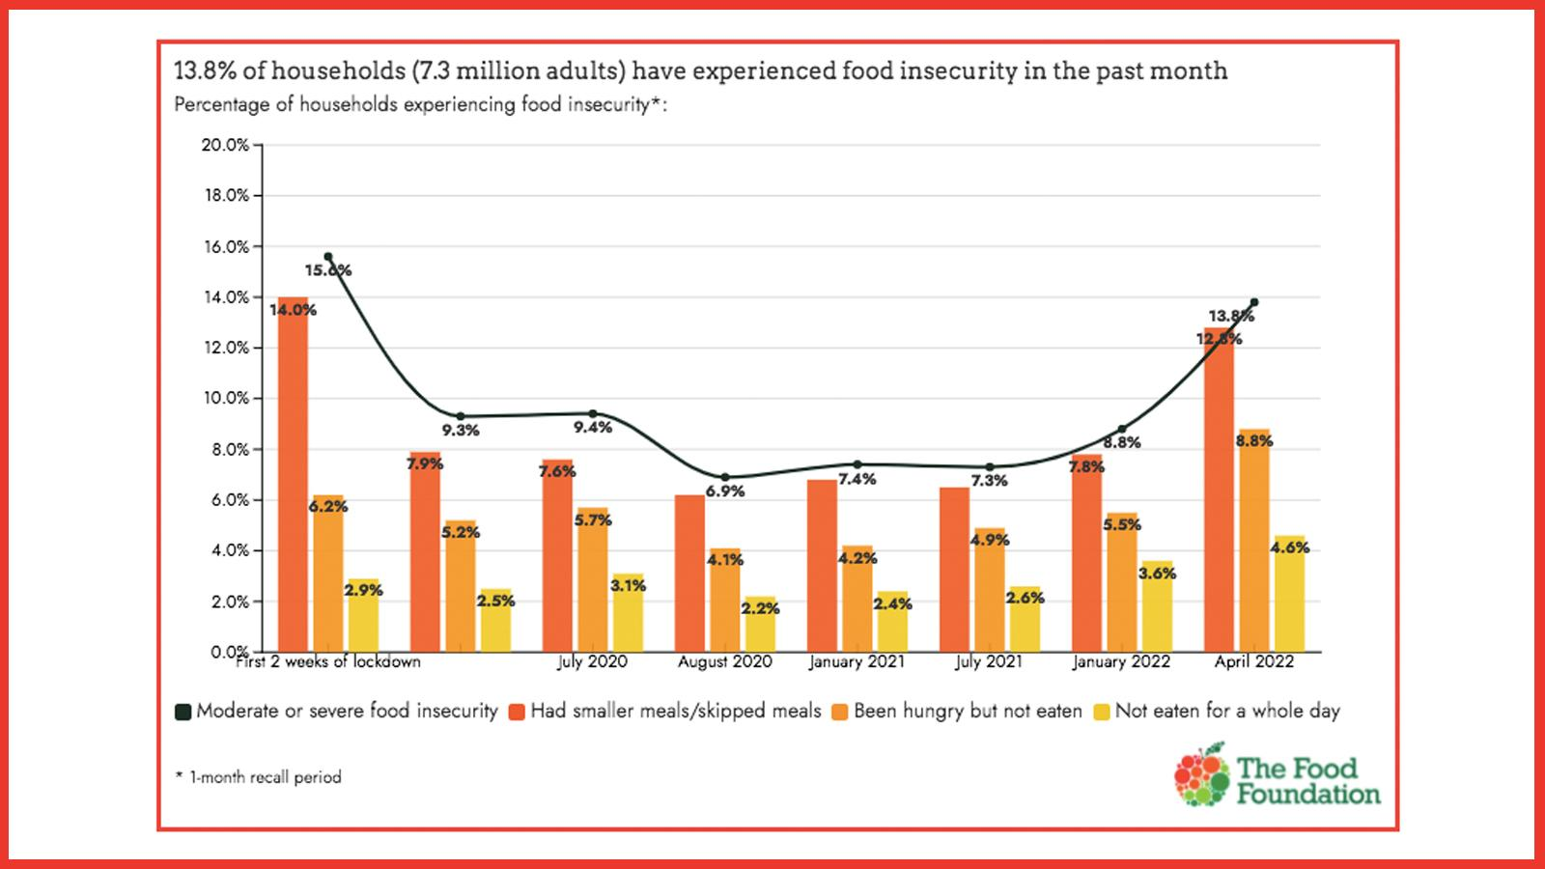

The media.
The media is believed to have an influence over public opinion due to what issues it covers and how it covers them, this has increased in recent years by the added social media platforms available reaching a wider audience. Gunther (1998) produced an experiment in to the medias influence on public opinion, finding that the way in which an issue was reported had a noticeable impact on individuals thoughts on others beliefs on these issues. Showing that individuals seem to determine public belief formed on their personal analysis of what has been reported, incidental influence of press coverage can have consequential results. McCombs (2002) explained the media influence how important a topic is based on coverage of the topic. Media outlets reporting of an issue influences the public such as newspapers putting the most important topics on the front pages. News reports will place the most important first and will also spend more time on them, meaning what each person understands about what is happening globally is increasingly formed by what the media reports.
The “cost of living crisis” began to become prevalent as of late 2021. Financial specialists anticipate that these escalations in costs will continue late in to 2024 (institute for government, 2022) (Appendix 2). In February 2022 the Guardian (2022) published an article highlighting findings regarding the cost-of-living crisis. The article includes six graphs showing the enormity of the problem. The issue of inflation increasing (Appendix 3) as well as areas in everyday life costs increasing, including “transport, household items, education, food, gas, electricity, health and clothes” among other everyday items and services (Appendix 4). Fuel costs were also shown in a graph highlighting how the cost of “brent crude” is the greatest price in seven years (Appendix 5). Explaining how all individuals across the country will be affected, and circumstances will be more difficult for certain families. It is thought that “low income single-adult households” will use 54% of their salary for energy bills (Appendix 6). These factors are amplified by salaries not being increased (Appendix 7). Crisis (2022) underlined how individuals in the UK are at danger of becoming homeless due to the increase in cost of living. Crisis studies issued in March 2022 revealed households on the poverty line are encountering an overall £372 shortfall from the amount of “local housing allowance” and the cost of the lowest priced rentals. The British Association for Counselling and Psychotherapy (2022) published survey findings in September 2022, the results showed that “two thirds” of their clients stated the cost of living is behind the mental health decline in the UK. “Six out of ten clients” stated they had anxiety due to worrying about “paying bills”, showing the momentous effect on individuals mental state within the UK. With the media coverage and constant negative narrative that is produced it is easy to understand the influence it has on the mental state of individuals. The impact of the cost-of-living crisis on individuals mental health and wellbeing as well as the standard of living is extremely apparent, with information provided emphasizing the issues within the UK playing a part in influencing the negative mindset of the public.

What has been the response.
The response to the cost-of-living crisis has varied throughout 2022, with the government continually changing what they propose to do to help, it is difficult to visualise what the governments plan is. In May 2022 GOV.uk (2022) published an article listing what financial help the government will be providing. This included assistance with “energy bills”, supplying as much as £550 to “28 million” homes. Every household power consumer in the UK will gain £400 subsidy to aid with the price of power through “the Energy Bill Support Scheme”, £650 “cost of living payment” will be paid to individuals that receive financial assistance, £300 allowance for the elderly, and £150 to individuals with special needs. Forbes (2022a) described energy suppliers such as “octopus and OVO” have stated they will reward consumers who have “smart meters” and who utilise their power during off peak periods. On 1st October 2022 saw the start of the “Governments Energy Price Guarantee” which restricts the price energy providers can bill. This was advised to be allocated for “two years”. However, an article published by Forbes (2022b) on 19th October 2022 outlined how the proposed “Energy Price Guarantee” is now set to finish within April 2023 (UK parliament, 2022).
An increase in food banks has assisted with household nutritional needs. 93% of “food bank organisations” described a rise or a remarkable rise in the amount of people utilising food banks from the beginning of 2022, and 95% of those that took part in the research described how this increase is due to the “cost of living crisis”. Within the UK there are 1,400 food banks and an additional 1,172 “independent food banks” (see figure 2).
Specifically, within Wales the Welsh government has planned the “£380 million package of support” the government in Wales has generated to be utilised in packages comprised of strategies such as “winter fuel support scheme”, which is £200 paid to homes that qualify, to assist with the price of important costs. Also “the cost-of-living payment” that is to assist homes that are in “council tax bands A-D, as well as those who are part of the “council tax reduction scheme” (GOV.wales, 2022).
There are websites, apps and charities available to assist with mental health issues specifically due to financial difficulties. Such as mental health & money advice (2021) that describe the worry about money and mental health issues such as anxiety and depression can become a pattern (see figure 3) Mental health & money advice (2022) highlight ways in which these worries can be helped such as being able to decompartmentalise issues and worries, toolkits accessible to help with sleep when stressed and also charities that are available to speak to if professional help is needed, including turn2us which is a charity that assists with financial difficulties, and helps acquire various funding including “welfare benefits, charitable grants and support services” (turn2us, 2021).

Figure 2
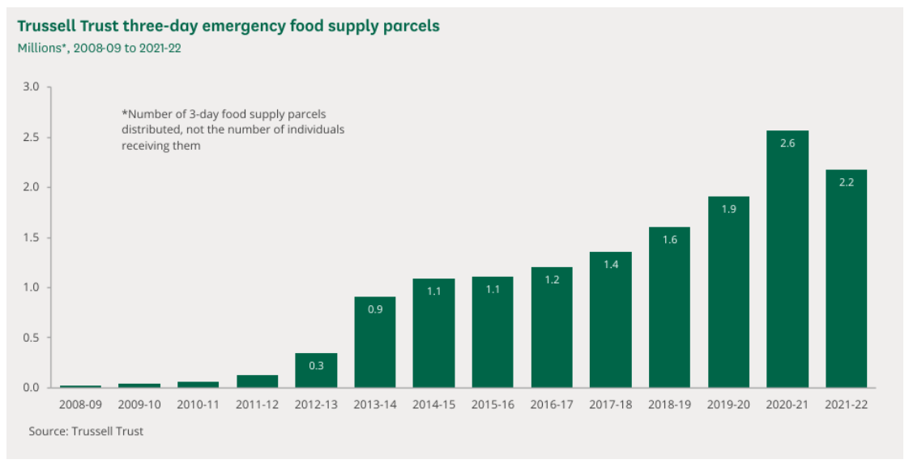

Figure 3
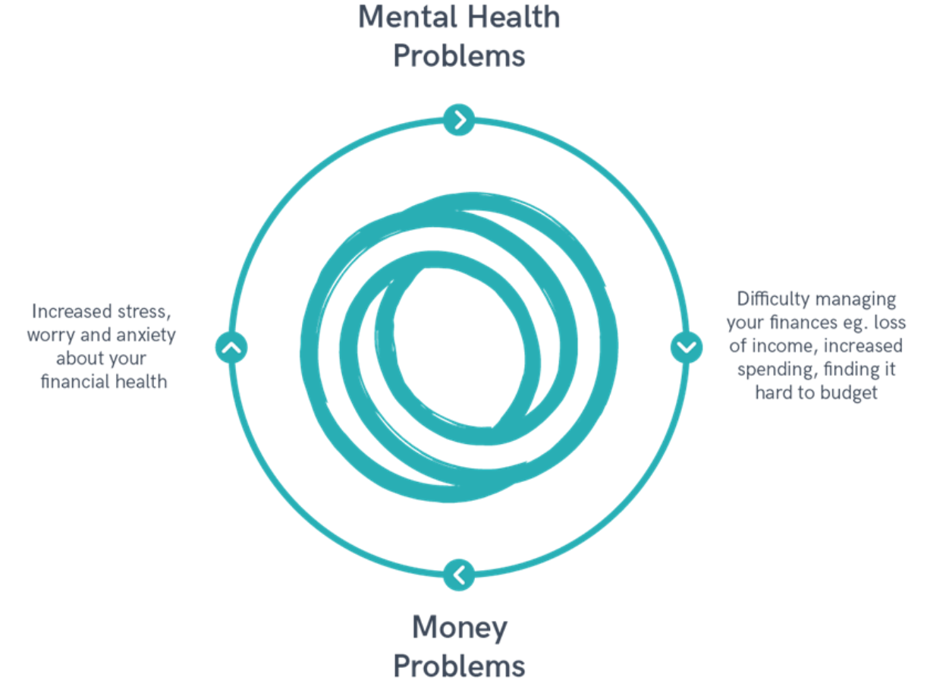

How effective has the response been.
The response to the cost-of-living crisis seems to be inadequate, with the proposals made that were described to assist households for two years being changed to ending in April 2023, is substandard and a disappointing move by the government. With these measures of assistance being removed it is difficult to visualise how homelessness, increasing health issues, mental health issues and unacceptable numbers of households not being able to afford essentials such as food to reach adequate nutritional needs will survive. If help with household bills is not made a fundamental priority by the government how will households survive and the knock on effects and issues be assisted or potentially prevented? Sion and Ifan (2022) underlined how the government decided to remove the “£20 a week” increase to “Universal Credit” which affects a fifth of homes in Wales. Lowest income homes encountered a 5% decline in “after housing cost disposable income”. Describing how these choices by the government seem especially thoughtless. The institute of employment rights (2022) champion the facts outlined by Sion and Ifan (2022) by describing the government reaction to the developing crisis is basically a “class war”. Tories hand out “a few hundred” pounds of citizens money to poverty-stricken areas which does not equal the cost of energy, then low-income families pay the wealthy “energy companies” leaving poorer households no better off or worse. Even though the effect of the government putting more money towards helping households will help short term, in the long run it does not seem financially feasible, as the government would need to continuously need to find money to help with energy bills. This could have a detrimental effect on the country’s stability as a whole in the future, if the public expects more money from the government, the government needs to get that money from somewhere, which could possibly end up with increases in costs again, leading to a never ending cycle, that can potentially get worse, however, ways of living with these costs could be addressed with changes at home.

Recommendations
A recommendation that seems the most evident is to maintain the Energy Price Guarantee past April 2023, this would help low-income households get back on their feet, if this isn’t the case and the help isn’t continued this potentially could see an even further decline in individual’s standard of living, health and wellbeing. There could be better tactics to assist with children being affected by the cost-of-living crisis, such things as counselling being offered and the topic of the cost of living to be discussed in comprehensive schools, and teaching children the importance of money from a young age and what it means to have to pay for things. Within workplaces making counselling available to assist if an employee is having financial difficulties to discuss what can be done to help. Further assistance for families to ensure the increase in the amount of children taken in to care doesn’t remain so high or get any higher. There needs to be further help provided for the elderly, households with children, any individuals with health conditions and those receiving end of life care at home. Due to some hospital equipment needing to be on 24/7 these households will naturally use more electric which they should’t be targeted for. These individuals are sometimes unable to heat their house or cook food that can have extremely bad consequences for their health and can result in death or dying uncomfortably in their home. Marie Curie (2022) described how palliative patients and their families have faced financial difficulties for a long time and even more so now, with “90,000 people dying in poverty each year”, agreeing that the government must provide continued, specific financial aid to make sure going forward no individual or families have to battle to “make ends meet at the end of life”.
With most recommendations being based on financial help it is also important to realise there is not an infinite amount of money available to always help everyone. Some changes can be done at home, with changes from more expensive food and clothing brands to cheaper ones. Taking food made at home in to work for lunch breaks instead of going to a canteen or café to buy food everyday or even cutting down on smoking or drinking if this is an issue, or possibly again choosing cheaper options if unable to quit completely. There are various aids to help with quitting smoking such as QUIT (2017) that provides help to stop smoking and even preventing youngsters from starting smoking.

Conclusion.
This report has investigated the reasons for the current cost-of-living crisis, what effects the crisis has had on individuals in the general public including their mental health, wellbeing and standard of living. The detrimental impact of this crisis is evident from the evidence presented within this paper, it is also clear that the governments back and forth decisions on what will be done to help during this crisis and the uncertainty they are adding to the country is also escalating the publics concerns as there is no set help put in place. The help available has been highlighted including help with mental health issues due to the crisis, assistance with food banks for those that are struggling to feed their families, also websites and charities that are able to point individuals in the right direction to gain further financial help. The cost-of-living-crisis is at present a very worrying and prominent problem for the whole country, how long this will last and how serious the crisis will become remains to be seen, however, one real positive is how the country collectively can come together to help each other through such difficult times and remain strong as a nation to ensure we all survive.

Appendix.
Appendix 1
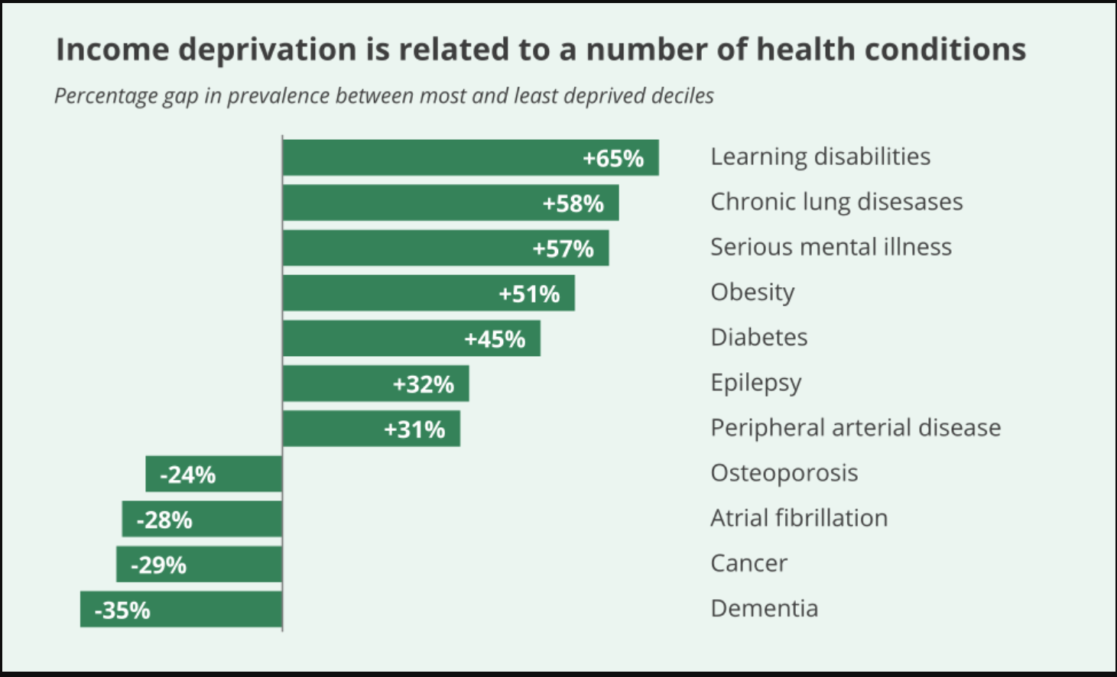
(UK parliament, 2019).
Appendix 2
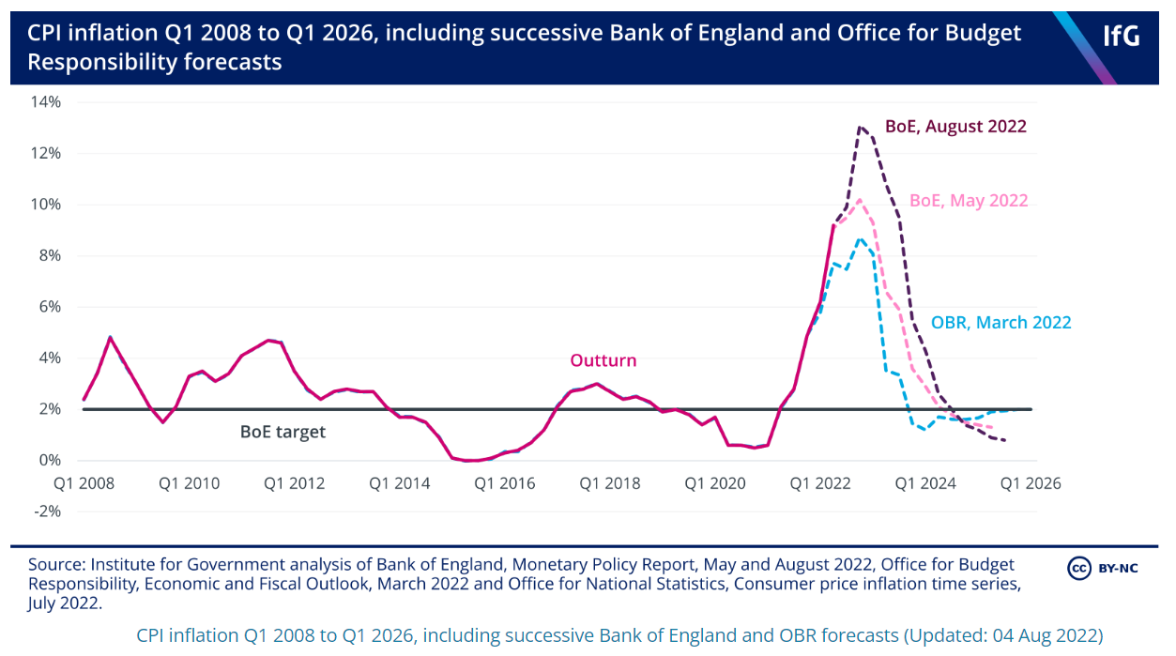
(Institute for government, 2022)

Appendix 3
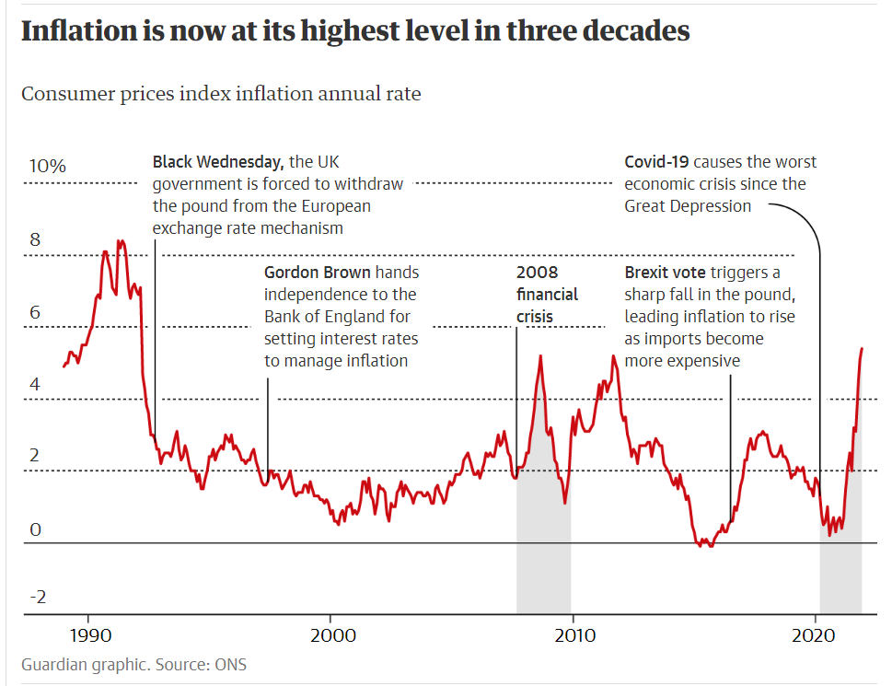
(The Guardian, 2022).

Appendix 4
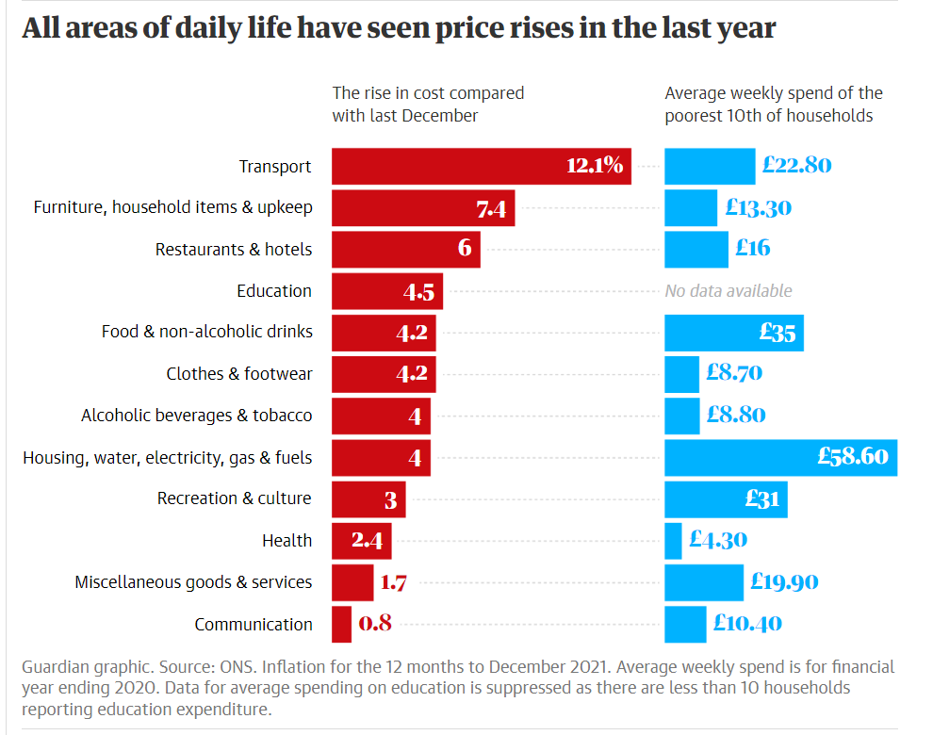
(The Guardian, 2022)
Appendix 5

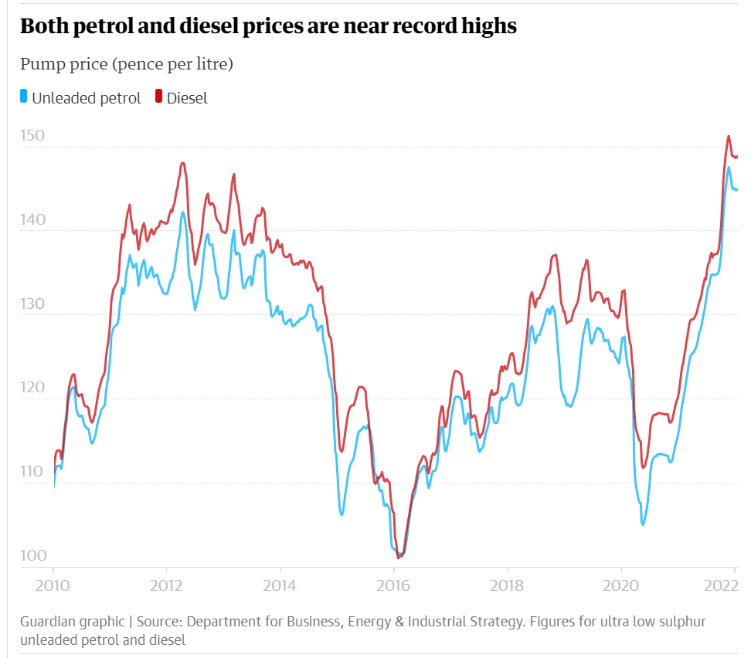
(The Guardian, 2022)
Appendix 6
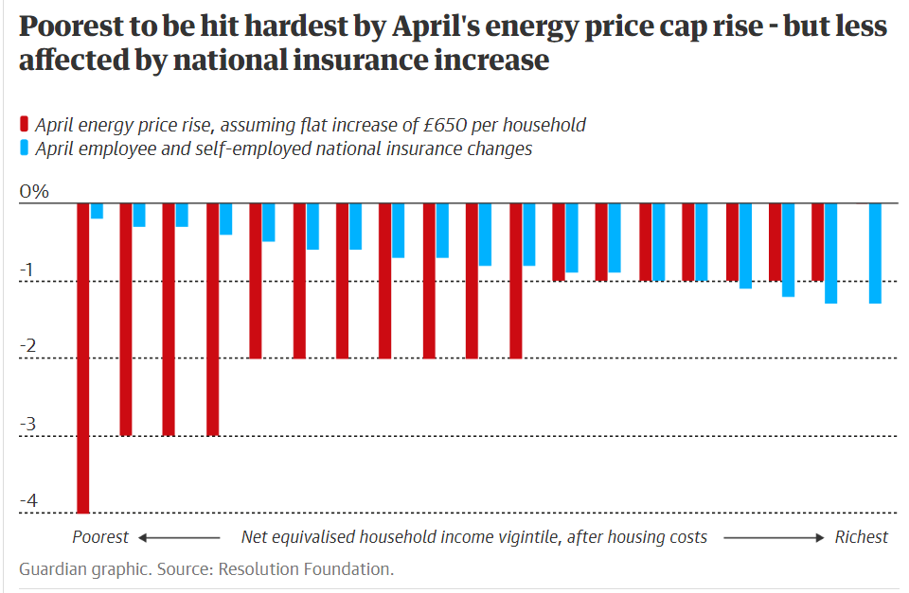
(The Guardian, 2022)
Appendix 7
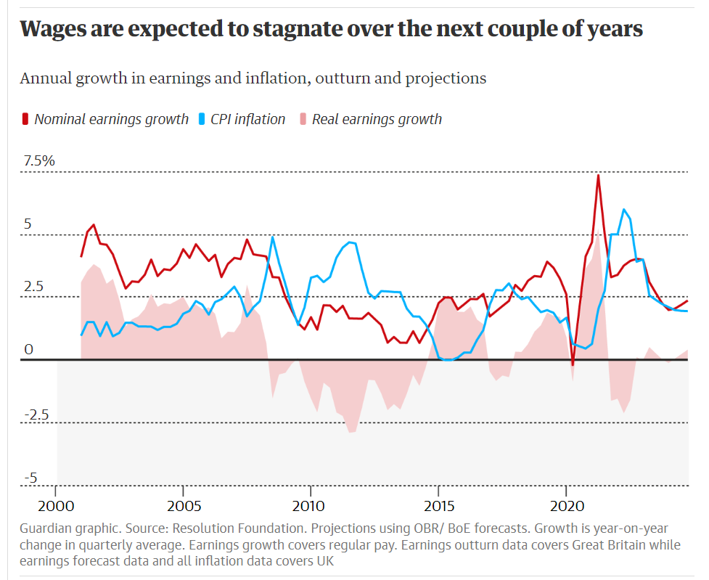
(The Guardian, 2022)

References.
BACP (2022) Cost of living crisis: survey shows impact on mental health. Available at: https://www.bacp.co.uk/news/news-from-bacp/2022/8-september-cost-of-living-crisis-survey-shows-impact-on-mental-health/ (Accessed on 29th October 2022).
BBC News (2022) Inflation: Seven reasons the cost of living is going up around the world. Available at: https://www.bbc.co.uk/news/business-59982702 (Accessed on: 23rd October 2022).
Crisis (2022) The cost of living crisis: how we are supporting our members. Available at: https://www.crisis.org.uk/get-involved/philanthropy/philanthropy-bulletins/the-cost-of-living-crisis-how-we-are-supporting-our-members/ (Accessed on 29th October 2022).
Forbes (2022a) Energy update: Centrica opens rough gas storage facility to boost reserves. Available at: https://www.forbes.com/uk/advisor/personal-finance/2022/10/28/energy-market-updates/ (Accessed on 29th October 2022).
Forbes (2022) Cost of living crisis: Government pulls on energy price guarantee. Available at: https://www.forbes.com/uk/advisor/energy/cost-of-living-crisis/ (Accessed on 29th October 2022).
Francis-Devine, B., Bolton, P., Keep, M., and Harari, D. (2022) Research briefing. Rising cost of living in the UK. House of commons library. Available at: https://researchbriefings.files.paliament.uk/documents/CBP-9428/CBP-9428.pdf. (Accessed on 23rd October 2022).
GOV.uk (2022) Overall government support for the cost of living: factsheet. Available at: https://www.gov.uk/government/publications/government-support-for-the-cost-of-living-factsheet/government-suppor-for-the-cost-of-living-factsheet (Accessed on 29th October 2022).
GOV.Wales (2022) £380m to help tackle the cost-of-living crisis in Wales. Available at: https://gov.wales/380m-help-tackle-cost-living-crisis-wales (Accessed on 30th October 2022).
Gunther, A.C., 1998. The persuasive press inference: Effects of mass media on perceived public opinion. Communication Research, 25(5), pp.486-504.
Health, T.L.P., 2022. The cost of living: an avoidable public health crisis. The Lancet. Public Health, 7(6), p.e485
Institute for government (2022) Cost of living crisis. Available at: https://www.instituteforgovernment.org.uk/explainers/cost-living-crisis (Accessed on 27th October 2022).
Institute of employment rights (2022) The governments response to the cost-of-living crisis is nothing short of class war. Available at:
Limb, M., 2022. Cancer patients’ health is at increased risk from cost of living crisis, charity warns. BMJ: British Medical Journal (Online), 377, p.o1103.

Marie Curie (2022) Response to measures set out to address rising cost of living. Available at : https://www.maricurie.org.uk/media/press-releases/response-to-measures-set-out-to-address-rising-cost-of-living/346415 (Accessed on 30th October 2022).
Marmot, M., 2022. There doesn’t need to be a trade-off between sustainability and the cost-of-living crisis. bmj, 379.

McCombs, M., 2002, June. The agenda-setting role of the mass media in the shaping of public opinion. In Mass Media Economics 2002 Conference, London School of Economics: http://sticerd. lse. ac. uk/dps/extra/McCombs. pdf.

Mental health & money advice (2021) How money worries can affect your mental health. Available at: https://www.mentalhealthandmoneyadvice.org/wal/managing-money/how-are-mental-health-and-money-worries-linked/money-worries-and-mental-health/ (Accessed on 30th October 2022).

Mental health & money advice (2022) How to manage your mental health and money following the energy price rise. Available at: https://www.mentalhealthandmoneyadvice.org/en/top-tips/how-to-manage-your-mental-health-and-money-following-the-energy-price-rise/ (Accessed on 30th October 2022).
Money and mental health (2022) Cost of living squeeze could cause national mental health crisis- with 11M UK adults saying they feel “unable to cope” due to rising costs. Available at: https://www.moneyandmentalhealth.org/press-release/cost-of-living-crisis/ (Accessed on 23rd October 2022).
Ng, K. (2022). How to cope with cost-of-living crisis. The Independent. 21st October. Available at: https://www.independent.co.uk/life-style/cost -of-living-crisis-payment-help-b2207529.html. (Accessed on 21st October 2022).
NHS England (2022) Cancer quality of life survey. Available at: https://www.cancerdata.nhs.uk/cancerqol (Accessed on: 27th October 2022).
Normandeau, F (2022) Why is the cost of living increasing in the UK?. BBN times. Available at: https://www.bbntimes.com/financial/why-is-the-cost-of-living-increasing-in-the-uk#:~:text=The%20cost%20of%20living%20has%20increased%20in%20the,not%20notice%20price%20rises%20from%20month%20to%20month. (Accessed on 23rd October 2022).
QUIT (2017) I want to quit. Available at: https://www.quit.org.uk/lets-quit/ (Accessed on 1st November 2022).

Sion, C. and Ifan, G., 2022. When ends don't meet: a cost-of-living update.
The Food Foundation (2022) Millions of adults missing meals as cost of living crisis bites. Available at: https://foodfoundation.org.uk/press-release/millions-of-adults-missing-meals-as-cost-of-living-bites. (Accessed on 26th October 2022).
The Guardian (2022) In numbers: What is fuelling Britain’s cost of living crisis? Available at: https://www.theguardian.com/business/2022/feb/03/in-numbers-britains-cost-of-living-crisis (Accessed on 28th October 2022).
Turn2us (2021) Get support. Available at: https://www.turn2us.org.uk/Get-Support (Accessed on 30th October 2022).
UK Parliament (2019) House of commons library: Health inequalities: Income deprivation and north/south divides. Available at: https://commonslibrary.parliament.uk/health-inequalities-income-deprivation-and-north-south-divides/ (Accessed on 27th October 2022).
UK Parliament (2022) House of common library: food banks in the UK. Available at: https://commonslibrary.parliament.uk/research-briefings//cbp-8585/#:~:text=This%20was%20still%20an%20increase,food%20parcels%20in%20the%20UK. (Accessed on 29th October 2022).
UNICEF Office of Research (2020) Worlds of influence: understanding what shapes child well-being in rich countries. Available at: https://www.unicef-irc.org/child-well-being-report-card-16 (Accessed on 26th October 2022).

