Task 1 - A written piece of reflection on the filmed/audio activity submitted last year in 'Yr Iaith ar Daith 2.’ Word Count – 1649 (1500 +/- 10%)

The Welsh language defines the people and nation of Wales signifying the importance of Welsh (WG, 2017a; Estyn, 2019). The Welsh Government (2017b) and Andrews (2011) acknowledge teachers’ Welsh language skills have major consequences on learners’ Welsh language acquisition. Therefore pupil progression is dependant on teacher’s subject-knowledge. Although, Estyn (2017a) recognise teachers lack necessary requirements to teach Welsh successfully possessing inadequate levels of confidence and expression. Andrews (2011) and Estyn (2017a) acknowledge teacher’s poor Welsh subject-knowledge discussing the drastic effects this has on children’s language development. This is evidenced within Estyn’s (2017a) report, where teaching standards of Welsh second language (L2) for 138,000 pupils aged sixteen and under were falling. This implies teachers’ linguistic and methodological abilities need improvement in order to gain confidence and good subject-knowledge. This occurred in Greenfield Primary where linguistic tutoring ensued. Greenfield Primary reinforced Welsh culture and increased staff confidence through training and self-reflections to achieve Welsh targets (Estyn, 2017b). Self-reflection processes are critical in cognitive understanding; therefore reflecting upon models of communication and applying humanistic approaches to practice might help strengthen one’s perception of language (Jones, Machpherson and Jayawarna, 2014; Saylag, 2012). Consequently, self-reflections are critical roles in improving Welsh language development amongst teachers and students, providing a step closer to achieving the governments aim of one-million Welsh speakers by 2050 (WG, 2017b). Therefore, this essay will critically evaluate the Welsh language development of a student primary teacher during the academic year of 2019-2020 to inform professional development.

The first skill utilised in the recording was a modelling approach, modelling different words and sentence patterns including Welsh farm animals and emotions for pupils to repeat evidenced in appendix-1. Accurate and contextualised language models are significant as they convey to learners the correct form providing contextual meaning (Skehan, 2009; Hyltenstam and Pienemann, 1985). Although language patterns were not always modelled correctly by the author, for example asking pupils “Sut mae’r teimlad iâr?” as opposed to “Sut mae’r iâr yn teimlo?” hindering learners’ language acquisition. This correlates with Estyn (2017a) and Furlong’s (2015) viewpoints, as many teachers do not possess the knowledge as to why certain language patterns are incorrect, similarly to the author’s dilemma. Consequently, the author would evaluate themselves at Foundation Level concerning oracy within the Welsh Language Competency Framework (WLCF) (WG,2019) as speech errors were not recognised or modified. Within the current academic year the author has attempted to improve their Welsh oracy and modelling skills to raise their ability to effectively speak and teach Welsh. Every Friday, the author volunteers in School A, evidenced in appendix-2, participating in Year 5 Welsh activities to observe how the class-teacher applied Welsh. Evidently, the teacher used the scaffolding ‘Sandwich-Technique’ enunciating a sentence in Welsh-English-Welsh to correct themselves if mispronunciations occurred, simultaneously emphasising and concluding with the correct pattern. This enabled the author to recognise when a sentence was pronounced wrong and hear the correct pattern immediately, assisting in Welsh development. The ‘Sandwich-Technique’ is admired highly during L2 acquisition as interference from the mother-tongue is avoided (Butzkamm, 2010; Caldwell, 1990) thus learners, including the author, focus on repeating the foreign phrase correctly. This develops the scaffolding approach as the ‘Sandwich-Technique’ enables learners to achieve goals which exceed their own knowledge (Wood et al.,1976) as the teacher controls elements of language correction, aiding learners L2 development. This corresponds with Vygotsky’s (1978) ZPD where skilled others are required to strengthen learners’ skills.

Additionally, signing was utilised in the video to aid children’s Welsh pronunciation, however, should have been developed further for pronunciation purposes. This has been developed within School A as the author was responsible for Welsh singing within Year 5, singing songs including “Hei Mistar Urdd” and “Can yr Enfys.” Singing for L2 development increases vocabulary, stimulates memory and improves speech thus an important pedagogical tool for development (Garcia, 2016; Mora, 2000; Alisaari&Heikkola, 2016). This aided the author’s pronunciation and fluency of Welsh and assisted in recognising mispronunciation in normal Welsh speech. Although, Macias (2008) opposes to Garcia (2016), Mora (2000) and Alisaari and Heikkola (2016) as singing detracts from main curriculums and does not model L2 accurately. Nevertheless, the author believes singing aided Welsh pronunciation and expression, as without informal L2 expression, L2 communication cannot occur in a meaningful way (Rukholm, 2015). Estyn (2018) coincides, evidencing excellent practice within Aberporth School where children learn through song and other informal teaching methods aiding bilingualism. Research advocates knowledge is obtained through informal educational approaches, as merely 25% of knowledge is acquired formally (Conner, 2002; Langton 2013; Grebow, 2012). Consequently, languages including Welsh need to include informal teaching methods. Therefore, the author believes they can now recognise Welsh errors in speech and correct themselves successfully due to ‘Sandwich-Techniques’ and Welsh songs. Accordingly, the author now evaluates themself at intermediary level regarding oracy, as the author recognises common errors and confidently models correct language arrangements (WG,2019). The author will continue to teach and learn through informal means including Welsh songs and ‘Sandwich-Techniques,’ evident within Task-2.

Reflecting upon the video, the author utilised the audio-lingual method to aid children’s Welsh listening and speaking skills. This consisted of using drilling and repetition approaches enabling pupils to listen to Welsh. The author’s role was drillmaster, controlling the direction of pupils and performances. The pupils showed enthusiasm for learning, enjoying repeating the names of animals in Welsh. The audio-lingual method, specifically concerning repetition, has been proven to successfully affect the complexity and accuracy of L2 production (Kim and Ventura, 2013; Borruel, 2017; Yoshimura&MacWhinney, 2007) demonstrating repetition as successful regarding L2 acquisition in writing, speech and listening, highlighted within the 2019 reflection. Although reflecting further, the author did not portray their Welsh understanding fully, as repeating Tedi Twt ar y Fferm animals did not showcase one’s Welsh knowledge. Ghazi-Saidi and Ansaldo (2017) propose one must learn essential skills and patterns before one can use drills and repetition successfully. The author agrees as repeating, translating and writing farm animals from English to Welsh is not a large achievement. Therefore, the author’s technique of drilling and repetition was not proficient, as they did not showcase sufficient Welsh knowledge. Nevertheless, the author has sought to improve their Welsh utilising repetition. One method was using the DuoLingo app improving the author’s listening skills, which increased confidence and the author’s knowledge of vocabulary. Additionally, writing skills have improved as the author wrote repeated language patterns to assist them in spelling and precision three times a week. Many commend DuoLingo as there are no tedious grammar or vocabulary drills and is extremely addictive (Freedman, 2018; Vesselinov&Grego, 2012). Although, when DuoLingo was not used for over two weeks, the author’s development decreased quickly. This issue is acknowledged by Nor and Rashid (2018) who state if repetition is not utilised frequently, L2 understanding rapidly declines. Therefore repetition for L2 development features limitations. To solve this, podcasts including Jason Shepherd’s (2018) “Learn Welsh Podcast” and Welsh audiobooks were utilised day-to-day by the author in order to listen subconsciously when completing mundane daily tasks, passively developing listening skills. Vandergrift (2004) and Yokoyama et al.,(2006) recognise the importance of passive listening for L2 development, as listeners subconsciously participate in the linguistic listening process, aiding individual development. Piaget (1955) concurs as learners should be lone-scientists when learning new skills, thus potentially utilising Welsh podcasts and apps within school could aid pupils’ language development. The author would evaluate themselves at Intermediary Level of the WLCF (WG,2019) regarding listening as they can understand and respond to main points inside and outside of school contexts. The author will continue to utilise podcasts and DuoLingo to reach the ‘Higher Level,’ improving understanding of unfamiliar subjects.

Conversely, Vygotsky (1978) believes individuals acquire knowledge from skilled others, opposing to Piaget (1955). Reflecting upon the video, it is difficult to correct errors in reading, speech and writing if one does not possess the knowledge to do so, one of the author’s struggles. Therefore, acquiring knowledge from skilled others can develop L2 (Palmer,1971). Skype sessions occurred when volunteering enabling the author to witness what Welsh books were read and how different teachers from different schools applied them. A previous proposed target was to consider various Welsh books, rather than Tedi Twt stories, as this did not challenge the author’s language development. This is an issue in Wales as Estyn (2017c) recognise many English-medium teachers do not possess the capacity to challenge their linguistic abilities. Therefore to improve reading skills and challenge oneself, the author read books including “Y Bachgen a’r Blaidd” to a Year 5 class in School A and other schools via Skype, evidenced in appendix-3. This challenged the author’s reading ability assisting in overcoming difficult wording and language patterns, increasing confidence. Edwards and Roger (2015) and Habrat (2018) propose for successful L2 acquisition, learners must challenge themselves for prosperous progress. Consequently, Skype sessions challenged the author’s Welsh reading skills, enabling the class teacher to correct mispronunciations, thus developing language skills from a skilled other. Accordingly, the author evaluates themself at intermediary level of the WLCF (WG,2019) concerning reading as the author can understand articles relating to daily topics, and can read stories with correct pronunciation. To progress onto ‘Higher Level,’ the author will continue to read stories within Skype sessions, however could additionally read other materials for pleasure including newspaper articles and reports to enhance Welsh development further, which can also be utilised within a school context.

Concluding, the author sought to improve their Welsh language development utilising DuoLingo, volunteering, singing, audiobooks and reading to improve teaching methods including the ‘Sandwich-Technique,’ modelling and repetition to use in classroom situations (task-2). These approaches have assisted the author’s Welsh development attaining the Intermediary Level in all aspects portraying progression since the previous academic year. To progress further, the author will continue to learn from a variety of sources including: podcasts, other teachers, Welsh TV and reading to gain an insight into unfamiliar topics, as languages are only learned when different methods are applied (Lightbown&Spada,2014).

Task 2 – Welsh lesson plans relating to the theme of Blood, Bones and Gory Bits (Year 3 Class)

Promoting Welsh planning sheets and resources are portrayed after the relevant lesson plan.

Lesson Plan 1

Student-teacher | Emily Thomas | Class: | Year 3
AoLE/Subject | Language, Literacy and Communication | Date: | 11th May 2020
Lesson Focus: | Welsh Language – Organ Carousel Activity – Oracy focus
Relevant/meaningful links to:  Curriculum  Cross-curricular responsibilities | Language Literacy and Communication  Progression Step 2  I can respond to what I hear, read and see, asking questions and showing my understanding.  I can listen to, understand and later recall what I have heard.  I can adopt a range of roles and manage my contributions appropriately.  I can spell common irregular words correctly  I can speak with expression and gestures to communicate my ideas.  Expressive Arts  Progression Step 2  I can create my own designs and work collaboratively with others to develop creative ideas
Personal Targets  (Linked to QTS and identfied in weekly review) | - Welsh Language - There is a commitment to incremental development of personal skills in the use of the Welsh language  - In planning and delivery, the teacher demonstrates an awareness of the importance of encouraging learners to reflect upon their own learning. (Learners leading learning)

Learning Objectives (Focus on Learning) | Activity 1 L.O- I can can respond to what I hear, asking questions to show my understanding and gain more knowledge.  Activity 2 L.O- I can speak with expression and gestures to communicate my ideas.
Success Criteria  (process/product) | I can name at least five organs in Welsh.  I understand the function of at least 5 body organs.  I can listen to a Welsh song and adapt the words to suit what I know.  I can ask questions in Welsh to find out an answer.

Key Resources Health & Safety | Backing boards with organ flashcards in Welsh  iPads to listen to the song  Welsh books  Language mat 1

Time | Content, Pedagogy & Assessment Opportunities (key teaching points and questions)
Links to Previous Learning | Previously children have learnt about body organs and their functions by visiting Body Worlds in London. The pupils can already translate parts of the body in Welsh. This lesson will enhance their knowledge of body organs, and will be able to translate body organs from English to Welsh by the end of each activity.
Opening Phase | Link for Welsh song:  https://www.youtube.com/watch?v=pDIJxVDF_mI  The children and teacher will sing the Fy Nghorff song as a reminder of the different body parts the pupils have already previously learnt in Welsh. The pupils will complete actions already learnt to the song (direct-method) helping them to remember the Welsh word for each body part including Trwyn, Coes, Braich, Cefn, Tafod, Llygaid and Clustiau. After completing the song, the teacher will introduce Welsh for body organs as opposed to body parts. (Link to term topic “Blood, Bones and Gory Bits!”)  The teacher will use the sandwich technique to introduce body organs in Welsh, which include Yr ymennedd, Yr aren, Y stumog, Y gallon, Yr ysgyfaint and Yr Afu. These will be shown on a powerpoint slide and the pupils will point to where these organs are on their body, repeating these Welsh organs throughout the introduction (slot-drill and repetition.) The teacher will ask questions such as “Ble mae’r ymennedd?” and the pupils will respond with “yr ymennedd” and point to their heads.  Pupils will then work in pairs to complete this slot drill task as modelled by the teacher previously. One pupil will ask “Ble mae’r ymennedd /aren/ysgyfaint etc” and the other pupil will answer with the Welsh translation of the organ and point to where the organ is on their body. The pupils will swap roles after they have completed each body organ. (Repetition and drilling)  AFL – ‘Mr Wrong’ will be used where the teacher will say the wrong pronunciation of Welsh organs and body parts for example, the teacher will say yr apu instead of yr afu or y sumdog instead of y stumog. This will assess whether the pupils will recognise the teacher’s mispronunciation and whether they will correct it. If they do not correct the teacher, another slot drill of the organs will occur.  An explanation of the carousel tasks will be given.
Teaching & Core Learning | Activity 1 (Speaking and listening activity)  –Two groups of pupils will be sat in pairs and will play a Welsh version of Dyflau Pwy? Each pair will have a backing board with six different body organ flashcards with the functions of each organ in English and the name of the organ in Welsh. Each child in the pair will pick a body organ and their partner has to guess which organ they have picked in Welsh. They will ask question and answers such as “oes… gyda ti?,” “oes mae…gyda fi,” “nag oes,” “dw i’n…” and “pa organ ydych chi?” in order to find out what organ their partner has picked, utilising a range of question and answer patterns. If children guess the correct Welsh organ using the correct Welsh phrasing, they earn a point. If they guess the wrong Welsh organ, they lose a point. All pupils will be given a language mat evident in Language Mat 1 regardless of Welsh ability, as this will help them to stay focused on the given task and ask the correct questions learning the correct language patterns without teacher help. Children will be paired in mixed ability partners, in order to create child-to-child learning. Extra support from the teacher and teaching assistant can be given to children who find this task difficult. The teacher needs to listen to the children’s phrasing and pronunciation to correct them if wrong. A picture of the language mat and backing board can be found below the lesson plan.  Activity 2 (Singing and writing activity) – The other two groups of pupils will sing the song they learnt within the introduction - Fy Nghorff. However, their challenge is to change the lyrics from body parts to body organs. Therefore instead of “pen…clustiau…gwallt” it could be “afu…stumog…aren” singing in the tune of the song and performing their actions to it. The pupils will write their Welsh organ song lyrics in their Welsh books in order to practise their spelling and vocabulary in order to learn their song.  AFL: Mr Wrong to check pronunciation throughout the activities by the teacher.  Before swapping groups in a carousel style, the pupils who created the song will perform to the rest of the class.  Children can sing, dance and create actions when performing with the main purpose of practising correct pronunciation of these body organs. The teacher can check whether their pronunciation is correct throughout the task.  Differentiation – These activities are child-led and within mixed ability groups. Therefore, differentiation will be based upon the amount of adult support to each child.
Plenary | Plenary  All groups will perform their song with their new lyrics again. Another slot drill will occur of both body parts and body organs to identify whether pupils remember where each organ is on their body. The Sandwich Technique will be utilised to do this, for example: the teacher will say yr ymennydd and the pupils will say yr ymennydd-brain-yr ymennydd and point to their body part. This will assess whether children can translate the organ from Welsh to English and point to where it lies.  AFL – Self and peer reflections on their songs.

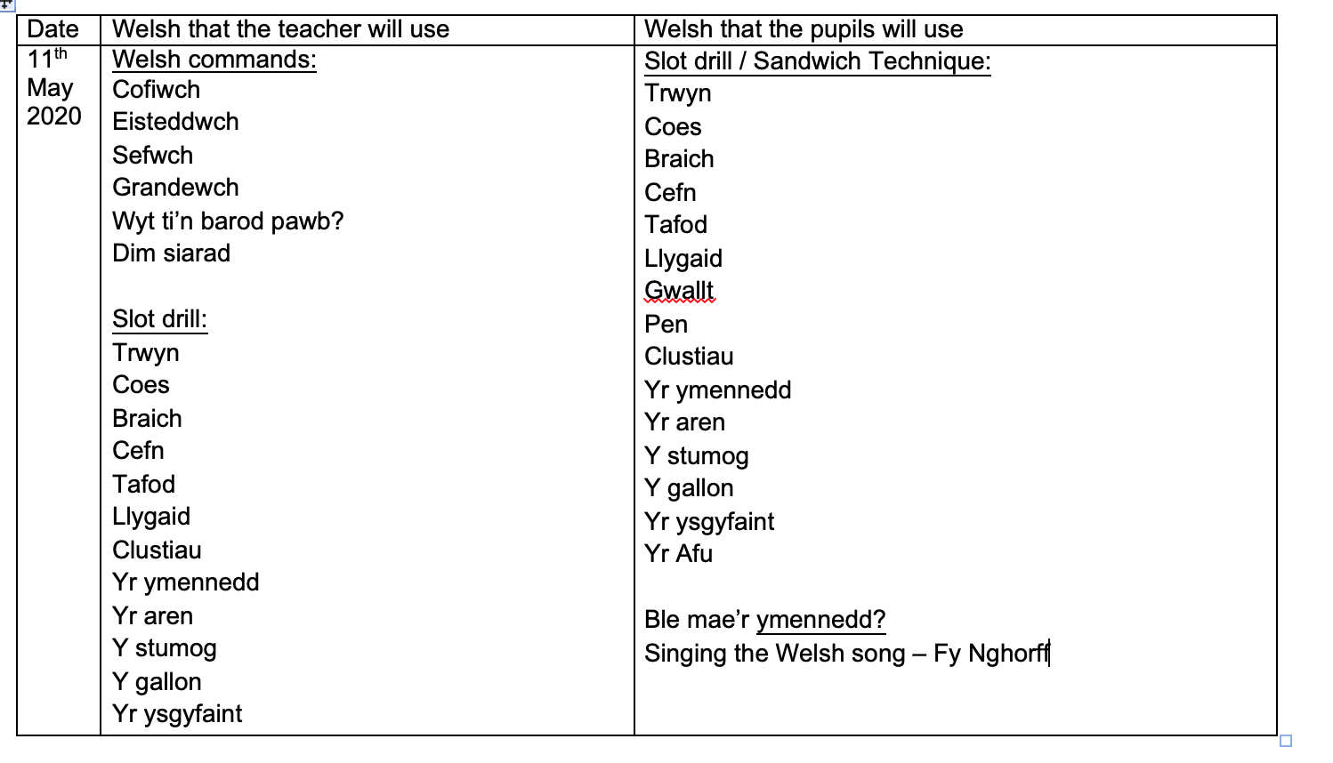

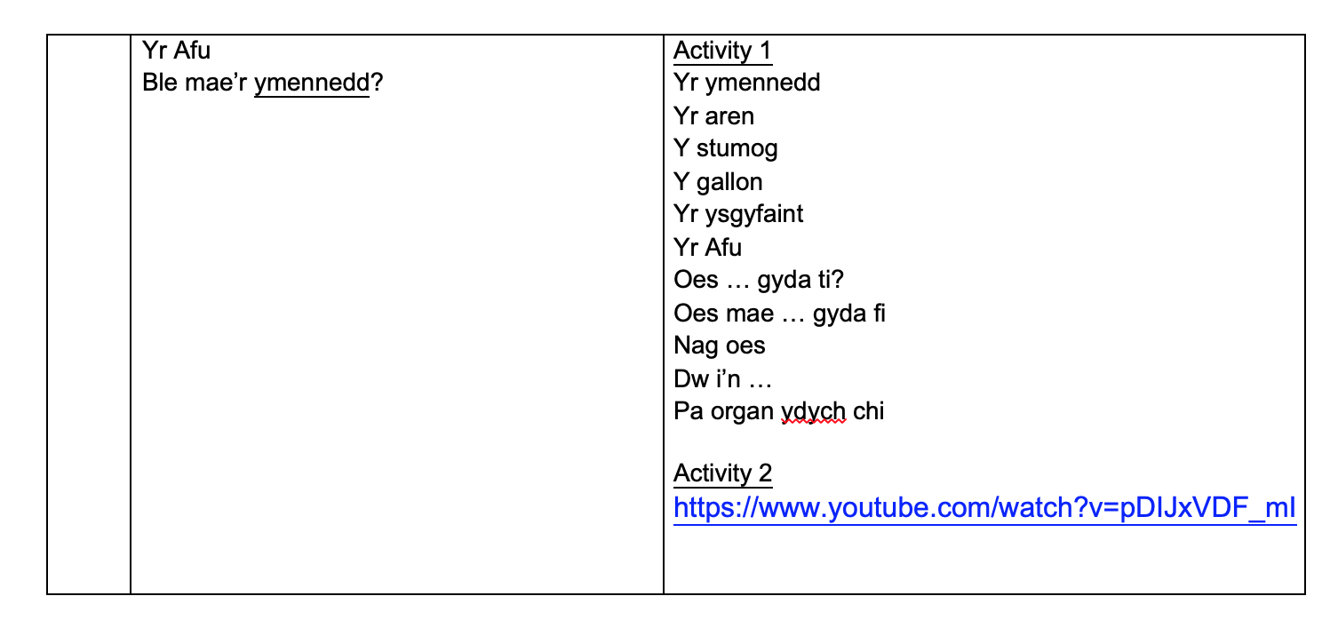
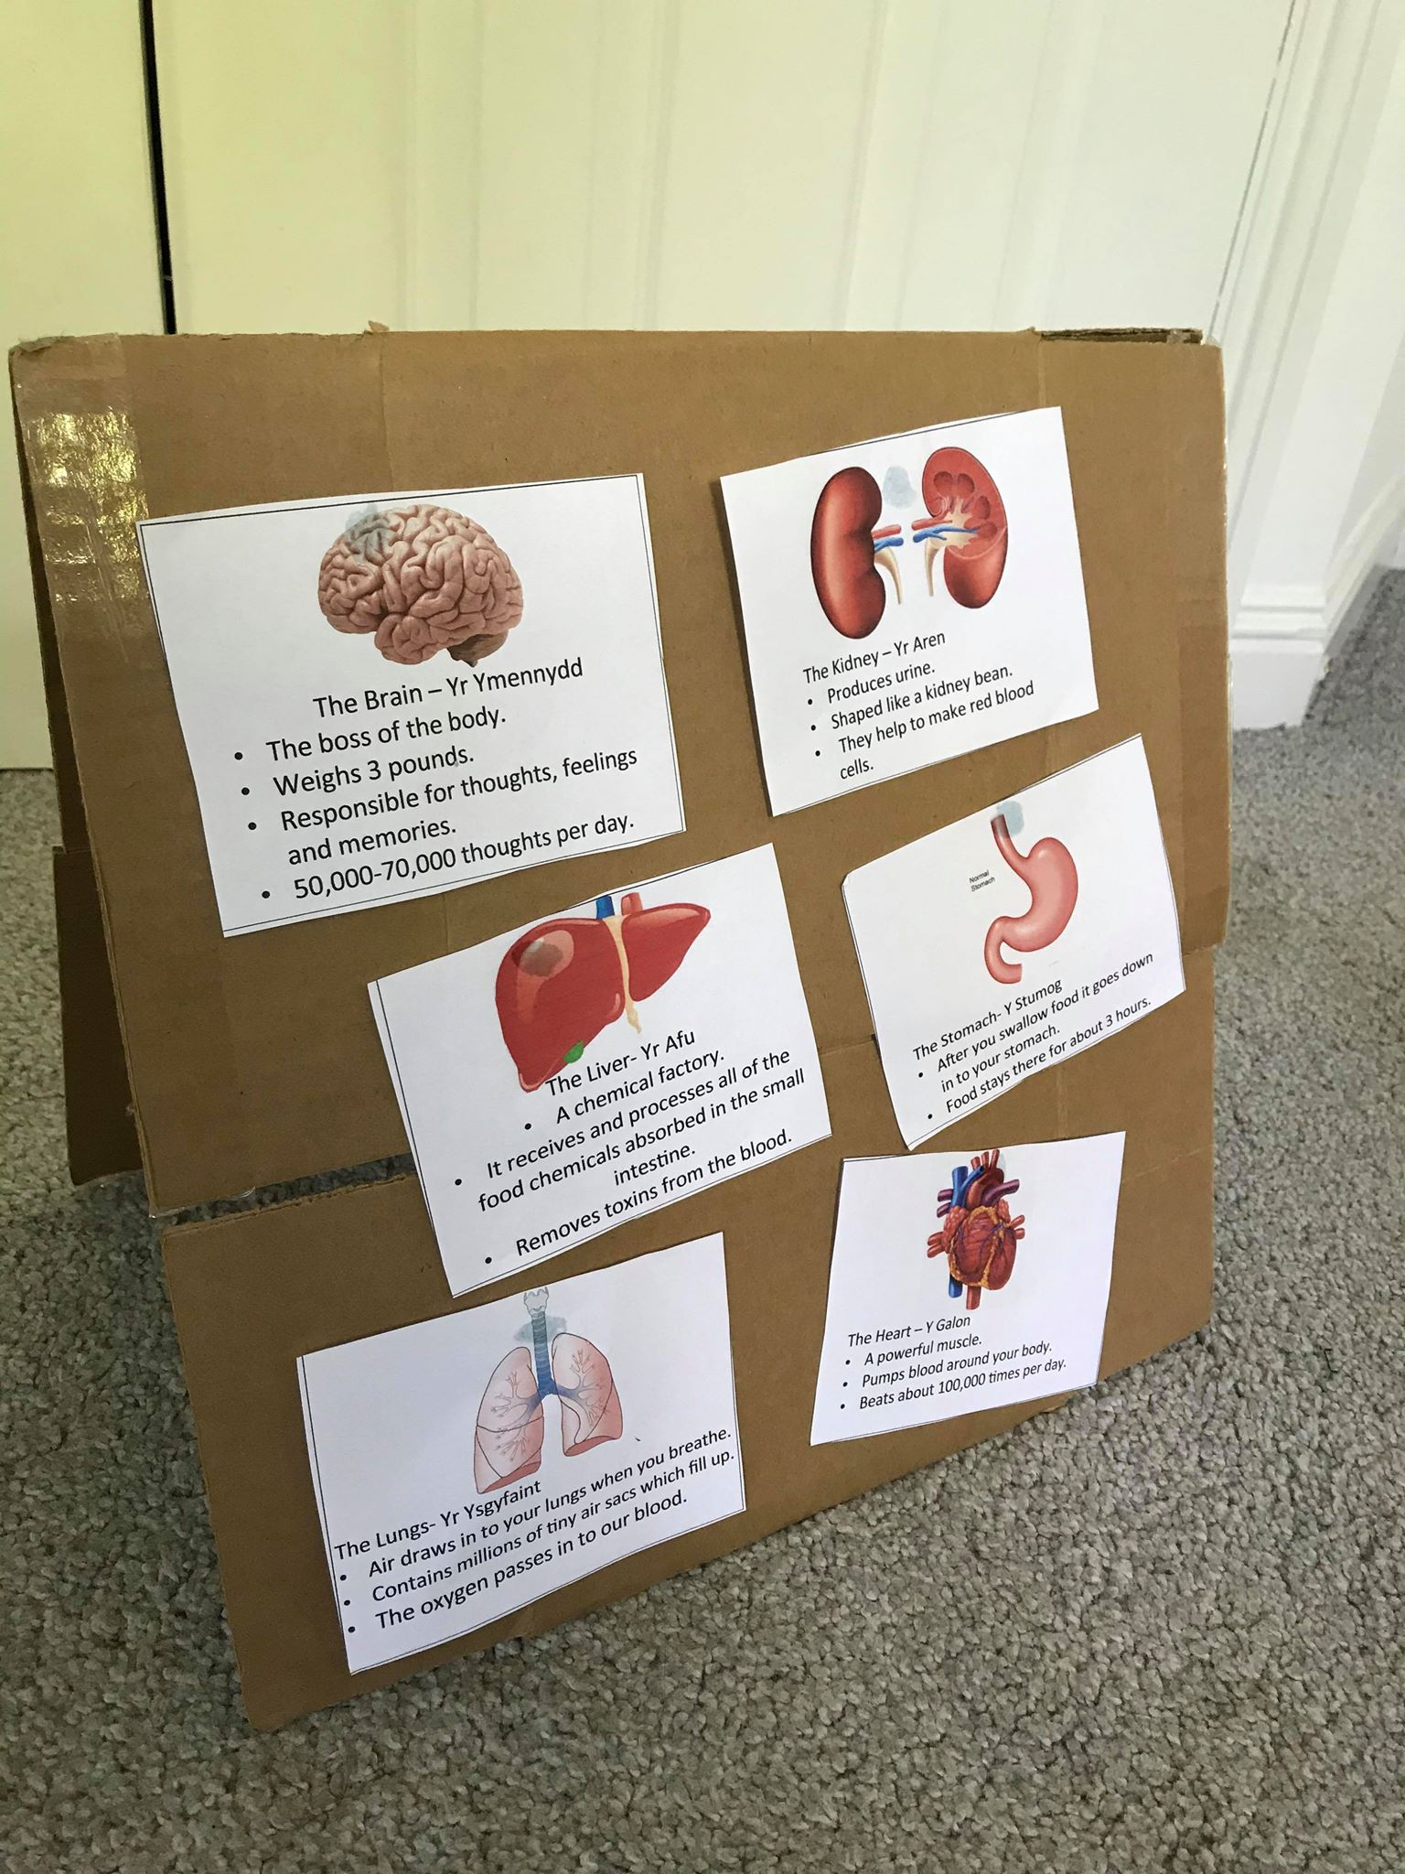

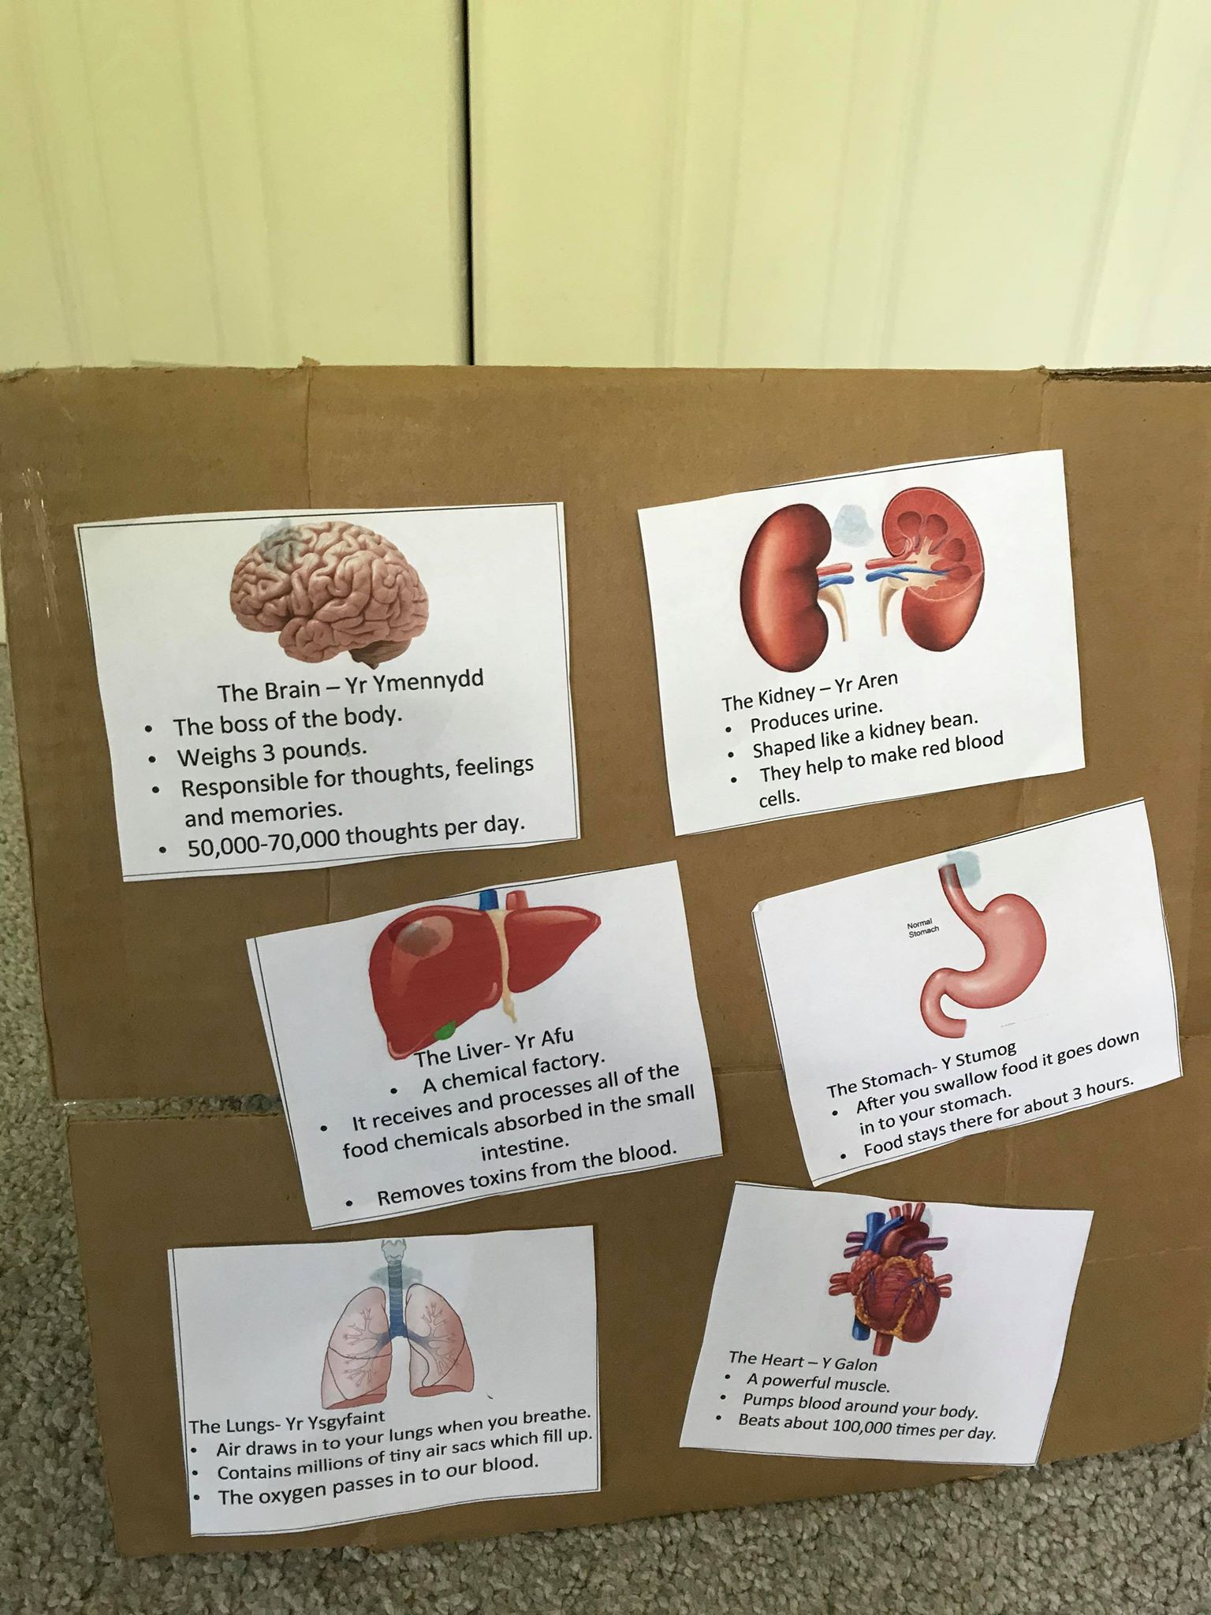

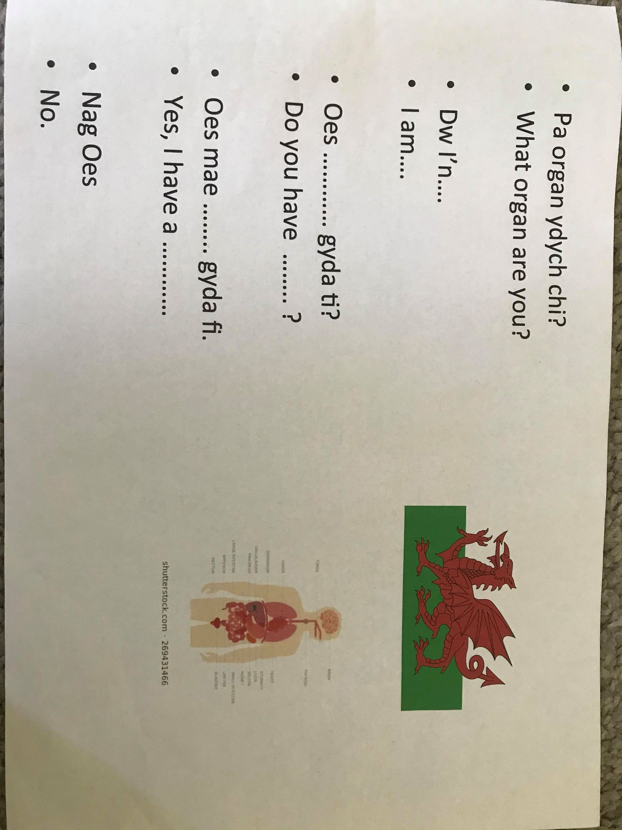

Lesson Plan 2

Student-teacher | Emily Thomas | Class: | Year 3
AoLE/Subject | Language, Literacy and Communication | Date: | 11th May 2020
Lesson Focus: | Welsh Language – Role Play and Writing Activity
Relevant/meaningful links to:  Curriculum  Cross-curricular responsibilities | Language Literacy and Communication  Expressing ourselves through languages is key to communication  Progression Step 2  - I can speak clearly, varying expression and gestures to communicate my ideas (During role-play)  - I can review my work and am beginning to use a range of familiar strategies and tools to improve my speaking and writing (Self-reflection process)  Understanding languages is key to understanding the world around us  - I can listen to, understand and later recall what I have heard.  - I can write legibly.  Expressive Arts  - I can give and accept feedback as both artist and audience.  - I can perform, produce, design, exhibit and share my creative work in a variety of ways for different audiences, inspired by a range of stimuli and experiences
Personal Targets  (Linked to QTS and identfied in weekly review) | - Welsh Language - There is a commitment to incremental development of personal skills in the use of the Welsh language  - Differentiation - The teacher demonstrates knowledge, understanding and experience of high expectations and effective practice in meeting the needs of all learners, whatever their different needs  ​

Learning Objectives (Focus on Learning) | To use first, second and third person language patterns in Welsh within writing and speech.
Success Criteria  (process/product) | I can speak about my own emotions in Welsh.  I can speak about someone else’s emotions in Welsh.  I can write Welsh sentences relating to emotions and parts of the body.

Key Resources Health & Safety | 3 to a group when performing  Y Meddyg Story Book  Language Mat 1 (Writing template)  Language Mat 2 (Writing template)  Computer for Skype  Welsh writing books  Pens

Time | Content, Pedagogy & Assessment Opportunities (key teaching points and questions)
Links to Previous Learning | Pupils can already label parts of the body including organs and simple appearances e.g yr ymennydd, pen, bola.  Pupils can already translate simple emotions from Welsh to English and vice versa.  Most pupils understand the difference between the first, second and third person in Welsh however this will be enhanced in the following lesson.
Opening Phase | An Afternoon of Welsh.  The teacher will perform a quick slot drill with the children repeating emotion words including, drist, hapus, etc (shown in promoting for Welsh planning sheet below). The teacher will also perform a slot drill with different body parts including yr ymennedd, bola, pen, yr afu and yr aren. The children will repeat these body parts using the sandwich technique “yr ymennedd -brain-yr ymennedd” completing actions alongside the body parts to help them memorise the vocabulary.  The teacher will read a book to the Year 3 pupils called Y Meddyg (Anifeiliad Difyr book) discussing how the characters are feeling. The Welsh book is about a Doctor (Doctor Jones the Giraffe) who visits the animals in the story to help them all get better. A question and answer 10 minute fire round will occur asking the children specific questions about the book including “Sut mae’r Llew / Siw / Arthur yn teimlo?” The children will respond to these questions using third person language patterns. Lower and middle ability children will be expected to say “Mae Llew’s bola yn brifo/poeni” “Mae pen Siw yn dost” and “Mae bys Arthur yn brifo/poeni.” Higher ability children will be expected to say “Mae Siw yn trist achos mae pen yn poeni” developing their sentence further. The teacher will use the Sandwich Technique in order to repeat the correct language patterns using the method of Welsh-English-Welsh for the children to listen to correct translations regarding how the characters are feeling. The children will repeat what the teacher says (audio-lingual method), almost in a Simon Says sort of game, pointing to the body parts discussed in the book and performing actions as to how each character is feeling.  AFL – Think Pair Share before teacher questions are asked, give them time to translate and think about how the characters are feeling and why.
Teaching & Core Learning | Summary of activity – Role-play activity with a doctor, receptionist and patient. The patient will describe to the doctor why they are feeling unwell and the doctor will try to get to the bottom of it to help (in Welsh). Children will use different Welsh language patterns, with language mat 2 assisting them in their development.  Pupils will become the characters in the story.  Children will participate in a writing and role-play activity working in groups of three. One pupil will become the doctor, one pupil will be the patient and one pupil will be the receptionist. All pupils can swap roles but will write out one script each. All pupils will be shown the writing template shown in Language Mat 1 below.  Lower ability groups will use and fill in the language mat as shown, adding in more complex sentences depending upon how easy they find the task. The teacher will work closely with these pupils to do this, supporting them further to add to their simple sentences. Middle ability pupils will be shown the template however, will be expected to add to their script using sentences including “Dw i’n ofnadwy achos mae coes dost gyda fi ac mae pen tost gyda fi” where they can adapt the feeling and what body part they feel pain within. Higher ability pupils will further develop their sentences including Dw i’n drist achos mae pen tost gyda fi a dw i eisiau chwarae rygbi heddiw” changing their emotion, where the pain lies and what they were hoping to do today. When higher ability pupils are using Dw i eisau, it will be emphasised by the teacher as to why it is not “Dw i’n eisau” repeating this throughout the lesson to see whether the pupils remember this pattern. The pupils will write their script in their Welsh books first, with all pupils utilising Language Mat 2 (differentiated by ability) shown below to assist them in their writing and development of Welsh skills. They will use first, second and third person language patterns depending on their roles, however they will all swap roles in order to practise writing and saying these patterns.  Once groups have finished writing their script, they will rehearse their performance reading their script using actions and facial expressions depending upon the emotions they have used. For example “Dw i ddim yn gallu chwarae rygbi [sad face expression] achos mae pen tost gyda fi [touches head and looks in pain]” utilising the direct-method. All children will watch the performances, giving critique as to what they could do in order to develop their Welsh skills and script further.  AFL- Self-reflections and peer reflections on performances.
Plenary | Another primary school in Carmarthen have completed the same activity. The class will Skype call this school, and both classes will perform their role-play doctor pieces, each class will attempt to translate the piece from Welsh to English and give constructive criticism as to how they could develop their Welsh writing and speech. A quick 5 minute slot drill will take place regarding emotions and parts of the human body – for example one child from one end of skype will shout “PEN – DRIST” the other child on the other end of skype will shout “HEAD – SAD” and so on.  AFL – Enhanced peer reflections on performances via Skype.

Welsh language utilised throughout the lesson:

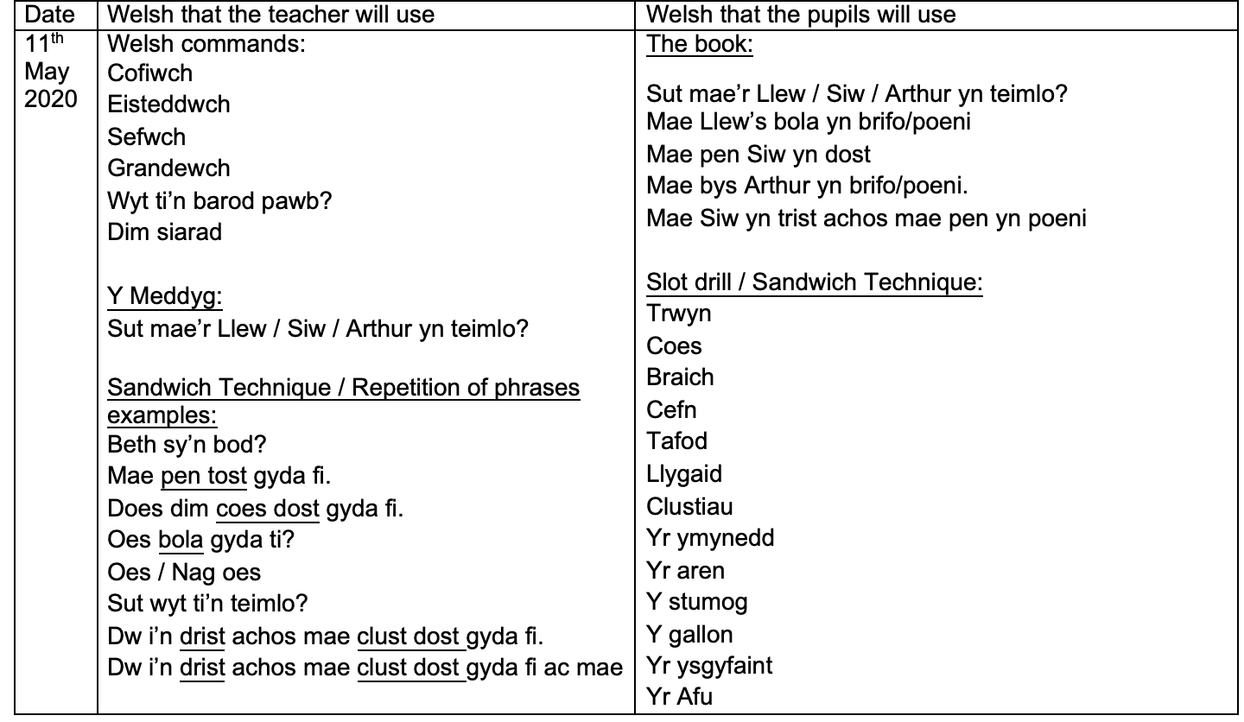

Yr ymennydd
Y

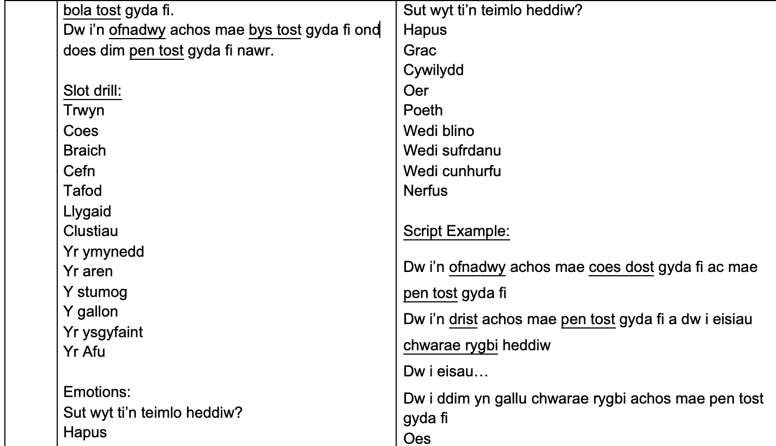
ymennydd
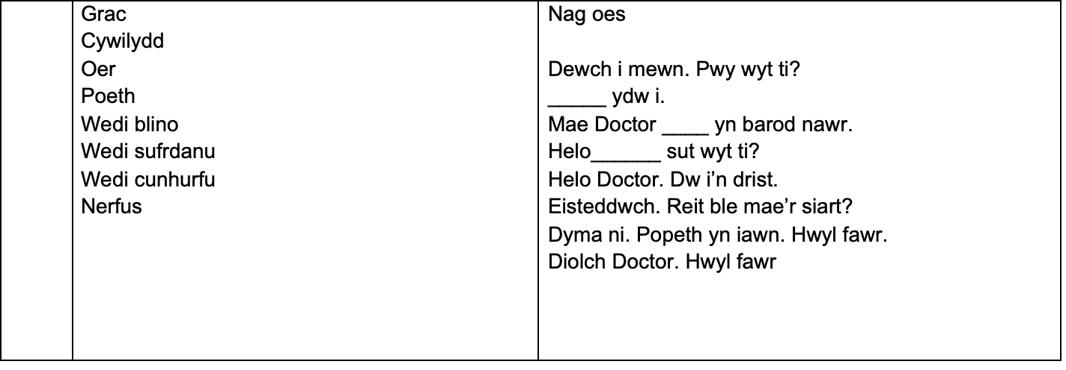

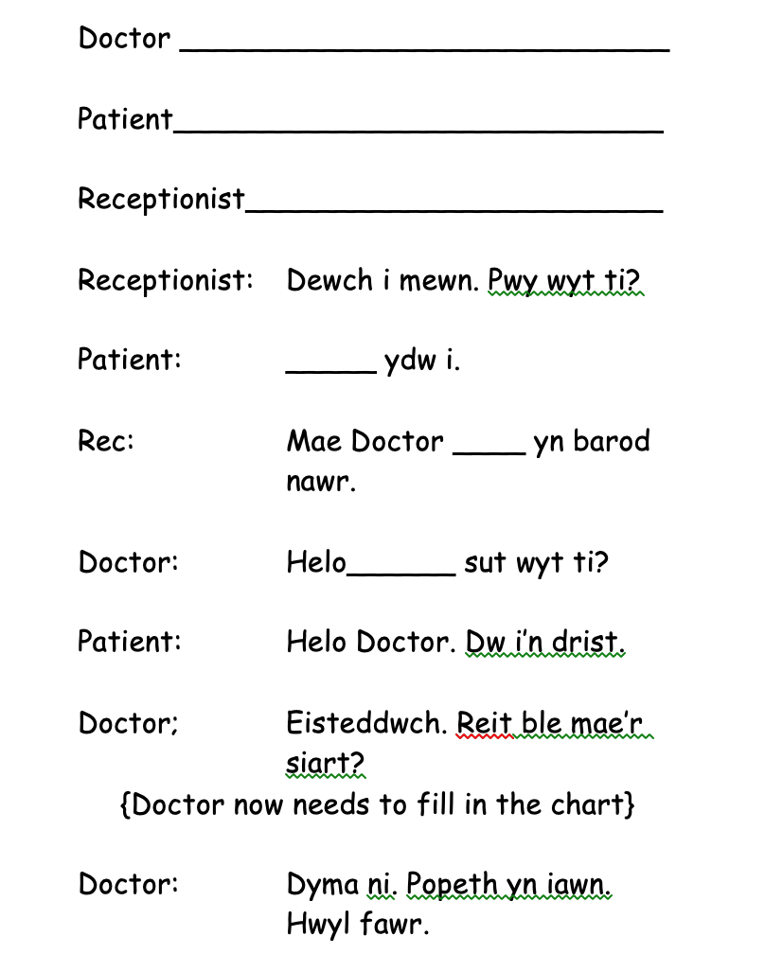
Language Mat 1

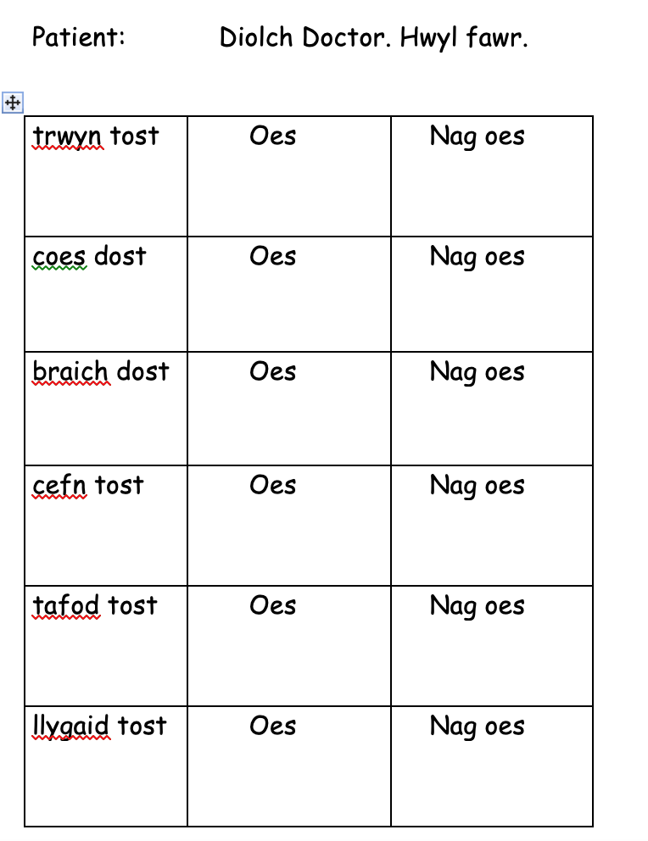

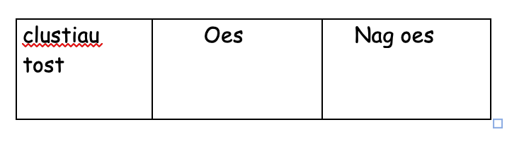

Language Mat 2

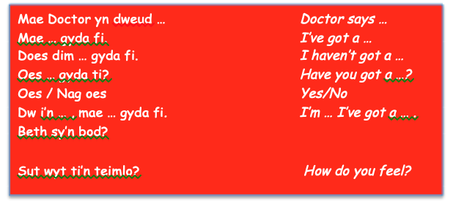
Lower Ability / Middle Ability / Higher Ability
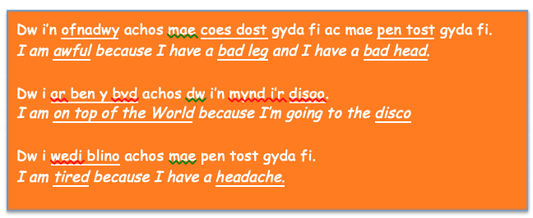
Middle Ability – To extend sentences
Higher Ability – To extend sentences
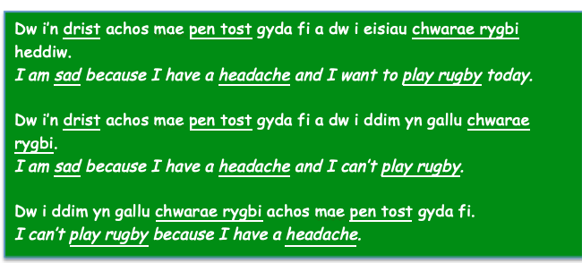

Reference List

Alisaari, J. and Heikkola, L.M. (2016). Increasing fluency in L2 writing with singing. Studies in Second Language Learning and Teaching, 6(2).

Andrews, A. (2011). Teaching Makes a Difference. IWA. [online]. Available at: https://www.iwa.wales/agenda/2011/02/teaching-makes-a-difference/ (Accessed: May 11th 2020).

Borruel, C.M. (2017). The role of task repetition in L2 acquisition. Basque: University of the Basque Country. [online]. Available at: https://pdfs.semanticscholar.org/66b4/bf8b2a622ff8c7e146c94d6e8c07d42252a9.pdf (Accessed: May 11th 2020).

Butzkamm, W. (2010). The Sandwich Technique. [online]. Available at:

Caldwell, J.A. (1990). Analysis of the theoretical and experiential support for Carl Dodson's bilingual method. Journal of Multilingual & Multicultural Development, 11(6), pp.459-479.

Conner, M. (2002). Transforming Culture: An Executive Briefing on the Power of Learning. Virginia: The University of Virginia’s Darden Graduate School of Business Administration.

Edwards, E. and Roger, P.S. (2015). Seeking Out Challenges to Develop L2 Self-Confidence: A Language Learner's Journey to Proficiency. Tesl-Ej, 18(4).
Estyn. (2017a). The Annual Report of Her Majesty’s Chief Inspector of Education and Training in Wales 2017-2018. [online]. Available at: https://www.estyn.gov.wales/sites/www.estyn.gov.wales/files/documents/ESTYN_Annual%20Report_Accessible_English__2018.pdf (Accessed: May 11th 2020).
Estyn. (2017b). Engaging all pupils in the Welsh language. [online]. Available at: https://www.estyn.gov.wales/effective-practice/engaging-all-pupils-welsh-language (Accessed: May 11th 2020).

Estyn. (2017c). Welsh-medium and bilingual teaching and learning in further education. Cardiff: Crown. [online]. Available at: https://www.estyn.gov.wales/sites/www.estyn.gov.wales/files/documents/Bilingual%20Teaching%20in%20FE.pdf (Accessed: May 11th 2020).

Estyn. (2018). Developing Welsh language skills for early years learning. [online]. Available at: https://www.estyn.gov.wales/effective-practice/developing-welsh-language-skills-early-years-learning (Accessed: May 11th 2020).

Freedman, D.H. (2018). How to almost learn Italian. TheAtlantic. [online]. Available at: https://www.theatlantic.com/magazine/archive/2018/12/language-apps-duolingo/573919/ (Accessed: May 11th 2020).

Furlong, J. (2015). Teaching Tomorrow’s Teachers. Oxford: University of Oxford. [online]. Available at: https://gov.wales/sites/default/files/publications/2018-03/teaching-tomorrow’s-teachers.pdf

Garcia, A. (2016). 5 reasons to learn a language through music - ESL language studies abroad. [online] ESL language studies abroad. Available at: https://blog.esl-languages.com/blog/learn-languages/5-reasons-to-learn-a-language-through-music/ (Accessed May 11th 2020).

Ghazi-Saidi, L. and Ansaldo, A.I. (2017). Second language word learning through repetition and imitation: Functional networks as a function of learning phase and language distance. Frontiers in human neuroscience, 11, p.463.

Grebow, D. (2012). At the Water Cooler of Learning. MarciaConner. [online]. Available at: http://marciaconner.com/water-cooler-learning/ (Accessed: May 11th 2020).

Habrat, A. (2018). The Role of Self-Esteem in Foreign Language Learning and Teaching. Springer.
https://juergenkurtz.wordpress.com/2010/12/22/the-sandwich-technique/ (Accessed: May 11th 2020).

Hyltenstam, K. and Pienemann, M. eds. (1985). Modelling and assessing second language acquisition (Vol. 18). Multilingual matters.

Jones, O., Macpherson, A. and Jayawarna, D. (2014). Resourcing the start-up business. 1st ed. Abingdon: Routledge Taylor & Francis Group.

Kim, Y. and Tracy-Ventura, N. (2013). The role of task repetition in L2 performance development: What needs to be repeated during task-based interaction?. System, 41(3), pp.829-840.

Langton, S. (2013). Eighty Percent of Learning is Informal. iWeb. [online]. Available at: https://www.itweb.co.za/content/VKA3WwqdwQXMrydZ (Accessed: May 11th 2020).

Lightbown, P. Spada, N. (2014). Patsy Lightbown and Nina Spada on How Languages are Learned (3 of 3): Oxford University Press ELT [video]. Available at: https://www.youtube.com/watch?v=pxMpgcIkfOo&t=76s (Accessed: 11th May 2020).
Macias, E. (2008). Music and Songs in the Classroom: Techniques to aid the language learning process. [online]. Available at: http://searchwarp.com/swa361554.htm (Accessed: May 11th 2020).
Mora, C.F. (2000). Foreign language acquisition and melody singing. ELT journal, 54(2), pp.146-152.
Nor, N.M. and Ab Rashid, R. (2018). A review of theoretical perspectives on language learning and acquisition. Kasetsart Journal of Social Sciences, 39(1), pp.161-167.

Palmer, A. (1971). Communication Practice vs. Pattern Practice or alive teacher is absolutely necessary. In English teaching forum (50).–P (pp. 25-31).

Piaget, J. (1955). The construction of reality in the child. Journal of Consulting Psychology, 19(1), p.77.

Rukholm, V.N. (2015). Singing to speak: An examination of adult L2 learners and vocabulary learning through song. Italica, pp.171-192.

Saylag, R. (2012). Self reflection on the teaching practice of English as a second language: Becoming the critically reflective teacher. Procedia-Social and Behavioral Sciences, 46, pp.3847-3851.

Shepherd, J. (2018). Learn Welsh: Lesson 7 and 8 (Omnibus edition). Learn Welsh Podcast. [video]. Available at: https://www.youtube.com/watch?v=Wh803caxXpo&feature=emb_title (Accessed: May 11th 2020).

Skehan, P. (2009). Modelling second language performance: Integrating complexity, accuracy, fluency, and lexis. Applied linguistics, 30(4), pp.510-532.

Vandergrift, L. (2004) . Listening to learn or learning to listen? Annual review of applied linguistics, 24, pp.3-25.

Vesselinov, R. and Grego, J. (2012). Duolingo effectiveness study. City University of New York, USA, 28.

Vygotsky, L.S. (1978). Mind in Society: The development of higher psychological processes. Cambridge, MA: Harvard University Press.

Welsh Government. (2017a). Cymraeg 2050: A Million Welsh Speakers. Cardiff: Welsh Government. [online]. Available at: https://gov.wales/docs/dcells/publications/170711-welsh-language-strategy-eng.pdf (Accessed 10th May 2020). (WG)

Welsh Government. (2017b). Welsh in Education: Action Plan 2017-21. Cardiff: Crown. [online]. Available at: https://gov.wales/sites/default/files/publications/2018-02/welsh-in-education-action-plan-2017–21.pdf (Accessed: May 11th 2020). (WG)

Welsh Government. (2019). Welsh Language Competence Framework. Cardiff: Crown. [online]. Available at: https://gov.wales/sites/default/files/publications/2019-06/welsh-language-competency-framework-for-education-practitioners.pdf (Accessed: May 11th 2020).

Wood, D., Bruner, J.S. and Ross, G. (1976). The role of tutoring in problem solving. Journal of child psychology and psychiatry, 17(2), pp.89-100.

Yokoyama, S., Okamoto, H., Miyamoto, T., Yoshimoto, K., Kim, J., Iwata, K., Jeong, H., Uchida, S., Ikuta, N., Sassa, Y. and Nakamura, W. (2006). Cortical activation in the processing of passive sentences in L1 and L2: An fMRI study. Neuroimage, 30(2), pp.570-579.

Yoshimura, Y. and MacWhinney, B. (2007). The effect of oral repetition on L2 speech fluency: An experimental tool and language tutor. In Workshop on Speech and Language Technology in Education.

Appendices

Appendix 1

https://www.youtube.com/watch?v=JaFwNixb4Ms&feature=youtu.be
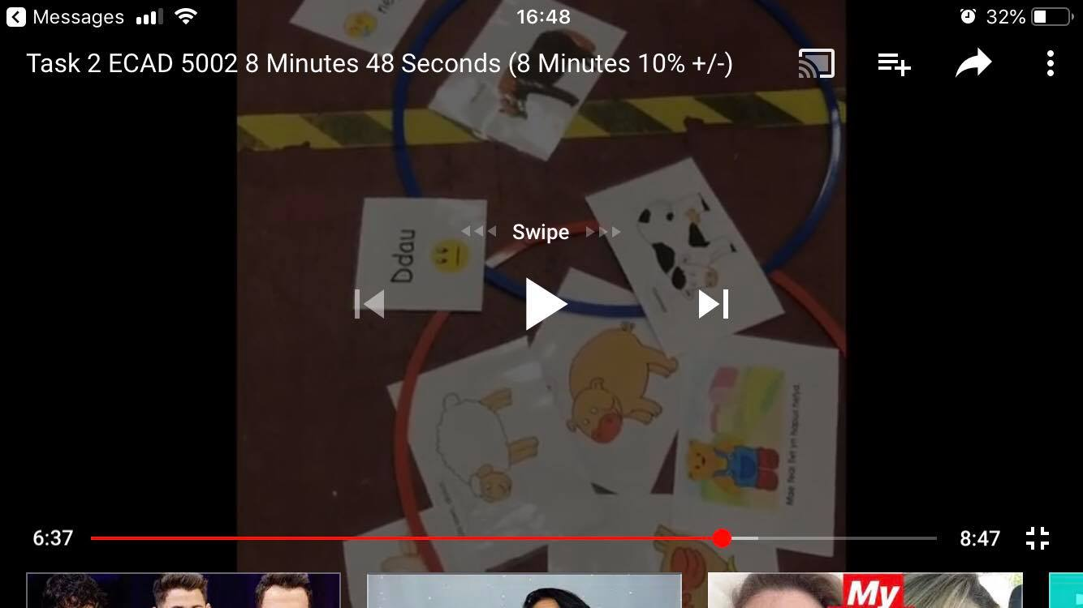

Appendix 2

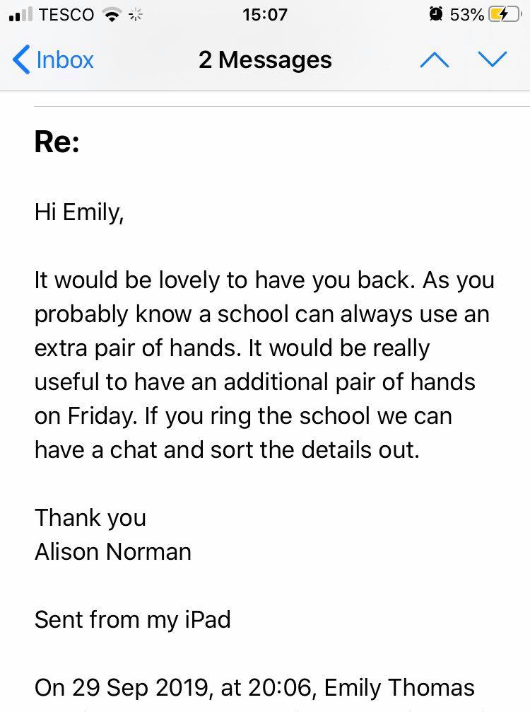

Appendix 3


