Assessment 1 Marking sheet

Module: BMPL6011 Conducting Investigations.
Assessment 1 Role Play, practical demonstration of knowledge application and demonstration of thought processes.

Student Name: | Jacob Cox
Student ID: | 2205411
Module Tutor: | M Thomas
Assessment 1 | Grade 0-19 | Grade20-39 | Grade 40 - 59 | Grade 60-69 | Grade 70+
Categories | Unsatisfactory | Improvement needed | Satisfactory / Good | Very Good | Excellent
Critical application of the National Decision Model | No / minimal reference to NDM | Reference made to but no application of NDM | Reference made to and a basic application demonstrated or NDM | A Very good reference made to and very good application of NDM | Excellent reference and application of the NDM
Stage 1  Gather Info and Intel  THRIVE  W’s & H’s  Witness/Victim details |  |  |  | Very good 5 WH questions of informant  Identification of victim and overview of events
 |  |  |  | Mark | 15 /20
Stage 2  Assess TRH and develop a working strategy  Golden hour Principles  Cross Contaminations  Crime Scene Management Considerations  3 Types of Evidence (DNA/Trace/Impressions) |  |  | Awareness of Golden Hour principles, used common pathway, identified. Gloved up to reduce contamination of scene, considered photographs but forgot about BWF. Decided to call CSI update control
 |  |  |  | Mark | 15/30
Stage 3  Consider Powers and Policies  Identify potential offence  Power of Arrest  IDCOPPLAN  Power of Entry  Power of Seizure  Power of Search |  |  |  | Identified offence as Burglary, possibly 9 1a or 9 1b. Ran through Assume nothing, Believe nothing and Challenge everything.  Gave Code G necessity for suspect  Identified search was with consent  Power of seizure Id’d as Sec 19
 |  |  |  | Mark | 17/20
Stage 4  Options and Contingencies  Officer Actions  Assistance  4 R’s |  | . |  | Called for CSI  Started log  Would take witness statements  Speak with security  Check CCTV
 |  |  |  | Mark | 8/10
Stage 5  Action and review  4 R’s |  |  |  | Talked through review record and retain appreciating his hypothesis was constantly under review and may change  Identified blood on table, cupboard, knife and window and can however missed DNA opportunities on cup / cans from saliva
 |  |  |  | Mark | 6 /10
Stage 6  Code of Ethics |  |  |  | Professional and very minded on the scene, did however miss safeguarding and target hardening for the victim
 |  |  |  | Mark | 5/10
Total Marks |  |  |  |  | 64 /100
Overall Comments / Summary of Feedback.

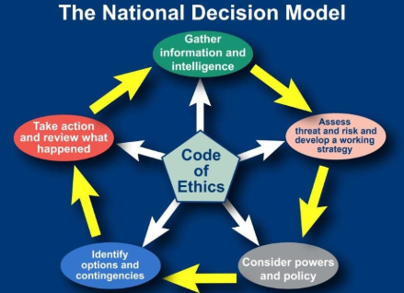

Golden hour considerations
Area | Considerations
Victims, witnesses and suspects | - Identification.  - Risk assessment.  - Safeguarding.  - Support, such as a family liaison officer or sexual offences liaison officer.  - Sensitively preserve and gather initial account and material (for example, clothing, forensic samples and digital opportunities) as appropriate. Consider use of body-worn video (BWV) for initial accounts.  - Use sensitive, non-accusatory and impartial language.  - Use communication enablers to support victims and witnesses, such as interpreters, intermediaries, and appropriate adults.  - Consider victims’ rights under the Code of Practice for Victims of Crime(opens an external website in the same tab), and conduct a victim needs assessment.  - Consider community impact and reassurance.  - Consider and record contextual background to situation, such as the demeanour of parties involved and the circumstance of the victim, suspect and any dependents (consider BWV). This may include the condition of their home environment, the overall welfare of the parties involved, previous calls for service, previous offending history and/or intelligence.  - Where the suspect is not already known, take steps to identify, trace, investigate and evaluate persons of interest.  - See APP on Working with suspects.
Scenes | - Identify, preserve (prevent contamination) and gather (where appropriate) material. Where material is exposed to the elements – such as footmarks in mud, or blood stains – take steps to preserve or protect pending recovery.  - Assess and commence crime scene log.  - Consider:  - entry and exit routes  - escape routes  - cordons  - forensics (including digital forensics)  - exhibits  - Remember that victims, witnesses and suspects are also scenes. Take steps to avoid contamination – for example, take victims and suspects to different police buildings and keep contact officers with each group separate. See also APP on Scene strategy.
Records | - Record decisions with rationale, circumstances (using professional curiosity to provide background detail, see the 'family and community' section of this table) and what is known (including 999 recordings and call taker notes).  - Witness first account given, description of suspects.  - Identify risks or threats.  - Consider use of incident management log, decision log, scene log, exhibits log and passive data, such as digital images and BWV.
Physical evidence | - Identify, preserve and gather physical and digital evidence – including use of crime scene investigators, digital media investigators, forensic evidence, use of early evidence kits, digital and passive data, CCTV and documentary evidence. See also APP on Forensics and Closed Circuit Television (CCTV) initial training level one(opens an external website in the same tab) (you will need to log in to College Learn).  - Consider proportionality and relevant powers. See APP on Investigative strategies – Scene strategy and Physical evidence.
Intelligence | - Identify and use police, community and open-source intelligence to inform risk and threat assessment, decision making and investigative lines of enquiry.
Lines of responsibility | - Identify, inform, brief and coordinate, as appropriate.  - Consider escalation to the appropriate line management or team.  - Consider relevant authorities for powers – for example, search and/or seizure, and use of the Police and Criminal Evidence Act 1984 (PACE) powers and identify authorising officers as appropriate.
Family and community | - Consider cultural and community factors, including:  - the protected characteristics of involved parties  - communities where cultural practices may exist, such as so-called honour-based abuse and female genital mutilation  - language and communication  - neurodiversity  - Consider the safety of those at the scene (for example, cordons and safeguarding actions).  - Identify a critical incident and escalate, if appropriate.  - Consider engagement with force media department.  - Consider specific duties under Children Act 2004, s 11(opens an external website in the same tab) and Equality Act 2010, s 149(opens an external website in the same tab).

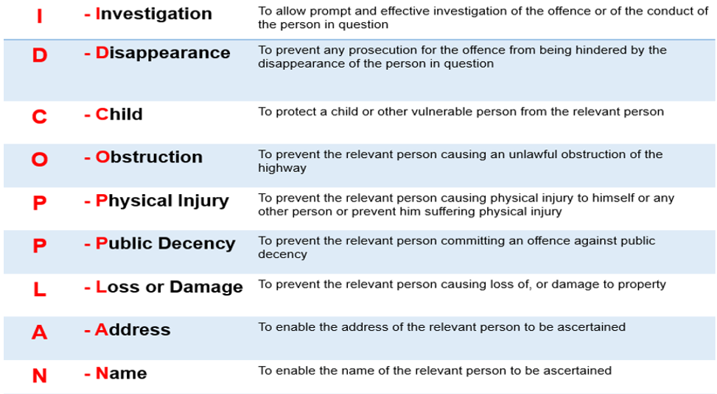
Sec 17, 18, 32 and 19 PACE 1984


