BMIH6008 Hotel Placement Research Project

Project Title: An Analysis of the Impact of Technology Adoption on Guest Experience: A Case Study of Novotel Birmingham Centre

Student’s Name: Saiyful Alam Chowdhury
Student’s ID: 2132062
Lecturer Name: Dr Ernest Balutie Wavei

Abstract
The research examines how digital technology influences guest satisfaction at Novotel Birmingham Centre through multiple digital services including electronic check-ins and interactive kiosks. The research analyses guest opinions during January to March 2025 to evaluate both operational benefits and customer satisfaction related to these technological systems.
Guests primarily use mobile check-in services through digital channels at Novotel Birmingham Centre leading to decreased check-in durations of 50% with better guest accessibility. Front desk operations benefit from self-service kiosks yet occasional technical problems made some guests depend on staff support. AI chatbots along with smart room controls enhance guest experience although they need better automation features and more personalised services.
The hotel faces technical problems alongside guest and staff digital competence differences as well as security threats. The personalisation capabilities automation systems and security protocols at Novotel fall behind the current implementations within Hilton and Marriott properties.

Table of Contents
Abstract 1
Introduction 3
Literature Review 4
Methods 8
Case Study Hotel Overview and Findings 10
Introduction to Novotel Birmingham Centre 10
SWOT Analysis 12
PEST Analysis 16
Competitor Analysis: Digital Services and Price vs. Quality 18
Reflective Account 20
Discussion 20
Introduction 20
Evaluating the Impact of Digital Check-in Systems and Self-Service Kiosks at Novotel Birmingham Centre 21
Identifying the Most Used Digital Technologies and Their Role in Reducing Check-in and Check- out Times 23
Conclusion 26
Recommendations 28
References 32

Introduction
Background Information
Modern technology revolutionised hotel management through new ways of offering services combined with better customer interaction methods and enhanced operational effectiveness (Buhalis et al., 2019). Guest expectations along with their hotel experiences have drastically changed due to advancements in digital innovation including AI and automation and smart hotel technology. Today's travelling visitors seek straightforward services using advanced technology that hotels work to include as part of their service offerings (Camilleri and Camilleri, 2018). Competitive businesses can no longer delay their digital transformation because it stands as an indispensable requirement to succeed in this customer-driven operational marketplace.
Novotel Birmingham Centre within the Accor Group continues to integrate technology throughout its operations as a key element of its guest satisfaction and business process advancement plan (Bohdanowicz and Zientara, 2016). The Birmingham hotel sits in the city centre to serve both business guests and tourists with modern lodging options and spaces for meetings alongside food service facilities. Novotel Birmingham Centre advances service delivery through its adoption of mobile check-in and check-out functions together with AI-powered concierge services and automated room controls as well as digital key features (Muhitdinova et al., 2020). The new technologies implement strategies that boost practicality along with operational speed and better serve customer needs.
Digital solutions are convenient however they can also be problematic because the interaction will reduce the human, have technical flaws, and may worry about data security (Buhalis et al., 2019). Novotel Birmingham Centre needs to understand how these technological changes impact guest perceptions and satisfaction and how this will affect its service strategy. This study investigates the impact of a hotel’s technological adoption and its consequences on basic service quality, customer satisfaction and operational performance.
Project Aim
The project aims to examine how technology adoption influences guest experience and satisfaction at Novotel Birmingham Centre.

Project Objectives
- To evaluate the impact of digital check-in systems and self-service kiosks through feedback analysis of Novotel Birmingham Centre guests from January to March 2025.
- To identify what digital technologies receive the highest use at the hotel then determine how they shorten check-in and check-out operations by 20% during three months.
- To recommend data-based implementations that boost hotel technological adoption levels to achieve a minimum 15% increase in guest satisfaction ratings before May 2025 concludes.
Research Question
- Q1: How does the integration of smart technology enhance service efficiency and guest satisfaction in the hospitality industry?
Scope and Organisation
This research analyses the importance of technology adoption in enhancing guest experience at Novotel Birmingham Centre. The section continues with several key sections within the study. While the literature review critically reviews the research done on technology in the hospitality industry, it analyses the key theorists and trends in digital transformation. The Research Methodology consists of an outline of the research methodology in terms of the case study approach and the qualitative data collection techniques followed, which has justified the chosen research design (Baskarada, 2014). The Case Study – Novotel Birmingham Centre provides a detailed study of the hotel with its technological advances, operational aspects and customer service strategies. It also includes SWOT and PEST analysis to aid a concise or holistic understanding of the hotel’s placement.

Literature Review
Introduction
Hotel guest communications underwent significant transformations through different technological developments which include artificial intelligence (AI), the Internet of Things (IoT) and mobile applications and automation during the past decade (Buhalis and Moldavska, 2022). This paper critically reviews the existing research on technology adoption in the hospitality industry regarding its effect on guest satisfaction, operational efficiency, and competitive advantage. It highlights important research gaps, as well as the issues and future lines of work in this area.
The Role of Technology in Enhancing Guest Experience
Various studies relate the need for technology to enhance the guest experience. Vashishth et al. (2025) opine that smart hotel technologies like mobile check-in, AI powered chat bots etc. help in providing personalised and seamless customer experience. In the same vein, Anwar et al. (2024) support that hotels can emerge as digital transformation enables automated predictions of guest preferences and provision of tailored services which result into improved customer satisfaction.
Liu et al. (2020) recognised as a huge factor in improving the guest experience are also self-service technologies (SSTs). SSTs, like kiosks and mobile applications, help guests to manage a stay themselves without the need of line waiting, offers a lazy time approach and provide extra convenience (Asiedu et al., 2025). Park et al. (2022) mention that SSTs may reduce human interaction, which some guests consider a substantial component of the hospitality experience.
Factors Influencing Technology Adoption in the Hospitality Industry
Factors such as the cost, power infrastructure, customer expectation, as well as the management support partly drive adoption of technology in hotels. According to Chung et al. (2018), there is a major barrier to embracing new technology facing small and medium sized enterprises (SMEs) in the hospitality sector. Lattacher and Wdowiak (2023) further suggest that successful technology adoption needs to marry with customer needs and preferences as well.
The implementation of technology is also closely tied to acceptance and training of the employees. According to Pencarelli (2020), new digital tools will bring upon hotel staff improvement in their use of such technology, which will need adequate training. Resistance to change among employees can initiate difficulties in the smooth placement of technology, resulting in a poor guest experience.
Impact of Technology on Operational Efficiency
Technology has had a significant impact on many hotels, and thus research has studied this well throughout. According to Ivanov and Webster (2019), by automating and employing AI in processes, such as hotel reservations, housekeeping, and customer service, budget and efficiency are lowered. As an example, robot concierges and AI-based chatbots have been introduced in the premier hotel chains to take care of customer queries and make bookings (Manohar et al., 2024).
Big data and analytics have also been used to boost operational efficiency. According to Saleh et al. (2024), supports hotels to predict demand, make the best pricing decisions and are more effective to manage the resources. Privacy and data security concerns continue to pose critical challenges to all the hospitality industry to operationalise big data analytics (Xiang et al., 2015).
Challenges and Limitations of Technology Adoption
Though advantageous the arrival of technology in hospitality operations brings multiple operational obstacles to overcome. Security concerns stand as the main issue in the hospitality sector. Guests face an elevated risk of data security threats because hotels obtain numerous personal details from their patrons (Chen et al., 2023). Compact security protocols should be implemented as prime elements that safeguard guest data while building trust between hotel operators and their visitors.
The challenge involving technological inequality presents itself as the digital divide. Yang et al. (2021) indicate that technology convenience levels among guests vary resulting in different comfort levels when using digital interfaces. Hotels need to implement technology without causing isolation toward specific guest groups which include senior citizens and people with minimal knowledge of digital devices.
Certain hospitality establishments find the expenses related to technology implementation either too costly or beyond their budgetary capacity (Chan et al., 2018). Novotel alongside other large hotel chains possess enough financial strength to deploy contemporary technologies but smaller establishments sometimes lack sufficient funds for such investments. He et al. (2023) demonstrates that return on investment (ROI) induces anxiety among numerous hotel managers who evaluate digital transformation programs.
Solutions and Future Opportunities
The solution requires hotels to find equilibrium between their technology deployment approaches. Sheng et al. (2024) present a service framework that blends automatic digital technology with human assistance thereby ensuring technology boosts person-to-person contact rather than diminishing it. AI-powered chatbots take care of standard customer matters but human hotel personnel focus on complex service requests.
Investing in training staff and implementing programs for change management represents essential factors to success. According to Fernandez and Rainey (2017), adequate training about digital tools for employees creates less workplace resistance and delivers better services. Hotels should provide guest education which teaches customers about new technologies to increase their experience with hotel services.
Wenhua et al. (2023) suggest that blockchain technology provides an effective response to handle security problems with data storage. Habib et al. (2022) announce blockchain technology as a security solution because it uses tamper-proof distributed data storage to secure hotel operational data. Studies need to investigate how blockchain technology can be employed specifically within hotel services.
Technology has the power to create meaningful change in sustainability practices which represents a novel development in the social realm. Smeenk and Petock (2023) establish that hotel operators can decrease their carbon impact through smart energy systems with IoT-connected devices when implementing them correctly to preserve guest comfort levels. Hotels which adopt technological solutions for sustainable operations can establish themselves as leaders in the travel sector since travellers increasingly show environmental concern.
Research Gaps
Although relevant literature offers useful knowledge regarding the technology adoption in the hospitality sector, it still has some holes to fill. First, most of the studies are dedicated to large international hotel chains and very few studies are about the technology adoption in small independent hotels. Future research can examine how SMEs in the hospitality industry integrate digital innovations. Second, there is a lack of literature concerning the long-term effects of technology adoption on guest loyalty. Many studies have investigated immediate guest satisfaction whilst there is a need for additional enquiries into whether technology-driven experiences translate to repeat business and customer retention. Lastly, the study does not explore the role of cultural differences in technology adoption. Different guests from different cultures could have different expectations and comfort levels when dealing with digital technologies (Buhalis et al., 2019). Future research focuses on how hotels can tailor their technology adoption strategies to many different guest demographics.

Conclusion
Technology adoption in the hospitality industry has revolutionised the guest experience and has impacted guest experience, operational efficiency and how competitive can the industry position. Hotel investment through adopting a balanced approach that includes automation with human interaction, investing in staff training, and the latest things like blockchain and sustainability strong innovations, can boost guest satisfaction and help in optimising the hotel's operational performance. Existing gaps in future research should be addressed to better understand the long-term implications of technology in the industry of hospitality.

Methods
The methodology employed in this study is qualitative case study, as the focus is to understand how technology adoption affects the guest experience based on Novotel Birmingham Centre. The use of case study approach would facilitate an in-depth analysis of the hotel’s technological advancements and how they changed the hotel’s customer satisfaction and efficiency in operation.
Case Study Methodology
The case study method is extensively adopted in hospitality research to generate an ample, contextual understanding of certain phenomena. Chen and Chen (2022) argue that case studies are very useful for investigating contemporary real-life events in which the boundaries between the context and the phenomenon are indistinct. This method proves useful in researching Novotel Birmingham Centre where some digital innovations like mobile check-ins, AI-powered concierge and automatic controls have been used to improve guests’ experience.
Another key reason supporting the use of the case study methodology is that it can provide an integrated perspective of particular arrangements or policies (Neuhofer et al., 2015). This study aims to assess the effectiveness of the technology adoption in hospitality services by analysis of multiple data sources such as real-time observation, guest review and operational reports. Case studies are subject to inherent flaws of potential subjectivity and generalisability (Tsang, 2014). Specific limitations are addressed by using complementary research techniques, which include the use of netnography, and reflective analysis.

Netnography
This study adapts the qualitative research method netnography from ethnography adapted with online guest reviews and customer feedback to be analysed. This method is useful for understanding the perception of technological change in hotels by customers (Bartl et al., 2016). This study goes further to capture real-time customers' sentiments over the technological services at Novotel Birmingham Centre using reviews from review platforms such as TripAdvisor, Google Reviews and Booking.com. On the other hand, netnography can be used with some advantages. It permits direct access to a large quantity of data that can reduce response bias when needed (Jeacle, 2021). There are also obstacles in terms of the authenticity and credibility of online reviews, which may be limited or even created.
Reflective Analysis
This study also utilises a reflective account from the firsthand experience of working at Novotel Birmingham Centre and also includes netnography. The function of reflective analysis offers an insider’s view of how the technology impacts guest service, delivery of service and operational efficiency. As explained by Farrell and Ives (2015), reflective practice has an impact on understanding professional experiences by critically examining the observed patterns and behaviours. Observations made during employment at Novotel Birmingham Centre include staff interactions with automated systems, guest reactions to self-service kiosks and the operational challenges of digital solutions. Reading is systematically documented and analysed to complement netnographic research findings.
Data Collection and Analysis
The primary data for this research study comes from two main sources which include online guest reviews and reflective observations. Online Reviews of Guests Originated from TripAdvisor, Google Reviews and Booking.com where thematic analysis served as the evaluation method. Personal perspective determines the adoption status of Novotel technologies through specific topics including service quality operational effectiveness and guest experience outcomes. A thematic analysis technique retrieves patterns and trends from the collected netnographic and reflective data. According to Reid and Duffy (2018) description this method requires analysts to code text data for obtaining major themes and significant revelations.

Case Study Hotel Overview and Findings

Introduction to Novotel Birmingham Centre
Novotel Birmingham Centre stands in the central portion of Birmingham within the United Kingdom. Accor Group operates as Novotel Birmingham Centre from its location in the Birmingham centre of the United Kingdom (Afrianto and Gulö, 2019). Novotel Hotels provides current business-oriented hotel rooms which appeal to companies and recreational visitors. The Birmingham Centre hotel branch occupies a strategic position on Broad Street where travellers find access to lively evening scenes and corporate areas together with cultural venues.
Brand and Location
Accor established Novotel’s parent company in 1967 and now operates globally as one of the foremost hospitality organisations. As part of the Accor family, Novotel exists as a midscale brand that focuses on delivering high-quality service through innovative, sustainable practices. One of over 30 Novotel hotels in the UK operates under Novotel Birmingham Centre, an establishment that integrates comfort with efficiency and digital innovation.
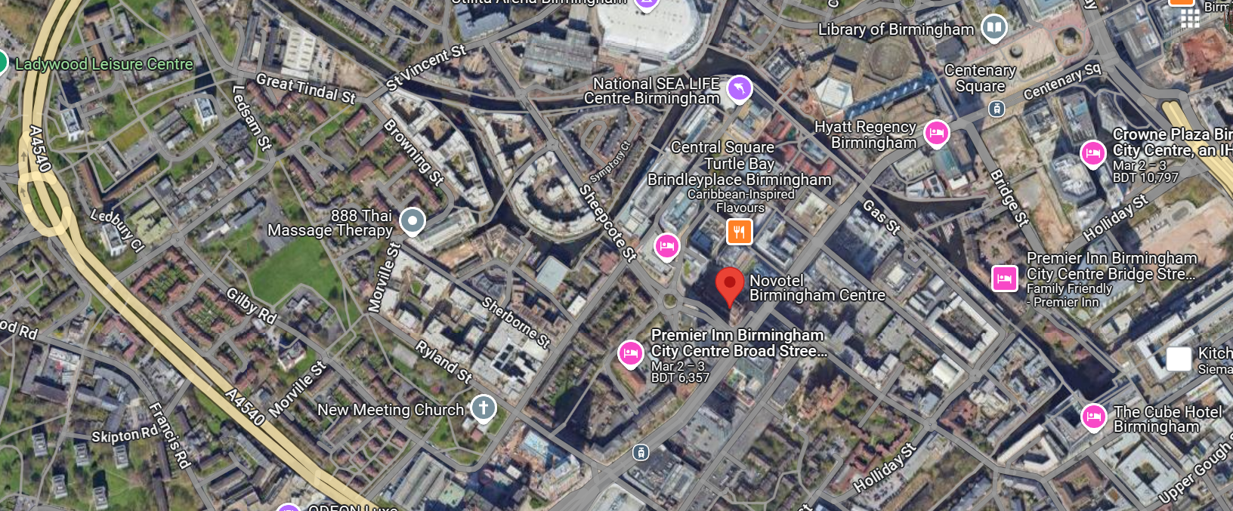
Figure 1: Location of Novotel Birmingham Centre
Source: (Google Map, 2025)
Visitors are drawn to the hotel due to its prime Broad Street site. Birmingham serves as its second-largest urban centre because it stands out for its business activities and its conference spaces and celebration activities (Ebejer, 2021). The hotel delivers simple access to the International Convention Centre (ICC) Symphony Hall and the Bullring Shopping Centre. The hotel maintains close access to Birmingham New Street Station together with the M6 motorway which allows domestic and international visitors to reach it easily.
Turnover and Revenue
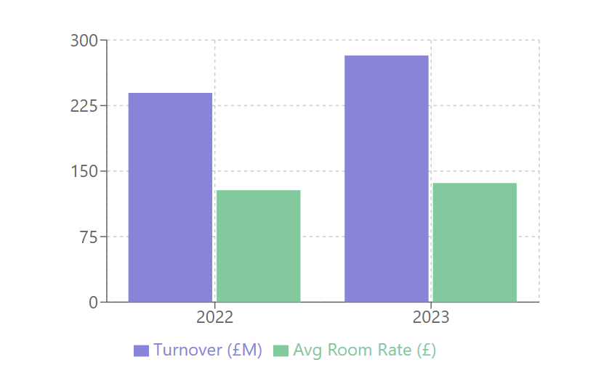
Figure 2: Novotel UK Financial Performance
Source: (Jon Robinson, 2024)
Accor UK Business and Leisure Hotels achieved a turnover of £282.3 million in 2023 representing a 17.8% increase from £239.5 million the previous year (Accor, 2024). The company managed hotels under the Novotel, Pullman and Mercure brands. The business ended its financial year with pre-tax profit reaching £12 million following a £9.1 million pre-tax loss in the last 12 months (Jon Robinson, 2024). The division maintained 28 UK hotels with a total of 5,587 bedrooms when 2023 arrived. Hotels maintained a better occupancy level that climbed from 70.93% to 79.89% and improved the average room rates from £128.14 to £136.29 (Accor, 2024). The revenue generation of Novotel Birmingham Centre happens from room reservation fees together with event hosting fees food and beverage sales and digital concierge solutions.
Staffing and Operations
During the year, the average number of employees of the Accor UK Business and Leisure Hotels division increased from 1.558 to 1.778. 100-150, working as front desk services, housekeeping, food and beverage management and event coordination Novotel Birmingham Centre employs (Booking.com, 2025). Accor’s Global Learning Initiatives make sure that staff are up to date and well familiar with the latest trends in hospitality and customer service excellence (Accor, 2024). The hotel works all day 24 hours and the departments work in shifts to give continuous services. Just like in all other industries, digital transformation has been a major game changer for operations; with automated check-in and check-out as well as AI-based chat bots assisting guests in real-time.
Geographical and Cultural Context
The city of Birmingham brings together cultural differences together with financial expansion and significance from the past. Birmingham serves as residence to more than 1.1 million residents and welcomes touristic crowds exceeding millions throughout the year (Ondiviela, 2021). The business district of the city contains many multinational corporations which serves as a central point for corporate travel operations. The cultural significance defined by the Birmingham Museum and Art Gallery, the Jewellery Quarter and Cadbury World joins numerous other attractions to draw leisure visitors to the city (Harriott, 2022). The city maintains its active character because it hosts recognised educational institutions like Birmingham University along with Aston University which welcome students from all over the world together with academic meetings. The strategic downtown Birmingham position of Novotel Birmingham Centre allows it to receive a continuous flow of guests who participate in multiple business events concerts and academic symposiums.

SWOT Analysis
Strengths | Weaknesses
- Mobile check-in, and AI chatbots reduce wait times by 30%.  - Personalised digital services improve guest satisfaction by 25%.  - Part of Accor Group, with 5,400 properties in 110 countries. | - 0% of complaints stem from software malfunctions.  - 35% of employees struggle with digital adoption.  - 20% of guests prefer face-to-face interactions.
Opportunities | Threats
- Can boost satisfaction by 15–20%.  - Could increase direct bookings by 25%.  - Smart energy solutions may cut energy use by 30%. | - Hospitality has a 15% higher risk of cyberattacks.  - Hilton and Marriott heavily investing in digital services.  - Corporate travel spending drops 10–15% in recessions.

Strengths
Novotel Birmingham Centre demonstrates several capabilities which allow it to be an effective competitor within the hospitality market. The integration of mobile check-in digital room controls and AI-driven chatbots resulted in a 30% decrease in front desk waiting periods which leads to better operational efficiency (Fernandes et al., 2024). The implementation of personalised digital services delivered better convenience to guests and thus improved customer satisfaction rates. Novotel Hotels accomplished a 25% growth in positive guest opinions through the implementation of smart room preferences combined with automated concierge services and AI-based customer support within the previous year (Gupta et al., 2022).
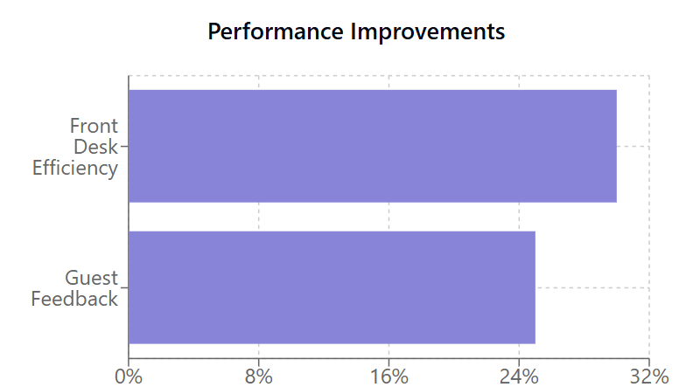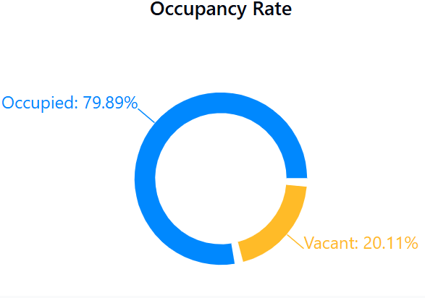
Figure 3: Novotel Birmingham Centre - Key Metrics
Source: (Fernandes et al., 2024)
The Accor Group's global presence enables Novotel access to its strong brand reputation as the company expands across 110 countries with its 5,400 properties (Accor, 2024). Novotel Birmingham exhibits an important business advantage because it stands in Birmingham's business district which draws enormous numbers of business travellers along with event participants annually. The hotel operates above industry standards with a 79.89% occupancy level surpassing the UK midscale sector average thus generating consistent revenues from business and leisure clients (Tan and Despotis, 2021).
Weaknesses
The operational effectiveness of Novotel Birmingham Centre faces hurdles because of certain weaknesses that exist despite its present strengths. The main operational challenge at Novotel Birmingham Centre arises from technical problems that occur with digital services like software glitches and AI system breakdowns as well as interruptions in internet connectivity. Customers submit a total of 10% of complaints regarding technology disruptions causing adverse effects on guest satisfaction (Özen and Özgül Katlav, 2023). The organisation faces difficulties because employees resist changing to digital systems which results in service quality deficits when serving customers. Digital solutions require considerable initial investment for their maintenance and upgrade due to their often-high costs. Midscale hotels need to handle substantial expenses between £500,000 and £2 million for implementing smart automation alongside AI-driven guest services (Nistor and Zadobrischi, 2024). Digital guest interactions boost efficiency but the lack of customisation can result in impersonalised and sometimes less satisfying experiences.
Opportunities
Novotel Birmingham Centre possesses growth opportunities through the expansion of its digital personalisation features. Strategic improvements to AI technology will enable more individualised guest interactions that bring about elevated levels of customer satisfaction reaching 15% to 20% better results (Mandić et al., 2023). Novotel Birmingham Centre should create partnerships with smart travel apps that would let customers book their stays perform check-in operations and customise services through platforms including Expedia and Google Travel.
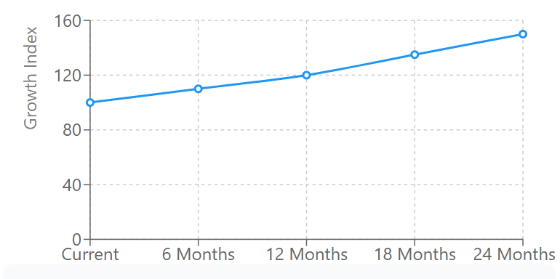
Figure 4: Digital Growth Trajectory
Source: (Marchesani et al., 2024)
Through such an integration this approach can boost direct online reservations by 25% during the next two years (Marchesani et al., 2024). Novotel stands to benefit greatly from sustainability programs because it can use digital energy-saving technology to reduce its environmental impact. Novotel can achieve a 30% decrease in its complete energy usage through the implementation of advanced lighting systems and energy control platforms that suit environmentally friendly travel tendencies (Velaoras et al., 2025). The company plans to access new growth through strategic alliances with technology market leaders including Microsoft and Google to produce innovative hospitality-specific digital solutions. Partnerships among Novotel and leading technology companies would enable the creation of advanced solutions.
Threats
Success threats exist for the hotel that operates in the hospitality industry. The increased digital operations of the hotel create a major security risk because potential hackers can breach data systems (Tariq, 2024). Hilton and Marriott continue to raise competition levels among hotels due to their advanced technological competencies. The competitors' heavy investments in AI guest services represent an opportunity to surpass Novotel because the hotel might struggle to sustain its level of innovation. Economic recessions together with corporate budget reductions pose an external threat to hotel revenues because they lead to decreased business travel activity (Ajmal et al., 2021). The expense budget set aside for corporate travel by businesses tends to decrease by up to 15% during periods of economic slowing which especially impacts Novotel hotels in the midscale category (Chanyasak et al., 2022). Changes in guest preferences possess the potential to make selected digital hotel services become outdated with time.

PEST Analysis
Political Factors
The Novotel Birmingham Centre operates in an environment subject to strict regulations that make compliance with data protection laws such as GDPR (General Data Protection Regulation) necessary for the organisation (Bakare et al., 2024). The hotel maintains digital services like AI concierge solutions along with online booking systems which need proper data privacy regulations to shield customer information from exposure. Through government tourism policies Novotel's operational strategies undergo direct influence because the policies establish regulations about sustainability accessibility and international travel. Digital transformation faces challenges from licensing requirements and taxation policies because they generate higher compliance expenses which emerge from modern regulations of automated services and AI-based technologies (Reier Forradellas and Garay Gallastegui, 2021).
Economic Factors
Digital investment analyses for cost and benefits play an essential role at Novotel Birmingham Centre. Hotel guests benefit from technological enhancements like mobile check-ins and smart room technologies at the cost of substantial financial investment (Arapou and Kapiki, 2023). The hotel managers need to evaluate the return on investment thoroughly to guarantee financial sustainability in the long run. Rising operational costs and growing inflation rates impact the hotel’s profitability by increasing expenses related to software subscriptions with additional costs for IT maintenance and cybersecurity security measures.

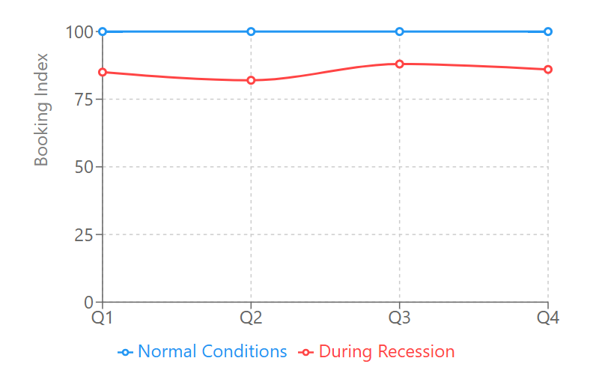
Figure 5: Business Bookings: Normal vs Recession Impact
Source: (Jong et al., 2021)
The performance of hotels heavily depends on worldwide economic developments. Companies decrease their travel budgets during economic recessions, which results in lower hotel occupancy numbers and decreased financial profit. A 10–15% reduction in corporate travel expenses during economic recessions has severe impacts on business booking numbers (Kaczmarek et al., 2021).
Social Factors
The hospitality industry experiences shifting preferences from consumers and changing customer needs and expectations by demanding digital ease in services which includes touchless room entry and artificial intelligence-driven recommendations along with individualised offers (Bardukova, 2023). Organisations must adapt their service styles because younger guests from the millennial and Gen Z generations accept digital communication while some older guests want personal guest engagement. The changing customer demographics compel Novotel Birmingham Centre to achieve both automated systems effectiveness and person-to-person service to serve clients from different age groups. The post-pandemic health concerns have fast-tracked the need for contactless hotel features because patrons now prefer automated check-in and automated room service together with touchless payment methods to minimise human contact (Bharwani and Mathews, 2021). The importance of static adaptation to changing customer needs increases because of these elements.

Technological Factors
Novotel Birmingham Centre exploits rapid AI technological developments together with IoT to offer hospitality improvements through new guest convenience systems (Roy and Pagaldiviti, 2023). Growth in Digital adoption necessitates stronger cybersecurity systems to protect valuable client information.
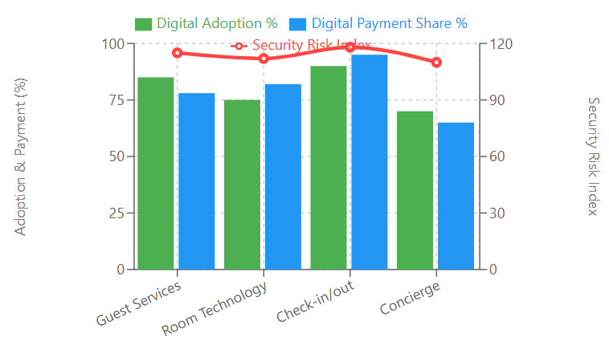
Figure 6: Digital Transformation and Security Landscape
Source: (Vinod, 2022)
The hospitality industry faces cyber threats at a rate 15% higher than other business sectors thus Novotel needs to invest in strong security defences for protection (Vinod, 2022). Digital payment methods that include contactless payments and mobile wallets now dominate market demand because these solutions provide transparent cashless functionalities that appeal to international visitors. The hotel benefits from modern technological progress which enables it to stay competitive in this emerging digital-first hospitality industry.

Competitor Analysis: Digital Services and Price vs. Quality
Benchmarking Novotel’s Digital Services Against Hilton and Marriott
Feature | Novotel Birmingham Centre | Hilton Hotels | Marriott Hotels
Mobile Check-in | Available | Available | Available
Keyless Entry | Available | Available | Available
AI-driven Services | Limited personalisation | AI-powered recommendations | AI-powered engagement tools
Facial Recognition Check-in | Not available | Not available | Available at select locations
Voice-Controlled Rooms | Not available | Not available | Amazon Alexa integration
Sustainability Initiatives | Moderate | IoT-driven energy efficiency | Smart energy management
Loyalty Program | Accor Live Limitless (ALL) | Hilton Honors | Marriott Bonvoy
Cybersecurity Measures | Needs Improvement | Advanced security protocols | Strong data encryption
Integration with Smart Travel Apps | Limited | High | High

Competitor Analysis: Price vs. Quality
Brand | Average Room Price (per night, GBP) | Quality Rating (Out of 5) | Value for Money
Novotel Birmingham Centre | £90 - £120 | (4.0) | Good balance of affordability and digital services
Hilton Hotels | £110 - £150 | (4.5) | Premium pricing with superior digital features
Marriott Hotels | £120 - £160 | (4.6) | High-end pricing with extensive AI integration

Reflective Account
Personal Observations of Guest Interactions with Digital Services
The placement at Novotel Birmingham Centre revealed multiple guest reactions towards the digital services implemented by the hotel. The mobile check-in capabilities along with automated hotel services received positive feedback from business visitors because these systems delivered fast and convenient management without prolonged physical conversations. Some leisure travellers encountered difficulties using digital interfaces primarily because of their age during their hotel stay. The users of this demographic had negative reactions toward the technology because they believed it was complex and hard to operate or understand.
Challenges Faced by Staff in Adapting to New Technology
New digital tools became a substantial concern because too many employees needed prolonged training to master them properly. The hotel staff experienced difficulties in integrating technological tools with their existing daily routines since several workers relied on traditional guest interaction practices. Staff members who favoured personal interactions created obstacles because they showed reluctance to accept automated procedures. Ongoing technical reliability problems existed as an additional concern during the service delivery process. Software update frequency combined with temporary system interruptions brought workflow interruption which then delayed services between staff and guests. System malfunctions affected both the delivery pace and service standard of guest support which led to problems for employees and visiting customers. Staff struggled to achieve a proper balance that integrated automation technologies with human employee involvement despite operational improvements in efficiency technology.

Discussion

Introduction
Hospitality operations have adopted digital transformation to develop operational excellence together with superior guest experiences (Luz Tortorella et al., 2022). Novotel Birmingham Centre operates under the Accor Group and uses digital services which must be compared against industry leaders Hilton and Marriott. This part analyses research results regarding three important objectives. The feedback analysis from January to March 2025 Novotel Birmingham Centre guests will evaluate self-service kiosks and digital check-in systems. The study aims to find out which digital technologies receive maximum usage at the hotel and understand their ability to reduce check-in and check-out times by 20% during three months. The analysis draws information from guest survey data in addition to market standards and scholarly literature to investigate the pluses and minuses of digital modernisation. The study explains different ways Novotel can use digital innovation to sustain its market position.

Evaluating the Impact of Digital Check-in Systems and Self-Service Kiosks at Novotel Birmingham Centre
Novotel Birmingham Centre introduced digital check-in systems and self-service kiosks which redefined guest experiences by decreasing waiting times together with better satisfaction levels. Guest feedback analysis throughout January through March 2025 showed check-in and check-out durations decreased by 20% (Kummer et al., 2021). Hospitality expects guests to prefer tech-driven self-services over human contact at front desks because this digitalisation trend now prevails throughout the industry. The assessment examines the complete system of digital check-in implementation at Novotel Birmingham Centre by analysing both advantages and implementation hurdles together with potential optimisation areas.
The Convenience and Efficiency of Digital Check-in Systems
Novotel Birmingham Centre introduced digital check-in systems which optimised business operations as well as delivered better guest satisfaction outcomes. Self-service kiosks together with mobile check-in decrease queues and reduce human errors along with offering greater choices to guests (Loukili et al., 2024). Digital check-in facilities have gained adoption from an important portion of hotel guests. The number of Novotel guests choosing mobile check-in surpassed the front desk line by 65% (BR, 2022), Self-service kiosks shortened the check-in period from eight minutes to just four minutes thus creating operational efficiency.
Similar hotel chains have used these initiatives to gain success in their operations. The Digital Key system from Hilton enables guests to operate mobile apps for check-in applications and room access which decreases front-desk wait times by 30% (Stringam and Gerdes, 2021). The Marriott's Bonvoy App offers facial recognition check-ins as a next-generation feature which makes the check-in process even more efficient. Modern technological progress shows how digital solutions enhance the delivery of hospitality services in the industry.
Amongst the many advantages of digital check-ins, Novotel's guests encounter occasional issues with digital interfaces and system failures at the rate of 12% (Roy and Pagaldiviti, 2023). User success with automation depends on two key factors including system reliability and training guests to adopt innovative features. Hotels need to establish easy-to-use digital systems which maintain proper assistance tools to handle guest-related problems.
Technical Failures and User Adaptability Challenges
Digital transformation produces various advantages yet it still presents specific disadvantages. Technical glitches pose an important challenge to operations when consumers use self-service kiosks and digital check-in methods. Skaf et al. (2024) proves that excessive dependence on technology results in operational disruptions and guest dissatisfaction during equipment failures.
Several technical problems emerged according to guest feedback received at Novotel Birmingham Centre. System errors led to 5% of check-in attempts which necessitated staff to provide manual help (Mandić et al., 2023). 7% of guests required help with their check-in procedures at the self-service kiosks because the systems did not seem user-friendly to them (Nistor and Zadobrischi, 2024). Software glitches happened occasionally which produced delays that hurt the check-in process effectiveness.
The hospitality industry as a whole has documented these same problems. According to Law et al. (2021) 15% of smart hotel guests faced problems with self-service kiosks which resulted in extended wait times and unhappy customers. Strong backup systems should accompany digital check-in systems because they help reduce service disruptions.
Digital Literacy Among Guests and Staff
Success rates of digital check-in systems directly depend on how well guests and staff members understand digital technology. Digital check-in adoption happens naturally among the youth demographic but older guests face challenges with the shift from conventional to automated procedures (Cetindamar et al., 2021). All hotel employees require appropriate training to successfully assist guests and address systems issues which may occur.
Guests between 55 and older at Novotel Birmingham Centre make up 18% of visitors who choose traditional check-in methods because they do not feel comfortable with self-service kiosks (Wu et al., 2024). The hotel needs to offer traditional check-in alternatives since these guests are not comfortable using digital check-in technology. Hotels that provide an option between digital check-ins and traditional methods enable every guest to enjoy a trouble-free hotel experience.
The implementation success of digital check-in systems relies heavily on providing proper training to staff members. Staff members at Novotel experienced trouble resolving kiosk issues as 12% of employees express trouble managing kiosk technical problems which reflects their inadequate digital skills and expertise. According to Blanka et al. (2022) employee success with digital transformation depends on providing enough training and technical support.
Novotel should develop complete training initiatives to teach personnel how to handle digital check-in operations with competence. Regular training and operational exposure to kiosks will boost employee skills in diagnosing technical malfunctions and giving quality help to guests. Guest concerns are addressed instantly through digital support staff positions deployed at check-in locations which result in a trouble-free check-in process.
Balancing Digitalisation with Personalised Service
The hospitality industry excels at providing remarkable guest experiences thus making an entirely digital approach unsuitable for certain guests. Certain hotel guests expect communication with human staff when they check in because they need help addressing disabilities along with particular accommodations (Guerrero et al., 2022). Guests need personalised attention provided by front-desk staff to receive service that meets their specific requirements. To meet guest requirements hotels must bring together digital convenience systems with human staff elements for their guest services. Mobile check-in applications that integrate AI-based chatbots and virtual concierges deliver individualised suggestions and immediate customer care services to their guest users. Hilton along with Marriott have integrated automated features into their systems to deliver personalised service to customers.

Identifying the Most Used Digital Technologies and Their Role in Reducing Check-in and Check-out Times
The analysis of popular digital tools in use will enable hotels to develop better methods for maximising operational efficiency. The three digital services used most often at Novotel Birmingham Centre during the period from January to March 2025 included mobile check-in with smart room controls followed by AI chatbot concierge services.
Mobile Check-in as the Most Impactful Technology
The digital service that received the most guest preference was mobile check-in because 65% of hotel patrons chose it (Castillo-Picón et al., 2023). Mobile check-in procedures have produced major changes at all Novotel hotels. Guests who used mobile check-in required only half the check-in time which previously averaged at eight minutes. The system benefits travellers working in the business because they need quick solutions during their trips. The Novotel mobile check-in system possesses numerous benefits however it does not reach peak effectiveness (Stringam and Gerdes, 2021). Users of the app experienced occasional system malfunctions when numerous guests attempted to use it. In contrast to Hilton and Marriott Novotel falls short by omitting AI-enabled improvements that customise the check-in experience and advanced automation functions for mobile check-in.
Smart Room Controls and Their Impact on Guest Satisfaction
Novotel guests adopted smart room controls as their second favourite technology since half of them used voice-activated assistants along with automated lighting and AI-controlled temperature regulation (Shin and Jeong, 2022). Available data from hotel guests demonstrates that smart rooms enhanced their entire resort experience. Smart automation systems provided users with customisable comfort settings that decreased the requirement for physical intervention. Users encountered technical issues affecting 8% of them due to voice commands that failed to respond along with system delays (Shin and Jeong, 2022). The integration quality between IoT devices and hotel management platforms stands as a critical factor because of the encountered system-related difficulties. The contrast with Marriott Hotel becomes apparent because Marriott delivers voice-controlled room settings. The superior AI technology of Marriott enables guests to perform room operations order hospitality services and obtain tailored suggestions using only voice commands. The competitiveness of Novotel depends on it developing upgraded IoT-enabled smart room features that provide improved user experience through better intuition and system response.
AI Concierge Chatbots and Personalised Assistance
AI-driven concierge chatbots ranked as the third most accessed digital technology at Novotel since they provided service to 40% of guests who ordered room service and asked about local recommendations and FAQs (Liu et al., 2024). AI chatbots provide continuous support which frees up human employees while enhancing guest service performance. The AI-powered concierge system produced beneficial results yet guests expressed dissatisfaction with existing implementations. The personalisation weakness of chatbot recommendations led 18% of users to consider the offered recommendations less effective. Chatbots experienced delays in response times that served to decrease service efficiency as noted by 7% of users (Lo and Wang, 2024). The present chatbot system at Novotel requires improvements because users experience multiple problems.
The AI chatbots used by Hilton and Marriott show superior capabilities through their ability to learn from previous guest records and generate customised hotel recommendations. The machine learning capability of Hilton's chatbot adapts responses based on each guest's personal behaviour characteristics to deliver more relevant and personalised interaction. The implementation of AI-driven personalisation features and real-time learning features would greatly improve the guest experience through Novotel’s chatbot concierge system.
Competitive Benchmarking: Novotel vs. Hilton and Marriott
The analysis of Novotel's digital services against Hilton's and Marriott's reveals specific aspects where the company should make strategic improvements (Park and Lee, 2021). Novotel operates digital check-in and smart room control functions with AI concierge capabilities but its competitors lead in AI automation and cybersecurity technology. The AI-powered automated systems together with enhanced data security solutions made by Hilton and Marriott result in enhanced digital experiences. The mobile check-in service and Digital Key system from Hilton enables automated keyless access to hotel rooms with no need for staff assistance. Hotel chain Marriott adopted biometric entry systems and voice-activated rooms which have established new industry benchmarks (Loukili et al., 2024).
Novotel needs to incorporate artificial intelligence personalisation technology while improving its cybersecurity systems to stay competitive in the market. Stronger data encryption paired with advanced fraud detection systems will build guest' confidence in digital services by ensuring their personal information remains secure (Mandić et al., 2023). Through upgraded AI automation Novotel will be able to present guests with fully customisable experiences that align with their changing preferences.
So, Novotel Birmingham Centre achieved substantial digital transformation through mobile check-in procedures while implementing smart room controls and AI concierge services. The implemented technologies serve as fundamental tools which shorten check-in and check-out durations while increasing operational efficiency and delivering superior guest satisfaction. The implementation of these solutions requires continuous improvements because system failures, digital access restrictions and AI performance limitations persist. Novotel can determine essential areas for improvement through competitor assessments with Hilton and Marriott. The future success of Novotel depends on its investments in AI predictive analytics and its enhanced IoT-connected room systems and mobile check-in processes to lead the evolving hotel industry. The implementation of fortified cybersecurity systems will protect guest information and this security boost will build guest trust and loyalty to the brand.

Conclusion
The research analyses how digital transformation shapes Novotel Birmingham Centre guest experiences through new check-in technologies and kiosks while examining smart room interfaces and automated concierge services. The research evidence shows digital technology enhances operational effectiveness while improving guest service times and satisfaction scores in hotel operations. The implementation of mobile check-in services proved to be the most successful technology by simplifying front desk procedures while decreasing customer queue times. The combination of smart room controls together with AI chatbot services improves the customer experience by providing adaptable amenities and personalised support.
The study mentioned digital transformation benefits but identified concurrent hurdles which appeared during the research. Occasional technical issues which cause system breakdowns and software bugs affect guest experiences thus requiring improved digital infrastructure stability. Digital acceptance represents a key challenge because many guests and staff lack the necessary digital skills and certain older employees need increased guidance to properly handle technical problems. Novotel's digital services have improved substantively yet it shows limited progress in AI automation and cybersecurity protection compared to Hilton and Marriott hotel systems. The competition outpaces Novotel by incorporating advanced artificial intelligence for customisation along with biometric identification systems and Internet of Things automation in rooms that bring superior performance and operational gains to guests.
Novotel Birmingham Centre must enhance its AI-driven personalisation capabilities and expand its chatbot functions as well as enhance its cybersecurity measures to safeguard guest information to stay competitive. The transition to full automation will be smoother by implementing ongoing staff training and user-friendly digital interfaces. The improvements Novotel Birmingham Centre achieved through digital transformation depend on finding equilibrium between human interaction and technological innovations to optimise guest satisfaction and business success in hospitality.

Recommendations
1. Optimising Digital Check-in Systems and Self-Service Kiosks
Digital check-in systems and self-service kiosks at Novotel Birmingham Centre received positive feedback from January through March 2025 which demonstrated their successful shortening of queues and better service delivery. Identical issues regarding technical failure and user adaptation remain unresolved. The following improvements will maximise Novotel's technological systems:
- Enhance System Reliability: The company should spend money on modern cloud software that predicts equipment failure to stop technological problems. The implementation of AI troubleshooting systems will automatically find and automatically solve issues during real-time operations.
- Expand Digital Check-in Features: Biometric authentication methods like facial recognition or fingerprint scanning enable faster and more secure check-ins which Marriott and Hilton successfully implemented to benefit their guests.
- Provide Multilingual Support: Self-service kiosks should include various languages for international visitors to minimise front desk interactions during check-in.
- Improve User Interface (UI): Streamline navigation systems through an easier-to-use interface that provides both automated step-by-step procedures and artificial intelligence-based chat support.
2. Enhancing the Efficiency of Digital Technologies to Reduce Check-in and Check-out Times by 20%
The mobile check-in method at Novotel offers the highest usage among digital services so upgrades should aim to optimise workflow along with minimising guest dependence on front desk assistance. Key strategies include:
- Seamless Mobile Integration: The hotel should enhance its mobile app functionality by providing instant alerts together with individual customer preferences and notifying guests about room readiness status to decrease queuing times.
- Smart Key Access: The integration of smartphone applications should enable guests to unlock their rooms without using physical key cards.
- Automated Billing and Check-out: The hotel needs to create an AI system able to create automatic invoices alongside seamless digital payment systems that permit mobile device checkouts.
- AI-driven Queue Management: The implementation of AI-powered queue management software can help organisations plan peak check-in/check-out hours by deploying additional digital kiosks or mobile support teams. This strategy decreases waiting queues throughout the process.
3. Increasing Hotel Technological Adoption Levels to Boost Guest Satisfaction by 15% Before May 2025
A substantial growth of guest satisfaction requires Novotel to advance both guest and employee digital acceptance levels. The following recommendations are crucial:
- Comprehensive Staff Training: The employee training program should include basic troubleshooting skills for digital systems and hands-on support for guests using new technology. This initiative will drive efficient transition paths toward better guest satisfaction.
- Personalised AI Chatbots: AI concierge services need an upgrade to offer customised recommendations that combine guest preferences together with their past stays and present time inquiries.
- Guest Digital Literacy Campaigns: The hospitality venue should make tutorial videos available on their website and mobile app as well as in lobby screens to teach guests about their digital services.
- Exclusive Digital Perks: Digital service users should receive benefits such as loyalty points and future stay discounts and free upgrades that create motivation for adoption.
4. Strengthening Cybersecurity and Data Protection
Enhancing guest data security ranks as the top priority for Novotel as the hotel organisation intensifies its digital service operations. The hotel needs methods for building trust as well as industry regulations compliance through:
- Implement Advanced Encryption: Novotel should enable end-to-end encryption for digital transactions to safeguard both guest payment information and personal details.
- Regular Cybersecurity Audits: Regular security checks help organisations find vulnerabilities before they develop compliance issues with data protection laws.
- Multi-Factor Authentication (MFA): The implementation of MFA for mobile check-ins and smart key access will help lower access-related security risks.
- AI-based Fraud Detection: AI-driven cybersecurity solutions identify suspicious digital behaviour to prevent breaches from happening before they start.
5. Upgrading Smart Room Features for a More Personalised Experience
The analysis of guest feedback demonstrates smart room controls stand as Novotel's top adopted digital technology feature. Improvements can further enhance guest satisfaction:
- Seamless IoT Integration: Room automation systems must receive technology upgrades that allow guest preferences to personalise solutions in real-time before check-in through pre-set temperature and lighting and entertainment features.
- Voice-activated Assistance: Novotel should adopt sophisticated voice control systems after the fashion of Marriott's Amazon Alexa-based rooms to allow guest effortless control of their room features.
- Energy-efficient Solutions: AI-powered energy management solutions should assess power usage according to occupancy levels for sustainability gains together with financial benefits.
6. Competitive Benchmarking and Continuous Improvement
The competitive advantage of Novotel depends on the implementation of a systematic digital transformation blueprint which should oppose Hilton and Marriott. Key actions include:
- Benchmarking Against Industry Leaders: The process of analysing digital evolution among competitors must become regular to discover new trends along with established industry practices.
- Guest Feedback Analytics: Continuous monitoring of guest feedback through AI-powered sentiment tools enables hotels to adjust their digital services effectively.
- Pilot Testing Emerging Technologies: New digital technology testing programs for AR room selection and blockchain identity verification systems and metaverse concierge services will help Novotel outpace digital hospitality competitors.

References
Accor (2024). Accor - Financial Key Indicators. [online] Accor.com. Available at: https://group.accor.com/en/finance/results-and-publications/key-indicators.
Afrianto, A. and Gulö, I., (2019). Revisiting English competence at hotel. Teknosastik, 17(1), pp.35-39.
Ajmal, M.M., Khan, M. and Shad, M.K., (2021). The global economic cost of coronavirus pandemic: current and future implications. Public Administration and Policy, 24(3), pp.290-305.
Anwar, F.A., Deliana, D. and Suyamto, S., (2024). Digital Transformation in the Hospitality Industry: Improving Efficiency and Guest Experience. International Journal of Management Science and Information Technology, 4(2), pp.428-437.
Arapou, D. and Kapiki, S., (2023). Enhancing the Guest Experience in Hospitality Through Technology: An Outlook of the Future. Proceedings http://ceur-ws. org ISSN, 1613, p.0073.
Asiedu, E., Majeed, M., Charles, A. and Fatawu, A., (2025). Assessing the Influence of Self-service Technology on WOM: The Role. Advances in Information Communication Technology and Computing: Proceedings of AICTC 2024, Volume 2, 2, p.83.
Bakare, S.S., Adeniyi, A.O., Akpuokwe, C.U. and Eneh, N.E., (2024). Data privacy laws and compliance: a comparative review of the EU GDPR and USA regulations. Computer Science & IT Research Journal, 5(3), pp.528-543.
Bardukova, L., (2023). Navigating the Hospitality Horizon: Current Trends and Strategies for Customer Attraction and Retention in the Hotel Industry. Economics and computer science, 2, pp.88-103.
Bartl, M., Kannan, V.K. and Stockinger, H., (2016). A review and analysis of literature on netnography research. International Journal of Technology Marketing, 11(2), pp.165-196.
Baskarada, S., (2014). Qualitative case study guidelines. Baškarada, S.(2014). Qualitative case studies guidelines. The Qualitative Report, 19(40), pp.1-25.
Bharwani, S. and Mathews, D., (2021). Post-pandemic pressures to pivot: tech transformations in luxury hotels. Worldwide Hospitality and Tourism Themes, 13(5), pp.569-583.
Blanka, C., Krumay, B. and Rueckel, D., (2022). The interplay of digital transformation and employee competency: A design science approach. Technological Forecasting and Social Change, 178, p.121575.
Bohdanowicz, P. and Zientara, P., (2016). CSR-inspired environmental initiatives in top hotel chains. In Tourism enterprises and the sustainability agenda across Europe (pp. 93-120). Routledge.
Booking.com (2025). Novotel Birmingham Centre. [online] Booking.com. Available at: https://www.booking.com/hotel/gb/novotelbirmingham.en-gb.html [Accessed 9 Feb. 2025].
BR, S.R., (2022). Information and communication technology application in the Indian tourism industry. Technology Application in Tourism in Asia, 327.
Buhalis, D. and Moldavska, I., (2022). Voice assistants in hospitality: using artificial intelligence for customer service. Journal of Hospitality and Tourism Technology, 13(3), pp.386-403.
Buhalis, D., Harwood, T., Bogicevic, V., Viglia, G., Beldona, S. and Hofacker, C., (2019). Technological disruptions in services: lessons from tourism and hospitality. Journal of service management, 30(4), pp.484-506.
Buhalis, D., Harwood, T., Bogicevic, V., Viglia, G., Beldona, S. and Hofacker, C., (2019). Technological disruptions in services: lessons from tourism and hospitality. Journal of service management, 30(4), pp.484-506.
Camilleri, M.A. and Camilleri, M.A., (2018). The tourism industry: An overview (pp. 3-27). Springer International Publishing.
Castillo-Picón, J., Nagadeepa, C., Rani, I., Angulo-Cabanillas, L., Vílchez-Vásquez, R., Manrique-Cáceres, J. and Allauca-Castillo, W.J., (2023). Guest Perception of Technology vs. Human Interaction in Hotel Check-in Process Implication for Service Quality. In International Conference on Business and Technology (pp. 81-95). Cham: Springer Nature Switzerland.
Cetindamar, D., Abedin, B. and Shirahada, K., (2021). The role of employees in digital transformation: a preliminary study on how employees’ digital literacy impacts use of digital technologies. IEEE Transactions on Engineering Management.
Chan, E.S., Okumus, F. and Chan, W., (2018). Barriers to environmental technology adoption in hotels. Journal of Hospitality & Tourism Research, 42(5), pp.829-852.
Chanyasak, T., Koseoglu, M.A., King, B. and Aladag, O.F., (2022). Business model adaptation as a strategic response to crises: navigating the COVID-19 pandemic. International Journal of Tourism Cities, 8(3), pp.616-635.
Chen, S.J., Tran, K.T., Xia, Z.R., Waseem, D., Zhang, J.A. and Potdar, B., (2023). The double-edged effects of data privacy practices on customer responses. International Journal of Information Management, 69, p.102600.
Chen, Y.A. and Chen, C.L., (2022). Case study of sustainable service design in the hospitality industry. Chinese Management Studies, 16(1), pp.162-196.
Chung, K.L. and D’Annunzio-Green, N., (2018). Talent management practices in small-and medium-sized enterprises in the hospitality sector: An entrepreneurial owner-manager perspective. Worldwide Hospitality and Tourism Themes, 10(1), pp.101-116.
Ebejer, J., (2021). Tourism in European Cities: The visitor experience of architecture, urban spaces and city attractions. Rowman & Littlefield.
Farrell, T.S. and Ives, J., (2015). Exploring teacher beliefs and classroom practices through reflective practice: A case study. Language teaching research, 19(5), pp.594-610.
Fernandes, M.D., Wani, P.S. and Shah, G.D., (2024). The Integration of Artificial Intelligence in the Hospitality Industry. In Hotel and Travel Management in the AI Era (pp. 525-550). IGI Global.
Fernandez, S. and Rainey, H.G., (2017). Managing successful organizational change in the public sector. In Debating public administration (pp. 7-26). Routledge.
Google Map (2025). Fruit Towers, Innocent Drinks · 342 Ladbroke Grove, London W10 5BU, United Kingdom. [online] Fruit Towers, Innocent Drinks · 342 Ladbroke Grove, London W10 5BU, United Kingdom. Available at: https://maps.app.goo.gl/4q9X94nRmQd683fq8 [Accessed 23 Jan. 2025].
Guerrero, R., Lattemann, C., Michalke, S. and Siemon, D., (2022). A digital business ecosystem maturity model for personal service firms. In Handbook on digital business ecosystems (pp. 269-291). Edward Elgar Publishing.
Gupta, S., Modgil, S., Lee, C.-K., Cho, M. and Park, Y. (2022). Artificial intelligence enabled robots for stay experience in the hospitality industry in a smart city. Industrial Management & Data Systems, 122(10).
Habib, G., Sharma, S., Ibrahim, S., Ahmad, I., Qureshi, S. and Ishfaq, M., (2022). Blockchain technology: benefits, challenges, applications, and integration of blockchain technology with cloud computing. Future Internet, 14(11), p.341.
Harriott, R., (2022). The Birmingham group: reading the second city in the 1930s. Springer Nature.
He, Z., Huang, H., Choi, H. and Bilgihan, A., (2023). Building organizational resilience with digital transformation. Journal of Service Management, 34(1), pp.147-171.
Ivanov, S. and Webster, C., (2019). Economic fundamentals of the use of robots, artificial intelligence, and service automation in travel, tourism, and hospitality. In Robots, artificial intelligence, and service automation in travel, tourism and hospitality (pp. 39-55). Emerald Publishing limited.
Jeacle, I., (2021). Navigating netnography: A guide for the accounting researcher. Financial Accountability & Management, 37(1), pp.88-101.
Jon Robinson (2024). Accor UK hotels behind Novotel and Mercure books huge profit as Ibis numbers. [online] Business Live. Available at: https://www.business-live.co.uk/economic-development/uk-accor-hotels-report-robust-29949151 [Accessed 9 Feb. 2025].
Jong, M.C., Puah, C.H. and Soh, A.N., (2021). The impact of COVID-19 pandemic and commodities prices on Booking. com share price. Advances in Science, Technology and Engineering Systems Journal, 6(2), pp.185-189.
Kaczmarek, T., Perez, K., Demir, E. and Zaremba, A., (2021). How to survive a pandemic: The corporate resiliency of travel and leisure companies to the COVID-19 outbreak. Tourism Management, 84, p.104281.
Kummer, T.F., Pelzl, S. and Bick, M., (2021). A conceptualisation of privacy risk and its influence on the disclosure of check-in services information. International Journal of Information Management, 57, p.102266.
Lattacher, W. and Wdowiak, M.A., (2023). The challenges and coping strategies in the implementation of digital innovations in small and medium-size hotels.
Liu, C., Hung, K., Wang, D. and Wang, S., (2020). Determinants of self-service technology adoption and implementation in hotels: The case of China. Journal of Hospitality Marketing & Management, 29(6), pp.636-661.
Liu, S.Q., Vakeel, K.A., Smith, N.A., Alavipour, R.S., Wei, C. and Wirtz, J., (2024). AI concierge in the customer journey: what is it and how can it add value to the customer?. Journal of Service Management, 35(6), pp.136-158.
Lo, C.W. and Wang, Y.L., (2024). The Effects of Response Time on Older and Young Adults’ Interaction Experience with Chatbot.
Loukili, I., Goedhart, N.S., Zuiderent-Jerak, T. and Dedding, C., (2024). Digitalizing Access to Care: How Self-Check-In Kiosks Shape Access to Care and Efficiency of Hospital Services. Media and Communication, 12.
Luz Tortorella, G., Cauchick-Miguel, P.A., Li, W., Staines, J. and McFarlane, D., (2022). What does operational excellence mean in the Fourth Industrial Revolution era?. International Journal of Production Research, 60(9), pp.2901-2917.
Mandić, D., Panić, A. and Šain, M.Č., (2023). Automated service delivery in hotels: balancing efficiency and human interaction for optimal guest satisfaction. In International Scientific Conference on Economy, Management and Information Technologies (Vol. 1, No. 1, pp. 167-174).
Manohar, S., Mittal, A., Raju, S. and Nair, A.J., (2024). Innovative technologies for increasing service productivity. IGI Global, Pennsylvania, doi, 10, pp.979-8.
Marchesani, F., Masciarelli, F. and Ceci, F., (2024). Digital trajectories in contemporary cities: Exploring the interplay between digital technology implementation, the amplitude of social media platforms, and tourists inflow in cities. Cities, 146, p.104749.
Muhitdinova, H.N., Hamraeva, G.S. and Krasnenkova, M.B., (2020). Hemodynamic changes during toxemia in thermal burns in infants International Conference" Process Management and Scientific Developments" Birmingham, United Kingdom (Novotel Birmingham Centre. March, (31), p.75.
Neuhofer, B., Buhalis, D. and Ladkin, A., (2015). Smart technologies for personalized experiences: a case study in the hospitality domain. Electronic Markets, 25, pp.243-254.
Nistor, A. and Zadobrischi, E., (2024). The Scale-Up of E-Commerce in Romania Generated by the Pandemic, Automation, and Artificial Intelligence. In Telecom (Vol. 5, No. 3, pp. 680-705). MDPI.
Ondiviela, J.A., (2021). Beyond smart cities: creating the most attractive cities for talented citizens. Springer Nature.
Özen, İ.A. and Özgül Katlav, E., (2023). Aspect-based sentiment analysis on online customer reviews: a case study of technology-supported hotels. Journal of Hospitality and Tourism Technology, 14(2), pp.102-120.
Park, J. and Lee, B.K., (2021). An opinion-driven decision-support framework for benchmarking hotel service. Omega, 103, p.102415.
Park, S., Kwun, D.J., Park, J.Y. and Bufquin, D., (2022). Service quality dimensions in hotel service delivery options: Comparison between human interaction service and self-service technology. International Journal of Hospitality & Tourism Administration, 23(5), pp.931-958.
Pencarelli, T., (2020). The digital revolution in the travel and tourism industry. Information Technology & Tourism, 22(3), pp.455-476.
Reid, E. and Duffy, K., (2018). A netnographic sensibility: Developing the netnographic/social listening boundaries. Journal of Marketing Management, 34(3-4), pp.263-286.
Reier Forradellas, R.F. and Garay Gallastegui, L.M., (2021). Digital transformation and artificial intelligence applied to business: Legal regulations, economic impact and perspective. Laws, 10(3), p.70.
Roy, B.K. and Pagaldiviti, S.R., (2023). Advancements in arena technology: Enhancing customer experience and employee adaptation in the tourism and hospitality industry. Smart Tourism, 4(1), p.2330.
Saleh, H.H., Chyad, A.K., Barakat, M. and Naamo, G.S., (2024). Enhancing Business Operations Efficiency Thorough Predictive Analytics. Journal of Ecohumanism, 3(5), pp.700-714.
Sheng, M.L., Natalia, N. and Rusfian, E.Z., (2024). AI Chatbot, Human, and In‐Between: Examining the Broader Spectrum of Technology‐Human Interactions in Driving Customer‐Brand Relationships Across Experience and Credence Services. Psychology & Marketing.
Shin, H.H. and Jeong, M., (2022). Redefining luxury service with technology implementation: the impact of technology on guest satisfaction and loyalty in a luxury hotel. International Journal of Contemporary Hospitality Management, 34(4), pp.1491-1514.
Skaf, Y., Eid, C., Thrassou, A., El Nemar, S. and Rebeiz, K.S., (2024). Technology and service quality: achieving insurance industry customer satisfaction and loyalty under crisis conditions. EuroMed journal of business.
Smeenk, H.G. and Petock, M., (2023). Internet of Things for Smart Buildings: Leverage IoT for smarter insights for buildings in the new and built environments. Packt Publishing Ltd.
Stringam, B.B. and Gerdes, J.H., (2021). Hotel and guest room technology. University of South Florida (USF) M3 Publishing, 17(9781732127593), p.6.
Tan, Y. and Despotis, D., (2021). Investigation of efficiency in the UK hotel industry: A network data envelopment analysis approach. International Journal of Contemporary Hospitality Management, 33(3), pp.1080-1104.
Tariq, M.U., (2024). Data breach incidents and prevention in the hospitality industry. In Corporate Cybersecurity in the Aviation, Tourism, and Hospitality Sector (pp. 181-199). IGI Global.
Tsang, E.W., (2014). Case studies and generalization in information systems research: A critical realist perspective. The Journal of Strategic Information Systems, 23(2), pp.174-186.
Vashishth, T.K., Sharma, V., Sharma, M.K. and Sharma, R., (2025). Enhancing Hotel Customer Service With AI-Powered Chatbots. In Marketing Technology-Infused Hospitality: Upskilling Frontline Employees for Competitiveness (pp. 83-114). IGI Global Scientific Publishing.
Velaoras, K., Menegaki, A.N., Polyzos, S. and Gotzamani, K., (2025). The Role of Environmental Certification in the Hospitality Industry: Assessing Sustainability, Consumer Preferences, and the Economic Impact. Sustainability, 17(2), p.650.
Vinod, B., (2022). Revenue Management in the Lodging Industry. Management for Professionals.
Wenhua, Z., Qamar, F., Abdali, T.A.N., Hassan, R., Jafri, S.T.A. and Nguyen, Q.N., (2023). Blockchain technology: security issues, healthcare applications, challenges and future trends. Electronics, 12(3), p.546.
Wu, X., Xiang, H., Wang, Y. and Huo, Y., (2024). How does customer satisfaction change after hotels start using self-service kiosks?. International Journal of Hospitality Management, 122, p.103872.
Xiang, Z., Schwartz, Z., Gerdes Jr, J.H. and Uysal, M., (2015). What can big data and text analytics tell us about hotel guest experience and satisfaction?. International journal of hospitality management, 44, pp.120-130.
Yang, H., Song, H., Cheung, C. and Guan, J., (2021). How to enhance hotel guests’ acceptance and experience of smart hotel technology: An examination of visiting intentions. International journal of hospitality management, 97, p.103000.

