

MODULE CODE: Digital Skills for Personal Development and Business Growth BMSW4008

ASSESSMENT COMPONENT: Portfolio

STUDENT NAME: Sara Lopez Delgado de Mendoza

STUDENT NUMBER: 2511447

LECTURER: Aqsar Shabir

DATE:

Contents

Task1
Assessment of Digital Skills
References

Task2
LinkedIn Learning Certificates for office 365

Task 3
Essay on Relevance of Excel in professional and personal life
References

Task4
7 Minute Reflective presentation
References

AI Acknowledgement
I confirm that I have no presented any AI generated materials as my own work.
I confirm I have copies of my drafts, notes, and other resources I used, which I may be asked to provide in evidence.

Task 1
Assessment of Digital Skills

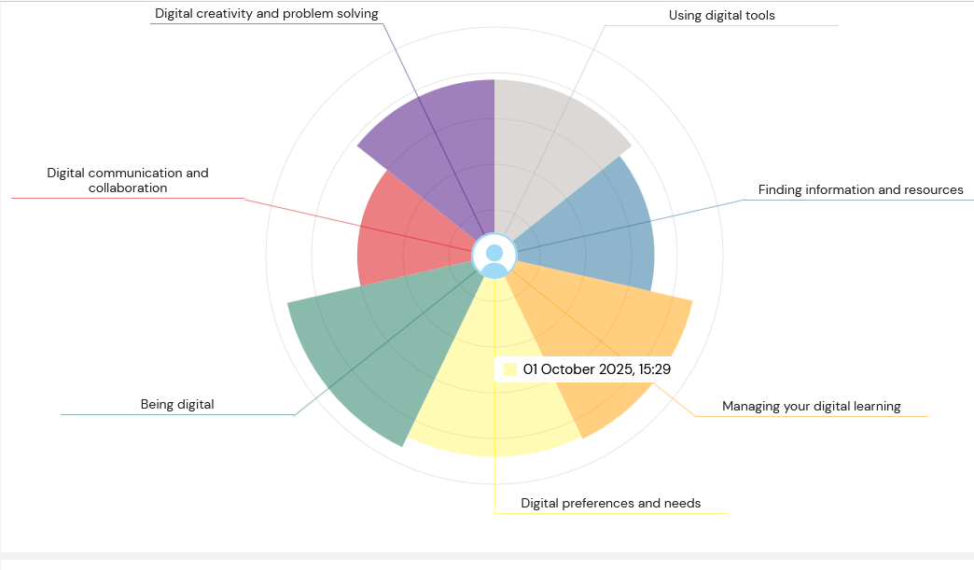
Digital Skills are essential and increasing in academic, professional and everyday context. The technology is in continues adapt in in how individuals learn, communicate and work, it is important to understand digital capability is more than a basic technical ability. Reflecting on the results of Jisc Digital Capabilities Framework let me to evaluate my current digital skills and recognise how they support and sometimes limit, my academic and professional development. This report explores the importance of digital skills, identifies key strengths and weaknesses, and outlines a structured action plan to improve weaker areas.
The Jisc Capabilities Framework defines digital capability as a combination of skills, behaviours and attitudes needed to live, learn and work in a digital society (Jisc,2003). This report highlights areas such as digital productivity, information literacy, communication and collaboration, and digital wellbeing. Engaging with the report helped me to understand that digital skills are linked employability and learning. In higher education, digital capability supports effective research, organisation and academic communication, while professional environments it enables adaptability, efficiency and innovation.
One of my main strengths is using digital tools. I am confident using digital tools like Microsoft Wpord, Excel and Power Point to organise information, manage data and present ideas clearly. This strength has developed through regular academic practice and structured online training, allowing me to work more efficiently and produce well organises assignments. Effective digital productivity is also linked with good knowledge management practices, as digital tools support the organisation and retrieval of information (Benscik, A, 2017).
A second strength is being digital. I am open to improve new digital skills and engaging with unfamiliar technologies. This adaptability aligns with research on innovation through collaboration, which highlights the importance of openness and continuous learning in digital environments (Pauli, P and Nijtad, N, 2019). Being adaptable has helped me engage positively with new platforms, online learning resources and emerging digital tools.
Despite these strengths, the report also revealed areas for improvement. One weakness is finding information and resources, particularly in evaluating the reliability and credibility of online information. While I can locate information quickly, I do not always apply consistent evaluation criteria. Critical engagement with digital content is essential for informed academic practice (Reedy, K, 2017).
Another area is required development is Digital communication and collaboration. I am not a strong user of social media, and I do not naturally engage with digital networking platforms. But I recognised that digital communication tools, including professional social media, online collaboration platforms and digital networking spaces, are increasingly essential in business environments. Research on digital transformation highlights that effective communication and collaboration are key to organisational success in digitally driven workplaces (Sandburg, K, 2020). Developing confidence in this area will help me collaborate more effectively, communicate professionally online and adapt to modern working places.
To address these weaknesses, I have developed a SMART action plan.
Specific: Improve critical evaluation of digital information and develop confidence in digital communication and collaboration tools.
Measurable: Complete one digital literacy course and course focussed on professional digital communication and collaboration and actively participate in at least two groups based in digital activities.
Achievable: The courses are accessible online and manageable alongside my studies.
Relevant: These skills are essential for academic success and future employability.
Time-bound: Complete the courses and apply these skills consistently within the next three months.
In conclusion, reflecting on the results of the Jisc Digital capabilities Framework helped me gain clearer understanding of my digital strengths and weaknesses. Strong digital productivity and adaptability provide a solid foundation, while further development is critical digital literacy and digital communication and collaboration is required. By following the structured action plan, I can continue to enhance my digital capability. Developing these skills will support, y academic growth through improved research quality and integrity, while also preparing me for the future career opportunities in digitally connected professional environments.

Reference list:
- A, Bencsik. (ed.) (2017) Knowledge Management Initiatives and Strategies. Cham: Springer.
- Jisc (2003) Digital Capabilities Framework. Available at: http://www.jisc.ac.uk/What-we-do/themes/digital-capability (Accessed: 2 December 2025)
- K, Reedy. (ed.) (2017) Digital literacy Unpacked. London: Facet Publishing.
- K, Sanburg. (2020) Digital Transformation and Innovate services for Business and Learning. 2nd edn. Berlin: Springer.
- P, Pauli and N, Nijtad (2019) Innovation through Collaboration. London: Routledge.

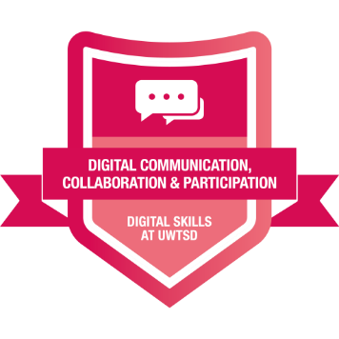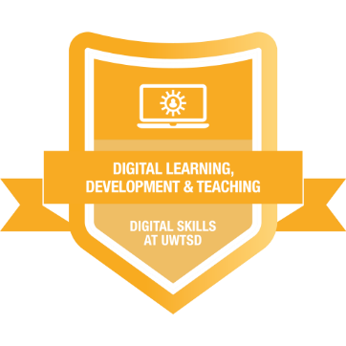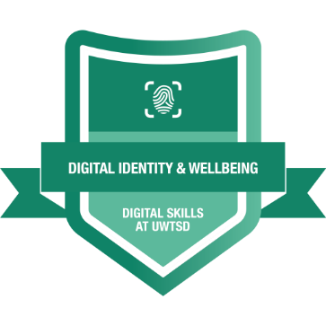

Task 2

LinkedIn Learning Certificates for office 365

Task 3
Essay on Relevance of Excel in professional and personal life.

References

Task 4

7 Minutes Reflective Presentation

Power point Presentation:

Slide 1 –

Hello mi name is Sara, and in this presentation, I will reflect what I have learned during this module in developing Digital Skills.

Slide 2 –

Already I had experience with Digital skills, but I did not fully understand how broad digital capability is. During these weeks I learned how to use digital tools more critically, ethically and with more confidence.
According with JISC(2003), digital capability includes the skills, behaviours and attitudes that people need to live, learn and work effectively in a digital society. This definition helped me to understand that having a good digital skills, is not only about knowing how to use the tools, but also about being confident, critical, adaptable and responsible. So, in this presentation I am going to explain the main thing I learned, how improved my skills, and how these abilities are now helping me in different parts of my life.

Slide 3 –

One of the most important things I learned this term it came form analysing the JISC Capabilities Framework. JISC (2003) divides digital skills into different areas such digital productivity, information and data literacy, communication and collaboration, digital creation, problem-solving and digital well-being.
Understanding these areas helped me to reflect on my own strengths and weaknesses. For example, I realised I was already strong in using digital tools and managing my digital learning but I needed to improve my information literacy, specially when evaluating online sources, and also digital communication and collaboration.
The report made me more aware that digital skills are essential for the university, for my career and personal live. Knowing this, motivated me to take the module seriously and try new tools that I did not use before. Also, I realised that digital skills are constantly changing, so we need to be flexible and always learning. I developed strongly during this term this mindset of continuous improvement.

Slide 4 –

A big part of these weeks, it was to improve my use with Microsoft Office 365. Even I though, I had used Word, excel, Power point, teams, Outlook, etc , I learned how to use them in a much effective and organised way also new features.
In Word, I improved my ability to structure reports, formal documents professionally and use tools like headings, automatic styles and layout features. This helped me make my written assignments more academic and clearer.
In Excel, I developed my confidence organising data, using formulas, creating tables, charts and analysing the information.
In Power Point, I learned how to design cleaner slides, use consistent formatting and focus in key messages instead of over crowding slides with text. I also learned how to use visual structure to support communication more effectively.
Another part of this learning was completing the courses for Microsoft word, excel and Power Point in LinkedIn learning. This helped me practise each tool step by step and obtain the certificates which made me more confident and gave me evidence of my digital progress, increasing my employability, as Microsoft applications are essential in most of the jobs. Microsoft (20032) highlights that these tools support productivity and communication, and now I can clearly see these skills are valuable in real work environments. Using these tools regularly and LinkedIn training allowed me to make real progress in my digital productivity, which JISC (2003) identifies as a key area of digital capability.

Slide 5 –

An Important part of this term was learning about artificial intelligence and the importance of using ethically. I already used IAs like ChatGPT, Dall-e , Google assistant in my personal life, but I did not fully understand how to use them responsibly or critically.
This term, I learned the importance of:
- Checking the accuracy of information
- Avoiding plagiarism
- Protecting my personal data
- Using AI to support learning, not replace it
- Being transparent and honest about the use of AI
St Geroge’s University of London Library (2024) explain that ethical digital behaviour includes, accuracy, privacy and responsibility, and this helped shape my approach. Open AI (20024) also emphasises tha AI should be a tool to support human thinking, not something that replaces it.
Now when I use AI, I use it in a more thoughtful and responsible way. I double check the information, rewrite content in my own words and make sure my final work reflects my own understanding.

Slide 6 –

This module surprised me because how digital skills affect my everyday life. At work, I became more organised and more confident when dealing with documents, emails, and online systems. I also realised that good digital skills make communication smoother and help solve problems faster. In my personal life, I understand digital safety better, I am more careful with privacy, passwords and the information I share online. I also use digital tools to manage my time, store documents and organise information more effectively. At University, I feel more prepared, I can research better, evaluate sources more critically, write assignments more professionally and create presentations that look more confident and structured, this made my academic life easier.
JISC (2003) notes that digital capability supports real-world adaptability, I noticied this clearly in my own life. I feel more confident facing new digital tasks, and I am not longer afraid of trying new tools or systems.

Slide 7 –

To Summarise, this term helped me to grow in many ways. I learned to understand digital capability through the JISC report. I improved my skills in Microsoft Office 365, I developed a responsible approach to using AI, and I became more confident applying digital tools in my work, studies and personal life.
And the most Important, I discovered that digital skills are not something you learn once, it is continue developing and improving through your whole life. Today I feel more prepared, more confident and more capable of adapting to new challenges in a digital world.
Thanks for your listening and this is your time for any questions.

References:
- JISC (2023). Digital Capabilities Framework. Available at: http://www.jisc.ac.uk/rd/projects/building-digital-capability (Accessed: 29 November 20025).
- Microsoft (2023). Microsoft 365; Overview of Word, Excel, PowerPoint. Available at: http://support.Microsft.com (Accessed: 2 December 2025).
- OpenAI (2024). Responsible use Guidelines for AI tools. Available at: https://openai.com/policies (Accessed: 1 December 2025)
- St George’s University of London Library (2024). Digital Literacy Skills. Available at: https://www.library.sgul.ac.uk/support/help/Microsft-office/digital-literacy (Accessed: 29 November 2025).

