Cameron Rees

Databases & application development – assignment 2

Table of Contents
Introduction 2
ERD 2
Queries 2
Data 6

Introduction
This is my first assignment with database and application development and for this assignment I made a database for a dentist surgery and made in SQL server but as a failure with my SQL software I couldn’t make the database, but I have the code that I would have used to make the database and I will be going thought that.

ERD
This is my ERD and with this I made 8 entity which will make up all of the areas in a dentist surgery.
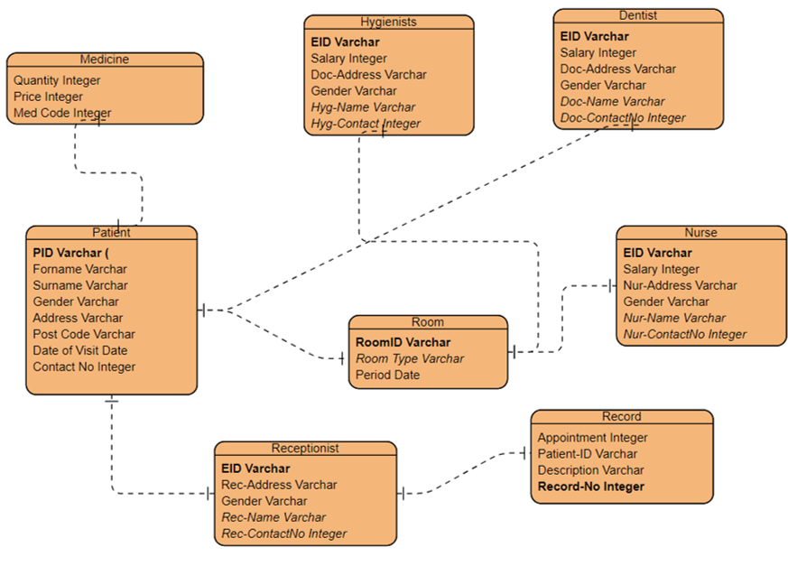

Queries
This is the first query and I had the basic things you would need to know about a patient for example there first and second name, age and gender
use Den_Database;
Create Table Patient(
PID varchar(3),
Forename varchar(20),
Surname varchar(25),
Gender Varchar(10),
Age integer(3),
Address varchar(100),
Post_Code varchar(7),
Date of Visit date(8),
Contact No integer(25),
);

This is the second query and its for the receptionist and I put some of the important things you would need to know bout the receptionist on the database
use Den_Database;
Create Table Receptionist(
EID varchar(3),
Rec-Address varchar(100),
Gender varchar(10),
Rec-Name varchar(50),
Rec-Contact No integer(25),
);

I have a record query so you can see patients and why they came into the dentists and this is connected to the receptionist
use Den_Database;
Create Table Record(
Appointment date(8),
Patient-ID varchar(6),
Description varchar(150),
Record-No integer(4),
);

I put a room query because I thought it would be a nice touch to been able to see what type of room and how long the patient was in the room
use Den_Database;
Create Table Room(
RoomID varchar(3),
Room Type varchar(50),
Period varchar(8),
);

This is the medicine query and this is for you can see what medinice is being used on a patient and how much it costs and how many are in stock and you can order more if the storage gets low
use Den_Database;
Create Table Medicine(
Quantity integer(3),
Price integer(8),
Med Code integer(7),
);

This is the nurse query and I put some of the important things you would need to know bout the nurse on the database

use Den_Database;
Create Table Nurse(
EID varchar(3),
Age integer (3),
Nur-Address varchar(100),
Gender varchar(10),
Nur-Name varchar(50),
Nur-ContactNo varchar(25),
);

This is the Dentist query and I put some of the important things you would need to know bout the Dentist on the database
use Den_Database;
Create Table Dentist(
EID varchar(3),
Age integer (3),
Doc-Address varchar(100),
Gender varchar(10),
Doc-Name varchar(50),
Doc-ContactNo varchar(25),
);

This is the Hygienists query and I put some of the important things you would need to know bout the Hygienists on the database
use Den_Database;
Create Table Hygienists(
EID varchar(3),
Age integer (3),
Doc-Address varchar(100),
Gender varchar(10),
Hyg-Name varchar(50),
Hyg-ContactNo integer(25),
);

Data
I also have the data I would of put in the database
use Den_Database
Insert Into Patient Values ('100', 'Cameron', 'Rees', 'Male', '10 Wimslow Drive', 'SA1 7JI', '20-01-21;, '01792 785624');
Insert Into Patient Values ('101', 'Sam', 'Walls', 'Male', '21 Dyfed Avenue', 'SA2 4QW', '21-01-21;, '01792 826301');
Insert Into Patient Values ('102', 'Skye', 'Jones', 'Female', '6 Brighton Road', 'SA4 8TY', '22-01-21;, '01792 092615');
Insert Into Patient Values ('103', 'Lewis', 'Blyth', 'Male', '82 Frogmore Drive', 'SA2 6GH', '22-01-21;, '01792 625381');
Insert Into Patient Values ('104', 'Kate', 'Smith', 'Female', '36 Tycoch Road', 'SA2 5DI', '20-01-21;, '01792 928749');
Insert Into Patient Values ('105', 'Morgan', 'Edwards', 'Male', '13 Claire Street', 'SA4 8KO', '23-01-21;, '01792 836391');

use Den_Database
Insert Into Receptionist Values ('001', '87 Stroude Road', 'Female', 'Madison Griffiths', '01792 826345');
Insert Into Receptionist Values ('002', '121 Redcliffe Way', 'Male', 'Jayden Payne', '01792 674932');
Insert Into Receptionist Values ('003', '81 Wern Ddu Lane', 'Female', 'Megan Sullivan', '01792 537302');
Insert Into Receptionist Values ('004', '107 Leicester Road', 'Male', 'Joe Wong', '01792 528392');
Insert Into Receptionist Values ('005', '58 Friar Street', 'Male', 'Ethan Thompson', '01792 263832');
Insert Into Receptionist Values ('006', '29 Academy Street', 'Male', 'Edward Palmer', '01792 373628');

use Den_Database
Insert Into Record Values ('10-02-21', '483921', 'Filling Teeth', '0101');
Insert Into Record Values ('10-02-21', '748302', 'Broken Tooth', '0102');
Insert Into Record Values ('11-02-21', '726282', 'Filling Teeth', '0103');
Insert Into Record Values ('12-02-21', '624821, 'Check-up', '0104');
Insert Into Record Values ('12-02-21', '638272', 'Broken Tooth', '0105');
Insert Into Record Values ('13-02-21', '629263', 'Check-up', '0106');

use Den_Database
Insert Into Room Values ('001', 'Big Room', '2 Hours');
Insert Into Room Values ('005', 'Small Room', '1 Hour');
Insert Into Room Values ('002', 'Medium Room', '2 Hours');
Insert Into Room Values ('001', 'Big Room', '1 Hour');
Insert Into Room Values ('004', 'Small Room', '1 Hour');
Insert Into Room Values ('003', 'Medium Room', '1 Hour');

use Den_Database
Insert Into Medicine Values ('020', £102.00, '4737281');
Insert Into Medicine Values ('012', £70.35, '7361836');
Insert Into Medicine Values ('001', £10.50, '8367272');
Insert Into Medicine Values ('060', £256.37, '7281961');
Insert Into Medicine Values ('023', £109.00, '6482726');
Insert Into Medicine Values ('011', £47.82, '1083726');

use Den_Database
Insert Into Nurse Values ('007', '23', '73 Old Edinburgh Road', 'Male', 'Jack Clayton', '01792 928372');
Insert Into Nurse Values ('008', '27', '65 Gloddaeth Street', 'Male', 'Evan Joyce', '01792 827272');
Insert Into Nurse Values ('009', '32', '106 Freezeland Lane', 'Male', 'Isaac Cameron', '01792 836374');

use Den_Database
Insert Into Dentist Values ('010', '35', '81 Dover Road', 'Female', 'Sienna Gough', '01792 538472');
Insert Into Dentist Values ('011', '40', '32 Wressle Road', 'Male', 'Thomas John', '01792 617537');
Insert Into Dentist Values ('012', '38', '69 Southend Avenue', 'Female', 'Rosie Hancock', '01792 526182');

use Den_Database
Insert Into Hygienists Values ('013', '35', '62 Shore Street', 'Male', 'Dylan Parsons', '01792 837281');
Insert Into Hygienists Values ('014', '36', '61 London Road', 'Female', 'Taylor Kirby', '01792 917368');
Insert Into Hygienists Values ('015', '29', '51 Cambridge Road', 'Male', 'Freddie Collins', '01792 547072');

