
Financial Management for the Hotel Industry



University of Wales Trinity Saint David

Name: Mohibur Chowdhury
Student ID: 1911447
Lecturer: Chris Wilkin
Executive Summary
Marriot international is one of the established hotel chains in the world. This chain of hotels is operating a business in the hospitality sector for a long time. In this report, ratio analysis is conducted on the results obtained from the financial ratios of Marriot international. In this report, different financial ratios have been evaluated. The first category of financial ratios is liquidity ratios. In the second stage, profitability ratios have been evaluated. In the third stage, the gearing ratios have been evaluated. At the same time, the interpretation of different ratios has been given.

Table of Contents
Introduction 3
Financial Analysis Trends 4
Profitability 4
Liquidity 6
Gearing 7
Knowledge from Ratio Analysis 9
Benefits and Limitations of Ratio Analysis 9
Conclusion 10
Bibliography 12

Introduction
This assignment is aimed to evaluate the practice of ratio analysis in an organisation working in the hospitality industry. In the hospitality industry, hotels operate their business in a competitive environment. To sustain in a competitive environment, it is necessary to have strong evidence for making decisions. Ratio analysis is a practice through which a firm can make decisions based on proper evidence (Kabajeh, Nu’aimat and Dahmash, 2012). Ratio analysis also ensures that the financial statements of an organisation are properly evaluated. Ratio analysis also ensures that data is extracted from the financial statements of a company.
Marriot International is a renowned face in the world of tourism and hospitality. This organisation started its journey in 1927 as a small root beer shop. That small shop now turned into a big hotel chain. Marriot International is operating the business in more than 35 countries. 6500 established branches of Marriot International are operating across the world. This hotel chain is renowned for the superior service given to the customers. At the same time, Marriot international ensures that customers get the best possible service from their hotel. That’s why they want to ensure that they make the correct decision for making the business successful. In this report, the use of ratio analysis in tourism organisations will be demonstrated (How and Lee, 2021). At the same time, how these tools help in making effective decisions will also be demonstrated by focussing on the ratio analysis output of hotel Marriot international.

Financial Analysis Trends

Profitability
Profitability is whether an organisation can earn profit or not. Several ratios determine the profitability of an organisation. The first ratio that determines profitability is the Gross profit margin ratio. This ratio is calculated using sales and gross profit (Laia, 2014). The gross profit of an organisation is the primary indicator of profitability. The following graph shows the Gross profit margin of Marriot international over the previous years.
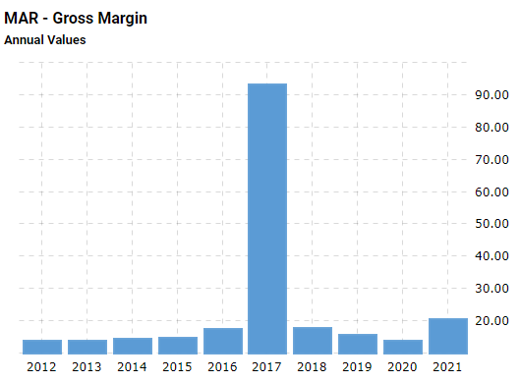

Figure: Gross profit margin (Novy-Marx, 2013)
The gross profit margin of Marriot international is not satisfactory. It lies under less than 20% in almost all of the years. The standard margin for GPM is 50-70%. But Marriot international failed to maintain this required level of GPM in the consequent years, which created burdens for their operations. Reductions in the GPS also indicates that the organisation is facing problem in managing sales and other primary activities. In 2017, the GPM was too high, which is risky for an organisation like Marriot international.

The Next profitability margin is the operating profit ratio. The operating profit ratio is calculated using the operating profit of an organisation (Primatama, 2015). The operating profit ratio indicates the operating efficiency of an organisation.
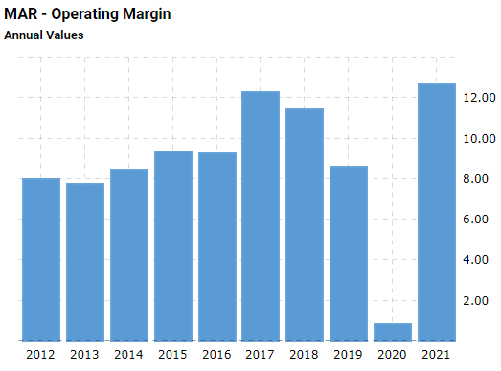

Figure: Operating profit ratio (Bauman, 2014)
The operating profit ratio is calculated using the sales and the operating profit of an organisation. These two elements are important. The operating profit ratio of Marriot international is also not satisfactory. This ratio has a standard of 20%. But these organisations failed to maintain this ratio properly.
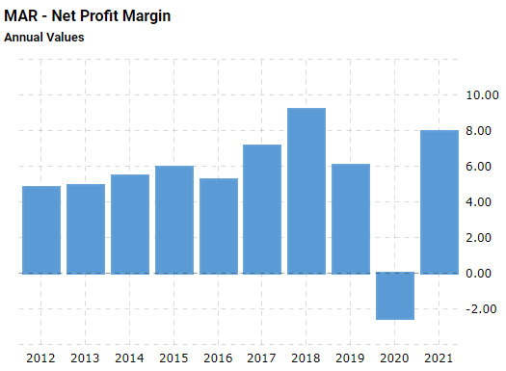

Figure: Net profit margin (Inzani, 2019)
Net profit margin is the best profitability margin. This margin determines how successful the firm is in managing its operations. Marriot International is operating with a very low net profit margin. But in the hospitality industry, the Net profit margin is quite low (Hutami, 2012). That’s why the NPM maintained by Marriot international is on a satisfactory level.

Liquidity
The most popular liquidity ratio is the current ratio. The current ratio shows the ability whether a firm can return short-term liabilities using short-term assets or not (Gambacorta, 2011). The current ratio is also an effective approach to determine how much effective current assets the organisation has.
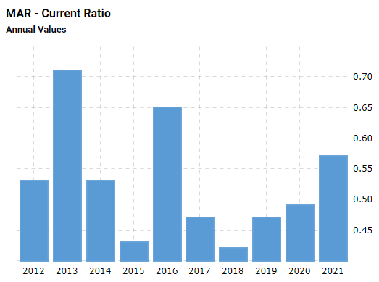

Figure: Current ratio (Supardi, Suratno and Suyanto, 2018)
Marriot international is not so expert in maintaining a stable current ratio throughout the years. The standard rate of the current ratio is 1 to 2. But Marriot international has a current ratio of less than 1, which indicates that they are not managing the current assets properly. At the same time, they also have an increasing amount of current liabilities within the organisation.

Gearing
The gearing ratio is engaged with the long-term assets and liabilities. Gearing ratios identified the effectiveness of debt and equity used in an organisation (Nuryani and Sunarsi, 2020). The gearing ratio compares the debt and equity of an organisation.
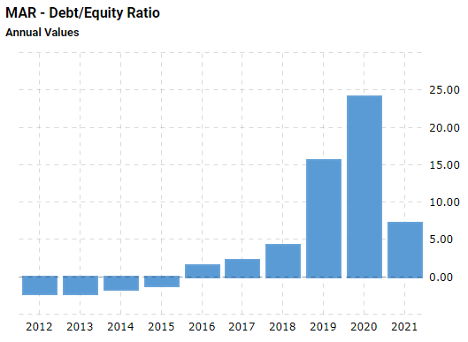

Figure: Debt to equity ratio (Jufrizen and Sari, 2019)
The debt-to-equity ratio has a standard of 2 to 2.5. Marriott International is a big brand. That’s why they undertook big expansion projects so by utilising the capital they have. They use both debt and equity to engage in expansion projects. If we evaluate the debt-to-equity ratio of Marriot international, it is easy to predict that Marriot International is relying on debts compared to their equity in expanding their projects. Over-dependence on debt will cause a loss in the profitability of the organisation. Because long-term debts become a liability for the organisation.
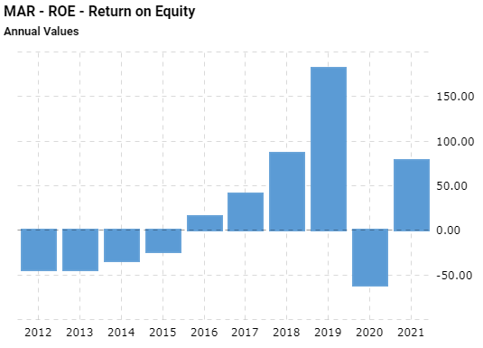

Figure: Return on equity (Heikal, Khaddafi and Ummah, 2014)
Investors invest their capital to get a return. The ROE determines how much return the investors are getting from the money they invested. The ROE of Marriot international is not that satisfactory. It showed a negative result in the prior years. In 2020, the ROE went negative, which is not accepted. The reason behind this negative effect is the Covid-19 pandemic (Pratama and Erawati, 2014). In 2021, the ROE of Marriot international increased, which is a matter of satisfaction for the organisation.

Knowledge from Ratio Analysis
Ratio analysis is an effective tool for evaluating the financial statements of business organisations. But ratio analysis also has some limitations. The first limitation ratio analysis has is it does not consider the present. Ratio analysis is completed based on historical information. It conducts analysis based on the previous information (Alrafadi and Md-Yusuf, 2012). That’s why making decisions at present time becomes risky. At the same time, ratio analysis does not consider the external elements that may hamper the profitability of a business. For example, a recession hampers the business adversely. But ratio analysis does not consider this element while making decisions. An organisation is not operated using machines and capital. An organisation is run using human beings. Human beings operate the activities of an organisation. But ratio analysis focuses on the numerical data only. It does not consider the human element of an organisation (Prawirodipoero, Rahadi and Hidayat, 2019). It ignores the roles of human beings within the organisation. Ratio analysis is completed to evaluate the results with other organisations. But is not possible to evaluate the results of a small organisation with a large-scale organisation. That’s why ratio analysis does not apply to all sections of businesses. Accounting principles are the same for all organisations. But due to geographical changes, there may be changes in tax rates and other rates, which may show different results (Mulla, 2013). Due to this limitation sometimes, financial statements developed in two different countries cannot be compared properly.

Benefits and Limitations of Ratio Analysis
Ratio analysis is a practice that is followed by professionals to evaluate the financial statements of a business organisation so that stakeholders engaged with the organisation can take their decisions. Financial decisions are calculated in some broad categories. Financial ratios are calculated to ensure that the decision-making process becomes an evidence-based process (Tam et al, 2019). As the decisions are made based on shreds of evidence, it is expected that the success rate will be higher. In modern organisations, financial professionals are hired to conduct finance-related activities. Ratio analysis helps the organisation to understand what is the actual state of the organisation. At the same time, ratio analysis ensures that problems in different parts of the organisation are found. Necessary actions can be taken after finding out the problems within the operation, finance and other departments of the organisation (Arem et al, 2015).
Ratio analysis is used by different parties of the organisation. In the hospitality industry, the profit margin is quite low, which makes this industry a competitive one. That’s why managers should be able of making effective decisions. Effectiveness in the decision-making process will increase the acceptance of the organisation in the market. Investors invest in different projects to get a return from their investors (Maier et al, 2015). They can't evaluate the financial statements manually. It will take a good amount of time and money, which will be a problem. If they look at the ratios, they will find out the financial health of an organisation easily within a very short time. At the same time, the managers also need to evaluate the performance of the organisation so that they can set the next target. By making a complete ratio analysis, managers can identify the areas of improvement for them. Shareholders are considered separate from the organisation (Hadded et al, 2015). That’s why they should be able to understand the functions of the organisation. To understand the financial position of an organisation, shareholders can look at the financial ratio analysis, which will also enhance their knowledge regarding the organisation (Welc, 2022). They will also get to know whether the managers are operating the organisation correctly or not.

Conclusion
An organisation wants to ensure that profit is generated from operational activities. To earn profit from operational activities, it is necessary to have a proper understanding of the financial statements of an organisation. The financial statements of an organisation show the results only. But these statements do not show the effectiveness of the results. To evaluate the effectiveness of the results, managers use the financial ratio analysis. This ratio analysis helps them to compare the results obtained from the financial statements with other organisations. Ratio analysis also has some benchmark scores. These scores can be compared with the actual output. If any deviation is found in ratio analysis, the managers can take action for solving any internal or external problem. At the same time, ratio analysis helps investors to take investment decisions. It also helps lenders to decide whether they should lend money or not. Ratio analysis also helps other stakeholders. Employees, government and other concerned parties also consider the outputs of ratio analysis to make their decision regarding an organisation. The ration analysis is also not free from errors. It has some in-built problems also. But these problems are not so visible in front of the benefits of this technique.

Bibliography

Alrafadi, K.M. and Md-Yusuf, M., 2012. Comparison between financial ratios analysis and balanced scorecard. American journal of economics and business administration, 3(4), pp.618-622.
Arem, H., Moore, S.C., Patel, A., Hartge, P., De Gonzalez, A.B., Visvanathan, K., Campbell, P.T., Freedman, M., Weiderpass, E., Adami, H.O. and Linet, M.S., 2015. Leisure time physical activity and mortality: a detailed pooled analysis of the dose-response relationship. JAMA internal medicine, 175(6), pp.959-967.
Bauman, M.P., 2014. Forecasting operating profitability with DuPont analysis: Further evidence. Review of Accounting and Finance.
Gambacorta, L., 2011. Do bank capital and liquidity affect real economic activity in the long run? A VECM analysis for the US. Economic notes, 40(3), pp.75-91.
Hadded, M., Muhlethaler, P., Laouiti, A., Zagrouba, R. and Saidane, L.A., 2015. TDMA-based MAC protocols for vehicular ad hoc networks: a survey, qualitative analysis, and open research issues. IEEE Communications Surveys & Tutorials, 17(4), pp.2461-2492.
Heikal, M., Khaddafi, M. and Ummah, A., 2014. Influence analysis of return on assets (ROA), return on equity (ROE), net profit margin (NPM), debt to equity ratio (DER), and current ratio (CR), against corporate profit growth in automotive in Indonesia Stock Exchange. International Journal of Academic Research in Business and Social Sciences, 4(12), p.101.
How, S.M. and Lee, C.G., 2021. Customer satisfaction and financial performance-linear or non-linear relationship: a case study of Marriot International. Current Issues in Tourism, 24(9), pp.1184-1189.
Hutami, R.P., 2012. Pengaruh Dividend Per Share, Return On Equity Dan Net Profit Margin Terhadap Harga Saham Perusahaaan Industri Manufaktur Yang Tercatat Di Bursa Efek Indonesia Periode 2006-2010. Nominal: Barometer Riset Akuntansi dan Manajemen, 1(2), pp.104-123.
Inzani, N., 2019. Pengaruh Return On Equity, Operating Profit Margin, dan Devidend Payout Ratio terhadap Perataan Laba dengan Kepemilikan Manajerial sebagai Variabel Moderasi (Studi pada Perusahaan Manufaktur yang Terdaftar di Bursa Efek Indonesia pada Tahun 2014-2018) (Doctoral dissertation, Universitas Islam Negeri Alauddin Makassar).
Jufrizen, J. and Sari, M., 2019. Pengaruh Current Ratio, Debt to Equity Ratio dan Firm Size terhadap Return on Equity. Jurnal Riset Akuntansi: Aksioma, 18(1), pp.156-191.
Kabajeh, M.A.M., Al Nu’aimat, S.M.A. and Dahmash, F.N., 2012. The relationship between the ROA, ROE and ROI ratios with Jordanian insurance public companies market share prices. International Journal of Humanities and Social Science, 2(11), pp.115-120.
Laia, M.J.C.C.N., 2014. Equity Research-Marriott Hotels (Doctoral dissertation, Universidade de Lisboa (Portugal)).
Maier, F., Schober, C., Simsa, R. and Millner, R., 2015. SROI as a method for evaluation research: Understanding merits and limitations. VOLUNTAS: International Journal of Voluntary and Nonprofit Organizations, 26(5), pp.1805-1830.
Mulla, D.J., 2013. Twenty five years of remote sensing in precision agriculture: Key advances and remaining knowledge gaps. Biosystems engineering, 114(4), pp.358-371.
Novy-Marx, R., 2013. The other side of value: The gross profitability premium. Journal of financial economics, 108(1), pp.1-28.
Nuryani, Y. and Sunarsi, D., 2020. The Effect of Current Ratio and Debt to Equity Ratio on Deviding Growth. JASa (Jurnal Akuntansi, Audit dan Sistem Informasi Akuntansi), 4(2), pp.304-312.
Pratama, A. and Erawati, T., 2014. Pengaruh current ratio, debt to equity ratio, return on equity, net profit margin dan earning per share terhadap harga saham (study kasus pada Perusahaan Manufaktur yang terdaftar di Bursa Efek Indonesia periode 2008-2011). Jurnal akuntansi, 2(1), pp.1-10.
Prawirodipoero, G.M., Rahadi, R.A. and Hidayat, A., 2019. The Influence of Financial Ratios Analysis on the Financial Performance of Micro Small Medium Enterprises in Indonesia. Review of Integrative Business and Economics Research, 8, pp.393-400.
Primatama, W.A., 2015. Pengaruh Company Size, Return On Asset, Net Profit Margin, Financial Leverage dan Operating Profit Margin Terhadap Praktik Income Smoothing. Jurnal Akuntansi Dan Sistem Teknologi Informasi, 11.
Supardi, H., Suratno, H.S.H. and Suyanto, S., 2018. Pengaruh Current Ratio, Debt to Asset Ratio, Total Asset Turnover dan Inflasi Terhadap Return on Asset. JIAFE (Jurnal Ilmiah Akuntansi Fakultas Ekonomi), 2(2), pp.16-27.
Tam, V., Patel, N., Turcotte, M., Bossé, Y., Paré, G. and Meyre, D., 2019. Benefits and limitations of genome-wide association studies. Nature Reviews Genetics, 20(8), pp.467-484.
Welc, J., 2022. Financial statement analysis. In Evaluating Corporate Financial Performance (pp. 131-212). Palgrave Macmillan, Cham.

