BUILD, DEPLOY, CONFIGURE, AND MANAGE A TYPE 2 HYPERVISOR PLATFORM BASED VIRTUALISED NETWORK

ACCA5023 – NETWORK OPERATING SYSTEMS AND SERVICES
  - JOSHUA JAMES HARRIES (2021807) 10th March 2023

Table of Contents
Team NOSS 3
Team Members 3
Team Evaluation 3
Introduction 4
Part 1 (Task 1 & 2) 4
VM creation and Operating System Installations 4
Installation of server operating System 5
Serial Advanced Technology Attachment(SATA) port1 5
Installation of Client Operating System 6
Virtual Network Configuration 6
LAN configuration for Servers 7
LAN Configuration for Clients 7
Firewall deactivation of Server1 and Client 1 7
Ping from Server1 to Client1 and Server 2 to Client 2 8
Sever IP is Statically Defined 8
Server1 nslookup 9
Changing machine name on Server1 to DMC1-NT 9
Installing Active Directory Domain Services Server1 10
Domain Controllers Window Server1 10
Add new logon account to Server1. 11
New Active Directory User Server1 11
Logging on active directory Client1 12
Logging in as alternative NT-ID 13
Time restrictions set for user NT-ID 13
Part 2 (Task 3) 14
Justify the reason why Type 2 Hypervisors is used in the above practical task? 14
DHCP 16
Active Directory 17
Terminologies 18
Windows Firewall 18
Ping ? 19
Server Manager ? 19
Conclusion and reflection on collaborative work 19
References 19

Team NOSS

Team Members
Student Name | Student ID
Iwan Dyke | 1800933
Joshua James Harries | 2021807
Karen Anne Windsor | 1918576
Cristian-Stefan Stancu | 2008911

Team Evaluation
 | Iwan Dyke | Joshua Harries | Karen Windsor | Cristian Stancu
Iwan Dyke | N/A | 5 | 5 | ?
Joshua Harries | 5 | N/A | 5 | ?
Karen Windsor | 5 | 5 | N/A | ?
Cristian Stancu | 1 | 1 | 2 | N/A
For this part of the assignment we worked closely as a team and we all played an important role in its completion. Therefore, the consensus of the team was that we should all have the same score.
Iwan: Iwan worked to write the annotation for the screen shots that the team included for part 1 – which included the research for the explanations.
Joshua: Joshua is a cyber/network student and it only due to him that the team was able to complete task 1 and 2 that made up part 1 of this assignment. Joshua provided the team with technical walkthroughs and assistance with the tasks and took the lead on any decisions needing to be made, while also contributing to the screenshots and captions.

Karen: Karen completed tasks 1 and 2 and took the necessary screen shots and worked on the annotations.

Cristian: Cristian joined the team late (16th Feb) and then was unavailable for the weeks leading up to the submission date. As a team, we have scored 1s and 2s for him, and we were unable to get scores from him for the team, hence the question marks.

Introduction
In this report, I am tasked with working collaboratively to build, deploy, configure, and manage a type 2 hypervisor platform based virtualised network using VirtualBox, to deploy a Network Directory Service, and to create and understand Active Directory Network Objects. In Part One of this report, I detail the steps taken to fulfil the requirements of the assignment with screenshots and a brief summary of steps taken. In Part Two, I explain and describe why a Type 2 Hypervisor was used over a Type 1; what DHCP and Active Directory is and how it was significant in the undertaking of my tasks; and explanation of some of the terminologies that was used during the undertaking of this task, such as Windows Firewall.

Part 1 (Task 1 & 2)

VM creation and Operating System Installations
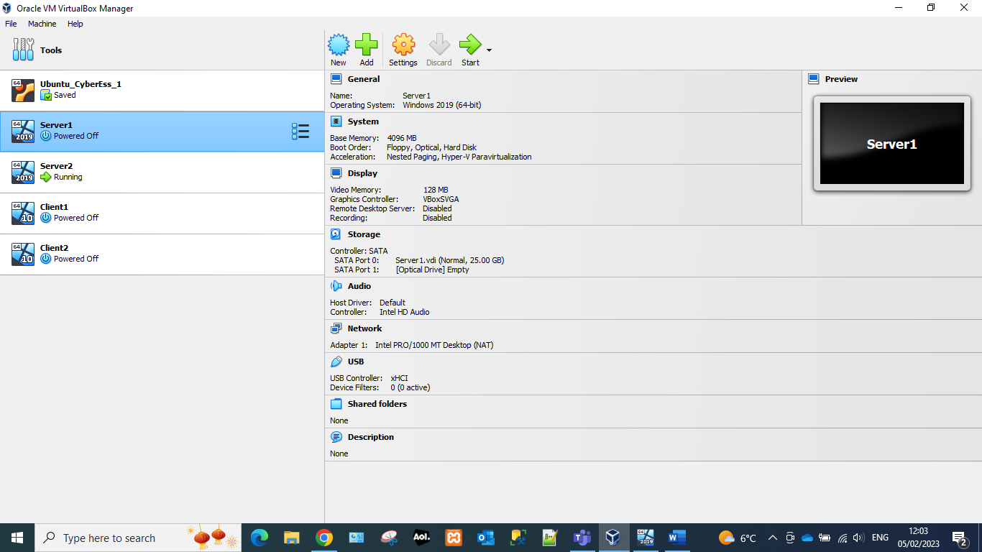 | 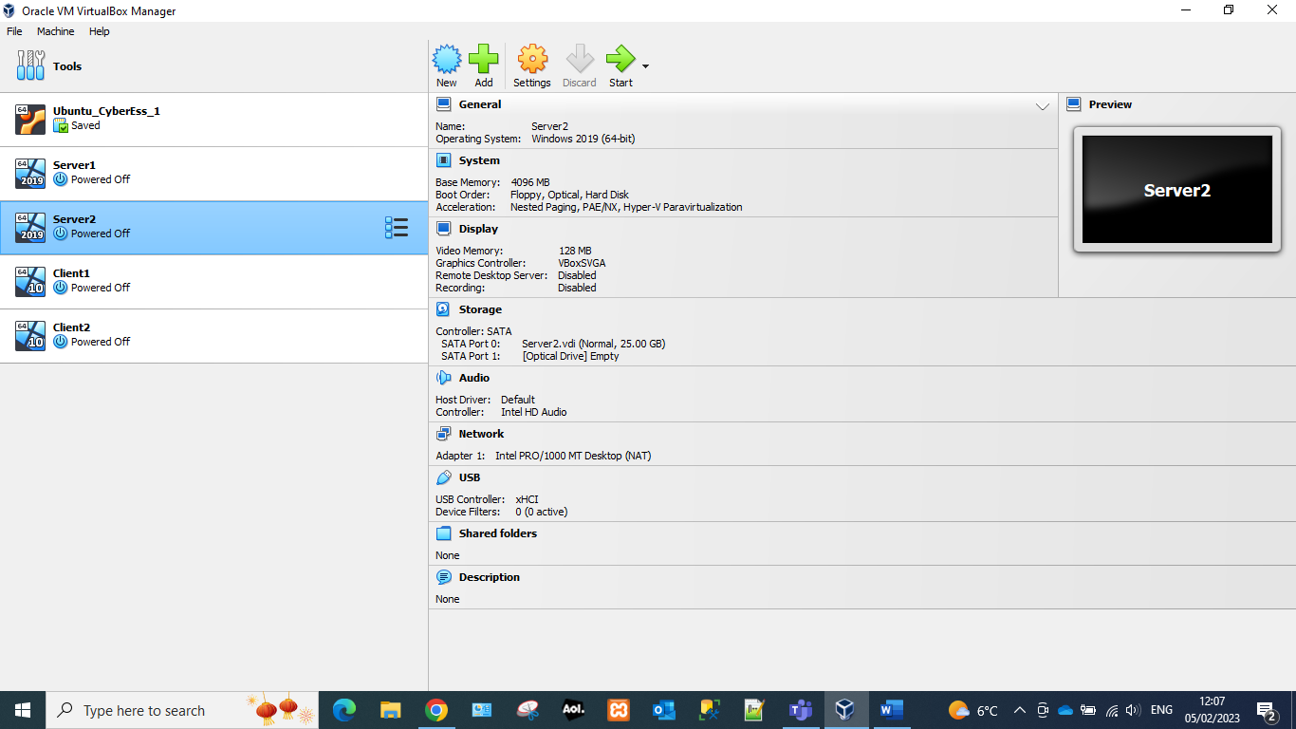

All servers have been created with a standard setup. These will be enough for standard usage on a LAN (local area network). This configuration has enough memory, and processing for most operations.
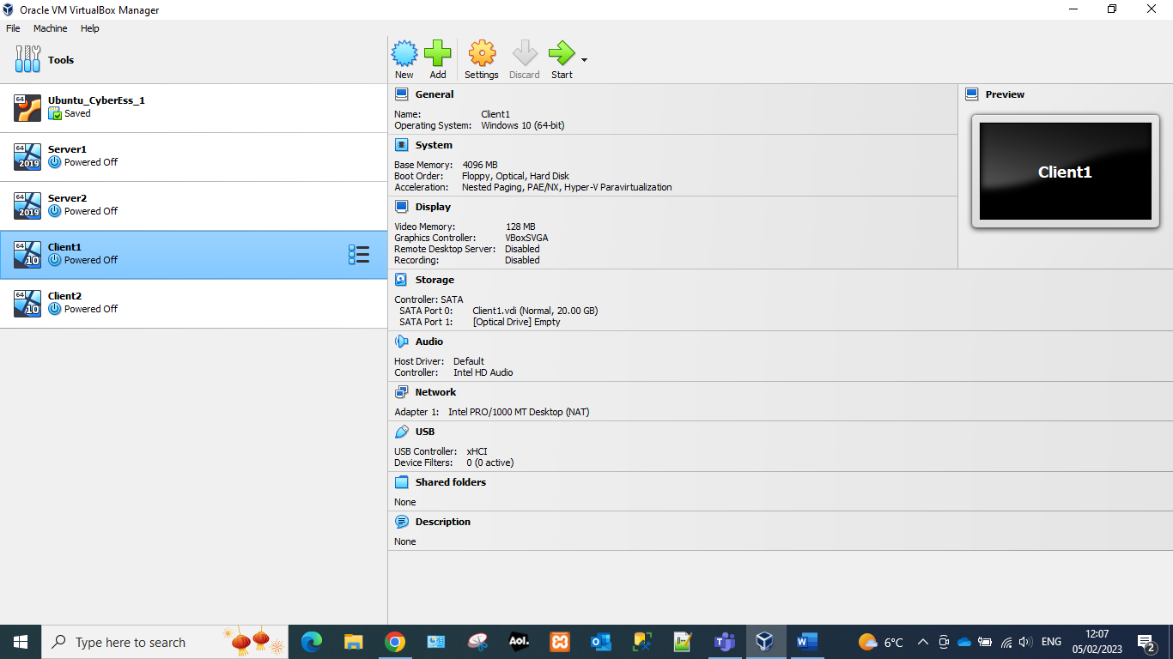 | 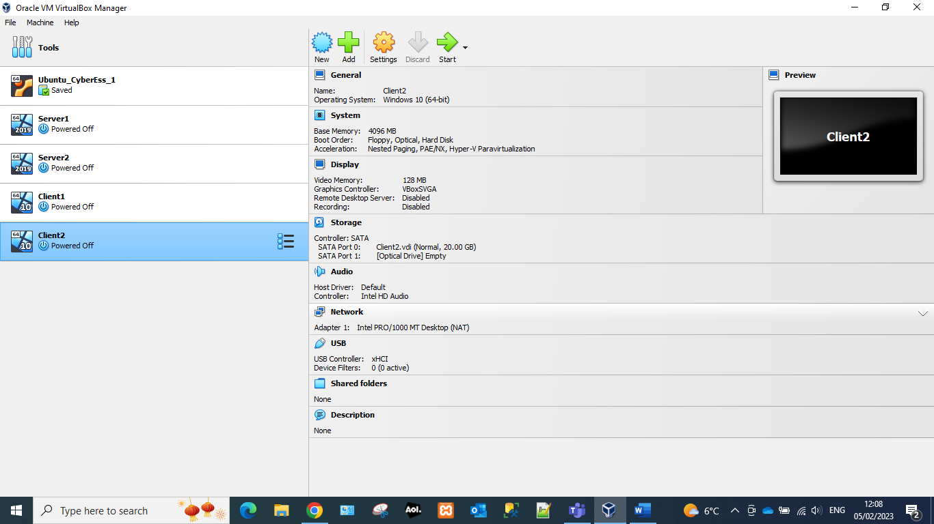

The client has been created with a lower specification to the server as it would not be hosting users. Storage has been created with a smaller amount as it is not doing any operations that require storage.

Installation of server operating System
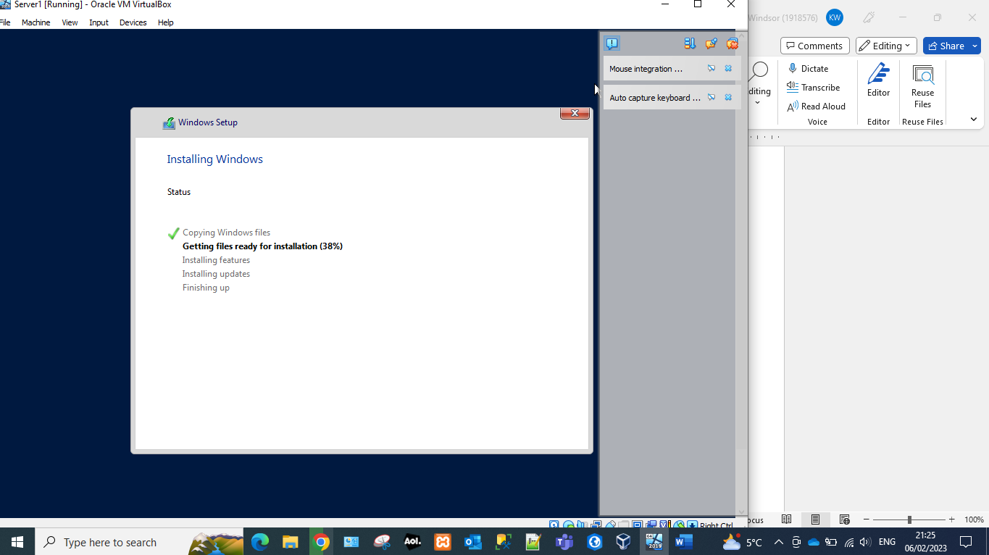 | 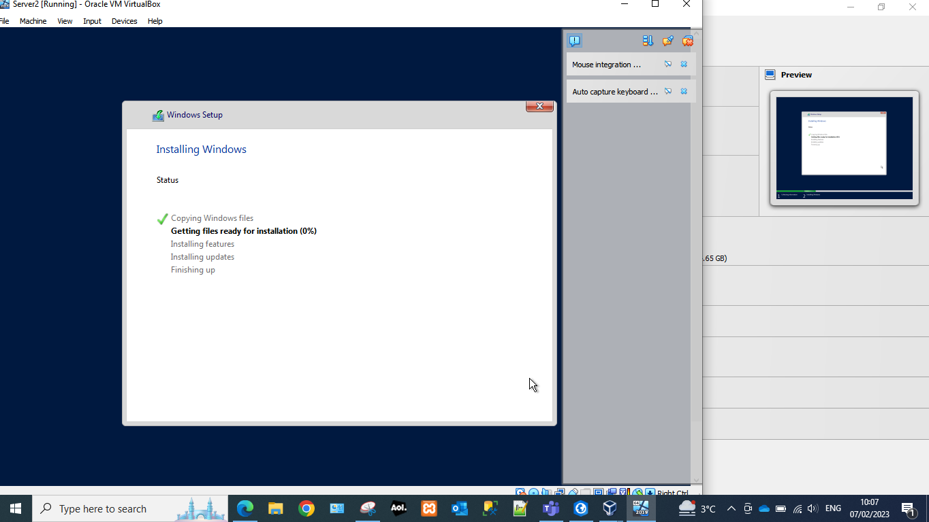

Windows 10 is the most recent operating system available on the market. This would ensure that the most recent security patches would be applied.
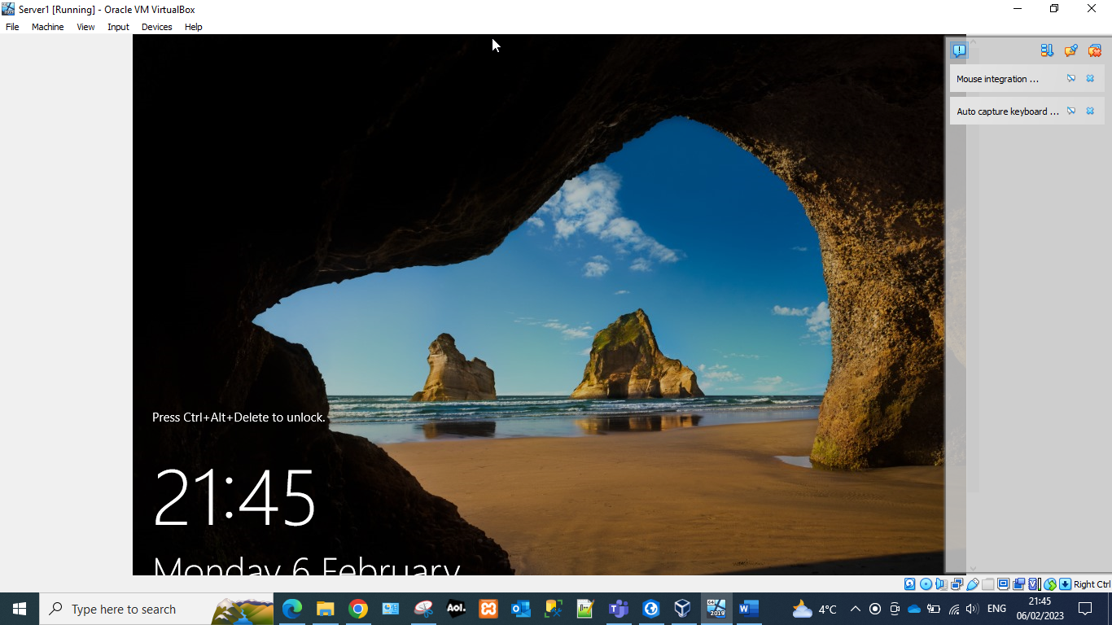 | 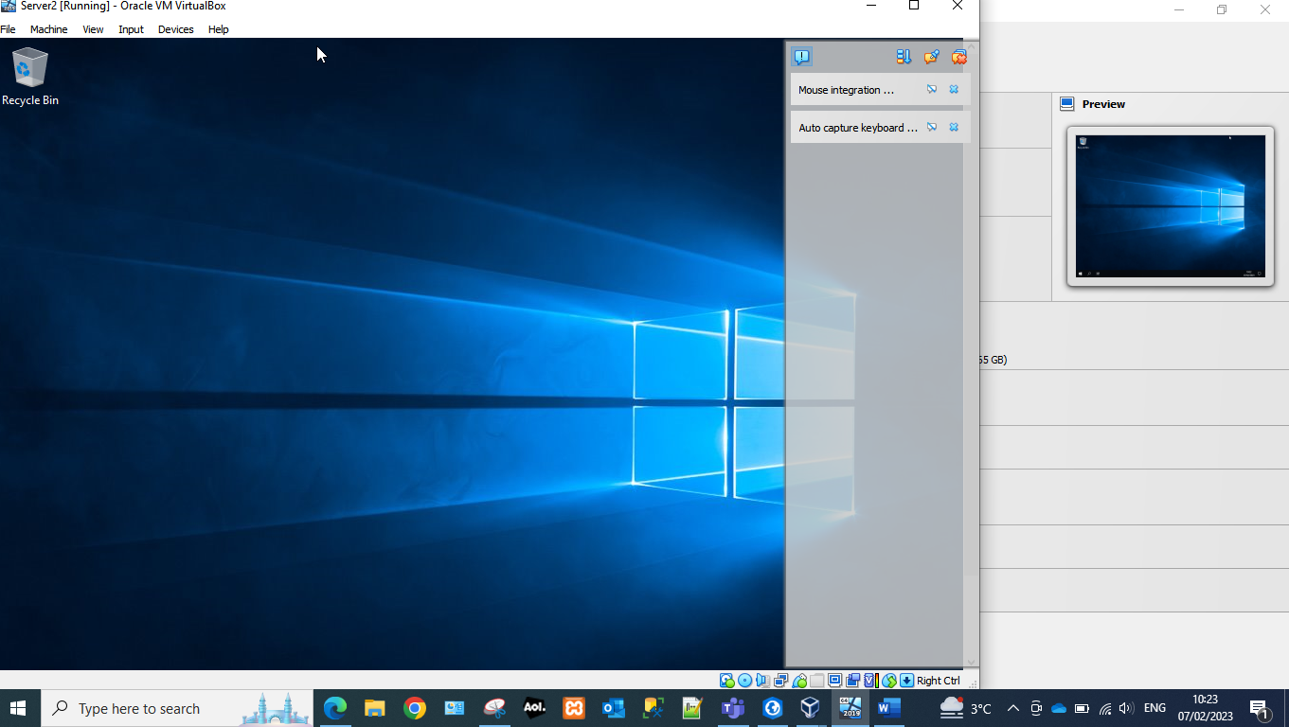

Checks were performed to ensure that the user would be able to logon to the operation system with the specified passwords.

Serial Advanced Technology Attachment(SATA) port1
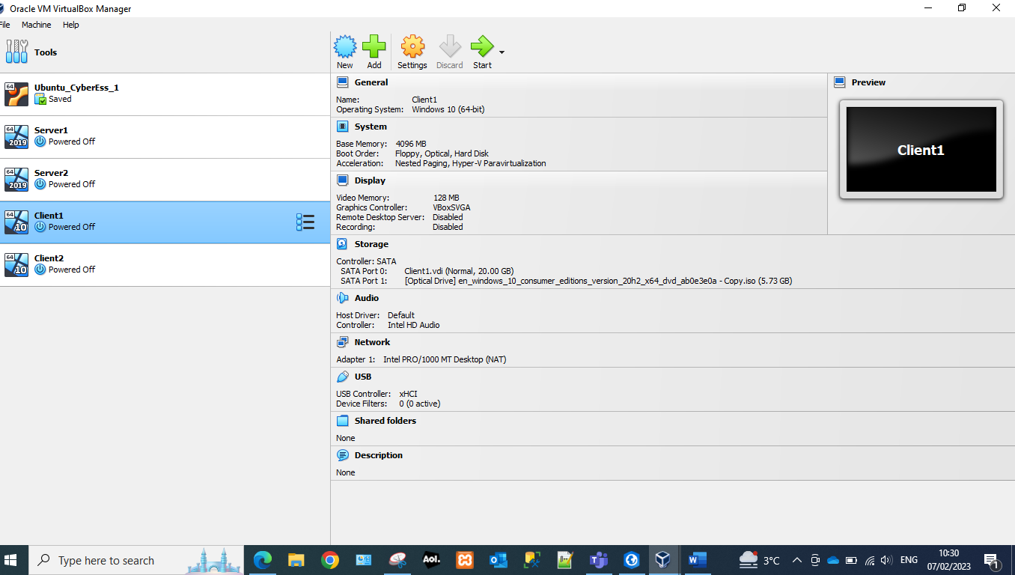 | The SATA enables communication between storage devices and the motherboard using high-speed serial cable over 2 pairs of conductors.  For the best compatibility settings windows 10 has been used on the client devices as well as the servers. The SATA port has a lower storage capacity due to the fact it is a client machine and will not be hosting multiple users. The storage space will be able to host windows and also be able to store basic data.

Installation of Client Operating System
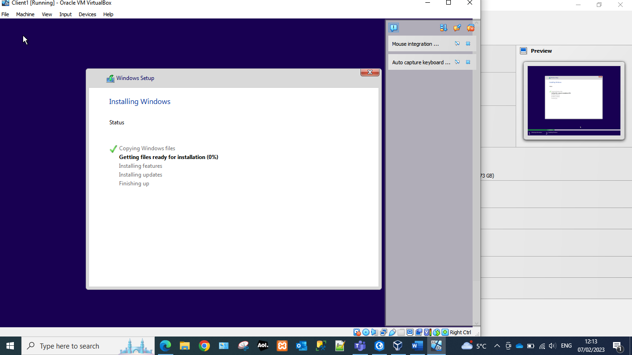 | 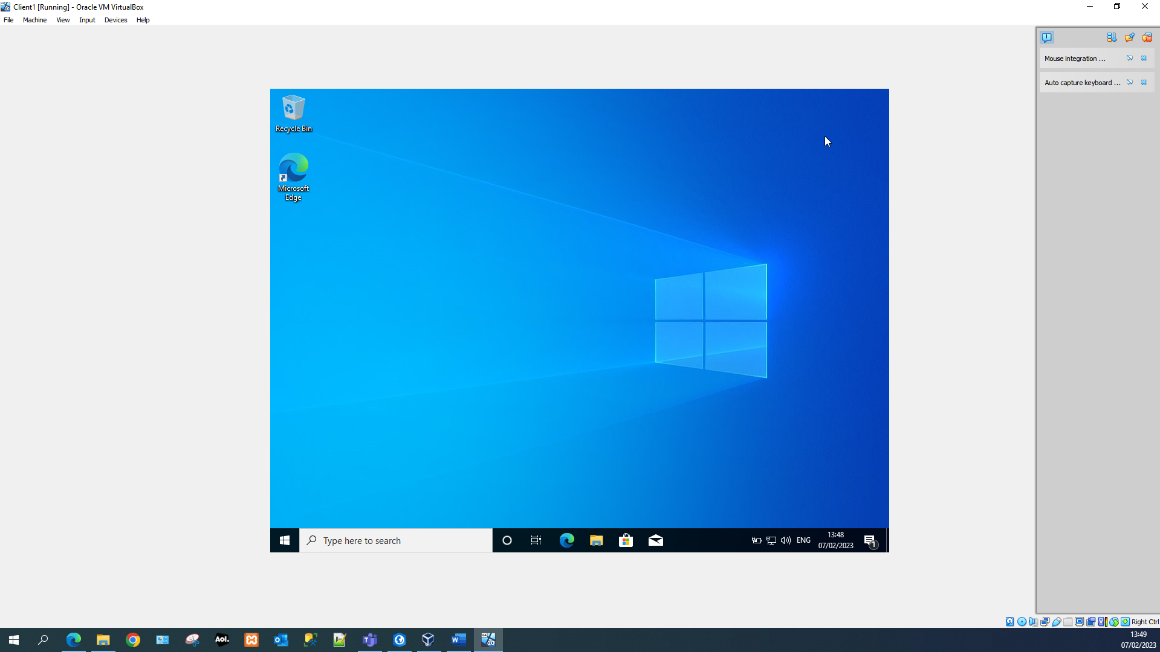
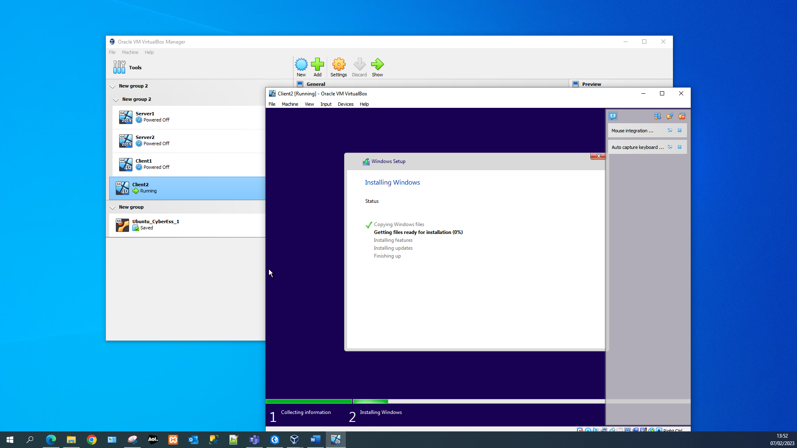 | 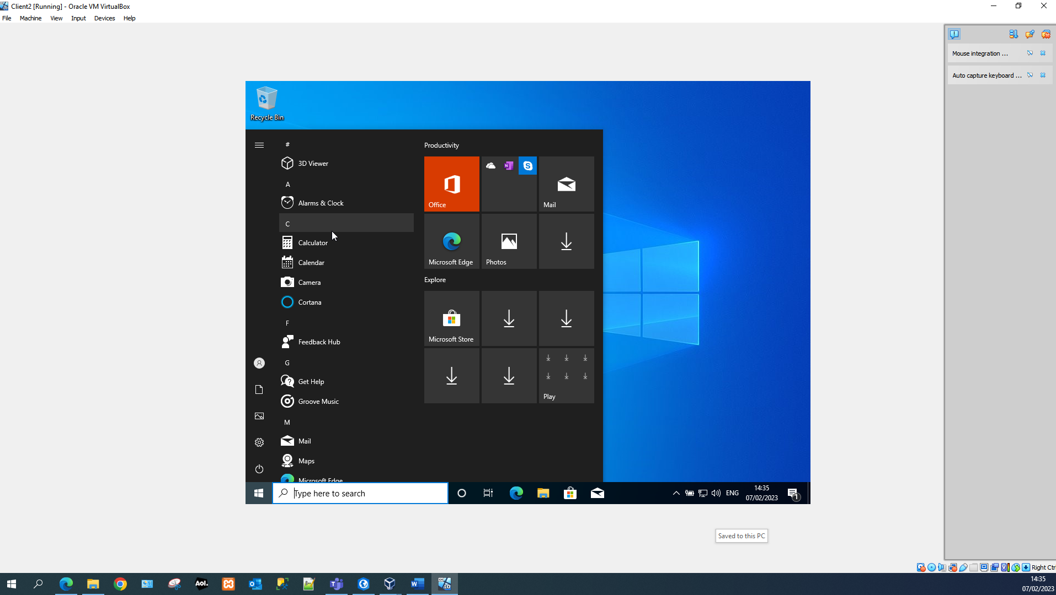
Window 10 pro was installed on the client machines and checks were performed post installation to ensure that the OS had been installed correctly and that the user was able to logon on the account.

Virtual Network Configuration
Adaptor configuration for Server and Client
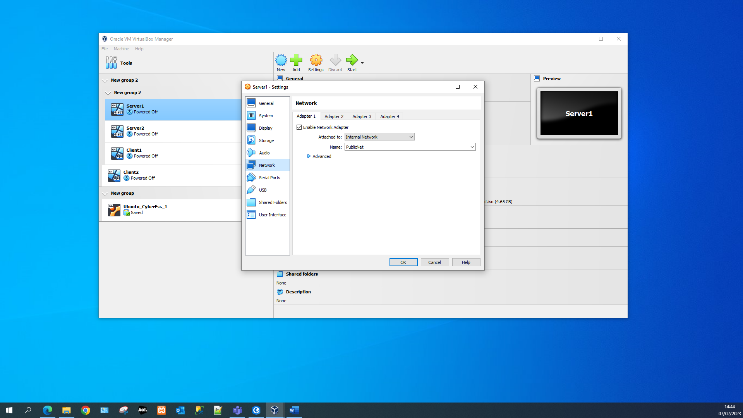 | 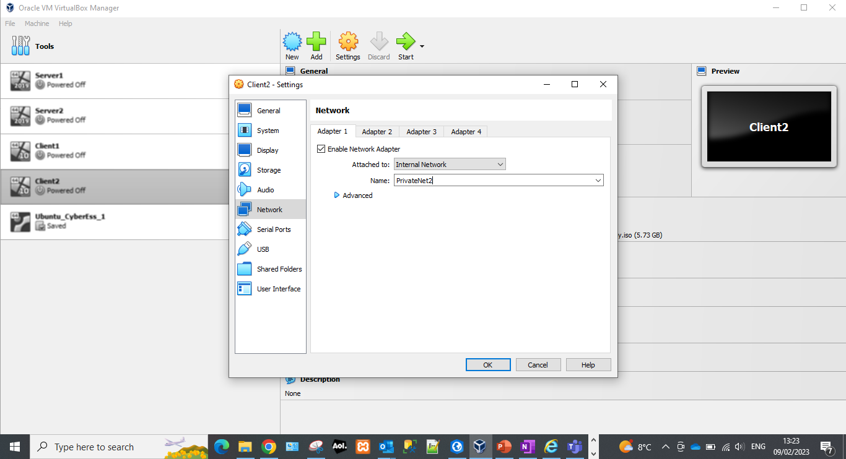

The network configuration for the LAN which is being set up is called “PublicNet.” As a local area network the server should be attached to an internal network and network access should be enabled otherwise it would be impossible for a connection to be made.

LAN configuration for Servers
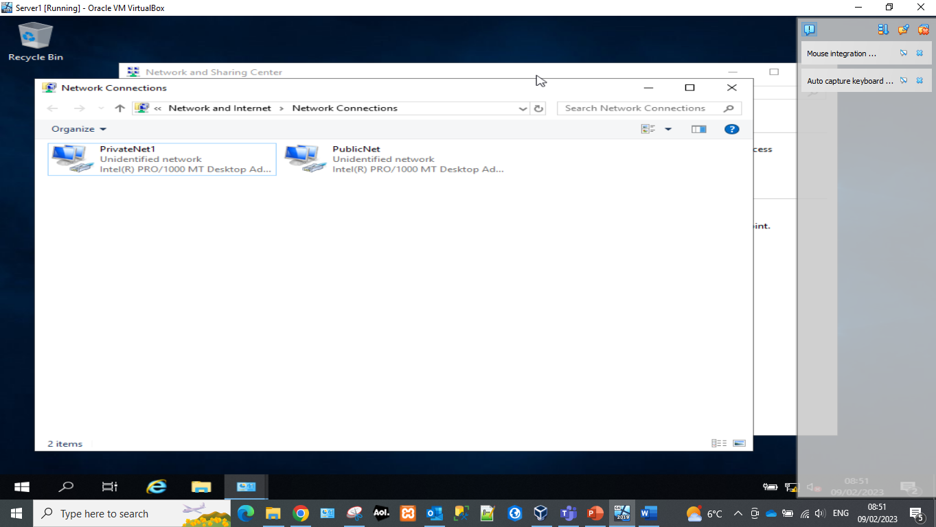 | 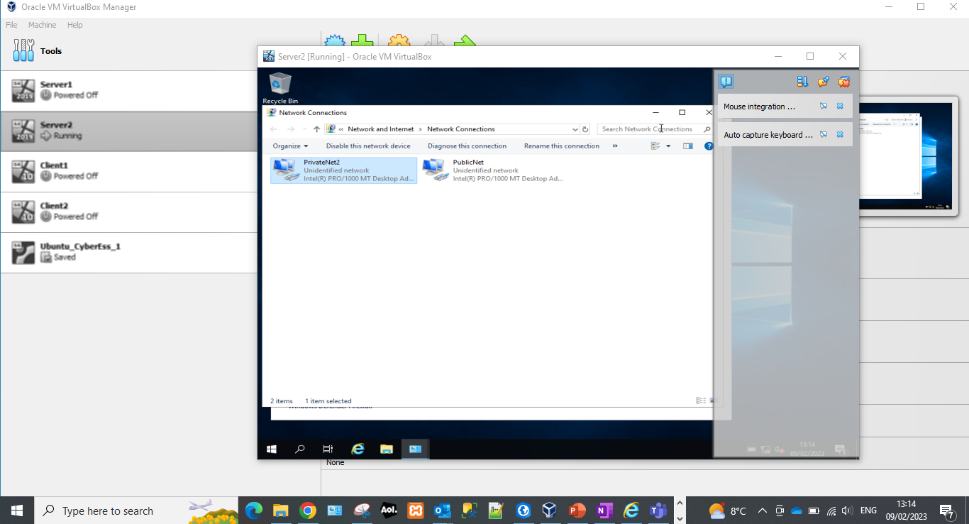

Two networks have been created within Server1: PrivateNet1 and PublicNet. One of these networks is a publicly discoverable and another one is private. The private network is a secure network which will need to be set up in a specific manner to allow the client machine to be able to connect to the domain.

LAN Configuration for Clients
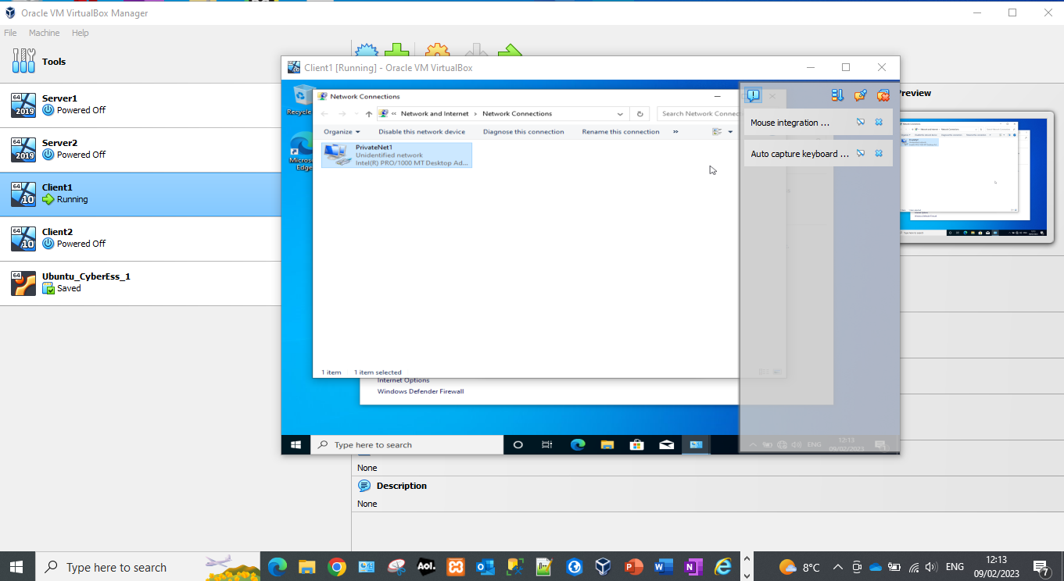 | 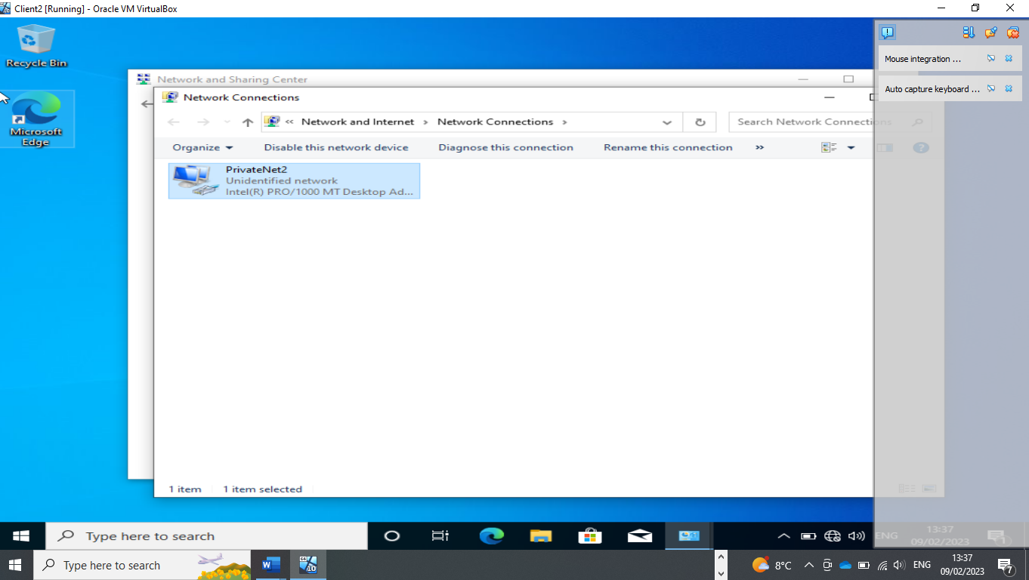

The client has been setup to allow access to the PrivateNet1.

Firewall deactivation of Server1 and Client 1
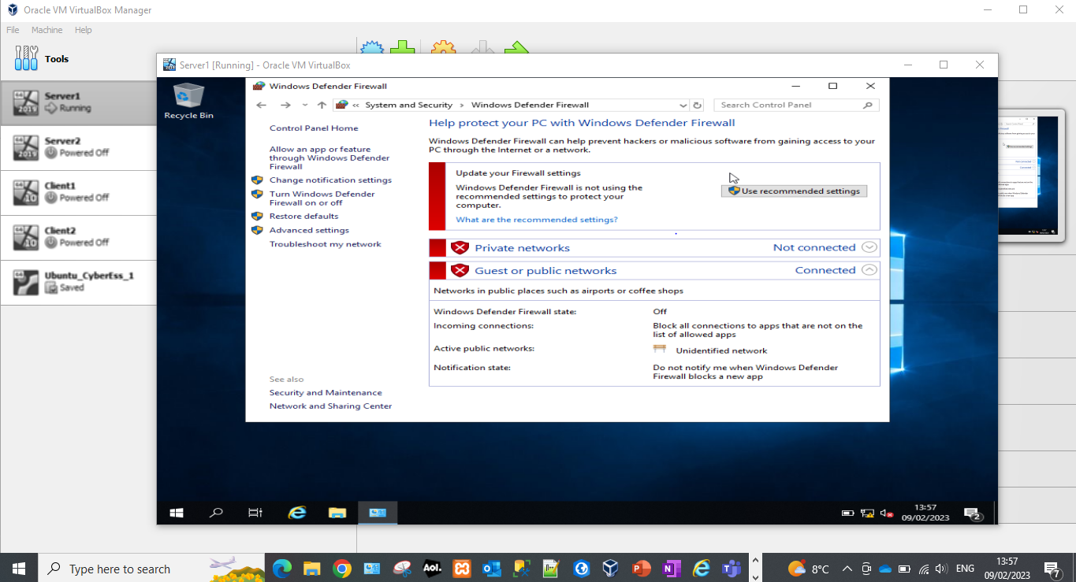 | 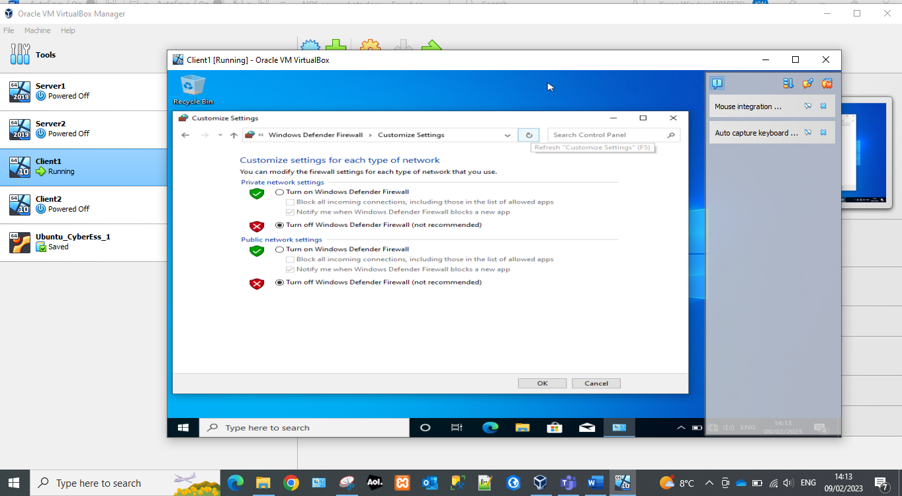

For the connection to be successful the firewalls need to be deactivated on both sides to allow data transfer between the two devices. Private networks are not automatically joined and therefore need extra configuration to be able to set up a successful connection.
The easiest way to ensure a connection can be successful is by turning off the windows firewall. This can be problematic for security reasons with clients connected to an external network. However as this is a local area network it should not be an issue.

Ping from Server1 to Client1 and Server 2 to Client 2
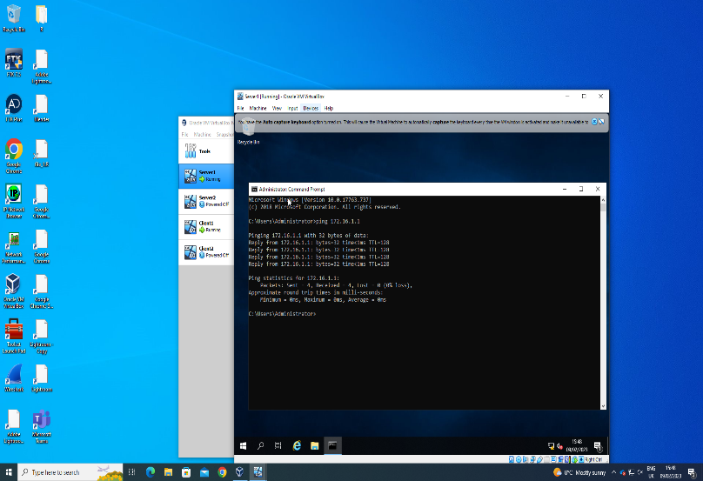 | 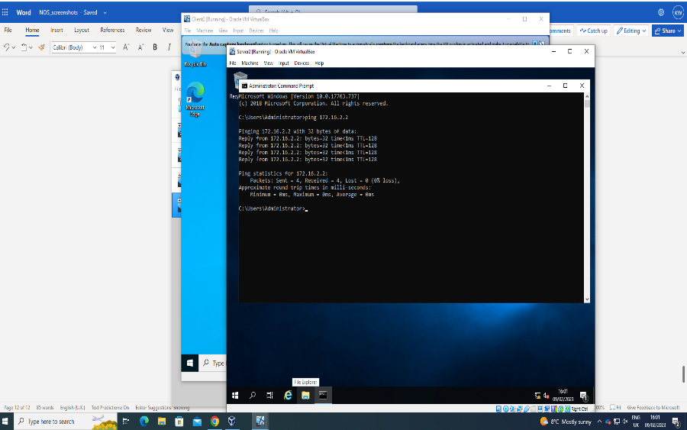

A successful ping between two devices shows a connection has been made over a network. This can be done using the following command within command prompt: ping <device IP address>. The ping command will send four packets to the specified IP address. If they are returned then it can be considered a successful ping.

Sever IP is Statically Defined
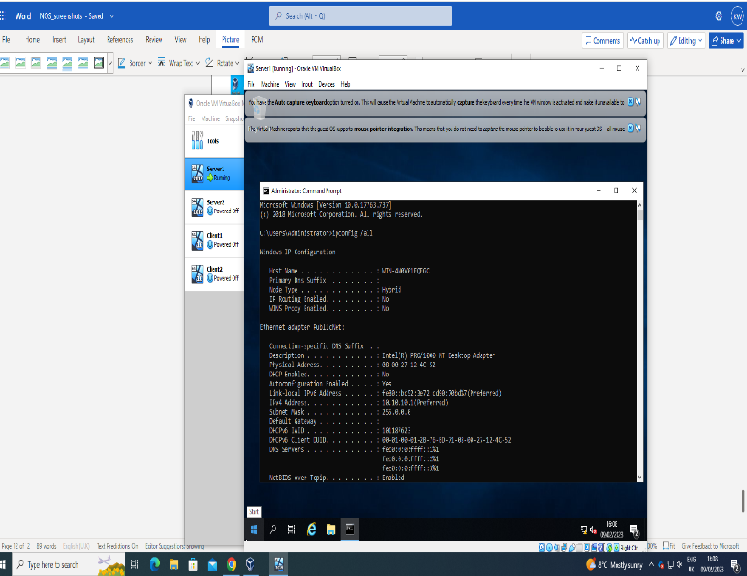 | 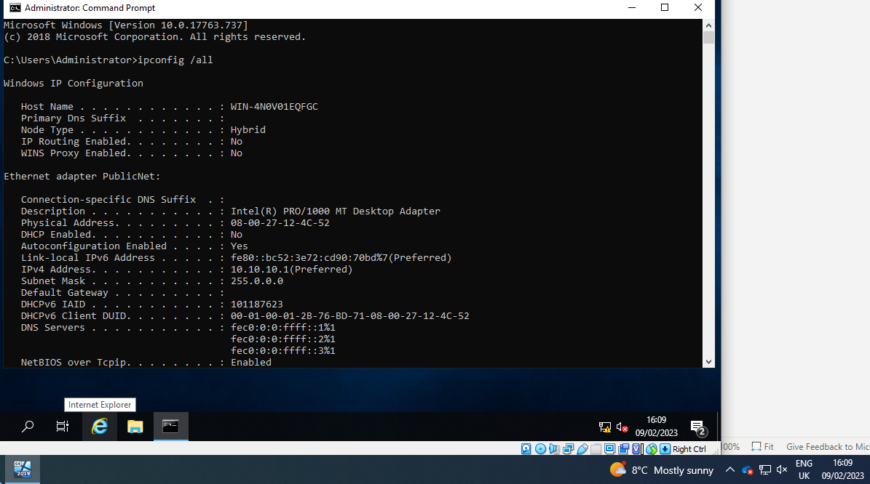
The ipconfig /all command was used to verify that the static IP that was assigned was pulling through to the network adaptor.

Server1 nslookup
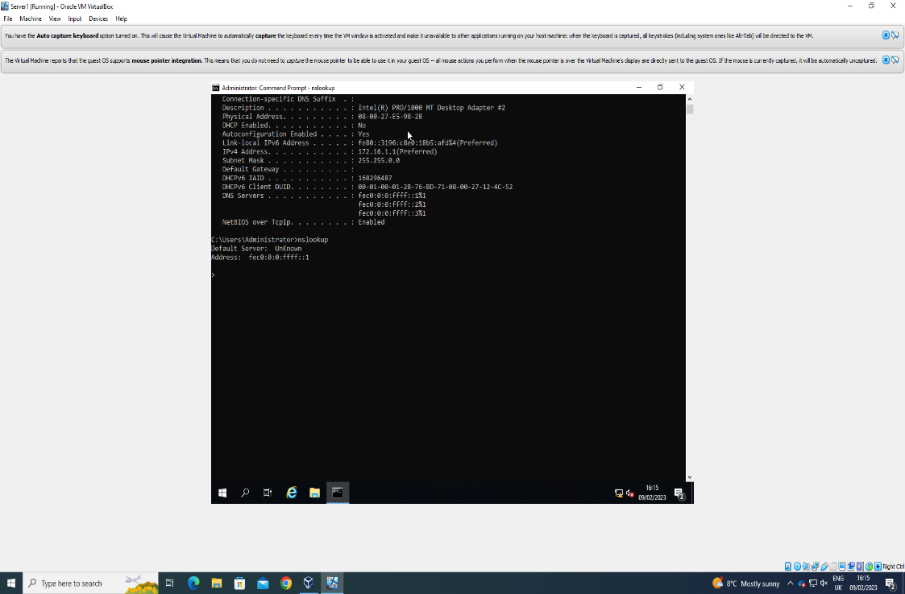
Nslookup was used to verify that the DNS was configured correctly.

Changing machine name on Server1 to DMC1-NT
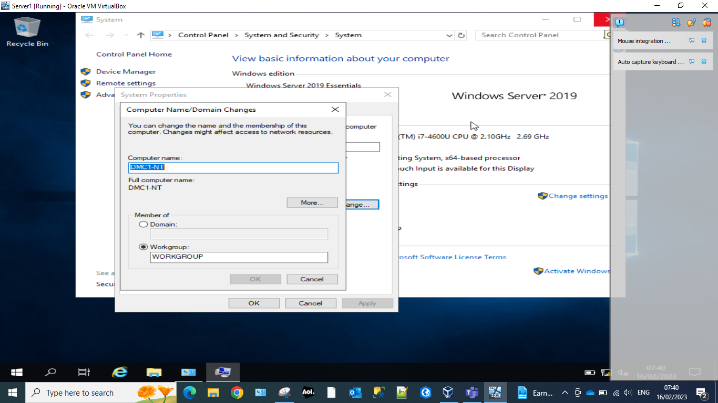

Installing Active Directory Domain Services Server1
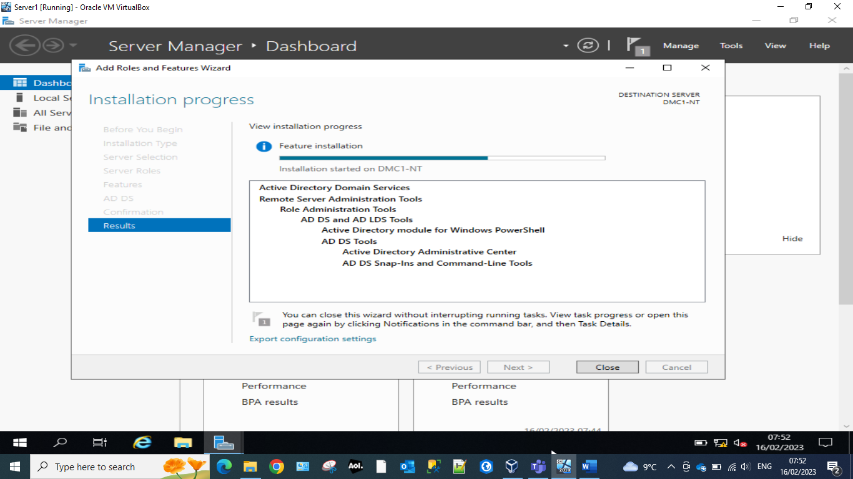
Active directory is an essential software which handles security and group policy management across entire network estates. It ensures users and devices are managed by groups, this is essential for larger network estates with multiple users as managing these devices or users individually can get unmanageable quickly.

Domain Controllers Window Server1
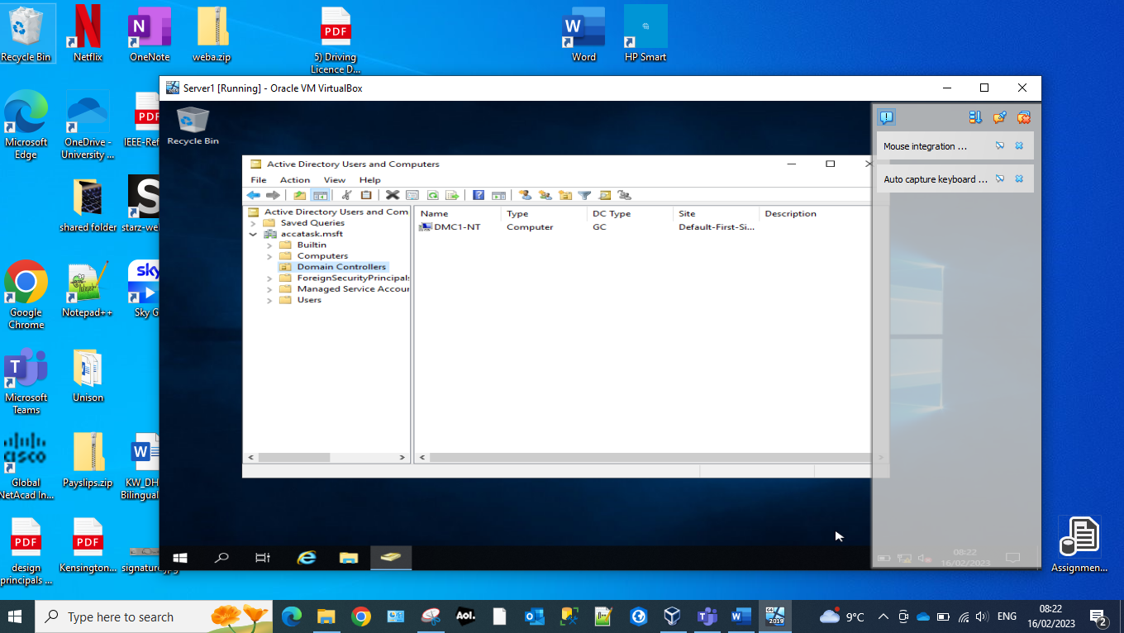
The domain controllers handle authentication requests from other devices trying to access a network. This is mostly common to active directory but can be used with other software. The domain controllers need to be specified in order for their permissions to be elevated to handle these requests.

Add new logon account to Server1.
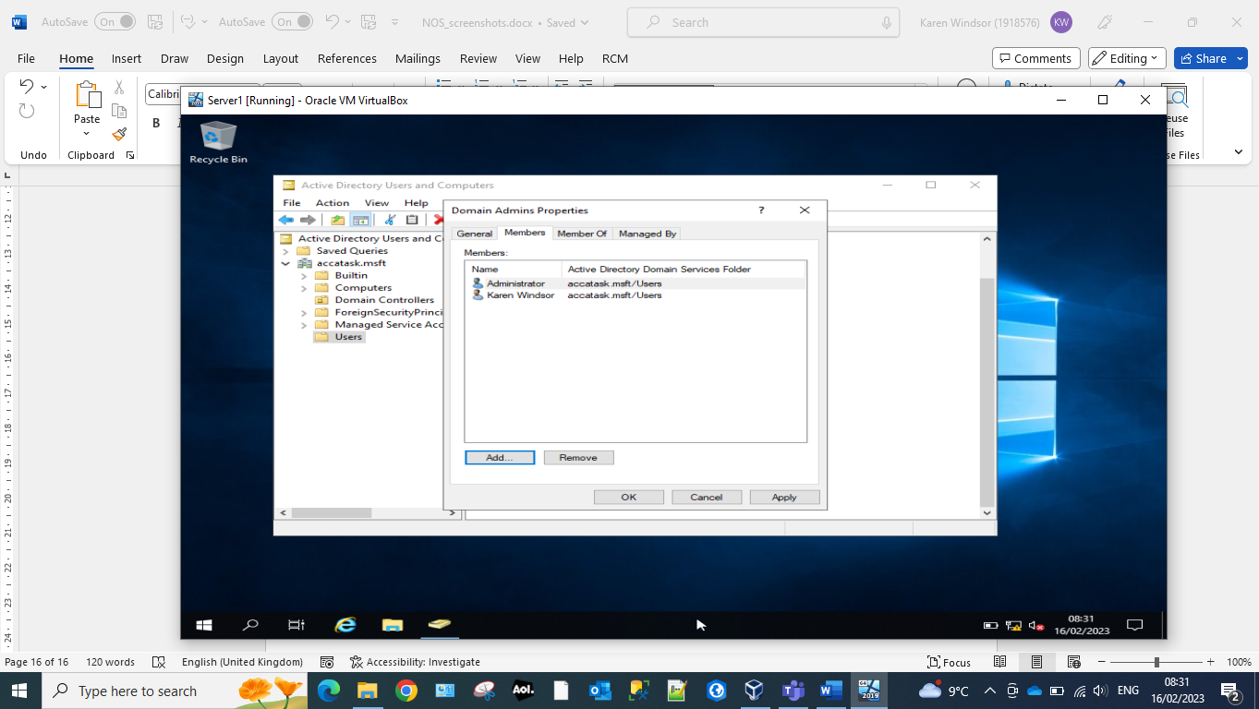

New Active Directory User Server1
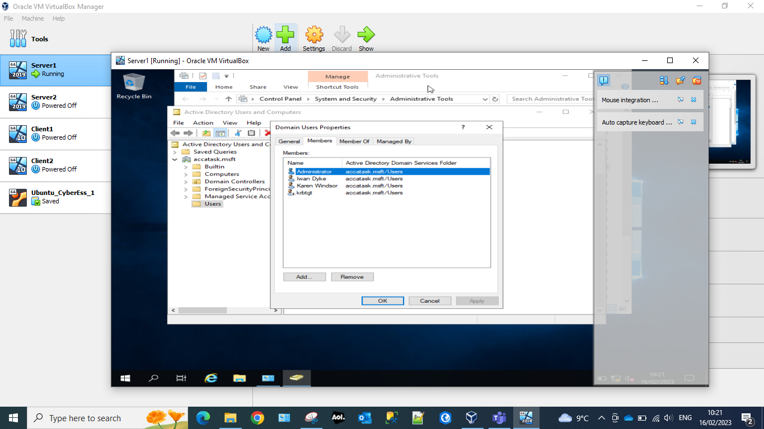
Users can be added to domains which will allow them to be managed within active directory. Users within a domain can be assigned to security groups. These users will then inherit the permissions and access granted to that group. This could be access to file shares, servers, data, software or networks among many other things.

Logging on active directory Client1
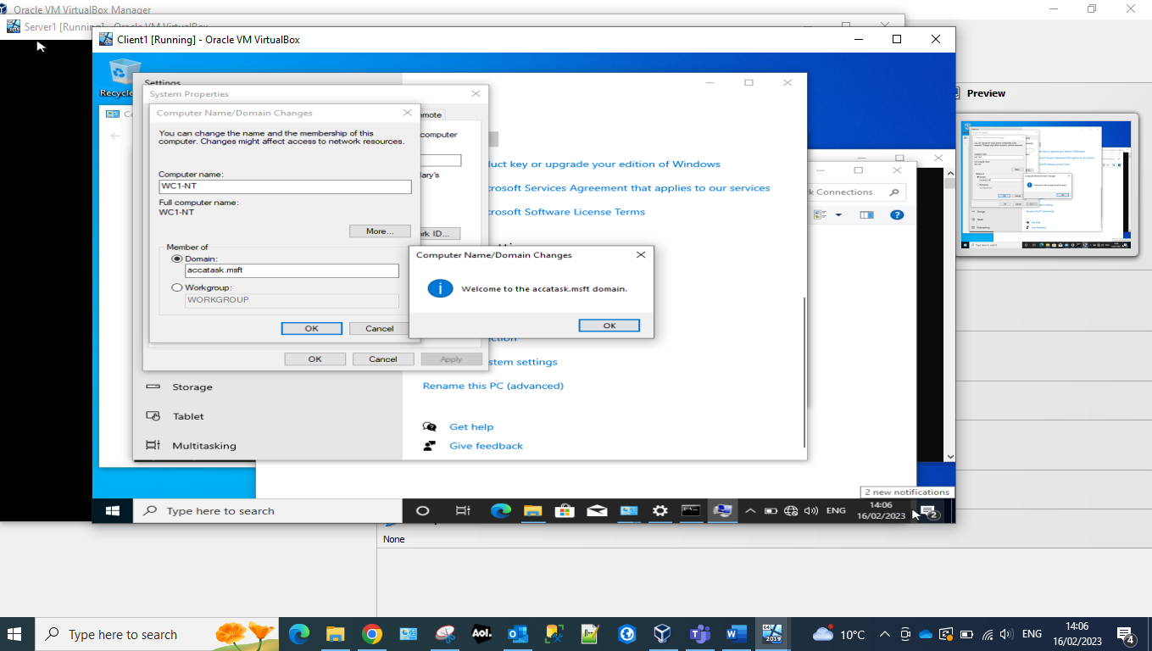
To connect to a created domain. Once the users have been given the required access, the domain will need to be set on the client device within system properties. This indicates to the client device which domain it should attempt to make a connection with. Any policies which have been applied to that domain will then be carried across to the device after a successful connection.

Logging in as alternative NT-ID
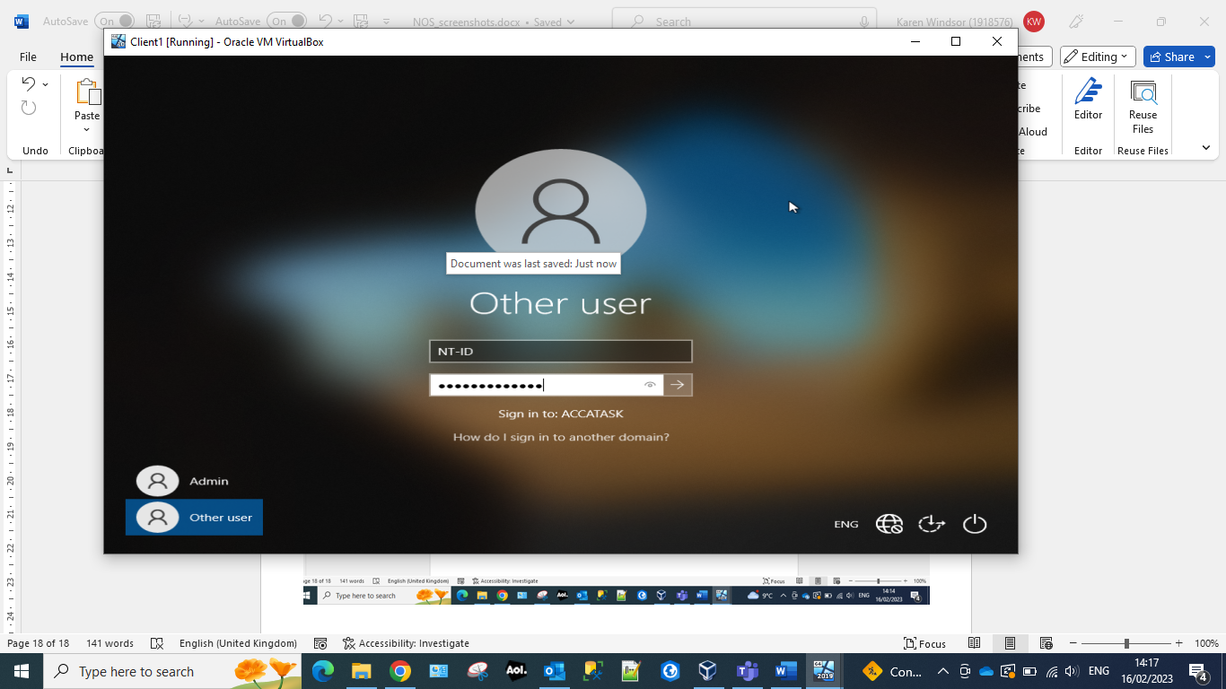

Time restrictions set for user NT-ID
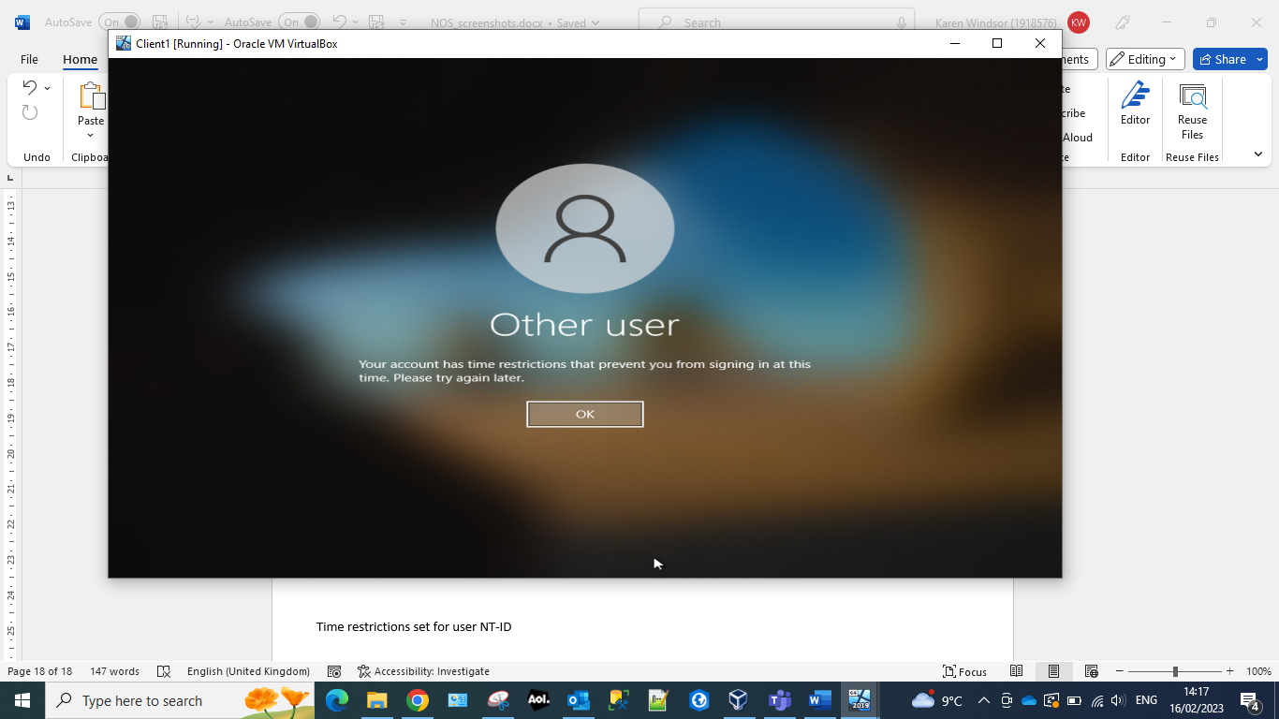
Active directory allows for users to be given limited timeframes to log into devices. This can be to limit the number of users which are connecting to a network at any one time. This could be for bandwidth issues or due to lack of resources available on a network or server.
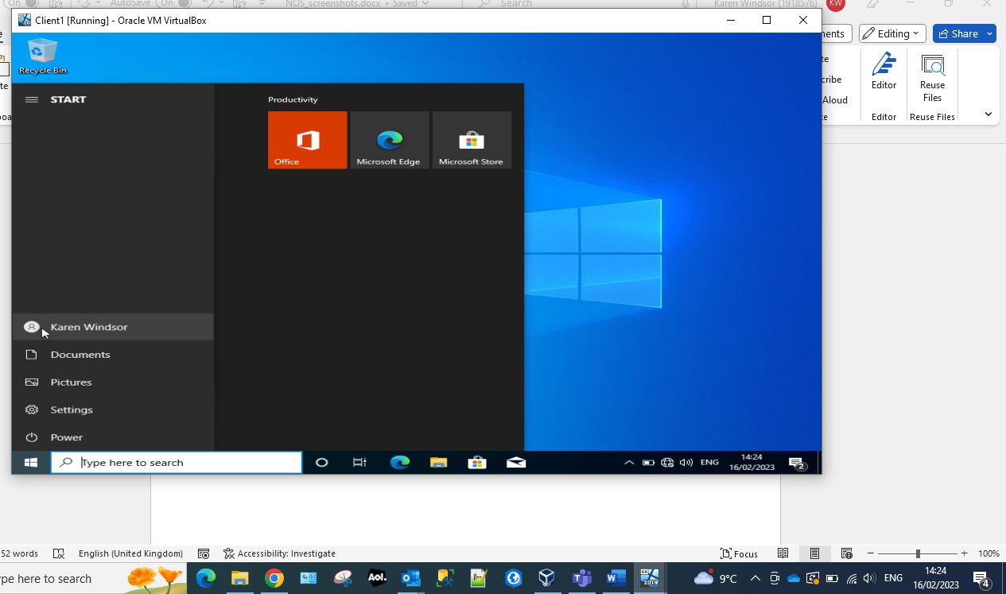

Part 2 (Task 3)

Justify the reason why Type 2 Hypervisors is used in the above practical task?
In the above practical task, we were required to create Virtual Machines to be able to complete the task. Creation of a Virtual Machine utilises the Hypervisor technology to translate the requests from physical infrastructure and the virtual resources, and allows the multiple Virtual Machines to share the host machines resources. Hypervisors enable users more flexibility, portability, efficiency and the ability to create and ‘spin up’ a new machine almost instantly, compared to the time it takes to build a physical server. Having multiple Virtual Machines running on a single system makes it more energy efficient and cost effective over having dedicated physical servers for these Virtual Machines.
There are two main variants of Hypervisors – Type 1 which is commonly known as ‘bare metal’, and Type 2 which is referred to as ‘Hosted’. Type 1 Hypervisors is where the Virtual Machine Manager is run directly on the machines hardware, hence why it’s known as ‘bare metal’, whereas a Type 2 Hypervisor is ran on top of the host machine’s operating system. In our task, we were required to create 4 Virtual Machines, all with limited amounts of storage, memory and processing power. For this reason, along with the fact that its very unlikely that University students would have dedicated hardware to run a Type 1 Hypervisor, we used a Type 2 Hypervisor, namely VirtualBox. This allowed us to create these Virtual Machines on our personal/work laptops that are usually used for less intensive day-to-day tasks, while still being able to just ‘power down’ the Virtual Machines and then using the computer as we normally would. Although a Type 1 Hypervisor is more common (for example in Data Centre usage) and much more secure due to its ability to isolate themselves from the guest operating systems, a Type 2 Hypervisor was much more suited to this task, and the level of ability of us University students, despite the fact that one of the biggest drawbacks of a Type 2 Hypervisor is the latency caused by the extra layer of communication caused by a separate operating system. [1]
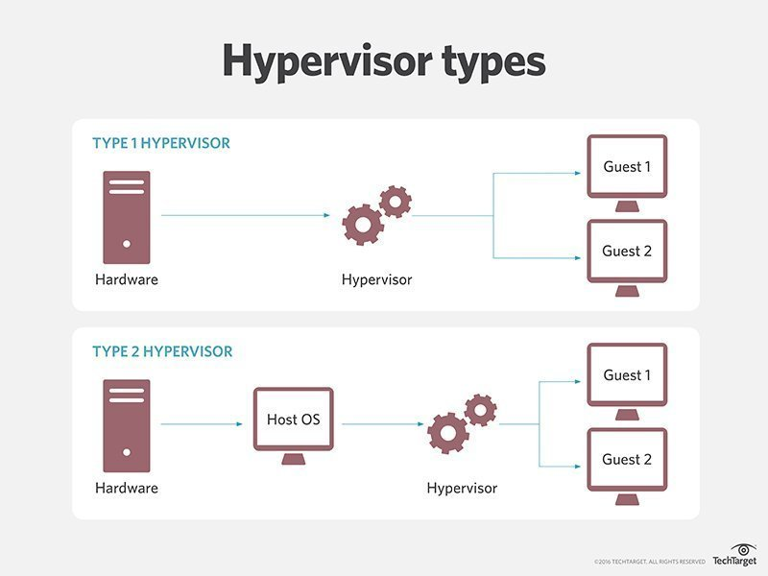
Illustration of the types of Hypervisors [2]

DHCP
Dynamic Host Configuration Protocol, more commonly known as the acronym DHCP, is a networking protocol that automatically provides a machine with an IP address, along with other networking configuration information such as the correct subnet mask and default gateway address. Based on the common TCP-IP network architecture and model, every device that intends to connect to a network requires a IP address which is unique to that network device. If DHCP wasn’t enabled, IP addresses would need to be defined and configured manually leading to statically defined IP addresses, whereas DHCP fully automates this process in the background and leases the IP address to the device dynamically – this reduces configuration errors such as incorrectly typed IP addresses, or conflicts caused by two network devices being assigned the same IP address [3].
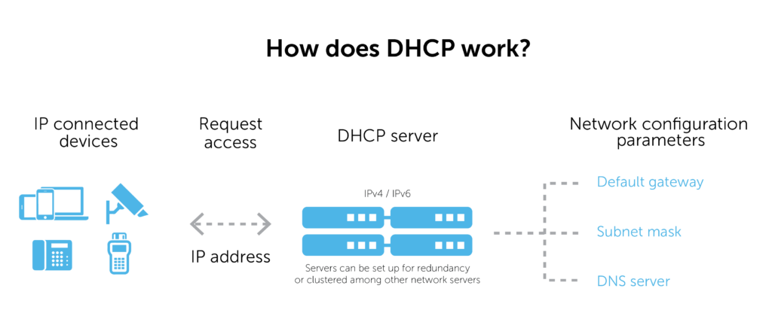
Illustration of how DHCP works [4]
The significance of DHCP in relation to our tasks above, is that to complete the task and enable the both servers to be able to communicate with each other and their client machines, we had to disable DHCP on all of the network cards used in the task, and statically define the IP addresses, subnet masks, default gateways and DNS servers – this was crucial in allowing the Client VMs to join the accatask domain. If this was a production environment and not a University task, a DHCP server would be set up to aid automation.

Active Directory
Active Directory (AD) is essentially a massive database that stores information that is critical to the network environment, such as user accounts and computer accounts, and what their individual permissions are. Within the individual user and computer accounts, information such as Job Title; Email; Phone Number; Password; Location (of computer or office location) and much more. Active Directory is the heart of an IT environment, as its responsible for authentication, authorisation, and rights management, by utilising products within the Active Directory eco structure such as Group Policy and Single Sign On.
Active Directory is extremely versatile with an easy to understand structure, and can be expanded after initial setup. All Active Directory objects sit under a domain, which is a group of Active Directory objects, such as users, printers and computers, that re related to each other. Multiple domains can sit under one tree, and multiple trees can sit in a single forest. For example, a company (forest) can have multiple directorates (trees) and each directorate can have multiple departments (domains) within it. It is actually possible to segregate a domain even further, by utilising Organisational Units within a domain, for example multiple teams (OUs) within a single department (domains) [5].
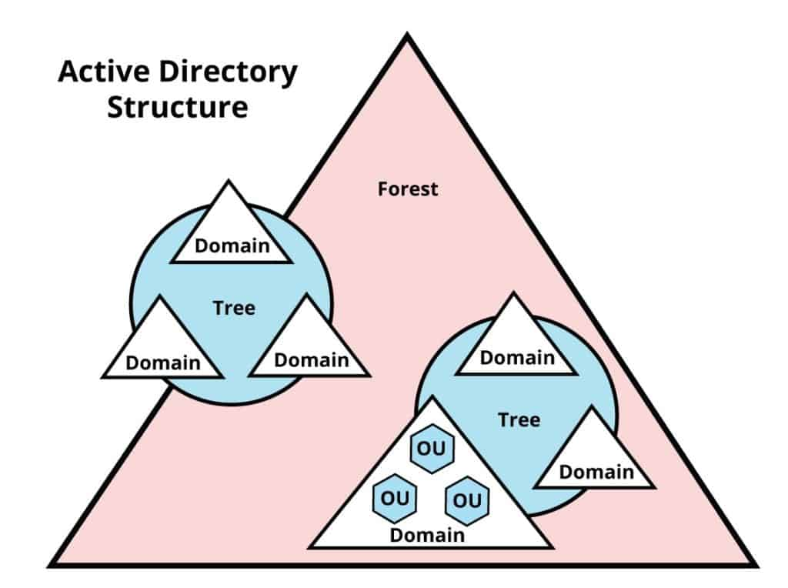
AD Structure [6]
In our above task, we were required to create and configure a new Active Directory service. We done this by enabling the core of Active Directories offerings – Active Directory Domain Services. As part of the setup, we created a new standalone domain called accatask, and we set up Server One as it’s Domain Controller and Global Catalogue. A Global Catalogue is where a read only replica of any other domains set up in the future is stored, along with the domain we created, accatask [7]. Once created and both Active Directory Domain Services and the individual Virtual Machine’s networks had been configured, we created the computer accounts for the Virtual Machines, along with a new Domain Administrator account that has full access over the domain, and various User accounts, ranging from zero access to log in to Local Administrator accounts – this was all done using Active Directories built in access control tool, Active Directory Users and Computers.

Terminologies

Windows Firewall
Windows Firewall is a built-in Inbound and Outbound firewall that was first introduced with the release of Windows XP [8]. On every modern Windows Operating System, Windows Firewall is enabled as default, which for the average end-user, saves them from being unprotected and attacked, but for us in our above task, this was an issue. As the firewall was enabled, we were initially unable to ping from the Server1 Virtual Machine to Client1 and vice-versa. To enable the ping to succeed, we had to disable the public, private, and domain network firewalls. Windows Firewall has multiple different zones configured due to laptops becoming much more popular over the years, and many businesses introducing Bring Your Own Device rather than handing out company issued hardware, so Windows Firewall has adapted to this to allow configuration of different settings based on what network you’re connected too – this is usually set automatically when the device first joins the network but Windows will prompt for the user to choose what type of network this is if it cannot recognise it. With the Windows Servers Operating System, any disabled / not-installed services such as DNS or Active Directory Domain Services are automatically blocked, but will automatically be allowed through the firewall when it is installed and configured within Server Manager [9]. Windows Firewall is drastically different compared to Mac OS’s Firewall – while Windows Firewall comes enabled as default, Mac’s are disabled as default. Another contrasting difference between Windows Firewall and Mac’s Firewall is that Windows allows configuration of both inbound and outbound, whereas Mac only allows configuration of inbound connections [10].
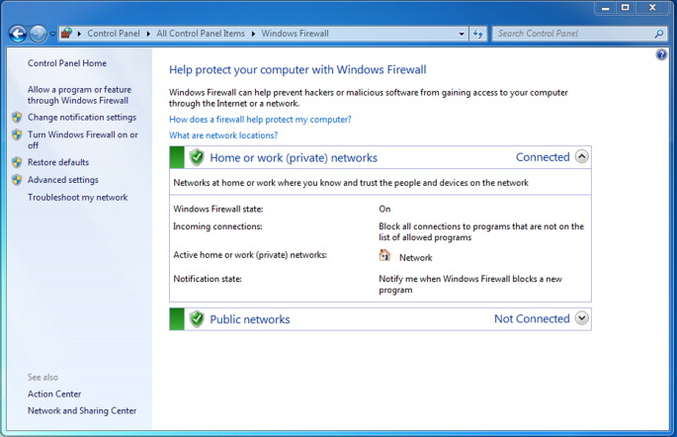
Screenshot of Windows Firewall [8]

Ping ?

Server Manager ?

Conclusion and reflection on collaborative work
In conclusion, completion of this task has been thoroughly enjoyable and I have learnt massive amounts during the physical section in Part One and the research that enabled me to complete Part Two. The knowledge that I will finish this part of the module with will equip me going forward to not only complete the second half of this module, but in my day to day work life. This task has been the first of my University life where collaborative work has been required. While it’s a nice change in the University lifecycle, I believe that to truly get the most out of this module, independent learning is required – for the majority of task one, I found myself being massively ahead of the rest of the team, and even experimenting with more advanced tasks such as linking the two servers and replicating the Active Directory Domain onto Server2 to allow Client2 to connect to the domain.

References

[1] | VMware, “What is a hypervisor?,” 2023. [Online]. Available: https://www.vmware.com/topics/glossary/content/hypervisor.html. [Accessed 09 03 2023].
[2] | TechTarget, “Hypervisor Types,” 2016.
[3] | Microsoft, “Dynamic Host Configuration Protocol (DHCP),” 29 07 2021. [Online]. Available: https://learn.microsoft.com/en-us/windows-server/networking/technologies/dhcp/dhcp-top. [Accessed 09 02 2023].
[4] | BlueCat Networks, “How does DHCP work?,” 2023. [Online]. Available: https://bluecatnetworks.com/glossary/what-is-dhcp/. [Accessed 09 03 2023].
[5] | Quest, “What is Active Directory,” Quest, 2023. [Online]. Available: https://www.quest.com/solutions/active-directory/what-is-active-directory.aspx. [Accessed 09 03 2023].
[6] | J. Parker, “Active Directory Structure,” 29 09 2022. [Online]. Available: https://www.pcwdld.com/wp-content/uploads/Active-Directory-Structure-1024x764.jpg. [Accessed 09 03 2023].
[7] | K. McCorry, “Exchange 2003 Deployment Fundamentals,” in Microsoft Exchange Server 2003, Deployment and Migration SP1 and SP2, 2006.
[8] | J. Orchilles, “Chapter 1 - Introduction to Windows 7,” in Microsoft Windows 7 Administrator's Reference, 2010, pp. 1-91.
[9] | T. Olzak, J. Boomer, R. M. Keefer and J. Sabovik, “Chapter 9 - Securing, monitoring, and managing a virtual infrastructure,” in Microsoft Virtualization, 2010, pp. 175-182.
[10] | C. Hoffman, “Your Mac’s Firewall is Off By Default: Do You Need to Enable It?,” How-To Geek, 10 07 2017. [Online]. Available: https://www.howtogeek.com/205108/your-mac%E2%80%99s-firewall-is-off-by-default-do-you-need-to-enable-it/. [Accessed 09 03 2023].

