

Postgraduate/Distance Learning

Assignment coversheet & feedback form

THIS SHEET MUST BE THE FIRST PAGE OF THE ASSIGNMENT YOU ARE SUBMITTING (DO NOT SEND AS A SEPARATE FILE)

For completion by the student:
Student Name: Hilda Hermann

Student University Email: 1706721@student.uwtsd.ac.uk
Module code: AHAN7003  Module title: History of Astrology | Student ID number:  1706721 |  |  | Educational support needs:  No
Assignment title: Discuss the role of astrology in the European medieval world using at least two primary sources from either art or literature

Assignment due date: 16-07-2018
This assignment is for the 1st 2nd 3rd 4th 5th 6th module of the degree
I confirm that this is my original work and that I have adhered to the University policy on plagiarism.

Signed ……………………………………………………………………... Hilda Hermann

Email submission:if you are submitting this form via email, please tick this box □

(as a substitute for your signature) to confirm that you agree to the above declaration.
Assignment Mark
1st Marker’s Provisional mark
2nd Marker’s/Moderator’s provisional mark
External Examiner’s mark (if relevant)
Final Mark

NB. All marks are provisional until confirmed by the Final Examination Board.

For completion by Marker 1 :

Comments:

Marker’s signature: |  |  | Date:
For completion by Marker 2/Moderator:

Comments:

Marker’s Signature: |  | Date:
External Examiner’s comments (if relevant)

External Examiner’s Signature: |  | Date:

Discuss the role of astrology in the European medieval world using at least two primary sources from either art or literature
Word Count: 3 104

Using images from two fifteenth century primary sources – a medieval folding almanac (MS. 8932) that was produced in England c. 1415–1420, and folios from an illuminated manuscript (Egerton 2572) dated c. 1486 – this essay will discuss the interdisciplinary position astrology held in the European late medieval world, and the roles of astrology across the church, medicine and lay society. In the course of discussion, historiographical issues will also be considered.

Leading up to this period, medicine, Aristotle’s physical works, and Greek and Arabic teaching on the stars and planets were of great interest in the West because of their practical applications. And although some historians represented astronomy as becoming scientifically precise by throwing off seemingly ‘unscientific’ astrology, terminology in the twelfth and thirteenth centuries was too variable to enable contemporary distinction between the two. According to Roger French, the twelfth century division of the sciences also separated medicine and astrology, and whether astrology was part of medicine was a topic disputed through to the fifteenth century in the context of growing religious hostility. French contends that astrological knowledge was available to be used because it had been claimed for such purposes, not because it had diffused or been transmitted to the West. When it came to the frontiers of European expansion, astrology also helped to maintain an ideology in which military power and religious belief were united. Thus, as French suggests, royal patronage may have been ‘another motive for scholars to tackle new Arabic material that furthered the art of prognostication’. Although many of the leading astrologers in the English court during the fifteenth century were royal physicians, Cornelius O’Boyle contends that the practise of astrology was not confined to court physicians, but extended down the social spectrum to ordinary medical practitioners such as Richard Trewythian, who practised medicine and horary astrology in London between 1442 and 1458, with no evidence of university training. Although the distinction between Latin and English manuscripts had social significance, handlists of Middle English manuscript collections indicate that astrological texts were in wide circulation during this time ‘from the most deluxe illuminated copy on parchment to the poorest household almanac on dog-eared paper’, many of which became early printed books. As Nancy Siraisi suggests, this implied a readership among ordinary practitioners and literate laypeople; in other words, astrology was not confined to those within learned, religious or political circles. In addition, given that most medieval scholars of astronomy were also practising astrologers, many astronomical calendars produced in the thirteenth and fourteenth centuries contained astrological data. In essence, ‘astronomy was the theoretical component and astrology the practical aspect of the same body of knowledge concerning the movement of the heavenly bodies’. Thus, both MS. 8932 and Egerton 2572, can be considered examples of astrological technology that furthered the art of prognostication.

MS. 8932 is an example of a medieval folded almanac, sometimes referred to as a physician’s folded calendar or girdle book. These portable and frequently used reference charts, which likely played a key role in the wider dissemination of astrology, comprised calendric, astrological and computational content that enabled medical practitioners and others to diagnose and prognosticate. However, given the well-preserved condition of this almanac, with its silk binding and finely executed illustrations, it may not have been an artefact intended for much practical use.

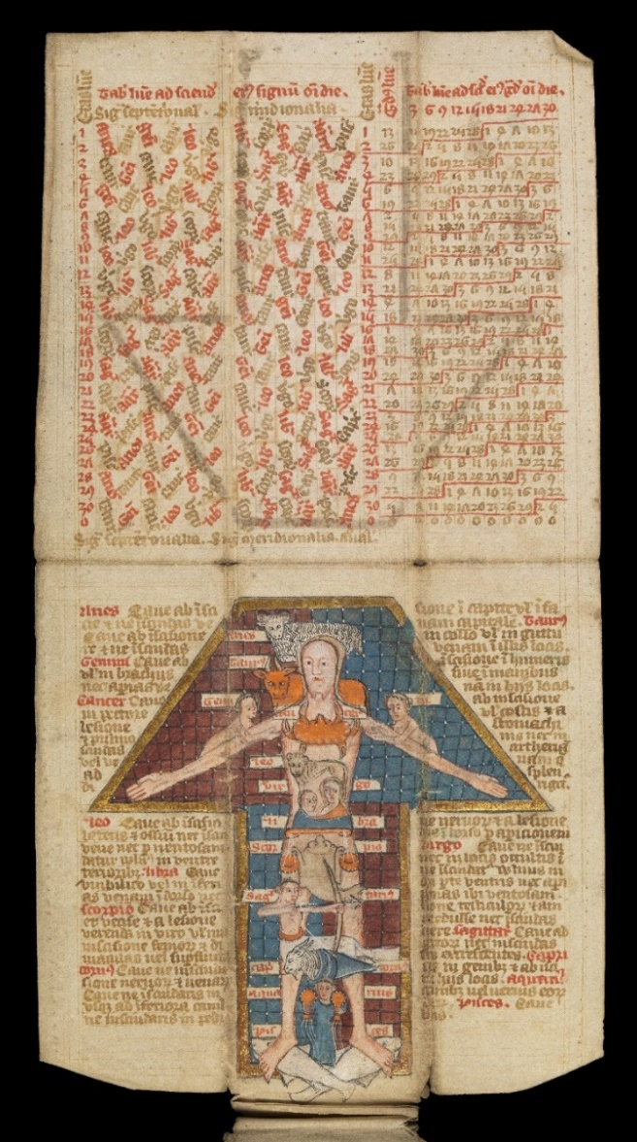

Figure 1: MS. 8932, f. 5, Table of the planetary hours and degrees of the moon, with large miniature of Zodiac Man in blue, red, dark red and brown ink with gilt border (Wellcome Library, London).
Astronomical tables were instrumental in determining the date of Easter and its related feasts, and there is evidence that the Bishop of Hereford directed their translation into English in 1432 so that ‘ordinary priests’ could calculate and confirm dates not only according to the solar cycle, but also the lunar cycle. These calendars also included medical-astrological information that could be used for the day-to-day medical needs of religious communities, thus making members of the clergy patrons of medical astrology. Bloodletting was common practice in these communities; ‘those who were sick were bled individually as part of a therapeutic regime, while group bleedings were performed as a prophylactic measure’. An illustration of Vein Man (or bloodletting man), such as the one in Egerton 2572 (see Figure 2), would have indicated which veins to open to relieve different conditions, and an illustration of Zodiac Man in combination with ready-prepared astronomical tables would have assisted in the selection of the most astrologically favourable time for this to take place. According to O’Boyle, the best evidence for surgeons using astronomical calendars appears in the ‘Guild Book of the Barber Surgeons of York’ (Egerton 2572), which dates from the latter half of the fifteenth century (c. 1486). While the calendar contains month-by-month pages in Latin, it ends in English with a summary of the astrological qualities of the heavenly bodies, a zodiacal lunary for offering prognostications based on the moon’s position in the zodiac, and verses on bloodletting. The manuscript’s Vein Man (Figure 2) and Zodiac Man (Figure 3) are also accompanied by advice and warnings in English. The volvelle (Figure 4), was a device with a moveable disc rotating with a fixed matrix, the pointing moveable index of which could be set at the sign and degree of the zodiac for a particular day in order to predict the best time to provide medical treatment.

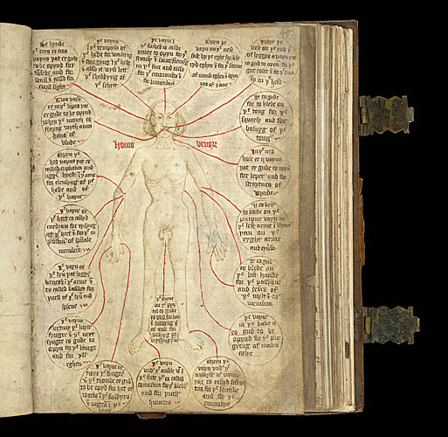

Figure 2: Egerton 2572, f. 50, Vein Man (Homo venorum) indicating the veins used for bloodletting or phlebotomy (The British Library, London).
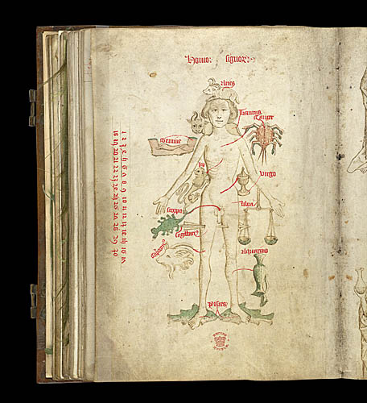

Figure 3: Egerton 2572, f. 50v, Zodiac Man (Homo signorum) with parts of the body linked to their governing zodiac symbols with labels and numerals (The British Library, London).

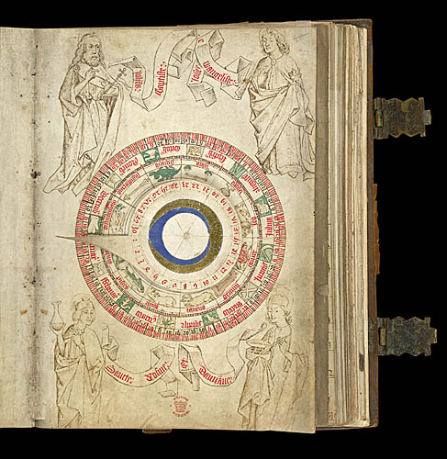

Figure 4: Egerton 2572, f. 51, Volvelle with moveable pointer, drawings of the signs of the zodiac and labours of the month within the wheel; surrounded by figures of John the Baptist with Agnus Dei (top left), John the Evangelist with cup and dragon (top right), Cosmas with urine file (lower left), and Damian spooning medicine from a box (lower right) (The British Library, London).
According to Laurel Means, the most widely circulated prognostic genre was the lunary. For each day or month, a lunary provided prognostications or predictions about the outcome of events, ranging from illness and bloodletting, which were particularly popular, to birth, death, travel, planting, business and marriage. Egerton 2572, ff. 58–61 is one such example of lunar astrology, where medical/phlebotomy lunaries were organised according to day or mansion. However, the Latin luna ‘moon’, developed to lunaria ‘use of the moon’, which, as Means point out, seems appropriate, but then draws attention to the fact that the term was seldom used in Middle English texts or in a prognostic sense; instead, it was used to show technical data about the moon’s age as applied to volvelles or lunar tables. This indicates that astrological computation was a practical necessity for everyday knowledge and accuracy, which accounts for references within the texts to consulting calendars or tables giving the age of the moon, and the frequent occurrence of these and related documents in lunary manuscripts. Means has also challenged Keith Thomas on two counts: firstly, that his description of the judicial astrologer’s four spheres of activity (general predictions, nativities, elections and horary questions) as an ‘unrealistic over-simplification of extant Middle English prognostic documents’, offering the alternative categories of electionary, lunary, destinary and questionary; and secondly, negating his claim that astrological activity in England by the beginning of the sixteenth century was ‘at a relatively low ebb’ and that ‘prognostications in circulation … were largely of foreign origin’. Theo Wedel’s conclusion that there were few indications ‘of the presence in medieval England of actual astrologers has also been refuted.

Siraisi succinctly describes medicine of the fifteenth century as ‘a diverse collection of areas of knowledge and of intellectual interests and commitments, pursued in the context of a variety of institutions, occupations, skills and activities’. Astrological-medical treatises, calendars and illustrations appear to have served a practical purpose in this field, and the procedures to treat the sick would have been much the same whether they were carried out by a learned physician or a non-university trained medical practitioner: planetary prognosis, urological diagnosis, and medication in the form of herbs, bloodletting and empirical remedies. Astrology played a distinct role in medieval medicine by offering ‘a technical apparatus that could extend the doctor’s power of prognostication’ beyond the visible, ritualistic technique of uroscopy, and extend his knowledge of the microcosm-macrocosm relationship, further enhancing his image. Intrinsically, Zodiac Man was an image that had been used in the West since the eleventh century to illustrate the macrocosmic-microcosmic relationship between the universe and the human body. It had also been used to illustrate the belief that each sign of the zodiac had a predominant influence over the part of the body with which it was symbolically associated. Later, with the new calendar, it was often accompanied by a text summarising astrological rules governing various medical procedures. This indicates that Zodiac Man was intended to facilitate a somewhat technical piece of lunar prognostication requiring the use of astronomical tables. Similarly, volvelle showing the days of the month, signs of the zodiac, houses of the twelve months, and the days of the lunar and solar years guided a medical practitioner to make a precise astrological prognosis. In Egerton 2572, Zodiac Man and a highly detailed volvelle appear on facing pages, supporting this idea (see figures 3 and 4). To ensure practitioners could have ready access to the references required for making accurate astrological computations, some manuscripts were miniaturised, in a form similar to MS. 8932, to enable them to fit in a pocket, or be hung from the belt, which Rossell Robins has described as ‘a badge of profession’.

Undoubtedly, predictive accuracy and personal status were closely linked as much during the late medieval period as it was in earlier times. As Morris Saffron has indicated, the Hippocratic Prognosis mentions the ‘glory’ that follows from successful prognostication, as does Marus of Salerno who wrote of the ‘praise and glory’ that came to the doctor from prognostications. With the practise of what was regarded as ‘Arabic mathematical astrology’ came the notion that celestial causes were linked to mundane effects in a necessary way, inferring that prediction was guaranteed once the rules were known. Practically, knowing the imminence or presence of a disease could enable the alleviation of its effects, or, if it was determined that a person was about to die, arrangements could be made for, among other things, last rites to be administered. However, O’Boyle suggests that, by the fifteenth century, a university-trained physician would not have needed to be reminded of the traditional Vein Man, Zodiac Man and urological charts as they offered simple advice that was generally well known. He also points out that readership could not be assumed based on the vernacular as physicians, who were fluent in Latin, could also read and write in English, and that surgeons of the time had a working knowledge of Latin. He asserts, therefore, that translating the calendar potentially broadened its audience and therefore constituted an act of dissemination and popularisation. While this may advocate a view that the calendars represented a bridge between high (learned) and low (popular) astrology, O’Boyle suggests that historians are probably wrong to distinguish between the two, and that there was instead a ‘continuum of astrological beliefs … united in the shared cosmological belief that the movements of the heavens influenced human events on earth’.

Possibly leading from this perspective, came the separation of medicine and surgery during the later medieval period in which astrology continued to play a role amid the cultural ideals of prestige in the tradition and development of medicine. However, through an over concern with scientific methodology, it has been suggested that medicine lost its contact with technology, including astrology. Vern Bullough points out that even though the political, religious and social unrest of the period, plus the inertia caused by the plague were significant, more important was the status conflict within the medical profession. Whereas in earlier medieval times there had been no separation of medicine and surgery, and medical practitioners had been drawn from the clergy and from the laity, with the development of universities medicine was acknowledged as a speculative discipline with practical application, lacking the intellectual prestige of other disciplines such as theology and law. Given this status consciousness, and for medicine to live up to its speculative status, physicians were reluctant to use manual techniques, resulting in an initial division between physicians and surgeons. While physicians attempted to build up a natural philosophy of medicine, surgeons were unwilling to be consigned to the class of manual practitioners and neglected important aspects of surgery to concentrate on the theoretical aspects of medicine that would gain them greater status. The combination of conflict and neglect created a void that led to the emergence of, among others, apothecaries and barber-surgeons. Although there were attempts to restrict the work of barber-surgeons, this was not supported as it was deemed prejudicial to public interest; surgeons, in their quest for status, did not treat poor people. However, the university-educated physician made up only a small number of those practicing medicine; most people were treated by the barber-surgeons or used simple household remedies and, in England, it was only towards the end of the fifteenth century that the practise of medicine was restricted to university graduates. While medical predictions may no longer have referred specifically to astrology, they were still most likely based upon astrological principles. Broadly speaking, medical practitioners not only helped to spread astrology through its use in prognostication, but also helped to underpin the place of astrology in daily life.

What has emerged in examining the role of astrology in the European medieval world is that, in late medieval society, the heavenly bodies were believed to influence almost every aspect of life, from war, famine and epidemics to dynastic succession, personal relationships, health and success. As such, astrological calendars and images were practical working tools that were not regarded as polemic or anti-religious. Vein Man, Zodiac Man, volvelles and planetary tables, like those contained in MS. 8932 and Egerton 2572, were widely recognised as instruments of medical practise of the time, and as French points out, medical practitioners and astrologers promoted themselves on the basis of an assumed rationality that depended on an analogy between macrocosm and microcosm. The significance of MS. 8932 lies not only in its intricately detailed content, but also in its fine textile binding and gold detailing, which suggests that it that it was less likely to have seen practical use and was more probably a treasured and valuable artefact in its own right, either held as a status object by a physician, or object of prestige by someone interested in the delicate art of miniaturisation. The folios from Egerton 2572 considered in this essay also represent key evidence of the use of astrology in medical thought and procedures. Irrespective of application, prognostic texts can be seen as forming part of the same astrological system, with their determinants, as Karen Rührdanz describes, helping to clarify their function for a particular public audience at a specific moment. Astrology was integral to the medieval world view and it would be impossible to attempt to understand medieval culture without taking the interdisciplinary position of astrology into account.

References

Primary sources

MS. 8932
- MS. 8932: Medieval folding almanac (15th century), Wellcome Images: L0075677, Foleave 5: Table of the planetary hours and degrees of the moon, with large miniature of the zodiac man in blue, red, dark red and brown ink with gilt border, Wellcome Library, London.
https://commons.wikimedia.org/w/index.php?curid=36305333 [accessed 16 June 2018]
- MS. 8932: Medieval folding almanac (15th century), ‘English folding almanac in Latin’ video created by Ben Gilbert, Wellcome Library, London, 2014.
https://wellcomelibrary.org/item/b20605055#?c=0&m=0&s=0&cv=0 [accessed 16 June 2018]
- MS. 8932: Medieval folding almanac (15th century), Wellcome Library, London.
https://commons.wikipedia.org/wiki/Category:Medieval_folding_almanac_MS_8932 [accessed 16 June
2018]

Egerton 2572
- Egerton 2572: f. 50 Vein Man, ‘Guild Book of the Barber Surgeons of York, including its ordinances’, British Library Catalogue of Illuminated Manuscripts, The British Library, London.
https://www.bl.uk/catalogues/illuminatedmanuscripts/ILLUMIN.ASP?Size=mid&IllID=11468 [accessed
16 June 2018]
- Egerton 2572: f. 50v Zodiac Man, ‘Guild Book of the Barber Surgeons of York, including its ordinances’, British Library Catalogue of Illuminated Manuscripts, The British Library, London.
https://www.bl.uk/catalogues/illuminatedmanuscripts/ILLUMIN.ASP?Size=mid&IllID=12991 [accessed
16 June 2018]
- Egerton 2572: f. 51 Volvelle, ‘Guild Book of the Barber Surgeons of York, including its ordinances’, British Library Catalogue of Illuminated Manuscripts, The British Library, London.
https://www.bl.uk/catalogues/illuminatedmanuscripts/ILLUMIN.ASP?Size=mid&IllID=12900 [accessed
16 June 2018]

Secondary sources

Bober, Harry, ‘The Zodiacal Miniature of the Très Riches Heures of the Duke of Berry: Its Sources and Meaning’, Journal of the Warburg and Courtauld Institutes, 11 (1948), 1–34.
Bullough, Vern L., ‘Status and Medieval Medicine’, Journal of Health and Human Behaviour, 2:3 (1961), 204–210.
Burnett, Charles. ‘The Translating Activity in Medieval Spain’, in The Legacy of Muslim Spain, ed. by Salma Khadra Jayyusi (Leiden: Brill, 1995), pp. 1036–1058, cited in Roger French, ‘Fortelling the Future: Arabic Astrology and English Medicine in the Late Twelfth Century’, Isis, 87:3 (1996), 454.
Catani, Remo, ‘The Polemics on Astrology 1489–1524’, Culture and Cosmos, 3:2 (1999), 16–30.
Cooper, Glen M., ‘Galen and Astrology: A Mésalliance?’, Early Science and Medicine, 16:2 (2011), 120–146.
French, Roger, ‘Fortelling the Future: Arabic Astrology and English Medicine in the Late Twelfth Century’, Isis, 87:3 (1996), 453−480.
Hill, Judith, Introduction to Medical Astrology: A guide to planetary pathology (Portland, OR: Stellium Press, 2005), p. 1.
Means, Laurel, ‘Electionary, Lunary, Destinary, and Questionary: Toward Defining Categories of Middle English Prognostic Material’, Studies in Philology, 89:4 (1992), 367–403.
O’Boyle, Cornelius, ‘Astrology and Medicine in Later Medieval England: The Calendars of John Somer and Nicholas of Lynn’, Sudhoff’s Archiv, 89:1 (2005), 1–22.
Page, Sophie, ‘Richard Trewythian and the Uses of Astrology in Late Medieval England’, Journal of the Warburg and Courtauld Institutes, 64 (2001), 193–228.
Robins, Rossell H., ‘Medical Manuscripts in Middle English’, Speculum, 45:3 (1970), 393–15.
Robinson, Pamela, ‘A “Very Curious Almanack”: The Gift of Sir Robert Moray FRS, 1668’, Notes and Records of the Royal Society of London, 62:3 (2008), 301–314.
Rührdanz, Karen, ‘Between Astrology and Anatomy’, Ars Orientalis, 42 (2012), 56–66.
Saffron, Morris H., ‘Maurus of Salerno: Twelfth-Century “Optimus Physicus” with His Commentary on the Prognostics of Hippocrates’, Transactions of the American Philosophical Society, 62:1 (1972).
Siraisi, Nancy G., ‘Medicine, 1450–1620, and the History of Science’, Isis, 103:3 (2012), 491–514.
Thomas, Keith, Religion and the Decline of Magic (Harmondsworth: Penguin, 1978).

MS. 8932, Medieval folding almanac (15th century), Wellcome Library, London; Egerton 2572: ff. 50, 50v, 51, ‘Guild Book of the Barber Surgeons of York, including its ordinances’, British Library Catalogue of Illuminated Manuscripts, The British Library, London.
Roger French, ‘Fortelling the Future: Arabic Astrology and English Medicine in the Late Twelfth Century’, Isis, 87:3 (1996), 454.
French, ‘Fortelling the Future’, 457; On religious hostility in the 1490s, see Remo Catani, ‘The Polemics on Astrology 1489–1524’, Culture and Cosmos, 3:2 (1999), 16–30.
French, ‘Fortelling the Future’, 479.
French, ‘Fortelling the Future’, 454, 463.
Cornelius O’Boyle, ‘Astrology and Medicine in Later Medieval England: The Calendars of John Somer and Nicholas of Lynn’, Sudhoff’s Archiv, 89:1 (2005), 11, 12; Sophie Page, ‘Richard Trewythian and the Uses of Astrology in Late Medieval England’, Journal of the Warburg and Courtauld Institutes, 64 (2001), 193–228.
Rossell H. Robins, ‘Medical Manuscripts in Middle English’, Speculum, 45:3 (1970), 394; Laurel Means, ‘Electionary, Lunary, Destinary, and Questionary: Toward Defining Categories of Middle English Prognostic Material’, Studies in Philology, 89:4 (1992), 368.
Nancy G. Siraisi, ‘Medicine, 1450-1620, and the History of Science’, Isis, 103:3 (2012), 500.
O’Boyle, ‘Astrology and Medicine in Later Medieval England’, 2.
This direction appears in Oxford, Bodleian Libraries, MS. Ashmole 789, f. 371r.
O’Boyle, ‘Astrology and Medicine in Later Medieval England’, 16.
O’Boyle, ‘Astrology and Medicine in Later Medieval England’, 14.
Means, ‘Electionary, Lunary, Destinary, and Questionary’, 376.
Means, ‘Electionary, Lunary, Destinary, and Questionary’, 379.
Means, ‘Electionary, Lunary, Destinary, and Questionary’, 367, referring to Keith Thomas, Religion and the Decline of Magic (Harmondsworth: Penguin, 1978), 338–339, 341.
Means, ‘Electionary, Lunary, Destinary, and Questionary’, 368, referring to Theo Otto Wedel, The Medieval Attitudes toward Astrology (New Haven: Yale University Press), 90.
Siraisi, ‘Medicine, 1450-1620, and the History of Science’, 492.
Robins, ‘Medical Manuscripts in Middle English’, 395.
French, ‘Fortelling the Future’, 454.
O’Boyle, ‘Astrology and Medicine in Later Medieval England’, 5.
O’Boyle, ‘Astrology and Medicine in Later Medieval England’, 6.
Robins, ‘Medical Manuscripts in Middle English’, 396.
Morris H. Saffron, ‘Maurus of Salerno: Twelfth-Century “Optimus Physicus” with His Commentary on the Prognostics of Hippocrates’, Transactions of the American Philosophical Society, 62:1 (1972), 22.
French, ‘Fortelling the Future’, 458-459.
French, ‘Fortelling the Future’, 456.
O’Boyle, ‘Astrology and Medicine in Later Medieval England’, 13.
O’Boyle, ‘Astrology and Medicine in Later Medieval England’, 18.
Vern L. Bullough, ‘Status and Medieval Medicine’, Journal of Health and Human Behaviour, 2:3 (1961), 205.
Bullough, ‘Status and Medieval Medicine’, 206–207.
Bullough, ‘Status and Medieval Medicine’, 209.
O’Boyle, ‘Astrology and Medicine in Later Medieval England’, 18.
French, ‘Fortelling the Future’, 454.
Karen Rührdanz, ‘Between Astrology and Anatomy’, Ars Orientalis, 42 (2012), 64.

