Data Handling & Business Intelligence
Current Trends of Business Intelligence

Module Tutor: Gasso Wilson Mwaluseke
Student: Bogdan Radulescu
ID: 2022697

Table of Contents
Introduction 4
Part 1 4
Evaluation of Sales and Profitability 4
Use of IF Function 5
Pivot Table 6
Part 2: Analysis of Survey 14
2.1 Number of students who like vanilla flavour ice cream 14
2.2 Gender division of respondents presented in the Survey 15
2.3 Mean and median of participants like chocolate and strawberry flavour ice-cream 16
2.4 Data Clustering 19
2.5 Most common data mining and text mining methods that can be used in the business 21
2.6 Advantages and disadvantages of Using SPSS and Excel 22
Conclusion 23
References 24

Introduction
Statistical assessment is one of the significant tasks that can be used to improve the assessment of the research effectively. In order to meet the research objectives effectively, it is necessary to use the data analysis tools in the static measurement process. In order to improve the numerical assessment in the research, it is necessary to find out the key aspects of the statistical evaluation. Statistical evaluation is important for the assessment of the numerical value of the datasets in the research operation. Descriptive statistics and the functional value of the datasets can be assessed through statistical assessment methods. The objective of this assignment is to find out the best statistical aspects used to improve the numerical evaluation of the datasets through the use of the PIVOT table and the IF function. Sales and profitability of the business can be evaluated in this assessment by using these aspects. On the other hand, the second part of this assignment mainly focuses on the descriptive analyses and statistical evaluation of datasets Ice Cream and demonstrates it by using a Bar chart or Pie chart. Mean, median, and mode are the key statistical aspects that have been calculated through the evaluation of the statistical measure in this assessment.

Part 1

Evaluation of Sales and Profitability
A statistical evaluation process can be used to recognize the performance of the business from the perspective of sales and profitability in the business operation (Teymen & Mengüç, 2020). Superstore datasets have been used in the part 1 section to evaluate the performance of the business considering the sales and profitability over the period. In order to improve the statistical evaluation of the datasets effectively, it is necessary to evaluate the performance of the sales and profitability in this assignment. In order to do so, the PIVOT table has been used in this assignment eventually. PIVOT Table is the statistical measurement technique used to identify different statistical interfaces effectively. Graphical illustration has also been taken under consideration for the assessment of the trends of the data eventually and helps the observer to monitor the trends effectively. Total sales value, Total profitability, and total performance of the superstores over the period of time by considering the order of the products have been illustrated in this assignment effectively. In the PIVOT table function, the average value and the total value of the sales and profitability of the business can be assessed in this assignment.

Use of IF Function
The "IF" function in Excel has been employed to indicate the conditional on the evaluation. The "IF" function can be used in the data evaluation procedure to determine if a particular precondition is appropriate in the commercial business (Qudratova, 2022). Any evaluation of organizational functioning can be accomplished through the manifestation of the IF function. The choice of whether something is appropriate or not has being taken into account in order for the IF Functionality to interconnect. The transaction will be accepted by the company if it has a number greater than 200; else, it will be refused. This method can be included into the business operation to produce profits.
The analytical researcher employed the IF function to interconnect the quantitative score by choosing suitable values. It is simple to collaborate the result with the help of the IF Procedure. The inclusion of the IF procedure enhances the validity of the statistical evaluation and interoperates the usefulness of the information evaluation. This procedure can be applied to the numerical evaluation to make a judgement call. It is evident that the use of this functionality on the advantages of the assessment products resulting in suggested conditions. The mathematical methodology has been successfully used in the empirical assessment procedure in order to implement the "If function."
“=IF (I804>200,”Acceptable”,” Not acceptable”)”
If the function is one of the most important and popular functions of MS excels, it helps to make the logical comparison in an appropriate way (Qudratova, 2022). The use of IF function helps to provide one out of two results. For example, if an organisation has a huge data set of sales and expenses, then it is not possible for the organisation to evaluate its profit or loss. At that time the use of IF function can be very helpful for the organisation to understand the profit or loss in all those years. In this context, the organisation can use the function in this way if the expense of any particular year is more than its income then it will be considered as loss otherwise it will be profit. By using this function they can easily get the result of first year and by dragging this result they will be able to get the result of rest of the years as well.
If function used in various sectors and it helps to give proper insight of the result. This function is totally based on the logical test. That is why it helps to get proper result. The if function is very important data analysis function, and it helps analyst to understand the each details related to a particular data properly. This paper used the if function for the analysis of superstore data and get proper information related to their profit or revenue.

Pivot Table
Row Labels | Sum of Sales | Sum of Profit
Atlantic | 2014248.204 | 238960.66
North Carolina | 116376.4835 | 2841.11
Northwest Territories | 83817.746 | 8307.05
Ontario | 3780242.063 | 439214.57
Prarie | 2837304.602 | 321160.12
Quebec | 1510195.08 | 140426.65
West | 3597549.276 | 297008.61
Yukon | 975867.371 | 73849.21
Grand Total | 14915600.82 | 1521767.98

Graph 1: Regional Sales Presentation
(Source: Author)
PIVOT table has been used in the excel sheet to illustrate the regional sales operation of the business (Jelen & Alexander, 2018). This statistical evaluation assists to evaluate the performance of the business from the perspective of sales operation in regional aspects. From the evaluation of the above statistical data, it can be identified that total sales and total profit is very low in North Carolina and Northwest Territories. On the other hand, sales and profitability are higher in West, Ontario, and Prarie regions. Considering these factors, it can be stated that the performance of the organization is effective in those regions which help to make the decision regarding the investment operation.
Row Labels | Sum of Sales
Consumer | 3063611.082
Corporate | 5498904.877
Home Office | 3564763.875
Small Business | 2788320.99
Grand Total | 14915600.82

Graph 2: Customer categories sales presentation
(Source: Author)
The above graphical illustration showcases the categorical sales of customers in the business operation. In the case of organizational performance, customer categories must be taken under consideration to evaluate the current performance of the business. It can be assessed that the performance of the business can be improved while using operational stability in the business process. On the other hand, it has also been identified that the sales are higher among corporate customers. This data indicates that the main customer base of the Stores is corporate customers. However, the stores need to focus on Small businesses as well as it has lower sales value in the small business categories.
Row Labels | Sum of Cost | Sum of Sales
2009 | 4342340.81 | 4169324.806
2010 | 3714419.88 | 3551642.382
2011 | 3642897.29 | 3455452.061
2012 | 3915464.83 | 3739181.576
Grand Total | 15615122.81 | 14915600.82

Graph 3: Yearly Sales Treads
(Source; author)
Based on the assessment, it is found that the yearly sales value of the business has reduced over a period of time. It can be measured that the sales operation of the business has reduced in 2010 compared to 2009 and 2011 compared to 2010. However, an increase in the sales operation can be seen in 2012 which is a positive sign for the superstores. Based on the data evaluation, it has been categorized that the net sales in 2009 were 4169324 whereas the cost of the business operation was 4342340. On the other hand, in 2012 total sales were 3739181 and the cost was 39154645. Here, it can be observed that is the company able to reduce the costs as well in the business operation along with total sales value. This data indicts the cost management operation of the business in the present circumstances.
Row Labels | Total Sales | Average Sales | Sales Percentage | Total Profit | Average Profit | Profit Percentage
2009 | 4169324.806 | 1947.372632 | 100.00% | 421514.28 | 196.877291 | 100.00%
Furniture | 1469508.194 | 3294.861422 | 35.25% | 62501.1 | 140.1369955 | 14.83%
Bookcases | 250979.16 | 5228.7325 | 6.02% | -3124.75 | -65.09895833 | -0.74%
Chairs & Chairmats | 518742.87 | 5187.4287 | 12.44% | 54459.57 | 544.5957 | 12.92%
Office Furnishings | 220564.95 | 1055.334689 | 5.29% | 27455.59 | 131.3664593 | 6.51%
Tables | 479221.214 | 5384.508022 | 11.49% | -16289.31 | -183.0259551 | -3.86%
Office Supplies | 1031244.56 | 892.0800692 | 24.73% | 177363.39 | 153.4285381 | 42.08%
Appliances | 169236.26 | 1511.038036 | 4.06% | 19459.62 | 173.7466071 | 4.62%
Binders and Binder Accessories | 359791.71 | 1564.311783 | 8.63% | 123929.06 | 538.822 | 29.40%
Envelopes | 30593.09 | 485.6046032 | 0.73% | 7049.53 | 111.8973016 | 1.67%
Labels | 10308.32 | 143.1711111 | 0.25% | 2603.97 | 36.16625 | 0.62%
Paper | 118048.2 | 387.0432787 | 2.83% | 17145.63 | 56.21518033 | 4.07%
Pens & Art Supplies | 42206.55 | 262.1524845 | 1.01% | 2066.03 | 12.83248447 | 0.49%
Rubber Bands | 3063.51 | 82.79756757 | 0.07% | -3.9 | -0.105405405 | 0.00%
Scissors, Rulers and Trimmers | 16653.41 | 462.5947222 | 0.40% | -2906.06 | -80.72388889 | -0.69%
Storage & Organization | 281343.51 | 2009.5965 | 6.75% | 8019.51 | 57.28221429 | 1.90%
Technology | 1668572.052 | 3095.680987 | 40.02% | 181649.79 | 337.0125974 | 43.09%
Computer Peripherals | 215565.07 | 1116.917461 | 5.17% | 21279.68 | 110.2574093 | 5.05%
Copiers and Fax | 245466.52 | 12273.326 | 5.89% | 21759.15 | 1087.9575 | 5.16%
Office Machines | 732505.45 | 6976.242381 | 17.57% | 60494.52 | 576.1382857 | 14.35%
Telephones and Communication | 475035.012 | 2149.479692 | 11.39% | 78116.44 | 353.4680543 | 18.53%
2010 | 3551642.382 | 1664.312269 | 100.00% | 370859.09 | 173.7858903 | 100.00%
Furniture | 1250043.046 | 2828.151688 | 35.20% | 9129.03 | 20.65391403 | 2.46%
Bookcases | 266937.25 | 4448.954167 | 7.52% | -1345.71 | -22.4285 | -0.36%
Chairs & Chairmats | 386127.16 | 4064.496421 | 10.87% | 20773.42 | 218.6675789 | 5.60%
Office Furnishings | 165258.63 | 838.8762944 | 4.65% | 29422.62 | 149.353401 | 7.93%
Tables | 431720.006 | 4796.888956 | 12.16% | -39721.3 | -441.3477778 | -10.71%
Office Supplies | 885095.79 | 757.1392558 | 24.92% | 113559.74 | 97.14263473 | 30.62%
Appliances | 198679.54 | 1742.802982 | 5.59% | 31831.57 | 279.2242982 | 8.58%
Binders and Binder Accessories | 177894.93 | 843.1039336 | 5.01% | 44319.26 | 210.0438863 | 11.95%
Envelopes | 49382.76 | 737.0561194 | 1.39% | 13716.87 | 204.729403 | 3.70%
Labels | 7447.88 | 104.8997183 | 0.21% | 2380.13 | 33.52295775 | 0.64%
Paper | 115732.89 | 362.7990282 | 3.26% | 11592.19 | 36.33915361 | 3.13%
Pens & Art Supplies | 46202.22 | 292.4191139 | 1.30% | 2491.77 | 15.7706962 | 0.67%
Rubber Bands | 3753.88 | 76.60979592 | 0.11% | -217.45 | -4.437755102 | -0.06%
Scissors, Rulers and Trimmers | 6877.25 | 221.8467742 | 0.19% | -1340.33 | -43.23645161 | -0.36%
Storage & Organization | 279124.44 | 1873.318389 | 7.86% | 8785.73 | 58.96463087 | 2.37%
Technology | 1416503.546 | 2708.419781 | 39.88% | 248170.32 | 474.5130402 | 66.92%
Computer Peripherals | 172968.75 | 873.5795455 | 4.87% | 15276.52 | 77.15414141 | 4.12%
Copiers and Fax | 367532.85 | 13612.32778 | 10.35% | 62151.35 | 2301.901852 | 16.76%
Office Machines | 446780.14 | 5878.686053 | 12.58% | 104221.57 | 1371.336447 | 28.10%
Telephones and Communication | 429221.8055 | 1933.431556 | 12.09% | 66520.88 | 299.6436036 | 17.94%
2011 | 3455452.061 | 1717.421501 | 100.00% | 384288.23 | 190.9981262 | 100.00%
Furniture | 1258336.514 | 3024.847389 | 36.42% | 47975.71 | 115.326226 | 12.48%
Bookcases | 140925.43 | 3914.595278 | 4.08% | -5164.59 | -143.4608333 | -1.34%
Chairs & Chairmats | 445675.77 | 4456.7577 | 12.90% | 36509.14 | 365.0914 | 9.50%
Office Furnishings | 164923.08 | 872.6088889 | 4.77% | 26167.6 | 138.4529101 | 6.81%
Tables | 506812.234 | 5569.365209 | 14.67% | -9536.44 | -104.796044 | -2.48%
Office Supplies | 816902.13 | 728.7262533 | 23.64% | 90159.82 | 80.42802855 | 23.46%
Appliances | 177716.73 | 1759.571584 | 5.14% | 22665.36 | 224.409505 | 5.90%
Binders and Binder Accessories | 184205.4 | 829.7540541 | 5.33% | 44431.02 | 200.1397297 | 11.56%
Envelopes | 39738.45 | 810.9887755 | 1.15% | 12735.85 | 259.9153061 | 3.31%
Labels | 12919.18 | 181.9602817 | 0.37% | 5702.02 | 80.31014085 | 1.48%
Paper | 101012.83 | 325.8478387 | 2.92% | 5031.82 | 16.23167742 | 1.31%
Pens & Art Supplies | 42949.48 | 265.1202469 | 1.24% | 2006.29 | 12.38450617 | 0.52%
Rubber Bands | 4219.94 | 87.91541667 | 0.12% | -144.42 | -3.00875 | -0.04%
Scissors, Rulers and Trimmers | 10644.95 | 287.7013514 | 0.31% | -1821.91 | -49.24081081 | -0.47%
Storage & Organization | 243495.17 | 2012.356777 | 7.05% | -446.21 | -3.68768595 | -0.12%
Technology | 1380213.417 | 2905.712456 | 39.94% | 246152.7 | 518.2162105 | 64.05%
Computer Peripherals | 192359.15 | 1111.902601 | 5.57% | 29469.2 | 170.3421965 | 7.67%
Copiers and Fax | 280821.12 | 14041.056 | 8.13% | 58896.48 | 2944.824 | 15.33%
Office Machines | 426103.41 | 6456.112273 | 12.33% | 76732.38 | 1162.611818 | 19.97%
Telephones and Communication | 480929.7365 | 2226.526558 | 13.92% | 81054.64 | 375.252963 | 21.09%
2012 | 3739181.576 | 1770.445822 | 100.00% | 345106.38 | 163.402642 | 100.00%
Furniture | 1200702.788 | 2858.816162 | 32.11% | -2172.81 | -5.173357143 | -0.63%
Bookcases | 163810.2 | 3640.226667 | 4.38% | -23947.08 | -532.1573333 | -6.94%
Chairs & Chairmats | 411290.75 | 4519.678571 | 11.00% | 37907.6 | 416.567033 | 10.98%
Office Furnishings | 147347.15 | 763.4567358 | 3.94% | 17382.12 | 90.06279793 | 5.04%
Tables | 478254.688 | 5255.546022 | 12.79% | -33515.45 | -368.3016484 | -9.71%
Office Supplies | 1019519.62 | 875.8759622 | 27.27% | 136938.48 | 117.6447423 | 39.68%
Appliances | 191359.01 | 1788.401963 | 5.12% | 23201.51 | 216.8365421 | 6.72%
Binders and Binder Accessories | 301065.55 | 1194.704563 | 8.05% | 94734.05 | 375.9287698 | 27.45%
Envelopes | 54371.5 | 811.5149254 | 1.45% | 14680.35 | 219.1097015 | 4.25%
Labels | 8306.17 | 112.2455405 | 0.22% | 2991.05 | 40.41959459 | 0.87%
Paper | 111658.94 | 383.7076976 | 2.99% | 11493.56 | 39.49676976 | 3.33%
Pens & Art Supplies | 35748.97 | 235.1905921 | 0.96% | 1000.69 | 6.583486842 | 0.29%
Rubber Bands | 3969.3 | 88.20666667 | 0.11% | 263.1 | 5.846666667 | 0.08%
Scissors, Rulers and Trimmers | 46820.7 | 1170.5175 | 1.25% | -1730.95 | -43.27375 | -0.50%
Storage & Organization | 266219.48 | 1957.496176 | 7.12% | -9694.88 | -71.28588235 | -2.81%
Technology | 1518959.168 | 2876.816606 | 40.62% | 210340.71 | 398.3725568 | 60.95%
Computer Peripherals | 214982.97 | 1108.159639 | 5.75% | 28262.08 | 145.6808247 | 8.19%
Copiers and Fax | 236540.81 | 11827.0405 | 6.33% | 24554.51 | 1227.7255 | 7.12%
Office Machines | 563308.14 | 6258.979333 | 15.07% | 66264.46 | 736.2717778 | 19.20%
Telephones and Communication | 504127.248 | 2250.568071 | 13.48% | 91259.66 | 407.4091964 | 26.44%
Grand Total | 14915600.82 | 1775.878179 |  | 1521767.98 | 181.1844243

Here, the PIVOT table has been used to categorize different numerical data in the assessment. Statistical data evaluation has been possible in this assignment through the use of the PIVOT table in this section. The PIVOT table is one of the useful tools that can be used by the statistical researcher to evaluate the effective outcome in a numerical way and enhance the processing operation. In addition to it, categorized data can find out in a simple way through the use of the PIVOT table. It is clear that the operating cost is greater for the furniture industry, which over the course of the time produced the least profitable segment for the company. The profit margin of the corporation decreased in this area of the firm as a result of rising costs. On the other side, the technology sector has the maximum revenue margin due to its effective cost structure and operational efficiency. Office supply sales have decreased, while income has increased as a result of efficient cost management techniques.

Part 2: Analysis of Survey
This part of the study is going to analyse the Survey of 200 high school students and their scores on various tests. The outcome of the analysis will be very useful for understanding the number of males and females presented in the Survey, their favourite flavour of ice cream and many more.

2.1 Number of students who like vanilla flavour ice cream
Vanilla | 1
Chocolate | 2
Strawberry | 3

Flavours of ice cream | Count of ice_cream
1 | 95
2 | 47
3 | 58
Grand Total | 200
Table 1: Number of students who like Various flavours of ice cream
("Source: Created by author")

Figure 1: Various flavours of ice cream by students
("Source: Created by author")
Table 1 shows the number of students who like various flavours of ice cream. Among 200 respondents to the Survey, 95 students choose vanilla flavour ice cream as their favourite ice cream. There were three options for respondents to choose their favourite flavour of ice cream. A maximum number of students presented in the Survey chose Vanilla flavour ice cream as their favourite flavour. While 58 students chose the strawberry flavour of ice cream as their favourite, 47 students chose the chocolate flavour as their favourite.
The graphical representation of the analysis shows the percentage wise distribution of data. The graphical representation of data shows that 47% of students choose the Vanilla flavour as their favourite flavour. On the other hand, 29% of students chose the strawberry flavour as their favourite flavour of ice-cream, and 24% Students chose the chocolate flavour ice cream. So both the tabular and graphical data representation show that out of 200 students, most students like the Vanilla flavour ice cream.

2.2 Gender division of respondents presented in the Survey
Male | 0
Female | 1

"Row Labels" | "Count of Gender"
"0" | "91"
"1" | "109"
"Grand Total" | "200"
Table 2: Gender division of data
"Source: Created by author"

Figure 2: Comparison of gender presented in the Survey
"Source: Created by author"
Table 2 and figure 2 is a representation of gender data that joined the Survey. In this analysis, o represents the male and 1 represents the female. Therefore, it can be stated that out of 200 students who were presented in the Survey there were 91 male and 109 female. So the representation of female participants was more in this Survey.

2.3 Mean and median of participants like chocolate and strawberry flavour ice-cream
Number of students, like chocolate and strawberry flavour ice cream
Chocolate | 2
Strawberry | 3

Flavours of ice cream | Ice cream
2 | 47
3 | 58
Grand Total | 105
Table 3: "Number of students who like chocolate flavour and strawberry flavour ice cream"
(Source: Created by author)

Figure 3: Percentage of students who like chocolate flavour and strawberry flavour ice cream
"(Source: Created by author)"
Table 3 is the tabular representation of data that demonstrating the number of participants who like "chocolate flavour ice cream" and "strawberry flavour ice cream". Out of 200 participants in the Survey, 47 participants stated that they love chocolate flavour ice cream. In comparison, 58 students stated that they love strawberry flavour ice cream.
Mean and median value of participants like chocolate and strawberry flavour ice-cream
"Statistics"
 |  | "GENDER" | "Ice Cream"
N | "Valid" | "200" | "200"
N | "Missing" | "0" | "0"
"Mean" |  | ".55" | "1.82"
"Median" |  | "1.00" | "2.00"
Table 4: Mean, the median of Gender and Ice cream data
(Source: created by author)
"GENDER"
 |  | "Frequency | "Percent | "Valid Percent | "Cumulative Percent
"Valid" | "MALE" | "91" | "45.5" | "45.5" | "45.5"
"Valid" | "FEMALE" | "109" | "54.5" | "54.5" | "100.0"
"Valid" | "Total" | "200" | "100.0" | "100.0"

"Ice Cream
 |  | "Frequency" | "Percent" | "Valid Percent" | "Cumulative Percent"
"Valid" | "vanilla" | "95" | "47.5" | "47.5" | "47.5"
"Valid" | "Chocolate" | "47" | "23.5" | "23.5" | "71.0"
"Valid" | "strawberry" | "58" | 29.0" | "29.0" | "100.0"
"Valid" | "Total" | "200" | 100.0" | "100.0"
The statistical analysis of gender and ice cream data shows that the mean value of the gender is .55, and the mean value of the ice cream data is 1.82. The mean helps to understand the average of any dataset. So the average value of the gender presented in the Survey is 0.55, and the average value of participants who like strawberry and chocolate flavour is 1.82.
At the same time, median value represents the number that is on the middle of any dataset. The median value of gender data is 1.00, and the median value of the ice cream data is 2.00.

2.4 Data Clustering
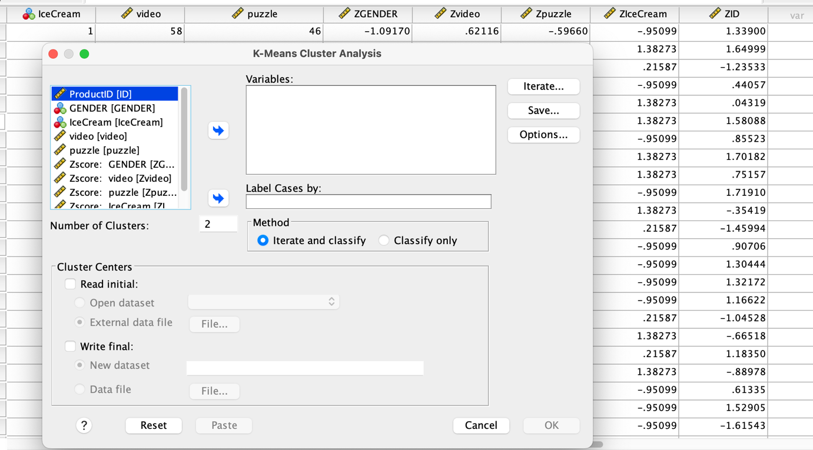
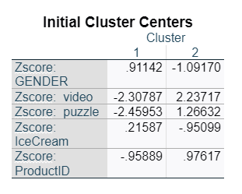
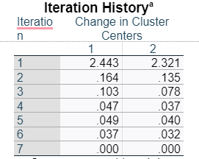
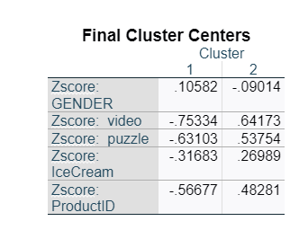
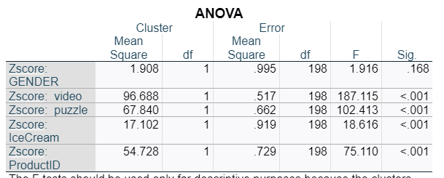
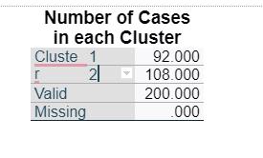
From the evaluation, it can be assessed that the z-score value in the clustering process is in negative figure which indicates to the strategic interaction. It can also identified that negative figure indicate to the lack of interconnection between the variables in the datasets assessment. This data has also illustrate to the ineffective management or stability in the data evaluation process in the datasets assessment.

2.5 Most common data mining and text mining methods that can be used in the business
There are several data mining and text mining methods that a business can use to make better decision in their business process.
Data mining methods that can be used in the business
Data clustering
Clustering is the method of representing the business data visually using graphs and charts. The use of clustering in the data mining helps to divide data in various subsets and helps a business entity to make informed decision (Shi and Pun, 2019). The clustering is also very beneficial for managing their data in an appropriate way. For an example, companies dealing in the retail sector can use the clustering model to identify which consumers purchase a particular product on which day and the quantity of their purchase. This method will be very helpful for retail companies to target products to consumers in a particular demographic.
Data cleaning
Data cleaning is the process of organising data, elimination of corrupted or duplicate data and filling all the "null values". By completing all these processes, the most useful information can be harvested from any analysis (Illyas and Chu, 2019). So, it can be stated that this method helps to identify the same data points and remove any data-related errors. The data cleaning method helps to analyse the data appropriately, and by properly analysis of data, a business entity can understand its business opportunities and threats.
Text mining methods that can be used in the business
Information Extraction
It is the method of extracting valuable information from a huge amount of data. It is the starting step for any system that helps decipher any unstructured data by discovering its key phrases and relationship within the text. So it is very beneficial for any business entity to extract valuable information for their business process.
Natural language processing
This process also helps to analyse any "unstructured textual information" and helps to give proper insight into important information related to the business process of a business entity. Using this method, a business entity can easily identify the changes in consumer behaviour and take proper strategies to satisfy consumers.

2.6 Advantages and disadvantages of Using SPSS and Excel
 | SPSS | Excel
Advantages | SPSS is essential software for data analysis, which is very effective for an organisation's data management (IpI.org, 2019). This software offers reliable and very fast answers and is useful for analysing qualitative and quantitative data. The healthcare sector generally uses SPSS to analyse data, which helps them make better decisions. | Excel helps to transform raw data into a redeemable format, and that helps to extract proper insight. On the other hand, excel is an important tool for analysing complex data. Excel is widely used in various small, medium and large sectors to analyse any complex or large data (Ramadhan et al., 2020).
Disadvantages | The SPSS is not an appropriate analysis tool for analysing a large dataset. | Excel lacks security and control. On the other hand, it does not identify human error. So these are some crucial disadvantages of Excel.
Table 4: Advantages and disadvantages of Excel and SPSS
(Source: Created by author)

Conclusion
The overall analysis of the paper revealed various important things related to the analysis of data and its importance. In the first part of the data analysis this paper use two important excel function Pivot tables and IF to analyse the sales and profit data of a company and in the second part this paper analyse the data of a survey. Both the analysis revealed important information related to the data. The first part of the analysis helps to understand the profitability and revenue generation of the company from various sectors and in various months. On the other hand, the second part helps to understand various aspects related to the various tests of students. Besides that, the discussion of the second part also revealed all those common data and text mining methods that can be used in the business operation. Moreover, this paper analysed the advantage and disadvantage of using SPSS and Excel in data analysis.

References
Ilyas, I. F., & Chu, X. (2019). Data cleaning. Morgan & Claypool.
Ipl.org, (2019) “Advantage of SPSS” Available at:https://www.ipl.org/essay/Spss-Advantages-And-Disadvantages-PCP7NHZZ26, [Accessed on: 16th September, 2022]
Jelen, B., & Alexander, M. (2018). Microsoft Excel 2019 Pivot Table Data Crunching. Microsoft Press.
Qudratova, G. S. (2022). Using MS Excel Function to Solve Economic Problems. Spanish Journal of Innovation and Integrity, 6, 501-506. http://sjii.indexedresearch.org/index.php/sjii/article/download/294/453
Qudratova, G. S. (2022). Using MS Excel Function to Solve Economic Problems. Spanish Journal of Innovation and Integrity, 6, 501-506.
Ramadhan, F., Rukmi, H. S., Imran, A., Nugraha, C., & Ferdiansyah, R. (2020). Software Design using Visual Basic for Application and Microsoft Excel Programming for Students. REKA ELKOMIKA: Jurnal Pengabdian kepada Masyarakat, 1(2), 86-97. https://ejurnal.itenas.ac.id/index.php/rekaelkomika_pkm/article/viewFile/4350/2427
Shi, Z., & Pun-Cheng, L. S. (2019). Spatiotemporal data clustering: a survey of methods. ISPRS international journal of geo-information, 8(3), 112. https://www.mdpi.com/2220-9964/8/3/112/pdf
Teymen, A., & Mengüç, E. C. (2020). Comparative evaluation of different statistical tools for the prediction of uniaxial compressive strength of rocks. International Journal of Mining Science and Technology, 30(6), 785-797.

