Academic and Employability skills

Module code B4X01917
Student Name: Mubaraca Mombassa
Student Number: 1905613
Lecturer: Dale Clarke

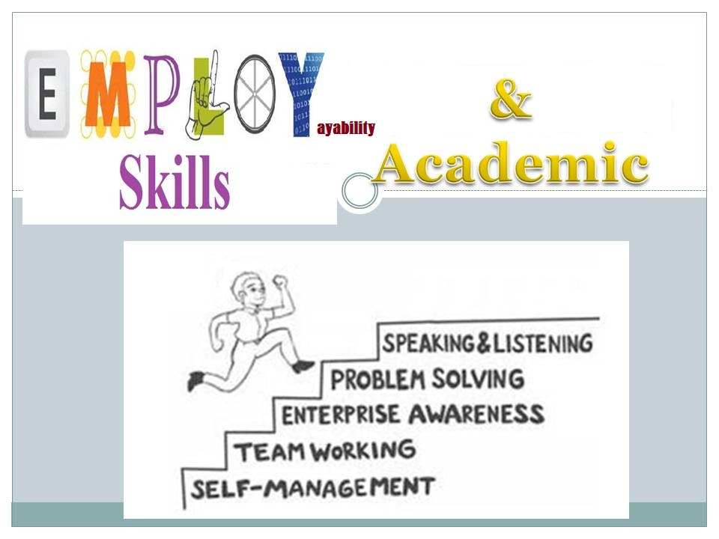

Contents
Introduction......................................................................... 2
My academic and employability skills.................................... 3
Swot analysis...........................................................................4
Personal development Plan.....................................................5
Skills to find employment in the hotel and hospitality industry..6
Conclusion.................................................................................7
References..................................................................................8

Introduction
In this report, I will analyze my academic and employability skills in hospitality and industrial tourism. First I will use Swot analysis to evaluate my strengths, weaknesses, opportunities and potential threats. Second, I intend to use a personal development plan which is going to establish my objectives. A personal SWOT analysis is crucial to creating a personal development plan as this type of analysis encourages an individual to be more self-aware. SWOT analyses demonstrate individual's strengths, weaknesses, opportunities, and threats as follows:
Strengths - The internal personal assets that an individual can control, expand, and use to their advantage, including skills, competencies, achievements, and education.
Weaknesses - The internal negative aspects of an individual, including lack of education or expertise, lack of focus, and unproductive work habits.
Opportunities - External events that may be exploited by individuals to their advantage, such as job vacancies, technology classes, and demand for skills.
Threats - External factors that threaten strengths and opportunities, such as job insecurity and downsizing.
When creating a personal development plan, individuals should seek to enhance strengths, minimize or eliminate weaknesses, capitalize on opportunities, and convert threats into opportunities. For instance, an individual with a bachelor's degree in IT (strength) could earn a more advanced certification in their field if they have not yet obtained such a credential (weakness). This plan may be based on increasing job opportunities for individuals in IT with this certification (opportunity) as well as the job insecurity facing individuals within the IT field who have no education beyond a bachelor's degree (threat).at will guide me through my career, for example to develop my weaknesses and threats.
Whit the assistant of swot analysis and personal development plan I will understand better my strengths and weaknesses and based on my knowledge so far I will improve the most I can.

My current Academic and Employability Skills
- Critical thinking and share my opinions
- Ability to work under pressure
- Motivated and hard worker
- Volunteering
- Committed to my course of study with interest;
- Determined to succeed
- Have a positive attitude to developing skills
- Maturity

Academic skills that I like to Develop
- Improve my writing skills
- Communication – being able to debate, discussing and presentations
- Comprehension – being able to understand academic texts and lectures
- IT skills – being able to use Excel and word accurately
- Manage my time and organize

SWOT analysis
Swot analysis is strategic planning method used to evaluate the strengths , weaknesses ,opportunities and threats involved in a project or in business venture . the technique is credited to Albert Humphrey (1960).
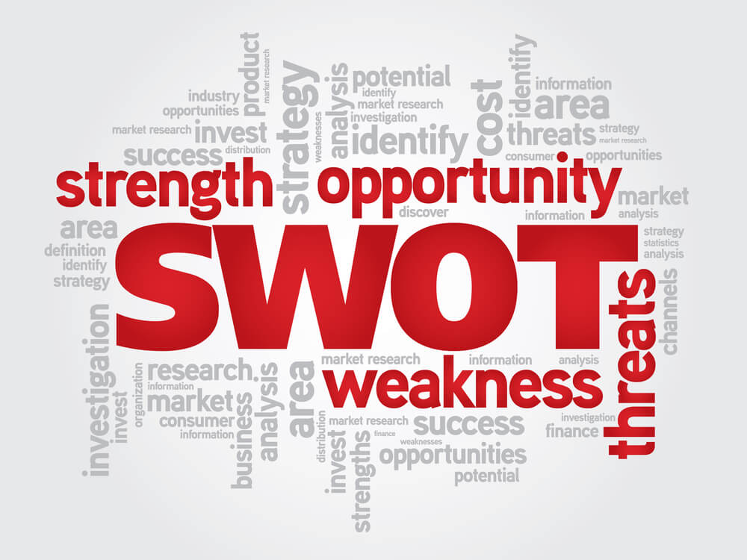

SWOT analysis helps de Management in the making of current and future decision of the business .It is a powerful tool in decision making as It helps unearth opportunities that may lead to a companies to success and also detect threats before they become a burden to the organization. According J.Scott Armstrong notes that “people who use SWOT might conclude that have done an adequate job planning and ignore sensible things as defining the firms objectives”.

My personal example of SWOT analysis
Strengths
- Optimistic – will help me to achieve my goals
- Social – easy to communicate with others
- Determined – I never give-up on my goals
- Friendly – I can interact with other people
Weaknesses
- Confident- Delivering presentation and speaking in front of people
- Overthinking – I spend more time thinking about some question
- Writing essay – I am struggling to organize

OPPORTUNITIES
- Graduate
- Find or apply to a better job
- Meet new friends and different culture
- Gaining experience on what I have learned
THREATS
- Learning and training difficulties
- IT skills – Excel
- Not able to present my work on time
- Not confident

PERSONAL DEVELOPMENT PLAN
According (kivimak 2018), project plan (PDP) in a course setting was co- designed with students , the aim was to design something that would help student track their achievement and plan their personal development. Example matches personal development with project planning. Choosing the best development plan is a source of motivation for any person who wishes to be successful (Stewart, 2016).The PDP template should typically contain space for entering your goals, an assessment of where you are now, and what specific development activities you want to do to move toward them you need to list goals in pieces ,each with clear measures for success. Also is much more effective when reviewed regularly. This will help you stay focused on goals, monitor how far have progressed, and make adjustments to ensure that the plan is still relevant your needs.
I am going to give a little brief of my personal development for the next 3 months to 3 years and I wish to improve my skills and also find a better job.

MY goals | Actions  (In 3 to 6months) | Evidences of achievements,  (after 1 year) | Target date  (between 2 or 3rd year)
Organize my time better when it comes to University work | Use post it notes, use to do list | I will be on top of all my work | September 2019
Be confident on my writing | Read, writing essays, assessments’ | I will be able to write an essay | September 2020
Obtain relevant work experience in hospitality and management | Apply for work , experience early  (bartenders). | I will obtain relevant work experience in hospitality and Management | October 2021/end of degree.
=
SKILLS TO FIND EMPLOYMENT IN SECTOR OF HOSPITALITY AND TOURISM
The importance of gaining experience by impressing an employer on internship, you have a great chance of landing a permanent upon graduation; and you will have a better understanding of the working world. If you be prepared and know the skills that employers look for to gain an advantages in such a competitive jobs market and really turn the heads of recruiters .You will need to arm yourself with a great set of transferable skills . On other hands you need to demonstrate flexibility by adapting quickly to changing roles and environments.
For example rules such as analytical thinking, commercial awareness, communication, organization, confidence, Negotiation and persuasion skills Leadership ability Resilience and teamwork.

Conclusion
In short, this report will help me to achieve my short and long term goals using these two methods,
The main purpose of a SWOT is to promote identified strengths, reduce weaknesses, exploit opportunities, and have contingency plans to minimize threats.
There are many benefits and advantages to using SWOT Analysis for personal development. It is good for your success and improvement. Some of the most common benefits of performing a personal SWOT analysis have been mentioned below.
Helps develop strategies to achieve your goals
You can be better than your friends and colleagues.
Shows where you are currently on the road to success.
Measure your scope of achievement of desired goals
Improves your career, life and personality
Helps you better understand who you really are as a person
Maximizes your strengths and decreases your weaknesses.
Explore and also enhance your personal and personal skills.
Helps to understand your preferences and personality traits
On the other hand personal development plan template typically contain spaces for entering your goals , an assessment of where you are now and what specific development activities you want to do toward them, you need to list goals in pieces with clear measures to success.
Personal development plan is much more effective when reviewed regularly. This will help you to stay focused on goals, monitor how far you have progressed and make adjustment s to ensure that the plan is still relevant to your needs.

References
Albert Humphrey (1960).
Laurie J. Mullin, Management and Organizational Behaviour, 11th Edition
Flannes, SW and G Levin (2005) Essential People Skills for Project Managers. Management Concepts.
F.D Pineda(2010)sustainable Tourism IV
John Eric Adair (2003) the concise time management and personal development
J.Scott Armstrong
Penny Tamkin , Personal development plan.
Stewart, J and V Knowles (2001) Graduate recruitment: implications for business and management courses in higher education. Journal of European Industrial Training, 25, 2-4, 98-108.
Steven Flanners, book title People skills for project Managers(2001)
Roger Peterson, (2007)Principles of Marketing.

Student career Guide (2018/19)
www.prospects.ac.uk- prospectstuden.career guide (p15)
Stewart (2016).

.

