University of Wales Trinity Saint David
Wales Institute of Science and Art


Application of CAE Processes
Structural and Fluid Analysis | ACHA6010

Morgan Davies
2205285
December 2024

Contents

1 Introduction 2
2 Validation of Software 2
2.1 Steps to Construct the Validation Model 2
2.2 Validation Calculation 4
3 Fully Linked System 4
4 Analysis of Results 8
4.1 Thermal study 8
4.2 Static Structural study 8
5 Optimisation of Piston 9
5.1 Geometry Optimisation 9
5.2 Material Optimisation 11
5.2.1 Past Case Studies 11
5.2.2 Aluminium Magnesium Silicon Alloy 11
5.2.3 Aluminium Silicon Carbide 12
5.2.4 Al 6061–1.5% B₄C-1.5% SiC MMC 13
5.2.5 Optimum Material 14
6 Limitations of the Model 14
7 Conclusion 15
8 Reference List 16

Introduction
The aim of this report is to discuss the use of computer aided engineering (CAE) in the design of a piston using a fully linked system, which includes, a crank shaft, connecting rod, gudgeon pin and piston assembly, to simulate, validate and optimise the piston design based on the numerical values retrieved by the software. CAE is crucial for structural analysis as it demonstrates the stresses, strains and displacements under loading, in either a static or transient study (Martin, 2021). The software used throughout this assignment is Ansys Workbench. Firstly, a validation of Ansys will be carried out, to vindicate whether the software will provide a reliable output. This will be constructed using a simple case study of a cantilever beam and comparing it to the analytical result to observe if Ansys provides an acceptable output. Once the CAE model is generated, an optimisation process will be carried out. This includes altering the geometry of the piston and changing the materials it can be made from to reduce the stresses and deformation the piston experiences.

Validation of Software

Steps to Construct the Validation Model
To validate Ansys a simple validation case study of a cantilever beam with an axial force will be used. The importance of doing this is to observe whether Ansys provides a similar result. The method for proving this, is to compare both results by calculating the percentage difference of the two values, to check whether they are within the acceptable range. An acceptable range for this experiment will be 10%, as that is typically the standardised range for an experimental analysis (Helmenstine, 2016).
The methodology for this to firstly create the geometry in a computer aided design (CAD) software. The beam constructed, has the equivalent dimensions shown in the case study (figure 1). Next, a static structural tab is generated, as the simulation requirement is to observe the result at a singular point in time. The engineering data had to be altered, to create a new material. This is carried out by adding a blank material and inserting the isotropic elasticity properties shown in figure 1. Ansys will the calculate all other required material properties using this information and provide a simulation using this material (steel). The CAD geometry is then imported to construct the model. To maintain accuracy, a mesh needs to be generated and sized, so the deformation and stresses are defined in their most optimal format. A mesh allows the software to break the volume of the part into smaller elements, to carry out numerical problem solving method (Martin, 2021). The mesh size used for this validation is 0.2x0.01m, to maintain the best accuracy. If a larger mesh size is used (such as the automatically generated one) it would not skew the results by a significantly large amount, however, when validating the software, a smaller mesh ensures that the most accurate representation of the software result is generated. Finally, the constraints and forces can be added to the model. A fixed support can be put onto the beam at one of the free ends, and the transversal force at the other free end and the axial force can be placed onto the beam, with the forces being 7.65kN and 1.6kN respectively. The model can be solved to give the result shown in figure 1.1
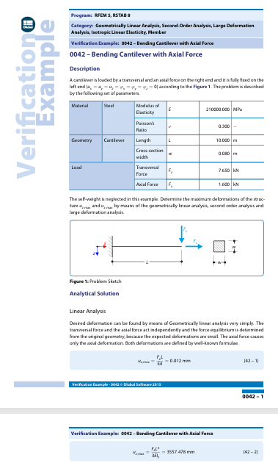
Figure 1.0- Cantilever beam case study, Dlubal software (2016)
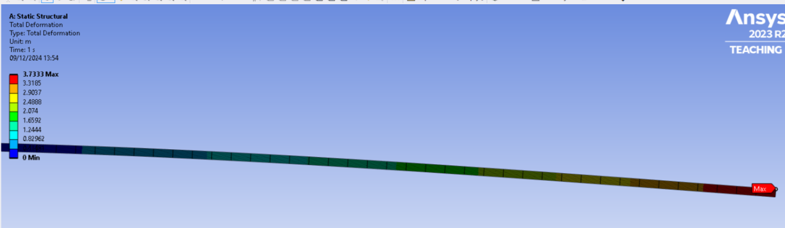
Figure 1.1- Cantilver beam simulation

Validation Calculation
To validate whether Ansys is suitable, a percentage difference between the analytical value and the value retrieved from Ansys is calculated this is carried out by the formula:
$$Percentage Difference= \frac{Ansys Value-Analytical Value}{\frac{Ansys Value+Analytical Value}{2}}X100=\frac{3.7333- 3.5575}{3.6454}X100=4.8\%$$
This calculation demonstrates that Ansys is a suitable software to use as it’s a valid result of 4.8%, which is less than the 10% required.

Fully Linked System
The material used for the piston is Aluminium 6061 T6, which is a high-strength alloy belonging to the 6000 series, primarily composed of aluminium with magnesium and silicon as the primary alloying elements (AZoM, 2013). This material is retrieved from Ansys Grata EduPack. It’s then imported within the engineering data tab on Ansys Workbench, and a new material is generated with its properties. This initial step is beneficial, as it allows for the material data to be transferred across each linked study.
A tab for rigid dynamics is then required to initially create the kinematic loadings that are observed through the assembly. The engineering tab is then linked to it, so the material data is transferred to this study. The geometry of the model is then imported into the rigid dynamics tab by importing the assembly directly onto the geometry section of the tab. It is important to use a step file for the CAD geometry of the model as the rigid dynamic system doesn’t recognise other file formats.
The next step is to open the model and inspect each element of the simulation. Firstly, the material selection within the geometry is required to be checked so the added material can be assigned to the piston. This is a crucial step as the masses of each component is based on the dimension sizes (volume) and densities of materials. Hence, the piston material is required to be assigned the Aluminium 6061 T6 to ensure the result produced is accurate. The components should also be shown as rigid bodies at this stage, as the results that require obtaining are the loadings that are generated by inertias.
Adjusting connections in the Ansys model involves replacing automatically generated contacts, which are unsuitable, with custom joints to establish accurate boundary conditions. Revolute joints are primarily used to simulate the rotational motion of a combustion engine. These joints are placed between the crankshaft and the base of the connecting rod, the connecting rod and the gudgeon pin, and the gudgeon pin and the piston. Body-to-ground joints are also applied to the crankshaft and piston to keep the assembly stationary and prevent unwanted movement. For the piston, a general joint is applied to its skirts, with the Z-axis set to "free" to allow translation only along this axis, ensuring accurate simulation of its linear motion.
In the mesh stage of the rigid dynamics study, a mesh is generated solely to enable Ansys to process the system, even though deformation is not analysed. The solver settings are configured for a transient study, with a time step of 0.05 seconds and an RPM of 4,000 to capture detailed iterations. A revolute joint between the crankshaft and ground is added as a joint load, while the joint between the piston and gudgeon pin is set up as a joint probe. This allows the forces to be mapped and calculated during the solution process, preparing the model for simulation and output generation.
The output solution can be retrieved which provides the maximum loadings, representing the most critical conditions a structure may experience. These values are essential for analysing safety, stress, and deformation limits, ensuring designs meet safety requirements and preventing failures. Engineers can use this data to evaluate material yielding and excessive deflection. The maximum load is exported as a motion load file and applied via a joint probe in the static structural study to simulate a maximum loading scenario.
The next stage is to insert the static structural tab to import the motion loads and link the geometry, engineering data and model setup from the rigid dynamics study to the model section of it. The static structural model needs to be opened such that all bodies apart from the piston are suppressed, as that is the only body that is to be analysed. This is so the other bodies are still part of the geometry but are ignored by the software, so no analysis is carried out on them. Next, in the geometry section the piston the body needs to be changed from rigid to flexible, to ensure the deformation can be mapped from the results. Then in the static structural solver, the motion loads created can then be imported, so that all loadings, such as, remote forces and moments experienced by the piston in that specific time step can be applied into the system.
The steady state thermal stage involves linking the study to the rigid dynamics system, ensuring consistent engineering data and geometry. It is crucial to verify the piston is assigned the correct material and remains flexible, as Ansys may not fully transfer these details. A mesh, sized to 0.5mm within the grooves, is generated for accuracy. Convection inputs are applied to define thermal loads, based on boundary conditions such as heat transfer coefficients and ambient temperatures (shown in figure 2). Average data assumptions are made for these conditions. The solution output displays a temperature profile, showing a maximum of 298.49˚C and a minimum of 163.9˚C (figure 2.1), aligning with expectations.
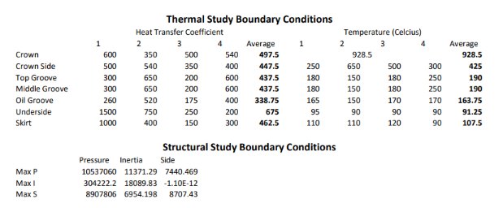
Figure 2.0- Boundary Conditions

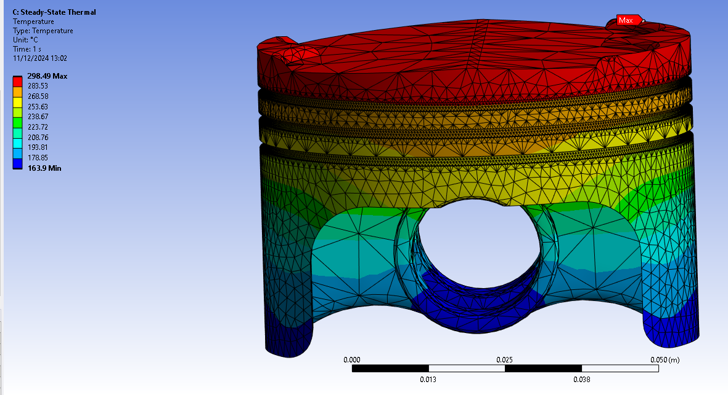
Figure 2.1- Initial Thermal Study

The thermal study is closed, and its solution is linked to the static structural setup to integrate the temperature profile as a boundary condition. After verifying the piston’s material and geometry, a fine 0.5mm mesh is generated to ensure accuracy in the grooves. Outputs are defined as equivalent stress and total deformation to analyse the stresses and deformation experienced by the piston. Weak springs are to be enabled to support the geometry flexibly while containing negligible stiffness, but an error required replacing them with a fixed support at the gudgeon pin, limiting the representability of stress and deformation in this area. The boundary condition that also needs to be applied is a pressure of 105×10⁷Pa to the crown to simulate combustion chamber gas pressure. The static structural study is then solved to produce outputs on stresses and deformations under combined loading conditions, representing the fully linked system. This final analysis highlights the piston’s performance under realistic operational conditions, incorporating all applied loads and moments as shown in figures 2.2 and 2.3.

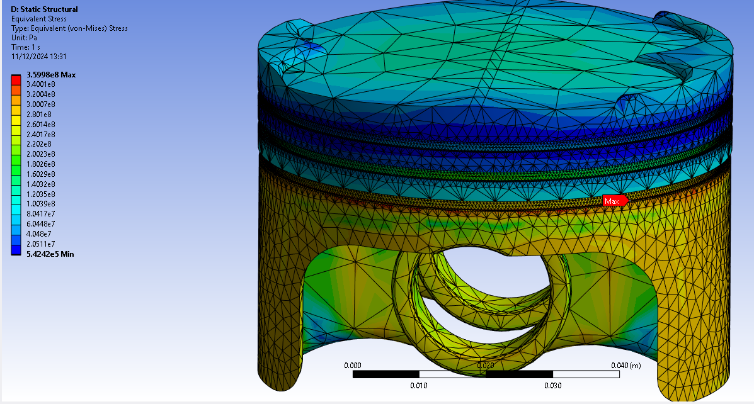
Figure 2.2- Initial equivalent stress from static structural study
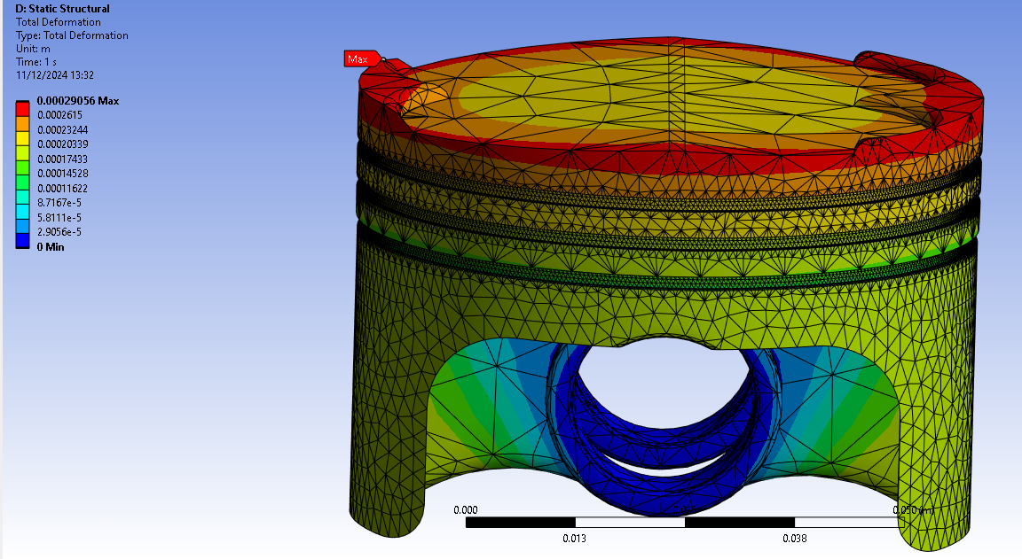
Figure 2.3- Initial total deformation from static structural study

Analysis of Results

Thermal study
The aluminium alloy 6061 T6 piston was simulated in Ansys Workbench for structural and thermal loadings. In the steady-state thermal study, the maximum temperature of 298.49˚C occurs at the top centre, exposed to combustion gases, while the minimum temperature of 163.9˚C is at the skirt and gudgeon pin bosses. This gradient reflects the boundary conditions, with temperatures decreasing along the piston height. Aluminium 6061 T6’s excellent heat resistance and high thermal conductivity make it suitable for high-temperature environments, such as combustion chambers, by effectively transferring heat and preventing hotspots (Karia, 2023).

Static Structural study
In the static structural study shown in figure 2.2, the maximum stress of approximately 3.6×10⁸Pa occurs on the oil groove, with higher stresses around the skirt and near the pin bosses due to shear and bending forces from the connecting rod. The minimum stress, about 5.42×10⁵Pa, is in the middle section of the piston, where load interactions are minimal. Combustion pressures act on the crown, while mechanical loads from the connecting rod affect the lower regions, leading to the observed stress distribution. These results highlight critical areas of concern for stress management in the piston design.
The structural study shows maximum deformation of 0.29mm at the crown ridges, where the piston experiences the highest thermal loads and combustion pressure. Sharp crown edges further amplify tensile and thermal stresses, increasing deformation. Minimum deformation is recorded as 0mm in areas with lower temperatures and pressures. However, this value is affected by the fixed support at the gudgeon pin, which restricts movement and reduces deformation in that region. This limitation impacts the accuracy of deformation results but highlights critical areas for structural improvement in the piston design.

Optimisation of Piston

Geometry Optimisation
To optimise the piston design, a new CAD geometry was generated to reduce the equivalent stresses and deformation experienced by the piston. As shown by figure 3.3 the high stresses appear in the oil groove, so to reduce the stress in this area, two fillets were applied to the piston as shown in figure 3.2 with a radius of 25mm on the inner corner and 10mm on the outer edge. This reduced the stress along the surface of the oil groove as shown in figures 3.4, where the highest stresses where experienced. Although the maximum stress was not reduced, the overall stress along this area is reduced as displayed by the colour gradient. Furthermore, the overall stress within the underside was reduced because of this change, however, this could be due to the pin bosses receiving additional load. Overall, this geometric change reduced the stresses and deformation experienced by the piston, leading to an optimised design as shown by figures 3.0 and 3.1.
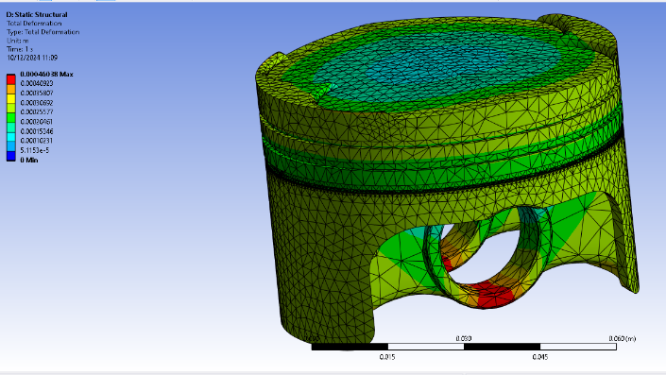
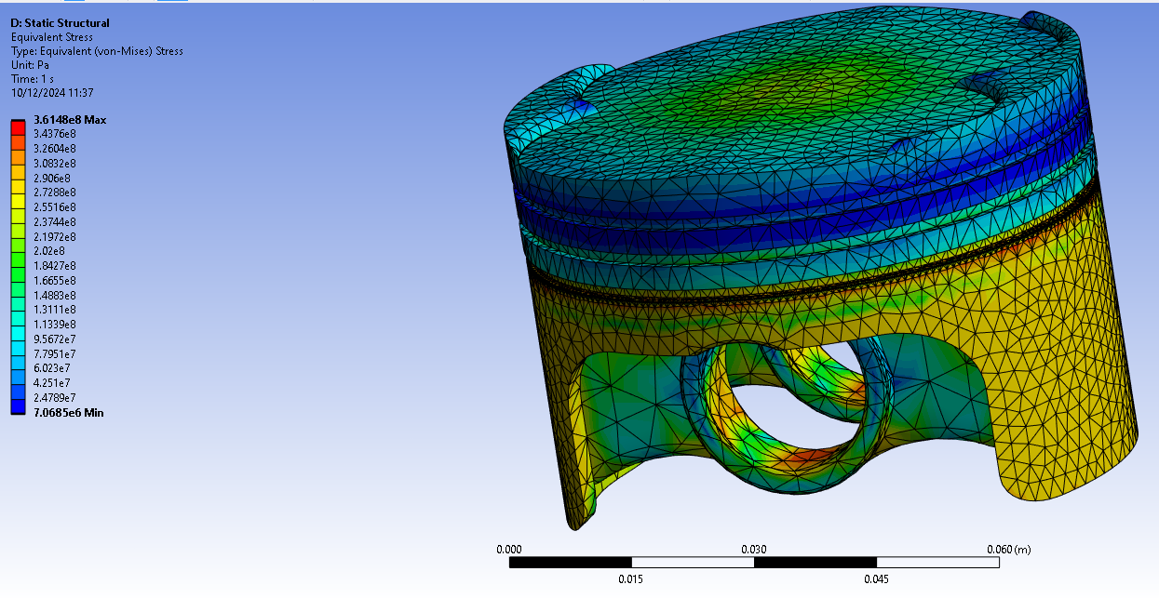
Figure 3.1- Figure 3.0- Total deformation for optimised geometry
Figure 3.0- Equivalent stress for optimised geometry

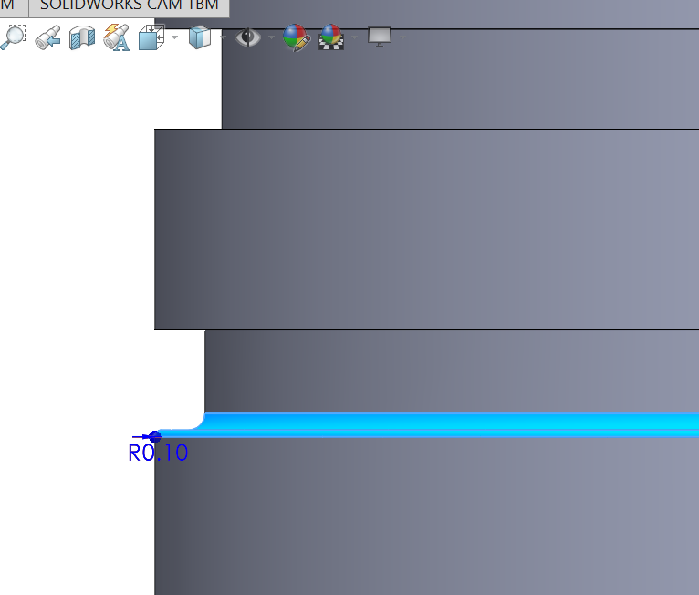
Figure 3.2- Geometric changes to piston

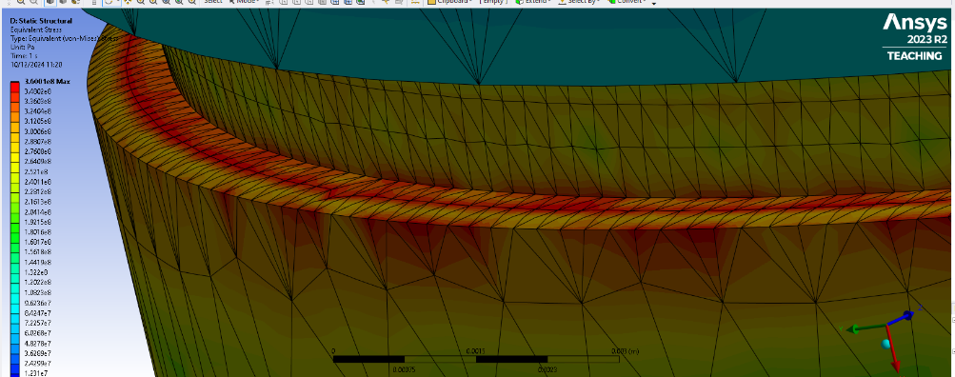
Figure 3.3- Equivalent stress for optimised geometry 2
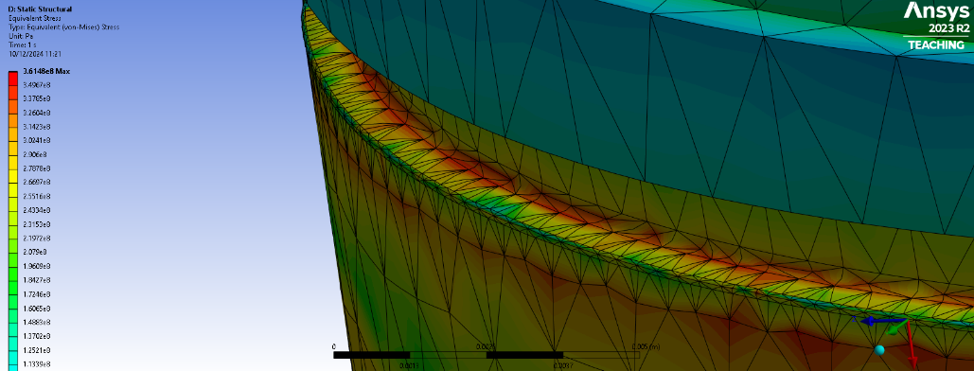
Figure 3.4- Total deformation for optimised geometry 2

Material Optimisation

Past Case Studies
Although aluminium 6061 T6 is a suitable material for a piston design due to it having a high strength and possessing heat resistive properties, to further optimise the piston, the material was altered (Karia, 2023). This is to further reduce the equivalent stresses and deformation experienced by the piston. The new material for optimisation used are aluminium magnesium silicon alloy (AlMgSi), aluminium silicon carbide (AlSiC) and Al 6061–1.5% B₄C-1.5% SiC MMC (AlBCSiC). By researching case studies demonstrating changes applied to material choice in piston design, it was observed that using a composite that contained elements such as carbon and silicon improved the properties required for a piston design.
Joel et al. found that carbon-carbon composite pistons outperform aluminium alloy pistons by offering lower thermal stress and maintaining strength at high temperatures, making them a viable alternative without significantly increasing inertial forces (Joel et al., 2018). Similarly, John et al. demonstrated that aluminium silicon carbide composite pistons provide better temperature distribution, reduced deformation, and lower stress compared to pure aluminium, demonstrating their higher thermal conductivity and Young’s modulus (John et al., 2015). Rashmita et al. identified AlBCSi as the optimal material due to its significantly lower deformation, reduced stress, and superior ability to withstand temperature changes while retaining mechanical properties (Rashmita et al., 2023).

Aluminium Magnesium Silicon Alloy
The results for AlMgSi is that it has a higher maximum stress of approximately 3.99x10⁸Pa compared to the optimised geometry in the oil groove. Compared to the optimised geometry, it has higher stress regions on the crown where the gudgeon pin supports on the underside resist compressive forces and on the underside near the pin bosses. However, it contains less stresses on the skirts and along the side of the piston as shown in figure 4 and has a lower minimum stress of approximately 2.7x10⁴Pa. Although the AlMgSi material has a lower minimum stress, the initial material has a lower maximum stress and more even distribution of stresses. Due to this high distribution of stresses, these could suggest an unsuitable material is used in the initial geometry change as the peak stresses in the AlMgSi piston could be mitigated by altering the geometry to result in a better piston.
In addition, this material also has a lower maximum deformation of approximately 2.32x10⁻⁵m along the edges of the piston crown. The deformation shown in figure 4.1 that deformation occurs at a lower amount across the faces of the piston compared to the gradient in figure 3, although the colour gradient seems higher in the AlMgSi, the value is much lower. This highlights that this material is suitable for optimising the piston as it deforms at a lower magnitude, which may prevent in the leaking of combustion gases and the leaking of oil into the combustion chamber that aluminium 6061 T6 may cause.
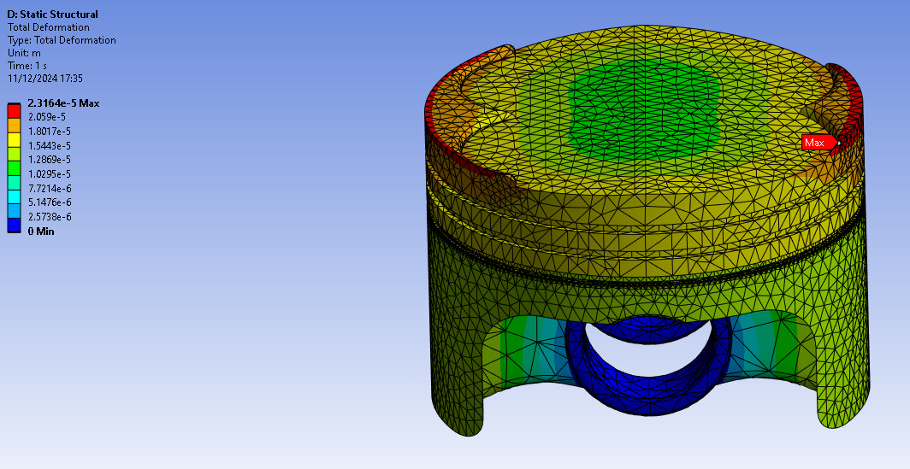
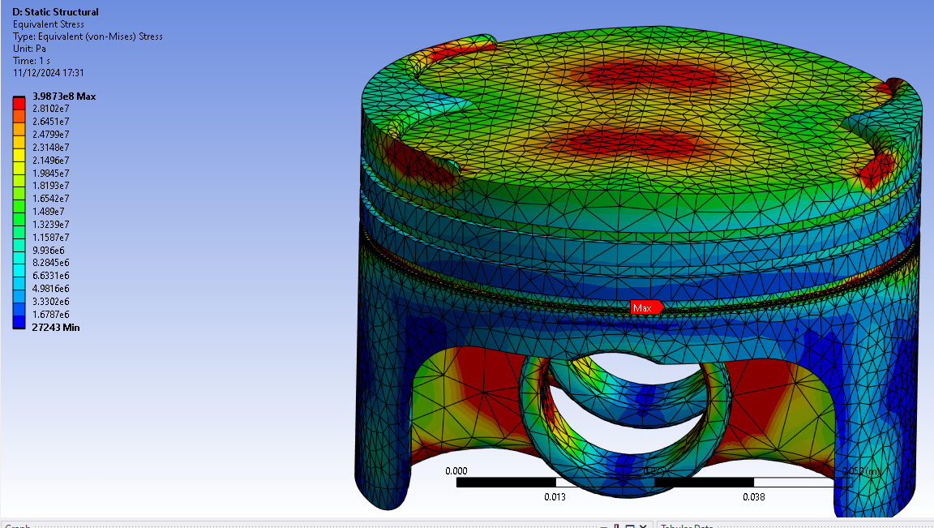
Figure 4.1- Total deformation for AlMgSi
Figure 4.0- Equivalent stress for AlMgSi

Aluminium Silicon Carbide
The results for AlSiC is that it has a higher maximum stress of approximately 4.1x10⁸Pa compared to the optimised geometry in the oil groove. Compared to the optimised geometry, it has similar results to the AlMgSi results shown in figures 4 and 4.2 which demonstrates that similarly to the AlMgSi piston, it is a suitable optimisation. This material optimisation is overall desirable in terms of the equivalent stresses and total deformation experienced.

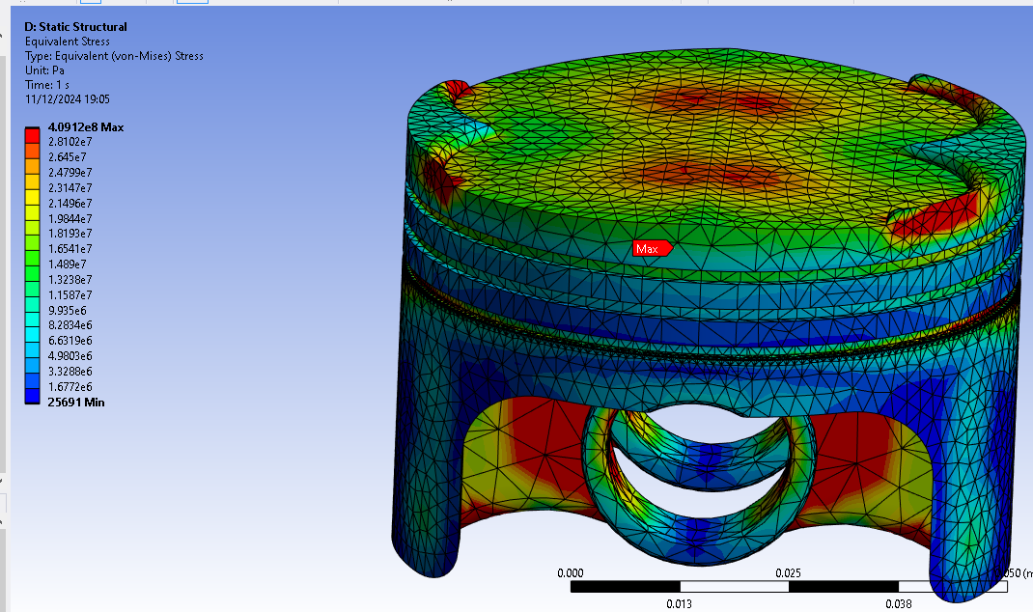
Figure 4.2-Equivalent stress for AlSiC

Al 6061–1.5% B₄C-1.5% SiC MMC
The results for the AlBCSiC is that it has a higher maximum stress of approximately 3.99x10⁸Pa. Although the maximum stress is higher, the stress distributed along this piston is more localised to the edges and crown (see figure 4.3). This indicates that the material is more efficient at managing the stress experienced. However, the stress values are more confined the in initial optimisation, suggesting ineffective stress management in material limits. Similarly to the previous two materials, the high distribution of stresses in the initial geometry change could suggest an unsuitable material is used and the AlBCSiC is a better suited material choice. Relating to stress this material is more suitable.
The result for deformation is that the maximum deformation value is approximately 5.5x10⁻⁶m, which is significantly smaller compared to the initial geometric optimisation of approximately 4.6x10⁻⁴m (see figure 4.4). This suggests that the material in the AlBCSiC model is better at resisting deformation under the same mechanical and thermal loading conditions. This demonstrates that this material is suitable for optimising the piston as it deforms at a lower magnitude, which may prevent in the leaking of combustion gases, leaking of oil and scraping of the piston cylinder.

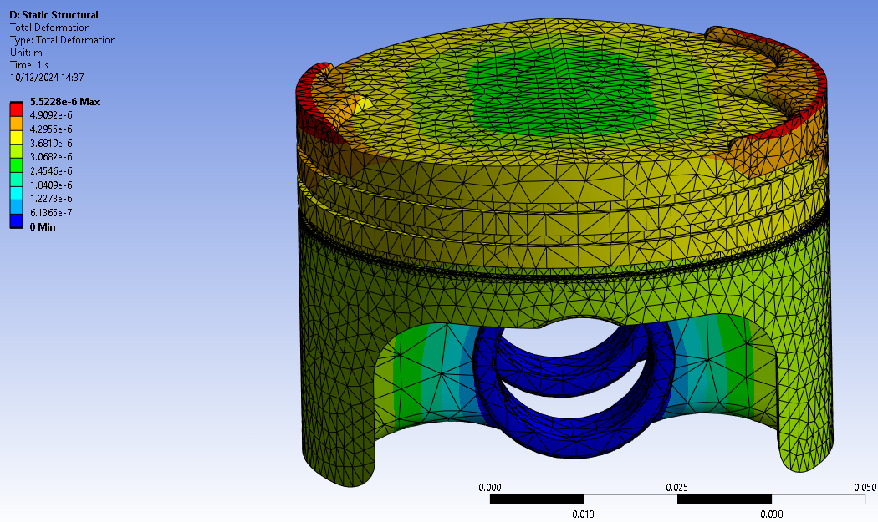
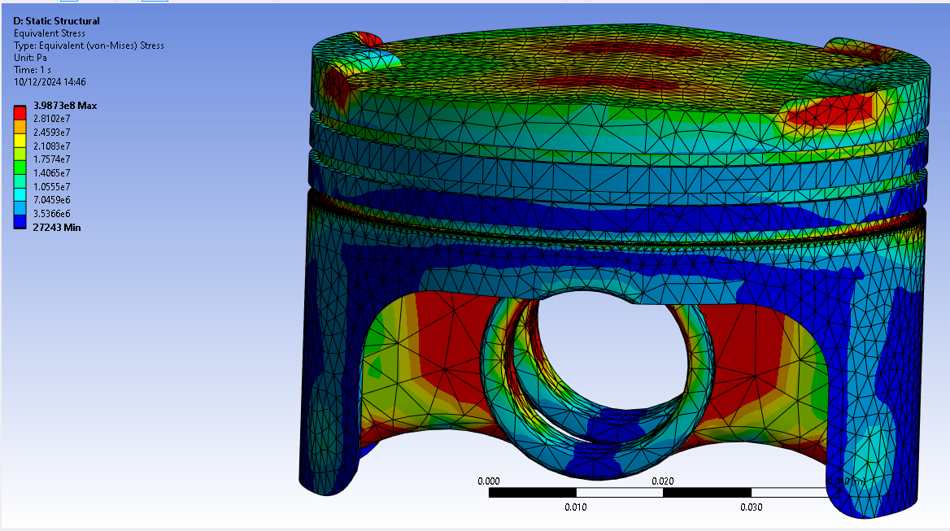
Figure 4.4- Total deformation for AlBCSiC
Figure 4.3- Equivalent stress for AlBCSiC

Optimum Material
The most optimal material choice is AlBCSiC. Although the stress and deformation profiles of all optimising materials are similar, AlBCSiS contains the lowest maximum values of stress and deformation and contain the lowest values throughout the profile. This displays that the material in the AlBCSiC model is better at resisting dimensional changes under the same mechanical and thermal loading conditions and the material is more efficient at managing the equivalent stress experienced.

Limitations of the Model
A limitation of using Ansys is the inaccuracy in motion loads for material changes, as the rigid dynamics system was not run for each material. However, this inaccuracy is negligible, with only a 0.022kg difference between the heaviest and lightest pistons, resulting in an 8% inertia change, which has minimal impact at low RPMs.
$$Percentage Difference=\frac{V1-V2}{(\frac{V1+V2}{2}}X100=\frac{0.27752-0.25513}{(\frac{0.27752+0.25513}{2})}X100=8.41\%≈8\%$$

Another limitation is the inability to solve with weak springs enabled, requiring a fixed support at the pin bosses. This reduced the accuracy of stress and deformation results, suppressing realistic movement in that region and causing the minimum deformation to be inaccurately displayed as zero.

Conclusion
Incorporating structural and thermal analysis along with material and shape optimisation, this report emphasises the crucial role that CAE contributes to piston design. Ansys Workbench's result for piston simulation was proven, by validating it against a case study involving a cantilever beam. AlBCSiC was proven as the best option for lowering stress and deformation while improving thermal efficiency. The optimisation process indicated that material selection has a major impact on engine performance. However, there are limitations to using Ansys, such as inaccurate motion load calculations and fixed support limits. Nevertheless, the study shows how well CAE can improve piston design for increased performance in practical applications.

Reference List
- Martin, D. (2021). CAE Simulation: How It Works and Why It Matters. [online] www.ptc.com. Available at: https://www.ptc.com/en/blogs/cad/cae-simulation-why-matters [Accessed 6 Dec. 2024].
- Technosoft (2023). What is Computer Aided Engineering - Its Benefits & Applications. [online] Technosoft Engineering. Available at: https://technosofteng.com/blogs/what-is-computer-aided-engineering/ [Accessed 6 Dec. 2024].
- AZoM (2013). Aluminium / Aluminum 6061 Alloy (UNS A96061). [online] AZoM.com. Available at: https://www.azom.com/article.aspx?ArticleID=6636 [Accessed 7 Dec. 2024].
- Dlubal Software (2016). Bending Cantilever with Axial Force. [online] Dlubal Software. Available at: https://www.dlubal.com/en/downloads-and-information/examples-and-tutorials/verification-examples/000042 [Accessed 11 Dec. 2024].
- Karia, P. (2023). Aluminium 6061 (T6) - Composition, Properties and Uses. [online] ThePipingMart Blog. Available at: https://blog.thepipingmart.com/grades/aluminium-6061-alloy-t6-composition-properties-and-uses/ [Accessed 12 Dec. 2024].
- Helmenstine, A. (2016). Sources of error in science experiments. [online] Science Notes. Available at: https://sciencenotes.org/error-in-science/ [Accessed 13 Dec. 2024].
- Joel, C., Anand, S., Padmanabhan, S. and Raj, P. (2018). Thermal analysis of carbon-carbon piston for commercial vehicle diesel engine using CAE tool. International Journal of Ambient Energy, 42(2), pp.163–167. doi:https://doi.org/10.1080/01430750.2018.1525594.
- John, A., Matthew, J., Malhotra, V. and Dixit, N. (2015). Design and Analysis of Piston by SiC Composite Material. [online] IJIRST –International Journal for Innovative Research in Science & Technology. Available at: https://d1wqtxts1xzle7.cloudfront.net/38877116/IJIRSTV1I12006-libre.pdf?1443101970=&response-content-disposition=inline%3B+filename%3DDesign_and_Analysis_of_Piston_by_Sic_Com.pdf&Expires=1734176333&Signature=SGbL1UjyfL8VyLdbJ2P9~T7aTFh9Ak-mwz1GwEjLuHvgqdLUPQkpTMZ91IPhRS8DlIJLzLL9IVyMUli1JrNO0fxAnBv86cyAEeyTg0JEcBGR4T5SzCNfoHIt-oRPvzAbA4Kt0fo06TX8ZLy~KecmMWLGFbrRhQaGkYcVRHnwHwboF43Blk3lOrI~PT2dhoJhGlzhwM86gchNTfMmRMfhYieJcW5dCbF-W20LCBOA0u4s384hqy2GyZjzigwaDMyUDlneiVLQcPr8ZZbl~Q0dhjUQRJqLOP29X6SPFP-8weW1ElDV8WY~wC-~4gVECouSIAdYXrjLiCVfxnGlr9HSBw__&Key-Pair-Id=APKAJLOHF5GGSLRBV4ZA [Accessed 14 Dec. 2024].
- None Rashmita, Singh, S., Kumari, A. and Aggarwal, S. (2023). Optimization of piston material with aluminium alloy based metal matrix composites. Materials today: proceedings. doi:https://doi.org/10.1016/j.matpr.2023.09.019. [Accessed 14 Dec. 2024].

