

LCMB7035
Dissertation Proposal

The Effectiveness of Nostalgia Marketing in Influencing Purchase Intention among Generation Z Consumers: A Study of Digital Advertising in the UK Food & Beverage Industry

Name-MD Natikul Islam
ID-2437633

Table of Contents
1. Introduction 4
1.1 Research Title 4
1.2 Study Background 4
1.3 Problem Statement 5
1.4 Research Rationale 5
1.5 Aims, Objectives and Questions 6
1.6 Research Hypotheses 7
1.7 Structure of Dissertation 8
2. Literature Review 8
2.1 Nostalgia marketing: Definition and Theoretical base 8
2.2 Nostalgia Marketing Digital advertising 9
2.3 Generation Z: Characteristics and Consumer Behaviour 9
2.4 Emotional involvement – brand attachment 10
2.5 Brand Attitude, Brand Trust and Purchase Intention 11
2.6 Theoretical Framework: 12
2.7 Conceptual Framework 12
3. Methodology 13
3.1 Research Philosophy 13
3.2 Research Approach 13
3.3 Research Strategy 13
3.4 Research Design 14
3.5 Data Collection Method 14
3.6 Data Analysis Method 15
3.7 Ethical Considerations 16
3.8 Limitations 16
3.9 Methodology Summary 16
4. Expected Findings 17
5. Timeframe 18
Work Breakdown Structure 18
Gantt Chart 19
6. Conclusion 20
7. References 21

1. Introduction

1.1 Research Title
The Effectiveness of Nostalgia Marketing in Influencing Purchase Intention among Generation Z Consumers: A Study of Digital Advertising in the UK Food & Beverage Industry

1.2 Study Background
Today, nostalgia marketing has become an effective tool in the promotional communication of brands. It means extending the consumer's emotional relation with experiential, cultural and historical heritage of the brand to impact more on their engagement and influence their purchasing behaviour (Cavazos, 2024)
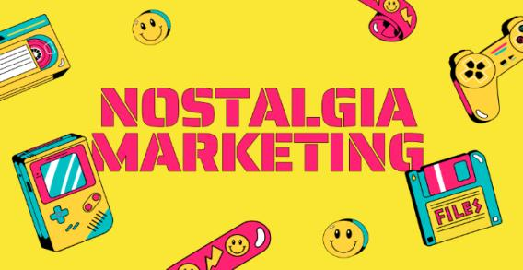
Figure: Nostalgia Marketing (Chen and Lin, 2024)
Nostalgia has become a key element in marketing and seen a rise in the food and beverage sector. Some of the successful applications of retro branding that iconic British brands like Heinz, Cadbury and Hovis have done have included the restoration of vintage packaging and collective cultural memories (Nguyen, Ngo and Ho, 2026).
The consumers born in the approximate period of 1995 to 2012, known as Generation Z, are a particular group with the digital native characteristic and yet a seemingly paradoxical obsession with authenticity and heritage Nostalgia can look like "vicarious" or "aesthetic" nostalgia—that accounts for the romanticised notions of other, often historical, times that did not occur in their lifetime and that are mediated through digital platforms

1.3 Problem Statement
Academic literature on the effectiveness of nostalgia marketing among younger generations, particularly in the field of digital advertisement is scarce even with the fact that the marketing ploy has already been adopted by food and beverage companies targeting the the younger ones (Chen et al., 2026). As such, marketing researchers are still not fully equipped with the empirical-backed advice to determine if nostalgia marketing is effective in creating purchase intention among generation Z and what specific mechanisms lead nostalgia to influence purchase intention and what types of nostalgia marketing appeals work best with this technology-savvy generation (Daszkiewicz, 2023)
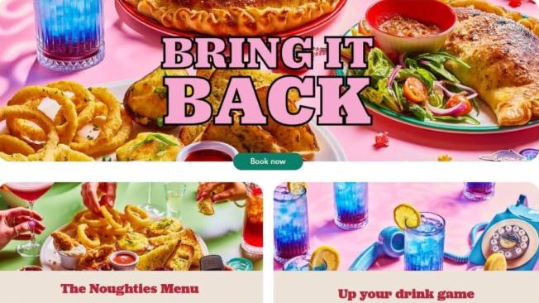
Figure: Nostalgia marketing (Neuvonen, 2026).

1.4 Research Rationale
Academic Rationale: The study is an extension of the theoretical knowledge of nostalgia marketing to the section of the population that has received less empirical attention – the Generation Z. The research contribute to the theoretical understanding of the process of how nostalgic stimuli become behavioural outcomes; using the Stimulus-Organism-Response (SOR) framework to integrate with already existing consumer behaviour theories (Estevam Dorneles, 2025).
Practical Rationale: This research offers marketing practitioners in the UK food and beverage industry insights into which types of digitally-extended nostalgia marketing stimuli are more effective and which are more important in the process of nostalgisation as a mediating process: emotional engagement, brand attitude, and brand trust (Chen and Lin, 2024)

1.5 Aims, Objectives and Questions
Research Aims
To investigate the extent to how nostalgia marketing strategies are effective and how they impact purchase intention of the Z Generation consumers in the Food and Beverage sector in the United Kingdom of Great Britain and Northern Ireland (UK), mediated by emotional engagement, brand attitude and brand trust.
Research Objectives:
- To critically discuss the literature of Nostalgia Marketing, Consumer Behaviour and Consumption Pattern of Generation Z.
- To analyse direct influence of the nostalgia marketing on the emotional involvement of Generation Z.
- To explore the correlation between emotional engagement and brands attitudes.
- To examine how brand trust is playing a mediation role between brand attitude and purchase intention.
- To derive marketing practitioner recommendations based on evidence.
Research Questions:
- RQ1: Does nostalgia positively influence purchase intention of Generation Z consumer in the UK food and beverage industry?
- RQ2: What happens when Gen Z Consumer follows the shots of nostalgia-evoking digital ads?
- RQ3: How emotional engagement plays a mediaiation role on the relationship between nostalgia marketing and brand attitude of the generation Z?
- RQ4: How are brand attitude and brand trust linked to purchasing intention for generation Z exposed to nostalgia marketing?
- RQ5: What are some of the actionable implications that can be drawn out for marketers developing digitally-based campaigns emphasizing nostalgia for Generation Z?

1.6 Research Hypotheses
Hypothesis | Statement
H1 | Nostalgia marketing positively and significantly influences emotional involvement of Gen Z shoppers.
H2 | There is a positive and significant influence of emotional engagement in brand attitude towards Generation Z consumers.
H3 | Brand attitude positively and significantly affects brand trust as a factor among the consumers belongs to the generation Z.
H4 | Positive relationship between brand trust and purchase intentions of the GenZ consumers is significant.
H5 | Emotional engagement is found to be a sequential mediator between the nostalgic marketing and purchase intention, followed by brand attitude and brand trust

1.7 Structure of Dissertation
The dissertation will contain six chapters: Introduction, Literature Review, Methodology, Findings, Discussion and Conclusion.

2. Literature Review

2.1 Nostalgia marketing: Definition and Theoretical base
Nostalgia marketing is a communication strategy which intentionally brings back positive memories and associations to the consumers' past experiences to create emotional appeal and impact on consumer behaviour. In the food and beverage industry, it expresses itself in the form of retro packaging, heritage storytelling, product revival and cultural referencing (Estevam Dorneles, 2025).
The academic world recognizes a distinction between 2 main types of nostalgia:
Type | Definition | Relevance to Generation Z
Personal Nostalgia | Direct autobiographical memories | Limited; Gen Z has fewer direct memories of pre-2000s eras
Vicarious/Aesthetic Nostalgia | Romanticised longing for eras not personally lived (George et al., 2025) | High; Gen Z's nostalgia is "borrowed" through digital media (Malcolmson, 2024)

2.2 Nostalgia Marketing Digital advertising
The media is mainly digital, and Gen Z' colours apps like Instagram, TikTok, and YouTube as the leading platforms that engage them with brands. Some examples of nostalgia marketing in digital advertising include social media campaigns that are set in the past, throwback content, in-person nostalgia marketing campaigns organized by fans or even influencers' collaboration with brands. Digital platforms contribute to the sense of nostalgia marketing by being virility, a sense of community, authenticity perception and emotional resonance (George et al., 2025)

2.3 Generation Z: Characteristics and Consumer Behaviour
Generation Z (those born around 1995-2012) is the first generation of "digital natives" (Kim and Song, 2023). These characteristics include being "digital native," socially conscious, fluid and flexible with their identities, experience orientation and scepticism about traditional advertising (Niño, no date). For nostalgia marketing, this means that those who are born and raised digitally are more likely to be receptive to digital nostalgia content, social-consciousness means that news will be more engaging for people who are able to see the authenticity and transparency behind the brand, and scepticism means that the more sceptical, the more people may feel that the nostalgia content is more authentic and less saleable (Hasselblatt, 2025)

Figure: nostalgic behaviour of people (Daszkiewicz, 2023)
Emotive and personal food and beverage consumption experiences, heritage as quality signals and preference for authentic and transparent brands are some of the characteristics of millennials' relationship to food and beverage products that are also attributable to generation Z (Hoang et al., 2026)

2.4 Emotional involvement – brand attachment
Emotional engagement is defined as the emotional reactions of consumers in the face of market stimuli, which involves their feelings of joy, nostalgia, warmth and connection. The Stimulus-Organism-Response (SOR) construct offers a theoretical basis in understanding how nostalgia marketing can be used to create emotional responses to the experience that are likely to lead to behavioural outcomes (Makkonen, 2026). Nostalgia triggers positive emotions such as warmth, comfort, joy and feelings of belonging, have been proven by research. In the mind of Generation Z, via aesthetic appreciation and expression of identity, nostalgia content can evoke them in digital spaces (Hoang et al., 2026)
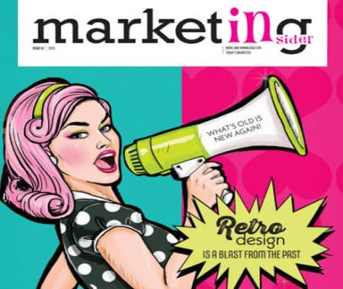
Figure: Retro branding (Hasselblatt, 2025)

2.5 Brand Attitude, Brand Trust and Purchase Intention
Brand Attitude: Overall consumers' evaluation of a brand. Nostalgia marketing has an impact in relation to brand attitude through an emotional transfer which means transferring the positive emotions from the past to the brand (Pacheco, 2026).
Brand Trust: A brand’s capability to deliver on promises. Heritage and nostalgia have been also identified to improve the degree of trust by creating perceived authenticity and emotional bonding and by mitigating the perceived risk.
Purchase Intention: Attitude to buy: Statement of consumers' likelihood to buy, which is a good indicator of actual behaviour. The purchase intention is determined by three factors: attitude, subjective norms and perceived behavioural control (PBC), according to the Theory of Planned Behaviour (TPB) (Lammersma and Wortelboer, 2017)
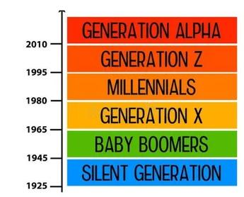
Figure: Generational Nostalgia Typology (Hasselblatt, 2025)

2.6 Theoretical Framework:
Stimulus-Organism-Response (SOR) Model Stimulus-Organism-Response (SOR) Model is one of the theories used in stimulus manipulation.
SOR | Construct | Definition
Stimulus (S) | Nostalgia Marketing | Exposure to nostalgia-evoking digital advertising
Organism (O) | Emotional Engagement | Affective responses to nostalgic stimuli
Organism (O) | Brand Attitude | Evaluative judgments of the brand
Organism (O) | Brand Trust | Confidence in brand reliability
Response (R) | Purchase Intention | Intention to purchase brand products (Makkonen, 2026)

2.7 Conceptual Framework
Nostalgia Marketing

Emotional Engagement

Brand Attitude

Brand Trust

Purchase Intention

3. Methodology

3.1 Research Philosophy
The research philosophy of this research involves positivism; the positivist approach acknowledges that all knowledge is based on observable and measurable entities. The study is to test the causal relationships for measurable causes and effects; positivism is appropriate (Košičiarová, 2019).

3.2 Research Approach
A deductive approach will be used, which means that from theory derived on the basis of literature, this will be tested against empirical evidence. This makes it possible for hypothesis testing and statistical inferences (Kaho, no date)
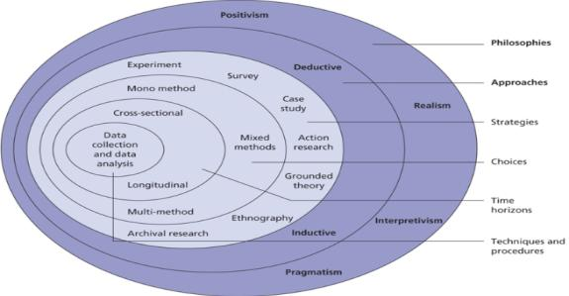
Figure: Research Onion Layer (Hasselblatt, 2025)

3.3 Research Strategy
A research strategy based on archival material will be used, which includes a systematic collection and quantitative analysis of secondary sources of data. This offers access to big and representative data sets within the time frame of MBA (Jose, no date)

3.4 Research Design
Primary analysis will use a cross-sectional design to analyse the data for the post-pandemic time period (2021 – 2024). Pre-pandemic baseline data (2017-2019) will be used to conduct a longitudinal comparison and examine the extent of change on the effectiveness of nostalgia marketing (Jain, Mishra and Kothari, 2025)

3.5 Data Collection Method
Secondary Data Sources only:
Source Type | Specific Sources | Data Provided
Academic Journals | Journal of Consumer Behaviour, Journal of Marketing | Quantitative empirical evidence
Industry Reports | Mintel, Nielsen, Kantar, YouGov | Consumer brand preference, heritage brand performance
Government Sources | Office for National Statistics | Food and beverage consumption trends
Brand Performance | Company annual reports, brand tracking | Sales figures, market share, campaign metrics

Inclusion Criteria: The criteria for inclusion were: UK based food and beverage data; the Generation Z consumer segment (ages 18-30); data including measures of emotional engagement, brand attitude, brand trust and purchase intentions (Holotová, Kádekova and Košičiarová, 2020)

3.6 Data Analysis Method
Stage | Analysis | Purpose
Stage 1 | Data Import and Organisation | All secondary sources have been systematically imported in NVivo and SPSS
Stage 2 | Variable Coding and Quantification | The relevant codes for nostalgia marketing, emotional involvement, brand attitude, brand trust, intention to buy ultimately.
Stage 3 | Code Frequency and Matrix Analysis | Create and analyse frequency data; look for co-occurrence patterns
Stage 4 | Statistical Analysis | Data is analysed by way of cross tabulation and Pearson correlation, utilizing NVivo and SPSS functions.
Stage 5 | Hypothesis Testing | Using correlation and regression analysis, test H1 – H5.

NVivo Functions:
- Code Frequency Query: Number of times coded variables occur;
- Coding Matrix: Review coincidences of codes;
- Cross tabulation: Test associations between variables (chi-square);
- Pearson correlation: Indicate the strength of relationships;
- Comparative Analysis: Make comparisons between pre/pandemic data.
Hypothesis Testing:
- Direct effects direct (correlation coefficient);
- Effect of mediation based on bootstrapping procedures;
- Significance level: p < 0.05.

3.7 Ethical Considerations
The ethical concerns of research that only produces secondary data are proper attribution of all sources, transparent use of research methods, honesty in reporting results, including any non-detected results, and disclosure of any data limitations (Holotová, Kádekova and Košičiarová, 2020)

3.8 Limitations
Limitation | Mitigation
Acknowledge; use multiple sources | No control over data collection methods
Solve consistency problems with data | Standardise coding procedures
Subjectivity in coding framework & | develop coding framework
Extract relevant subsets of data (GZ) | Extract relevant subsets
Geographical scope in UK: | Convey results in the context of the UK.

3.9 Methodology Summary
Element | Choice
Philosophy | Positivism
Approach | Deductive
Strategy | Archival Research
Design | Cross-sectional
Data Type | Secondary Quantitative
Sources | Academic, Industry, Government
Analysis Tool | NVivo , SPSS

4. Expected Findings
According to the theoretical framework the following findings are expected:
Hypothesis | Expected Outcome | Rationale
H1 | Supported | Positive emotions are triggered by nostalgic stimuli
H2 | Supported | Positive emotions, such as happiness and joy, are spread to brand assessments
H3 | Supported | Positive brand evaluations creates trust
H4 | Supported | Trust is correlated with buying behaviour
H5 | Supported | In keeping with SOR approach

5. Timeframe

Work Breakdown Structure
Phase | Task | Duration
Phase 1 | How to select a topic and develop a proposal | Week 1-3
Phase 2 | Literature Review and Theory | Week 4-7
Phase 3 | NOVELTY will follow a methodology designed to develop a questionnaire. | Week 8-9
Phase 4 | Ethical Approval and Pilot Testing will occur before final publication. | Week 10-11
Phase 5 | Data Collection (Survey Distribution): The individual or organization that disseminates the survey. | Week 12-14
Phase 6 | Learn how to analyse data and perform hypothesis testing. | Week 15-17
Phase 7 | Writing the Finding, Discussion and Conclusion | Week 18-21
Phase 8 | Final editing, referencing and submission. | Week 22-24

Gantt Chart
Task | W1 | W2 | W3 | W4 | W5 | W6 | W7 | W8 | W9 | W10 | W11 | W12 | W13 | W14 | W15 | W16
Topic Selection
Literature Review
Methodology Design
Data Collection
Data Analysis
Writing and Discussion
Editing and Submission

6. Conclusion
This proposal presents a dissertation which will explore the nostalgic marketing towards the purchase intention of Generation Z shoppers in the UK food and beverage industry. Using a quantitative survey approach, based on a SOR perspective, the research will aim to test five hypotheses that explore the mediating stage of emotional engagement, then brand attitude, ending with brand trust. Academically, the study extends the theory of nostalgia marketing to an under-researched generation: Generation Z; and in practical terms, offers evidence-based insights to the field of marketing practice, when they are designing advertising campaigns using digital media for younger consumers. The results anticipated will guide brand strategies as consumers are looking for comfort, authenticity and emotional experiences, all of which are based on nostalgic brand experiences in the current “post-pandemic” climate.

7. References
Cavazos, B.A.G. (2024) The Influence of Nostalgia on Brands. PhD Thesis. EGADE Business School, Instituto Tecnologico y de Estudios Superiores de …. Available at: https://search.proquest.com/openview/d098522099099824cbc60042a305d1d9/1?pq-origsite=gscholar&cbl=18750&diss=y (Accessed: 6 July 2026).
Chen, V.Y. and Lin, P.M. (2024) ‘The power of nostalgic emotion: how Hong Kong traditional tong sui influences generation Z’s purchase intentions’, British Food Journal, 126(8), pp. 3197–3220.
Chen, Z. et al. (2026) ‘A taste of nostalgia: linking consumption values and the decision-making process for Gen Z’, Tourism Recreation Research, pp. 1–25. Available at: https://doi.org/10.1080/02508281.2026.2637455.
Daszkiewicz, M. (2023) ‘Nostalgic consumer trends and nostalgia marketing’, Ekonomia–Wroclaw Economic Review, 29(4), pp. 69–82.
Estevam Dorneles, P. (2025) Blending Tradition with Experience: The Impact of Hybrid Marketing on Consumer Perceptions in the Caffeinated Beverage Sector: A Generational Study of Emotional Engagement, Authenticity, and Brand Loyalty Among Millennials and Generation Z in Europe. PhD Thesis. Dublin, National College of Ireland. Available at: https://norma.ncirl.ie/id/eprint/9039 (Accessed: 6 July 2026).
George, J. et al. (2025) ‘Reconstructed nostalgia and vintage branding: A cross-platform engagement model for Gen Z brand loyalty’, Lex Localis, 23(S4), pp. 3481–3496.
Hasselblatt, S. (2025) ‘Balancing Tradition and Innovation: Generational Perceptions of Brand Heritage in the Beverage Industry’. Available at: https://www.doria.fi/handle/10024/192715 (Accessed: 6 July 2026).
Hoang, C.L. et al. (2026) ‘The Taste of Memories: How Nostalgia Marketing Builds Brand Equity and Retains Customers in the FnB Industry’, Journal of Promotion Management, pp. 1–21. Available at: https://doi.org/10.1080/10496491.2026.2679287.

Holotová, M., KÁDEKOVÁ, Z. and KOŠIČIAROVÁ, I. (2020) ‘RETRO MARKETING-A POWER OF NOSTALGIA WHICH WORKS AMONG THE AUDIENCE.’, Communication Today, 11(2). Available at: https://search.ebscohost.com/login.aspx?direct=true&profile=ehost&scope=site&authtype=crawler&jrnl=1338130X&AN=147726092&h=4qmLcsc0YCLfL3T5V3Dti5Eb2egZ3BzqwJvnyVJ4AAtiqw%2FCclXqfQMRe7qM5y2cTQZYmRKNcshgDzOAH5mrag%3D%3D&crl=c (Accessed: 6 July 2026).
Jain, T., Mishra, V.K. and Kothari, M.D. (2025) ‘Digital Nostalgia Marketing: How Past-Centric Ads Affect Gen Z Consumption’, Advances in Consumer Research, 2, pp. 4279–4291.
Jose, J. (no date) ‘Leveraging Nostalgia Marketing: Psychological Influences on Consumer Purchase Behavior in the Digital Age’. Available at: https://papers.ssrn.com/sol3/papers.cfm?abstract_id=5388389 (Accessed: 6 July 2026).
Kaho, W.K.P.R. (no date) ‘THE EFFECT OF PRODUCT INNOVATION ON PURCHASE INTENTION IN THE MSME FOOD AND BEVERAGE INDUSTRY WITH GEN Z SEGMENTATION’. Available at: https://digilib.itb.ac.id/assets/files/2023/MjAyMyBTSyBQUCBXb2xvIEtyaXNuYSBQYXVsdXMgUml3dSBLYWhvICAgWzE5MDE5MDQ2XSAtIEZ1bGwgVGV4dC5wZGY.pdf (Accessed: 6 July 2026).
KOŠIČIAROVÁ, I. (2019) ‘RETRO MARKETING–A POWER OF NOSTALGIA WHICH WORKS AMONG THE AUDIENCE’, Journal of Food Sciences, 13(1), p. 1034.
Lammersma, M. and Wortelboer, A. (2017) ‘Millennials purchasing the good old days: The effects of nostalgic advertising on brand attitude and purchase intention among millennials’. Available at: https://www.diva-portal.org/smash/record.jsf?pid=diva2:1103718 (Accessed: 6 July 2026).
Makkonen, S. (2026) ‘The role of storytelling in influencing corporate brand image among Generation Z consumers’. Available at: https://lutpub.lut.fi/handle/10024/172114 (Accessed: 6 July 2026).
Malcolmson, S. (2024) ‘THE EFFECT OF NOSTALGIA ON CONSUMER BEHAVIOUR’. Available at: https://burjcdigital.urjc.es/items/08b5e070-21c9-466a-b3eb-c79ffa70bcaf (Accessed: 6 July 2026).
Neuvonen, M. (2026) ‘Nostalgia in modern marketing communication: a study of Gen Z consumer responses to personal and historical nostalgia in advertising’. Available at: https://aaltodoc.aalto.fi/items/8d9f5cbc-e0bd-4039-a8d6-0ca75b2c2a12 (Accessed: 6 July 2026).
Nguyen, K.M., Ngo, N.T.Q. and Ho, A.T.Q. (2026) ‘Nostalgic advertising and consumer–Brand relationships: Revisiting the role of effective communication and sensory experience in the F&B sector’, Journal of Global Scholars of Marketing Science, 36(3), pp. 509–552. Available at: https://doi.org/10.1080/21639159.2026.2657023.
Niño, M.A.C. (no date) ‘Impact of emotional marketing: Exploring the influence of nostalgia marketing on generation z fast food purchases’.
Pacheco, M.I. de V.T. (2026) ‘The nostalgia effect: analyzing the impact of music, visuals and storytelling in advertising on gen z’s consumer responses’. Available at: https://repositorio.ulisboa.pt/entities/publication/c8403bf7-6dc4-46e8-8422-30ed4cac8575 (Accessed: 6 July 2026).

