BA (Hons) Business Management
LCBB4015: Introduction to Leadership and Management
Component 1: Practical: Group Presentation
Selected Organisation: Bentley

Student ID:2013750
Student Name: Florina Loizidis
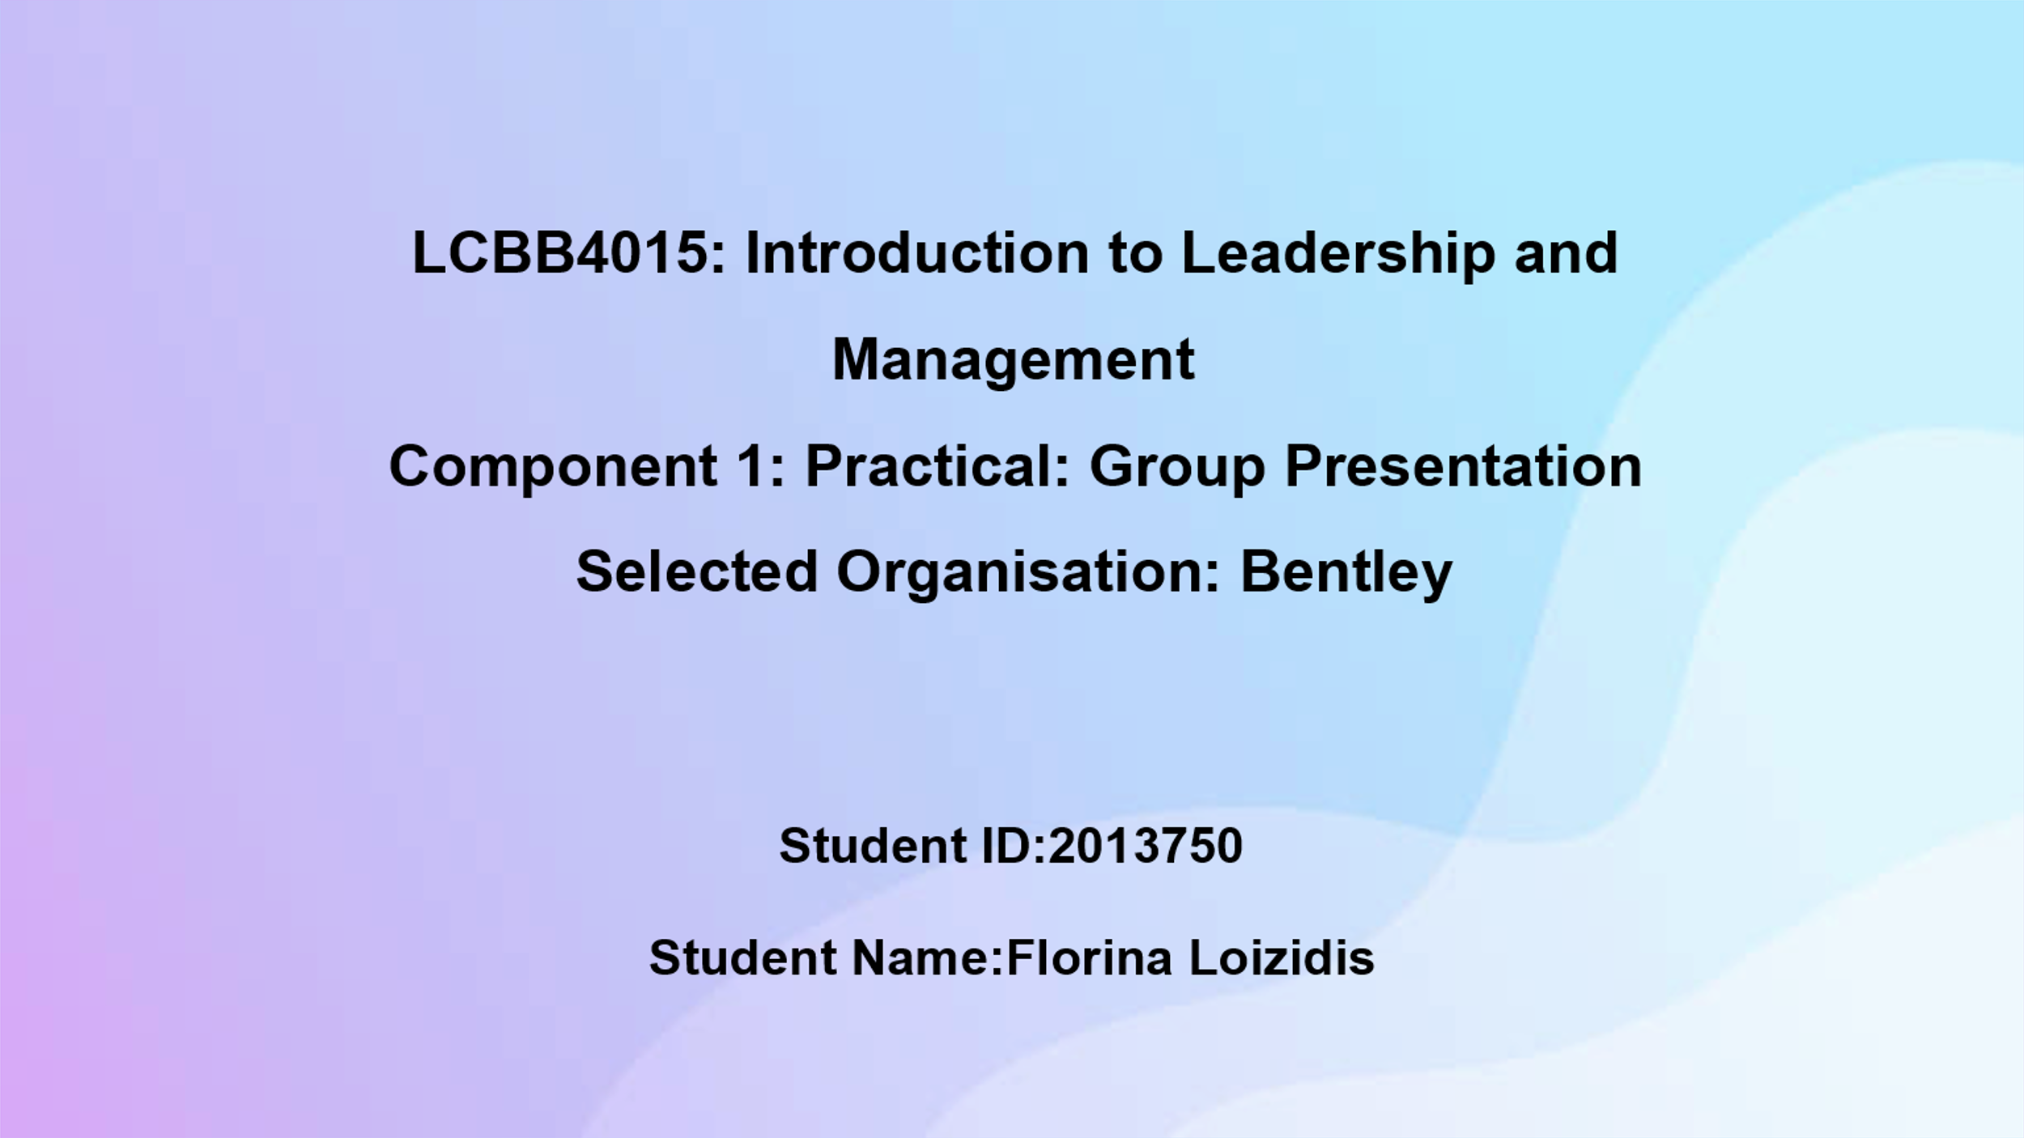
Slide 1: Cover Page

Slide 2: Table of Content
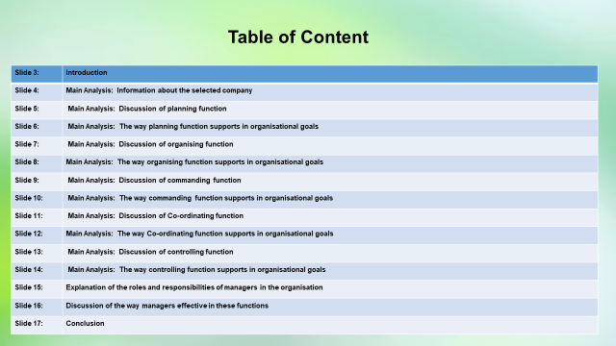

Slide 3: Introduction
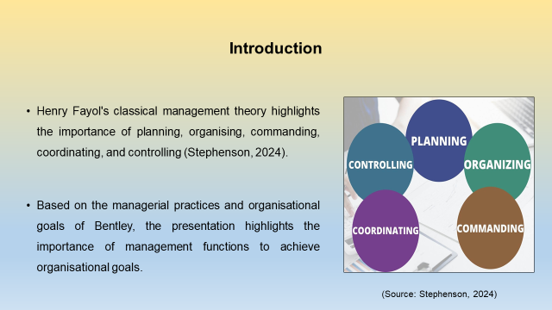
Speaker Notes
Management functions allow an enterprise to operate smoothly, optimise resource usage, and attain long-term goals effectively. Henry Fayol’s classical management theory described five core functions of management, which includes planning, organising, commanding, coordinating, and controlling (Stephenson, 2024). I have observed that these functions describe the way managers should interact with employees and manage operational tasks to attain business goals. The presentation aims to discuss the way managers work in different management functions and support enterprises to achieve long-term goals. Based on the organisational functions and management strategies of Bentley, the presentation explains the roles and responsibilities of managers in a contemporary business environment.

Slide 4: Main Analysis: Information about the selected company
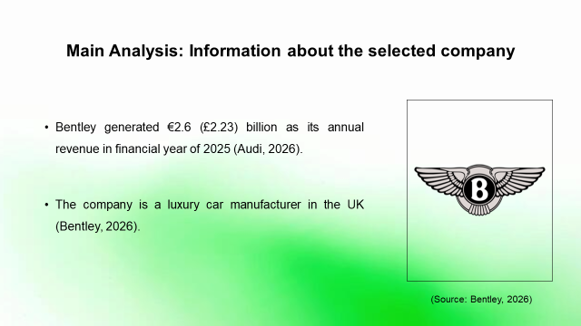
Speaker Notes
Bentley is a British luxury car manufacturer that was founded in 1919 (Bentley, 2026). The automobile company is globally renowned for handcrafting high-performance grand tourers, executive sedans, and luxury SUVs under. Bentley generated €2.6 (£2.23) billion revenue in the last financial year. The automobile company operates across 61 markets worldwide and 229 retail partners support the enterprise. Bentley attains a premium brand image in the industry by focusing on handmade artisanship, and luxurious vehicles.

Slide 5: Main Analysis: Discussion of planning function
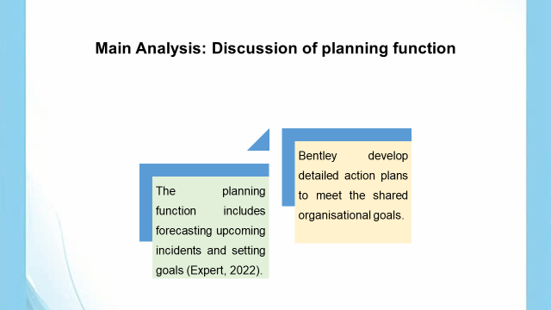
Speaker Notes
I have found that the planning is the important function of management that includes predicting upcoming conditions in the workplace and setting achievable goals. According to Henri Fayol, planning is the foundational function of management that involves forecasting upcoming conditions in workplaces, setting targets and creating a structured plan of action to attain organisational objectives. Effective planning at Bentley sets the direction of the entire organisation and ensures every staff is working toward clear and aligned objectives (Bentley, 2025). The planning stage helps the organisational leaders to prepare for uncertainties and mitigate potential business challenges. The leaders develop detailed action plans, where design engineering, hand-craftsmanship teams and global marketing units collaborate with each other to meet the long-term goals of the enterprise that centres on increasing the premium customer base in the automobile industry.

Slide 6: Main Analysis: The way planning function supports in organisational goals
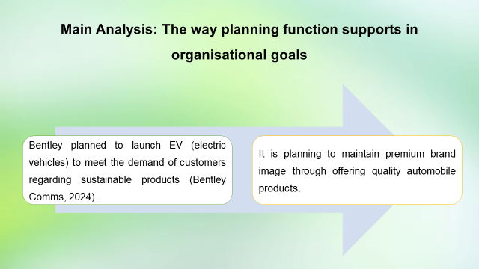
Speaker Notes
The organisational goal of Bentley is to maintain its premium brand image, improve sustainability performance, and enhance luxurious customer base. Bentley identified that the demand for electric vehicles (EV) is increasing among customers. In this aspect, the company planned to launch its first EV in 2026 to respond to customer demands (Bentley Comms, 2024). The enterprise planned to manage its premium brand image by launching high-quality EV. In addition, the company wants to increase its sustainability performance within the automotive sector. In this scenario, the automobile company is planning to improve its sustainability performance through its comprehensive Beyond 100 strategies and targeting end-to-end carbon neutrality by 2030 (Bentley Comms, 2026). These planning strategies have supported the enterprise to boost growth by aligning workforce needs with goals, and integrating cross-departmental data.

Slide 7: Main Analysis: Discussion of organising function
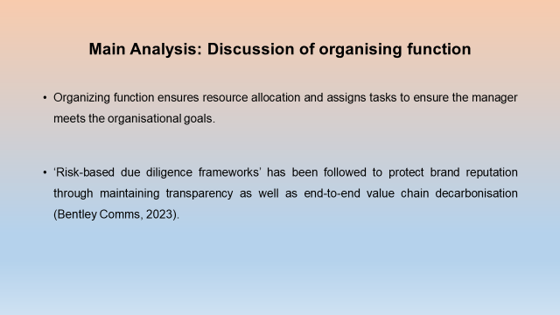
Speaker Notes
Organising function in management is about determining the way things are done, specifically structuring work, allocating resources, and assigning tasks to reach goals. It turns a plan into reality by building a clear framework for the team. I observe that the automobile company has adopted risk-based due diligence frameworks to monitor multi-tier suppliers, which ensure Bentley protects its brand reputation through transparency and end-to-end value chain decarbonisation. The enterprise has focused on research and development operations to increase its sustainability performance through carbon neutralisation.

Slide 8: Main Analysis: The way organising function supports in organisational goals
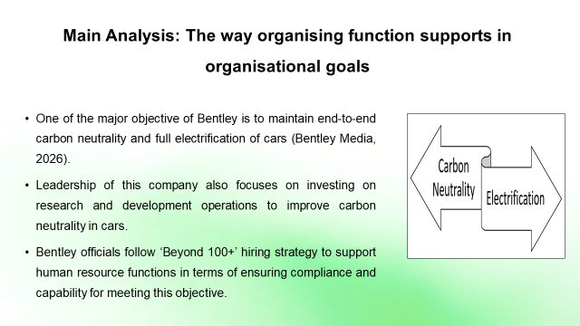
Speaker Notes
According to my theoretical knowledge about the theory, proclaimed by Henry Fayol, resource management, and staff engagement are the core parts of human resource functions. In the case of Bentley, I have found that this company provides extensive focus on their hiring strategies, and invests into research and development functions. Cross-functional team management, allocation of human, financial, and technical resources, digitalisation, and diversity are the parts of organisational resource allocation strategies, which can successfully contribute to the process of attaining objectives such as carbon neutrality and electrification.

Slide 9: Main Analysis: Discussion of commanding function
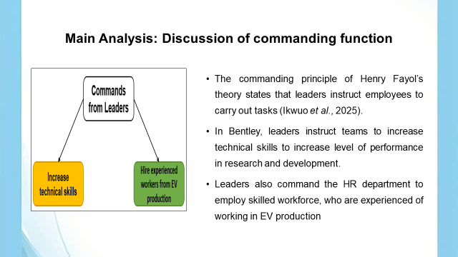
Speaker Notes
We know that leaders are responsible for sharing instruction with teams to execute tasks. In Bentley, leaders use their power to command the employee base regarding improving technical skills. This command to focus on research and development can successfully influence the process of meeting objectives such as carbon neutrality and electrification of automobiles. Moreover, the leader's command to hire skilled workers, with experience in EV production units, can also help Bentley to achieve this objective. Experienced workers in EV production can help this company to manage full electrification of the cars.

Slide 10: Main Analysis: The way commanding function supports in organisational goals
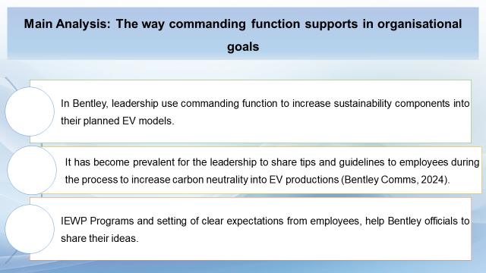
Speaker Notes
I have understood that, leaders of Bentley are focused on attaining 100% carbon neutrality into their electric vehicles. Therefore, it has become important for them to command employees with a set of guidelines, which can help to ensure a sustainable production pipeline. IEWP Programs and delivering clear expectations to the employees can help Bentley to achieve the objective of carbon neutrality and complete electrification of cars. This command system can help the employees as well as to clear understanding of their responsibilities and perform accordingly, especially in research and development.

Slide 11: Main Analysis: Discussion of Co-ordinating function
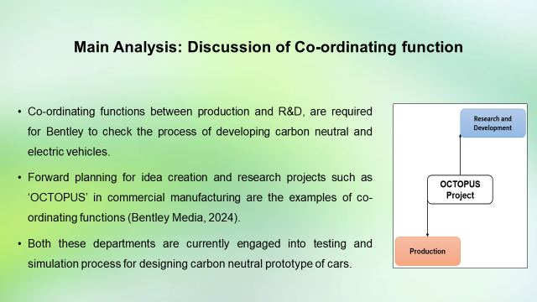
Speaker Notes
According to the principles of Henry Fayol’s theory, co-ordination among different departments can help a company to attain objectives. In the case of Bentley, I have found that co-ordination between departments such as R&D and production. Currently, these departments are focusing on testing and simulation processes to produce carbon neutral electric cars as per the objectives of Bentley.

Slide 12: Main Analysis: The way Co-ordinating function supports in organisational goals
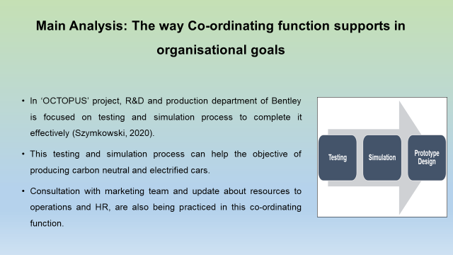
Speaker Notes
I have understood that, R&D and production is the two departments of Bentley, those are accountable for designing electrified carbon-neutral cars. Therefore, co-operation between these two departments (OCTOPUS) can help this company to achieve the mentioned goal accordingly. Moreover, marketing teams are being considered into this co-operative program to get updates about current trends and customer demand. Officials of these departments also collaborate with operations and HR departments to meet resource gaps for executing this project.

Slide 13: Main Analysis: Discussion of controlling function
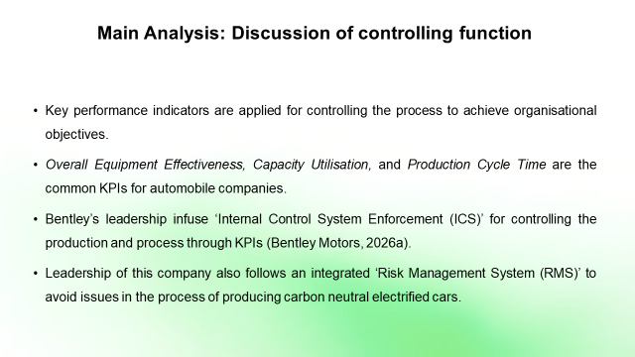
Speaker Notes
I have found that Bentley’s officials maintain ‘Internal Control System Enforcement (ICS)’ and ‘Risk Management System (RMS)’, as parts of its controlling functions. Application of KPIs such as Overall Equipment Effectiveness, Capacity Utilisation, and Production Cycle Time, can help this company to monitor and control the production of carbon neutral, electrified vehicles.

Slide 14: Main Analysis: The way controlling function supports in organisational goals
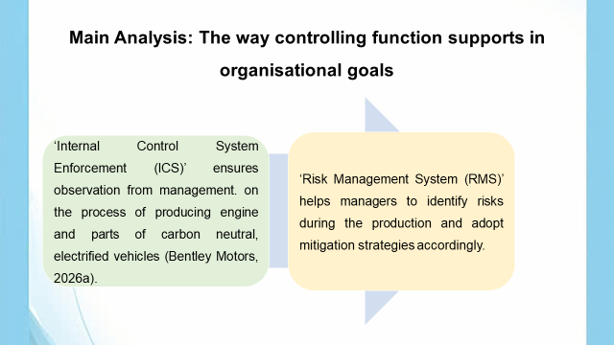
Speaker Notes
I have understood that both the ICS and RMS technique help Bentley for producing carbon neutral electrified cars. Along with that, common industrial KPIs such as Overall Equipment Effectiveness, Capacity Utilisation, and Production Cycle Time can help this company to evaluate production’s capacity and plan for development.

Slide 15: Explanation of the roles and responsibilities of managers in the organisation
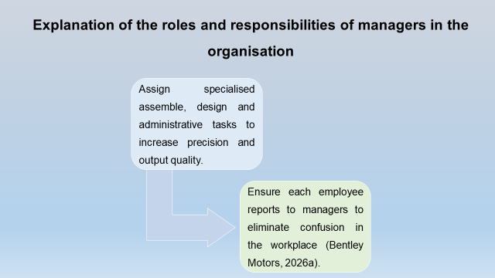
Speaker Notes
I have found that the core role and responsibilities of the managers of Bentley to assign specialised assemble, design and administrative tasks to experts to maximise precision and output quality. The managers are responsible for maintaining the legitimate right to issue directives while remaining fully accountable for team outcomes. The managers of the company ensure each staff reports to them and receive instructions from the designated supervisor to eliminate confusion in the workplace, which helps to improve efficiency of staff and organisation.

Slide 16: Discussion of the way managers effective in these functions
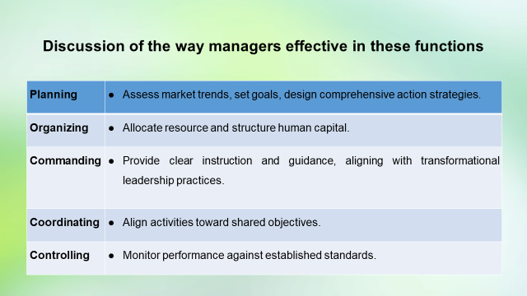
Speaker Notes
Based on my attained knowledge on classical management theory, I have found that in the planning stage, the managers of Bentley assess future market trends, set goals, and design comprehensive action strategies to improve the sustainability performance and brand image. The managers of the company structure human capital, workflows, and tasks in the organising function to ensure staffs works effectively, understand their roles and achieve the company’s strategic goals (Fayol, 2026). Transformational leadership theory states that leaders focus on a shared vision and provide clear instruction to team members to achieve goals (Eaton, et al., 2024). The managers of Bentley deliver clear instructions to staff to ensure operational consistency, maintain strict quality control, and streamline production efficiency across manufacturing departments within commanding function, aligning with transformational leadership theory. In the coordinating function, the managers of the company harmonise efforts across different departments and align activities such as Internal Control System Enforcement to produce high-quality luxury cars (Bentley Media, 2024). In the controlling function, the managers are responsible to monitor performance against established standards and implement corrective measures when necessary.

Slide 17: Conclusion
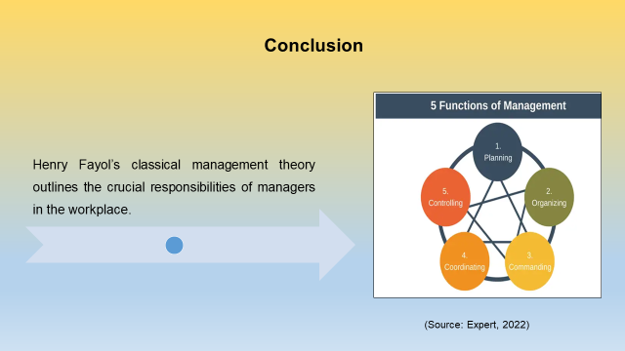
Speaker Notes
I have found that principles of Henry Fayol’s classical management theory highlighted the essential responsibilities of managers to achieve organisational efficiency and productivity. The manager of Bentley analyses information anticipates challenges and develops action plans based on previous information, which align with the core aspect of planning function. The crucial management functions support the enterprise to reduce duplication and help to maintain organisational unity to increase organisational productivity.

Slide 18: Reference List
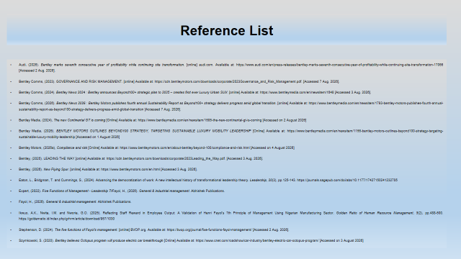
Slide 19: GAI Declaration

I hereby declare that I have not used any kinds of GAI tools in this assignment to collect any information. I have used journals and websites to gather authentic and relevant information.

Slide 20: Thank You

Reference List
Audi, (2026). Bentley marks seventh consecutive year of profitability while continuing site transformation. [online] audi.com. Available at: https://www.audi.com/en/press-releases/bentley-marks-seventh-consecutive-year-of-profitability-while-continuing-site-transformation-17066 [Accessed 2 Aug. 2026].
Bentley Comms, (2023). GOVERNANCE AND RISK MANAGEMENT. [online] Available at: https://cdn.bentleymotors.com/downloads/corporate/2023Governance_and_Risk_Management.pdf. [Accessed 7 Aug. 2026].
Bentley Comms, (2024). Bentley News 2024 : Bentley announces Beyond100+ strategic plan to 2035 – creates first ever Luxury Urban SUV. [online] Available at: https://www.bentleymedia.com/en/newsitem/1648 [Accessed 3 Aug. 2026].
Bentley Comms, (2026). Bentley News 2026 : Bentley Motors publishes fourth annual Sustainability Report as Beyond100+ strategy delivers progress amid global transition. [online] Available at: https://www.bentleymedia.com/en/newsitem/1793-bentley-motors-publishes-fourth-annual-sustainability-report-as-beyond100-strategy-delivers-progress-amid-global-transition [Accessed 7 Aug. 2026].
Bentley Media, (2024), The new Continental GT is coming [Online] Available at: https://www.bentleymedia.com/en/newsitem/1585-the-new-continental-gt-is-coming [Accessed on 2 August 2026]
Bentley Media, (2026). BENTLEY MOTORS OUTLINES BEYOND100 STRATEGY, TARGETING SUSTAINABLE LUXURY MOBILITY LEADERSHIP [Online] Available at: https://www.bentleymedia.com/en/newsitem/1156-bentley-motors-outlines-beyond100-strategy-targeting-sustainable-luxury-mobility-leadership [Accessed on 1 August 2026]
Bentley Motors, (2026a), Compliance and risk [Online] Available at: https://www.bentleymotors.com/en/about-bentley/beyond-100/compliance-and-risk.html [Accessed on 4 August 2026]
Bentley, (2025). LEADING THE WAY.[online] Available at: https://cdn.bentleymotors.com/downloads/corporate/2023Leading_the_Way.pdf. [Accessed 3 Aug. 2026].
Bentley, (2026). New Flying Spur. [online] Available at: https://www.bentleymotors.com/en.html [Accessed 3 Aug. 2026].
Eaton, L., Bridgman, T. and Cummings, S., (2024). Advancing the democratization of work: A new intellectual history of transformational leadership theory. Leadership, 20(3), pp.125-143. https://journals.sagepub.com/doi/abs/10.1177/17427150241232705
Expert, (2022). Five Functions of Management - Leadership Training from EPM. [online] Available at: https://expertprogrammanagement.com/2017/11/five-functions-of-management/ [Accessed 3 Aug. 2026].
Fayol, H., (2026). General & industrial management. Abhishek Publications.
Ikwuo, A.K., Nwite, I.M. and Nworie, G.O. (2025). Reflecting Staff Reward in Employee Output: A Validation of Henri Fayol's 7th Principle of Management Using Nigerian Manufacturing Sector. Golden Ratio of Human Resource Management, 5(2), pp.488-500. https://goldenratio.id/index.php/grhrm/article/download/957/1030
Stephenson, D. (2024). The five functions of Fayol’s management. [online] BVOP.org. Available at: https://bvop.org/journal/five-functions-fayol-management/ [Accessed 2 Aug. 2026].
Szymkowski, S. (2020). Bentley believes Octopus program will produce electric car breakthrough [Online] Available at: https://www.cnet.com/roadshow/car-industry/bentley-electric-car-octopus-program/ [Accessed on 3 August 2026]

‌

‌

‌

‌

‌

