

Programme: | MBA- Masters of Business Administration
Module: | Marketing Management – Assessment 1
Module code: | LCMB7001 | Contribution to Overall Module Assessment (%): | 75%
Lecturer: | Tushara Balendran | Internal Verifier: | Gladius Kulothungan
Assignment Title: | Marketing Management Assessment 1 | Word count (or equivalent): | 3500
Submission deadline: | To be announced by the Assessment team-  Please refer to the assessments schedule published on Students’ Hall in Moodle | Return date of provisional marks & written feedback: | After the Exam Board

Executive Summary
The report focused and discussed on various existing as well as new strategies which Unilever can use to attain set goals in time while increasing customer support in the changing rival scenario. The report explained that better use of integrated marketing communication tactics including a better understanding of customer behaviour and needs assist Unilever to increase and maintain success. The study also showed that Unilever can maintain strong relationships with customers while working for the benefit of society. The study also focused on stakeholder's analysis including various recommendations may help Unilever to improvise proficiency, recognition and awareness in various business scenarios.

Table of Contents
Introduction 4
Critically appraising how your chosen organisation can create innovative marketing strategies for raising awareness of the brand 5
Existing marketing strategies 5
Innovative marketing strategies 6
Managing and evaluating the customer journey across a variety of communication channels 10
Stakeholders’ expectations concerning innovative marketing strategies to improve brand awareness and recognition 15
Conclusion 18
Bibliography 19

Introduction
Fierce corporate competition has pushed many companies towards utilizing product innovations and re-modelling for retaining and expanding their customer base. Variables like product, price, promotion and place are areas of innovations that can greatly affect the performance of a product, while enhancing the customer experience and building customer loyalty (Sirajuddin and Kumar, 2018). Although many companies have started paying importance to the customer experience rather than focusing solely upon customer satisfaction, they mostly consider the touch points, missing the end-to-end customer experience. This study will discuss the innovative marketing strategies that Unilever could implement to promote brand growth.
Unilever is a multinational brand with consumer products including food, cleaning, and personal care products, and so on (Unilever, 2021). The company owns more than 400 brands including 11 billion-dollar brands with annual revenues exceeding $1 billion.

Critically appraising how your chosen organisation can create innovative marketing strategies for raising awareness of the brand
A company’s marketing strategy has a direct impact on the market share and revenue generation. The overall performance of the company is not determined solely based on market performance; it also depends on the brand image. A company’s brand image is not limited to their logo or name. It encompasses the entire perception of the brand by the customers from the point they discover the brand, to the end of purchase of a product (Investopedia, 2021). A positive brand image is crucial to establishing strong market presence and influencing customer buying-habits.

Existing marketing strategies
- Social media
The impact of social media on the marketing process of businesses is unprecedented. Companies now prefer digital marketing to traditional print ads and television commercials due to the ease, efficiency and cost effectiveness. It provides a way not to simply reach out to the customer base but engage them in direct interaction with the brand (Iankova et al., 2019). However, a giant like Unilever is not dependent on social media alone, and decided to stop all social media marketing in the US in 2020. This was a stand against the increasing racial and political polarisation in the country. The company has previously pushed for transparency and improvements in the fractured digital promotion system (Adams, 2020). This is a rare case where a company chose to take a stand on a social issue over organizational goals. The company should maintain their dedication towards aligning corporate strategies with social causes. To spread their initiatives among the public, however, Unilever should utilise the strengths of social media.
- Affiliate marketing
Many of the lifestyle/beauty brands under Unilever utilise affiliate marketing to increase their reach to potential customers through partnerships with celebrities and influencers who promote the brand to their audience. This increases brand engagement and allows the brand to acquire a set of loyal customers through the influencers. This includes the production of quality content by the brand directly or indirectly. The company must identify a specific product among their wide selection that would be optimum for attracting customers.
- Market integration
Unilever’s most effective business strategy is the integration of their global strategies in the local communities. This serves consumers looking for products that are famous worldwide while retaining the local essence. Through their immensely successful Sustainable living plan, the company accepted sustainability by incorporating the USLP targets into their core workings (Unilever, 2021). The company should focus on strengthening their presence in developing areas by utilising their strong distribution network. With their ability to adapt global brand strategies with local markets, Unilever can capitalise on these untapped markets.

Innovative marketing strategies
Unilever uses advertising to communicate their value to the customers. This value can be the importance of the product or new corporate initiatives. The company has always been involved in addressing social issues and working towards building a sustainable future. They implement various ingenious strategies that make them stand out and connect better with the people. Some of those are:
- Transparent communication with the public
- Clear information regarding the use of a product and the risks involved
- Total transparency for ingredients, nutritional values of food and beauty products
- Open communication through product labels, websites and consumer leaflets (Unilever, 2021)
Responsible marketing
Marketing has an extraordinary impact on lifestyle choices of the population. Marketers have the power of modelling consumer habits according to their needs, which provides a pathway for exploitation. As the world’s leading consumer goods company, Unilever takes marketing very seriously and maintains their standard for responsible and thought provoking advertisements.
- The real beauty campaign by Dove challenges traditional beauty stereotypes.
- The dirt is good campaign by Omo/Persil encourages getting dirty as a natural part of growing up for children.
- Comfort one rinse’s campaign educates the public on how to save water efficiently.

Unilever was one of the first companies to extend principles of marketing to children. They promote healthy diets not only through nutrition, but through responsible marketing of the products. These initiatives shed light on the continued concern about children obesity, the vast implications of social media and the wide availability of products (Unilever, 2021).
Through involvement in various arenas of societal and environmental issues, Unilever remains relevant with the times. The company is actively involved in tackling climate change by eliminating carbon emissions from their production. They have pledged to reach net zero carbon emissions by 2039. They are encouraging the sourcing of lower carbon materials, reforming products to provide plant-based alternatives, vegan foods and fossil fuel free cleaning items (Unilever, 2021). These initiatives establish the company as a part of society and connect the brand message with the environment conscious public. Unilever believes that nothing is more important to them than decarbonising their business while remaining profitable.
Unilever is one of the most profitable retailers in UK. The organisation follows a plethora of marketing strategies to promote its brand and raise awareness among the consumers. Unilever boasts a very attractive portfolio of products and brands which are well known in the market. As the brand grows perpetually it needs innovative strategies to boost its marketing needs.
- Product Development Strategy
This is fairly a simple concept of introducing new products to an existing set of on consumers. Unilever already a well number of products such as tea, ice cream and powdered soup (Unilever, 2021). The products are used by around 2 billion people every day (Unilever, 2021), thus stating the existing size of customers. Although Unilever has a sizeable customer pool, it should anticipate the risk of developing a new product. The organisation should look for competitive advantage while launching a new product. Identifying the competitive advantage will drastically reduce any form of risk related to decision making (Hosseini et al., 2018). It is important to understand that the new products should act as a substitute to the existing product in the market produced by a rival organisation. Unilever has an impressive hold in packed food market, it can enter the packed juice market. The best way to analyse competitive advantage is to gather customer data. With the help of modern technologies like machine learning tools and big data analysis an unbeatable competitive advantage analysis can be done (Hagiu and Wright. 2020). Launching a good substitute product gives a recognition to the brand and allows it to penetrate the existing product market efficiently. Unilever should invest more in its Research and Development department. For developing a new product rigorous research in needed, a well finance R&D department will allow Unilever to launch quality new products. The organisation can also try producing goods complementary to its own product.
- Market Development Strategy
This strategy stresses on expanding sales of the existing products in new market of the organisation. To sell at a new market an organisation needs to understand the cultural standpoint of the same. The organisation needs to conduct market research to understand the modifications needed in their existing products. Penetrating a new market can be risky, therefore a proper market analysis needs to be done (Branding Strategy Insider, 2020). The organisation will first need to focus on a target audience. Identifying the potential consumers from the new market will make it easier to modify the existing products as peer the market needs. Unilever should investigate expanding its business in the Asian market. Inclusive expansion will promote the brand and increase its goodwill. The organisation should also investigate regional markets for increasing the brand awareness. Unilever is also recommended to ensure that the new market it plans to integrate should have a good disposable income.
- Market Penetration Strategy
Market penetration strategy stresses on existing product and market. The essence of this strategy lies in attracting the consumers of the competitors. Unilever already has a sizeable market share; its focus should be on attracting the customers of the competitive organisation. There are abundant ways in which the organisation can attract consumers from the competing companies. Some of the most effective ways the organisation can use are competitor analysis, identifying market gaps and rigorously using the social media (Fleximize, 2021). The organisation can also analyse the product and price range of the competitors. Unilever should do in depth research on consumers if brands like Proctor and Gamble and Nestle. To penetrate the existing market with existing products, Unilever should increase social media promotion and decrease the cost of the products to attract more consumers. The cost of the products sold by Unilever should be competitive. The quality of the product should not be compromised for the sake of reducing the price. Last but not the least the organisation can acquire the competitor’s product.
- Diversification Strategy
Considered one of the riskiest strategies among all. This stresses on opening a new business altogether. This can be done in two different ways – Related diversification and Unrelated Diversification. The strategy will require in depth product and market research. Although Unilever already has widespread market capture in the FMCG industry. Unilever should plan on expanding its business into the delivery industry. FMCG products are widely ordered online and if Unilever can invest in the delivery business, then it can increase the brand power by dominating the industry. Although diversification is risky, it can be advantageous too. Other than related diversification Unilever can also choose an unrelated diversification.
It is recommended that Unilever use the Ansoff Matrix for raising brand awareness. The Ansoff matrix is a method by which an organisation can strategically grow their business (Corporate Finance Institute, 2021). Ansoff matrix includes all the above strategies. It will allow the organisation to analyse different types of strategies and how it can hedge the related risk.
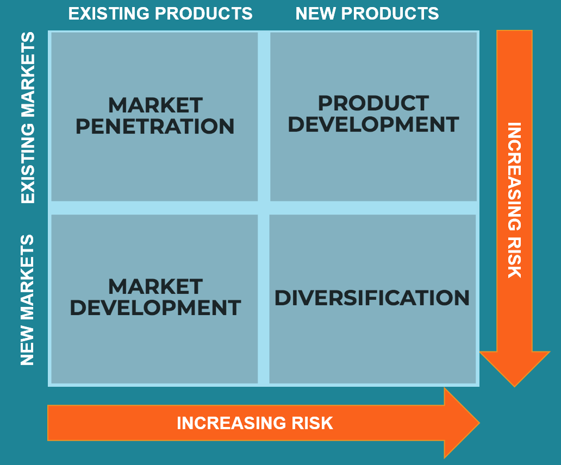

Figure 1: The Ansoff Matrix
(Source: Corporate Finance Institute, 2021)

Managing and evaluating the customer journey across a variety of communication channels
Good marketing communication plays a significant role in the better progress and success of a firm while helping to satisfy and fulfil customer needs and expectations in time. Integrated marketing communication (IMC) is an essential marketing tool that focuses on customer development progress while increasing the value and stability of a firm in the market. It is possible as unique usage of the IMC technique assists an organisation like Unilever to use innovative ideas to develop better relationships with customers while measuring the impact of several tools on overall improvement. Better marketing interaction with the right messages assists Unilever to develop and deliver quality products and services resulting in creating and maintaining better relationships with the customers. Another importance of IMC is that it helps to make, improve and maintain better equity, value and stability for a long time while minimising various types of costs (Finne and Grönroos, 2017). It is possible as innovative IMC strategies help to improve staff proficiency besides ensuring and increasing customer satisfaction. Proper planning, implementation and monitoring of the IMC technique can assist Unilever to recognise the needs, preferences and expectations of customers while purchasing the product and availing their services.
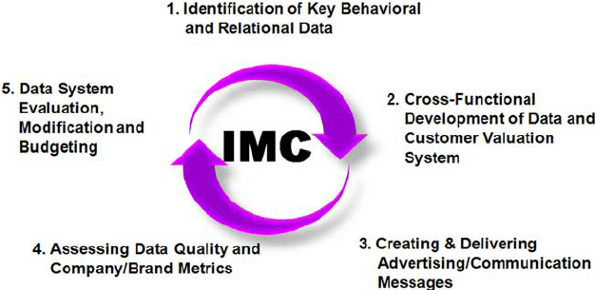
Figure 2: IMC
(Source: Juska, 2017)
Better analysis about customer requirements through strong R&D, suggestion and review techniques help Unilever to understand customers from several aspects leading to increasing value and creating better awareness for the firm (Wang and Kim, 2017). Innovative creation as well as delivery of correct information to the customer through creative IMC techniques while assessing them based on various metrics helps to improve the budget. It may become possible to increase success and progress rate as well.
Better selection and use of exclusive IMC techniques can assist Unilever management and staff to understand more precisely about customer behaviour while determining actions to influence them and improve their satisfaction and trust level. In the problem or need recognition, the Unilever team identifies various ideas which influence customers to select and buy a product or service while gathering information properly (Kushwaha et al., 2020). After problem analysis, they not only evaluate problems but also identify solutions that can help to improve their effectiveness and efficiency in the rapidly changing business scenario. Better services and commitment levels help customers to buy and even encourage others to buy Unilever's goods, services or both resulting in maximising success.
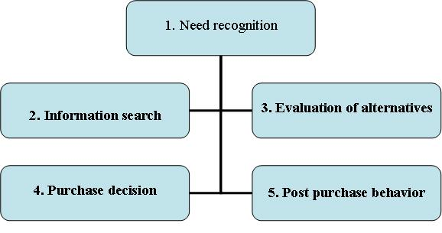
Figure 3: Customer Need Analysis
(Source: Deepak and Jeyakumar, 2019)
However, the inability to use IMC and customer behaviour analysis tools problem can lead to an increase in various types of problems and challenges resulting in affecting the overall progress of Unilever in the market. The most important problem is to fulfil various needs as well as desires of the customers in less time which may lead to losing a better amount of customer base. Lack of advanced technologies and selection of promotion, interactive and advertising methods can decrease awareness, value, picture of Unilever while increasing various types of costs for a long-time frame (Porcu et al., 2017). The ineffectiveness to use marketing mix strategies properly also decreases success and customer satisfaction and loyalty for Unilever resulting in minimising share, revenue and sales. Better use of IMC tools such as online, digital, offline, advertisement and many more while maintaining a good work culture can help to increase customer satisfaction while ensuring their better journey with the firm.
A good organisational culture assists the staff to give their best services and guidance to the customers resulting in increasing their commitment and support for a chosen firm. Unilever has an innovative corporate work culture where employees get equal opportunities to increase their productivity and growth leading to maximising achievement rate in the market (Unilever, 2021).
Advertising is an essential IMC technique that not only helps to reach, interact about product and service in less time but also help to increase awareness as well. Unilever uses television, radio, newspaper and other print media tools which maximise its visibility among customers (Wijaya et al., 2019). Creative and informative messages about various initiatives and goods also help to improve customer support to a greater extent. Personal selling or direct interaction with the present and potential customers can help Unilever to increase its customers base while delivering quality products and services (Beheshtian-Ardakani et al., 2018). It may become possible to increase customer’s journey with the firm while maximising financial stability and right market segmentation to attain success. It can conduct small contests or events to interact and analyse customer preferences and expectations with Unilever leading to better improvement. For instance- the real beauty campaign of Dove, a famous product of Unilever increases the trust and commitment of the various customers resulting in maximising success in the market (Unilever, 2021).
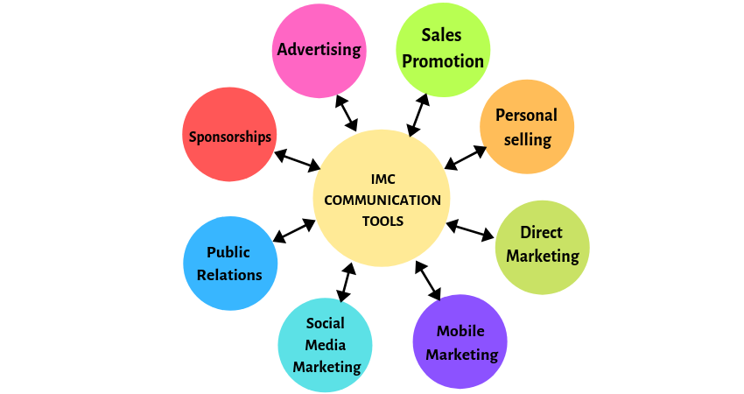
Figure 4: IMC Tools
(Source: Twum and Yalley, 2021)
Direct Marketing is the oldest form of IMC technique that helps assist an organization such as Unilever to communicate and understand customer requirements more precisely (Matviiets and Kipen, 2021). Unilever employees can contact and communicate with customers especially after purchasing a product or service to improve their effectiveness in the market. Unilever team can use creative and interactive strategies to influence and increase customer support and experiences by using emails, messages, catalogues, brochures through mail resulting in increasing their awareness. It will be easier to inform about new initiatives as well. Mobile marketing is the technique of interacting with consumers by using mobiles and cell phones. In this technique, Unilever management can use the messaging technique to inform and increase the engagement rate of the buyers through phone (Tong et al., 2020). It is not only cheapest but also can help Unilever to improve its visibility and competitiveness in the market. For example- Unilever does campaigns on children food as well as a beverage in the competitive scenario (Unilever, 2021).
Social media marketing is the most powerful IMC tool that helps to reach, interact, influence and increase engagement, commitment and satisfaction rate of consumers with the chosen brand (Zerrweck et al., 2020). Unilever can use innovative tactics to inform and deliver important messages to several consumers in less time while increasing visibility and value. Unilever can use both digital and online social media tools like Facebook, Instagram, YouTube, emails and so on leading to earning better achievements. Public relations (PR) is another essential strategy which Unilever can use effectively to inform consumers about its new initiatives, success and achievements (Paliwoda-Matiolanska et al., 2020). It even helps to manage and improve relationships too. Unilever to increase and improvise its goodwill can conduct press releases and do various CSR activities and sponsorships with proper planning leading to maximising success in the market. For example- Unilever does CSR activities on various aspects of society resulting in creating a better place and image in the market (Unilever, 2021).
Sales promotions are incentives that Unilever can use as an essential strategy to increase and improve sales and profit (Genchev and Todorova, 2017). The firm has a good opportunity to deliver attractive offers such as discounts, coupons, rebates, contests and many more to increase customer support and commitment rate. These tactics can increase their engagement and experiences level with the firm. Sponsorships which is a combination of promotion and PR can help Unilever to create and manage strong brand equity and place in the market while offering quality goods and services in better amounts (Cornwell, 2019). The firm can sponsor various types of sports, entertainment and health and safety shows to increase customer support rate. For example- Unilever uses its own Facebook, Twitter, Instagram, YouTube as well as LinkedIn to inform customers and other stakeholders about various initiatives leading to maximising success in the rival scenario (Unmetric, 2021).
Better creation and implementation of innovative strategies with the help of IMC tools can help to improve customer experience, expectation and commitment while helping Unilever to improve share and sales. It may increase customer base and engagement rate while increasing competing place and value in the market for a long time (Kurunathan et al., 2019). For instance- Unilever use various IMC tools which help it to increase its effectiveness and performance while increasing satisfaction and loyalty of customers resulting in the better accomplishment of goals in time

Stakeholders’ expectations concerning innovative marketing strategies to improve brand awareness and recognition
The stakeholders or shareholders play a crucial in the better productivity, success and sustainability of an organisation in the rapidly changing business scenario. The better evaluation of stakeholders needs assists an organisation to understand, analyse, handle and resolve several problems and issues leading to better accomplishment of goals in time.
Identification
Unilever’s stakeholders who can help to improve and increase value proposition and value while minimising costs and competition are staff, buyers, suppliers, investors, government, society, NGO’s as well as communities (Unilever, 2021).
Figure 5: Stakeholders of Unilever

Interest
Low
High
Power
High
Low
Employees and Investors
(Managed Closely)
Buyers and Several communities
(Keep them satisfied)
Suppliers and society
(Kept Informed)
NGO’s along with government
(Monitored Regularly)

Analysis
Staffs and investors assist Unilever to monitor, make and impellent unique strategies to increase awareness while maintaining better performance in the market. The buyers including various communities help to increase performance as good behaviour and the right products increase stability and trust. Suppliers along with society assist the firm to use the right tactics to deliver better services and experiences to the customer and communities while improving society and the economy. The government with the help of NGOs guides Unilever management to work nicely while following rules and regulations This become easier to maximise customer satisfaction while increasing value in the rival scenario.
Mapping
Employees, as well as an investor, should be managed properly as they help to implement right strategies to increase productivity for a long time. buyers and communities should be kept satisfied as they help to increase stability, the feasibility of a firm while increasing growth opportunities (Xue et al., 2020). Suppliers and society should be kept informed about fresh changes so that they can help Unilever to gain better stability while increasing customer support and commitment effectively. New rules and regulations of government along with NGO initiatives should be monitored regularly to maintain success while controlling customers from any kind of diversion by providing quality goods,
Different types of stakeholders have different expectations so it is the responsibility of the firm to analyse and implement innovative promotional, advertising and interactive tools to ensure better consumer satisfaction. The stakeholders especially the customers want a better quality of goods, services in less time and money. It is also important to deliver the right information to the consumers about a good and service including new initiatives of Unilever firm. Correct and accurate information including better interaction with the consumers at any point in time can increase the value, reputation, recognition, productivity and success of Unilever. It is possible as better experiences and satisfaction levels influence the decision-making behaviour and attitude of customers resulting in creating a better place for the firm. For instance- Unilever can gain and earn better performance both financially as well as non-financially till 2021 resulting in making a strong position and recognition during the time of emergency as well (Unilever, 2021).
Therefore, the strategies which Unilever management can use to improve and maintain its awareness, recognition and proficiency in the market are-
It can use more interactive promotional and advertising marketing tools to reach, communicate and provide the right messages resulting in improving customer commitment rate with the firm.
Second, continuous monitoring and implementing new technologies to satisfy customers by listening and solving their problems and queries can help to increase customer experiences and loyalty for the firm for a long time (Alkhawaldeh et al., 2017).
Finally better selection and use of advanced technologies while providing better training and encouragement to the staff also help to develop a good relationship with the stakeholders. It does not become easier to accomplish present needs but also future requirements of various stakeholders while maintaining a better place and recognition

Conclusion
After the end of the study, a rigorous research has been conducted on how Unilever can raise its brand awareness by utilising new marketing strategies and improving the existing one. Conclusive recommendations have been given related to Unilever’s marketing strategies. The study has found that using the Ansoff matrix to determine new marketing plans will help the organisation. It has also been analysed how using the existing form of marketing such as digital and affiliate can be improved by identifying target market and product. A detailed study has been done on what the stakeholder expects on aspects related to innovative marketing strategy.

Bibliography
Adams, P., 2020. Unilever stops advertising on Facebook, Instagram and Twitter in bold stance against hate speech [Online] Available at: https://www.marketingdive.com/news/unilever-stops-advertising-on-facebook-instagram-and-twitter-in-bold-stanc/580660/ [Accessed on 24 August 2021]
Alkhawaldeh, A., Al-Salaymeh, M., Alshare, F. and Eneizan, B.M., 2017. The effect of brand awareness on brand loyalty: Mediating role of brand commitment. European Journal of business and Management, 9(36).
Beheshtian-Ardakani, A., Fathian, M. and Gholamian, M., 2018. A novel model for product bundling and direct marketing in e-commerce based on market segmentation. Decision Science Letters, 7(1), pp.39-54.
Branding Strategy Insider, 2020. 4 types of marketing plans and startegies [Online] Available at: https://www.brandingstrategyinsider.com/4-types-of-marketing-plans-and-strategies/#.YSSRWo4zZPY [Accessed on 24 August, 2021]
Cornwell, T.B., 2019. Less “sponsorship as advertising” and more sponsorship-linked marketing as authentic engagement. Journal of Advertising, 48(1), pp.49-60.
Corporate Finance Institute, 2021.What is the Ansoff Matrix? [Online] Available at: https://corporatefinanceinstitute.com/resources/knowledge/strategy/ansoff-matrix/ [Accessed on 24 August, 2021]
Deepak, R.K.A. and Jeyakumar, S., 2019. Marketing management. Educreation Publishing.
Finne, Å. and Grönroos, C., 2017. Communication-in-use: customer-integrated marketing communication. European Journal of Marketing.
Fleximize, 2021. 7 Ways to Win Your Competitors' Customers [Online] Available at: https://fleximize.com/articles/001027/7-steps-to-attracting-customers-away-from-your-competitors [Accessed on 24 August, 2021]
Genchev, E. and Todorova, G., 2017. Sales promotion activities–effective tool of marketing communication mix. Available at SSRN 3089894.
Hagiu, A. and Wright, J., 2020. When data creates competitive advantage. Harvard business review, 98(1), pp.94-101.
Hosseini, A.S., Soltani, S. and Mehdizadeh, M., 2018. Competitive advantage and its impact on new product development strategy (Case study: Toos Nirro technical firm). Journal of Open Innovation: Technology, Market, and Complexity, 4(2), p.17.
Iankova, S., Davies, I., Archer-Brown, C., Marder, B. and Yau, A., 2019. A comparison of social media marketing between B2B, B2C and mixed business models. Industrial Marketing Management, 81, pp.169-179.
Investopedia., 2021. How Do Brand Image and Marketing Affect Market Share? [Online] Available at: https://www.investopedia.com/ask/answers/032615/how-does-brand-image-and-marketing-affect-market-share.asp [Accessed on 24 August 2021]
Juska, J.M., 2017. Integrated marketing communication: advertising and promotion in a digital world. Routledge.
Kurunathan, D., Shanmugathas, S. and Ashoka, K., 2019. Analysis of relation between customer behavior and information technology market. Journal of System and Management Sciences, 9(1), pp.87-104.
Kushwaha, B.P., Singh, R.K., Varghese, N. and Singh, V.N., 2020. Integrating social media and digital media as new elements of integrated marketing communication for creating brand equity. Journal of Content, Community & Communication, 11(6), pp.52-64.
Matviiets, O. and Kipen, V., 2021. The features of direct marketing and personal selling as a form of marketing communications. VUZF Review, 6(2), pp.139-145.
Paliwoda-Matiolanska, A., Smolak-Lozano, E. and Nakayama, A., 2020. Corporate image or social engagement: Twitter discourse on corporate social responsibility (CSR) in public relations strategies in the energy sector. Profesional de la información, 29(3).
Porcu, L., Del Barrio-Garcia, S. and Kitchen, P.J., 2017. Measuring integrated marketing communication by taking a broad organisational approach: The firm-wide IMC scale. European Journal of Marketing.
Sirajuddin, M.M. and Kumar, M.P.S., 2018. Innovative Marketing Strategies in Retailing Giants: Big Bazar &D-Mart. International Journal of Pure and Applied Mathematics, 118(15), pp.151-156.
Tong, S., Luo, X. and Xu, B., 2020. Personalized mobile marketing strategies. Journal of the Academy of Marketing Science, 48(1), pp.64-78.
Twum, K.K. and Yalley, A.A., 2021. Green Integrated Marketing Communication. In Green Marketing in Emerging Markets (pp. 117-144). Palgrave Macmillan, Cham.
Unilever, 2021. Our Brands [Online] Available at: https://www.unilever.co.uk/brands/?category=408118 [Accessed on 24 August, 2021]
Unilever. 2021. Advertising and marketing | Unilever. [online] Available at: <https://www.unilever.com/planet-and-society/responsible-business/advertising-and-marketing/> [Accessed 24 August 2021].
Unilever. 2021. Annual Report and Accounts 2020 Highlights. [online] Available at: <https://www.unilever.com/investor-relations/annual-report-and-accounts/> [Accessed 24 August 2021].
Unilever. 2021. Engaging with stakeholders | Unilever. [online] Available at: <https://www.unilever.com/planet-and-society/responsible-business/engaging-with-stakeholders/> [Accessed 24 August 2021].
Unilever. 2021. Planet & Society | Unilever. [online] Available at: <https://www.unilever.com/planet-and-society/> [Accessed 24 August 2021].
Unilever. 2021. Unilever - Corporate Culture. [online] Available at: <https://corporateculture.co.uk/case-studies/unilever-winning-together/> [Accessed 24 August 2021].
Unilever., 2021. Advertising and marketing [online] Available at: https://www.unilever.com/planet-and-society/responsible-business/advertising-and-marketing/ [Accessed on 24 August 2021]
Unilever., 2021. Our strategy [Online] Available at: https://www.unilever.com/our-company/strategy/ [Accessed on 24 August 2021]
Unilever., 2021. Unilever at a glance [Online] Available at: https://www.unilever.com/our-company/at-a-glance/ [Accessed on 24 August 2021]
Unmetric. 2021. Social Media Analytics & Intelligence Dashboard by Unmetric. [online] Available at: <https://unmetric.com/brands/unilever> [Accessed 24 August 2021].
Wang, Z. and Kim, H.G., 2017. Can social media marketing improve customer relationship capabilities and firm performance? Dynamic capability perspective. Journal of Interactive Marketing, 39, pp.15-26.
Wijaya, I., Rai, A. and Hariguna, T., 2019. The impact of customer experience on customer behavior intention use in social media commerce, an extended expectation confirmation model: An empirical study. Management Science Letters, 9(12), pp.2009-2020.
Xue, J., Shen, G.Q., Yang, R.J., Wu, H., Li, X., Lin, X. and Xue, F., 2020. Mapping the knowledge domain of stakeholder perspective studies in construction projects: A bibliometric approach. International Journal of Project Management, 38(6), pp.313-326.
Zerrweck, C., Arana, S., Calleja, C., Rodríguez, N., Moreno, E., Pantoja, J.P. and Donatini, G., 2020. Social media, advertising, and internet use among general and bariatric surgeons. Surgical endoscopy, 34(4), pp.1634-1640.

