Research And Case Scenario In Data Security and Compliance
Data security and compliance
jonathan wilcox - 2206641
2024
Table of Contents
Table of Figures 3

Task 1 – Research In Data Security and Compliance
- Introduction 4
II Threats to Information Security 4
III Risk Assessment and Planning 5
IV Implementing Physical Security 5
V. Physical Security Strategy 9
VI. Conclusion 10

Task 2 – Research In Data Security and Compliance
1. Introduction 11
2. What is Information Security 11
3. Design Approach 11
3.1 Organisation Structure 11
3.2 Policies and Procedures 13
3.2.1 Key Polices 14
3.2.2 Policy Management 15
3.2.3 Policy Blueprint 15
3.3 Data Protection and Compliance 15
3.4 Security Standards 18
3.4.1 Choosing a standard 18
3.4.2 Core Functions Of NIST 18
3.4.3 NIST implementation 19
3.5 Contingency Planning 20
3.6 Governance and Strategic Planning for Security 22
3.7 Risk Management 23

4. Conclusion 24

Abbreviations 25

References 26

Table of Figures

Figure 1: How a Mantrap operates. Two-door system. 5
Figure 2: Traditional v Mist System 6
Figure 3: Standby UPS example. 7
Figure 4: Organisational structure for proposed information security department 12
Figure 5: Organisational Policy, Standards and Practices. 14
Figure 6: Core Functions of NIST security standard. 18
Figure 7: Contingency planning impact analyses steps 20
Figure 8: Risk Matrix – Likelihood vs Impact 23

Research in Physical Data Security
Jonathan Wilcox
Student University of Wales Trinity St David, Swansea, Wales
2206641@student.uwtsd.ac.uk

Abstract - Physical security is crucial to data security and compliance for every organisation. With more sophisticated attacks, employers must use modern technology to protect data and secure information. This research paper looks deeper into modern-day threats to physical security and data, with research into methods to limit the risk and help detect, protect, and safeguard devices and information systems. Furthermore, the paper investigates physical security strategies that can be implemented to enhance protection. The research highlights insights into threats and vulnerabilities, providing recommendations for businesses to aid in protecting against emerging threats.

- INTRODUCTION
Data security involves protecting data and preventing any data breaches/loss through illegal access, for example, via a planned hacker attack. Also, data can be lost accidentally, for instance, through employees being negligent with sensitive data, granting improper access or not being aware of security policies.
Loss of data can cost a business both time and money to rectify; a recent study by Ponemons Institute and IBM identified on average, damage caused by a data breach in America was $4.5 million [1].
Modern organisations face ongoing challenges in protecting and safeguarding applications and data within their IT computer systems and infrastructure. As technology evolves cyber criminals have access to more tools to carry out and attacks and it’s an organisation s duty to protect the data they hold.
There are many methods to aid a business in protecting its data; this report will focus on physical security, including modern-day issues and how physical security is a vital part of protecting data.
- THREATS TO INFORMATION SECURITY
Physical security within an organisation is the protection of the IT infrastructure, network and hardware that holds the company’s data within a physical space [2]. Physical security is an essential part of protecting against the loss or damage to integrity of the data. There are many threats which could compromise the physical security within an organisation, including:
Natural Disasters: Natural disasters such as earthquakes, floods, or fires can cause irreparable damage to equipment such as servers and data storage devices. Disasters can also compromise the building structure, leading to further security risks, such as potential breaches in perimeter fencing or access control gates.
Human attacks: These involve the intentional attempt to gain unauthorized access to an organisation operating facility. If successful, an attacker could get access to the underlying data held by the company. There are many types of human attacks, including:
- Unauthorized Entry: methods such as Tailgating, when an attacker follows/tailgates an employee and bypasses secured access points by closely following a genuine member of staff [3]. Once an attacker gains entry, they can access secure data locations.

- Vandalism: intentional damage to a business property which can impact the security of a facility; for example, damage to a security fence could leave the company more vulnerable and open to other types of attacks.

- Theft: Another common reason for a human attack is to gain access to high-value equipment, PCs, laptops, servers and other technologies. Many attacks aim to get hold of valuable data either to sell or to blackmail the company for financial gain [4].
Human Error: A study by IBM identified that 95% of security incidents are due to human error [5]. In relation to physical security, this could be due to someone leaving a secured door unlocked/open or carelessness, for example, misplacing an access control card or key.
Technology Failure: Often, physical security will require technology, such as security cameras or electronic access control doors. While often rare, technology has the potential to fail; this could leave an open door to protected systems and rooms. Power outages could leave systems vulnerable, surveillance cameras could stop working, or necessary access may be prevented if access control doors do not allow entry.
Environmental: D. B. Parker identifies many environmental risks that may impact physical security [6]. Extreme weather could increase/decrease temperature, potentially impacting technology's operation. Animals and insects have the potential to damage security measures that are in place. Energy anomalies could cause power outages and electrical surges that damage physical security systems.
Structural: Poor building/property design may allow an intruder to gain unauthorized access, such as a lack of security perimeter fencing. Inadequately maintained properties can pose a risk; the structure must be regularly audited to identify and resolve potential vulnerabilities. Vandalism, earthquakes, weather or general wear and tear could impact the structure.
III. RISK ASSESSMENT AND PLANNING
Before implementing physical security, a risk assessment should be completed to identify an organisation's potential threats and vulnerabilities. An assessment will help understand potential risks in order to prioritise any implementations. Risk management should be conducted at the beginning and continually reevaluated and tweaked based on changes in threats/ vulnerabilities [7].
To perform a security risk assessment, all assets need to be recorded, e.g. IT requirements and servers. From here, the potential threats and vulnerabilities must be identified, and any weaknesses that could be vulnerable to an attack must recorded. An organisation should then determine and document solutions to minimise the risk. Finally, the impact of the risk needs to be determined; this will help a company prioritise the time and money spent on solutions to minimise the risk.
IV. IMPLEMENTING PHYSICAL SECURITY
There are many options an organisation can look at to minimise the risk of a data breach. Commonly, this would be a blended approach of using people and technology to provide an appropriate defense against any threats. This section looks at some potential/ commonly used solutions and discusses their effectiveness.
- Access Security Controls
An organisation can protect data and restrict access to equipment using different access controls to reduce the risk of physical access. There are several options available, depending on the facilities and budget.
Guards: The physical presence of a security guard can act as a deterrence against an Attack. Guards use human judgement and experience to help react to certain situations. Guards can also be used to oversee and check other access control systems, such as the security cameras and security gates. However, guards come at a high cost and are often required 24/7. The salaries and training costs could be significant compared to automated surveillance. There is a risk of human error, often due to a lack of experience and training. People can also be manipulated or bribed; background checks should be completed to lower this risk.
Fences and Gates: permitter fencing, and access gates can offer reliable protection and deterrence; after the initial investment, the only cost would be regular maintenance. This type of defense is only sometimes possible or even required depending on the premises; for example, a city office may not have the opportunity for fences and gates.
CCTV: A surveillance system for monitoring and recording security operating on a closed circuit with restricted access. Cameras often act as a deterrent to protect and detect unauthorised access but can also be used to gather evidence if a breach has occurred. Crime analysis by the British transport police showed that where CCTV was available to prosecutors, it was useful 29% of the time [8]. A lower percentage would be due to criminals using face coverings or camera blind spots to hide from surveillance.
Mantrap: [9-10] is a security measure used to prevent unauthorised persons entering a space. Usually comprised of two or more interlocking doors, the first must be closed before the others can open. This system momentarily traps personnel in a space before entering the second door.

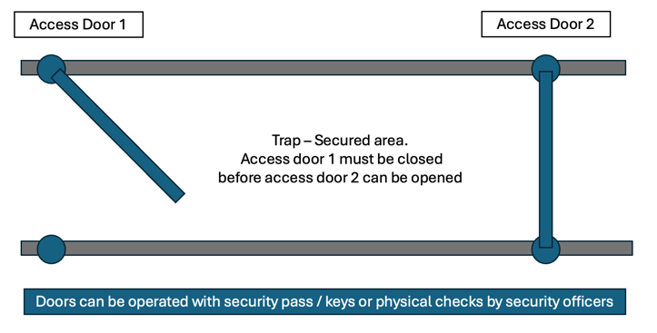
Figure 1: How a Mantrap operates. Two-door system.
Advantages of this control include the prevention of tailgating and higher protection against break-ins as two or more doors need to be compromised. People can be physically held in the “Mantrap” if suspected of unlawful entry until further checks are completed. These types of doors can be costly and can require modification of the floor layout of the premises; this is not always possible for a business.
Security Dogs: often act as a deterrent to prevent potential threats, normally used on large premises or where a security guard may be at risk. Dogs can smell and hear better than people, giving them an advantage over a traditional security guard. Security dogs will need to be trained and have a handler/security guard, increasing the cost of this type of protection.
ID cards and badges: These are often used to identify if the cardholder is permitted on the premises, usually by matching the photo on the card to the person wearing the pass. ID cards may also store access control information to enable holders to enter secured locations depending on their access permissions. There is a risk with access control keys; if they are lost or stolen, an attacker could gain unauthorized access. ID card holders must report a lost/stolen card straight away to allow security to deactivate access rights. This method of security often works well in conjunction with other measures, as it does not prevent tailgating and access from stolen\ duplicated cards.
Locks and keys: There are two main types of locks; mechanical locks require a physical key to enter a location, there are many types of lock mechanisms providing different levels of security. Physical keys may get stolen, and it is not possible to track / control who is entering a location. Electromechanical locks use technology such as magnetic strips or PIN entry systems to grant access via an electric-controlled mechanism. These systems require power to operate, and an alternative entry method would be required in the event of power failure.
Alarms and alarm systems: Detect and notify when there is physical intrusion or other disruptions such as vandalism, flooding or a power outage. Alarms can be set up to automatically alert security and emergency services to allow for a quick response and limit any disruptions and any data loss.
- Fire Safety & Security
A significant threat to data security and people's safety is the potential damage and loss caused by a fire. All business premises should have a robust and tested fire and safety plan to help limit this risk.
Fire detection can be triggered automatically using triggers and sensors or manually by people activating alarms and alerting emergency services. Automatic systems can be faster, allowing for a quicker response. However, they are more costly, and there is more chance of a false alarm; data from the Home Office Incident Recording System (IRS) reports that 40% of incidents where emergency services attended were false fire alarms [11].
There are many detection and prevention systems to aid an organisation, including:
Fire Suppression options including manual intervention extinguishers, often used for more minor incidents as they cause less damage compared to room-scale sprinklers.
Sprinklers can either be triggered manually or set up for automatic triggers based on thermal, smoke or flame detection. Sprinklers are very effective and can operate over a large area very quickly. However, these would cause much damage, potentially resulting in data loss. Measures should be in place to prevent triggering due to a false alarm. Modern mist systems use far less water than traditional sprinklers, causing less damage.
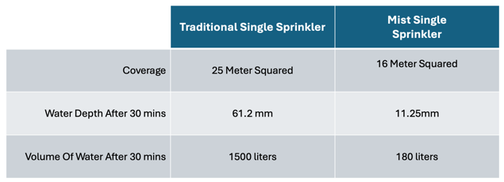
Figure 2: Traditional v Mist System [12]
Although Mist systems result in less damage, they may not be suitable for large open areas such as a factory warehouse [12].
Gaseous emission systems help protect assets in the event of a fire. If triggered, the system deploys a gas that can extinguish a fire without damaging equipment and assets. The most common systems use carbon dioxide or Halon gas. Filing a room with Carbon dioxide eliminates the oxygen supply required for a fire to burn. Halogenated systems deploy a Halon agent, which stops the chemical reaction and the combustion chain. However, this system is now banned from new installations due to its effects on the ozone layer.

Gas systems help protect equipment and any data stored, however, these systems can be expensive. Organisations must consider the risk to people if these are deployed in an emergency; rooms must be evacuated before operation. Any installation will need to follow the international standards for clean agent fire extinguishing systems NFPA 2001 [13]
Fires could allow an attacker to gain access during a planned test evacuation or an actual incident. Physical security needs to be in operation during evacuation, including designated people to monitor floors, ensure cameras remain operational and limit the opening of security doors.
- Utilities Support
Most organisations require utilities to operate, including heating, air conditioning, electricity and water. Consistent power is essential to keep systems operating in terms of data security and integrity. In a security breach, the building must have electricity for security measures, such as access doors and cameras, to continue operating.
Air conditioning may be required to ensure no technical issues with any information systems. Sensors can be set up to ensure technology is operating at a safe temperature.
In the event of a fire, any water loss could result in sprinkles being unable to operate. Issues with internal pipework could result in leaks damaging IT systems. Regular maintenance and audits should be conducted to reduce the risk; alarms could alert personnel of any pressure loss.
Power loss can be devastating for the security of a building and can directly impact many other security measures put in place. An uninterrupted power supply (UPS) can be implemented to help combat this threat. A UPS is a system that allows equipment such as servers or access control doors to keep operating if there is a loss of power [14].
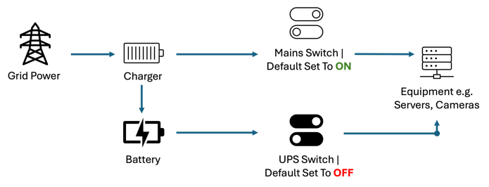
Figure 3: Standby UPS example.
As shown in the diagram, a battery stores a charge of electricity during regular operation. In the event of power failure, the battery is activated to provide power to critical devices temporarily.
Batteries and UPS systems should be regularly maintained and tested to ensure they are fit for purpose. UPS are not designed to run heavy appliances; a generator should be considered in these scenarios.
- Structure
The structure of a building can be impacted by environmental issues such as subsistence/earthquakes. Improper use of buildings, e.g. exceeding load limits, can also cause irreparable damage. Structural damage can lead to physical security systems being unable to operate as intended, e.g. damage to walls/ fences. Structural damage can directly impact data information systems, causing damage and potential data loss.
Regular inspections should be carried out to highlight and repair any potential issues. Load limits must be adhered to ensure the building is being used within its intended design. Drills should be carried out to provide a fast and effective response and ensure data security can be properly protected in the event of an emergency.

- Mobile Systems
Mobile system protection can be challenging to secure outside an organisation's premises. A study by Forbes shows a rise in homeworking since the COVID-19 pandemic, showing that 46.6% of employers now do part of their role from home, compared to just 4.7% pre-pandemic [15].

Mobile devices have several threats, including the loss of data from a stolen or lost device, the use of insecure networks/access points and proximity-based hacking [16]. To combat this a business has several options:

Secure Storage and Tracking: Locked carry cases when a device is not being used can help slow down an attack. The use of tracking devices could also aid in the recovery of a stolen device.

Encryption: Data encryption is vital for any device that stores data to prevent unauthorised access if the device is lost/stolen. Modern solutions allow the user to remotely delete and lock a device if it is suspected to be in the wrong hands.

Access Control: Passwords, biometrics and multifactor authentication (MFA) can secure a device to ensure only the authorised user can access the device.

Mobile Device Management (MDM): IT departments can use MDM to ensure that devices' security policies are updated with the latest security and compliance standards.

Training: Employees should know the risks of mobile computing, including regular training on best practices for device and data protection. Training should include information on the risks to mobile users by hackers, including threats such as phishing and social engineering methods.

There is a heightened risk of using a mobile device off premises. Training, encryption and access control methods are essential with limited physical security options.

V. PHYSICAL SECURITY STRATEGY
Organisations should have a strategy in place for the protection and safeguarding of data and IT systems. A Physical security plan could involve [17]:
Protection: Using access control measures to prevent unauthorised access, such as access control locks of MFA. Physical fences, gates and barriers should be implemented where possible to help protect the infostructure.
Detection: Site monitoring using CCTV, sensors and alarms can detect unwanted access or issues that could cause damage to data assets. Regular audits help detect weaknesses and issues in security measures.
Reaction: A good strategy will incorporate an incident response plan, which outlines roles and responsibilities if a breach occurs. Staff training is essential to ensure emergencies are handled safely and quickly to limit the potential damage or loss. Clear communication and documentation are essential, with any lessons learnt after an incident recorded to help improve future issues and training.
Safeguarding: Encryption is vital for mobile devices to ensure data is protected. Any incidents should be reported urgently to allow the admin to remote wipe and lock lost or stolen equipment. Organisations should remain in compliance with industry standards and any legal requirements.
Employee Training: Not all security breaches are due to intentional attacks. A poorly trained workforce could unintentionally damage data systems, leading to a data breach. Staff should enrol on regular training sessions to keep up to date with evolving threats and security issues.

VI. CONCLUSION
Physical security plays an important part in protecting an organisation's assets and data. Data breaches can result in reputational damage and cost to customers and the business, leading to a loss of trust and future business and investments [17]. Data loss can be intentional through organised attacks or unintentional from people not following the process, being negligent or having improper training.
Security can be expensive; organisations should conduct risk assessments to assess how much risk they are willing to accept and how much they wish to invest to protect their data. This paper discussed the many options available to a company, but not all will be suitable, depending on the premises and infrastructure of the IT systems. Geographical location will also need to be considered, e.g. some countries are prone to environmental factors such as earthquakes.
An effectively implemented security strategy is vital to protect against the ongoing threat. Strategies and risks should be continually evaluated and updated to keep up with changing threats and technology. With a rise in mobile computing also comes unique challenges; users must have adequate training and use encryption and multifactor authentication to better protect data assets when off-premises.
To enhance this research, the next step would be to look at future technologies and how they may aid in both protecting and potentially causing enhanced threats. Artificial intelligence (AI) is developing rapidly, and understanding developments in this field will be vital to creating solutions to enhance physical security and protect against attacks using AI.

Task 2 | Establishing An Information Security Unit

1. Introduction
Protecting an organisation's data and IT assets is vital for a modern-age business. Attacks using modern technology, such as AI, have become more sophisticated, leaving businesses at risk of a potential data breach. A successful attack or data breach could devastate a company; customer data could be leaked, leading to substantial financial penalties and loss of trust from customers and stakeholders [19].
The following report covers a proposed approach to setting up a new information security unit, including organisational structure, policies and procedures, data protection compliance, security standards, contingency planning, governance and strategic planning, and risk management.
The information security unit will use modern-day resources and technical expertise to aid in protecting information assets. The unit is vital part of a security plan to safeguarding the organisation's data while remaining compliant with legislation.

2. What is Information Security
Information security is a method and practice to safeguard data and help reduce risks to information loss [20]. Businesses require a multi-layer approach to protect hardware and software that hold data; this could include physical measures such as access controls and staff straining to raise awareness to help understand and identify risks and issues.
Information security consists of three principles that make up the CIA triad which include:
Confidentiality: protecting data to ensure it is kept private and secret. This involves controlling access and preventing unauthorised disclosure.
Integrity: This involves ensuring the quality of the data is complete, preventing unauthorised editing, and ensuring accuracy with no unnecessary duplication.
Availability: Ensure data is kept available to authorised personnel when needed. This involves ensuring systems are kept running and data is accessible.

3. Design Approach
Security can be implemented using a bottom-up approach, which involves system admins and non-managerial staff using their local knowledge to implement measures. However, this approach is not robust and is open to single points of failure. A top-down approach has a higher success rate, where qualified higher management and specialists set the rules and goals, including policy, process and procedures. This approach will give clear direction from qualified professionals to modernise security and the organisation's culture.

3.1 Organisation Structure

An Information security unit department structure will need several qualified professionals to operate a security unit. Senior management should guide key security strategies and direction. A team of technical and administrative staff for day-to-day operations, with line managers to manage tasks and projects in each department.
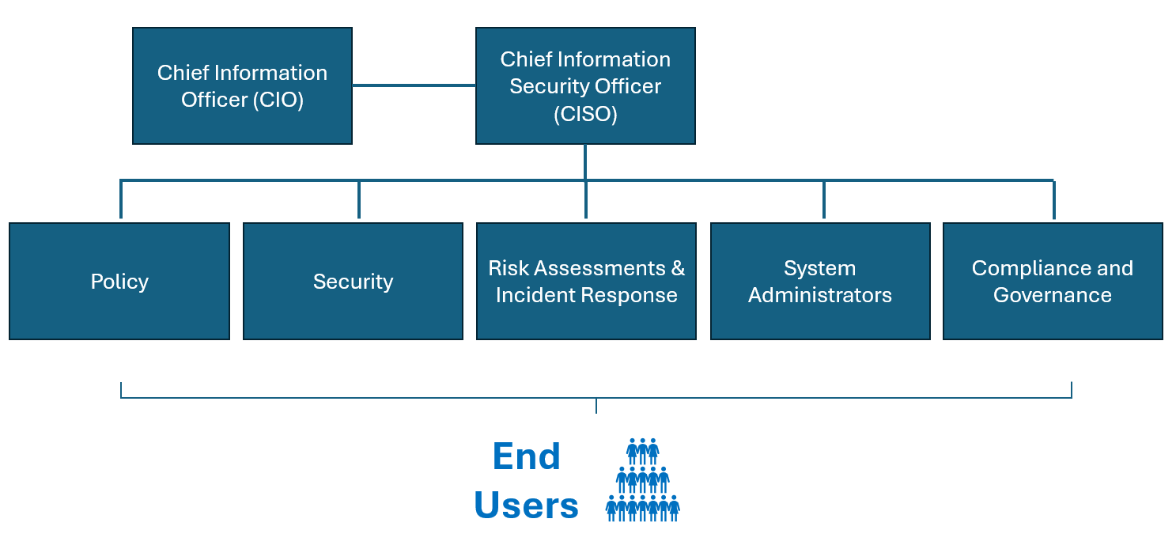
Figure 4: Organisational structure for proposed information security department
The example structure above illustrates the critical departments required for a unit, covering various information security needs. The size of each department would be determined based on workload, assets, risk and budget considerations. Below outlines the roles and responsibilities for each element of the structure:

Chief Information Officer
The CIO is responsible for the implementation and planning of the company’s assets and IT resources, also advising executives on strategic planning.

Chief Information Security Officer
The CISO is responsible for the security of all information assets and systems. Duties include implementing security policies, overseeing security staff and teams, understanding potential threats and coordinating any responses in the event of a data breach [21]. A successful CISO must have expert knowledge in current security technologies and process, and best practices for risk management.

Policy
Policy specialists are responsible for defining, developing and implementing security policies across the organisation. The policy department will also be responsible for training and awareness of any changes to security policy and ensure best practices are being followed.

Risk Assessment & Incident Response
The risk department identifies potential risks to assets and security. A risk team develops and maintains risk assessments and produces mitigation strategies. A sub-department could include an incident response team that is trained to deal with certain scenarios; acting quickly during an incident will limit any damage or data loss.

Security
Security professionals are essential to the overall structure and are on the front line for protection. Made up of qualified personnel to protect the physical premises and IT assets, ensuring access is only for authorised personnel.

System Administrators
System administrators monitor internal systems to identify potential threats. They are trained to identify data breaches and react to eliminate the threat. Technical system administrators maintain assets and infrastructure with up-to-date software and company policies.

Compliance and Governance Team
A compliance team ensures that the business follows regulations, laws, and internal policies. The team will conduct regular audits to ensure compliance and that all correct documentation is available. The compliance team ensures data integrity, ensuring it is accurate, available and kept confidential.

End Users
The structure is designed to sit within an organisation of end users. The new unit would be required to work closely with end users to ensure compliance and training are maintained to safeguard assets and data.

3.2 Policies and Procedures

Defining and setting out policies and procedures are essential to an information security unit. An information security policy is a set of statements and rules to direct the workforce's behaviors when working with data and technology assets to ensure data integrity, confidentiality, and availability [22]. Policies should follow the business's risk appetite, giving guidance for the security framework that is necessary to protect. Policies ensure that individual employees are accountable for their behavior when dealing with company data and assets

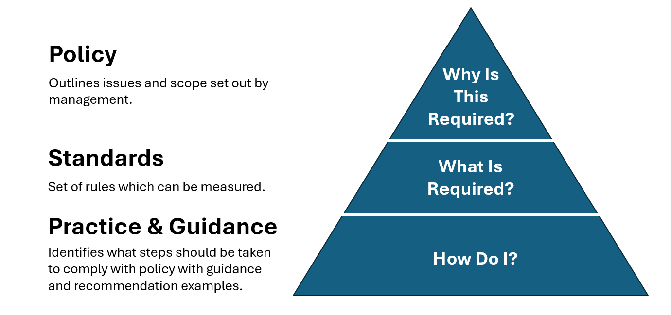
Figure 5: Organisational Policy, Standards and Practices.
Standards documentation can be used to give more details on what is required to comply with company policies. Best practices and guidelines need to be documented to aid the workforce in the steps needed to ensure compliance.
Prior to creating a new unit, a full review needs to be conducted of existing policies and procedures.

3.2.1 Key Polices
Several of the key policies required in the unit are detailed below:

Enterprise Information Security Policy (EISP)
An Enterprise Information Security Policy (EISP) is a more general security policy outlining the philosophy/direction of the company [23]. The consequences of a policy breach should be detailed to end users. The EISP should include but not be limited to:
- Acceptable Use Policy: AUP is a set of rules and guidelines that outlines the appropriate use of the company’s systems, including computers, mobile phones and internet access. The policy outlines acceptable user behaviours and identifies any illegal or prohibited activities, listing what is restricted, for example, accessing inappropriate websites.

- Bring Your Own Device Policy (BYOD): This policy will identify the rules for using personal devices for work or personal use using the corporate internet. HP Tetradic identified that 48% of 8,000 employees used their devices for work [24]. With a rise in BYOD usage, essential rules and guidelines must be set to protect the data and IT infrastructure.

- Access Control Policy: An access control policy describes measures to restrict access to data and information assets. The policy should describe who can access what; this could be based on the user role and the sensitivity of the data. Access control can be built into physical security with access control doors and ID badges; software restrictions can be implemented to allow only authorised access. A part of the policy should outline password and encryption control requirements. Data access auditing and monitoring should be detailed to allow security teams to check for authorised access.

- Network Security Policy: A network security policy establishes the measures required to protect the internal network. The policy should detail the usage of network security measures such as intrusion detection systems, antivirus software and firewalls. The policy should outline network auditing and monitoring methods to identify unauthorised behaviour and threats.

- Data Protection Policy (DPP) - A DPP will outline guidelines and practices required to ensure the correct use of processing personal data and that the data is kept secure and private to reduce the risk of a data breach. The rules for data collection need to be outlined, along with policies on how long data should be stored. The policy should reflect relevant data protection laws such as the General Data Protection Regulation (GDPR) [25].

- Incident Response Policy: This policy will outline the approach to be used in the event of an incident such as a data leak. Roles and responsibilities should be identified to reduce the impact quickly and ensure communication with relevant stakeholders. The policy should be structured to deal with various incidents, from viruses to internal/external attacks.

Issue-Specific Security Policy (ISSP)
An ISSP can be used to look at specific threats, such as email security or the use of mobile applications.

Systems-Specific Security Policy (SysSP)
SysSP policies should be written to establish rules within a particular system, including access control permissions and encryption requirements for when data is transferred over a network/internet.

3.2.2 Policy Management
Policies and procedures need to be assed and reviewed on a regular basis as the needs of the company change and to keep up to date with emerging threats and technology. A detailed plan should be set out for when policies should be reviewed, with clear, dated documentation of any alterations.

3.2.3 Policy Blueprint
After setting out policies and procedures, a blueprint can be developed to create an organised guide to define and document security measures to base the implementation of security measures.

3.3 Data Protection and Compliance
While handling personal data, the organisation must comply with regulation requirements, internal policies and industry standards. It is a legal obligation to secure data when processing personal data; leaked data can significantly impact an organisation's reputation and pose a danger to the safety of individuals.
GDPR is a European Union law that ensures the protection of personal data and the privacy of individuals; GDPR was introduced in 2018 to replace the Data Protection Directive. GDPR describes how data should be processed (article 6), how special category data should be handled (article 9) and identifies conditions for consent (article 7) [26]. To compile with GDPR, the organisation will need to consider the following:
- Data should be only accessible and editable to authorised personnel; this will ensure confidentiality. This could be implemented using access control methods and login authentication. Data should be audited regularly to ensure the correct level of access is being adhered to. Firewalls must be in place to stop unauthorised access, and data must use end-to-end encryption while it's being transferred and stored.

- Data must be kept up-to-date, accurate and complete to ensure data integrity. Stored data should go through validation checks, either when it is processed or during user input; this will reduce the risk of error. Checks should be carried out for duplicate data within a dataset, and processes must be outlined to merge any duplication.

- Data must be made available to the organisation and end users when required. To ensure availability, regular backup strategies must be considered to enable data to be recovered quickly in the event of a loss. Security implementations should be in place to protect data loss and help mitigate a data breach or damage to data assets; this could include physical security implications, guards, access control technologies and the use of a UPS to ensure the system remains available during a power outage. If availability is compromised, GDPR states it should be restored in a "timely manner"; however, this is not defined in detail; risk assessment and action plans should be developed to outline a recovery plan and priorities for the different datasets across the organisation.

- Training – Data from the Information Commissioner's Office (ICO) reveals that between 2019 and 2023, 76% of reported incidents were not cybercrime-related, many breaches caused by employees by accident [26]. Lack of training can lead to data breaches, for example, emails/paperwork sent to the wrong receipts or data not being securely stored / locked away. A training programme will be required to be completed by all levels of staff, the material can be tailored to the job role and should have regular refresher courses and updates when there are changes to law or policy.
To aid in mitigating a data breach and ensure compliance, a data protection impact assessment (DPIA) should be conducted before individuals' data is processed. A DPIA will evaluate any risks including the impacts and rights of individuals. It will not always be possible to eliminate the risks, but all risks must be justified, and mitigation strategies must be outlined.

3.4 Security Standards
Choosing a security standard to follow will provide a framework to aid in protecting against security risks and offer guidelines into preventions methods.

3.4.1 Choosing a Standard
Many security frameworks are available, and ISO 27001 and the National Institute of Standards and Technology (NIST) are two of the most used cybersecurity frameworks within a business. ISO 27001 involves a structured certification process; as of 2022, the ISO reports that it has certified over 70,000 enterprises worldwide [27]. The NIST framework is often used as an initial guidance for security; as security and organisations scale up, many will opt for formal certification and adopt ISO 27001 as it offers a structured solution.
TABLE I – NIST / ISO Comparison
NIST | ISO 27001
Designed to be used as a guide | A form standard
No certification | Certified
No cost of use | Cost to purchase and for certification
Guidelines created by US government | Recognised globally
 | Time consuming to implement

The new security unit should adopt the NIST framework as guidelines and aim to move to an ISO 27001 certification solution as the unit/organisation matures and develops.

3.4.2 Core Functions Of NIST
To implement the framework the following approach should be used:

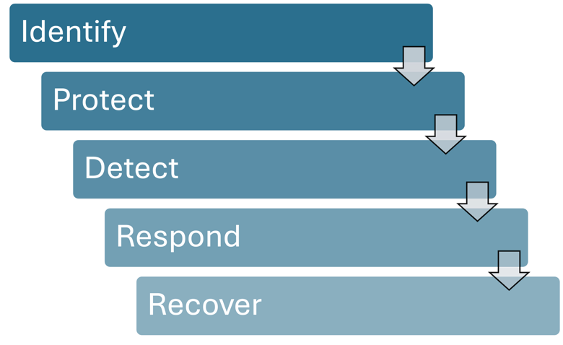
Figure 6: Core Functions of NIST security standard.

Identify: Outlines the need to understand how the organisation will manage the potential risk to data and assets. This will involve identifying the assets, understanding the business's environment, and conducting risk assessments to identify risks facing the company. Upon completion, the business will understand what processes and assets need protection.
Protect: protection involves implementing measures to safeguard processes, data and assets. Protect involves access controls and physical security, including security guards and Mantraps. Staff training and awareness to help combat the risk of accidental breaches. Multifactor authentication should be implemented to protect the access to data.
Detect: The decent element of the framework requires implementing security measures to help identify any security incidents. Attacks need to be identified quickly to help prevent any damage or loss. The security unit should have the tools to recognise anomalies, such as systems to recognise potential hacking or virus detection. Physical security, such as security guards and cameras, will be essential in detecting and eliminating threats.
Respond: A quick and efficient response is an essential element of the NIST standard; a rapid response could limit the level of damage. This function should include a response plan, communication, and analysis of incidents to ensure lessons learnt are documented and to aid with continuous improvement.
Recover: NIST framework can be used to outline processes and guidelines for restoring data and assets after a security breach as quickly as possible. Quick recovery would be needed to ensure the business remains operational and that data is available to customers and stakeholders. A recovery plan will need to be established, including communication procedures and improvement documentation requirements, to prevent similar incidents in the future.

3.4.3 NIST Implementation
Implementing the NIST framework will provide a strong foundation for a robust security solution. The organisation should establish a clear list of goals, understand what measures are currently in place and make an action plan to assess what needs improvement to meet the goals. This Framework can then be implemented. However, the frame needs to be continuously reviewed and tweaked as the needs of the business and potential threats change.

3.5. Contingency Planning
The new data security unit will need a contingency plan to establish a structure to follow during a security incident. The contingency plan must follow the NIST standard, SP 800-34 Rev. 1 (2010), "Contingency Planning Guide for Federal Information Systems" [28]. This will include:
Step 1: Develop a policy statement to document the outline and purpose of the contingency plan. The statement should identify the plan's major components, the key people responsible for the plan and any actions.
Step 2: Carry out a business impact analysis to identify and prioritise the data and assets within the organisation.
Step 3: Identify preventative controls to ensure data availability, such as a UPS system to prevent power outages.
Step 4: A contingency strategy must be created to set out the procedures to recover systems and data quickly with limited disruption.
Step 5: A contingency/action plan will outline procedures to follow if data or systems are unavailable.
Step 6: The plan will need testing to ensure it is fit for purpose, including regular training and exercises to test scenarios. Lessons learned, and any issues will need to be documented and actioned.
Step 7: The plan will require maintenance to ensure it develops with any business changes or changes in technology.
The continuity strategy should include an incident response plan (IRP), disaster recovery (DRP), and business continuity plan (BRP).
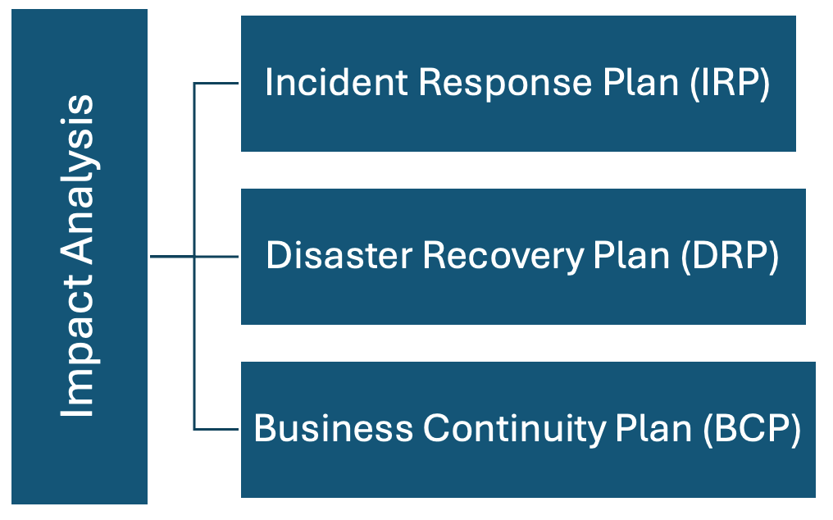
Figure 7: Contingency planning impact analyses steps.
Incident Response Plan: will outline the tasks needed to detect and correct an incident. Being prepared will enable the incident response team to follow a structured approach of rules to enable quicker recovery.
Disaster Recovery Plan: this will outline the plan for recovery from an incident. The plan will need to prioritise assets and systems for recovery to minimise downtime whilst maintaining compliance and continuing to protect data.
Business Continuity Planning: The BCP must outline a strategy to enable core functions to operate during an incident. In the event of a catastrophic disaster, it may not be possible to recover all systems; the BCP should focus on critical processes and assets and include guidelines for maintaining the operation of these functions to limit the impact on customers and stakeholders.

3.6. Governance and Strategic Planning for Security
Planning for security is critical to protect the business information assets. Planning involves establishing goals. Information security governance is the system that sets procedures to control information security. A framework that meets the business objectives, policies, local laws and regulations will need to be implemented; this will include the following goals:

- Strategic Alignment: This involves ensuring alignment with the organisation's goals and objectives. Key stakeholders and management will need to be involved in the decision-making process.

- Risk Management: The goal of risk management is to understand security threats and the impact they may have on the business. Risk will need assessment to understand impact vs likelihood, and mitigation strategies need to be identified and documented. Risk management should not be a one-off exercise; it will require regular monitoring as security risks or organisation goals and priorities change.

- Resource Management: Resources will need to be used efficiently to ensure cost-effectiveness, bringing value for money to the organisation. This will involve using skilled professionals in areas that suit their area of expertise. Priorities must be identified to ensure resources can be focused on areas based on the highest priority.

- Performance Measurement: Key performance indicators (KPIs) should be used as a tool to measure the effectiveness of all implemented security measures. These indicators will need to be regularly reviewed to ensure the security measure is fit for purpose and achieving the required performance target. Any failing security measures may require more investment and reviews to understand issues, with a documented plan on how the measure can be improved.

- Value Delivery: Security implementations must be regularly audited and reviewed to ensure any measures provide value for money and support organisation objectives.

- Culture and Security Awareness: Employees must be regularly trainned of security threats, with promotion of best practices. Training will be vital to ensure compliance and upskilling of staff. Security needs to be built into the culture of the organisation at all levels, not just withing management.

An Information security governance plan will demonstrate to stakeholders and customers that data security is a high priority, which will build trust and credibility.

Management will play an essential role in creating and maintaining the security framework. Objectives will need to be set, and policies will need to be established. Management will be key in promoting a culture that values security; this will need to be done with security awareness training and promoting the value of security. Any security failures and lessons learnt should be documented to encourage continuous improvement. The executive team will have overall responsibility for the governance and security plan; the executive team will need to work closely with the new security unit to ensure satisfaction with the plan and direction.

3.7. Risk Management
The proposed unit must include a risk management team to help manage and mitigate information security risks. Risk Analysts must regularly monitor threats and vulnerabilities and adjust risk documentation accordingly. Risk management involves using technology, processes, and people to identify risks and create processes to monitor and help mitigate risks where possible [29]. Risk management involves understanding the risk, the potential issues and the scale of impact.
Risk management will involve understanding the risk appetite for each identified risk. As part of an assessment, decisions will need to be made on an acceptable level of risk compared to the cost required to secure the assets and data. After security measures are put in place, there may still be a residual risk where information assets are susceptible to a level of risk. Risk management will involve identifying, assessing, and setting out methods to control risks.
Risk Identification: Initially, an inventory of information assets needs to be listed and recorded in an asset register, including IT systems, people, software, hardware, and data and information systems. The list will help understand the protection required, allowing for priorities to be established using weighted factor analysis. Threats to each asset can then be recorded and all vulnerabilities identified for the risk to be assessed.
Risk Assessment: Where risks are identified, a risk scoring matrix can be used to determine the likelihood of risk and the impact if the risk occurs. Below is an example of the risk matrix:
 |  | Impact
 |  | Insignificant  1 | Minor  2 | Significant  3 | Major  4 | Severe  5
Likelihood | Almost Certain  5 | Medium  5 | High  10 | Very High  15 | Extreme  20 | Extreme  25
Likelihood | Likely  4 | Medium  4 | Medium  8 | High  12 | Very High  16 | Extreme  20
Likelihood | Moderate  3 | Low  2 | Medium  6 | Medium  9 | High  12 | Very High  15
Likelihood | Unlikely  2 | Very Low  2 | Low  4 | Medium  6 | Medium  8 | High  10
Likelihood | Rare  1 | Very Low  1 | Very Low  2 | Low  2 | Medium  4 | Medium  5
Figure 8: Risk Matrix – Likelihood vs Impact
The risk assessment will assign a score to each information assets, high scores identify the risk is almost certain to happen and have a serve impact. Each risk will be described and categorised by an owner who will be responsible for managing the risk.
Risk Control: Risk control involves setting out preventive measures, including outlining justifications for the level of control needed based on the risk assessment results. The business will need to determine a strategy to control each risk:
  - Defense: prevention or reduce likelihood
  - Transfer: Move risk to a third party
  - Mitigation: Use contingency plants to minimise impact if a breach occurs
  - Acceptance: accept the risk without implementing measures
  - Termination: discontinue the operation that is causing the risk.

4. Conclusion
The proposed approach to setting up a new information unit will deliver a successful security implementation to protect the organisation's information and assets. This approach will enable the unit to set out measures and apply techniques to continuously monitor and improve measures as threats, the operation landscape, and goals change.
The proposed approach ensures data protection and compliance using modern security standards. Risk management techniques are outlined to identify the prioritised risks with mitigation strategies. The approach outlines the importance of contingency plans to ensure the organisation remains operational during an incident with recovery plan strategies. The plan identifies an organisation's structure capable of delivering the unit and all its functions.
A new unit will need regular review to ensure goals are being met. Initially, requirements and priorities may change as the unit develops and matures. Training at all levels of the organisation will be essential to promote a culture change and learn how the new unit will work for the business.
Future research should focus on emerging technology and how AI developments could create more threats and opportunities for protection. A new unit could benefit from using machine learning and advanced data science methods to identify breaches and better protect the organisation.
Security breaches would devastate the organisation, potentially causing irreparable reputational damage and resulting in loss of business, time and money. A dedicated information security unit will prove an essential investment in the ongoing battle against evolving security threats, showing stakeholders and customers the dedication to protecting the company's data and assets.

Abbreviations
Abbreviation | Definition
CCTV | Closed circuit television
IRS | Incident Recording System
UPS | Uninterruptible power supply
MFA | Multifactor authentication
MDM | Mobile device management
AI | Artificial intelligence
CISO | Chief Information Security Officer
CIO | Chief Information Officer
EISP | An Enterprise Information Security Policy
BYOD | Bring Your Own Device Policy
GDPR | General Data Protection Regulation
ISSP | Issue-Specific Security Policy
SysSP | Systems-Specific Security Policy
ICO | Information Commissioner's Office
NIST | National Institute of Standards and Technology
ISO | International Organization for Standardization
IRP | Incident response plan
DRP | Disaster recovery plan
BRP | Business continuity plan
KPI | Key performance indicators (KPIs)

References

[1] A.B Tunggal, "What is the Cost of a Data Breach in 2023?", Up Guard [Online], Available https://www.upguard.com/blog/cost-ofdatabreach. [Accessed 01/07/2024].
[2] T.Fitzgerald and T. Peltier, Information security governance simplified: from the boardroom to the keyboard, 1st edition. Boca Raton: CRC Press, 2012. Doi: 10.1201/b11357.
[3] D Chu, "Data Security: Physical Security Breaches", Secoda [Online], Available https://www.secoda.co/learn/data-security-physical-security-breaches#:~:text=A%20physical%20security%20breach%20occurs,or%20devices%20containing%20sensitive%20information. [Accessed 04/07/2024].
[4] M. Joyl, "Cybersecurity 101: Why Hackers Want Your Data & What Happens to It", Onsip [Online], https://www.onsip.com/voip-resources/voip-fundamentals/cybersecurity-101-why-hackers-want-your-data-what-happens-to-it [Accessed 01/07/2024].
[5] “Cost of a data breach 2023 | IBM,” www.ibm.com. https://www.ibm.com/reports/data-breach?trk=article-ssr-frontend-pulse_little-text-block. [Accessed 06/07/2024].
[6] D. B. Parker, “The strategic values of information security in business,” Computers & security, vol. 16, no. 7, pp. 572–582, 1997, doi: 10.1016/S0167-4048(97)80793-6.
[7] C. D. and D. O. (CDDO) Office Cabinet, “Performing a security risk assessment - UK Government Security,” www.security.gov.uk. https://www.security.gov.uk/guidance/secure-by-design/activities/performing-a-security-risk-assessment [Accessed 06/07/2024].
[8] M. P. J. Ashby, “The Value of CCTV Surveillance Cameras as an Investigative Tool: An Empirical Analysis,” European journal on criminal policy and research, vol. 23, no. 3, pp. 441–459, 2017, doi: 10.1007/s10610-017-9341-6.
[9] M. K. Kusserow, “LESSONS LEARNED IN ROBBERY PREVENTION,” Credit Union Management, vol. 29, no. 4, pp. 20-, 2006.
[10] MANTRAPS: A Unique Solution, vol. 42, no. 9. Troy: BNP Media, 2005, pp. 20-.
[11] a. Li, “Trends in fire false alarms and fire false alarm policies", Home Office [Online], https://www.gov.uk/government/publications/trends-in-fire-false-alarms-and-fire-false-alarm-policies/trends-in-fire-false-alarms-and-fire-false-alarm-policies [Accessed 06/07/2024].
[12] S. A. Hill, A. A. Kelly, J. L. Scheffey, G. G. Back, and J. P. Farley, “Report on the Use of Sidewall Sprinklers and Water Mist Nozzles for Primary Damage Area (Fire) Cooling,” 2003.
[13] “NFPA 2001 Standard Development,” www.nfpa.org. https://www.nfpa.org/codes-and-standards/nfpa-2001-standard-development/200. [Accessed 17/07/2024].
[14] R. Mcfarlane, “uninterruptible power supply (UPS)", Tech Target [Online], https://www.techtarget.com/searchdatacenter/definition/uninterruptible-power-supply [Accessed 16/07/2024].
[15] M. Hooson, “UK Remote and Hybrid Working Statistics 2024”, Forbes [Online], https://www.forbes.com/uk/advisor/business/remote-work-statistics/ [Accessed 17/07/2024].
[16] K. Munir, Security management in mobile cloud computing. Hershey, Pennsylvania: Information Science Reference, 2017. doi: 10.4018/978-1-5225-0602-7.
[17] M. Chapple, Carpenteria, CA. CompTIA Security+ (SY0-601) Cert Prep: 5 Physical Security Design and Implementation., (2020).
[18] Y. Zhang and T. Smith, “The impact of customer firm data breaches on the audit fees of their suppliers,” International journal of accounting information systems, vol. 50, pp. 100628-, 2023, doi: 10.1016/j.accinf.2023.100628.
[19] B. Bulgurcu, H. Cavusoglu, and I. Benbasat, “Information Security Policy Compliance: An Empirical Study of Rationality-Based Beliefs and Information Security Awareness,” MIS quarterly, vol. 34, no. 3, pp. 523–548, 2010, doi: 10.2307/25750690.
[20] W. Li, A. Leung, and W. Yue, “Where is IT in Information Security? The Interrelationship among IT Investment, Security Awareness, and Data Breaches,” MIS quarterly, vol. 47, no. 1, pp. 317–342, 2023, doi: 10.25300/MISQ/2022/15713.
[21] S. Watts, “The CISO Role: What Does a Chief Information Security Officer Do?”, Splunk [Online], https://www.splunk.com/en_us/blog/learn/chief-information-security-officer-ciso-role.html [Accessed 23/07/2024].
[22] R.Dunham, “Information Security Policies: Why They Are Important To Your Organization?”, linfordco [Online], https://linfordco.com/blog/information-security-policies/ [Accessed 24/07/2024].
[23] RSI, “What Is The Purpose Of An Enterprise Information Security Policy?”, RSI [Online], https://blog.rsisecurity.com/what-is-the-purpose-of-an-enterprise-information-security-policy/ [Accessed 24/07/2024].
[24] Information Commissioners Office, “UK GDPR guidance and resources,” ico.org.uk, 2023. https://ico.org.uk/for-organisations/uk-gdpr-guidance-and-resources/ [Accessed 24/07/2024].
[25] C. Staunton, S. Slokenberga, and D. Mascalzoni, “The GDPR and the research exemption: considerations on the necessary safeguards for research biobanks,” European journal of human genetics : EJHG, vol. 27, no. 8, pp. 1159–1167, 2019, doi: 10.1038/s41431-019-0386-5
[26] ICO, “Data security incident trends,” ico.org.uk, Jan. 14, 2020. https://ico.org.uk/action-weve-taken/data-security-incident-trends/ [Accessed 24/07/2024]
[27] 14:00-17:00, “ISO/IEC 27001:2022,” ISO. https://www.iso.org/standard/27001#:~:text=ISO%2FIEC%2027001%20is%20widel, [Accessed 24/07/2024]
[28] NIST, “NIST SP 800-34,” NIST, Jan. 12, 2020. https://www.nist.gov/privacy-framework/nist-sp-800-34
[29] IBM, “What is risk management?,” www.ibm.com, 2024. https://www.ibm.com/topics/risk-management [Accessed 20/07/2024]

