Transmission Matching
By
Charles Sangster
1902452

Contents
Introduction 3
Methodology 3
Equations 3
4
Research 4
Clutch 4
Gearing 4
Drag 4
Transmission efficiency 5
Results 5
Analysis 7
Conclusion 8
Bibliography 9
Appendices 10

Graph 1:Torque at Wheels v Engine Speed 5
Graph 2:Tractive Effort v Engine Speed 6
Graph 3:P drag v Velocity 6

Introduction
This report will look at arrange of data collected from a BMW 1000rr, it will look at how the transmission system impacts data and why the transmission system is needed. The BMW will run on a dyno and data from this collected and used in specific calculations to further the range of data. From this the impacts of the transmission system along with exterior forces will be shown.

Methodology
The data used was collected by performing a squeak test on the chosen vehicle whilst in 5th gear (this is to achieve a 1:1 drive ratio). This test simulates constant traction/speed on the vehicle as it runs through a range of rpms, this means that power from the engine as it goes through the powertrain to the wheels can be measured; the dyno controls the rpm of the vehicle. Test started at 1000rpm and finished at 14000rpm, errors in data during acceleration and deceleration meant only data from 1969rpm to 13920rpm was used. During the engines slow down period the clutch was engaged, this allowed the drag of the transmission system to be measured.

Equations
$$Speed Ratio=\frac{Max Torque Engine Speed }{Max Power Engine Speed }$$
$$Max TE=\frac{T Max ×p×f×n×ƞ }{R }$$
$$Transmission efficiency (ƞ)=\frac{Power at the Wheels }{Power at the Engine }$$
$Torque at the Wheels \left(T\right)=T at Engine×P×F×n×ƞ$
$$Tractive Effort (TE)=\frac{Torque at the Wheels }{Rolling Radius (R)}$$
$$V=\frac{2×π×R×14200 }{60×p×f×n }$$
$$Pdrag =\frac{1}{2}×ρ×Cd×A×{(V+V0)}^{2}×V$$
$$1st Ratio=n1$$
$$2nd Ratio=n1×Speed Ratio$$
$$3rd Ratio=n1×{Speed Ratio}^{2}$$
$$4th Ratio=n1×{Speed Ratio}^{3}$$
$$5th Ratio=n1×{Speed Ratio}^{4}$$
$$6th Ratio=n1×{Speed Ratio}^{5}$$
$$f=\frac{2π×R×N}{60×V×n×p}$$
$$MAX Engine power at the wheels =Max Power at Engine × ƞ$$
P = Primary Gear
F = Final drive
N = Engine Speed
n = Number of gear (5th)
V = Velocity
Cd = Coefficient of Drag
A = Front area
ρ = Density of Air
Π = Pie
T = Torque

(Summerfield, A. 4th March)

Research

Clutch
The clutch allows drive from the engine to be disengaged from the powertrain, this allows the vehicle to be stopped without the engine having to be off. It also stops drive going through the gears whilst being changed. (Newton, Steeds & Garrett. 1989)

Gearing
When looking at gear ratios they are expressed as, 2:1. This means for every 2 rotations of the input shaft there’s 1 rotation of the output shaft. This Can be used to calculate the speed of the two shafts along with other data (Hillier & Pittuck. 1981).
The primary gear ratio transfer’s torque between the crankshaft and the gear box inlet, this gear ratio impacts the rest of the drive train (Graham. 2010).
Speed and torque within an engine are affected by each other, as torque increases power decreases and vice versa. Due to this a gear box is used, this uses different gear ratios to balance out speed and torque produced by the engine. Using a Smaller driver gear and a large driven gear results in a higher torque output, this helps overcome the mass and friction of the vehicle/tyres. The 4th and 5th gear are close to 1:1 drive, this means the speed at the wheels is close to that of the engine. A larger driver gear and a smaller driven gear results in higher speed output, when these gears are selected the speed at the wheels is greater than that of the engines (Hillier & Pittuck. 1981; Harris. 2003).
Final drive is the ratio between the gear box outlet and the sprocket on the wheel (Graham. 2010).

Drag
Drag is the force that acts on a vehicle during acceleration, to overcome this force the engine must produce an equal amount of torque to allow the vehicle to maintain speed; once torque and drag are equal the engine can no longer accelerate and has reached its maximum speed (Rowley. 2006).

Transmission efficiency
Due to moving parts within the transmission, large amounts of energy/power are lost threw friction and play off rotating parts, this results in loss of power as it travels from the engine to the wheels. This is transmission efficiency (Irimescu, Miho & Pãdure. 2011).

Results
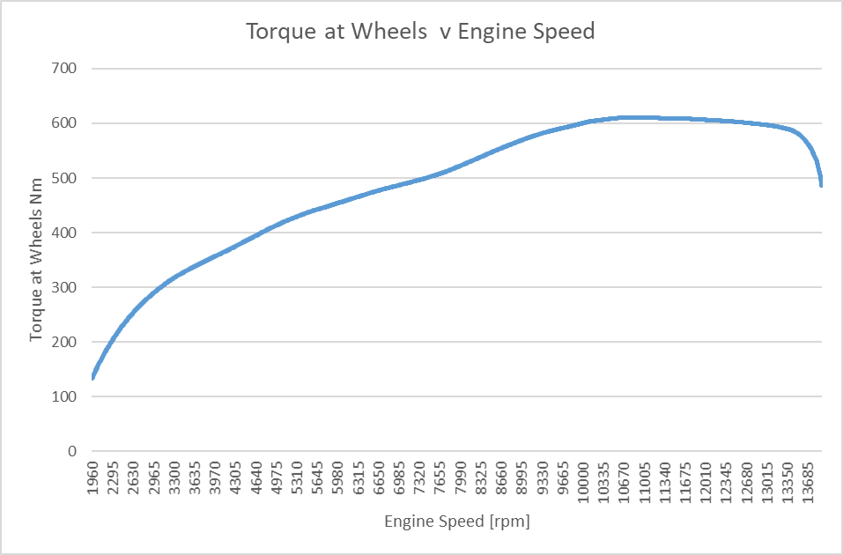
Graph 1:Torque at Wheels v Engine Speed
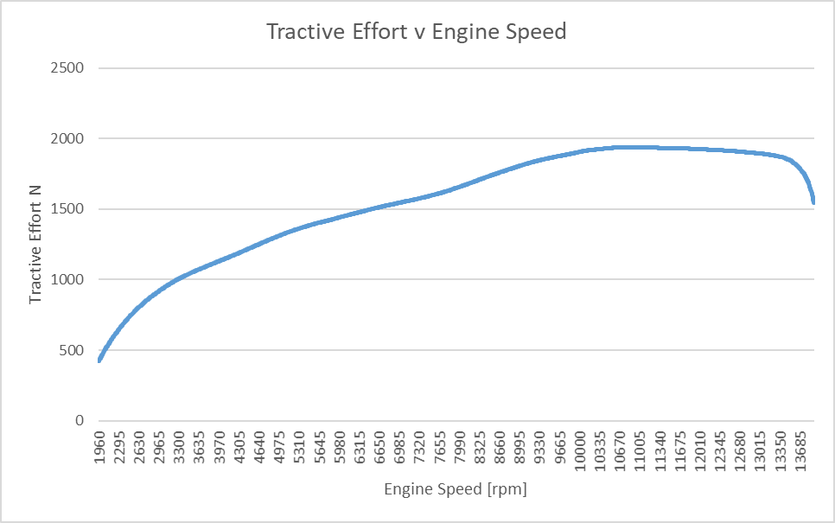
Graph 2:Tractive Effort v Engine Speed
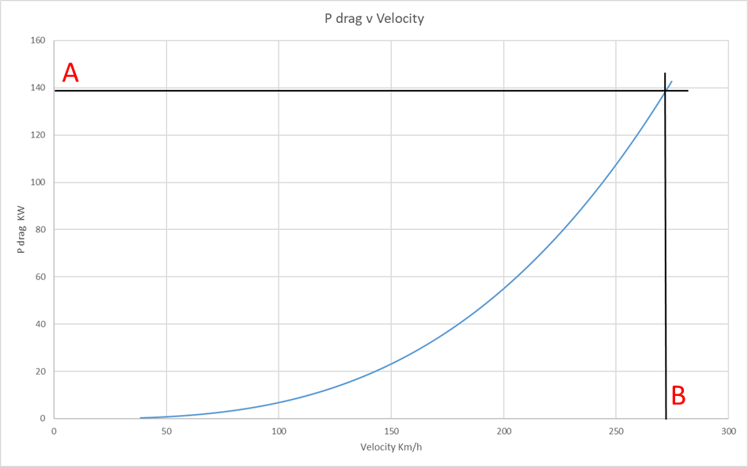
Graph 3:P drag v Velocity
For further data calculated look at appendices 1

Analysis
Graph 1 shows that as speed increases so does torque output of the engine, this is the engine trying to overcome the mass and tractive resistance (TR) of the vehicle during acceleration. When at an rpm of 10565 a max torque off 114.3Nm was reached, from here the graph flattens our before dropping. This is due to load on the engine being overcome by torque. When considering the relationship between torque and power it can be seen that as torque drops, power increases, this increase in power helps the vehicle accelerate/maintain a constant speed. (Newton, Steeds & Garrett. 1989).
As engine speed increases so does tractive effort (TE), this is seen in graph 2. Torque from the engine affects TE, as one increases so must the other. Between 1960 rpm and 10565 rpm a rise in TE can be seen, this increase in TE helps the vehicle overcome TR during pulling away and acceleration. Once at an rpm of 10565 the maximum torque of the engine has been reached, from here the graph flattens out before dropping; this is due to the 5th gear reaching/exceeding its TE value. Once this drop in TE happens the driver would than shift to a higher gear, this would help maintain vehicle speed now that TR and mass have been overcome. The value given to TE when max torque is achieved matches that given for TE of 5th gear, this further supports the previous statement (Šarić & Avdić. 2011; Kett. 1982).
When looking at the maximum TE of the gears, as the gear ratio increases the TE decrees. This Is because as the speed of the vehicle rises TR decrees meaning less TE is required to help the vehicle move. This is shown in graph two.
P drag (drag power) is the drag that a vehicle experiences as a result of acceleration/aero load, this is shown in graph 3. As the velocity of the vehicle increases so does P drag acting on the vehicle. From this graph, max road speed can be found. To find the max road speed, first find the max engine power available at the wheels; this is calculated by multiplying the max engine power by transmission efficiency. Once this value has been calculated (139.1 KW) a horizontal line (A) can be placed on the graph indicating the value. Where this line intersects with the curve, a vertical line can be added (B); This will indicate the max road speed (272 Km/h). (Summerfield, A. 6th January). The max road speed is also dependent on the maximum road speed of the gear selected, in this case 5th gear.
An average difference of 0.05 was found when comparing calculated final drive and the final drive specified. Within the calculation for theoretical gear ratio only two values fluctuate, these are the engine speed and velocity, these factors are affected by their surroundings; this coursed fluctuation in the final result. The final result is also affected by the gear selected; 5th gear was used due to it being closest to a 1:1 drive. Although being close to a 1:1 drive it’s not exactly 1:1, this is due to the transmission efficiency. All this leads to a difference between the factory specification and the calculated figure. This difference could also be due to manufacturing processes/limitations, this is further explained in the following paragraph.
The result produced for the theoretical gear ratio is less than that of the gear ratio used, this resulted in an average difference of 0.1; this is shown in the results (speed ratio was used in this calculation). This difference is due to the manufacturing process of the vehicle. The gear ratio calculated cannot be exactly made due to cost of designing and manufacturing new gear sets, therefore manufactures will use a gear set all readily available that is close to the one calculated (Crolla. 2009).

Conclusion
The transmission efficiency impacts all calculations used within this report. The transmission efficiency is how well power/ torque gets from the engine to the wheels. This is mainly affected by frictional loss from rotating parts inside of the gear box, this can also be affected by other factors like play of components and oil viscosity. This figure will be different for each vehicle depending on design, age and usage.
Graphs 1 and 2 show the engine/transmission overcoming the mass/TR of the vehicle during pulling away and acceleration. Once the max torque of the engine was reached a drop can be seen in both graphs, this is the torque of the engine decreasing and the power increasing. This increase in power helps the vehicle further accelerate/maintain max speed. Although showing the same thing, graphs 1 and 2 have different perspectives. Graph 1 shows torque produced by the engine where graph 2 shows torque produced by the engine as it travels through the transmission system, this allows the impact of the transmission system to be seen.
When looking at graph 3, two points can be made:
- Impacts that body shape/ air density have on the vehicle.
- How P drag affects the vehicles max road speed.
When calculating P drag the velocity of the vehicle, coefficient of drag, Frontal area and air density are used. As vehicles velocity increases so does aero load placed on to it, this is a result of negative and positive air pressure over/under the vehicle (Tudor. 5th March). How air flows over the vehicle is affected by vehicle shape, this relates to the coefficient of drag and frontal area figures given; air flow can also be affected by the density of air being driven threw. The impact of this on the vehicle is shown in graph 3, from this graph the impact that P drag has on the vehicles max speed can also be seen.
By applying the max engine power at the wheels (calculated as previously explained) to graph 3, the max road speed can be found. When this is done it produces a value of 272 Km/h for max road speed. This figure shows the impact of the aerodynamic design/P drag and the transmission efficiency on the vehicle’s max road speed.
When comparing the gear ratios calculated (theoretical and final) against the ones used on the vehicle, a difference can be seen. This is due to 3 main reasons:
- Manufacturing restrictions
- Transmission efficiency
- Fluctuations in data
Due to costs of designing and manufacturing new gear sets, manufactures will use an existing set. This set is closest to that calculated and is normally found to be slightly bigger, this in shores that power and torque needed is available.
When calculating the final drive, velocity and engine speed are used within the calculation. Due to the fluctuations in these figures, when an average is calculated there will be a slight difference in the final result when compared to that of the vehicle. The transmission efficiency will also have an impact on this figure.

Bibliography

Crolla, D.A. (2009) Automotive Engineering, Powertrain, Chassis System and Vehicle Body, 1st edn., Oxford: Butterworth-Heinemann.
Graham, M (2010) Understanding Gearing, Available at: https://www.visordown.com/features/workshop/understanding-gearing (Accessed: 10th March 2020).
Harris, W (2003) Motorcycle Transmission, Available at: https://auto.howstuffworks.com/motorcycle2.htm (Accessed: 31st of March 2020).
Heisler, H (1999) Vehicle and Engine Technology, 2nd edition end, London: Hodder Headline Group.
Helmenstine, A.M (2020) What Is the Density of Air at ATP, Available at: https://www.thoughtco.com/density-of-air-at-stp-607546 (Accessed: 05th April 2020).
Hillier, V.A.W. & Pittuck, F. (1981). Fundamentals of Motor Vehicle Technology (3rd edition). Tiptree: Wm Brendon & Son Ltd.
Irimescu, A. Miho, L. & Pãdure, G (2011) 'Automotive Transmission Efficiency Measurement using a Chassis Dynamometer', International Journal of Automotive Technology, Vol.12(No.4), pp. pp. 555-559.
Kett P.W. (1982) Tractive effort and tractive resistance (C12). In: Motor Vehicle Science Part 2. Springer, Dordrecht. Available at: https://link.springer.com/chapter/10.1007%2F978-94-009-5943-9_12.
Newton, K, Steeds, W & Garrett, T.K. (1989) The Motor Vehicle, 11th edition., Sevenoaks: Butterworths.
Rowley, W (2006) An Introduction to Race Car Engineering, 3rd edition. Rowley Race Dynamics.
Šarić, I & Avdić, V (2011) Tractive Effort Curves in Gearbox Analyse, Available at: https://www.researchgate.net/publication/235618460_Tractive_Effort_Curves_in_Gearbox_Analyse(Accessed: 31 of March 2020).
Summerfield, A. Semester 2, Powertrain Technology. M4X02196 Powertrain Technology. 6th January. University of Wales Trinity Saint Davids.
Summerfield, A. Transmission Matching. M4X02196 Powertrain Technology. 4th March. University of Wales Trinity Saint Davids.
Tudor, K. Basic Aero. M4X02198 Vehicle Systems. 5th March, University of Wales Trinity Saint Davids.

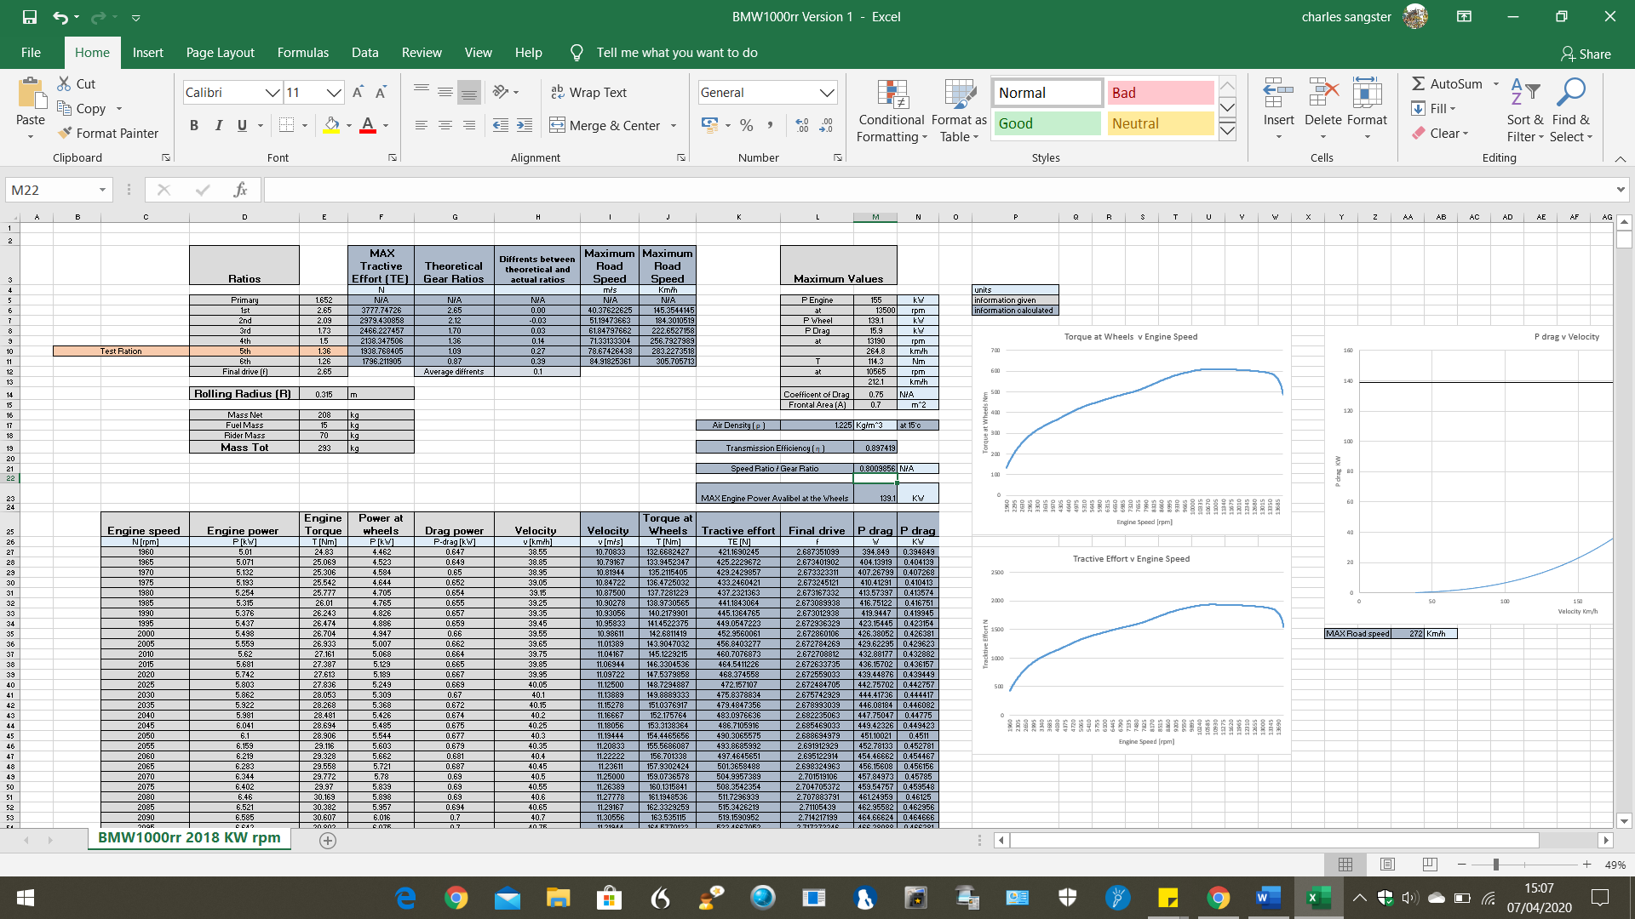

Appendices
Appendices 1: Spreadsheet data
https://uowtsd-my.sharepoint.com/:x:/g/personal/1902452_student_uwtsd_ac_uk/EWG1DFVWwwZNgs7igfXTSl4B9hRm5zbAagezjUX-xnbN2w?e=XFbFML

